Linked List Of Books

BIT 143 – ASSIGNMENT 2
Due: < Listed in the course schedule >
You are not allowed to work in groups this assignment. For this assignment, you should start, finish, and do all the work on your own. If you have questions, please contact the instructor.

What the program must accomplish
Imagine that you're going to keep track of some data. In this case, you're going to keep track of a collection of books. Each book has an author (a string), a title (another string), and a price.
For this assignment, you're going to create a program that will manage a linked list of books. There's a twist, however – instead of boring objects that only contain integers (like you saw in the lectures) instead you will create Book objects that have an Author, a Title, and a Price.
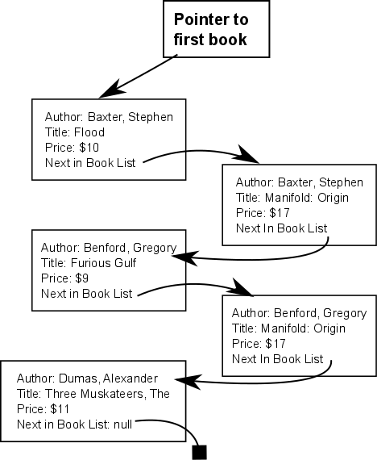
Notice how the list of books is sorted alphabetically by the author’s name. Similarly, the all the books by the same author are sorted alphabetically by the book’s title.
Thus, if we were to print the books, we'd get:

Book Author: Baxter, Stephen
Book Title: Flood
Price: $10
Book Author: Baxter, Stephen
Book Title: Manifold: Origin
Price: $17

Book Author: Benford, Gregory
Book Title: Furious Gulf
Price: $9

Book Author: Benford, Gregory
Book Title: Manifold: Origin
Price: $17

Book Author: Dumas, Alexandre
Book Title: Three Musketeers, The
Price: $11

You need to implement a program that will allow someone to add a book, remove a book, and print the books. The Book objects must be stored in the linked list described above. If you've already got a book with a particular author AND title, and you try to add another book with exact same author & title, you must indicate that an error has occurred, and not add the (duplicate) book.
To be clear: you need to implement not just the data structures that store this information, but you also need to finish implementing the Console-based user interface that will allow the user to interactively create books, print the list, and remove books that is partially provided to you in the starter project. There are a couple of comments that start with // STUDENTS: that should identify areas that you need to complete (in addition to the multiply linked list work). Make sure that you fill in any error-handling code in the UserInterface class that needs to be finished, as well as any unfinished methods!

Just as an FYI, I don't think that the term 'multiply linked' is a standard term. DOUBLY LINKED lists are a standard term (in a doubly-linked list is one in which each node has both a next pointer, and a previous pointer – a link to the node prior to it in the list), but what you'll be doing here is different from a doubly linked list.

Working Around Problems:

In ‘the real world’ you’re going to encounter problems in the program that you and your coworkers are working on. It’s not unheard of for someone else to change something that accidentally breaks something that you’re working on. It's good to start thinking about how you can continue to make progress on your work items even when the program that's given to you isn't in perfect shape.

For this assignment the Program.cs file does not compile as written, because it's missing something. You need to find a way to work around the missing part – you should change the file so that it does compile, and then complete all the work that's possible for you to complete.
You also need to put a comment at the top of the file clearly explaining both how you worked around this problem, and what else would you do if you were to encounter a similar problem in a professional work situation. (Just to be clear: there are no correct answers to this question – the objective here is to get you thinking about who you'd interact with and how you'd interact with them if you were in a situation like this).

Commenting:

You should comment your code, paying particular attention to areas that are difficult to understand. If you found something to be tricky when you wrote it, make sure to comment it so that the next person (the instructor, who's grading you) understands what your code is doing. It is not necessary to comment every single line.

The purpose of this requirement is to both help you understand, and have you demonstrate, a thorough understanding of exactly how your program works.

Every file that you turn in should have:
- At the top of the file, you should put your name (first and last), the name of this class (“BIT 143”), and the year and quarter, and the assignment number, including the revision number, which starts at 0 (“A3.0”). If you’re handing this in again for a regrade, make sure to increase the minor version number by one (from “A3.0”, to “A3.1").

In general, you should make sure to do the following before handing in your project:
- All variables used should have meaningful names.
- The code should be formatted consistently, and in an easy to read format.

What to turn in:

- A single electronic folder (a directory). This folder should contain:
  - The C# source code for the entire program. This will be all the .CS files that Visual Studio.Net creates for you.
  - Any other files that Visual Studio.Net has created for you, including the solution file (.SLN), and the project file (.CSPROJ). Basically, you need to hand in the entire directory that VS.Net created for you. You should leave out subfolders (such as the Debug, bin, or obj directories) that are generated from the source code/project.
- Don't forget to explain how you worked around the compile-time problem with the Program.cs file AND to explain how you'd deal with this in a real-world work situation.
Put this explanation in a comment at the top of the Program.cs file so the instructor can quickly and reliably find your answer.
How to electronically submit your homework:

There's a link on the homework page to the document that guides you through handing in your work.

