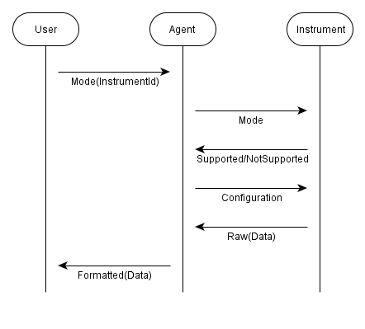0 // U is User, A is ION Agent (Integrated

1 // Observatories Network), I is Instrument

2 global protocol DataAcquisition (role U, role A, role I) {

3 interruptible { choice at U {

4 PushMode(InstrumentId) from U to A;

5 PushMode from A to I;

6 choice at I {

7 Supported from I to A;

8 ConfigPush from A to I;

9 rec PUSH {

10 Raw(Data) from I to A;

11 Formatted(Data) from A to U;

12 continue PUSH;}

13 } or { NotSupported from I to A;

14 ConfigPoll from A to I;

15 rec POLL {

16 Poll from A to I;

17 Raw(Data) from I to A;

18 Formatted(Data) from A to U;

19 continue POLL;} }

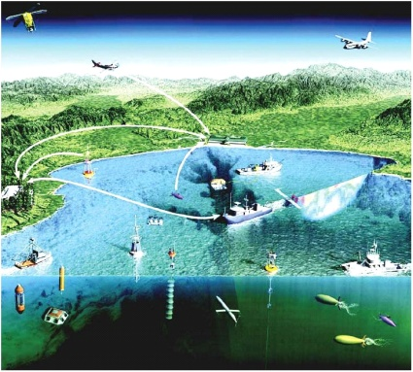

20 } or { PollMode(InstrumentId, int) from U to A;

21 PollMode from A to I;

22 choice at I {

23 Supported from I to A;

24 ConfigPoll from A to I;

25 rec POLL {

26 Poll from A to I;

27 Raw(Data) from I to A;

28 Formatted(Data) from A to U;

29 continue POLL;}

30 } or { NotSupported from I to A;

31 parallel {

32 ConfigPush from A to I;

33 rec PUSH {

34 Raw(Data) from I to A;

35 continue PUSH;}

36 } and { rec POLL {

37 Formatted(Data) from A to U;

38 continue POLL; }} }}

39 } by U with Stop

40 }