Static System V3.0 -- 1998 Beta Edition
TECHNICAL DOCUMENTATION FOR LGCK DEVELOPPERS

Table of content
Table On Content
0.0 Legal stuff
Disclaimer
Copyrights
Why this document?
Beta testing license
Note on the prerelease package
1.0 Game components
Defining Objects
Objects attributes
Forwardground Classes
Counters
Triggers
Procedures
2.0 Basic object components
Objects attributes
Forwardground Classes
3.0 Basics of moving actors
3.1 How moving works?
Walking left/right
Moving up or down
Jumping
Falling
3.2 Movements sequences supported
4.0 Basic of mapping objects
5.0 Events to triggers responses
6.0 Objects properties by class
6.1 Background Class
6.2 Forwardground classes
7.0 Adding code to events
PTS
LIVES
PLAY
MUSIC
GO
CHANGE
MOVE
ENDIFNOT
SPEED
ANIMATE
TRIGGER
CREATE
DESTROY
DEBUG
MESSAGE
GAMEOVER
EQUALCALL
REM
AIM
COUNTER
SETCOUNT
ADDCOUNT
BULLET
8.0 Understanding the behavior of the game engine
8.1 Background class
8.2 Forwardground classes
8.3 Games Events
8.3 Views and controls
9.0 Using Wizards to create objects
9.1 Creating a player
10.0 Editing an existing object
10.1 Editing the properties
10.2 Editing a sequence
11.0 Importing external resources
11.1 External utilities
11.2 Supported formats
12.0 Creating custom object wizards
13.0 Creating custom object classes
14.0 Game properties

0.0 Legal stuff

Disclaimer

This document is a work in progress, it is provided as it is without any warranty of fitness, accuracy or of any other kind explicit or otherwise. It is not intended to any purposes but to provide inside edge on the LGCK package.

In no event can the author be held liable for any damage resulting from the usage of this document or any portion of the accompanying product which include but is not restricted to the modification done by any executive programs to your system or Windows' registry.

By using this prerelease package, the user agrees to hold harmless the author and any third parties from lawsuits based on claims of consequent damages direct or indirect to him or to others.

Copyrights

This electronic document is the property of his author and cannot be distributed, duplicated or used in conjuncture with other copyrighted material without prior authorization.

All the graphics provided in the document are the property of Francois Blanchette. Game components and simulated screen shots are not from any existing games but are there just to provide tangible examples.

Some graphic have been imported from VLAMITS and VLAMITS II, computer games © Francois Blanchette and not available for market distribution. However, the assembler source code can be obtained on request. To comply with any inquiries is left the discretion of the author.

Why this document?

This document is only reference to this system. It's my personal notes on how the system was to be built. In the upcoming pages there will be discrepancies between what's written and the system; remember it's a work in progress.

For almost three year, I have written and rewritten the concept below to integrate my vision on how a simple side-scroller could be designed. The work below is sum of that long reflection. A simple way to allow a flexible design environment while not compromising the friendly interface power users need.

You should read through it once you are ready to embark on your journey into the LGCK beta package.

Beta testing license

The beta testing license entitles you and any third-parties to use this prerelease package for a duration 90-days without obligation or restrictions for evaluation purpose only. You are forbidden from distributing any part of the package for commercial usage or profit.

After the free 90-days trial period if you haven't registered you are required to delete all the files pertinent or belonging to the product from your computer. Failure to do so will be considered a breach of the license agreement, also a criminal offense punishable by the laws.

Note on the prerelease package

The original archive of this product can be freely distribute only in compliance of the shareware licensing and if the original files aren't modified or removed. You must distribute the unmodified complete kit to any potential tester. This package cannot be sold for profit or in conjuncture with copyrighted material from alternate sources.

This document and the accompanying files are part of the a prerelease package of the software. This program is marked as shareware and is entitled to any restrictions that apply to this marketing methods. Porting of the software was intentionally disabled.

The electronic document you are hereby reading was not intended for end users but as a note to clarify the usage of the product. Should you fell any part of the accompanying documentation is not clear feel free to report it to the author.

However since this is a prerelease version we do not provide technical assistance for it. Remember this document is provided courtesy of the author as basic guideline help to user in understanding the fundamental concepts of the game engine and the development environment interface.

Only should you purchase the full-registered version then you will be entitled to customary help.

The author,

Francois Blanchette
e-mail: lba_tech@hotmail.com

1.0 Game components

The static system V3.0 uses the following basic building components as can be seen on the tree structure of the main library screen. The user can add and remove items from any of the following components groups. However, some of these components are system attributed and cannot be deleted.

Triggers
Levels (also call scripts)
Counters
Frames handler

Sound & Music

Objects Class
1.Background (class 0)
2.Fowardground (class 0x80 and up)

Objects (themselves)

Procedures (SSV3 code)

Defining Objects

The objects are spliced between two groups of classes: background and forwardground. The system defined specific are shown below. The user can add new class when needed.

Background are also refereed as simple objects because they only handles ON TRIGGER CALL handlers.

Fowardground are complex because they can process many more messages handlers. It's the reason why they also requires more CPU time in game play. Use few of them as possible.

NOTE: New classes must provide their own handler. The current LGCK package doesn't support custom class definitions or sub-classing .

Objects attributes

00 Background
01 Antigravity
02 Solid
03 Deadly
04 Drain Oxygen
05 Water
06 Antigravity - Jump Stopper
07 Kill Player
08 Kill Others
09 Hurt Player
0a Solid Up Only

STATIC ATTRIBUTE
20 Goal

RUNTIME ATTRIBUTES
40 Stop
80 Inactive

Forwardground Classes

81 Players
82 Generic Objects
83 Keys
84 Doors
86 Triggers
90 Creatures

90 Dummy (Preprogrammed path)
91 COS 1.0

9a Computer - Red Devil
9b Computer - Advanced

a0 Drone up/Down
a1 Drone Left/right
a2 Platform up/Down
a3 Platform left/right

b0 Bullets (0xb0)
c0..ff Customs (free for extensions)

See also 2.0 BASIC OBJECT COMPONENTS for a complete up to date list.

Counters

The default counters are Lives, Vital Force and Oxygen, they are system attributed and cannot be deleted.

They can be renamed. Or hidden.

Triggers

Trigger allow interactions between two or more objects in a game environment. When an objects call a trigger in response to an events, all others objects with that same given trigger key will do their "When Trigger Call" response.

In short, triggers are making object to object "dialogs" possible. The role they play in the process of game play is enormous and often unseen.

Sound and music

Sound and music components are external resources not linked with the current version of LGCK. To utilize them they must be add as game objects with a complete and correct path to them. For simplicity all .WAV and .MID files should be in the same repertory (folder) as the game itself, for this allow you to type-in only the filename and not complete paths.

Procedures

Special code procedure can be defined using the Static System interpreter based language. However, this portion is optional and isn't required unless you want to go deep into the programming techniques.

2.0 Basic object components


Objects attributes

The decor objects cannot be animated as they are mapped once and are drawn only when need. This provide maximum execution time and prevents delay in game play.

Background: The background object are not taken into account. Green grass and other object that do not register are also counted into that category. (0x0)

 Antigravity: The ladder is one of many antigravity objects. The can range from tree, ropes and even water. In the LGCK environment, water is an antigravity item that drains a counter called oxygen. (0x1)

Solid: Many solid object can be found, they for the most part just block your way as you move into the game area. Bricks are just one example. (0x2)

Deadly: These objects kill you in a second. The lava is just one of many deadly objects you will encounter in the LGCK environment. This attributes is also referred as kill all.(0x3)

Drain Oxygen: Remove the player oxygen progressively. (0x4)

Water: Combine Antigravity and Drain Oxygen. Also a jump stopper. (0x5)

Antigravity - Jump Stopper: An antigravity item that stop a jump in progress. (0x6)

Kill Player: This attribute only affect the player and causes instant death. The amount of life the player has is reduced by one. (0x7)

Kill Others: This attribute affects only actors other than the players. It doesn't affect bullets. Other actors are killed on contact.(0x8)

Hurt Player: Providing we don't want to kill the player we can just warm him. Use this attribute for background item and the WHEN TOUCHED event from actors and other fowardground objects. (0x9)

Solid Up Only: Prevent object from walking down or falling onto it. (0xa)

TOUCH-ME ATTRIBUTE (STATIC)

Object Contact Zone: This attribute denotes a zone where this item can be in contact with other objects. This attribute applies only to mapping and is ignore otherwise. (0x10)

STATIC ATTRIBUTE

Goals: Object with this attribute need to be collected or destroyed before the "All goal collected trigger" can be called. Be careful, not to add this attribute with another like the deadly or solid which can render it's elimination impossible. (0x20)

RUNTIME ATTRIBUTES

Runtime attributes will we applied to an object outrun mapping.

Stop: This attribute prevents creatures from walking onto this space. Although any object can fall onto a part of the maze marked as such. The stop attribute is ignored if a mapped object is not background. (0x40)

Disabled: Any objects marked will not show up while it has this attribute. (0x80)

Forwardground Classes

 Player (0x81): Represents the player actor.

 Generic Objects (0x82): The collectible objects range from mushrooms, flowers, gold bars, bottles to diamonds. Once pickup they disappears.

 Doors (0x83)

 Creatures (0x90)

90 Dummy (Preprogrammed path)
91 COS 1.0

9a Computer - Red Devil
9b Computer - Advanced

a0 Drone up/Down
a1 Drone Left/right
a2 Platform up/Down
a3 Platform left/right

 Bullets (0xb0)

c0..ff Customs (free for extensions)

3.0 Basics of moving actors

_______________________________________________________
/
/
/ < Antigravity >
/______| |_________________________________________________
| |---|
| | |
| |---| <- Antigravity
| | |
| |---| <= Background =>
| | |
_____|______|---|__________________________________________________
/  /
/ Antigravity /
/ /
_/___________________________________________________________________/

3.1 How moving works?

Walking left/right

An actor can move into a given direction for as long as it's lower coordinate's position isn't blocked.

__________________############ <- This blocks the player
so he cannot walk any further.

Moving up or down

#########
_________________________ She's going up. First because she is blocked. And two, an actor cannot move up into a non gravity supported square. However you can move down into a blank.

An actor can go up or down if the positions along top or bottom of him are cleared. It cannot go up should moving up result in falling.

The support for the antigravity item is measured from the lower position (lowest Y) (that's where the feet's are).

Jumping
________________________________________

The player initiate the jump sequence. It consist of moving toward-up and then back down.

Should phase one be not completed. The player falls until it cannot any longer. In phase two the player move down as long as it cannot any longer.

For example, brick-like objects can prevent the actor from completing a jump. In such cases the jump is broken as state above.

Falling
 <- feet

The player falls until he has a solid /antigravity item under it's feet. Or an antigravity item where his feet are.

3.2 Movements sequences supported

 | Aims | Background | Player | Others | Bullets | Objects
 | 0. Stand | X | X | X | X | X
 | 1. Killed |  | X | X | X
 | 2. Hurt |  | X | X
 | 3. Rebirth |  | X | X
 | 4. Up |  | X | X | X
 | 5. Down |  | X | X | X
 | 6. Left |  | X | X | X
 | 7. Right |  | X | X | X
 | 8. Jump Up |  | X | ?
 | 9. Fall |  | X | ?
 | a. Jump Left |  | X | ?
 | b. Jump Right |  | X | ?
 | c,d,e,f Unused

4.0 Basic of mapping objects


Objects are represented into a game as a rectangular bitmap surface. While the idea of it made up into a place rectangle seem a pretty simple both efficient and fast, it become a problem when your object isn't rectangular.

Balls for example aren't using the four corner of the square the are in, a collision between an empty part of the rectangle and other objects will result in a hit even it that part is empty.

Trees were the first offenders, player could walk anywhere in them even in the empty spaces. The problem was then solve by manually disabling these little pockets of blanks. A process that was both long and trial and tribulation a kind of story.

You can specify any of the object attributes into the mapping except inactive. However they cannot be mixed in the same they are with the object class.

Also, when an object is mapped the default attributes are no longer taken into account only that of the mapping.

Mapping is manual and should prove long and painful. Should you encounter any difficulty, remember mapping is to be used with diligence. Too many mapped objects may cause slowness is the game subsystems.

 |  |  |  |  |  | 1 |  |  |  | 2
 |  |  |  |  |  |  | 2 |  | 1
 |  |  |  |  |  |  |  | 4 |  | 3
 |  |  |  |  |  | 1 | 3 |  | 4
 |  |  |  |  |  |  |  | 1

Think as mapping a mean of giving attributes to individual square in a Cartesian plan a little like a battle ship or chess board.

By mapping the entire game screen we can determine if a collision occurred between two object, the nature of the contact and the object involved without doing a object to object coordinates check a much more time consuming process. Attributes are given in a priority level only.

MAPPING AND ATTRIBUTES

Mapping will outrun the object's attribute under most circumstances unless you specified a static or runtime attribute on that object. In the later case, the object attribute will deny the mapping application.

This is one of those thing you have to look for when debugging your levels because it may not always be obvious what the source of the problem is.

In an unmapped object when the player's rectangle comes in contact with it a WHEN TOUCHED event is called. However with mapped object the event is triggered only when the player comes in contact with part of the object marked (mapped) as contact zone.

5.0 Events to triggers responses

Game events | Levels Events | Objects Events
WHEN GAME ENDS /OVER | WHEN LEVEL STARTS | WHEN TOUCHED
WHEN GAME COMPLETED | WHEN LEVEL ENDS | WHEN Z-PRESSED
 | WHEN ALL GOALS COLLECTED | WHEN TRIGGER CALLED
WHEN ANY LEVEL ENDS |  | WHEN HURT
WHEN ANY LEVEL ALL GOAL COLLECTED |  | WHEN KILLED
 |  | WHEN REBORN
 |  | WHEN TIMER TICK
 |  | WHEN USED
 |  | WHEN REACHING FOR PLAYER

NOTES:

Game events are defined in the library itself (physical term) also referred to as the Static System Database. In short, you set them only once per game.

Level events are unique for every level; and must be redefined overtimes.

Object events only apply to forwardground objects except WHEN TRIGGER CALLED which applies to everyone. And WHEN TOUCHED OCCURS when the player touches it.

In response to any of the events below the objects will call the following properties sheet. An event marked by a X identifies that it is handled by the object class.

The table below represent the property tab shown in response to object events.

EDITS | Life force + -
 | Points + -
 | Oxygen + -

COMBOS | Change to
 | Change Player to
 | Transport to
 | Call Trigger | ???????????
 | Sound | A sound to be played

CHECK BOXES | 0. Destroy item
 | 1. End Level | By pass the "all goals collected"
 | 2. Restart Level
 | 3. Kill Player | Remove one life to player
 | 4. Time Stop
 | 5. Extra life
 | 6. Flash screen
 | 7. Add to inventory | LGCK does not support this switch
 | 8. Death Scroll | Kill Others
 | 9. Call trigger
 | a. Inverse disable state | Hide/un-hide
 | b. Inverse stop state
 | c. New Player Bullet
 | d. Unused
 | e. Unused
 | f. Unused

For each event handled by an object there will be a property sheet like the one above. Filling them in one at a time to ensure that the program can be carried out correctly.

It might look a little something like this...

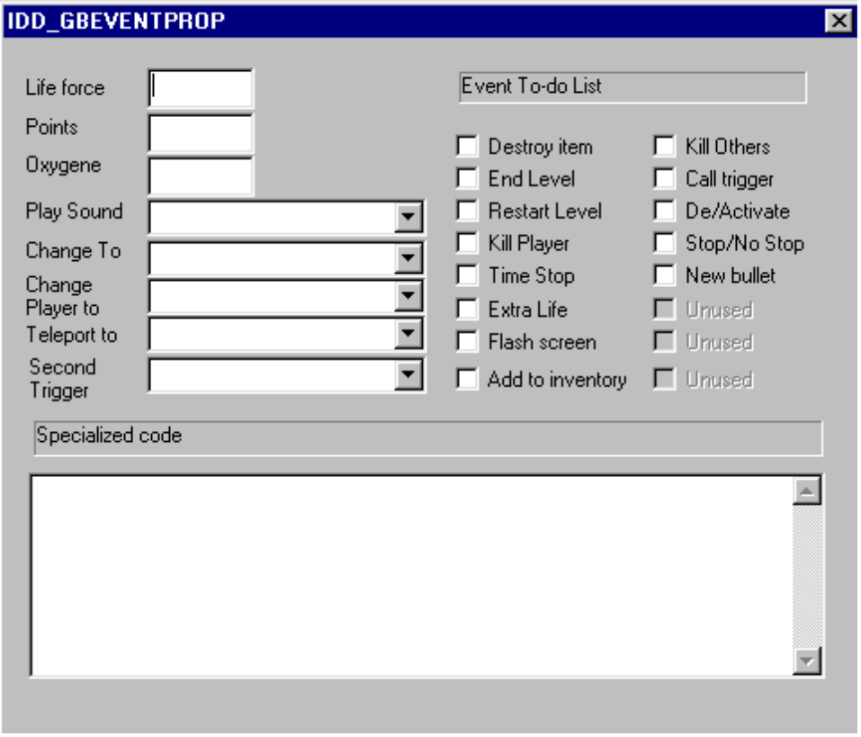

NOTE: Actual screen may vary from version to version, or at final release time. Screen shot provided as an example only.

6.0 Objects properties by class

Each class requires his own handler. A handler is special routine hard coded into the program that will allow items to interacts.

Look a the chart on the previous page for basic attributes granted to objects by the wizard. On this section we dealt with special class related attributes that only apply to a specific class or classes.

6.1 Background Class

The property frame for all background Class Objects have only two sheets. The first is the main page displaying the object's name, attributes and whether or not it has been mapped.

MAIN PAGE
- Name of the object EDIT
- Object Attributes COMBO
- Mapped or Not CHECK BOX

"WHEN TRIGGER CALL" PAGE

The property sheet for background objects looks like this...

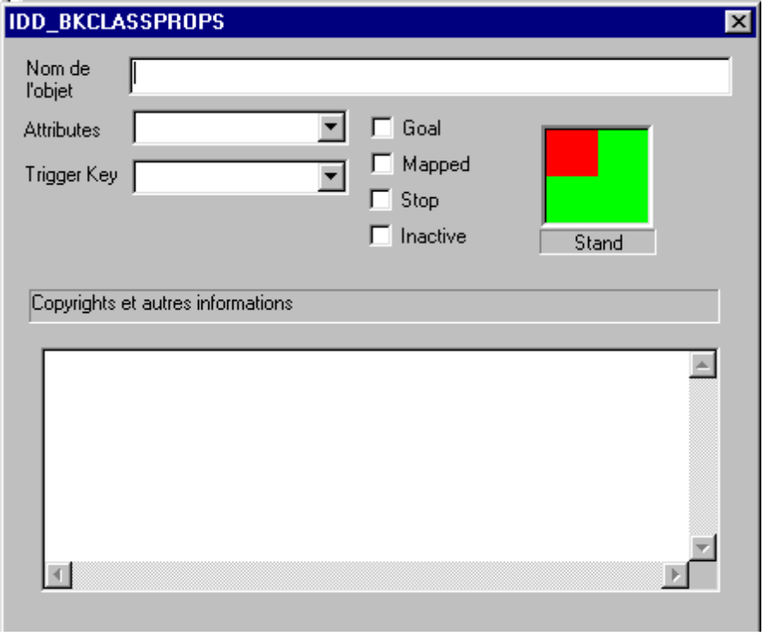

6.2 Forwardground classes
The property frame contains the main page and several event pages. The events covered for each object class are discussed in another section of this document.

The objects attributes are discussed elsewhere in this document. As for the special attributes they apply to only to the players, others actors and generic objects; which thereby excludes the background objects. The tables below cover the special attributes.

TABLE OF SPECIAL ATTRIBUTES FOR PLAYERS AND OTHER ACTORS

Attributes
SERIES A | SERIES B | SERIES C
0- Can Move Up | 8. Killed by Water ?
1- Can Move Down | 9. Killed by Lava ?
2- Can Move Left | a. Killed by Bullets ?
3. Can Move Right | b. Killed by Others ?
4- Can Fire | c. Unused
5. Can Jump Left/Right | d. Unused
6. Can Jump Up | e. Unused
7. Can Fall | f. Unused

TABLE OF PROPERTIES FOR PLAYERS AND OTHER ACTORS (NOTE: special attributes in table above)

 |  | APPLIES | TO
PAGE AND CONTENT | FORMAT ON SCREEN | PLAYER | OTHERS | OBJECTS | BULLETS
MAIN PAGE
- Name of the object | EDIT | X | X | X | X
- Object Attributes | COMBO | X | X | X | X
- Mapped or Not | CHECK BOX | X | X | X | X
- Time for Rebirth | EDIT / COMBO | X | X | X | N/A
- Number of rebirths | EDIT / COMBO | N/A | X | X | N/A
- Time Out delay | EDIT / COMBO | X | N/A | N/A | N/A
- Bullet | COMBO | X | X | X | N/A
- Fire Aim | COMBO | N/A | X | X | N/A
- Fire Rate | COMBO | X | X | X | N/A
- Movement speed | COMBO | X | X | N/A | X
- Animation Speed | COMBO | X | X | X | X
- Resistance | COMBO  0- Normal  1- Hurt all  2- Killed by Water  3- Invincible | X | X | X | N/A
SPECIAL ATTRIBUTES PAGE
- Series A | MANY CHECK BOXES | X | N/A | N/A | N/A
- Series B | MANY CHECK BOXES | X | N/A | N/A | N/A
- Series C | MANY CHECK BOXES | X | N/A | N/A | N/A
SEVERAL "WHEN" EVENT PAGES

NOTE: Check the property page for forwardground objects. The actual page may vary from the example. Some fields will be either disabled or hidden depending on the class of the object being edited.

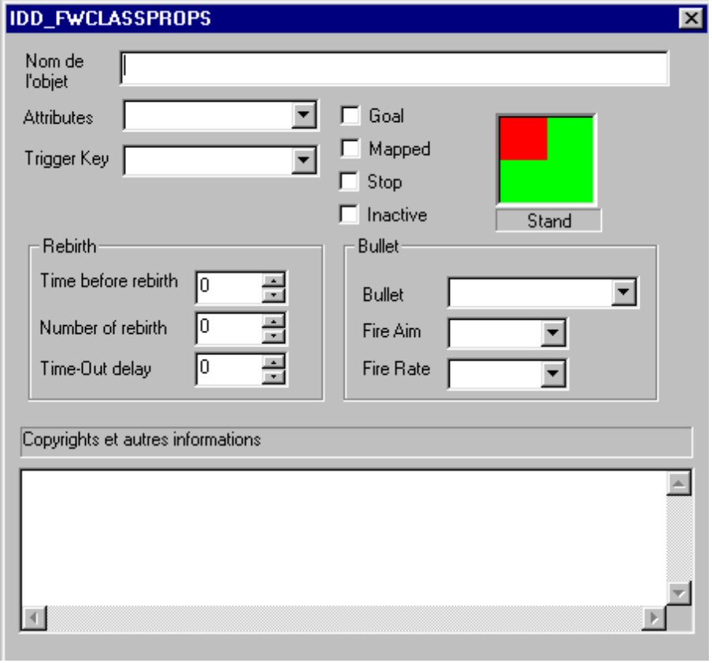

7.0 Adding code to events

WARNING: Just heard this one advice about adding personalized code. "Improper usage may cause the game to hang, crash or one of other unpleasant results. Please consider what you are carefully doing because the upcoming commands tackles directly into the game engine itself. Power Users only"

Expressions

All expressions are included within quotes. Even numeric expressions must be include into quote. Failure to do so will result in an error.

Special expression such as "(this)" and "(that)" are reference to objects as explain below.

The "(this)" refers to the object whose property sheet invoked the call to the subroutine. Where "(that)" is a mention to the object that caused the event to be invoked.

For example, when the player steps onto a mushroom the WHEN TOUCHED of the mushroom is invoked. "This" is the mushroom and "That" is the player.

When an object call a trigger it become "That" and all the recipient of the WHEN TRIGGER CALL are "This".

Objects name and expression are case insensitive. None special expressions are considered class names unless preceded by a @ (like "@Mushroom_4F") then it refers to an item object.

Operators

Operator can only be used in expression. Fallow the examples to see all valid uses of operators in an expression.

The following operators are available
- denote a negative
@ denote a specific object (not a type)

Commands

Look below for a list of available commands supported by LGCK. More commands may be available to the STATIC SYSTEM V3 but aren't known at this time.

PTS

Adjust the player's points according to a specified amount inside the quoted expression. Positive values are added and negatives are subtracted.

Syntax:
PTS "999"
PTS "-9999"

LIVES

Adjust the player's number of lives according to an amount specified in the expression inside quote. Positive values are added and negatives are subtracted.

Syntax:
LIVES "1"
LIVES "-1"

PLAY

Play the specified sound file. If the file cannot be opened an error will written onto the debug log.

Syntax:
PLAY "SOUND.WAV"

MUSIC

Play the specified music file. If the file cannot be opened an error will written onto the debug log.

Syntax:
MUSIC "MUSIC.MID"

GO

Move up to another level. This command will bypass the WHEN ALL GOAL COLLECTED and WHEN LEVEL END. The remainder of the script will not be executed. If the call fails, the execution will be suspended any way and an error message will be displayed.

Syntax:
GO "Level-01"
GO "(next)"

CHANGE

Changes the given object or object into object specified by the second argument.

Syntax:
CHANGE "(this)" "Bugs"
CHANGE "(that)" "Turtle"
CHANGE "Bugs" "Turtle"

MOVE

Changes the X & Y position of a given object or objects.

Syntax:
MOVE "(this)" "(up)"
MOVE "(that)" "(down)"
MOVE "(this)" "(that)"

ENDIFNOT

Check two objects and end the script if the two are not the same class.

Syntax:
ENDIFNOT "(this)" "(that)"
ENDIFNOT "(this)" "Player"

SPEED

Changes the speed of an object or objects. The first argument is the expression designating the object. And the second is the speed.

Using + and - will modified by the one the current amount. You can also use the default class speed as argument.

Syntax:
SPEED "(this)" "0"
SPEED "(all)" "+"
SPEED "(all)" "-"
SPEED "(that)" "Turtle"

ANIMATE

Changes the animation speed of an object or objects. The first argument is the expression designating the object. And the second is the new speed.

Using + and - will modified by the one the current amount. You can also use the default class animation speed as argument.

Syntax:
ANIMATE "(this)" "0"
ANIMATE "(this)" "0"
ANIMATE "(this)" "0"
ANIMATE "(this)" "0"

TRIGGER

Call another trigger that the one the object is assigned.

Syntax:
TRIGGER "TriggerName"

CREATE

Create a new object at the same X & Y as this one.

Syntax:
CREATE "ObjectName"

DESTROY

Destroy the designated target. While destroying the player will end the game, destroying this object will end the code procedure.

DESTROY "ObjectName"
DESTROY "(this)"
DESTROY "(that)"

DEBUG
Add a string to the debug log.

Syntax:
DEBUG "Player up"

MESSAGE
Display a message.

Syntax:
MESSAGE "Message"

GAMEOVER

End the game. Bypassing all the triggers and events.

Syntax:
GAMEOVER

EQUALCALL

If the first argument is an object class then an external procedure is called if the first two objects are the same class.

Syntax:
EQUALCALL "(this)" "Player" "TheProcedure"

REM

Place a remark or a comment

Syntax:
REM fdssfdidfsdfsokgfl;s;lfd

AIM

Change an actor's aim

Syntax:
AIM "(this)" "(left)"
AIM "(that)" "(this)"

COUNTER

Add or remove value from a system or custom counter. The first argument is the counter's name and the second is the value to be applied, positive are added and negative are subtracted.

Syntax:
COUNTER "Points" "10"
COUNTER "Lives" "-1"
COUNTER "Oxygen" "5"

SETCOUNT

Set a counter at a precise value. When the specified second expression is a class or object name SSV3 will count the objects matching the specification and the set the counter appropriately.

Syntax:
SETCOUNT "Goals" "Diamonds"
SETCOUNT "Goals" "10"

ADDCOUNT

Add a given amount to a counter. When the specified second expression is a class or object name SSV3 will count the objects matching the specification and add the value to the counter.

Syntax:
ADDCOUNT "Goals" "Diamonds"
ADDCOUNT "Goals" "10"
ADDCOUNT "Goals" "-1"

BULLET

Change the player's bullet to another. When the specified bullet object cannot be found then the player's bullet revert to NULL.

Syntax:
BULLET "SlimeBall"

8.0 Understanding the behavior of the game engine

8.1 Background class

Background objects are immobile component of the game screen. They aren't redrawn often or re-mapped; it most often happens when a WHEN TRIGGER CALLED occur. Other object perform this call in response to an event, each class of object has his own set of events it support.

In the overall, all background items have a single class handler that simply process the WHEN TRIGGER CALL event. The inherited event handling will take on the processing of the properties sheet WHEN TRIGGER CALL.

Interactions between them and other objects is performed by the handlers of the other objects of forwardground classes. Background items provide decor related texture mapping of the game area. They require low processing time and therefor should be your first choice for every chore.

8.2 Forwardground classes
Forwardground objects have every properties of the background ones obviously of top of that they handle many more event and consume more CPU time. Needless to say they are the core of the game engine in the sense they allow to perform many complex operations.

The player object is the interactive component of the game engine, in essence it allow the user (gamer or human player) to have input into the game environment. This object is handled through the game interface in response to an input from the keyboard or joystick.

Other objects can have interaction with it. Generic object are the easiest of the most, they lay still unless pull toward the ground by gravity. Most often we'll turn-off the gravity influence on them for performance reasons; the gravity handler takes-up a lot of CPU time. The only objects influenced by it are normally the player and other actors.

Flowers, diamonds and gold chests are typical forwardground generic objects. Back in 1995 we call those Pick-Up objects because they could be pick-up when the player walked on them. Some would stir-up chain reactions, those were called Pick-Up Trigger because they carries a Trigger Key that activated objects that had the same key when pick-up.

You can combine many properties from the common attributes (Antigravity, water or solid) to the special attributes discussed elsewhere; most combination are allowed but weird ones can create unusual effects. This system isn't full proof so limit yourself or you may find a new unexpected crash situation that aren't always easy to spot.

The Trigger Key allow "communication" between objects, it's signature will allow object from send it the okay signal to make all the walls turn blue or make a bridge appears. This is perhaps one of the most difficult to understand concept of this system. So the following text breaks it into a series simple of easy to understand steps.

1. A flowers had a trigger key name "23" and a disabled bridge has a trigger key also call "23". Disabled objects are not visible and therefor not taken into account while their disabled attribute is active. The flower is a generic object, while the bridge is background item with a solid attribute.

2. When player step onto the flower, a WHEN TOUCH event occurs. In the WHEN TOUCH property sheet of the flower there is :

- Add 50 points
- Destroy object (so the flower will be gone)
- Call trigger (calling trigger "23" which is the flower's trigger
key)

3. The game engine searches for all item with a trigger key equal to 23.

4. When it finds the bridge, it will look at it's WHEN TRIGGER CALL property sheet and find:

- An inverse disable state (which make the bridge visible again)

5. At the end of the process: we get 50 points for the player, no more flower and a visible bridge.

The object issuing the call cannot be affected by it's own call which in short mean that it's WHEN TRIGGER CALL sheet won't be read. Also object that are triggered cannot trigger again to prevent infinite loops.

Other objects also make trigger call; often they are switches that can be pulled up and down with the [Z] key. They work in the same way that the flower except that instead of the destroying the object they simply change into another object. The first object is the switch down and the other has the switch looking up, in essence they are the same class and most of the properties are the identical.

Some objects will be added to inventory, we call those keys because in traditional gaming keys are what player pick-up during a game. Just for the form a few of those objects could also be called guns. In plain short those are again generic objects with a ADD TO INVENTORY property in their WHEN TOUCH event.

Objects from the DOOR class will not activate their WHEN USED property unless the player has the right "key" in his possession. In the WHEN USED you'll often find a Change Object or a Destroy object so the player may pass.

Other referred as guns will when used change the player's bullet to another set in the object's property sheet.

A note on mapping

Ever since the notion of mapping came up it stirred-up nightmare in perspective not because adding a map was hard but moreover it was hell to make interactions check especially with actors.

When the player touches the Object Contact Zone it will do a WHEN TOUCH event regardless of whether it is a generic object, a bullet or another actor. Other attributes (common attributes like antigravity, water or deadly) will act like normal background attribute). Objects carrying an attribute isn't affected by it but any other will.

When one Object Contact Zone reaches for the Player's contact zone it will do WHEN REACHING FOR PLAYER. An unmapped object is all contact zoned. If you don't provide a contact zone they won't be any WHEN TOUCH event triggered.

Only the player can cause WHEN TOUCH events.

8.3 Games Events

When all the goal destroyed (or collected) the game engine trigger a WHEN ALL GOALS COLLECTED event. This even is handled for each level and at the game level. Usually every level is handled in the very same way so it makes common sense to use the global handler; however in some circumstances you will want to handle it yourself level by level.

The same also applies to the WHEN LEVEL START and WHEN LEVEL END. WHEN THE GAMES ENDS it another event that need handling, it occurs when the game has ended as you might guess, this the perfect opportunity to add a "game over" screen and some sad music with a nasty voice.

As you should understand the STATIC SYSTEM V3.0 is an events driven system like Windows and therefor most of everything that occurs here is modulated in that spirit.

8.3 Views and controls

9.0 Using Wizards to create objects

The following table identifies most basic object type and the class from which they can be derived. Add the required attributes at the end to allow the process to be "natural".

This feature is not available in the prerelease version.

10.0 Editing an existing object type

10.1 Editing the properties

For each object there is a certain number of property page whose content will enlist how it interacts with other object in the game environment. Those page have been introduced and explained in the previous sections of this document.

When we think of the objects in the library we should refer to the as object type because that's what they are. Objects positioned in the game screens are reference to those typed objects. Customs objects can be derived from those in the database library.

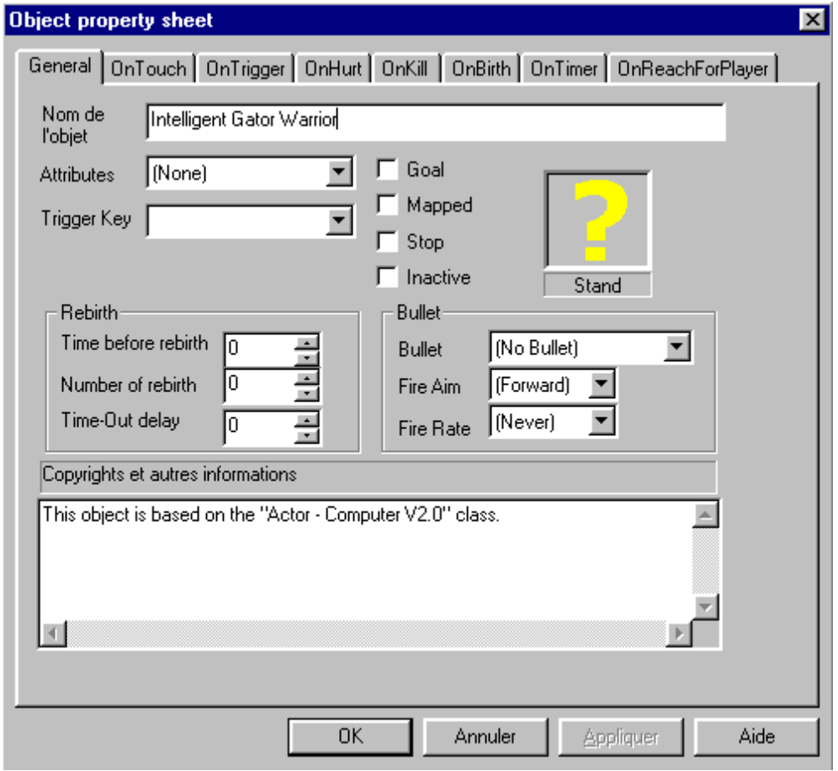

10.2 Editing a sequence

The screen display just below is used to edit sequence a particular sequence. For each on of the supported sequence an object can have unlimited amount of frames. Each frame can be mapped individually. Remember that mapping isn't enabled at runtime unless the Mapping attribute of the object's property sheet is enabled.

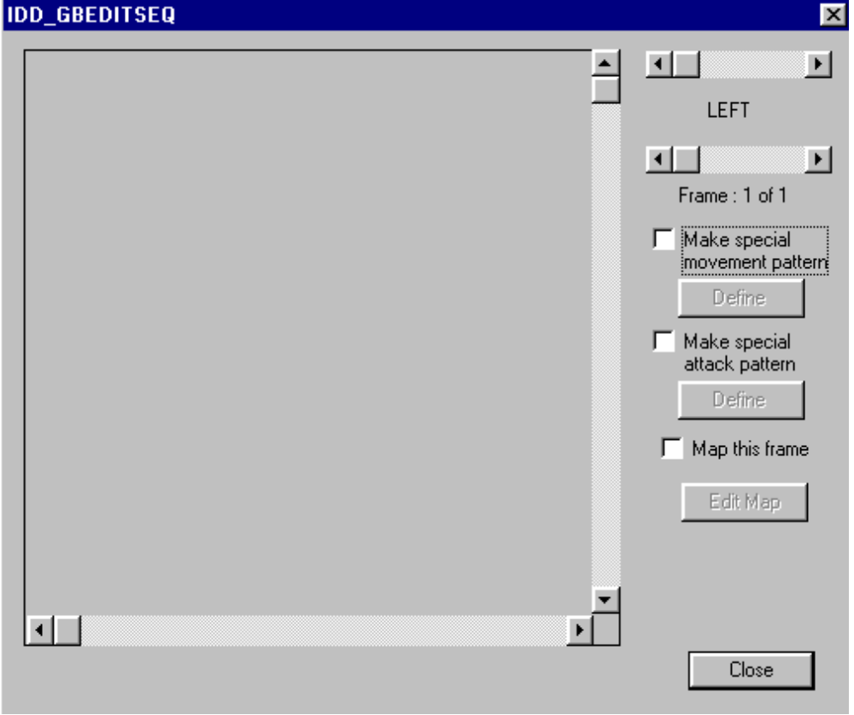

Once a map is defined it will not be deleted. It can however be disabled or hidden. Each sequence can support be a special movement. These later allows the object to attempt walking in some strange way. In special sequence pattern movement the object ignores gravity even though it is gravity aware.

To allow a special sequence to take place the object's sequence mustn't run into solid object that can block it's way. Further, the last position of the object mustn't be in fall situation if the actors is gravity aware and not allowed to jump.

11.0 Importing external resources

11.1 External utilities

GE96.EXE

The Graphic Editor 96 was provided with this package along with some graphic elements in MCX format. The program is 32x32 pixel tile editor that ensure basic draw capabilities. This editor will allow you to make graphic element and the import them into your Static System V3 database projects.

OBL3EDIT.EXE

This an 1997 graphic editor provided with a previous system it provide another more complex storage format know as OBL3. This editor will allow you to make graphic element and the import them into your Static System V3 database projects.

IMAVIEWW.EXE

This a Windows 95 program designed as an image file viewer that can view only files stored in the IMA-FNT or IMC1 formats.

IMSMAKER.EXE / IMS2MCX.EXE

The IMSMAKER program allows you to combine multiple MCX into one .IMS file. The result file can then be converted back into MCX by the later utility, IMS2MCX program.

11.2 Supported formats

The current beta package supports only 3 proprietary formats: IMA (IMA-FNT and IMC-1), MCX and OBL3. Future installments may allow import from DIB (Windows device independent) BITMAPS.

12.0 Creating custom object wizards

This feature is not available in the prerelease version, 90-days limited edition.

13.0 Creating custom object classes

This is the most powerful and most dangerous feature of the STATIC SYSTEM V3.x. It is available at this time, when it will be it should allow user almost unlimited control over their new constructed classes.

SSV3 interpreter languages macros will allow to tackles event deeper by allowing direct call to LGCK functions and readout of the results. New custom actors will be able to seek the player and do what the user please. Total unprotected access to every feature of the game engine.

14.0 Game properties

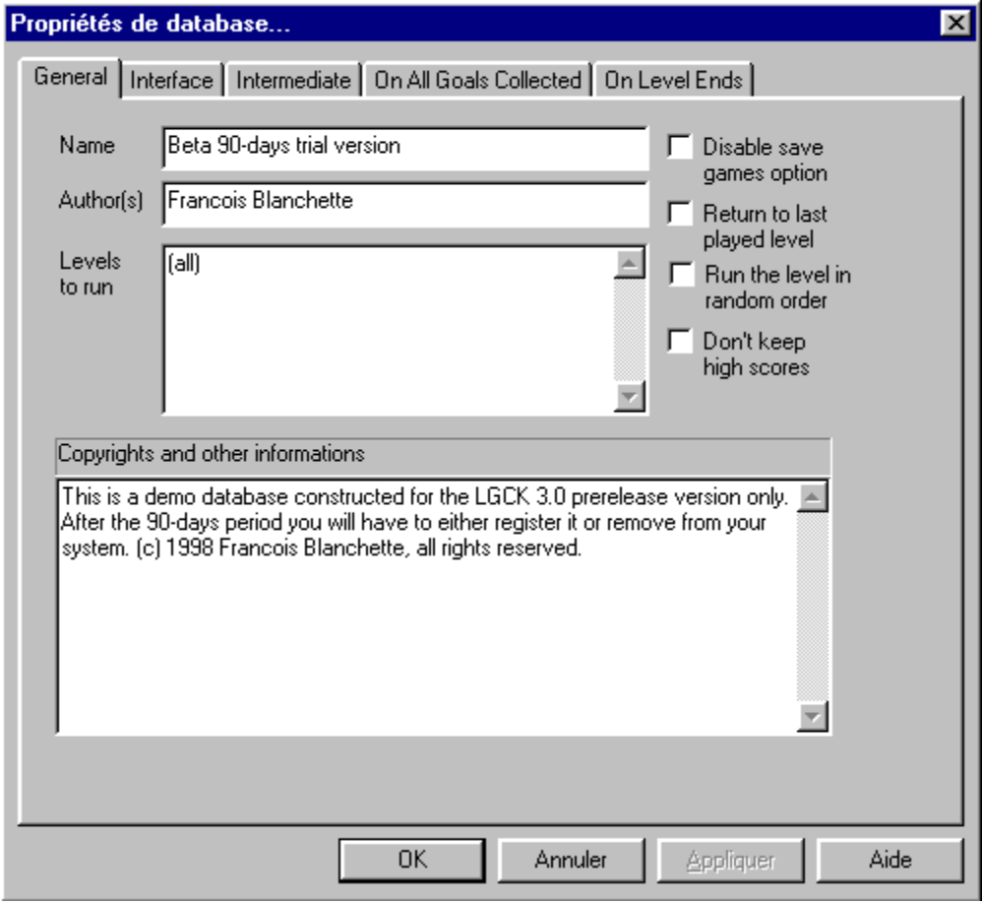

The database's properties are LGCK game specific that allows the customization of the game itself.

The "OnAllGoalsCollected" and "OnLevelEnds" sheets are relevant to WHEN ANY LEVEL ALL GOALS COLLECTED and WHEN ANY LEVEL ENDS. These are generic level event that will occur on every level.

They are processed after the level specific event should no END-LEVEL is called before them.

