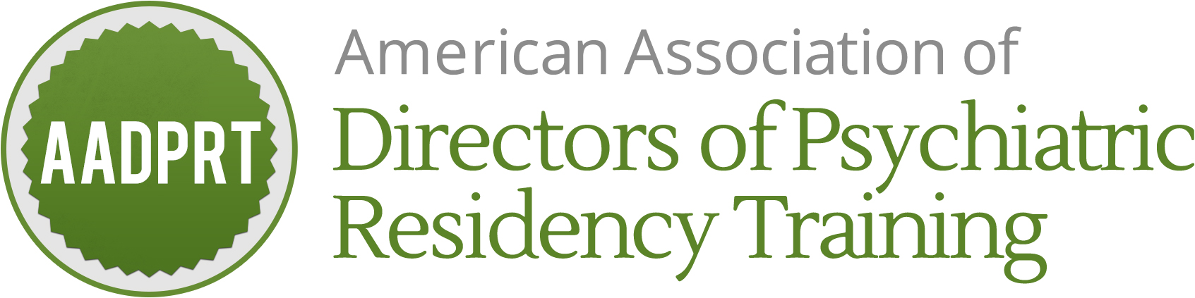

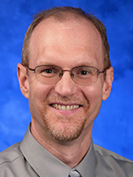**Biosketch**

**Randon S. Welton, MD**

**AADPRT Position: Chair, Program Committee**

**Chair, Match Consultants**

Randon S. Welton M.D. is the Margaret Clark Morgan Chair of Psychiatry at NEOMED (Northeast Ohio Medical University) charged with helping the department refocus on training medical students and psychiatry residents. In recent years, the department focused on hosting Ohio Centers of Excellence – Treatment of Schizophrenia, Campus Safety and Student Health, and Coordinating with the Criminal Justice System – and hosting statewide mental health teleconferences called ECHO Projects. Prior to that he was the Training Director for the general psychiatry residency at Wright State University in July 2013.  Prior to that he served as a psychiatrist in the United States Air Force for over 20 years. He currently serves as the Chair of the Program Committee and Match Consultants.