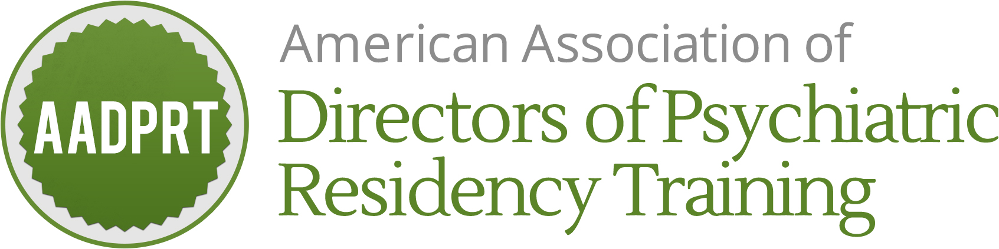

**48th AADPRT Annual Meeting & BRAIN Conference**

**February 27 - March 2, 2019**

**Hilton San Diego Bayfront**

**Application and Contract for Annual Meeting Exhibit Space: Due 12/31/18**

Exhibit Dates February 28 & March 1, 2019

**Two ways to register:**

*Email: Complete form and email to Sara at exec@aadprt.org

*Mail: Complete form and mail to AADPRT to:

AADPRT

P.O. Box 30618

Indianapolis, IN 46230

**Please print or type.**

Company Name:

Company Description:

Why do you wish to exhibit at AADPRT?

Planning Contact Name:

Planning Contact Phone Number:

Planning Contact Email:

Onsite Contact Name:

Onsite Contact Mobile Phone Number:

Onsite Contact Email:

**Exhibitor Responsibility Clause**: To the fullest extent permitted by law, the person/legal entity described as “Exhibitor” in this clause and in this exhibitor contract (regardless whether such person/legal entity is also described as “Exhibitor” in this contract) hereby assumes full responsibility and agrees to indemnify, defend and hold harmless **Hilton San Diego Bayfront** (“Hotel”), Hotel’s owner **Sunstone Park Lessee, LLC, a Delaware limited liability company**, Hilton Worldwide, Inc., and each of their respective owners, managers, subsidiaries, affiliates, employees and agents (collectively, “Hotel Parties”), as well as **American Association of Directors of Psychiatric Residency** (“Group”) and **Liz Group LLC**, from and against any and all claims or expenses arising out of Exhibitor’s use of the Hotel’s exhibition premises. Exhibitor agrees to obtain and maintain during the use of the exhibition premises, Comprehensive General Liability Insurance, including contractual liability covering the Exhibitor’s indemnity obligations in this clause. Such insurance shall be in the amount of not less than $1,000,000 combined single limit for personal injury and property damage. The Hotel Parties and Group shall be named as additional insureds on such policy, and Exhibitor shall supply the Hotel with a Certificate of Insurance at least 30 days prior to the use of the exhibition premises. The Exhibitor understands that neither the Group nor the Hotel Parties maintain insurance covering the Exhibitor's property and it is the sole responsibility of the Exhibitor to obtain such insurance.

*The aforementioned company wishes to reserve an exhibit booth at AADPRT’s 2019 annual meeting. By signing this contract, company agrees:*

1. *they have reviewed and will abide by all policies as addressed in exhibitor prospectus*
2. *they have reviewed and agreed to aforementioned language*
3. *they will provide check payment to AADPRT no later than January 18, 2019*
4. *they will provide insurance certificate to Hilton San Diego Bayfront via Kirsten Johnson at* [*Kirsten.johnson@hilton.com*](mailto:Kirsten.johnson@hilton.com) *no later than January 18, 2019.*

*Space is not guaranteed until application, payment, and insurance certificate have been received. Signer understands that if check payment and/or insurance certificate is not received by January 18, 2019, they will not be able to exhibit at the event.*

*AADPRT has all rights to reject application and return fee. Refunds are only given in the event the application is rejected.*

Authorized Signature:

Printed Name:

Date: