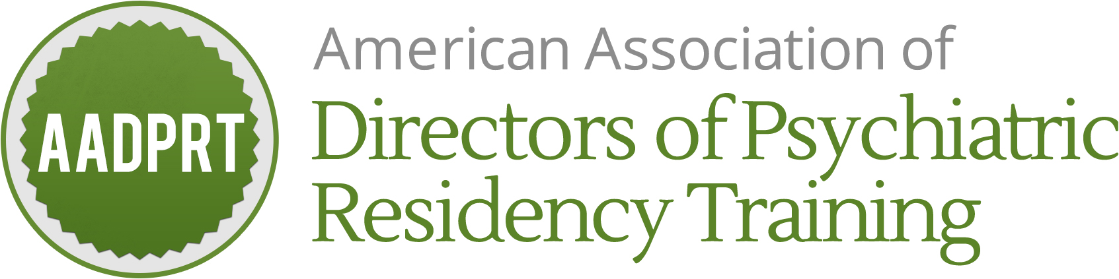

PO Box 30618
Indianapolis IN 46230
47th AADPRT Annual Meeting
March 1-3, 2018
Hilton New Orleans Riverside

Application and Contract for Annual Meeting Exhibit Space
Applications and payment received after January 18 will not be accepted.

Exhibit Dates March 1 & 2, 2018

Two ways to register:
*Email: Complete form and email to Sara at exec@aadprt.org (check payment should be mailed to address below)
*Mail: Complete form and mail with check payment payable to AADPRT to:
AADPRT
P.O. Box 30618
Indianapolis, IN 46230

Please print or type.

Company Name:

Company Description:

Why do you wish to exhibit at AADPRT?

Planning Contact Name:

Planning Contact Phone Number:

Planning Contact Email:

Onsite Contact Name:

Onsite Contact Mobile Phone Number:

Onsite Contact Email:

The aforementioned company wishes to reserve an exhibit booth at AADPRT’s 2018 annual meeting. By signing this contract, company agrees they have reviewed and will abide by all policies as addressed in exhibitor prospectus and will provide check payment to AADPRT no later than January 18, 2018. Space is not guaranteed until payment has been received. AADPRT has all rights to reject application and return fee. Refunds are only given in the event the application is rejected.

Authorized Signature:

Printed Name:

Date:

