**Impact of climate change on the capture fisheries economy**

The dynamics of harvested marine fish and invertebrate populations are sensitive to climate change via changes in both environmental (e.g., warming, deoxygenation, acidification, etc.) and biological conditions (e.g., changing habitat availability, food webs, predator-prey dynamics, etc.). In some cases, these changes can increase fisheries productivity. For example, warming can drive the expansion of thermal habitat available to a species or negatively impact a key predator or competitor species. In other cases, these changes can decrease fisheries productivity. For example, hypoxia can increase mortality, acidification can decrease growth rates, and spatial-temporal mismatches in the availability of prey can reduce the recruitment of juveniles. In the section below, we detail how retrospective and forward-looking studies have revealed the impact of climate change on marine fisheries and the opportunity for fisheries management to mitigate the negative impacts of climate change on the ocean economy.

**Climate change modifies the life history of marine fish and invertebrates including their growth, natural mortality, and recruitment rates. Fisheries stock assessments will increasingly have to account for time-varying life history under climate change.**

Observed changes: Climate change has already resulted in reduced growth rates and smaller body sizes in many marine fishes (Sheridan and Bickford 2011), resulting in reduced yield per recruit (Baudron *et al.* 2014) and by extension, reduced catch potential. Climate change has also altered the timing and location of the phytoplankton and zooplankton blooms that support marine food webs (Cushing 1990; Edwards and Richardson 2004; Poloczanska *et al.* 2013). Spatial-temporal mismatches in prey availability have resulted in increased mortality (Beaugrand *et al.* 2003; Clausen *et al.* 2017) while matches have resulted in reduced mortality (MacKenzie and Köster 2004). Finally, recruitment of juveniles is often more strongly driven by environmental factors than by spawner biomass (Szuwalski *et al.* 2014; 2019) and has declined as a result of environmental change and overfishing ((Britten *et al.* 2016) but see (Szuwalski 2016)).

Forecasted changes:Fish growth rates and body sizes are forecast to decline under continued warming and deoxygenation with consequences for catch potential ((Cheung *et al.* 2012) but see (Lefevre *et al.* 2017) and (Pauly and Cheung 2017) correspondences). On average, maximum body weights are expected to shrink by 14-25% globally from 2000-2050 under a high emission scenario (Cheung *et al.* 2012). Furthermore, changes in physical oceanography are expected to transport nutrients from surface waters into the deep ocean, driving a 24% reduction in the primary productivity that supports marine food webs by 2300 (Moore *et al.* 2018).

Implications for adaptation: Fisheries stock assessments will increasingly have to account for environmentally-driven, time-varying natural mortality, growth rates, and recruitment.

**Marine fish and invertebrates are shifting distributions to track their preferred temperatures. Transboundary institutions will be necessary to ensure that management remains both effective and equitable as harvested species shift into new management jurisdictions.**

Observed changes: As the oceans have warmed, marine fish and invertebrates have shifted their distributions to track their preferred temperatures (Perry *et al.* 2005; Dulvy *et al.* 2008; Poloczanska *et al.* 2013; Pinsky *et al.* 2013). In general, this has resulted in shifts poleward and into deeper waters. At a rate of 72 km per decade, marine species have been shifting an order of magnitude faster than terrestrial species (Poloczanska *et al.* 2013). These distribution shifts have already presented management challenges (Pinsky *et al.* 2018). For example, a “mackerel war” erupted in 2007 when the northeast Atlantic mackerel stock shifted from waters managed by the European Union, Norway, and Faroe Islands into Icelandic waters. Disagreements over the drivers of the shift, the expected duration of the shift, and appropriate catch reallocations resulted in the stock becoming increasing overfished (Spijkers and Boonstra 2017).

Forecasted changes: The rate of distribution shifts and associated management conflicts are forecast to increase under climate change. All studies forecast poleward shifts in species distributions under continued warming (Cheung *et al.* 2008; 2010; Blanchard *et al.* 2012), often with a loss of species diversity in equatorial regions and an increase in diversity in poleward regions, resulting in the formation of novel communities (García Molinos *et al.* 2015; Cheung *et al.* 2016). These shifts are likely to increase the risk of management conflicts over transboundary stocks. For example, 23% to 35% of exclusive economic zones (EEZs) are expected to receive a new stock by 2100 under strong (RCP 2.6) to business-as-usual (RCP 8.5) greenhouse gas emission mitigation scenarios, respectively (Pinsky *et al.* 2018).

Implications for adaptation: Establishing or strengthening transboundary fisheries management institutions will be necessary to ensure that management remains both effective and equitable as fish stocks shift into new management jurisdictions.

**Although the net global impacts of climate change on fisheries productivity (catch potential) are modest, regional impacts are strong, with pronounced winners and losers. Well-managed fisheries are the most resilient to climate change and preventing overfishing, rebuilding overfished stocks, and accounting for shifting productivity is necessary in a warming ocean.**

Observed changes: Over the past eighty years, ocean warming has driven a 4.1% decline in the maximum sustainable yield (MSY), the maximum amount of catch that can be harvested for perpetuity, of 235 of the world’s largest commercial fisheries (Free et al. 2019). In five regions, including the North Sea and ecosystems of East Asia, losses in MSY have ranged 15-35%. Meanwhile, the Baltic Sea and other regions have seen increases in MSY up to 15%. Well-managed fisheries have been among the most resilient to ocean warming while overexploited fisheries have been among the most vulnerable (Free et al. 2019). Analyses of historical changes in juvenile recruitment, another metric of productivity, yield conflicting results (Britten *et al.* 2016; Szuwalski 2016), and are also difficult to interpret in terms of food and income security.

Forecasted changes: Net global catch potential is not expected to change considerably under climate change (though see RCP 8.5 results below), but strong regional impacts are expected to result in pronounced equatorial “losers” and poleward “winners”. For example, (Cheung *et al.* 2010) project modest changes in global catch potential of +1% and -1% from 2005-2055 under low and high emissions scenarios, respectively. (Gaines *et al.* 2018) also project modest changes in global MSY of +1%, -1%, and -5% from 2012-2100 under RCPs 2.6, 4.5, and 6.0, but forecast a considerable decline of -25% under RCP 8.5[1]. (Cheung *et al.* 2010) predicts 30-70% increases in catch potential in poleward regions and 40% decreases in equatorial regions and similar patterns are predicted by (Gaines *et al.* 2018). The redistribution of catch potential will drive a concomitant redistribution of revenues (Lam *et al.* 2016) and nutrition (Golden *et al.* 2016).

Implications for adaptation: First, preventing overfishing and rebuilding overfished stocks will enhance resilience to climate change. Second, fisheries stock assessment and management procedures will need to account for shifting productivity (a.k.a., non-stationary or time-varying population dynamics). This will involve one of many strategies (Pinsky and Mantua) including: (1) using assessments with time-varying productivity; (2) restricting assessments to the current environmental regime; and/or (3) using climate-adaptive harvest control rules.

**Ability for climate-adaptive fisheries management to mitigate the impacts of climate change**

Most forecasts of the impacts of climate change on fisheries compare the maximum biological potential for food production today with that in the future (Cheung *et al.* 2010; Lam *et al.* 2016). While this is useful for understanding the biological limits of the ocean under change, it fails to consider the effects of alternative human responses (Barange 2019), which could either limit or exacerbate the impacts of climate change on society. The actions of fishers, management institutions, and markets all influence the benefits derived from fisheries (Costello *et al.* 2016) and could mitigate the negative impacts of climate change (Gaines *et al.* 2018).

***Thus, we present a new analysis that documents the benefits that countries stand to gain by implementing climate-adaptive fisheries management reforms that address both changes in species productivity and distribution due to climate change.***

Methods: We forecast the distribution and productivity of 779 harvested marine species to 2100 under two greenhouse gas emissions scenarios (RCPs 6.0 and 8.5) and compare the health of these fisheries and the amount of catch and profits derived from them under climate-adaptive management and business-as-usual management. Under climate-adaptive management, fisheries stock assessments and management procedures account for shifts in productivity and transboundary institutions maintain management performance as stocks shift into new management jurisdictions. Under business-as-usual management, current (rather than economically optimal) harvest rates are initially applied and gradually transition toward open-access as stocks shift into new management jurisdictions. We then measure the extent to which adaptation will (1) maintain catch and profits into the future and (2) generate catch and profits relative to a failure to adapt fisheries to climate change.

Results: Even countries experiencing declines in fisheries productivity and catch potential would derive more catch and profits through adaptive management than through business-as-usual management (**Figure X**). Furthermore, in many countries, adaptive management would not only reduce the impacts of climate change, but would actually increase catch and profits relative to today (**Figure X**). Climate-adaptive fisheries management results in greater cumulative profits than business-as-usual management for 99% of countries under both RCPs 6.0 and 8.5. It results in greater cumulative catches than business-as-usual management in X% and X% of countries in RCPs 6.0 and 8.5, respectively. Furthermore, under adaptive management, X% and X% of countries derive more catch and profits from fisheries in 2100 relative to today under RCPs 6.0 and 8.5, respectively. The impacts of climate change on fisheries and the opportunities and benefits of climate-adaptive fisheries management reforms can be explored for specific countries in this interactive web application: <https://sfg-ucsb.shinyapps.io/fishcast1/>

Implications for adaptation: Fisheries management that accounts for shifts in species distributions and productivity due to climate change will generate better outcomes than business-as-usual management in all countries, even those hardest hit by climate change. In the section below, we detail six key recommendations for implementing such reforms.

**Six recommendations for mitigating the impact of climate change on the fisheries economy**

1. **Eliminate illegal, unreported, and unregulated (IUU) fishing:** IUU fishing is a widespread problem that undermines the effectiveness of fisheries management and reduces climate resilience by promoting overfishing (Agnew *et al.* 2009). By eliminating IUU fishing, countries can rebuild fisheries and increase climate resilience without incurring the short-term reductions in food and income associated with typical reforms (Cabral *et al.* 2018).
2. **Implement best, though not necessarily climate-adaptive, practices in fisheries management:** Best practices in fisheries management, even when not explicitly climate-adaptive, confer climate resilience through two mechanisms: (1) well-managed fisheries are the most resilient to negative climate impacts (Free *et al.* 2019) and preventing overfishing and rebuilding overfished stocks will enhance climate resilience; and (2) a portfolio of well-managed fisheries buffers fishers against declines in a subset of targeted stocks.
3. **Use assessment methods that account for productivity shifts and management strategies that are resilient to climate variation:** Although fisheries scientists and managers are increasingly incorporating environmental drivers into stock assessments (Marshall *et al.* 2018) and management decisions (Kritzer *et al.* 2019), advancements in methods that account for non-stationary population dynamics will be necessary in a warming ocean (Punt *et al.* 2014). See Mantua and Pinksy (2014) for a review of opportunities.
4. **Establish and strengthen transboundary institutions and agreements to account for stocks shifting between jurisdictions:** Pinsky et al. (2018) make the following recommendations: (1) promote data sharing to foster identification of shifting stocks; (2) use pooled data to inform collaborative management; (3) use a system of side payments to incentivize cooperation and prevent asymmetry in wins and losses; and (4) develop fisheries permits that are tradeable across political boundaries to establish dynamic catch allocations.
5. **Use marine protected areas (MPAs) as a buffer against transboundary growing pains:** MPAs placed along country borders could buffer against the degradation of management as stocks shift into new management jurisdictions. The protection offered by MPAs would provide more time for the establishment of the transboundary institutions and development of climate-adaptive methods required to manage stocks into the future.
6. **Promote flexibility and diversification in access to fisheries and implement other climate-resilient management principles:** Enacting policies that allow fishers access to a diverse portfolio of fishing opportunities establishes resilience by buffering fishing communities against climate-driven declines in any one stock. INSERT A FEW EDF CLIMATE RESILIENCE PRINCIPLES HERE.

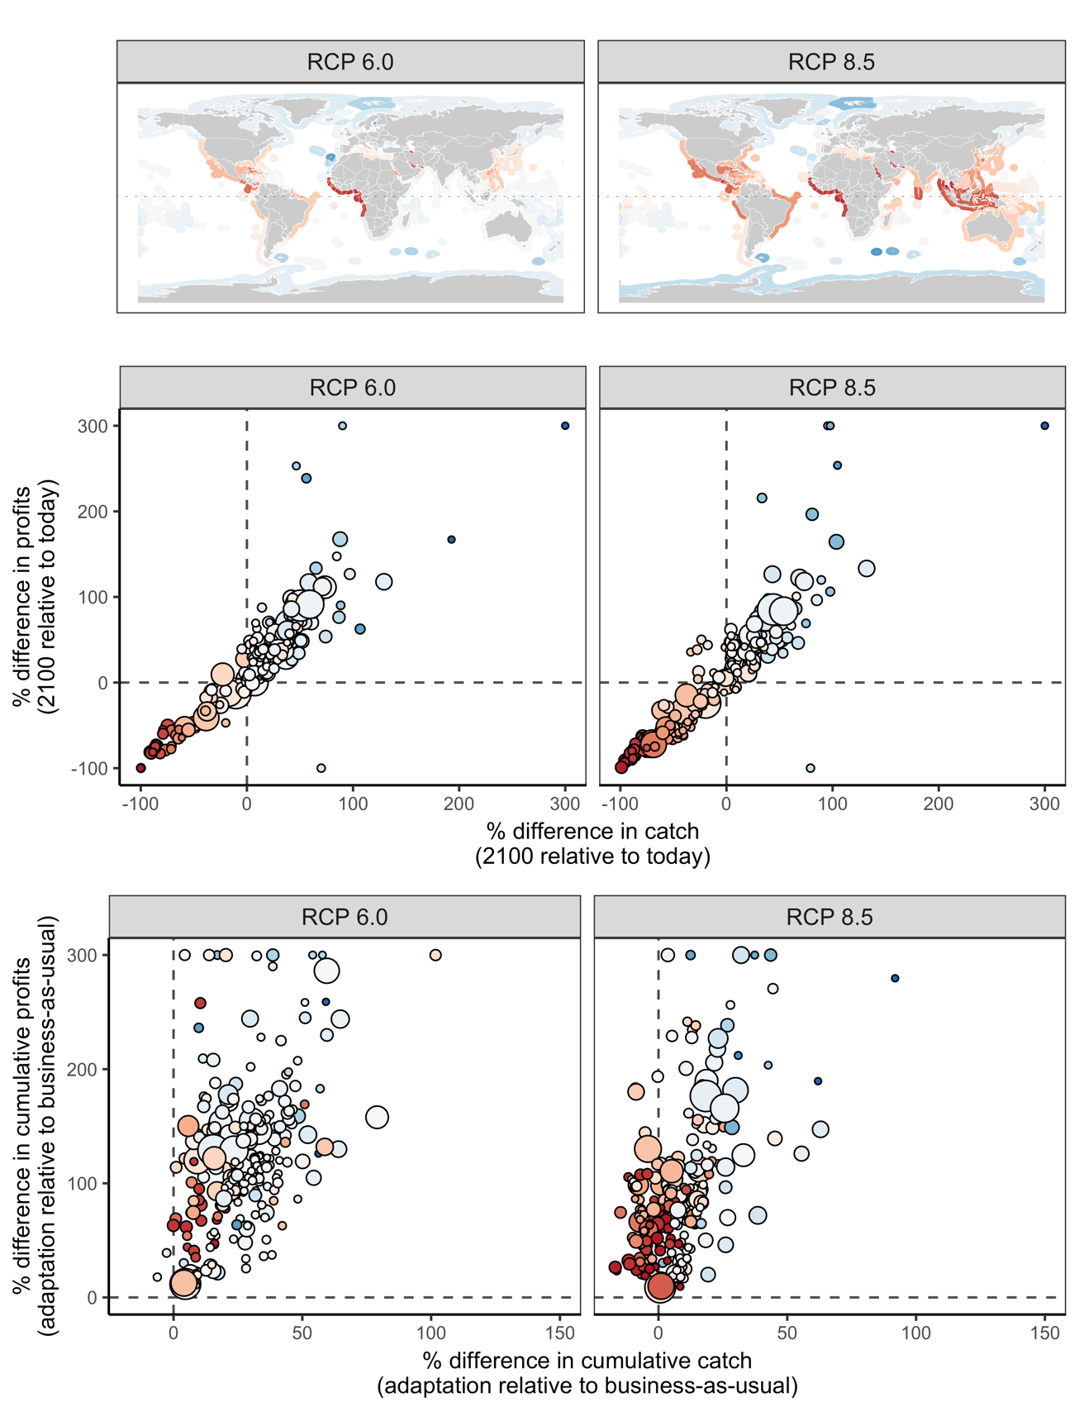

**Figure X.** The **(a)** percent change in maximum sustainable yield (MSY) from 2012 to 2100, **(b)** percent difference in fisheries outcomes in 2100 relative to today under adaptive management, and **(c)** percent difference in fisheries outcomes over 2012 to 2100 under adaptive management relative to business as usual management for 260 exclusive economic zones (EEZs) under two high emissions climate scenarios.

**References**

Agnew, D.J., Pearce, J., Pramod, G., Peatman, T., Watson, R., Beddington, J.R. and Pitcher, T.J. (2009) Estimating the worldwide extent of illegal fishing. *PLOS ONE* **4**, e4570.

Barange, M. (2019) Avoiding misinterpretation of climate change projections of fish catches. *ICES Journal of Marine Science: Journal du Conseil* **4**, 211–3.

Baudron, A.R., Needle, C.L., Rijnsdorp, A.D. and Tara Marshall, C. (2014) Warming temperatures and smaller body sizes: synchronous changes in growth of North Sea fishes. *Global Change Biology* **20**, 1023–1031.

Beaugrand, G., Brander, K.M., Alistair Lindley, J., Souissi, S. and Reid, P.C. (2003) Plankton effect on cod recruitment in the North Sea. *Nature* **426**, 661–664.

Blanchard, J.L., Jennings, S., Holmes, R., et al. (2012) Potential consequences of climate change for primary production and fish production in large marine ecosystems. *Philosophical Transactions of the Royal Society B: Biological Sciences* **367**, 2979–2989.

Britten, G.L., Dowd, M. and Worm, B. (2016) Changing recruitment capacity in global fish stocks. *Proceedings of the National Academy of Sciences of the United States of America* **113**, 134–139.

Cabral, R.B., Mayorga, J., Clemence, M., et al. (2018) Rapid and lasting gains from solving illegal fishing. *Nature Ecology & Evolution*, 1–11.

Cheung, W., Close, C., Lam, V., Watson, R. and Pauly, D. (2008) Application of macroecological theory to predict effects of climate change on global fisheries potential. *Marine Ecology Progress Series* **365**, 187–197.

Cheung, W.W.L., Lam, V.W.Y., Sarmiento, J.L., Kearny, K., Watson, R., Zeller, D. and Pauly, D. (2010) Large-scale redistribution of maximum fisheries catch potential in the global ocean under climate change. *Global Change Biology* **16**, 24–35.

Cheung, W.W.L., Reygondeau, G. and Frölicher, T.L. (2016) Large benefits to marine fisheries of meeting the 1.5°C global warming target. *Science* **354**, 1591–1594.

Cheung, W.W.L., Sarmiento, J.L., Dunne, J., et al. (2012) Shrinking of fishes exacerbates impacts of global ocean changes on marine ecosystems. *Nature Climate Change* **3**, 254–258.

Clausen, L.W., Rindorf, A., van Deurs, M., Dickey-Collas, M. and Hintzen, N.T. (2017) Shifts in North Sea forage fish productivity and potential fisheries yield. *Journal of Applied Ecology* **51**, 45–10.

Costello, C., Ovando, D., Clavelle, T., et al. (2016) Global fishery prospects under contrasting management regimes. *Proceedings of the National Academy of Sciences of the United States of America* **113**, 5125–5129.

Cushing, D.H. (1990) Plankton production and year-class strength in fish populations: an update of the match/mismatch hypothesis. In: *Advances in Marine Biology Volume 26*, Vol. 26. *Advances in Marine Biology*. Elsevier, pp 249–293.

Dulvy, N.K., Rogers, S.I., Jennings, S., Stelzenmller, V., Dye, S.R. and Skjoldal, H.R. (2008) Climate change and deepening of the North Sea fish assemblage: a biotic indicator of warming seas. *Journal of Applied Ecology* **45**, 1029–1039.

Edwards, M. and Richardson, A.J. (2004) Impact of climate change on marine pelagic phenology and trophic mismatch. *Nature* **430**, 881–884.

Free, C.M., Thorson, J.T., Pinsky, M.L., Oken, K.L., Wiedenmann, J. and Jensen, O.P. (2019) Impacts of historical warming on marine fisheries production. *Science* **363**, 979–983.

Gaines, S.D., Costello, C., Owashi, B., et al. (2018) Improved fisheries management could offset many negative effects of climate change. *Science Advances* **4**, eaao1378.

García Molinos, J., Halpern, B.S., Schoeman, D.S., et al. (2015) Climate velocity and the future global redistribution of marine biodiversity. *Nature Climate Change* **6**, 83–88.

Golden, C.D., Allison, E.H., Cheung, W.W.L., et al. (2016) Nutrition: Fall in fish catch threatens human health. *Nature* **534**, 317–320.

Kritzer, J.P., Costello, C., Mangin, T. and Smith, S.L. (2019) Responsive harvest control rules provide inherent resilience to adverse effects of climate change and scientific uncertainty. *ICES Journal of Marine Science: Journal du Conseil* **71**, 298–12.

Lam, V.W.Y., Cheung, W.W.L., Reygondeau, G. and Sumaila, U.R. (2016) Projected change in global fisheries revenues under climate change. *Scientific Reports* **6**, 32607.

Lefevre, S., McKenzie, D.J. and Nilsson, G.E. (2017) Models projecting the fate of fish populations under climate change need to be based on valid physiological mechanisms. *Global Change Biology* **20**, 1023–11.

MacKenzie, B.R. and Köster, F.W. (2004) Fish production and climate: sprat in the Baltic Sea. *Ecology* **85**, 784–794.

Marshall, K.N., Koehn, L.E., Levin, P.S., Essington, T.E., Jensen, O.P.Handling editor: Marta Coll (2018) Inclusion of ecosystem information in US fish stock assessments suggests progress toward ecosystem-based fisheries management. *ICES Journal of Marine Science: Journal du Conseil* **76**, 1–9.

Moore, J.K., Fu, W., Primeau, F., et al. (2018) Sustained climate warming drives declining marine biological productivity. *Science* **359**, 1139–1143.

Pauly, D. and Cheung, W.W.L. (2017) Sound physiological knowledge and principles in modeling shrinking of fishes under climate change. *Global Change Biology* **24**, e15–e26.

Perry, A.L., Low, P.J., Ellis, J.R. and Reynolds, J.D. (2005) Climate change and distribution shifts in marine fishes. *Science* **308**, 1912–1915.

Pinsky, M.L. and Mantua, N.J. Emerging adaptation approaches for climate-ready fisheries management. *Oceanography* **27**, 146–159.

Pinsky, M.L., Reygondeau, G., Caddell, R., Palacios-Abrantes, J., Spijkers, J. and Cheung, W.W.L. (2018) Preparing ocean governance for species on the move. *Science* **360**, 1189–1191.

Pinsky, M.L., Worm, B., Fogarty, M.J., Sarmiento, J.L. and Levin, S.A. (2013) Marine taxa track local climate velocities. *Science* **341**, 1239–1242.

Poloczanska, E.S., Brown, C.J., Sydeman, W.J., et al. (2013) Global imprint of climate change on marine life. *Nature Climate Change* **3**, 919–925.

Punt, A.E., A'mar, T., Bond, N.A., et al. (2014) Fisheries management under climate and environmental uncertainty: control rules and performance simulation. *ICES Journal of Marine Science: Journal du Conseil* **71**, 2208–2220.

Sheridan, J.A. and Bickford, D. (2011) Shrinking body size as an ecological response to climate change. *Nature Climate Change* **1**, 401–406.

Spijkers, J. and Boonstra, W.J. (2017) Environmental change and social conflict: the northeast Atlantic mackerel dispute. 1–17.

Szuwalski, C.S. (2016) Changing fisheries productivity and food security. *Proceedings of the National Academy of Sciences of the United States of America* **113**, E1773–4.

Szuwalski, C.S., Britten, G.L., Licandeo, R., Amoroso, R.O., Hilborn, R. and Walters, C. (2019) Global forage fish recruitment dynamics_ A comparison of methods, time-variation, and reverse causality. *Fisheries Research* **214**, 56–64.

Szuwalski, C.S., Vert-pre, K.A., Punt, A.E., Branch, T.A. and Hilborn, R. (2014) Examining common assumptions about recruitment: a meta-analysis of recruitment dynamics for worldwide marine fisheries. *Fish and Fisheries* **16**, 633–648.

1. RCPs = the Representative Concentration Pathways adopted by the Intergovernmental Panel on Climate Change (IPCC) in its Fifth Assessment Report (AR5) to describe potential greenhouse gas emission trajectories and associated climate futures. The scenarios are named according to the amount of radiative forcing experienced in 2100 of the projections (2.6, 4.5, 6.0, and 8.5 W/m2, respectively).