**S5. Taxonomic group attribute and factor scores.**

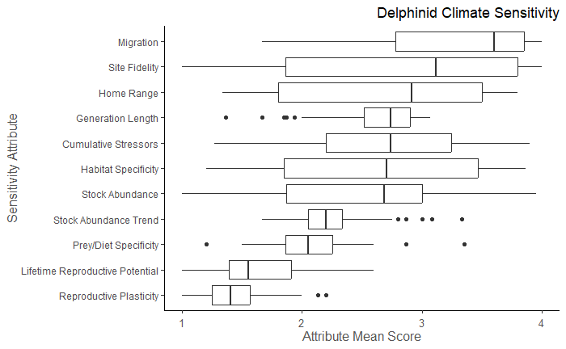

**Fig 1. Sensitivity attribute mean scores for delphinid stocks.**

Sensitivity attribute mean scores for 84 U.S. delphinid stocks in the western North Atlantic, Gulf of Mexico, and Caribbean Sea. The vertical bar represents the median; the box is bounded by the first and third quartiles; whiskers represent 1.5 times the inter-quartile range; points represent all outlying values.

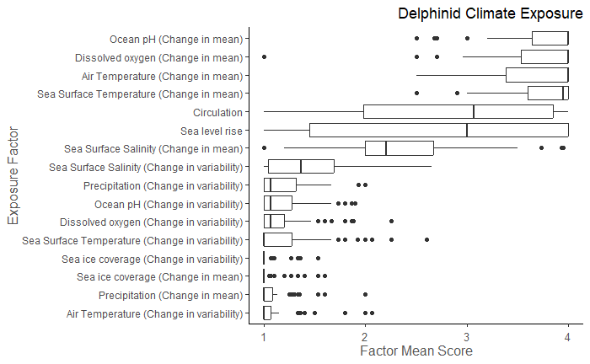

**Fig 2. Exposure factor mean scores for delphinid stocks.**

Exposure factor mean scores for 84 U.S. delphinid stocks in the western North Atlantic, Gulf of Mexico, and Caribbean Sea. The vertical bar represents the median; the box is bounded by the first and third quartiles; whiskers represent 1.5 times the inter-quartile range; points represent all outlying values.

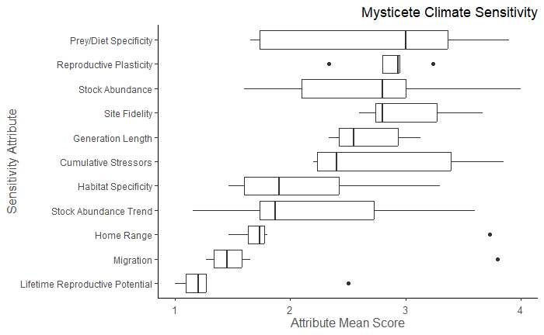

**Fig 3. Sensitivity attribute mean scores for mysticete stocks.**

Sensitivity attribute mean scores for 7 U.S. mysticete stocks in the western North Atlantic, Gulf of Mexico, and Caribbean Sea. The vertical bar represents the median; the box is bounded by the first and third quartiles; whiskers represent 1.5 times the inter-quartile range; points represent all outlying values.

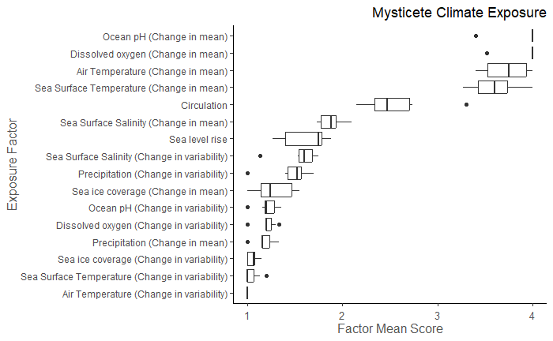

**Fig 4. Exposure factor mean scores for mysticete stocks.**

Exposure factor mean scores for 7 U.S. mysticete stocks in the western North Atlantic, Gulf of Mexico, and Caribbean Sea. The vertical bar represents the median; the box is bounded by the first and third quartiles; whiskers represent 1.5 times the inter-quartile range; points represent all outlying values.

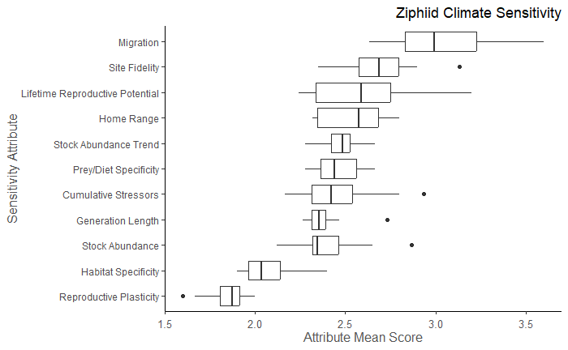

**Fig 5. Sensitivity attribute mean scores for ziphiid stocks.**

Sensitivity attribute mean scores for 8 U.S. ziphiid stocks in the western North Atlantic, Gulf of Mexico, and Caribbean Sea. The vertical bar represents the median; the box is bounded by the first and third quartiles; whiskers represent 1.5 times the inter-quartile range; points represent all outlying values.

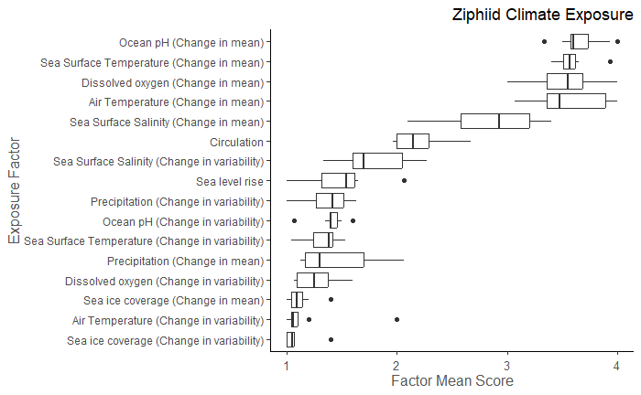

**Fig 6. Exposure factor mean scores for ziphiid stocks.**

Exposure factor mean scores for 8 U.S. ziphiid stocks in the western North Atlantic, Gulf of Mexico, and Caribbean Sea. The vertical bar represents the median; the box is bounded by the first and third quartiles; whiskers represent 1.5 times the inter-quartile range; points represent all outlying values.

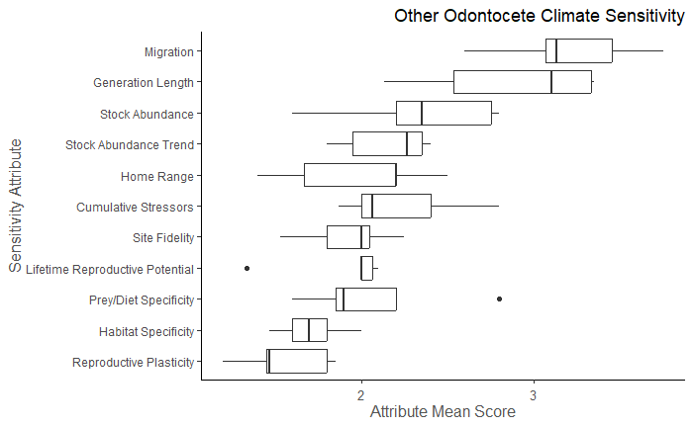

**Fig 7. Sensitivity attribute mean scores for other odontocete stocks.**

Sensitivity attribute mean scores for 5 U.S. “other odontocete” stocks in the western North Atlantic, Gulf of Mexico, and Caribbean Sea. The vertical bar represents the median; the box is bounded by the first and third quartiles; whiskers represent 1.5 times the inter-quartile range; points represent all outlying values.

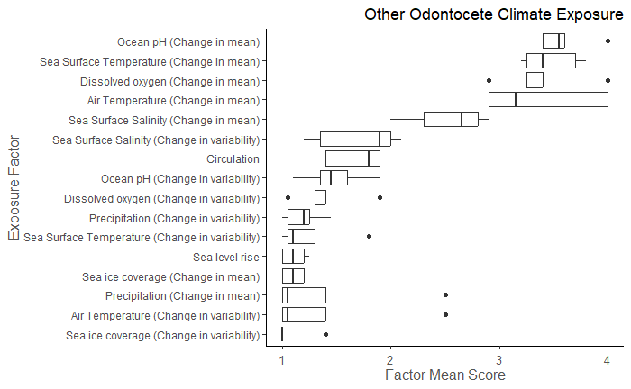

**Fig 8. Exposure factor mean scores for other odontocete stocks.**

Exposure factor mean scores for 5 U.S. “other odontocete” stocks in the western North Atlantic, Gulf of Mexico, and Caribbean Sea. The vertical bar represents the median; the box is bounded by the first and third quartiles; whiskers represent 1.5 times the inter-quartile range; points represent all outlying values.

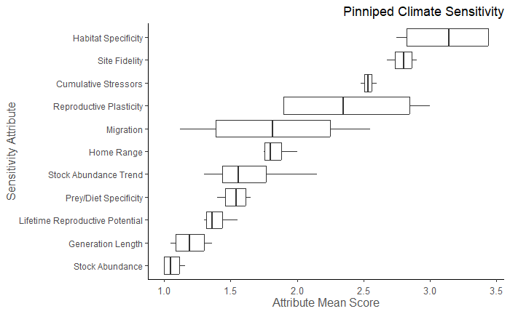

**Fig 9. Sensitivity attribute mean scores for pinniped stocks.**

Sensitivity attribute mean scores for 4 U.S. pinniped stocks in the western North Atlantic, Gulf of Mexico, and Caribbean Sea. The vertical bar represents the median; the box is bounded by the first and third quartiles; whiskers represent 1.5 times the inter-quartile range; points represent all outlying values.

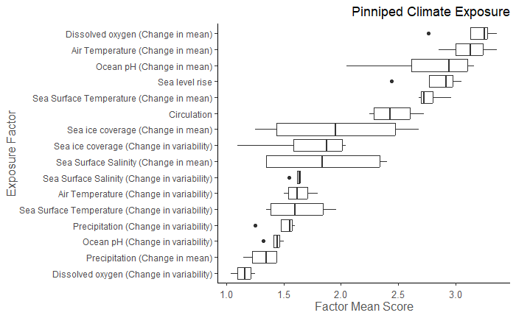

**Fig 10. Exposure factor mean scores for pinniped stocks.**

Exposure factor mean scores for 4 U.S. pinniped stocks in the western North Atlantic, Gulf of Mexico, and Caribbean Sea. The vertical bar represents the median; the box is bounded by the first and third quartiles; whiskers represent 1.5 times the inter-quartile range; points represent all outlying values.