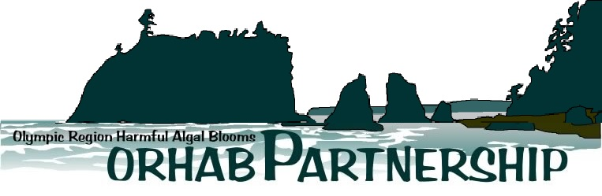

Aquatic Program

UW Olympic Natural Resources Center

1455 South Forks Avenue (Hwy 101)

Forks, WA 98331

Data Release and Acknowledgment Agreement

Due to a high number of requests for Olympic Region Harmful Algal Bloom Partnership (ORHAB) data, we ask that you please fill out the following form. **Please sign the last page of this form if you agree to the conditions listed.**

**Data Set Name:** ORHAB Longitudinal Shore Monitoring Data

**Data Set Manager Name:** Rich Osborne ([osborner@uw.edu](mailto:osborner@uw.edu) ) 360-301-2175

## Submitter Information:

Name(s): Christopher Free

Organization: University of California, Santa Barbara

Contact Information: [cfree14@gmail.com](mailto:cfree14@gmail.com) | 610-999-4732

Date of Request: December 22, 2021

## Purpose of the Data Use

[*Briefly describe in general terms the purpose for which the data is to be used. Additionally please provide links or, attach any appropriate project proposals, draft manuscripts that describe or demonstrate how the data are to be used.*]

We hope to use the data to examine the coastwide *Pseudo-nitzschia* and particulate domoic acid over the course of the commercial Dungeness crab fishing season and to understand the timing of domoic acid contamination risk in Dungeness crab. We will plot this data by adding it to the following figure.

**Data Requested**

[*Please be specific about what data you are interested in using by filling out the data menu below (e.g., data fields, dates, locations*)]

*Pseudo-nitzschia* and particulate domoic acid data at all sites from 2010 to present.

**Project Timeline**

[*Please describe when you need the data and when deliverables might be expected for your project*]

We have a manuscript written and hope to submit to *Harmful Algae* in mid-January.

**Plans for publication**

[*If you are considering a peer-reviewed publication, we would like to know your plans for where our data fit into the project, are they integral, and to what degree you would like for ORHAB partners to participate in preparation of publication as co-authors?*]

We hope to publish this data as a figure in the journal *Harmful Algae.* The data are integral to illustrating mid- to late-season domoic acid contamination risk in Dungeness crab. Vera Trainer, an ORHAB partner, is a co-author on the paper.

**Plans for future data requests**

[*Are you considering including ORHAB data in any future studies or peer-reviewed publications? What possibilities are there for including funding to ORHAB in your planned proposals*]

No current plans.

**--------------------------------------------------------------------------------------------------------------------------**

**Terms of Agreement:**

Use of the requested data shall be limited to the projects specified above. Data may not be used in any other project or distributed to other parties without the approval of a new data release agreement with ORHAB. This dataset may not be displayed on the internet, in any form, without the permission of ORHAB. Peer-reviewed and other publications should include co-authorship where determined appropriate by both parties. In all cases acknowledgement for the data should be cited as "The Olympic Region Harmful Algal Bloom (ORHAB) partnership has been funded since 2006, through a surcharge to Washington State shellfish and seaweed licenses as authorized by RCW 77.21.555. We thank ORHAB and its member partners for providing (*list data types*) used in this manuscript."

**Ownership of Items Produced as a result of this data:**

All writings, programs, analyses, art work, music, maps, charts, tables, illustrations, records or other written, graphic, analog or digital materials prepared by the signatories, in connection with the use of this data shall be the sole and absolute property of the signatories without dispute as long as ORHAB and its data set are acknowledged (as previously agreed upon) in all associated reference citations and graphic captions where the data are used. The signatories also agree to provide, in accordance with customary standards, the appropriate acknowledgement in any such publication of ORHAB support or other role in the project.

**Publication and Acknowledgement of Data User products by**:

ORHAB reserves the right to make or permit to be made scholarly disclosures of the results of the Project, including without limitation, publication in scholarly journals, presentations at academic and other conferences, disclosures to ORHAB and non-ORHAB scholars, and disclosures in grant and funding applications. ORHAB agrees to provide, in accordance with customary standards, an appropriate acknowledgement in any such publication of Sponsor’s support or other role in the Project.

### Reviewed and approved by:

**Data Requestor/Submitter:**

[PRINT]

______________________________________________________ _________________

[SIGN] [DATE]

**ORHAB Administrative Coordinator (**On behalf of the ORHAB Steering Committee):

_________________________________________________ ____________________

[SIGN] [DATE]