#### Appendix B. Washington’s biotoxin monitoring and management data

##### Sampling data

The Washington Department of Health (DOH) shared biotoxin monitoring data for 13 species from its Pacific Coast from 2000-2020 (**Table S1**) and GPS coordinates for all biotoxin sampling sites (Pacific Coast, Salish Sea, Puget Sound, etc.; **Figure S1**). We formatted this data by: (1) adding scientific names; (2) harmonizing location meta-data; and (3) cleaning results data. We added scientific names based on **Table S2**. We recoded results below the detection limit as zeros (**Table S1;** e.g., “<1 ppm” of domoic acid becomes “0 ppm” of domoic acid**)** and we recorded results listed as “NTD”, “UNSAT”, and “no test” as unavailable (“NA”).

**Questions for Tracie**

1. Did I correctly identify the scientific names for the species in the data?
   1. Razor clam (*Siliqua patula*)
   2. California mussel (*Mytilus californianus*)
   3. Pacific oyster (*Crassostrea gigas*)
   4. Dungeness crab (*Metacarcinus magister*)
   5. Blue mussel (*Mytilus trossulus*) - different from California mussel? Yes. *Mytilus edulis*
   6. Manila clam (*Ruditapes philippinarum*)
   7. Littleneck clam (*Leukoma staminea*)
   8. Horse clam (*Tresus capax*)
   9. Barnacle (Barnacle spp.) -- do we know which species of barnacle? This one is unknown. Those tests are before my time.
   10. Butter clam (*Saxidomus gigantea*)
   11. Other (Unknown)
   12. Cockle (*Clinocardium nuttallii*)
   13. Olympia oyster (*Ostrea lurida*)
2. How should I interpret the following codes in the results columns?
   1. NTD – No Toxin Detected – This can be interpreted as 0
   2. UNSAT – the samples was unsatisfactory for testing
   3. No test – typically be cause we were interested in other toxins and did not test for whichever toxin this column is for. For instance, crab are typically only run for DA but we require a PSP Number for the system. Thus, all PSP results will be No Test
3. Westport (Grays Harbor) has two site ids: GHGH004 and GHPO010. I think you told me in our call that “GHGH004” is the correct site id. Is that right? GHGH004 is Westport for mussels and is a consistent site. There are a few samples from the 90’s for Half Moon Bay Dungeness Crab but those can be assigned to GHGH000 which is inside Grays Harbor.
4. Only 10 sites (wow!) are missing coordinates and other meta-data in the grid codes files. What are the coordinates, waterbodies, and counties for these sites? **That’s amazing!!!** The big zones are for crab. The coast is divided into sections by WDFW. Crab lat/lon aren’t collected as they are taken from fish holds and could have been from pots anywhere in the associated section composed of multiple zones. I’ve tried to define those below. The rest are one off sites. I’ve google mapped approximate locations for mussels.
   1. Cape Alava – assign to closure zone 15, Pacific Ocean, Clallam. Approx 48.164697, -124.733465
   2. Destruction Is to US/Canada Border – use closure zones 18.01 and 15, Pacific Ocean, Jefferson & Clallam
   3. James Island Quillayute River – use closure zone 15, Pacific Ocean, Clallam. Approx 47.906585, -124.643489
   4. North Jetty – use closure zone 17.03, Pacific Ocean, Grays Harbor Approx 46.926910, -124.176899
   5. North Willapa Bay – everything inside Willapa Bay north and west of 20.17, 20.07 (Does not include these) Willapa Bay, Pacific
   6. Offshore Grayland - closure zone 19.01, Pacific Ocean, Pacific
   7. OR/WA border to Pt Chehalis - use closure zones 19.02, 19.01, 17.04, Pacific Ocean, Grays Harbor and Pacific
   8. Pt Chehalis to Destruction Island - use closure zones 17.03, 17.02, 17.01, 18.02 Pacific Ocean, Grays Harbor & Jefferson
   9. Shoalwater Bay Reservation – cz 20.19, Willapa Bay, Pacific County
   10. South Willapa Bay – everything inside Willapa Bay including 20.17, 20.07 and south. Willapa Bay, Pacific

##### Commercial and recreational closures, 2014-2021

The Washington Department of Health (DOH) shared a log of biotoxin closures for commercial and recreational fisheries from 2014-2021 in all state waters. Each row of the closure log describes a single closure event including information on: (1) when the closure went into effect (closing date) and when the closure was lifted (opening date); (2) the location of the closure; (3) the species or group of species impacted by the closure; and (4) whether the closure was for commercial or recreational fishing. We assume that the 59 events without opening dates were still closed when the data was shared with us (April 6, 2021). The closure log describes closures affecting 11 individual species groups and 3 broad categories of species groups: “all species”, “all species including crab”, and “all species excluding razor clams” (**Table S3**). We assume that the “all species” category does not include crab species whereas the “all species including crab” category does include crab. We also assume that the “all species excluding razor clams” category also excludes crabs (**Table S3**). Although the exact reasons for the biotoxin closures were not explicitly provided, a careful review of the closure comments could reveal whether a closure was due to domoic acid (ASP), PSP, DSP, or lack of data, etc.

The biotoxin management areas used to delineate closures vary by fishery and species (**Table S4**). The commercial Dungeness crab fishery is managed using 6 management zones on the Pacific Coast (**Figure S8**); however, data on closures in this fishery were not included in the shared closure log. Commercial mollusk fisheries are managed based on 488 commercial growing areas along Washington’s coast (**Figure S9**). Recreational fisheries are predominantly managed using 201 biotoxin closure zones (**Figure S10**) but are sometimes managed based on waterbody, county, or beach (**Table S4**). Waterbody and county closures are generally composed of multiple closures zones; thus, to merge closures occurring across multiple scales, we split waterbody and county closures into their constituent biotoxin management zones (**Table S5-S6)**. We do not consider the single beach closure which occurs at Semiahmoo Marina (Whatcom County) from Feb-July 2014 for all bivalve species. Furthermore, the comment column for this closure event reads: “Data conversion error”. Overall, this allows us to visualize spatial-temporal time series of two types of closures: (1) commercial bivalve fishery closures by commercial growing area (**Appendix A)**; and (2) recreational crab and bivalves fishery closures by biotoxin management zones (**Appendix B**).

**Questions for Tracie**

1. There are 59 closure events without an end date. Is it correct to assume that these closures are all still in effect today? Some began in 2014. Some of these are likely the seasonal biotoxin closures and have been in place since the shellfish safety map was created. The coast is closed for all bivalves except razor clams during razor clam season. You’ll see them noted on the rec closure logs.
2. Could you confirm that I have interpreted the species information correctly (**Table S3**)? I am least sure about the following broad categories:
   1. **All species** -- I think this is all bivalve species (no crab species) - Correct
   2. **All species excluding razor clams** -- I think this is all bivalve species (no crab species) except razor clams.- Correct
   3. **All species including crab** -- I think this is all bivalve/crab species - Correct

##### Recreational closures, 2000-2021

The Washington Department of Health (DOH) shared logs of biotoxin closures for recreational fisheries from 2002-2020 in all state waters. The closure logs were provided in 11 Excel files, which frequently contained multiple data sheets, sometimes containing data from previous or even future years. We selected the best source of data for each year by visually inspecting and comparing the completeness of alternative sources of data for a given year. **Table S7** lists the data sources ultimately used for each year. In general, each row of the closure log describes a biotoxin sampling result and a management action triggered by that sampling result; thus, attributes of a single management action are often repeated over a few rows, where each row describes the results of the sampling that informed that action. Management actions are described in two columns: (1) a column indicating the waterbody impacted by the action; and (2) a composite column containing information on the date of the action, the type of action (closure or opening), and the species impacted by the action. The sampling events triggering these actions are described by the date and location (county and site) of sampling, the species sampled, the toxin measured, and the resulting measurements.

We formatted the data by first breaking the composite management action column into its three constituent parts: (1) the type of action (closure or opening); (2) the date of the action; and (3) the species impacted by the action. We standardized the species categories into the 17 categories shown in **Table S8**. We assume “all species” actually implies “all bivalve species but not any crab species” given the occurrence of another category called “all species including crab species”. We standardized the location information by reviewing the names and descriptions of waterbodies impacted by the action and assigning them their constituent biotoxin management zone identifiers (**Figure S10**).

**Questions for Tracie (WA-DOH)**

1. Am I using the correct data sources for each year (**Table S7**)?
2. Is it correct to assume that “all species” refers to “all bivalve species but not any crab species” unless the impacted species is called “all species including crab”? Yes

##### Tables and figures

**Table S1.** Biotoxins monitored in the WA DOH biotoxin monitoring program.

|  |  |  |  |
| --- | --- | --- | --- |
| **Biotoxin** | **Phytoplankton source** | **Detection limit** | **Action threshold** |
| Amnesic shellfish poison (ASP) - domoic acid | *Pseudo-nitzschia* spp. (diatom) | 1 ppm | 20 ppm |
| Paralytic shellfish poison (PSP) | Many species of phytoplankton | 38 ug/100 g | 80 ug/100 g |
| Diarrhetic shellfish poison (DSP) | *Dinophysis* spp.(dinoflagellate) | 1 ug/100 g | 16 ug/100 g |

**Table S2.** Number of biotoxin samples tested on Washington’s Pacific Coast from 2000 to 20201.

|  |  |  |  |  |
| --- | --- | --- | --- | --- |
|  | **Number of samples:** | | | |
| **Species** | **Total** | **ASP** | **PSP** | **DSP** |
| Razor clam (Siliqua patula) | 12,963 | 5,197 | 3,883 | 3,883 |
| California mussel (Mytilus californianus) | 7,445 | 2,425 | 2,510 | 2,510 |
| Pacific oyster (Crassostrea gigas) | 3,180 | 62 | 1,559 | 1,559 |
| Dungeness crab (Metacarcinus magister) | 1,731 | 1,731 | 0 | 0 |
| Blue mussel (Mytilus trossulus) | 1,055 | 343 | 356 | 356 |
| Manila clam (Ruditapes philippinarum) | 234 | 18 | 108 | 108 |
| Littleneck clam (Leukoma staminea) | 32 | 10 | 11 | 11 |
| Horse clam (Tresus capax) | 22 | 6 | 8 | 8 |
| Barnacle (Barnacle spp.) | 9 | 3 | 3 | 3 |
| Butter clam (Saxidomus gigantea) | 7 | 1 | 3 | 3 |
| Other (Unknown) | 4 | 4 | 0 | 0 |
| Cockle (Clinocardium nuttallii) | 2 | 0 | 1 | 1 |
| Olympia oyster (Ostrea lurida) | 2 | 0 | 1 | 1 |
| **Overall** | 26,686 | 9,800 | 8,443 | 8,443 |

1 ASP=amnesic shellfish poison (domoic acid), PSP=paralytic shellfish poison, DSP=diarrhetic shellfish poison.

**Table S3.** Species in the 2014-2020 commercial and recreational biotoxin closure data.

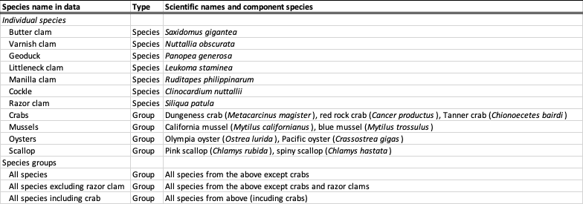

**Table S4.** Closure zone types used to manage biotoxin contamination in commercial and recreational crab and bivalve fisheries in Washington.

|  |  |  |  |
| --- | --- | --- | --- |
| **Zone type** | **#** | **Fishery type** | **Species** |
| Closure zones | 497 | Recreational | All species (bivalves/crabs) |
| Commercial growing areas | 165 | Commercial | Bivalves |
| Waterbody | 21 | Recreational | All species (bivalves/crabs) |
| County | 17 | Recreational | Bivalves |
| Recreational beach | 1 | Recreational | Bivalves |

**Table S5.** Closure zones associated with waterbody closures.

|  |  |
| --- | --- |
| **Waterbody name** | **Closure zones** |
| Bellingham Bay | 31.02 |
| Birch Bay | 32 |
| Budd Inlet | 62 |
| Deception Pass | 34.01, 34.02 |
| Fidalgo Bay | 39, 39.01 |
| Guemes Channel | 42 |
| Guemes Island | 43 |
| Kilisut Harbor | 24.01, 24.02, 24.03, 24.04, 24.05 |
| Liberty Bay | 78.01 |
| Lummi Bay | 45.01, 45.02 |
| Padilla Bay | 46.01, 46.02, 46.03 |
| Port Gamble | 12 |
| Port Susan | 48.01, 48.02 |
| Similk Bay | 52 |
| West Fidalgo Island | 57 |
| Willapa Bay | 20.01, 20.02, 20.03, 20.04, 20.05, 20.06, 20.07, 20.08, 20.09, 20.10, 20.11, 20.12, 20.13, 20.14, 20.15, 20.16, 20.17, 20.18, 20.19 |

**Table S6.** Closure zones associated with county closures.



**Table S7.** Source of data on biotoxin closures to recreational fisheries in Washington from 2002-2020. The 2014 data file is corrupt.

|  |  |  |  |
| --- | --- | --- | --- |
| **Year** | **File name** | **Sheet name** | **Number of rows** |
| 2002 | Rec Closure log 2002-2011.xlsx | 2002 | 91 |
| 2003 | Rec Closure log 2002-2011.xlsx | 2003 | 53 |
| 2004 | Rec Closure log 2002-2011.xlsx | 2004 | 59 |
| 2005 | Rec Closure log 2002-2011.xlsx | 2005 | 52 |
| 2006 | Rec Closure log 2002-2011.xlsx | 2006 | 60 |
| 2007 | Rec Closure log 2002-2011.xlsx | 2007 | 40 |
| 2008 | Rec Closure log 2002-2011.xlsx | 2008 | 45 |
| 2009 | Rec Closure log 2002-2011.xlsx | 2009 | 26 |
| 2010 | Rec Closure log 2002-2011.xlsx | 2010 | 66 |
| 2011 | Rec Closure log 2002-2011.xlsx | 2011 | 39 |
| 2012 | Rec Closure log 2012.xlsx | 2012 | 98 |
| 2013 | Rec Closure log 2013.xlsx | 2013 | 57 |
| 2014 |  |  |  |
| 2015 | Rec Closure log 2015.xlsx | Sheet1 | 123 |
| 2016 | Rec Closure log 2016.xlsx | Sheet1 | 91 |
| 2017 | Rec Closure log 2017.xlsx | Sheet1 | 145 |
| 2018 | Rec Closure log 2018.xlsx | Sheet1 | 139 |
| 2019 | Rec Closure log 2019.xlsx | 2019 | 115 |
| 2020 | Rec Closure log 2020.xlsx | 2020 | 122 |

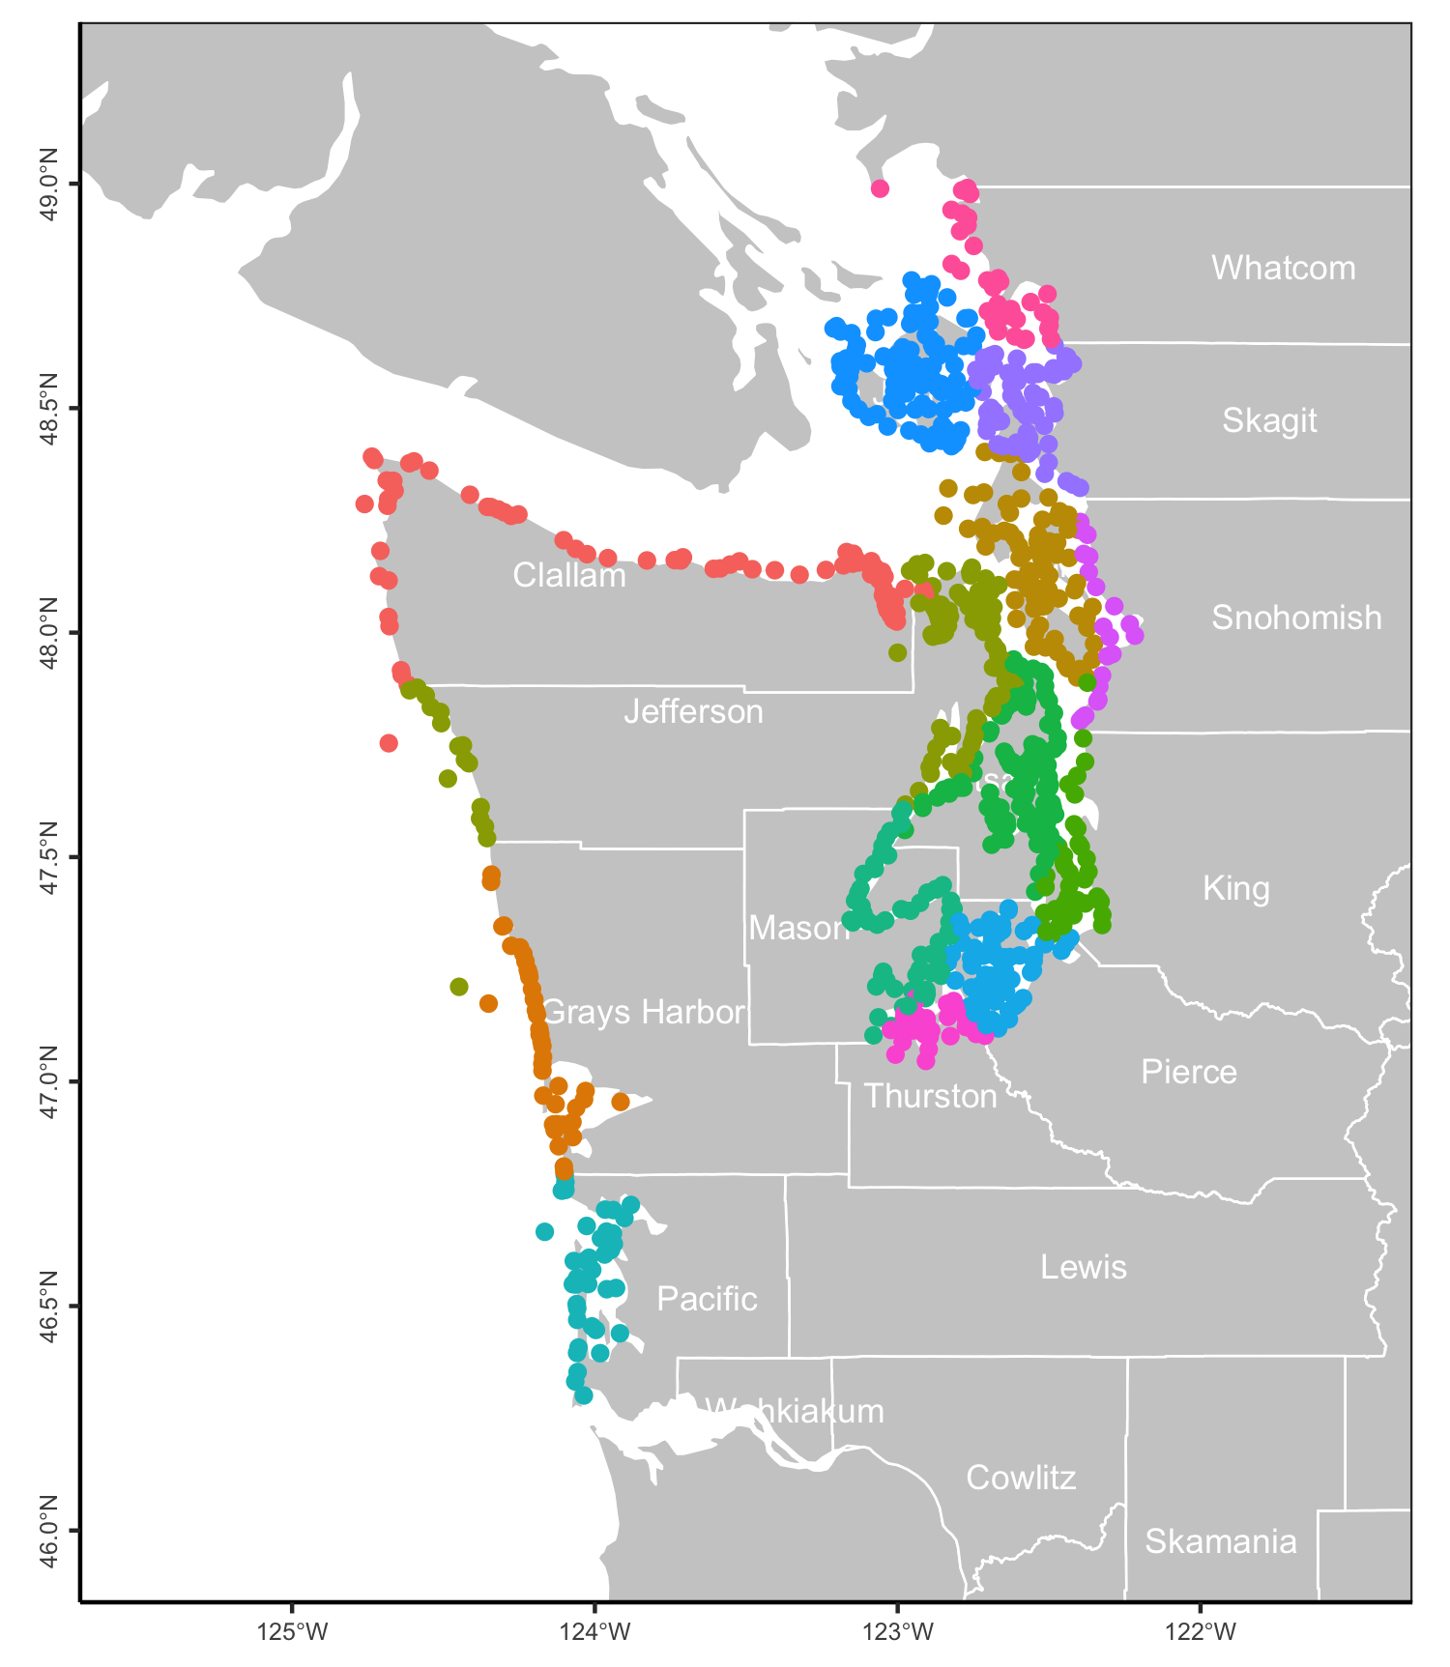

**Figure S1.** Location of WA DOH biotoxin sampling sites. Points are colored by county.

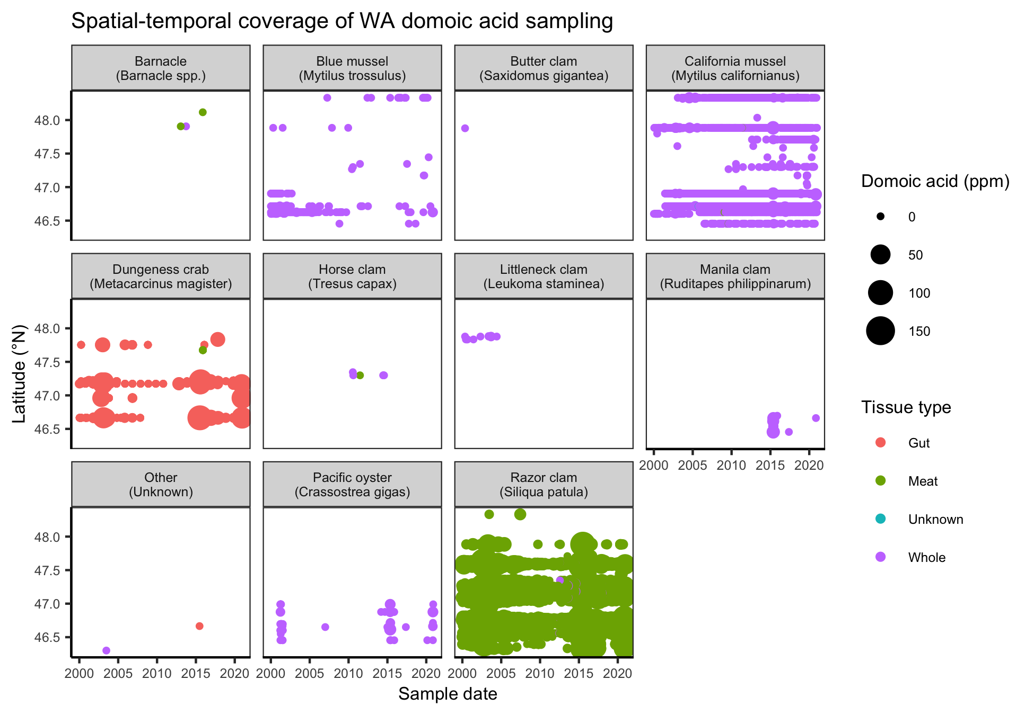**Figure S1.** Spatial temporal coverage of Washington’s domoic acid sampling program.

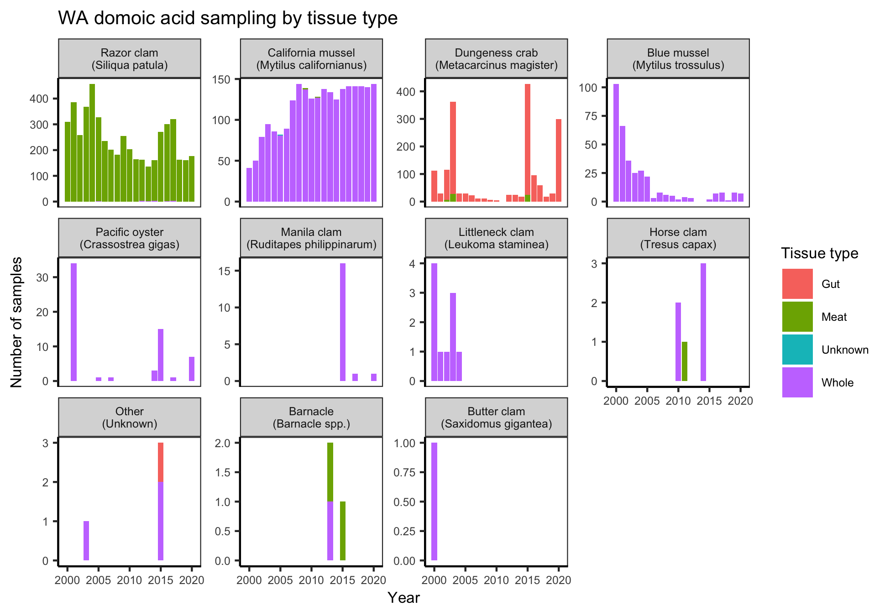**Figure S2.** Number of WA-DOH domoic acid contamination samples collected over time by species and tissue type.

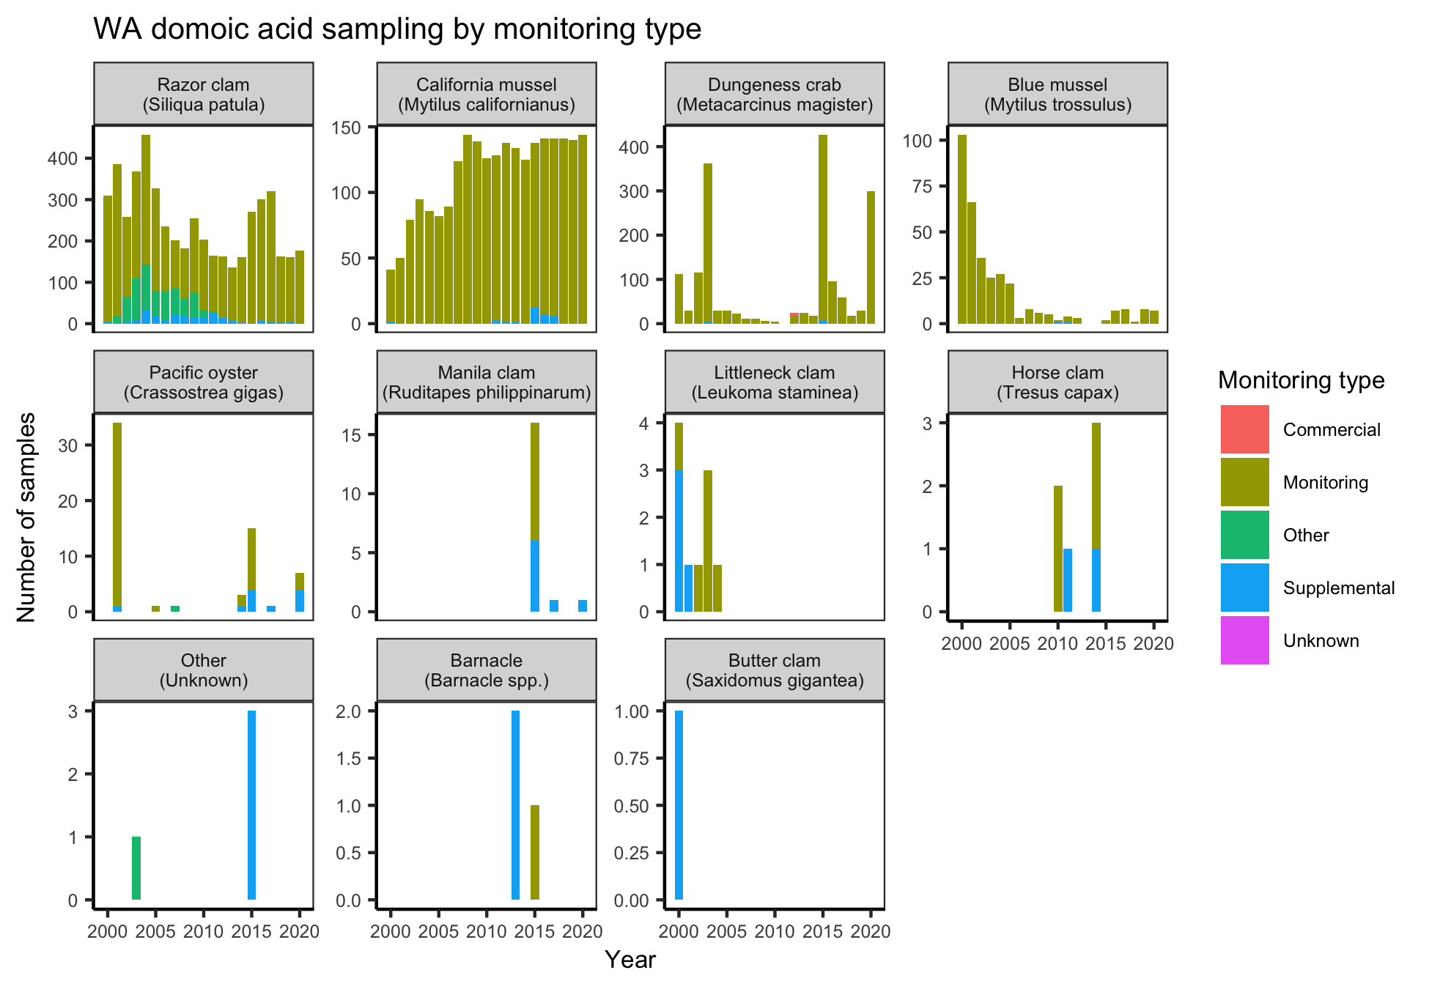**Figure S3.** Number of WA-DOH domoic acid contamination samples collected over time by species and monitoring type.

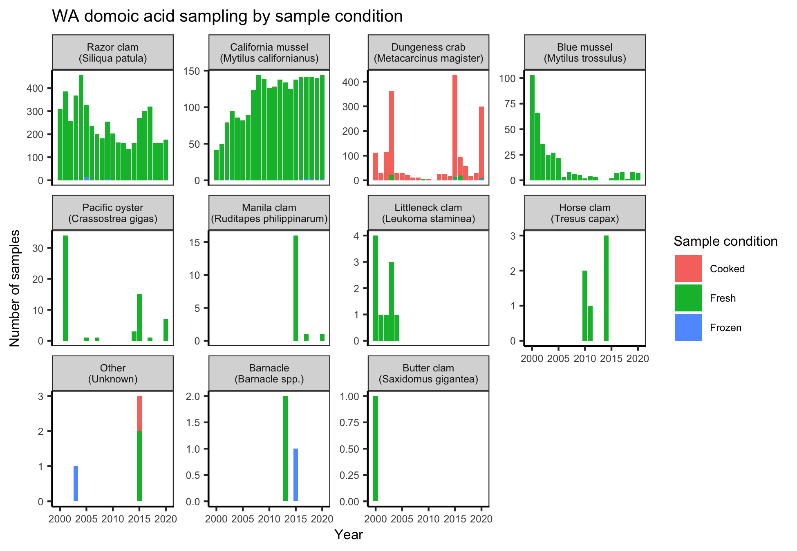**Figure S4.** Number of WA-DOH domoic acid contamination samples collected over time by species and sample preparation.

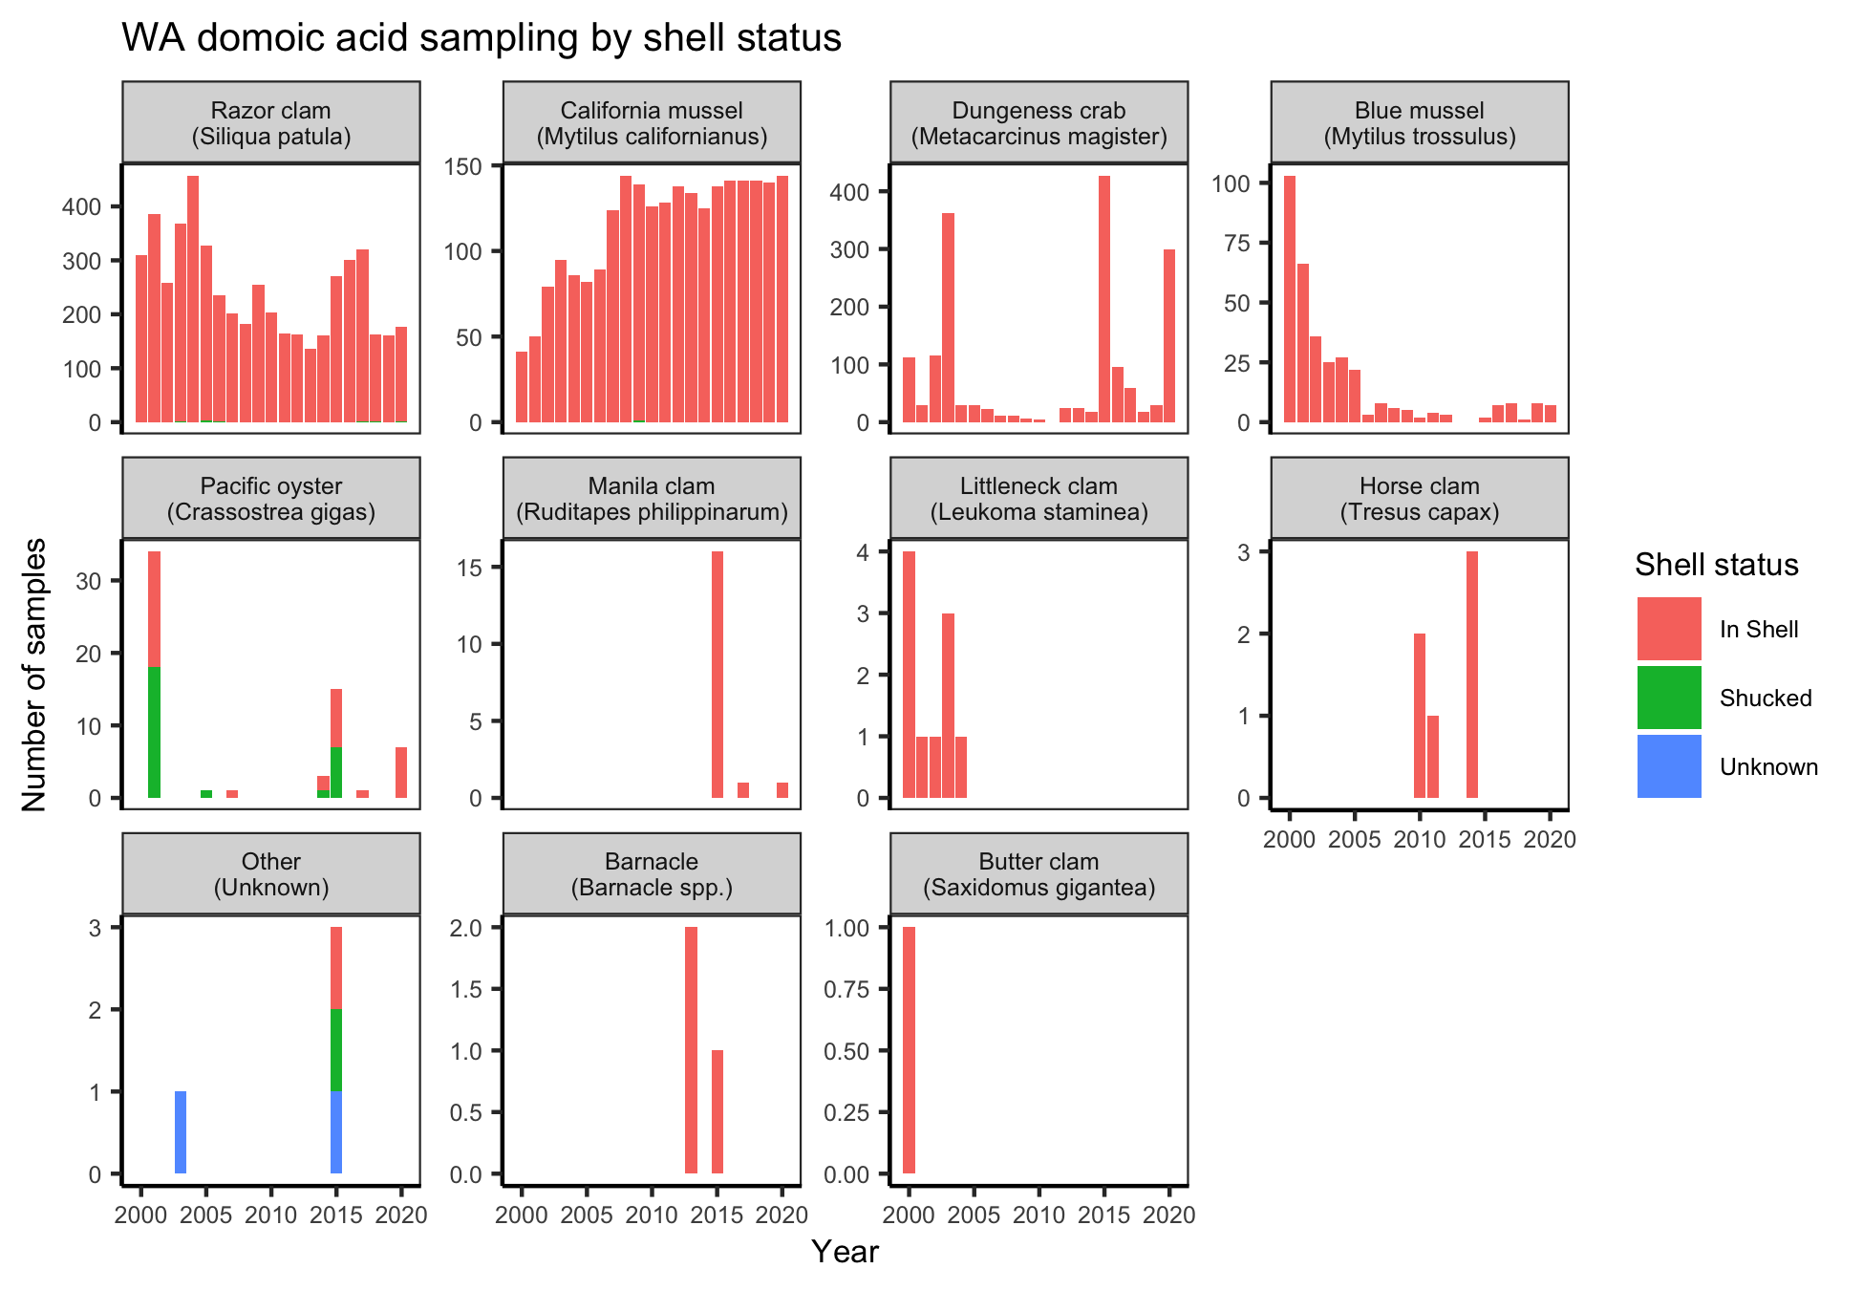**Figure S5.** Number of WA-DOH domoic acid contamination samples collected over time by species and shell status.

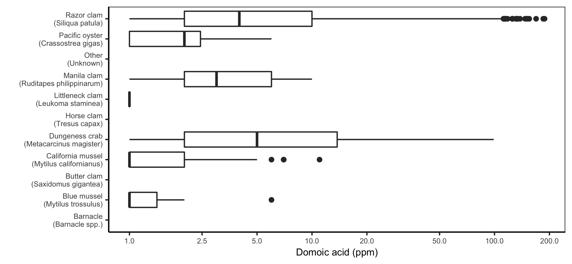**Figure S6.** Distribution of domoic acid contamination levels by species in the ODA samples. Note that the x-axis is log-scaled.

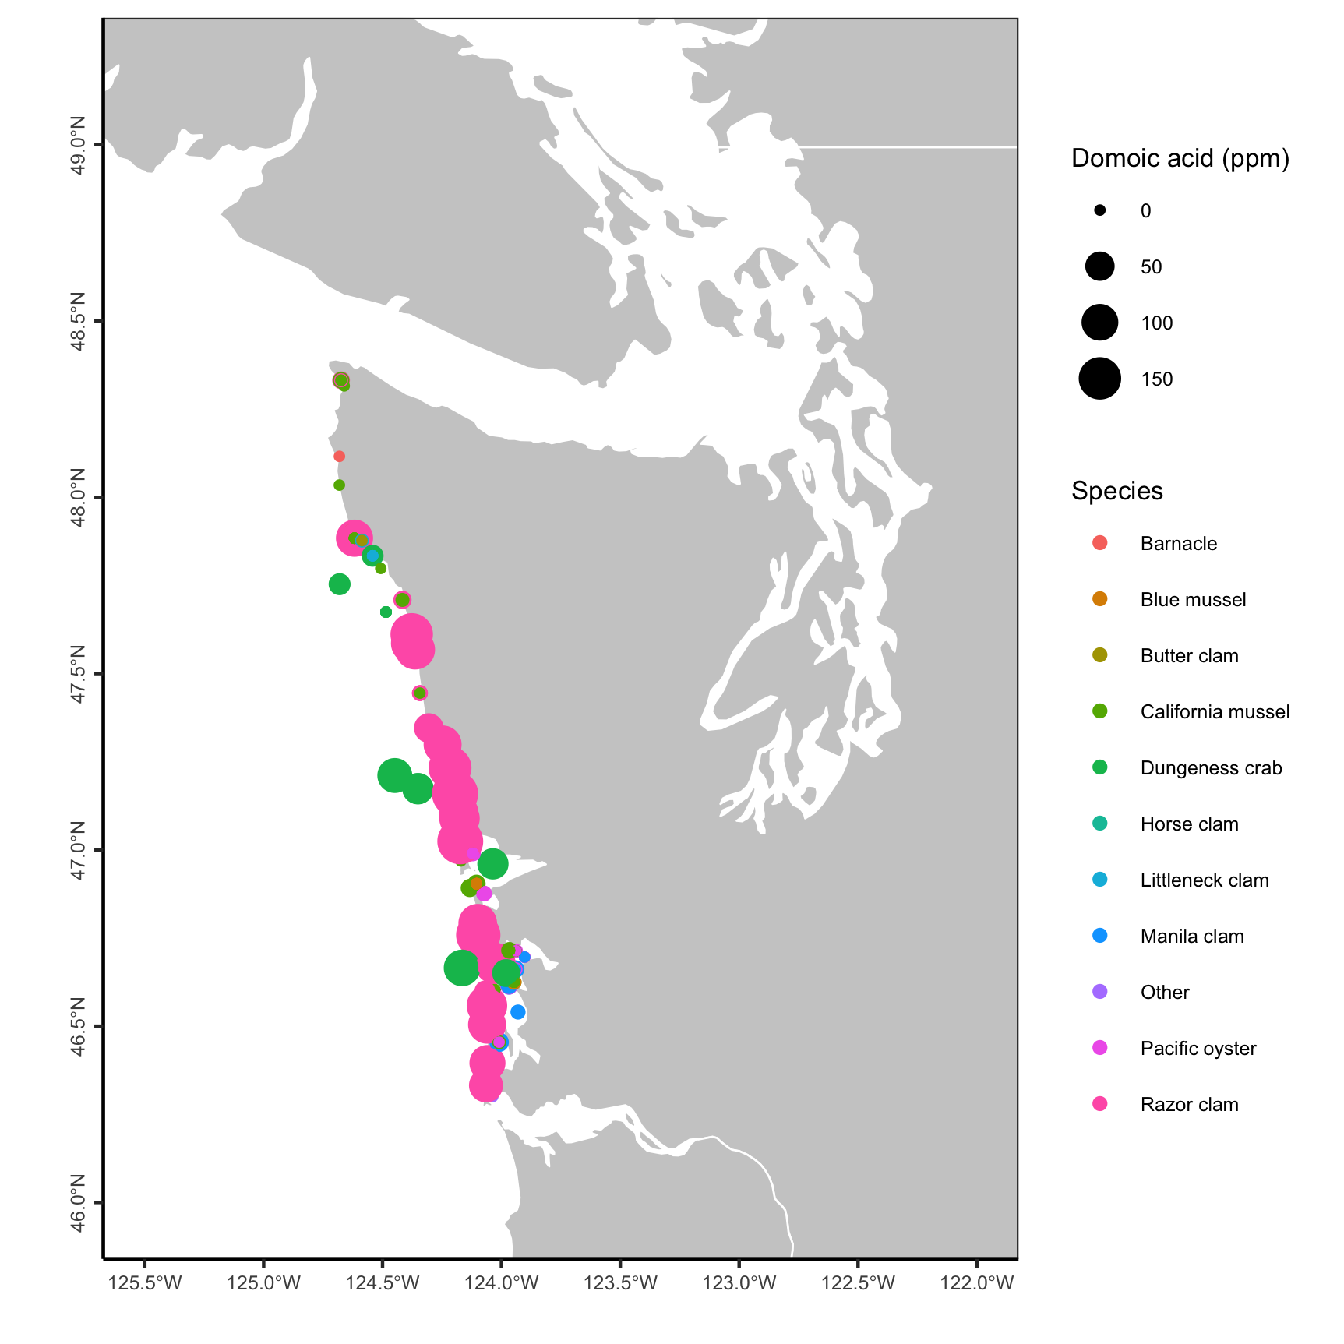

**Figure S7.** Map of domoic acid sampling locations and results by species.

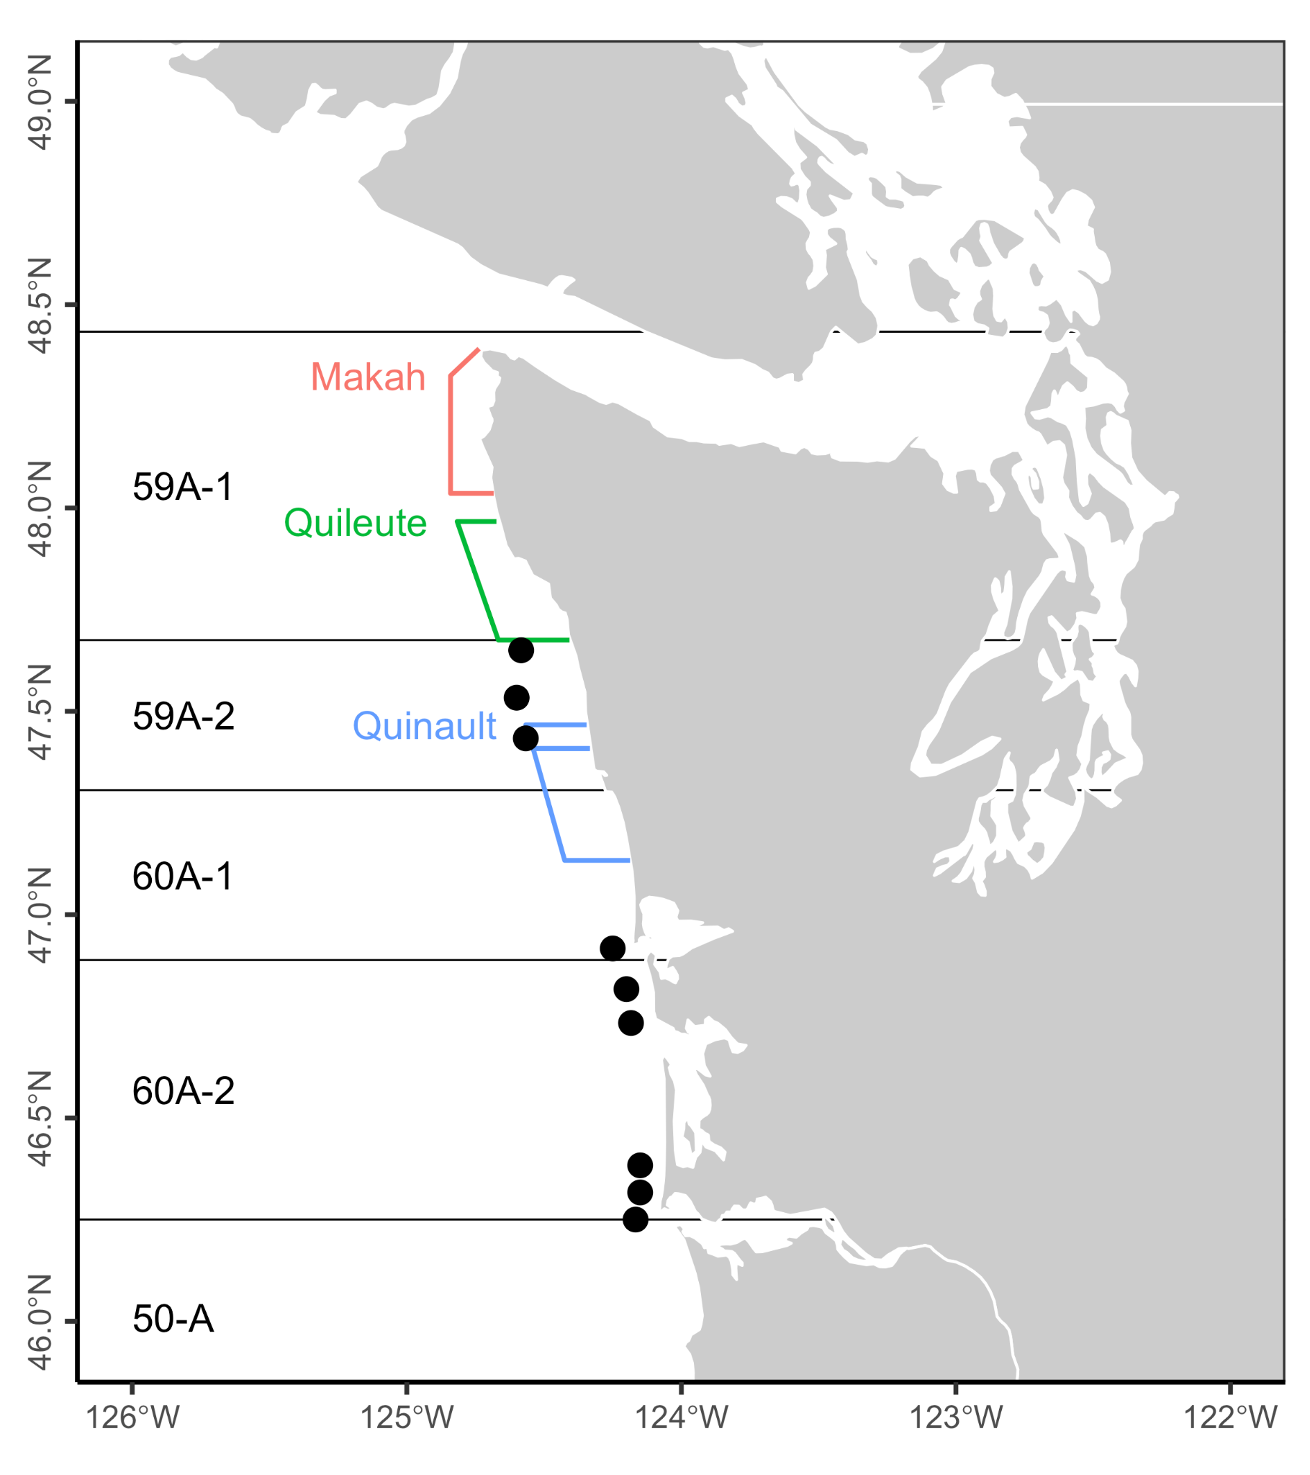**Figure S8.** Dungeness crab management areas. The colored lines indicate Special Management Areas (SMAs).

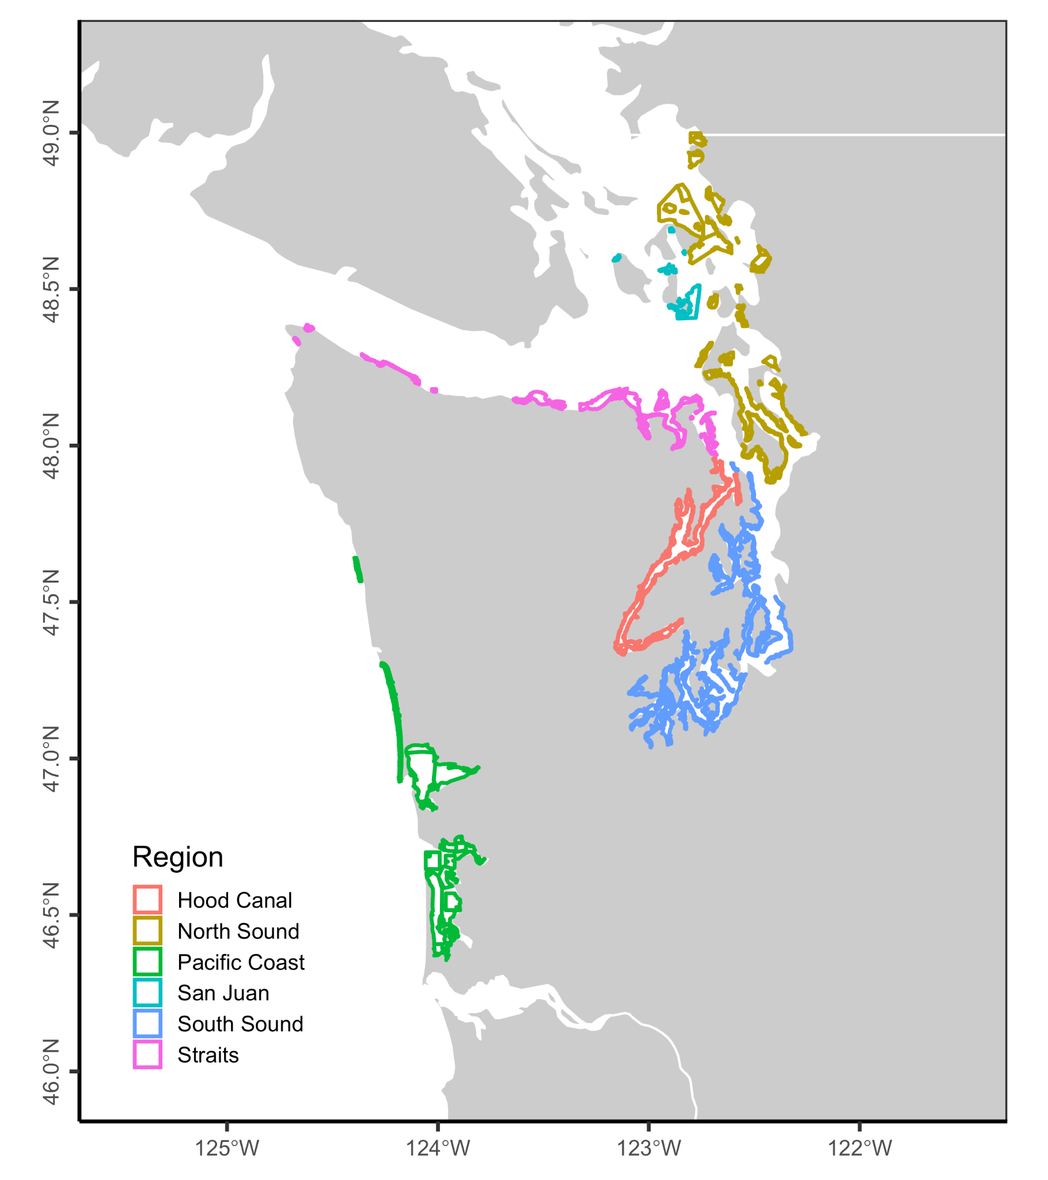

**Figure S9.** Commercial growing areas for bivalves in Washington.

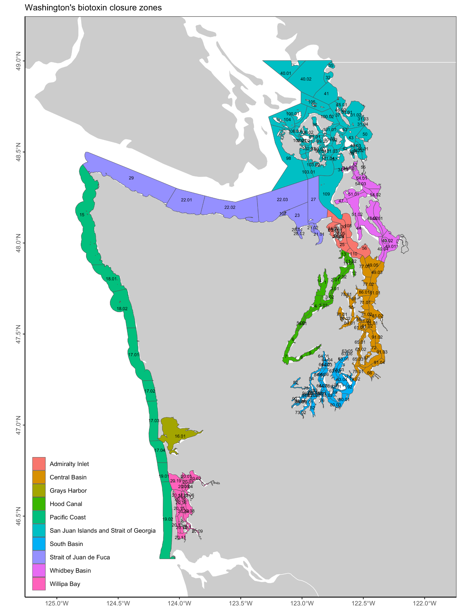**Figure S10.** Washington’s biotoxin closure areas.