#### Washington’s domoic acid monitoring data

##### Questions for Tracie

1. Did I correctly identify the scientific names for the species in the data?
   1. Razor clam (*Siliqua patula*)
   2. California mussel (*Mytilus californianus*)
   3. Pacific oyster (*Crassostrea gigas*)
   4. Dungeness crab (*Metacarcinus magister*)
   5. Blue mussel (*Mytilus trossulus*)
   6. Manila clam (*Ruditapes philippinarum*)
   7. Littleneck clam (*Leukoma staminea*)
   8. Horse clam (*Tresus capax*)
   9. Barnacle (Barnacle spp.) -- do we know which species of barnacle?
   10. Butter clam (*Saxidomus gigantea*)
   11. Other (Unknown)
   12. Cockle (*Clinocardium nuttallii*)
   13. Olympia oyster (*Ostrea lurida*)
2. How should I interpret the following codes in the results columns?
   1. NTD
   2. UNSAT
   3. No test
3. Westport (Grays Harbor) has two site ids: GHGH004 and GHPO010. I think you told me in our call that “GHGH004” is the correct site id. Is that right?
4. Only 10 sites (wow!) are missing coordinates and other meta-data in the grid codes files. What are the coordinates, waterbodies, and counties for these sites?
   1. Cape Alava
   2. Destruction Is to US/Canada Border
   3. James Island Quillayute River
   4. North Jetty
   5. North Willapa Bay
   6. Offshore Grayland
   7. OR/WA border to Pt Chehalis
   8. Pt Chehalis to Destruction Island
   9. Shoalwater Bay Reservation
   10. South Willapa Bay

##### Tables and figures

**Table S1.** Biotoxins monitored in the WA DOH biotoxin monitoring program.

|  |  |  |  |
| --- | --- | --- | --- |
| **Biotoxin** | **Phytoplankton source** | **Detection limit** | **Action threshold** |
| Amnesic shellfish poison (ASP) - domoic acid | *Pseudo-nitzschia* spp. (diatom) | 1 ppm | 20 ppm |
| Paralytic shellfish poison (PSP) | Many species of phytoplankton | 38 ug/100 g | 80 ug/100 g |
| Diarrhetic shellfish poison (DSP) | *Dinophysis* spp.(dinoflagellate) | 1 ug/100 g | 16 ug/100 g |

**Table S2.** Number of biotoxin samples tested on Washington’s Pacific Coast from 2000 to 20201.

|  |  |  |  |  |
| --- | --- | --- | --- | --- |
|  | **Number of samples:** | | | |
| **Species** | **Total** | **ASP** | **PSP** | **DSP** |
| Razor clam (Siliqua patula) | 12,963 | 5,197 | 3,883 | 3,883 |
| California mussel (Mytilus californianus) | 7,445 | 2,425 | 2,510 | 2,510 |
| Pacific oyster (Crassostrea gigas) | 3,180 | 62 | 1,559 | 1,559 |
| Dungeness crab (Metacarcinus magister) | 1,731 | 1,731 | 0 | 0 |
| Blue mussel (Mytilus trossulus) | 1,055 | 343 | 356 | 356 |
| Manila clam (Ruditapes philippinarum) | 234 | 18 | 108 | 108 |
| Littleneck clam (Leukoma staminea) | 32 | 10 | 11 | 11 |
| Horse clam (Tresus capax) | 22 | 6 | 8 | 8 |
| Barnacle (Barnacle spp.) | 9 | 3 | 3 | 3 |
| Butter clam (Saxidomus gigantea) | 7 | 1 | 3 | 3 |
| Other (Unknown) | 4 | 4 | 0 | 0 |
| Cockle (Clinocardium nuttallii) | 2 | 0 | 1 | 1 |
| Olympia oyster (Ostrea lurida) | 2 | 0 | 1 | 1 |
| **Overall** | 26,686 | 9,800 | 8,443 | 8,443 |

1 ASP=amnesic shellfish poison (domoic acid), PSP=paralytic shellfish poison, DSP=diarrhetic shellfish poison.

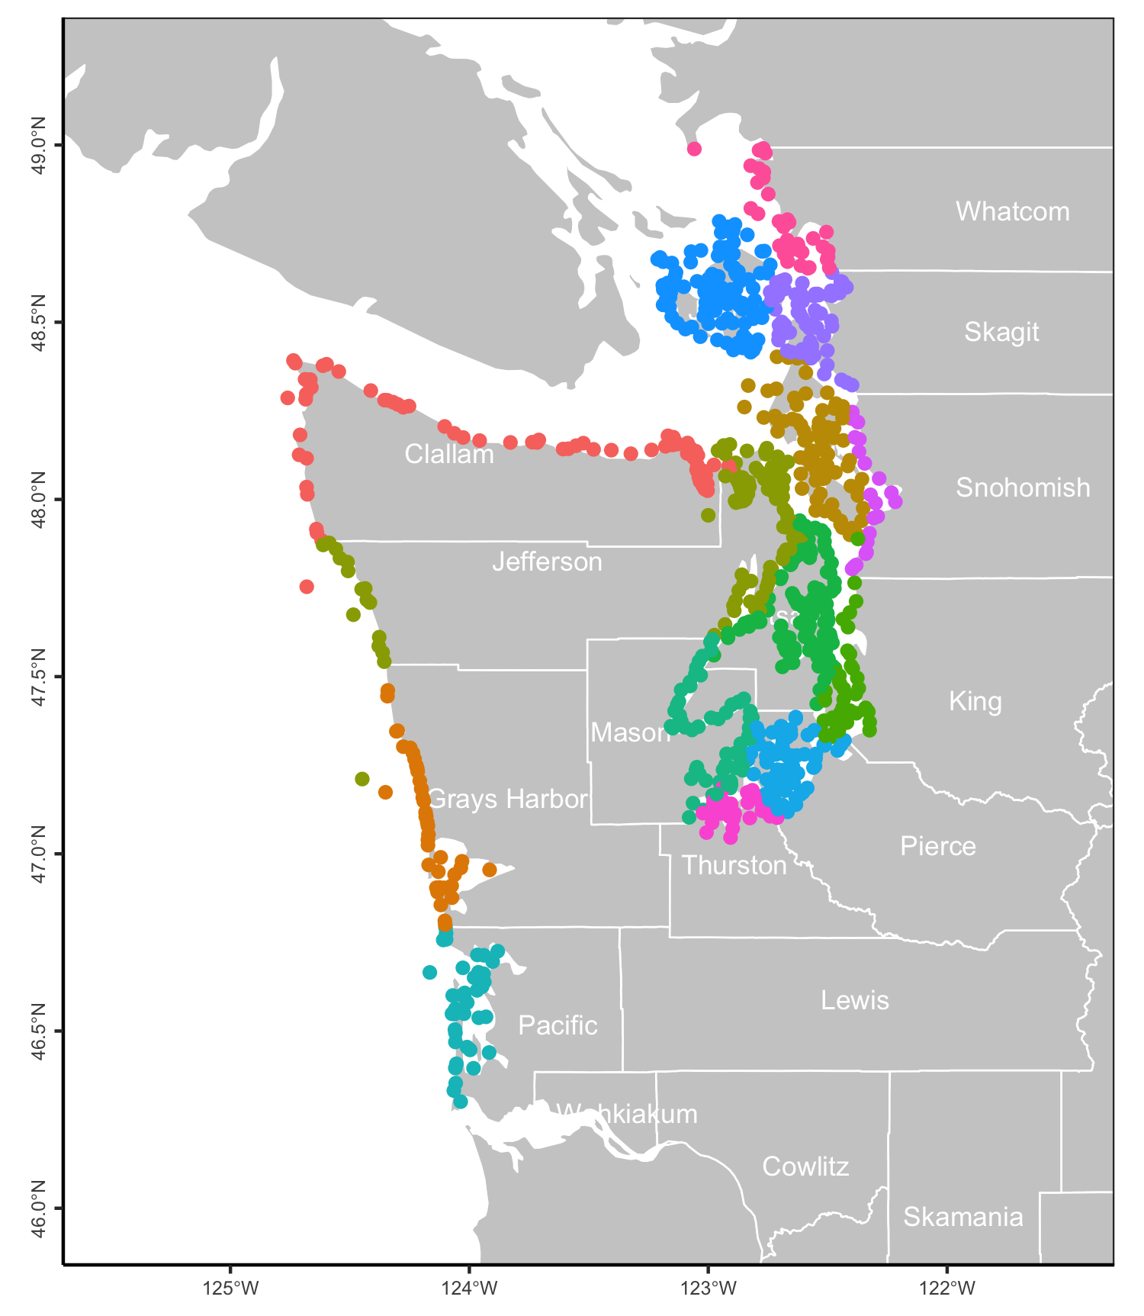

**Figure S1.** Location of WA DOH biotoxin sampling sites. Points are colored by county.

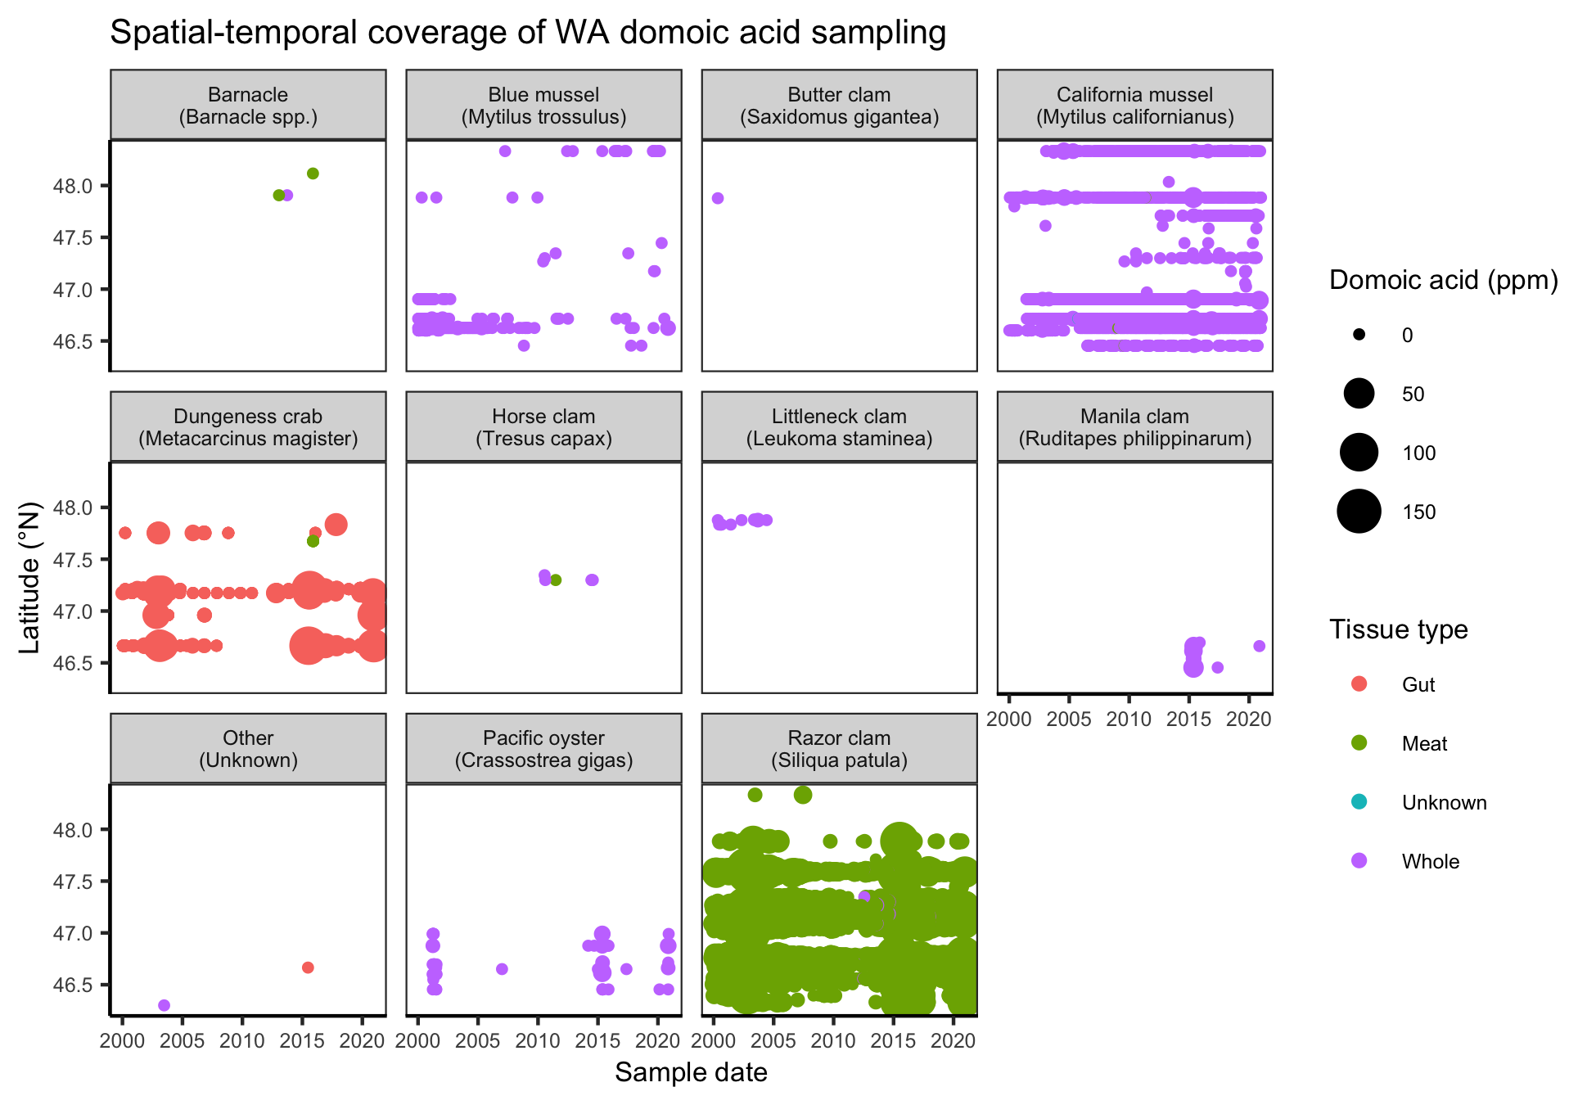**Figure S1.** Spatial temporal coverage of Washington’s domoic acid sampling program.

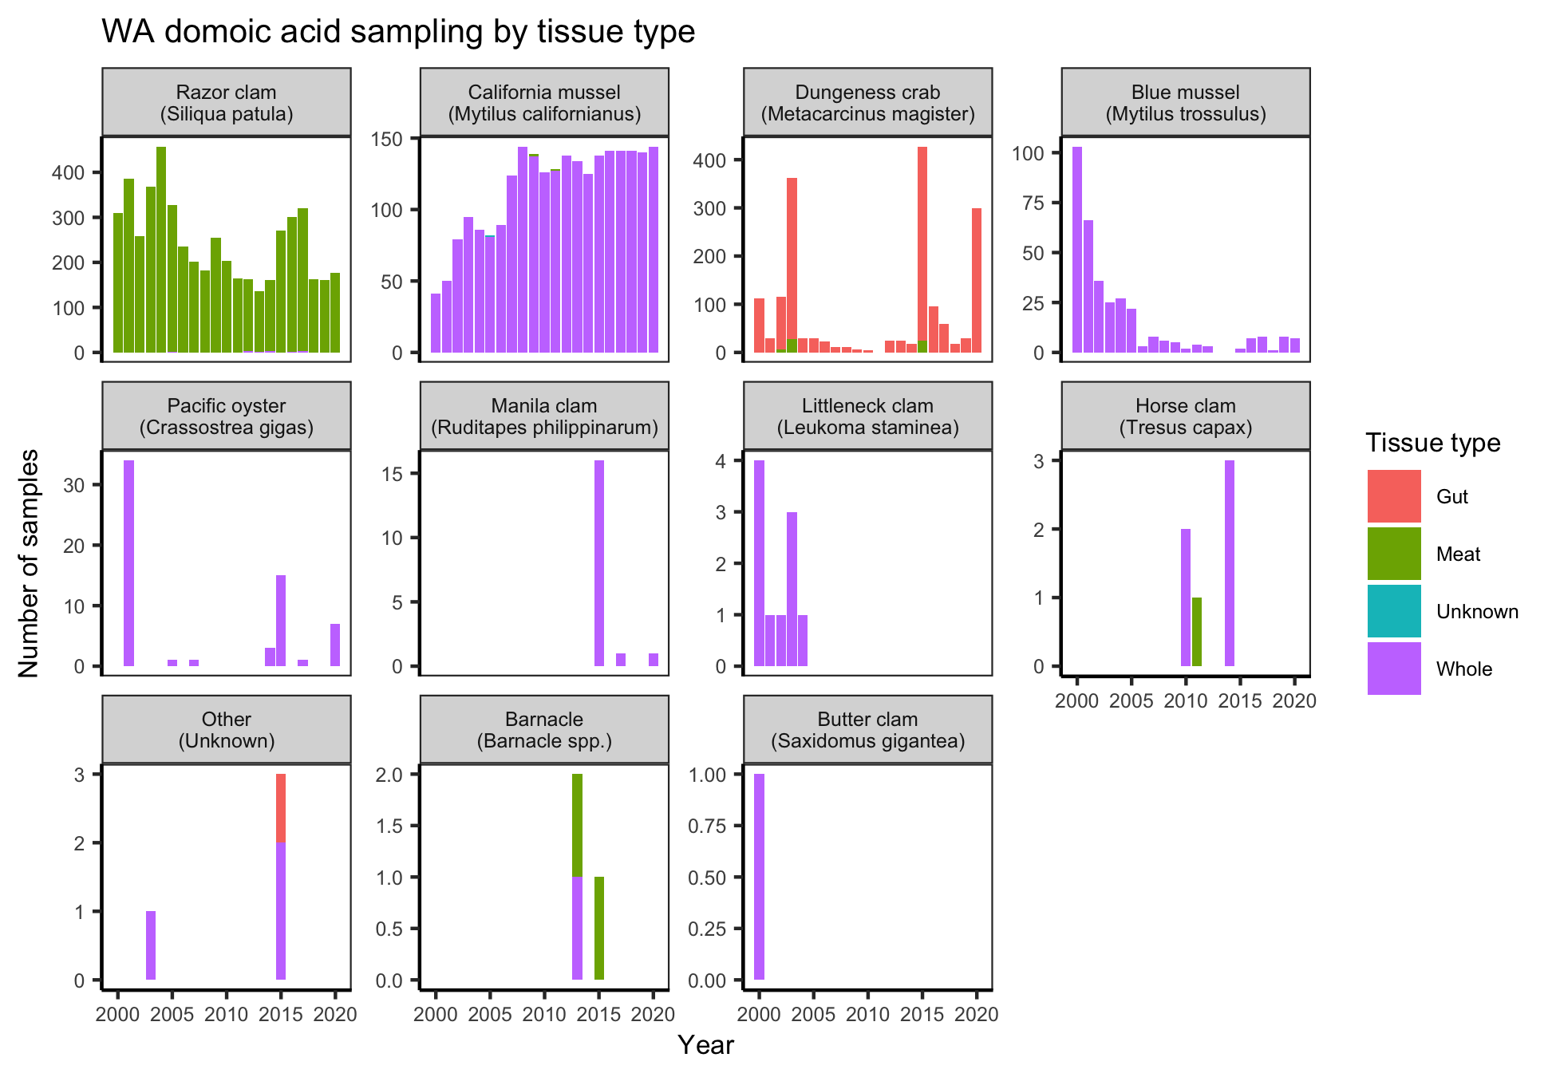**Figure S2.** Number of WA-DOH domoic acid contamination samples collected over time by species and tissue type.

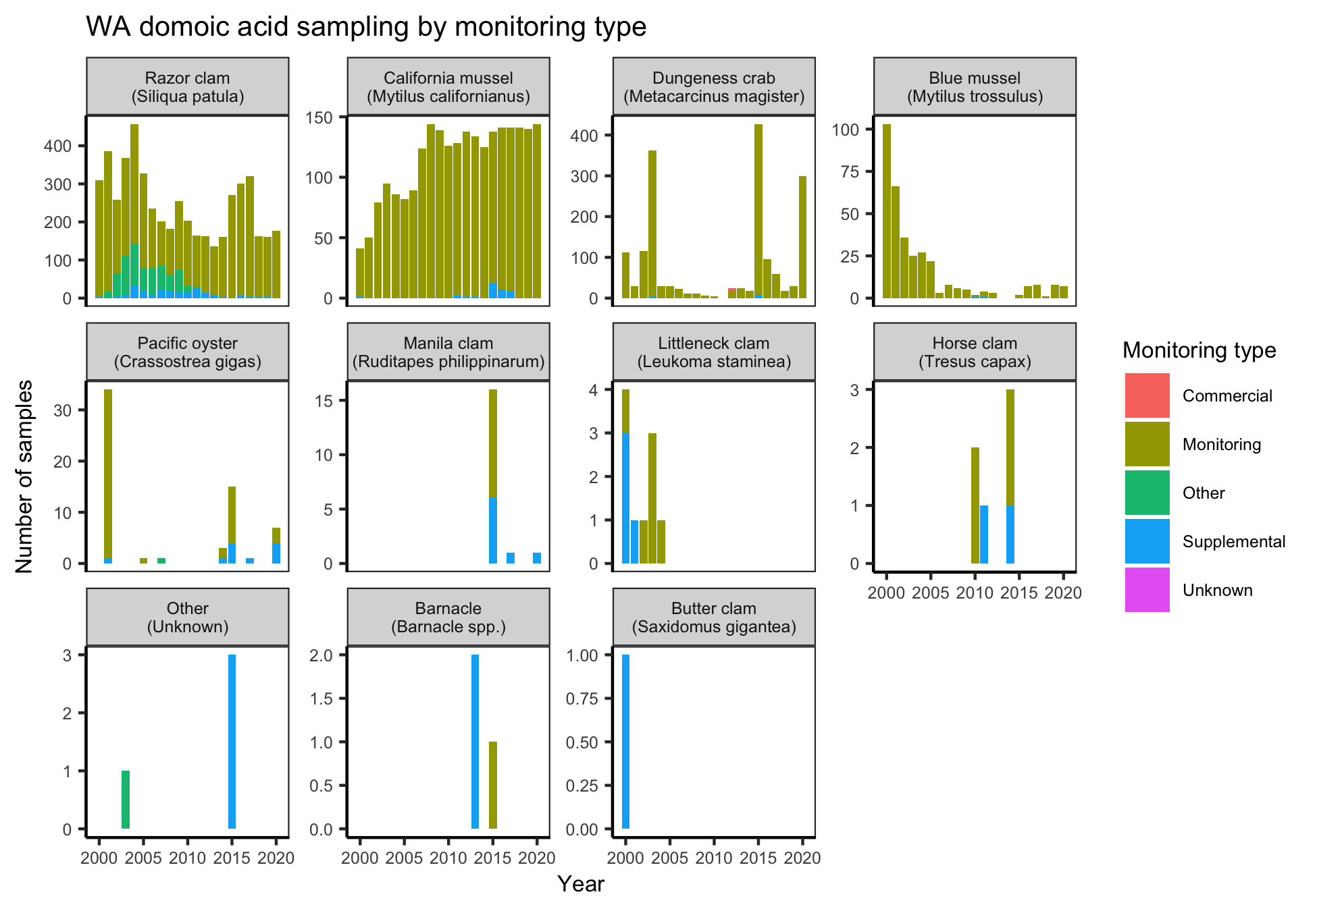**Figure S3.** Number of WA-DOH domoic acid contamination samples collected over time by species and monitoring type.

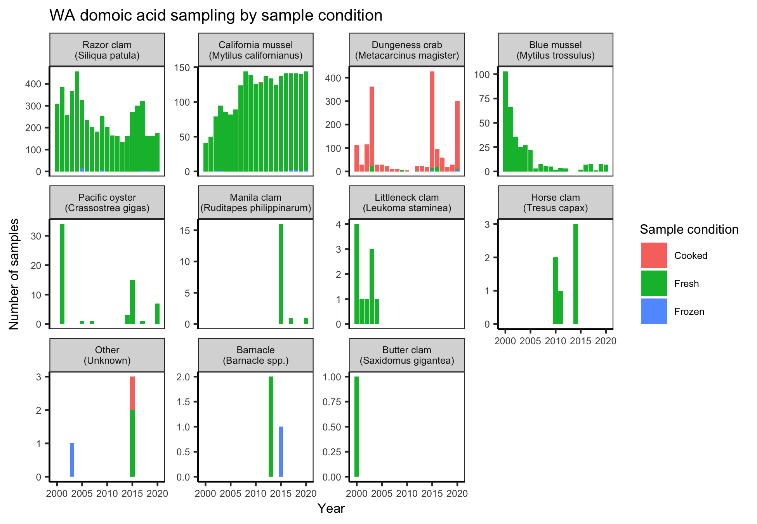**Figure S4.** Number of WA-DOH domoic acid contamination samples collected over time by species and sample preparation.

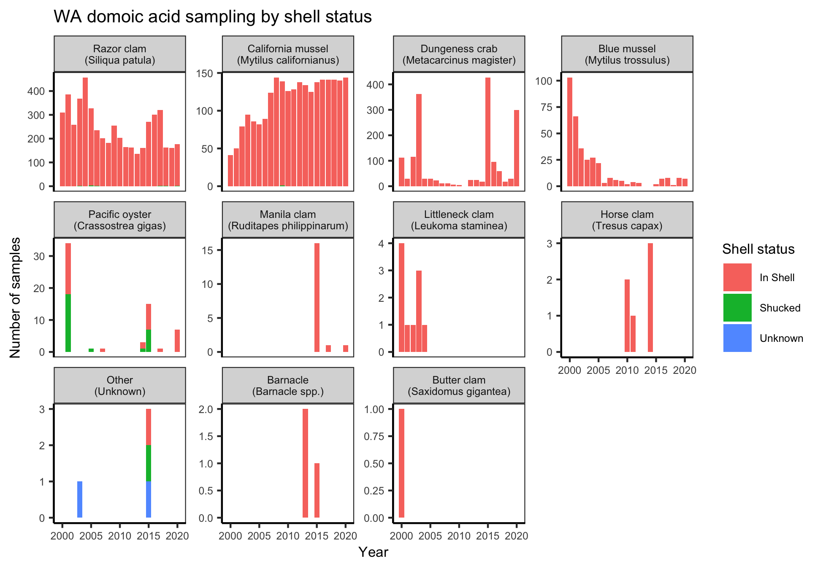**Figure S5.** Number of WA-DOH domoic acid contamination samples collected over time by species and shell status.

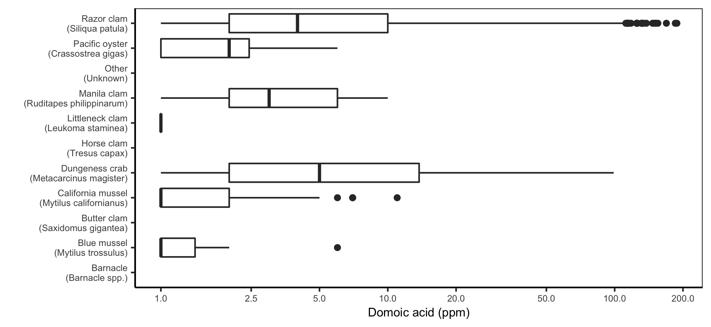**Figure S6.** Distribution of domoic acid contamination levels by species in the ODA samples. Note that the x-axis is log-scaled.

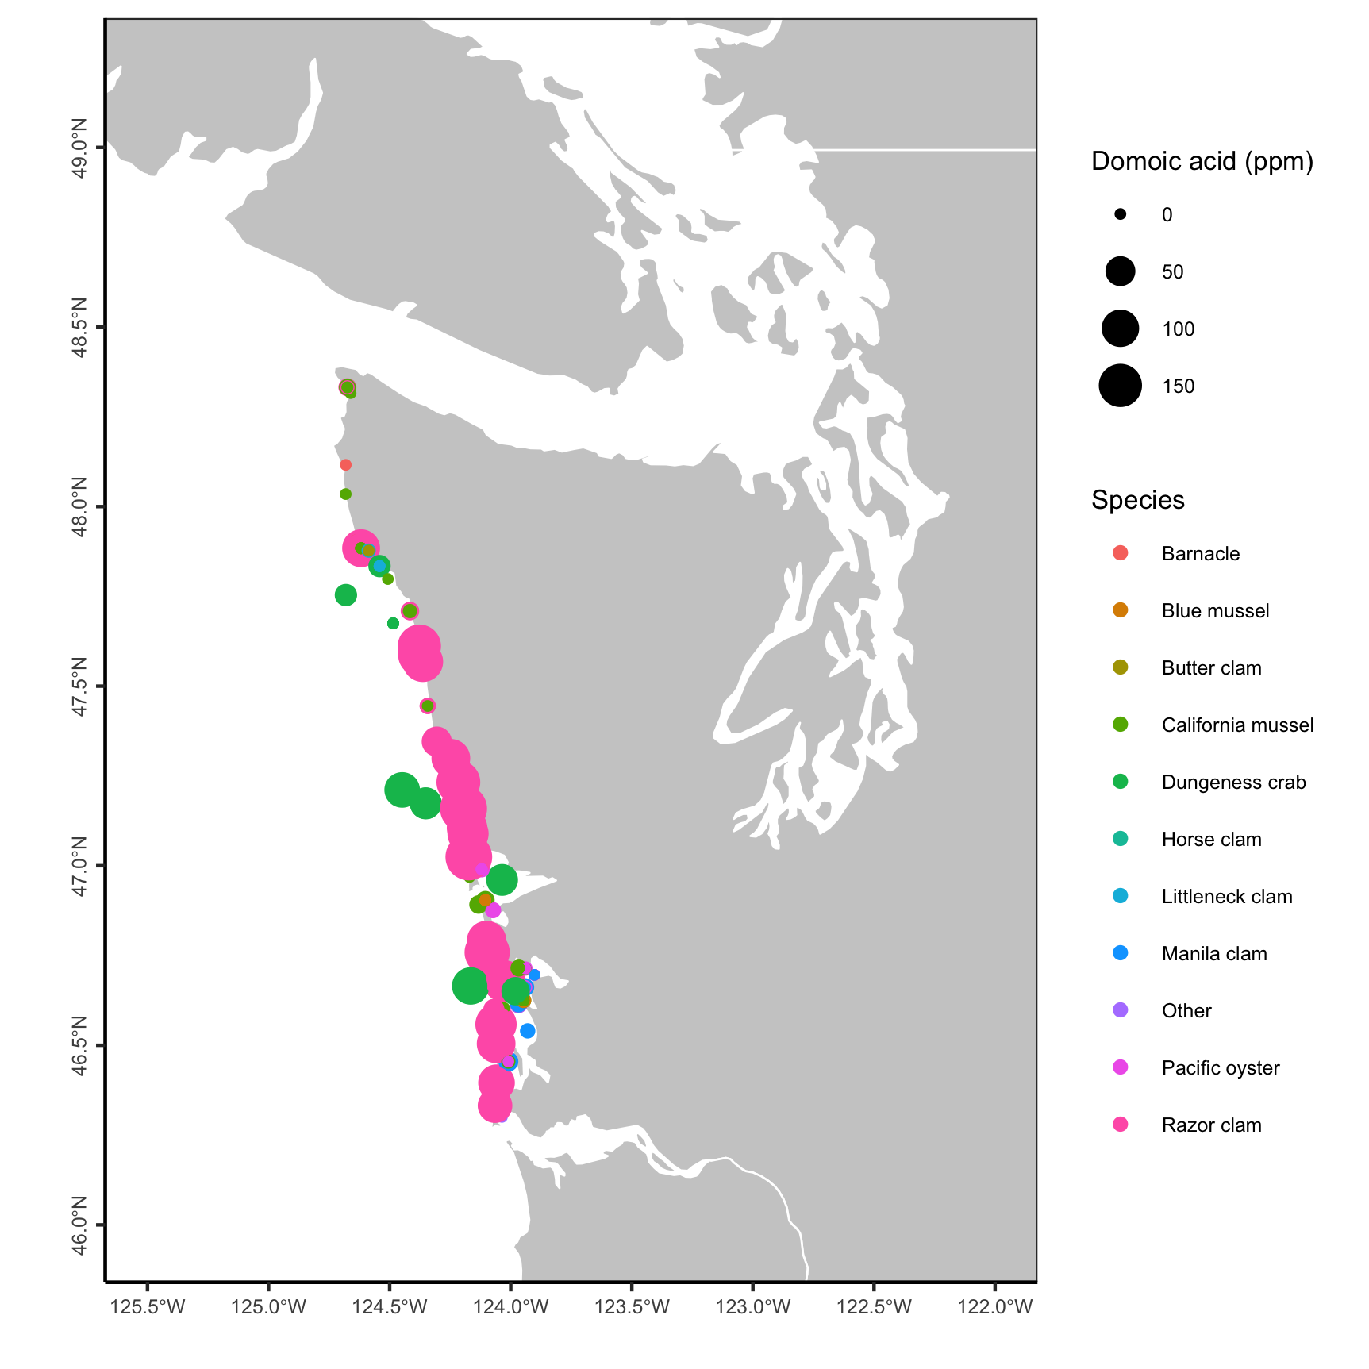

**Figure S7.** Map of domoic acid sampling locations and results by species.