## The value of monitoring in efficiently and adaptively managing biotoxin contamination in marine fisheries

Christopher M. Free1,2*, Vera L. Trainer3

1 Bren School of Environmental Science and Management, University of California, Santa Barbara, Santa Barbara, CA, 93106, USA

2 Marine Science Institute, University of California, Santa Barbara, Santa Barbara, CA, 93106, USA

3 Environmental and Fisheries Science Division, Northwest Fisheries Science Center, National Marine Fisheries Service, National Oceanic and Atmospheric Administration, Seattle, WA, 98112, USA

**\* Corresponding author:** Bren School of Environmental Science and Management, University of California, Santa Barbara, 2400 Bren Hall, Santa Barbara, CA 93106-5131; 610-999-4732; cfree14@gmail.com

### Abstract

Harmful algal blooms (HABs) can produce biotoxins that accumulate in seafood species targeted by commercial, recreational, and subsistence fisheries and pose an increasing risk to public health as well as fisher livelihoods, recreational opportunities, and food security. The impacts of HABs are expected to worsen under climate change highlighting a need to design biotoxin monitoring and management programs that eliminate public health risk with minimal impacts to the fishing communities that underpin coastal livelihoods and food systems. We review the history of domoic acid monitoring and management in the U.S. West Coast Dungeness crab fishery and highlight three adaptive changes made to these programs that efficiently manage mounting HAB risk: (1) expanded spatial-temporal frequency of monitoring; (2) delineation of clear management zones; and (3) legalization of evisceration orders as a potential management option. We then use simulation models grounded in historical data to measure the value of monitoring information in facilitating efficient domoic acid management. We confirm that monitoring surveys sampling 6 crabs (the current protocol) have high power to correctly diagnose contamination levels. Across a range of contamination scenarios, we find that increasing the spatial-temporal frequency of monitoring allows management to more quickly respond to changing toxin levels and to prevent public health risk with the least impact on fishing opportunities. Our results highlight the underutilized role of simulation testing and power analysis in designing efficient biotoxin monitoring programs, demonstrating the credibility of these programs to stakeholders, and justifying their expense to policymakers.

**Keywords:** harmful algal blooms, *Pseudo-nitzschia,* domoic acid, amnesic shellfish poisoning, Dungeness crab, *Metacarcinus magister*

### Highlights

* Efficient biotoxin management prevents public health risk at least cost to fishers
* Evisceration orders are useful tools for efficient biotoxin management
* Clearly delineated management zones promote predictable management
* High frequency monitoring (spatially/temporally) enables efficient management
* Simulation testing and power analysis should be the first step in survey design

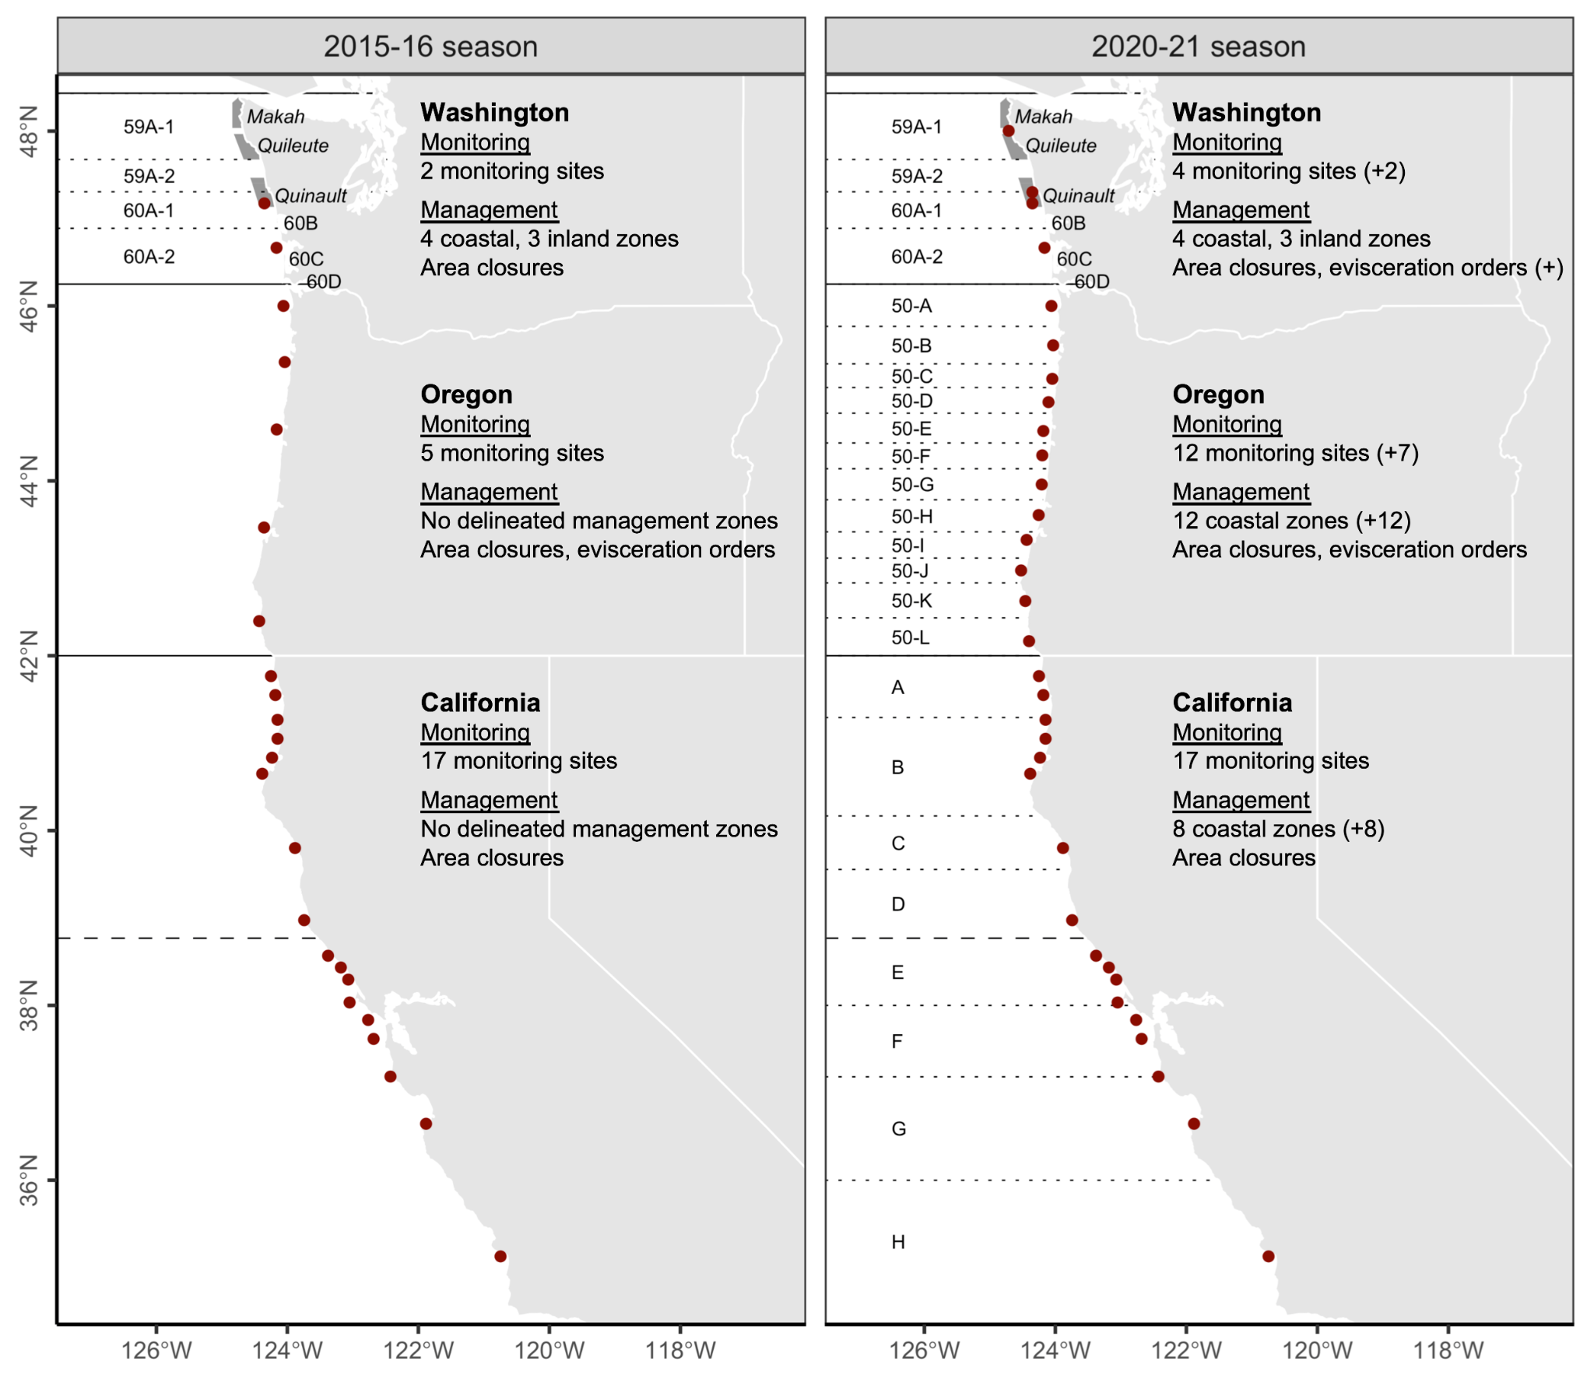**Figure 1.** Dungeness crab domoic acid monitoring sites, management zones, and action options along the U.S. West Coast before the 2015-16 and 2020-21 seasons. Since the 2015-16 season, state agencies have added 9 monitoring sites and delineated 20 monitoring zones along the coast. Solid black lines indicate state borders, dotted lines indicate biotoxin management zones, and the dashed line indicates the boundary between the Northern and Central California management regions. In Washington, zones 60B, 60C, and 60D are the semi-enclosed coastal bays of Grays Harbor, Willapa Bay, and the Columbia River, respectively. At-sea shaded polygons and italic text indicate Special Management Areas (SMAs) that are co-managed by state and treaty tribe managers.

### 

**Figure 2.** Results of coastal Dungeness crab domoic acid monitoring surveys on the U.S. West from 2014-2021. A survey (circles) is defined as a group of five or more individuals samples collected at the same location on the same day. Solid black lines indicate state borders and the dashed line indicates the border between the Northern and Central California management zones. Grey shading indicates the commercial Dungeness crab fishing season in each region. Grey lines indicate the biotoxin management zones established in Washington several decades ago, in Oregon before the 2017-18 season, and in California before the 2020-21 season. The labeled points highlight the following notable events: (1) elevated and extended contamination in California relative to southern Oregon; (2) elevated late season contamination in Washington; elevated mid-season contamination Oregon observed by (3) coarse and (4) resolved monitoring systems; and (5) elevated early season contamination in Washington.

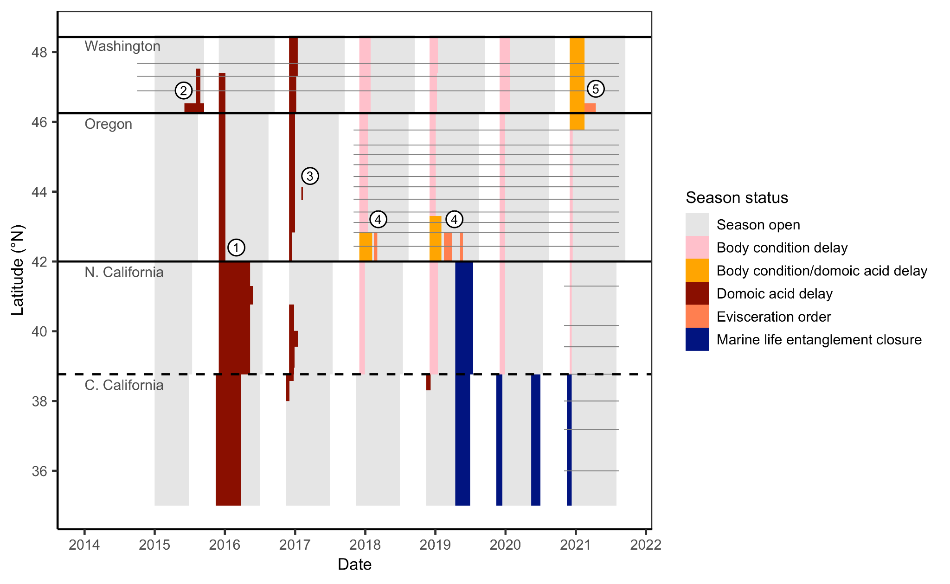**Figure 3.** Timeline of coastal fishery closures in the commercial Dungeness crab fishery on the U.S. West Coast from 2014-2021. Grey shading indicates when the season is open and other colors indicate a closure and its cause. Solid black lines indicate state borders and the dashed line indicates the border between the Northern and Central California management zones. Grey lines indicate the biotoxin management zones established in Washington several decades ago, in Oregon before the 2017-18 season, and in California before the 2020-21 season. The labeled points highlight the following notable events: (1) extended closures in California relative to southern Oregon; (2) late season biotoxin closure in Washington, (3) mid-season biotoxin closure in Oregon; (4) mid-season evisceration orders in Oregon; and (5) the first evisceration order in Washington.