## The value of monitoring in efficiently and adaptively managing biotoxin contamination in marine fisheries

Christopher M. Free1,2*, Vera L. Trainer3

1 Bren School of Environmental Science and Management, University of California, Santa Barbara, Santa Barbara, CA, 93106, USA

2 Marine Science Institute, University of California, Santa Barbara, Santa Barbara, CA, 93106, USA

3 Environmental and Fisheries Science Division, Northwest Fisheries Science Center, National Marine Fisheries Service, National Oceanic and Atmospheric Administration, Seattle, WA, 98112, USA

**\* Corresponding author:** Bren School of Environmental Science and Management, University of California, Santa Barbara, 2400 Bren Hall, Santa Barbara, CA 93106-5131; 610-999-4732; cfree14@gmail.com

### Abstract

Harmful algal blooms (HABs) can produce biotoxins that accumulate in seafood species targeted by commercial, recreational, and subsistence fisheries and pose an increasing risk to public health as well as fisher livelihoods, recreational opportunities, and food security. The impacts of HABs are expected to worsen under climate change highlighting a need to design biotoxin monitoring and management programs that eliminate public health risk with minimal impacts to the fishing communities that underpin coastal livelihoods and food systems. We review the history of domoic acid monitoring and management in the U.S. West Coast Dungeness crab fishery and highlight three adaptive changes made to these programs that efficiently manage mounting HAB risk: (1) expanded spatial-temporal frequency of monitoring; (2) delineation of clear management zones; and (3) legalization of evisceration orders as a potential management option. We then use simulation models grounded in historical data to measure the value of monitoring information in facilitating efficient domoic acid management. We confirm that monitoring surveys sampling 6 crabs (the current protocol) have high power to correctly diagnose contamination levels. Across a range of contamination scenarios, we find that increasing the spatial-temporal frequency of monitoring allows management to more quickly respond to changing toxin levels and to prevent public health risk with the least impact on fishing opportunities. Our results highlight the underutilized role of simulation testing and power analysis in designing efficient biotoxin monitoring programs, demonstrating the credibility of these programs to stakeholders, and justifying their expense to policymakers.

**Keywords:** harmful algal blooms, *Pseudo-nitzschia,* domoic acid, amnesic shellfish poisoning, Dungeness crab, *Metacarcinus magister*

### Highlights

* Efficient biotoxin management prevents public health risk at least cost to fishers
* Evisceration orders are useful tools for efficient biotoxin management
* Clearly delineated management zones promote predictable management
* High frequency monitoring (spatially/temporally) enables efficient management
* Simulation testing and power analysis should be the first step in survey design

### 2. Methods

#### 2.1 Historical review

##### 2.1.1 Monitoring history

We received records of domoic acid testing results from state-run biotoxin monitoring programs from the California Department of Public Health (CDPH), Oregon Department of Agriculture (ODA), and Washington Department of Health (WDOH). The records were variable in temporal coverage but all spanned 2014 to 2021 (**Figure 2**). The records primarily described domoic acid contamination in Dungeness crab (*Metacarcinus magister*), razor clam (*Siliqua patula*), and California mussel (*Mytilus californianus*) but included results for 22 other species (**Table S2**). In general, we formatted the data by: (1) harmonizing common names, scientific names, and other categorical attributes (e.g., tissue type, tissue source) across states and years; (2) harmonizing location names and georeferencing all locations; and (3) grouping results into surveys, which we defined as samples collected from a given location on the same day. See the supplemental appendices for more details on formatting and visualizing these datasets.

##### 2.1.2 Management history

We reconstructed fishery closures, health advisories, and other management actions resulting from biotoxin contamination on the U.S. West Coast by extracting information from news releases posted on various agency websites (see **Table S3** for sources). We extracted the following information from each news release: (1) the date of the action; (2) the type of action (i.e., open/close or enact/lift); (3) the category of action (i.e., fishery closure, health advisory, gear reduction, evisceration order); (4) the reason for the action (e.g., domoic acid, other biotoxin, body condition, oil spill, etc.) (4) the latitudinal extent of the action; and (5) the species and fisheries (i.e., commercial, recreational, tribal) impacted by the action. In a few cases, fishery openings were missing for earlier closures (and vice versa), and we filled missing announcements using information from the other sources or through targeted internet searches. Finally, we merged the datasets derived from each source to create the most detailed spatial-temporal history of fishery closures and other management actions possible for Dungeness crab, California mussel, razor clam, and other species. See the supplemental appendices for more details on the management histories documented by each source.

#### 2.2 Simulation testing

##### 2.2.1 Parameterization using historical data

The first step in evaluating monitoring and management programs through simulation testing and power analysis is to leverage already collected data to parameterize the analysis to mimic the conditions that such programs are likely to confront in the real world. We used the domoic acid testing results described above to characterize the range of contamination profiles that West Coast Dungeness crab biotoxin monitoring and management programs will likely need to track and respond to. We used the *fitdistrplus* package [(Delignette-Muller and Dutang, 2015)](https://www.zotero.org/google-docs/?hAE6Yw) in R [(R Core Team, 2021)](https://www.zotero.org/google-docs/?sC3Wos) to fit log-normal distributions to the XXX domoic acid surveys comprising at least 6 sampled crabs from 2014 to 2021. We fit log-normal distributions because contamination results are continuous, greater than zero (i.e., the lowest detection limit is >1 ppm), and are generally right-skewed. We describe the centrality and variability of the contamination profiles using the median and coefficient of variation (CV) of the distributions, respectively. We use these values rather than the explicit centrality (μ) and variability (σ) parameters of the log-normal distribution because of their ease of interpretation and familiarity to readers. These distributions are central to the simulation methods described below and the range of centrality and variability values and example distributions are illustrated in **Figure 5**.

##### 2.2.2 Power analysis of monitoring survey sample size

We measured the power of monitoring surveys of varying sample sizes to accurately diagnose contamination across a range of potential contamination profiles. Because West Coast Dungeness crab monitoring has historically relied on a baseline of 6 sampled crabs (**Table S1**) with additional samples occasionally collected in intervals of 6 crabs, we evaluated sample sizes of 6, 12, 18, 24, and 30 crabs. We tested the performance of these sample sizes across the range of centrality and variability combinations observed in historical surveys. This range was delineated using a generalized envelope surrounding historical values (**Figure 5**) and scenarios within this envelope were defined using combinations of medians in 5 ppm intervals and coefficients of variability in 0.25 intervals. For each combination of centrality and variability parameters, we simulated 1,000 monitoring surveys (iterations) using each sample size; a survey represents random draws of each sample size from the contamination distribution defined by the selected centrality and variability parameters. We then calculated the proportion of surveys that (1) correctly diagnosed contamination rates and therefore recommended the appropriate management action (power of the test), (2) incorrectly diagnosed the results as ‘clean’ when they were actually ‘contaminated’ (Type II error) and thus riskily opened the fishery; and (3) incorrectly diagnosed the results as ‘contaminated’ when they were actually ‘clean’ (Type I error) and thus unnecessarily closed the fishery (**Table S6**). A clean survey is one in which <1 in 6 crabs (16.6%) are contaminated above the action threshold and a contaminated survey is one in which ≥1 in 6 crabs are contaminated above the action threshold.

### 3. Results

#### 3.2 Simulation testing

##### 3.2.1 Number of sampled crabs

The current protocol of sampling six crabs per survey has high power to correctly diagnose the safety of opening the Dungeness crab fishery across a wide range of possible contamination profiles (**Figures 7 & 8**). Across all 146 evaluated contamination profiles, the six crab sampling program was, on average, 89% effective at recommending the correct decision about whether to open or close the fishery (**Figure 7A**). The six crab sampling program was more vulnerable to unnecessary closures than to risky openings. On average, the six crab sampling program risked closing the fishery unnecessarily in 7% of contamination scenarios (**Figure 7B**)and opening the fishery riskily in 4% of contamination scenarios (**Figure 7C**). The six crab sampling program is especially vulnerable to recommending incorrect management actions when median contamination is low but the variability in contamination is high (**Figure 8**). These situations have been, historically, relatively rare (**Figures 6 & 8**).

Increasing the sample size of monitoring surveys would slightly increase power to correctly recommend management actions (**Figures 7 & 8**) but with increased costs. Doubling the current sample size (6 to 12 crabs) would increase average effectiveness across the evaluated scenarios from 89% to 92% probability of making the correct management decision (**Figure 7A**). Notably, however, these gains are made largely by reducing the risk of unnecessary closures, which drops from 7% to 5% (**Figure 7B**). In comparison, the risk of risky openings only declines from 3.5% to 3.2% (**Figure 7C**). Further increases in sample size would further increase the statistical power of monitoring surveys, though the gains become increasingly more marginal (**Figures 7 & 8**).

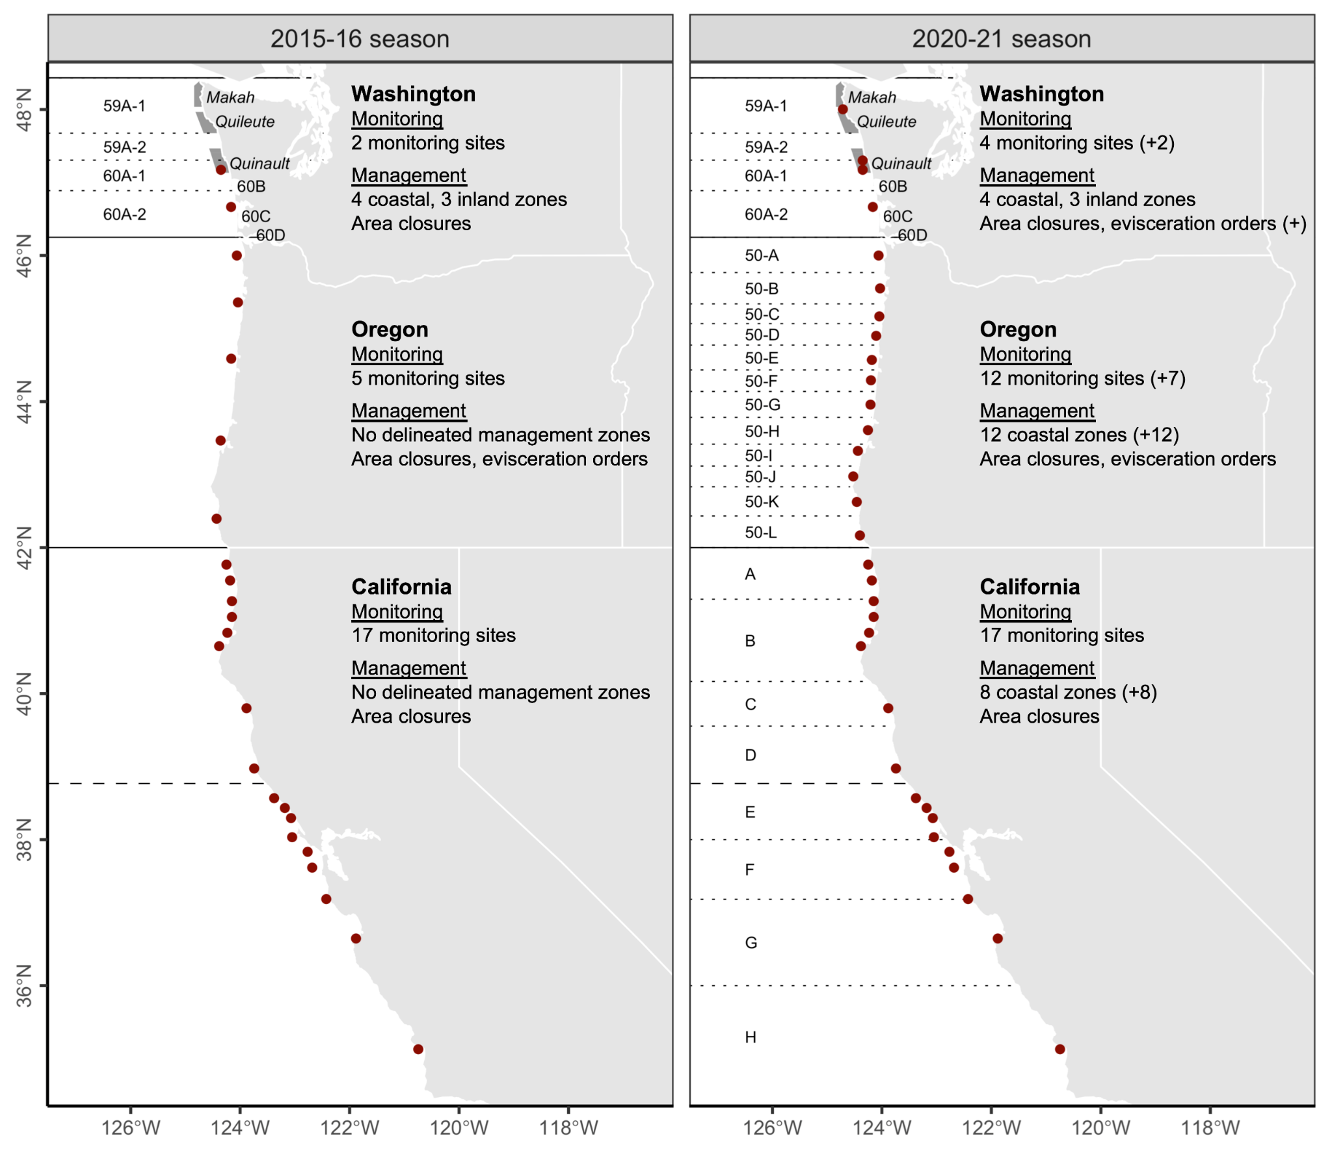**Figure 1.** Dungeness crab domoic acid monitoring sites, management zones, and action options along the U.S. West Coast before the 2015-16 and 2020-21 seasons. Since the 2015-16 season, state agencies have added 9 monitoring sites and delineated 20 monitoring zones along the coast. Solid black lines indicate state borders, dotted lines indicate biotoxin management zones, and the dashed line indicates the boundary between the Northern and Central California management regions. In Washington, zones 60B, 60C, and 60D are the semi-enclosed coastal bays of Grays Harbor, Willapa Bay, and the Columbia River, respectively. At-sea shaded polygons and italic text indicate Special Management Areas (SMAs) that are co-managed by state and treaty tribe managers.

### 

**Figure 2.** Results of coastal Dungeness crab domoic acid monitoring surveys on the U.S. West from 2014-2021. A survey (circles) is defined as a group of five or more individuals samples collected at the same location on the same day. Solid black lines indicate state borders and the dashed line indicates the border between the Northern and Central California management zones. Grey shading indicates the commercial Dungeness crab fishing season in each region. Grey lines indicate the biotoxin management zones established in Washington several decades ago, in Oregon before the 2017-18 season, and in California before the 2020-21 season. The labeled points highlight the following notable events: (1) elevated and extended contamination in California relative to southern Oregon; (2) elevated late season contamination in Washington; elevated mid-season contamination Oregon observed by (3) coarse and (4) resolved monitoring systems; and (5) elevated early season contamination in Washington.

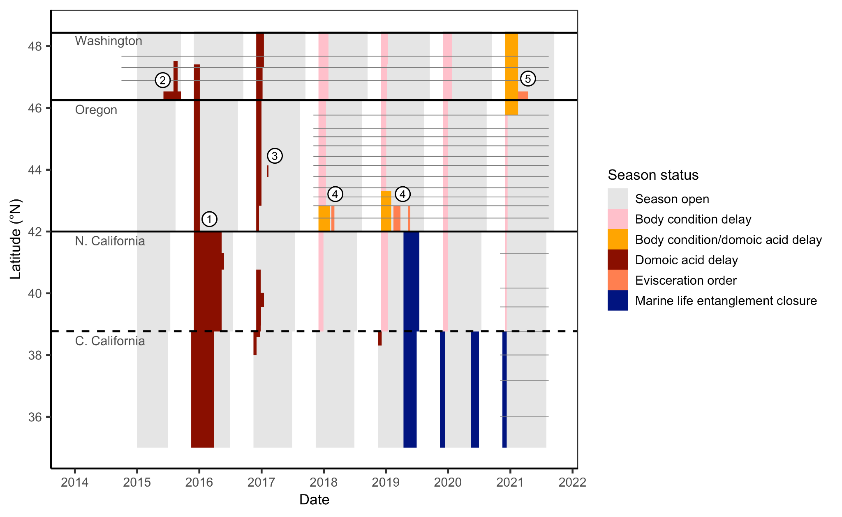**Figure 3.** Timeline of coastal fishery closures in the commercial Dungeness crab fishery on the U.S. West Coast from 2014-2021. Grey shading indicates when the season is open and other colors indicate a closure and its cause. Solid black lines indicate state borders and the dashed line indicates the border between the Northern and Central California management zones. Grey lines indicate the biotoxin management zones established in Washington several decades ago, in Oregon before the 2017-18 season, and in California before the 2020-21 season. The labeled points highlight the following notable events: (1) extended closures in California relative to southern Oregon; (2) late season biotoxin closure in Washington, (3) mid-season biotoxin closure in Oregon; (4) mid-season evisceration orders in Oregon; and (5) the first evisceration order in Washington.

To-do list:

1. Fix CA 2018-2019 closure that was body condition and domoic acid

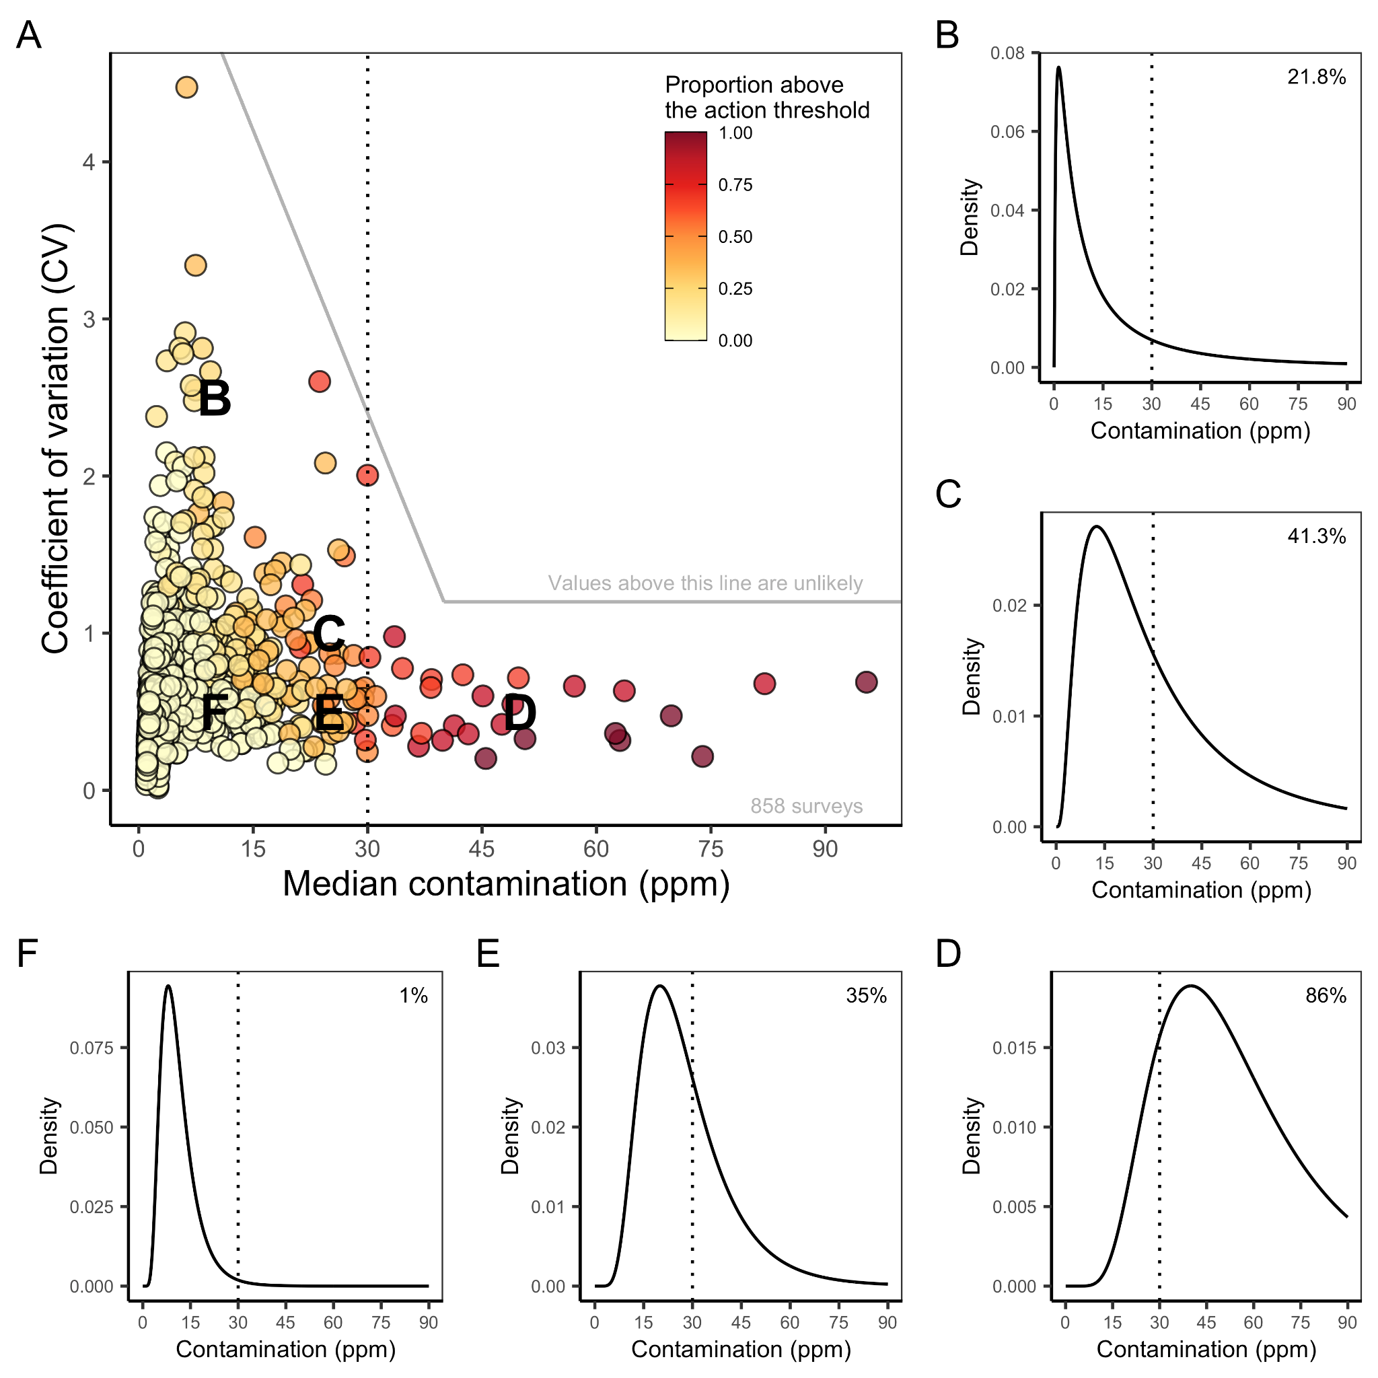

**Figure 6.** Distributions of domoic acid contamination in sampled Dungeness crab viscera in 858 biotoxin surveys (≥ 6 crabs per survey) conducted on the U.S. West Coast from 2015-2021. In (A), each point represents the scale (median) and shape (CV) of a log-normal distribution fit to the results of each survey. Points are colored based on the observed proportion of samples testing above the 30 ppm action threshold (vertical dotted line, in all panels). The solid grey lines delineate unlikely contamination distributions based on historical monitoring; values above these lines are not considered in simulation testing (see Figure 8). The letters indicate the scale and shape of the five example domoic acid contamination distributions illustrated in B-C. In B-C, percentages indicate the percent of crabs testing above the 30 ppm action threshold.

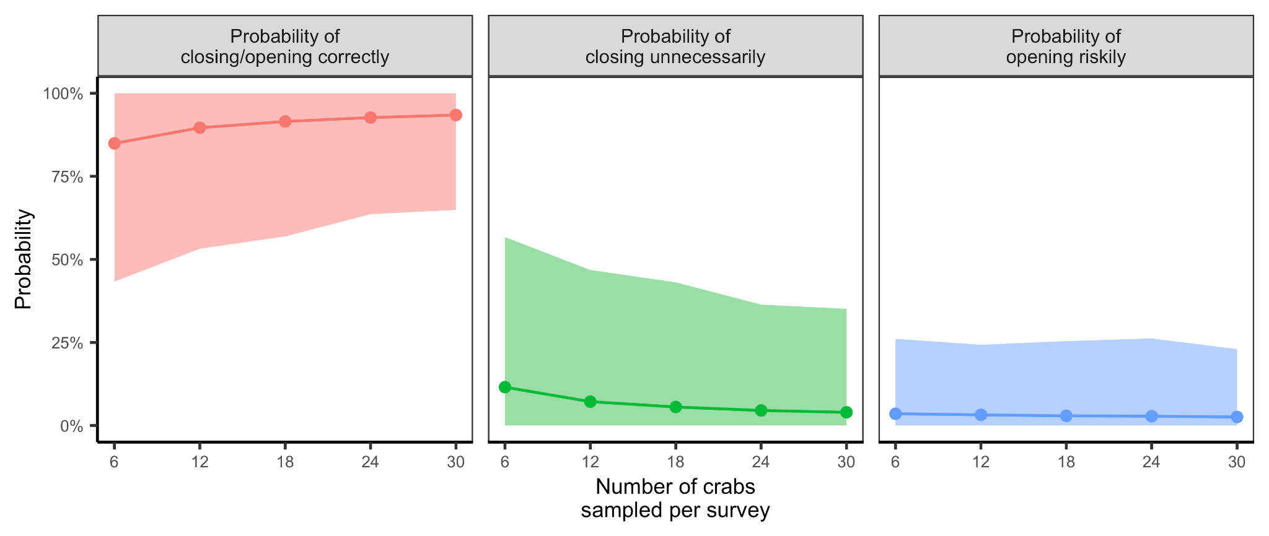**Figure 7.** The power for domoic acid monitoring programs of varying sample sizes to correctly diagnose contamination rates and recommend management actions. Probabilities represent the proportion of 1,000 surveys made for each of the 146 evaluated contamination profiles (defined by unique combinations of centrality-variability parameters), in which the survey correctly diagnosed the true level of contamination as requiring (≥1 in 6 crabs above the 30 ppm action threshold) or not requiring (<1 in 6 crabs above the action threshold) management action. The points illustrate the mean probabilities across the 146 evaluated contamination profiles and the shading indicates the inner 90th percentile of these values. Unnecessary closures occur when a survey deems that management action is necessary when it is not and risky openings occur when a survey deems that management action is not necessary when it is (Table S6).

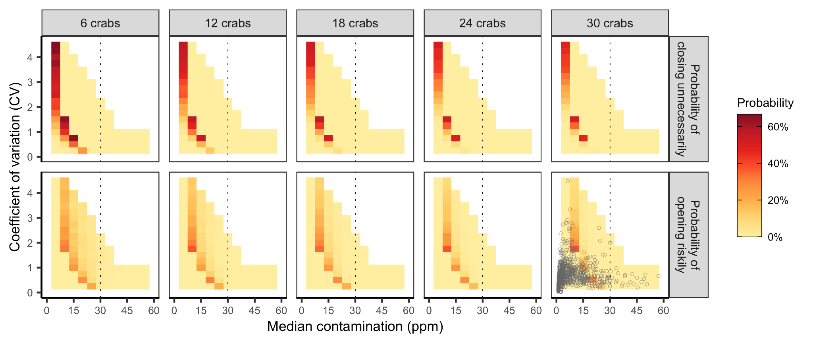**Figure 8.** The simulated risk of making an incorrect management decision based on the number of crabs sampled in a survey and the distribution of domoic acid contamination in the sampled population. Risk is measured as the probability of unnecessarily delaying a season opening when levels are actually below the action threshold (top row) and as the probability of opening the season when levels are actually above the action threshold (bottom row). Probabilities are determined based on the outcomes of 1,000 randomized simulations. The white cells were not evaluated because they represent unlikely contamination distributions based on historical observations (points in lower right corner; see **Figure 6** for additional information). Correct management decisions were nearly universal when median contaminations were above 60 ppm; thus, to highlight results at more challenging levels of contamination (0-30 ppm), results between 60-100 ppm are not plotted here.

### Supplemental Tables and Figures

#### Supplemental Tables

**Table S1.** Dungeness crab domoic acid contamination monitoring and management program design in California, Oregon, and Washington before the 2020-21 and 2015-16 seasons (2015-16 season values are provided in parentheses if different from the 2020-21 season).

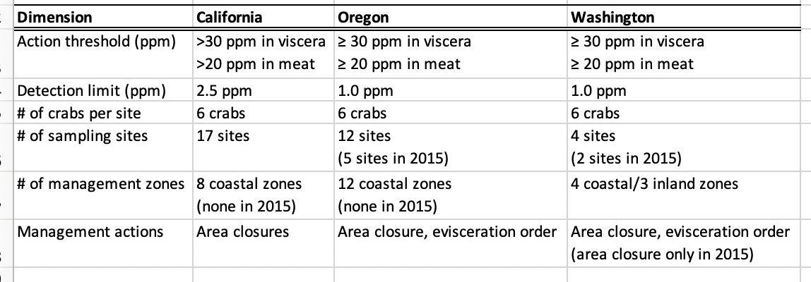

**Table S6.** A guide to interpreting the results of the power analysis.

**​​**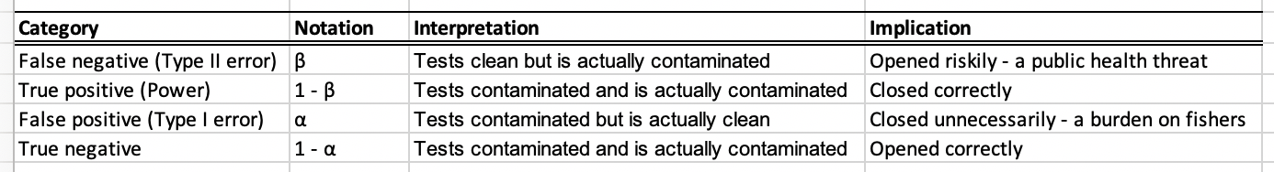

1 Negative test = clean test; Positive test = contaminated test

2 Clean = <1 in 6 crabs above threshold; Contaminated = ≥1 1 in 6 crabs above threshold