### Appendices

#### Appendix A. Cleaning Oregon’s domoic acid monitoring data

We received Oregon’s historical domoic acid monitoring data in three files: (1) 1999-2015 razor clam samples; (2) 1999-2015 California mussel samples; and (3) 2010-2021 samples for all species. The “California mussel” and “razor clam” files included information on sample date, sample site, and domoic acid concentration. The “all species” file includes additional information describing sample id, sample time, and sample type (e.g., viscera, cooked viscera, legs, viscera/legs, in shell, etc.). Given the additional attributes provided in the “all species” file and the high level of agreement between the three files during the years of overlap (**Figure S1**; 2010-2015), we used the data in the “all species” file from 2010-forward and only used the pre-2010 data from California mussel and razor clam files.

We formatted the 2010-2021 all species data by: (1) harmonizing the common names provided in the product names; (2) adding scientific names for each harmonized common name; (3) separating sample type (i.e., meat, viscera, legs, in shell, yearlings, viscera-cooked, etc.) information from the product name; (4) separating location information from the product name; (5) harmonizing location names; (6) adding GPS coordinates for each location name; and (7) filling missing quantities using values in the quantity comments. We harmonized the common names and scientific names according to **Table S1**. We geolocated locations using: (1) ODA coordinates for Dungeness crab sampling sites; (2) ODA coordinates for some bivalve sampling sites; and (3) Google Earth for the remainder of sampling sites. Harmonized locations are mapped in **Figure S2**. We filled missing quantities using values provided in the comments column. For example, we assigned sample 18-A765, which is missing a value in the data, a value of 3.9 ppm, based on the fact that the comments column reads: “3.9 ppm MRL=1.0 ppm”.

The domoic acid contamination data (n=7706 samples) is dominated by Dungeness crab (n=2661), California mussels (n=3213), and razor clam sample (n=1691) but includes 141 samples from another 11 taxonomic groups (**Figure S5**). The majority of samples tested below 10 ppm of domoic acid but many samples tested higher, especially for razor clam, Dungeness crab, and California mussel (**Figure S4**). The spatial-temporal coverage of sampling is variable by year and species (**Figures S5-S8**). Data appears to be missing for Dungeness crab in the 2012-13 and 2013-14 seasons and are limited in the 2010-11, 2011-12, and 2014-15 seasons.

**Table S1.** Harmonized common and scientific names of species sampled in the OR biotoxin monitoring program.

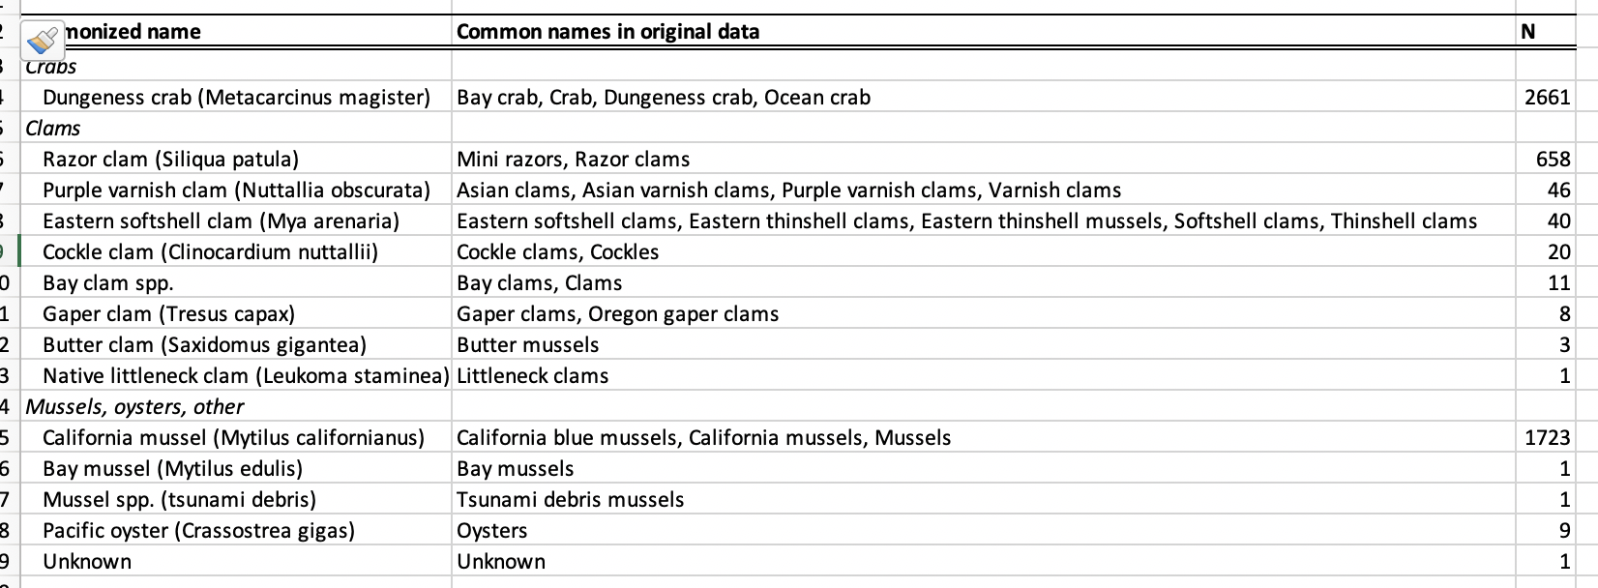

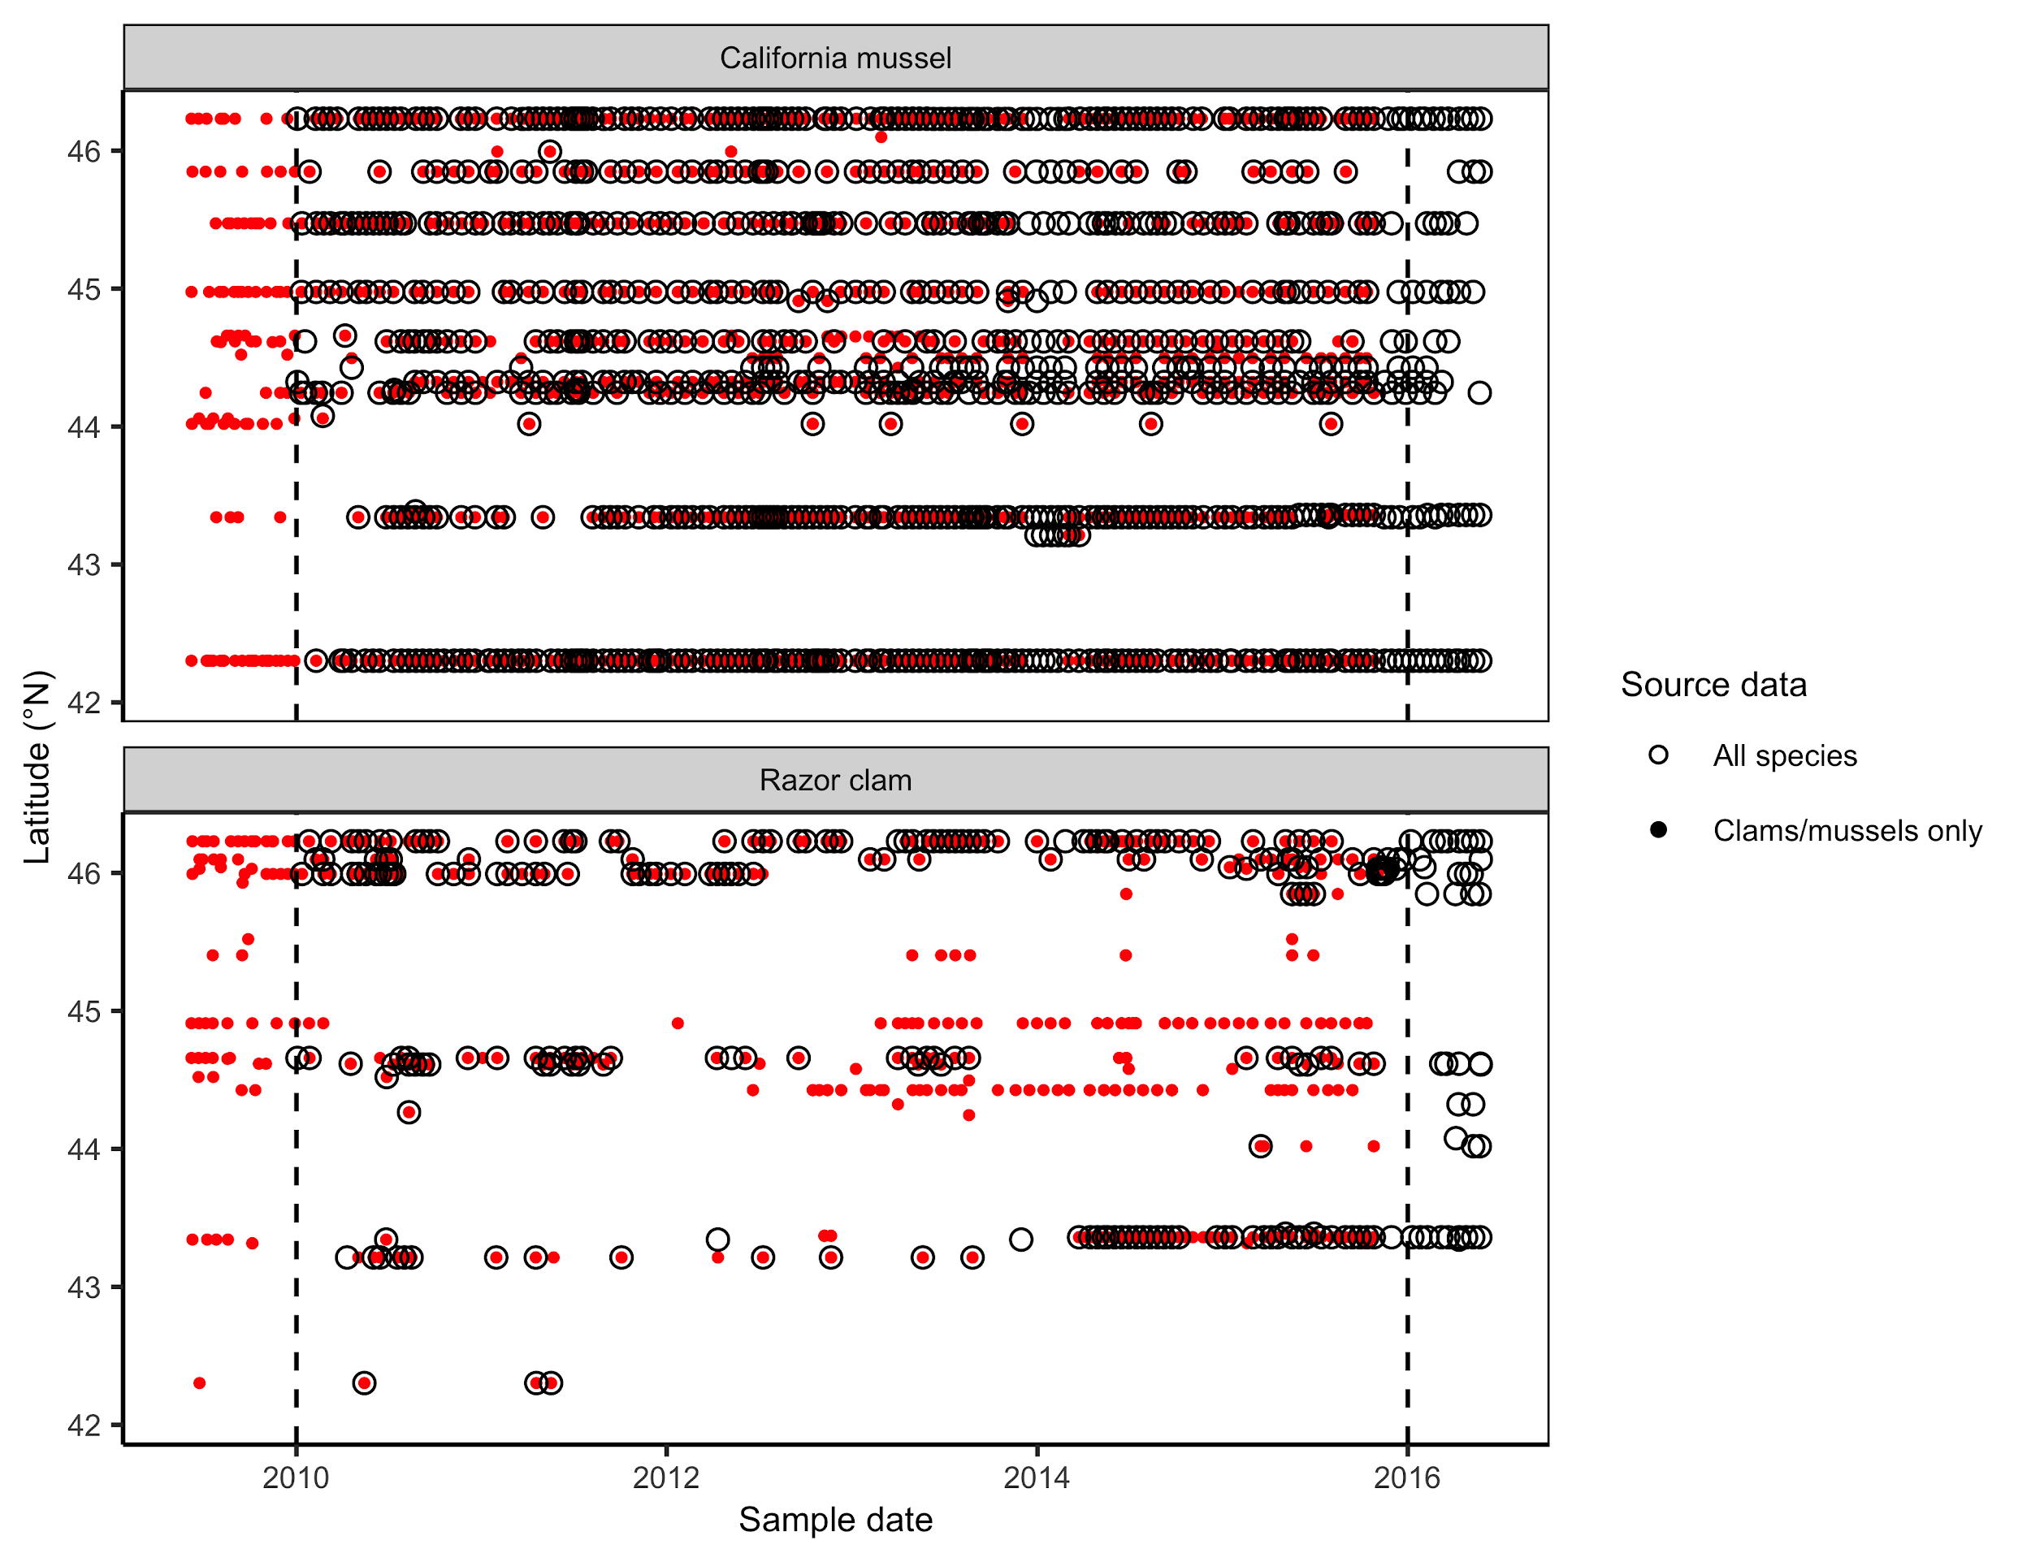**Figure S1.** The spatial-temporal coverage and agreement of biotoxin samples represented in the “all species” file and the “California mussel” and “razor clam” files during the years of overlap (2010-2015; marked by vertical dashed lines). Although the files do not perfectly match each other, they are close, and we use data from the “all species” file during this period of overlap. The “all species” file has additional attributes for sample id, sample time, and sample type.

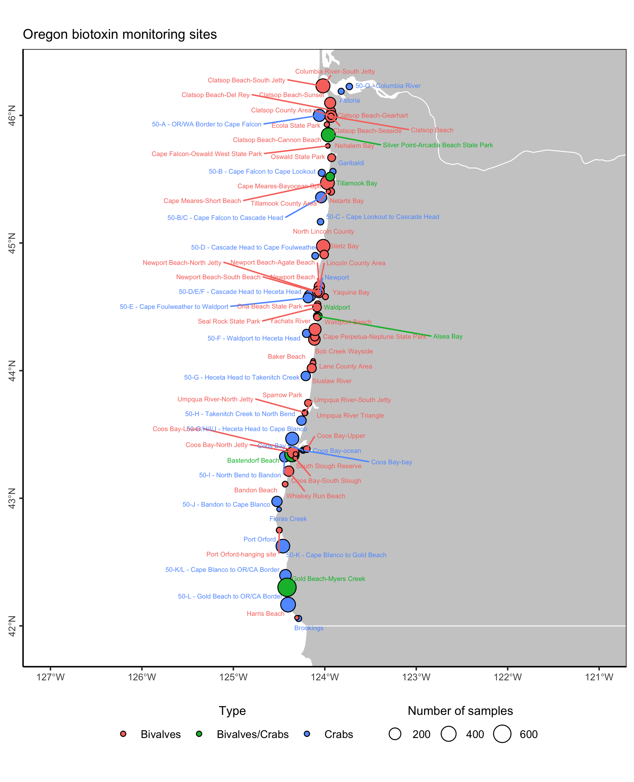

**Figure S2.** Location of biotoxin sampling sites for Dungeness crabs, California mussels, razor clams, and other bivalve species.

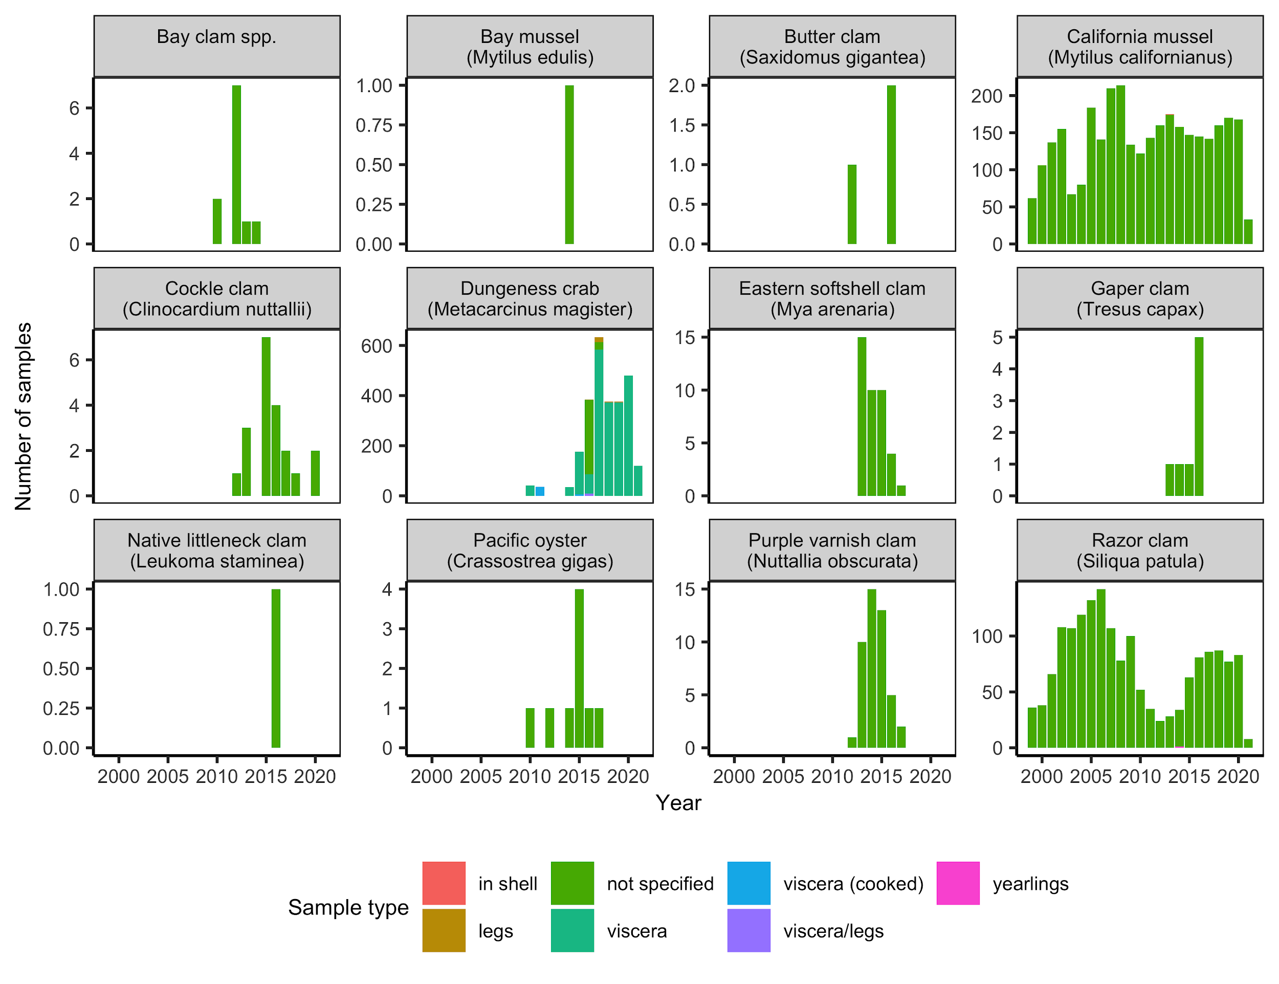

**Figure S3.** Number of ODA domoic acid contamination samples collected over time by species and sample type.

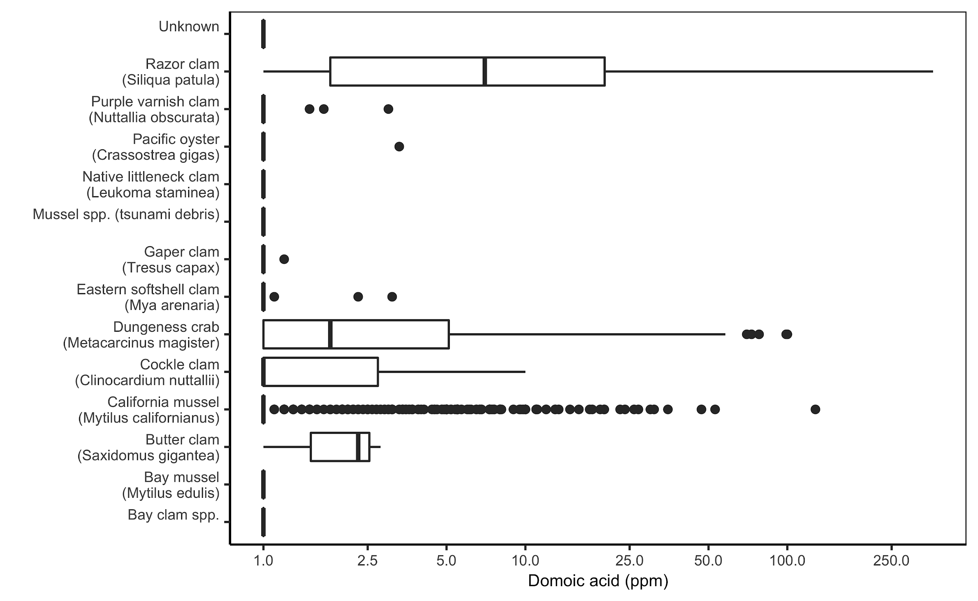**Figure S4.** Distribution of domoic acid contamination levels by species in the ODA samples.

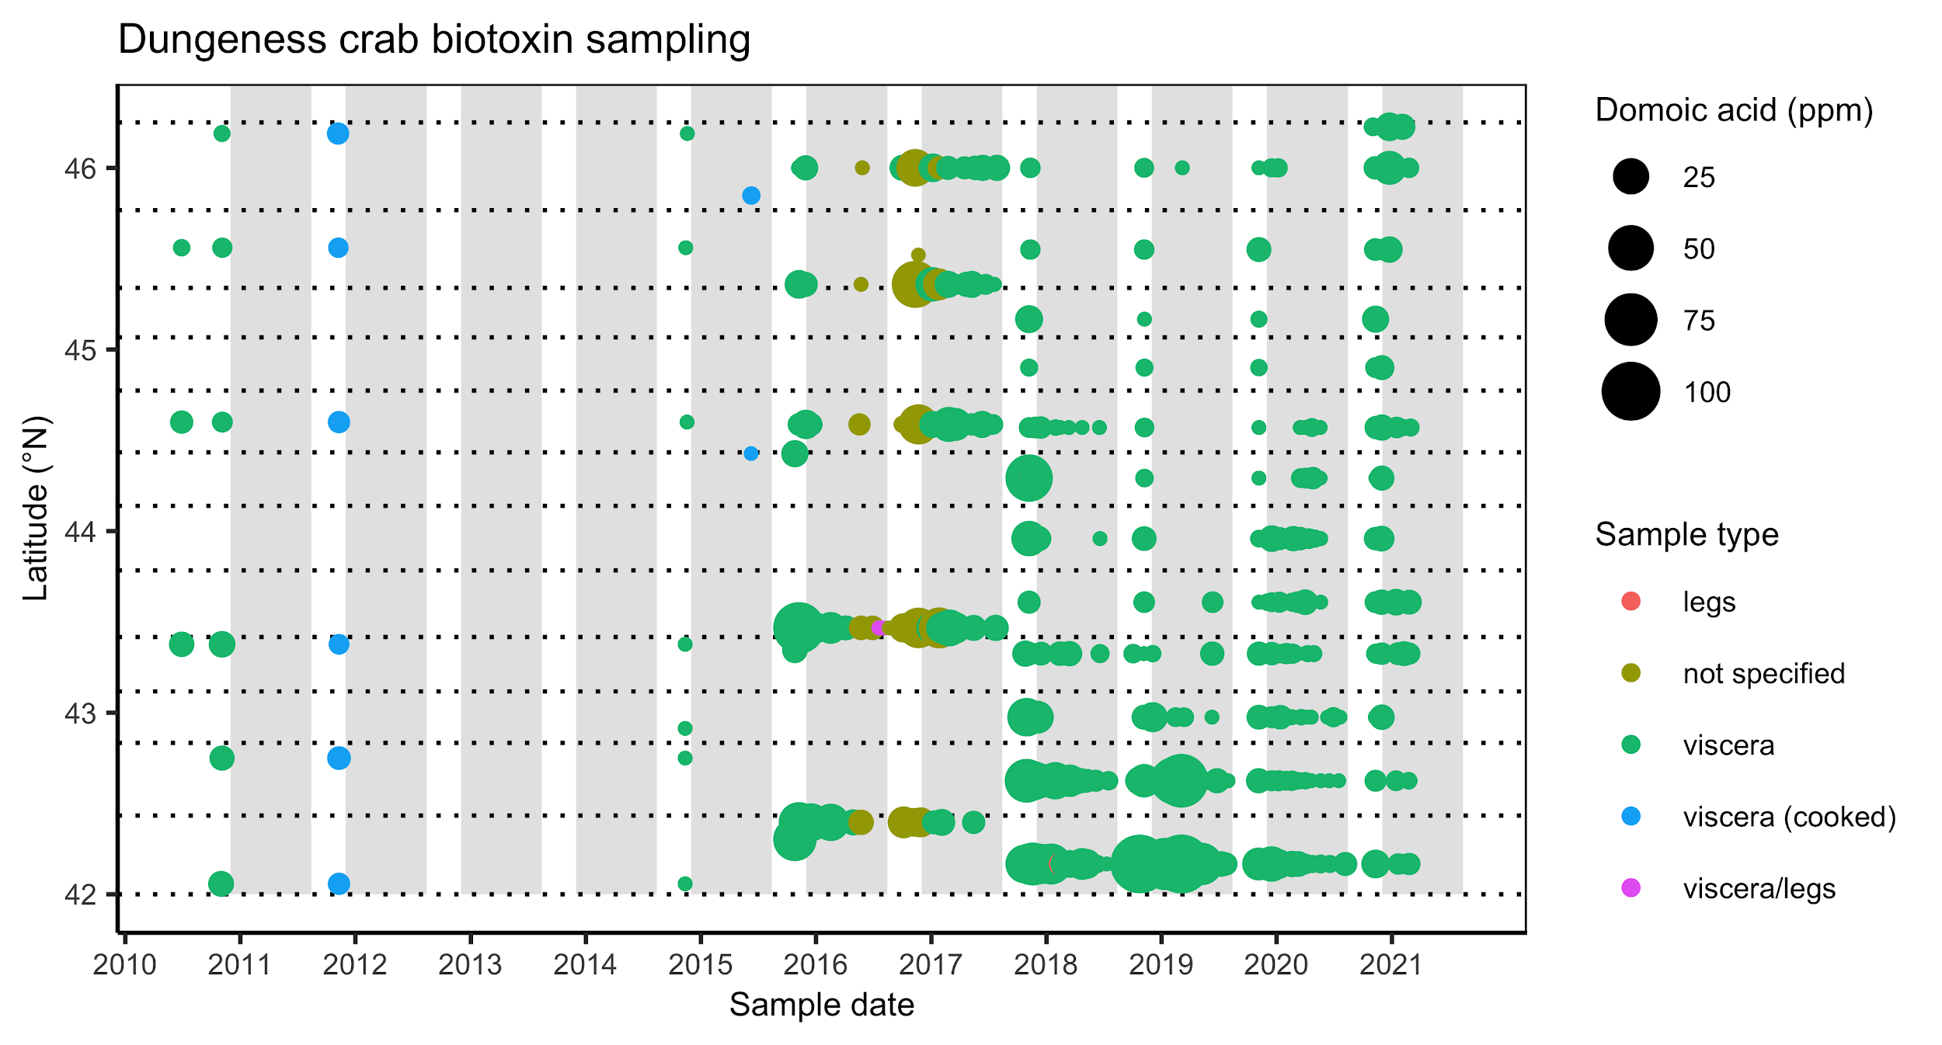**Figure S5.** Spatial-temporal coverage of ODA domoic acid contamination for Dungeness crab.

The grey rectangles indicate the commercial Dungeness crab fishing season (Dec 1 - Aug 14). The dotted lines indicate the biotoxin management zones established in 2017. Domoic acid samples are missing for the 2012-13 and 2013-14 seasons and are limited in the 2010-11, 2011-12, and 2014-15 seasons.

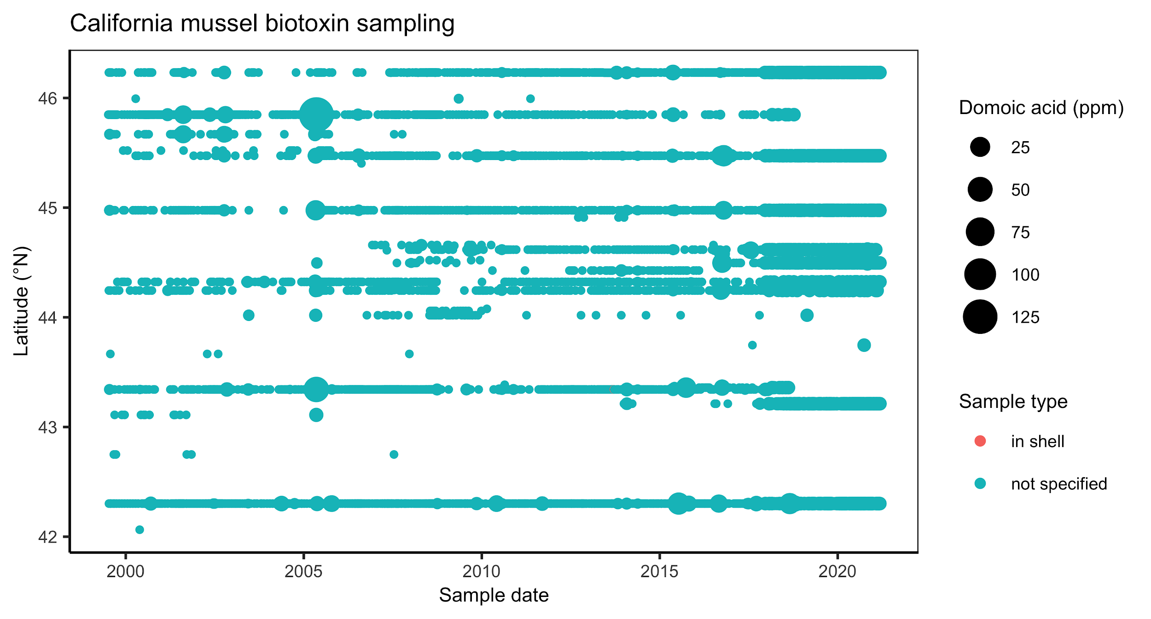**Figure S6.** Spatial-temporal coverage of ODA domoic acid contamination for California mussels.

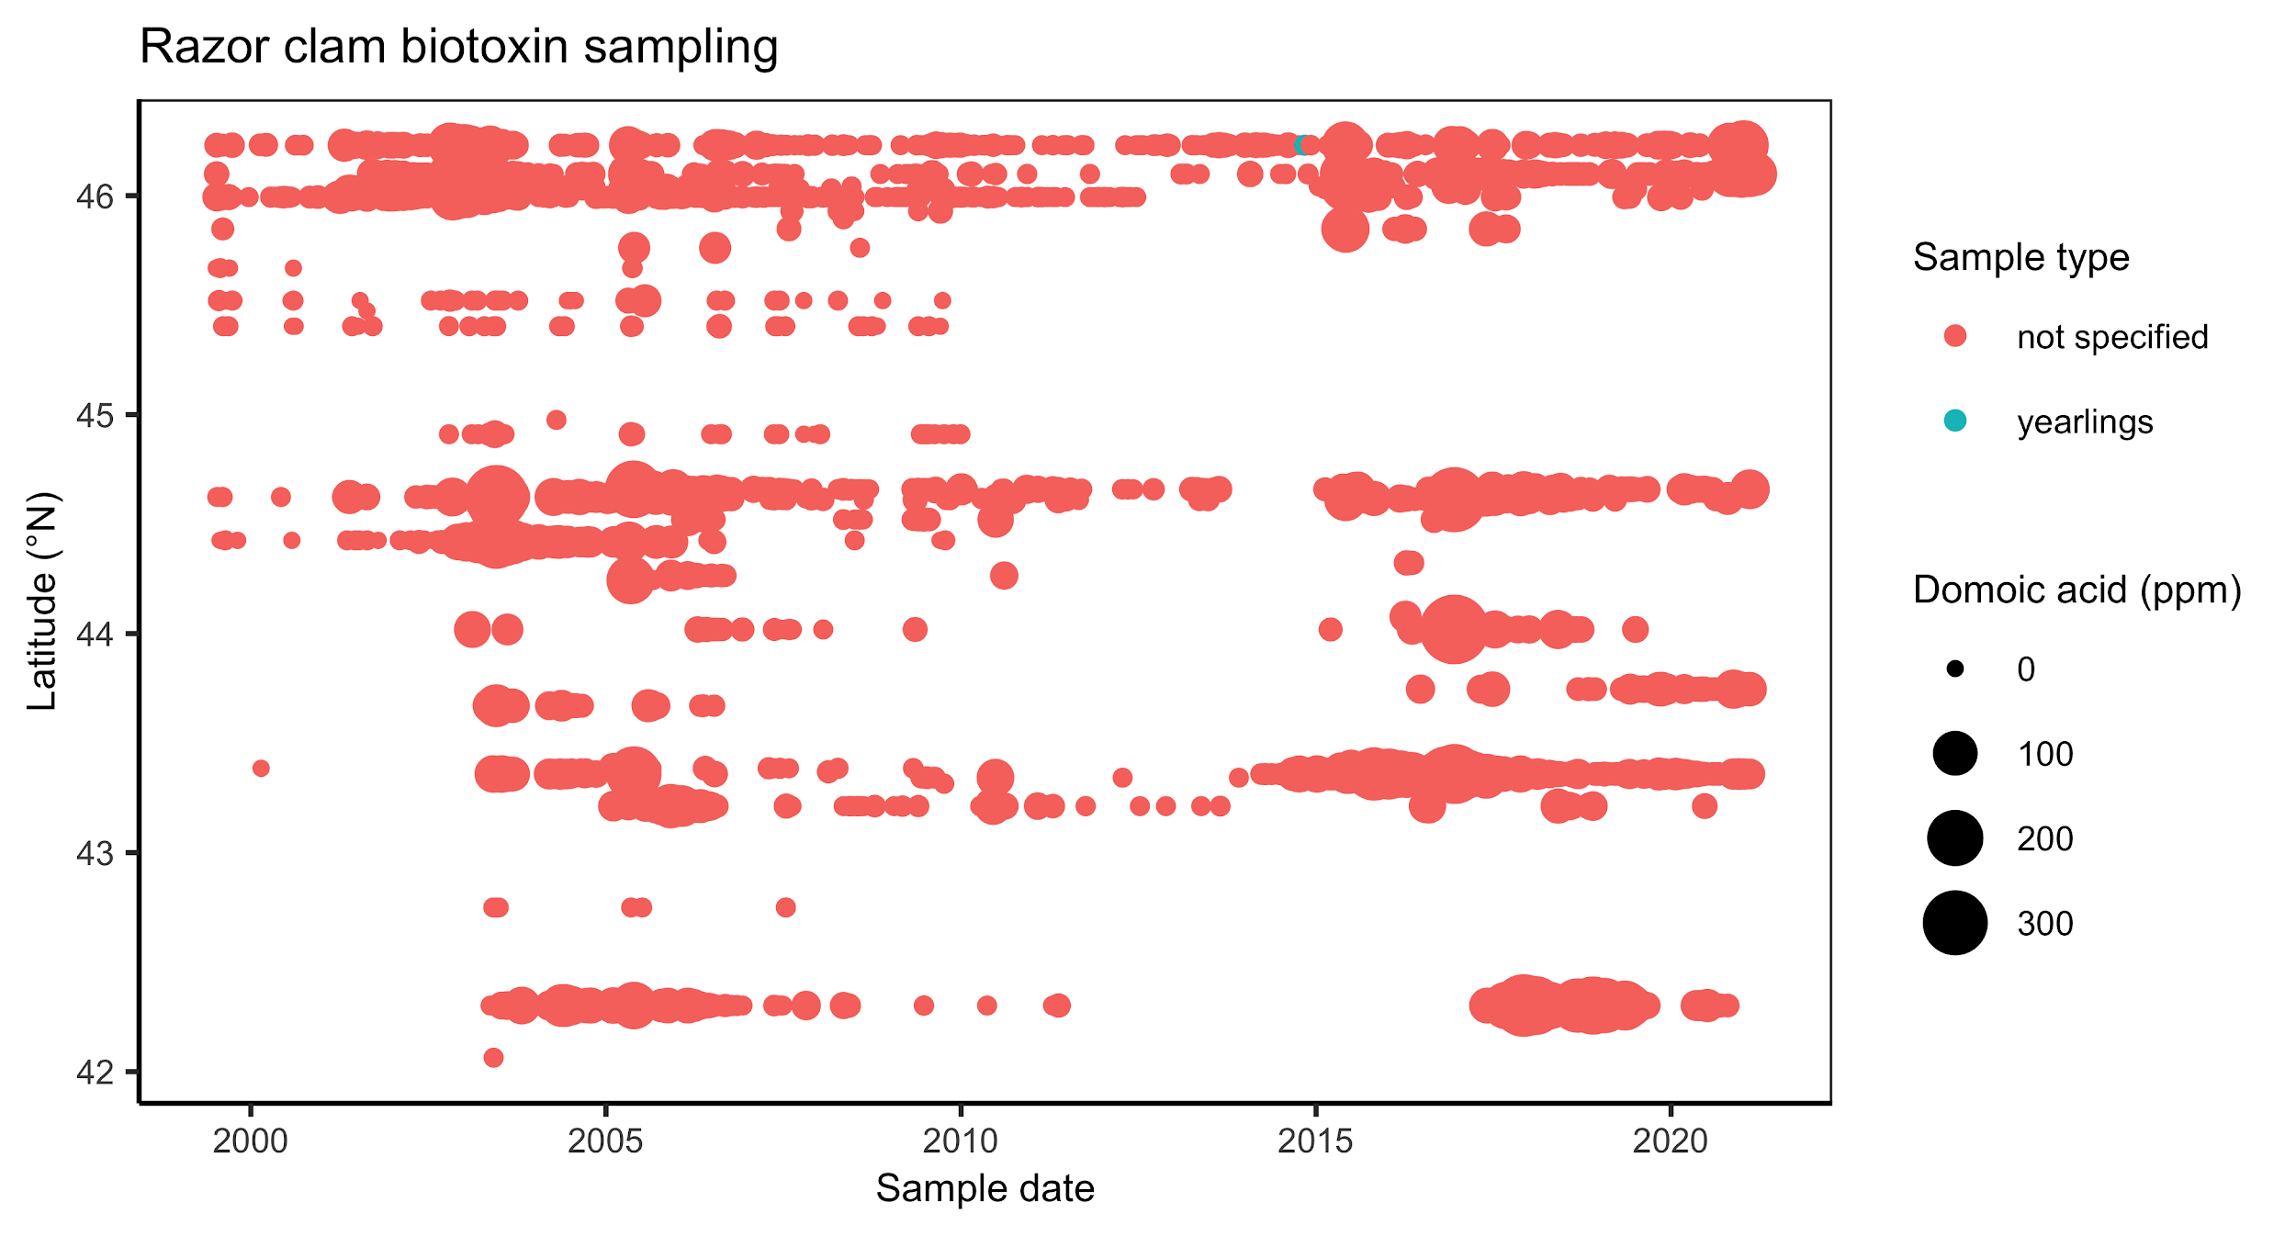**Figure S7.** Spatial-temporal coverage of ODA domoic acid contamination for razor clams.

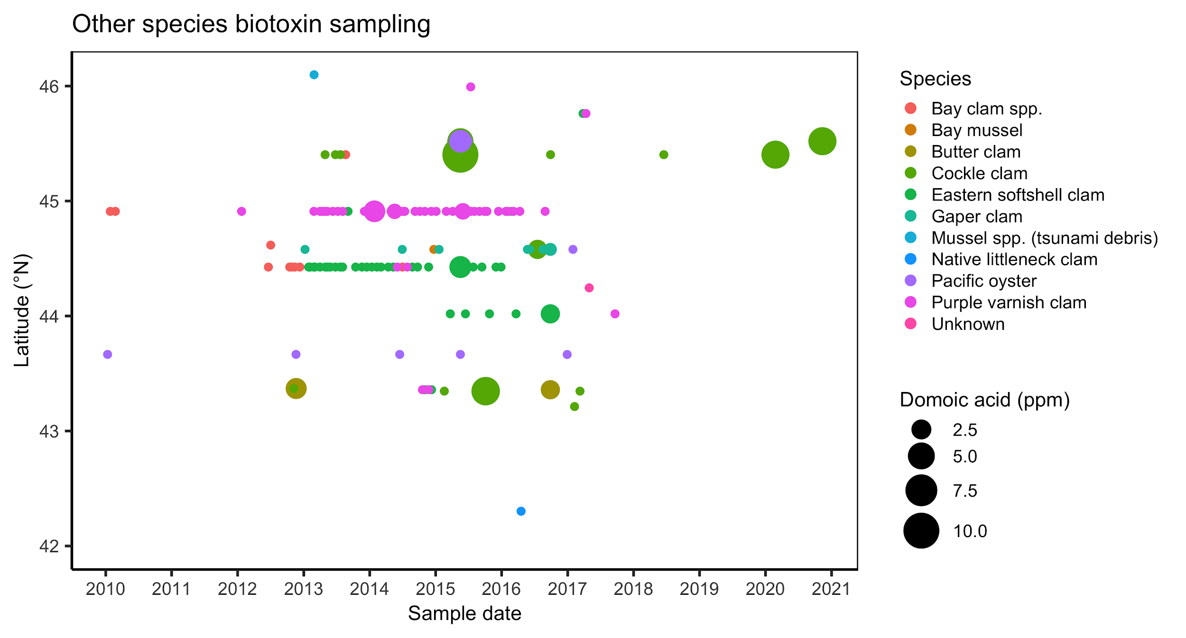

**Figure S8.** Spatial-temporal coverage of ODA domoic acid contamination for other species.