**Table 1.** Ports of landing and vessel counts for the seven California PacFIN communities included in this study. The number and proportion of commercial fishing vessels with any Dungeness crab landings at the given community is reported for the 2015 crab year (large / small vessels). “Total vessels” reports the mean annual number of fishing vessels with any commercial landings at the given community, with standard deviation, for crab years 2008-2017. Regional totals are calculated from raw vessel counts, not averaged community statistics.

|  |  |  |  |  |  |
| --- | --- | --- | --- | --- | --- |
| **Region** | **Community** | **Ports of Landing** | **Total, 2008-17** | **D. crab,**  **2015 (lg/sm)** | **Proportion**  **D. crab, 2015** |
| **North** | **Crescent City** | Crescent City  *Other Del Norte County* | 109 ± 16 | 68 (40/28) | 0.75 |
| **Eureka** | Eureka, Fields Landing, Trinidad  *Other Humboldt County* | 150 ± 24 | 77 (34/43) | 0.51 |
| **Fort Bragg** | Albion, Point Arena, Fort Bragg  *Other Mendocino County* | 237 ± 96 | 41 (22/19) | 0.12 |
| **Bodega Bay** | Bodega Bay, Bolinas, Point Reyes, Tomales Bay  *Other Sonoma/Marin County* | 208 ± 77 | 105 (56/49) | 0.44 |
| ***Total*** |  | ***753 ± 149*** | ***291 (152/139)*** | ***0.36*** |
| **Central** | **San Francisco** | Alameda, Berkeley, Oakland, Princeton / Half Moon Bay, Richmond, San Francisco  Sausalito  *Other San Francisco Bay/San Mateo County* | 388 ± 97 | 221 (121/100) | 0.49 |
| **Monterey Bay** | Santa Cruz, Monterey, Moss Landing  *Other Santa Cruz/Monterey County* | 286 ± 83 | 47 (15/32) | 0.14 |
| **Morro Bay** | Avila, Morro Bay  *Other San Luis Obispo County* | 187 ± 26 | 30 (17/13) | 0.14 |
| ***Total*** |  | ***567 ± 98.2*** | ***298 (153/145)*** | ***0.30*** |

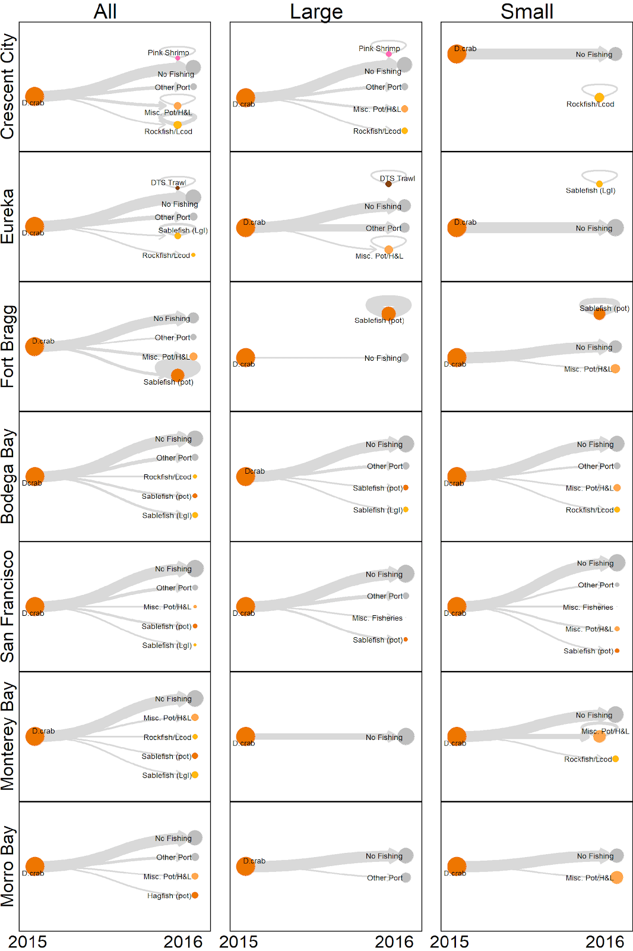  
**Figure 3.** Change in early season fishery participation by all (left), large (middle), and small (right) Dungeness crab vessels from the 2015 to the 2016 crab year. Edges show the flow of vessels out of the 2015 Dungeness crab fishery (left) into 2016 alternatives (right). Edge-weight is proportional to the number of Dungeness crab vessels which shifted participation from Dungeness crab in 2015 to the alternative fishery in 2016. Self-loops were included if Dungeness crab vessels participated in a fishery during both seasons. When multiple pot-based or hook and line-based fisheries had fewer than three vessels participating, we collapsed the fisheries into a single “Misc. Pot/H&L” node. “Misc. Fisheries” is a similar compilation of fisheries with fewer than three vessels participating, of any gear type. We added two non-fishery nodes to indicate whether a vessel stopped fishing altogether during the Dungeness crab closures, or whether the vessel stopped fishing at the given community but was recorded landing catch at another California port.

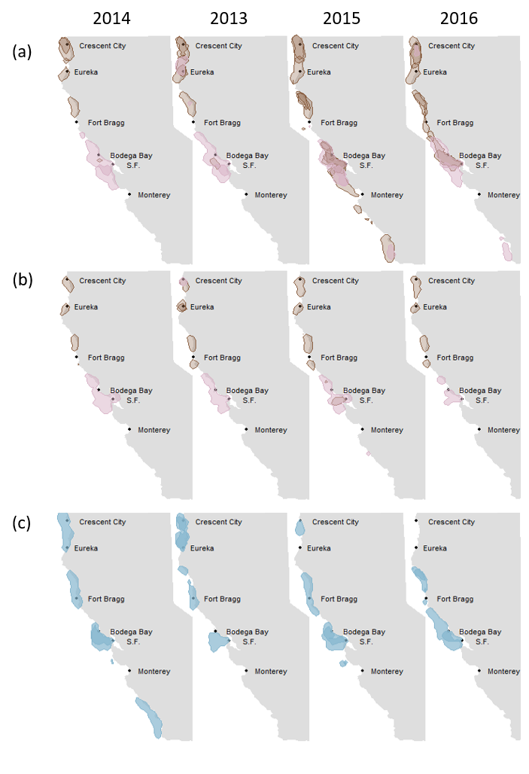

**Figure 3.** Annual fishing grounds of (a) large northern / central, (b) small northern / central, and (c) large coastal, vessels through time. In (a) and (b), fishing ground area is colored according to the management district in which the vessel group fished in 2014 (yellow = northern district; pink = central district).