**2. Methods**

*2.1 Overview*

Is there an influence?

1. Primary prey
2. All prey summed (infinite prey switching)
3. All prey weighted (inflexible prey switching)

What drives influence?

1. Taxonomy
2. Dominance of primary prey
3. Number of prey
4. Spatial overlap in predator/prey stocks

*2.2 Stock selection*

*2.3 Population model*

We modeled the influence of prey abundance on predator productivity using a Pella-Tomlinson surplus production model with normally distributed variation around the specified production function and multiplicative prey influence. Observed surplus production was calculated for each predator stock as the net change in total biomass in the absence of harvest:

$${SP}_{i,t}=B_{i,t+1}-B_{i,t}+C_{i,t}$$

where *SPi,t* is the surplus production for stock *i* over year *t*, *Bi,t* and *Bi,t+1* are the biomasses of stock *i* in years *t* and *t+1*, respectively, and *Ci,t*is the catch for stock *i* removed between years *t* and *t+1*. We used a Pella-Tomlinson surplus production model (Pella & Tomlinson 1969) because it contains a shape parameter (*p*) that allows it to replicate either the Fox (*p*→0) or Schaefer (*p*=1) surplus production models (Schaefer 1954; Fox 1970). We extended the Pella-Tomlinson model to include prey influence and assumed normal residual process variability:

$${SP}_{i,t}=\frac{r_{i}}{p}B_{i,t}\left(1-{\left(\frac{B_{i,t}}{K_{i}}\right)}^{p}\right)*\exp\left({Prey}_{i,t}*θ_{i}\right)+ ε_{i}$$

where *SPi,t* is the surplus production for stock *i* in year *t*, *Bi,t* is the biomass, *SSTi,t* is the prey abundance, *ri* is the intrinsic rate of growth, *Ki*is the carrying capacity, $θ_{i}$ is the influence of prey abundance on productivity, and $ε_{i}\sim N(0,σ_{P,i}^{2})$ is independent identically distributed normal residual process variability. We used Akaike Information Criterion (AIC; Akaike 1974) to compare models using shape parameters (*p*) that maximize productivity at 50% (*p*=1), 45% (*p*=0.55), 40% (*p*=0.2), and 37% (*p*=0.01) of carrying capacity and selected the model with the lowest AIC score as the “base” model. We evaluated these shape parameter values because 50% produces the symmetric Schaefer model, 40% is the meta-analytic mean (Thorson et al. 2012), and 37% is the asymptotic limit of this parameterization of the Pella-Tomlinson model.

$θ_{i}$ < 0 means increasing prey abundance reduces predator productivity at a given biomass and $θ_{i}$ > 0 means increasing prey abundance magnifies predator productivity at a given biomass.

To ease model fitting, we scaled biomass and production to each stock's maximum biomass and centered SST data around each stock’s mean SST. We also placed a likelihood penalty on carrying capacities greater than five times the observed maximum biomass to constrain unrealistic carrying capacities. We fit the model using maximum likelihood estimation in the *TMB* package (Kristensen et al. 2016; Template Model Builder) in R (R Core Team 2017).

*2.4 Data analysis*

**Results**

**Tables & Figures**

**Figure 1.** Primary prey influence

**Supp. Tables & Figures**

**Supp. Table 1.** Stock selection and sample size.

**Supp. Figure 1.** Prey time series

**Supp. Figure 2.** Predator time series w/ inset primary prey time series

**Supp. Figure 3.** Predator surplus production and fit

**Supp. Figure 4.** Predator diet composition

**Supp. Table 1.** Stock selection and sample size.

|  |  |  |  |
| --- | --- | --- | --- |
|  | **# of stocks** | |  |
| **Condition** | **Atlantic** | **Pacific** | **Total** |
| All predator stocks | 73 | 76 | 149 |
| ≥20 yr of data | 26 | 19 | 45 |
| ≥20 yr of data and ≥20% of diet from forage fish | 19 | 16 | 35 |

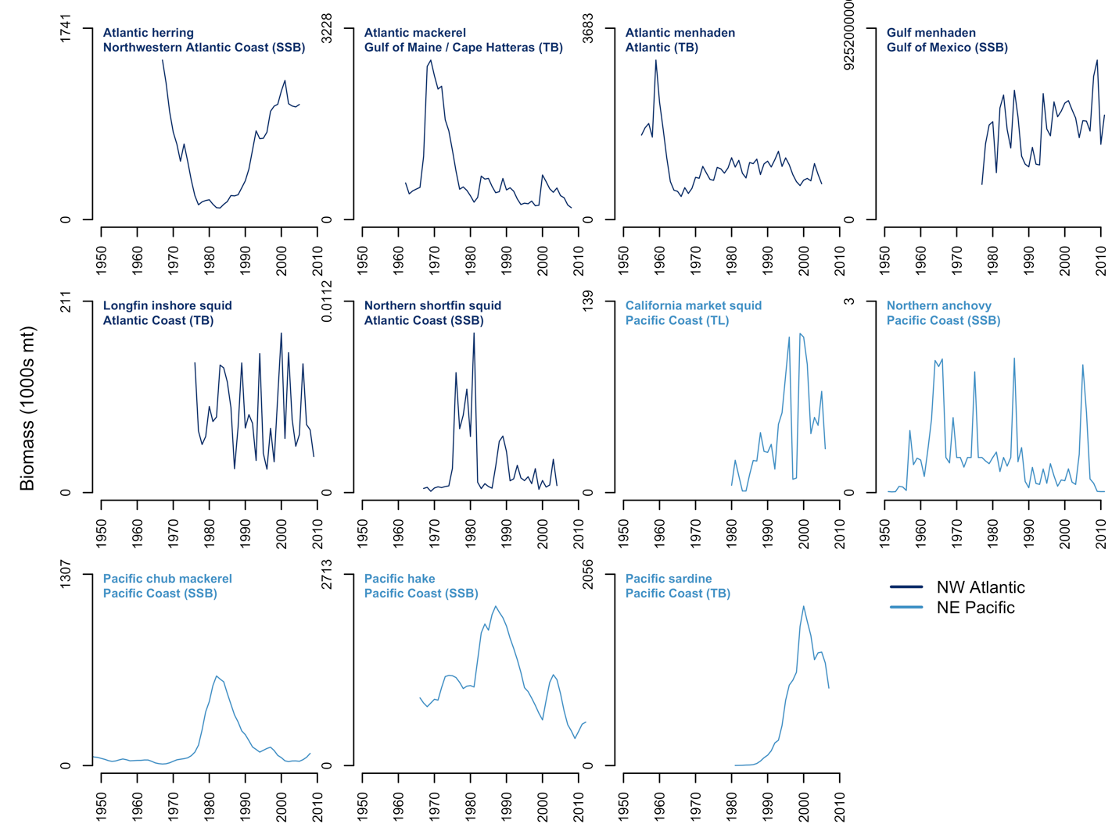

**Supp. Figure 1.** Hilborn et al. (2017) prey biomass time series. Biomass time series are in terms of total biomass (TB), spawning stock biomass (SSB), and total landings (TL).

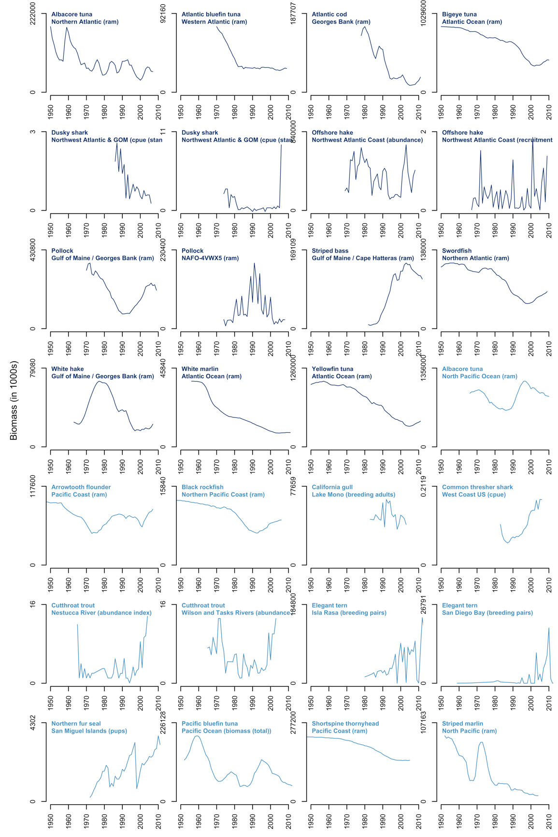

**Supp. Figure 2.** Hilborn et al. (2017) predator biomass time series.

**Supp. Figure 3.** Hilborn et al. (2017) predator surplus production.