Dear Dr. Davidson,

On behalf of the author team, I am pleased to submit our revised manuscript, “Global estimation of dietary micronutrient inadequacies”, for consideration as an Article in *The Lancet*.

We carefully reviewed the comments from you and the reviewers and are grateful for this thoughtful feedback. We address each comment individually below with the original comment shown in black text and the response shown in **bold** text. This feedback and the associated revisions have greatly improved the manuscript and we are excited by the opportunity to showcase our work in your journal.

Briefly, we made the following notable changes to the manuscript text:

1. Significantly rewrote the introduction to (a) explain the differences between the GBD (which estimates the burden of disease), GDD (which estimates nutrient intakes), and our study (which estimates prevalence of inadequate intake) and (b) clarify that this work represents the first global estimate of the prevalence of inadequate nutrient intakes;
2. Throughout, we better highlight the policy importance of our work, which can be used to target public health interventions;
3. Added a new figure (Figure 1) to conceptually illustrate our methodological workflow, clarify the data sources, and highlight the key assumptions;
4. Removed the 33 countries without GDD data from our analysis; these countries represent 0.7% of the global population so our analysis still encompasses the vast majority (99.3%) of people;
5. Recalculated both calcium and magnesium intake inadequacies using an improved algorithm to account for calcium and magnesium intakes from drinking water;
6. Added a new “Limitations” section to better highlight the limitations of our study.

Thank you for your consideration and please let us know if you have any questions.

On behalf of all authors,

Sincerely,

Christopher Golden

## 

## Editor comments

Dear Dr. Golden,

Thank you for submitting your manuscript to *The Lancet*.

Your submission has now been assessed by external advisers and discussed by the Editorial team. Comments were mixed. Several editors felt that the manuscript does not convincingly establish the merits of your approach over existing GBD/FAO data (in terms of accuracy, validation, etc) and that sources of potential bias such as measurement error and missing data need to be presented more clearly. The lack of data on supplementation and fortification was also raised as a major concern that requires further discussion within the context of the existing literature. The perceived advance over your previously published work in *The American Journal of Clinical Nutrition* (DOI: [10.1093/ajcn/nqac108](https://doi.org/10.1093/ajcn/nqac108)) was also unclear to some editors.

Given these concerns, at this time, we do not feel the manuscript is suitable for publication in *The Lancet.* However, we would like to hear your responses to these concerns and those of the reviewers (below) before making a final decision. Therefore, we would like to invite you to **REVISE** your paper in light of the editorial and reviewers' comments below. We will be seeking further review by external advisors.

Please be aware that an invitation to revise does not imply acceptance. Our target revision time is 10 working days.

Yours sincerely,

Dr Callam Davidson  
Senior Editor  
*The Lancet*

**We carefully reviewed the comments from you and the reviewers and are grateful for this thoughtful feedback. We address each comment individually below with the original comment shown in black text and the response shown in bold text. This feedback and the associated revisions have greatly improved the manuscript and we are excited by the opportunity to showcase our work in your journal.**

## 

## External advisor comments

The following comments were informed by discussion with external advisers:

Are you able to provide objective indicators to substantiate the superiority of your methods over previously established methods such as those used by GBD? Can your results be compared horizontally with the results of surveys from similar large-scale studies that use different methodology?

**We thank the reviewers for these comments as it is critical to distinguish what we are doing in comparison to the Global Burden of Disease (GBD) Study and other efforts. Our research is not in competition with other efforts so we have no intention to claim superiority of our methods. Rather, we are uniquely publishing global estimates of the prevalence of inadequate intakes for the first time. The GBD Study publishes estimates of the global burden of disease, not the prevalence of inadequate intakes. The Global Dietary Database (GDD) publishes modeled estimates of nutrient intakes, not the prevalence of inadequate intakes. A few studies have estimated the micronutrient inadequacy of the global food supply at the country level (e.g., Beal et al. 2017 and Wang et al. 2023), but none have estimated the prevalence of inadequate intakes.**

**We significantly rewrote the introduction to clarify these differences. This better highlights why our methods and results are complementary rather than competitive to these other studies.**

**There is one example (Wang et al. 2023) of a recent global analysis of nutrient availability, but this used a food-supply based methodology as opposed to our methodology, which uses modeled dietary intake. This is essentially the difference between availability of nutrients versus the actual consumption of nutrients. Using dietary intake is more appropriate than using food-supply based approaches for the purpose of understanding dietary nutrient gaps because the connection between food supply and intake is mediated by many factors, including food waste and variable sub-national distribution, both of which are avoided through our methodology. There are several surveys from small-scale studies that use different methodology, but they are impossible to compare with our work because they are either outdated or focus on fewer micronutrients.**

**We better highlight the key differences between approaches based on food supply and dietary intakes in our significantly revised introduction.**

* **Beal, T., Massiot, E., Arsenault, J.E., Smith, M.R. and Hijmans, R.J., 2017. Global trends in dietary micronutrient supplies and estimated prevalence of inadequate intakes. *PloS one*, *12*(4), p.e0175554.**
* **Wang, X., Dou, Z., Feng, S., Zhang, Y., Ma, L., Zou, C., Bai, Z., Lakshmanan, P., Shi, X., Liu, D. and Zhang, W., 2023. Global food nutrients analysis reveals alarming gaps and daunting challenges. *Nature Food*, *4*(11), pp.1007-1017.**

In Section 2.3, it is mentioned that vitamin D was excluded from the analysis because it can be obtained through sunlight. However, reference 24 does not support this statement, and vitamin D deficiency is prevalent worldwide.

**There is substantial evidence that sunlight is the primary determinant of vitamin D status globally (e.g., Lips et al. 2014). Based on empirical estimations (Holick et al. 2007), a few minutes of sunlight each day can make 1,000 IU vitamin D, which is four times as much as 100 g (4 oz) of oily fish. It is suggested that sunlight accounts for 90% of vitamin D and diet only 10%, although this will vary, primarily according to location (Kimlin 2008). Therefore, for most people, diet is a poor source of vitamin D. There are clearly exceptions to these statements, such as Nordic countries where dietary intake may play an important role in reaching vitamin D adequacy. However, given the primary importance of sunlight and the lack of issues in attaining vitamin D adequacy globally that are primarily related to diet, we have decided to exclude it from our analysis.**

**However, we replaced reference 24 (Allen et al. 2020) with a reference to Lips et al. (2014) to better justify this decision.**

* **Holick MF, Chen TC, Lu Z, Sauter E (2007) Vitamin D and skin physiology: a D-lightful story. J Bone Miner Res 22(Suppl 2):V28–V33**
* **Kimlin MG (2008) Geographic location and vitamin D synthesis. Mol Aspects Med 29:453–461**
* **Lips, P., van Schoor, N. M., & de Jongh, R. T. (2014). Diet, sun, and lifestyle as determinants of vitamin D status. Annals of the New York Academy of Sciences, 1317(1), 92-98.**

"We defined median intakes by age-sex group averaged across areas of residence and levels of education." This definition is ambiguous, and the specific method/related reference could not be located.

**As described earlier in this paragraph, the GDD defines subpopulations by “44 age-sex groups, three levels of education (i.e., low, medium, and high), and two areas of residence (i.e., rural and urban).” We rewrote the flagged sentence to clarify that we use the GDD-provided median intake for each age-sex group that averages across areas of residence and levels of education. The sentence now reads:**

**“We defined median intakes for each age-sex group using the GDD-provided average across areas of residence and levels of education.”**

Is it reasonable to directly substitute GDD indicators from neighboring countries for data from countries without GDD intake data?

**We removed the 33 countries without GDD intake estimates from our analysis. Our analysis still covers 99.3% of the global population as these 33 countries only have a combined total population of 53 million people (0.7% of the global population).**

Regarding the issue of calcium supply in water, Reference 8 uses the United States region and American adults as reference standards, without considering water-deficient areas. Moreover, the study population includes children and infants aged 0-20 - is their water intake assumed based on the water intake of American adults? Is it reasonable to use the United States as a substitute for the global context?

**This is a good point. We took two steps to improve these calculations.**

**First, we used age- and sex-specific estimates of daily water adequate intakes (AIs) from IOM (2004) to set age- and sex-specific estimates of water intakes. Previously, we assumed that all age-sex groups consumed 1.7 L of water per day.**

**Second, we updated our calcium concentration based on the average of the median sources of different types of drink water from around the world (WHO, 2009). As the reviewer correctly suggests, calcium concentration varies depending on the location and type of water source. This changed our estimate from 42 mg/L to 46 mg/L.**

**We used data from this same source to account for magnesium in water (16 mg/L) using the same approach.**

* **World Health Organization. (2009). Calcium and magnesium in drinking-water: public health significance. World Health Organization.**
* **IOM (2005) *Dietary reference intakes for water, potassium, sodium, chloride, and sulfate*. National Academies Press.**

In Figure S6, it is mentioned that "Males and females have identical average requirements for calcium, folate, iodine, riboflavin, selenium, vitamin B12, and vitamin E." Is it reasonable not to consider gender differences? Can average requirements based on U.S. and European standards represent all countries?

**We are using the best and latest available evidence on global nutrient requirements, based on harmonized nutrient reference intakes (Allen et al. 2020).**

**While men and women have identical average requirements for several nutrients, they have different energy requirements and consume different amounts of food on average. Therefore, our results show important gender differences (but note that for some nutrients, men have higher prevalence of inadequacy while for other nutrients women have higher prevalence). There are certainly limitations to using average requirements based on the U.S. and European standards. But the harmonized nutrient reference intakes improve upon using a single country source by choosing the most suitable reference intakes for each nutrient. Future research on region-specific, or even country-specific, nutrient reference intakes could allow for a more sophisticated approach in the future. But there are also limitations with using more nutrient requirements at the regional or country level. For example, it may introduce systematic bias for particular regions or countries, simply because they have specific nutrient reference values, whereas other regions may need specific nutrient reference values but not have them. Or they may use contrasting methods to determine nutrient reference values. These considerations are the basis for the harmonized nutrient reference values proposed by Allen et al. (2020) and used here.**

* **Allen LH, Carriquiry AL, Murphy SP. Perspective: Proposed Harmonized Nutrient Reference Values for Populations. Adv Nutr 2020; 11: 469–83.**

Dietary factors that inhibit or enhance zinc and iron absorption are considered in section 2.6. Reference 24 does not mention the method used to determine the specific scope of adjustment.

**We believe we have cited reference 24 (Allen et al. 2020) correctly in this section and in the associated figures. Allen et al. 2020 provide average requirements for iron and zinc that vary based on absorption (iron) and phytate (zinc). The black lines in Figures S6 and S7 are from Allen et al. 2020.**

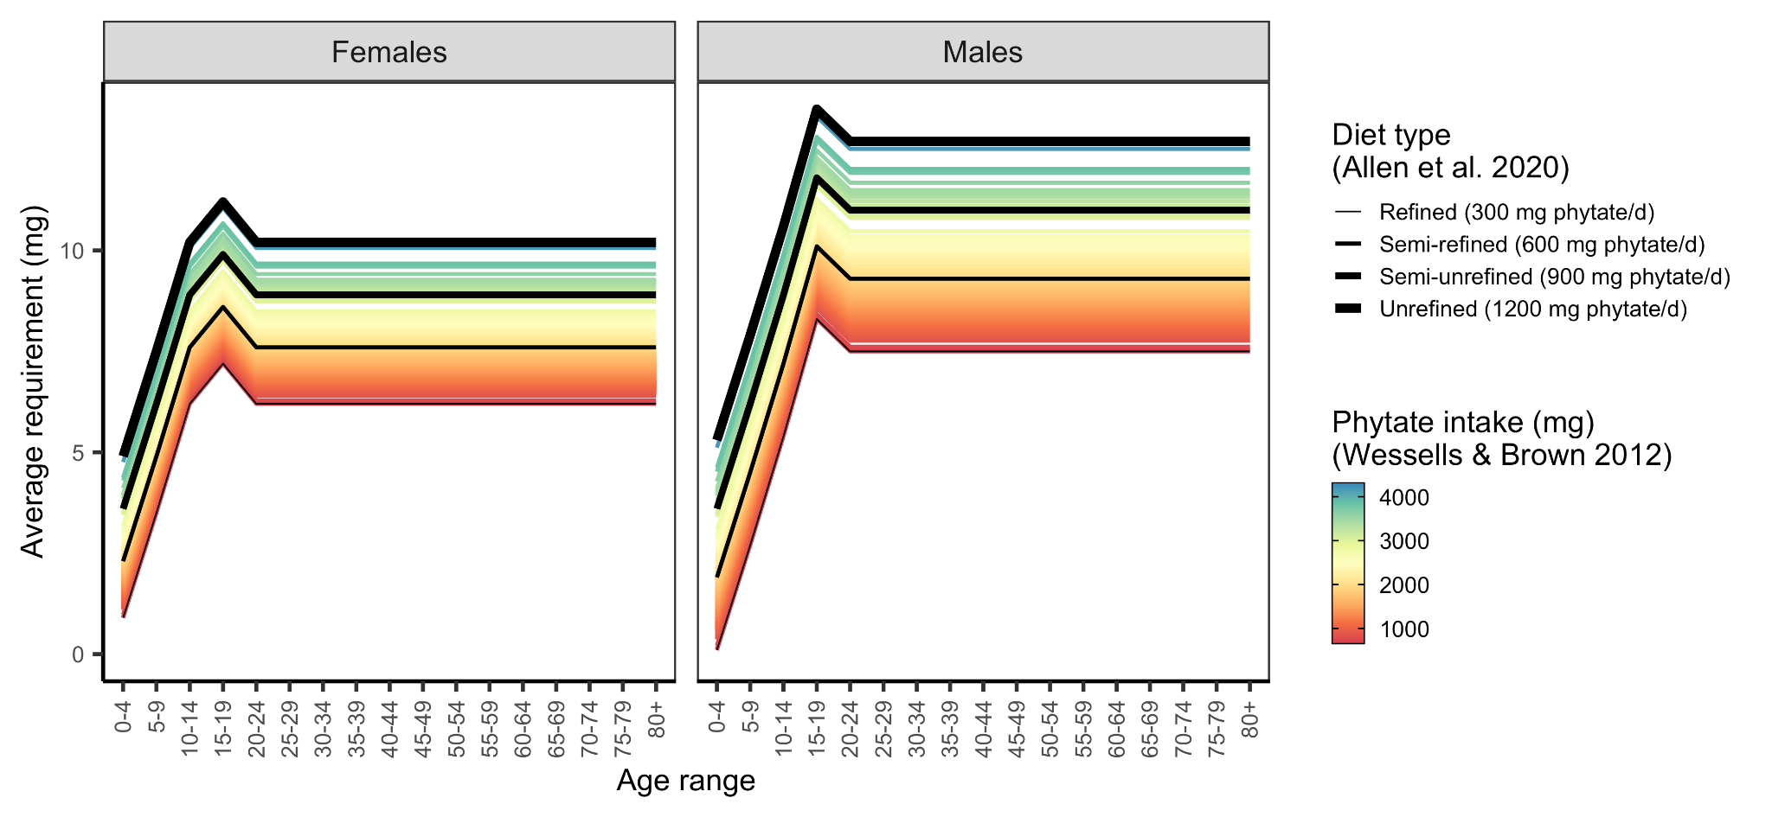

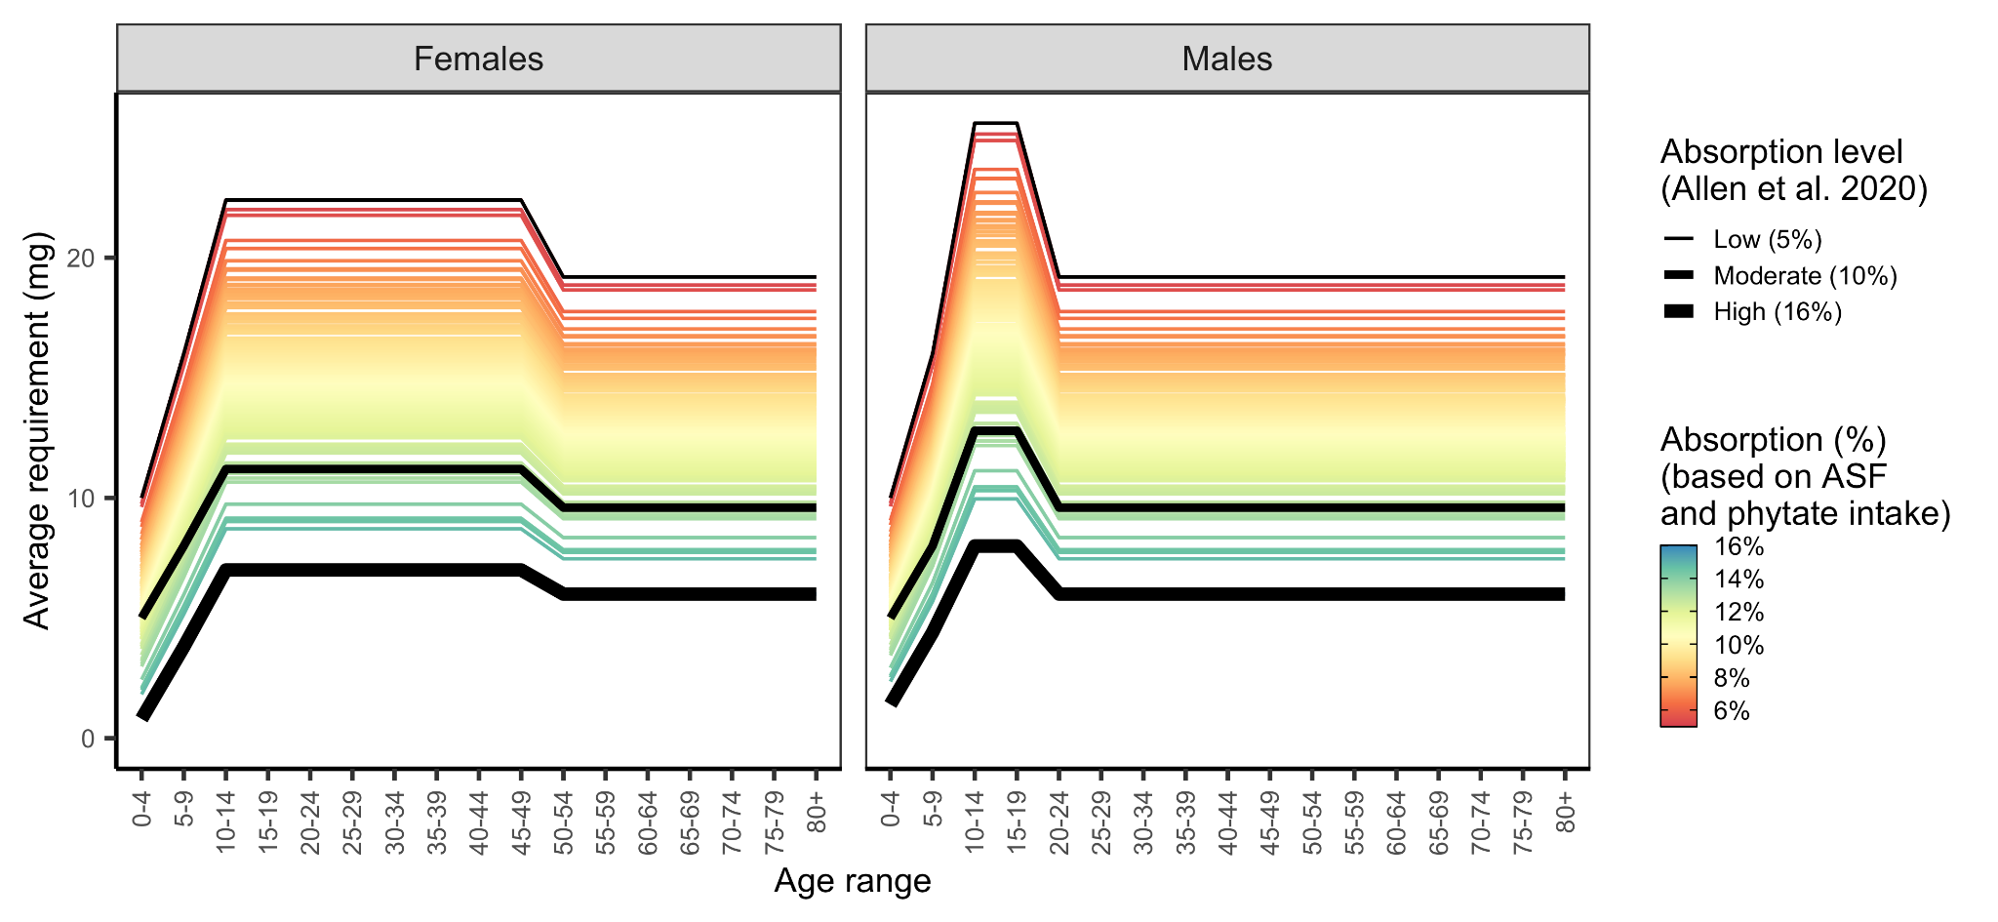

**As the reviewer correctly states, the procedure for interpolating country-specific ARs is a novel contribution of this paper, and not a procedure developed by Allen et al. 2020. However, we do not make a claim to the contrary. For example, see the following two sentences where we describe our novel approach and where we provide no citations for Allen et al. 2020 but instead describe our novel method:**

**“We derived country-specific ARs for zinc based on average country-level estimates of phytate intake from Wessels and Brown**[**36**](https://www.zotero.org/google-docs/?lhlTWv) **(Figure S8) by linearly interpolating between the lowest AR and lowest phytate intake and the highest AR and highest phytate intake within each age-sex group (Figure S6). We derived country-specific ARs for iron accounting for the joint impacts of phytate and non-dairy ASF on iron absorption using a procedure similar to Beal et al.**[**10**](https://www.zotero.org/google-docs/?mFAXzG)**”**

Phytate and dairy products also affect calcium absorption, why are they not included in the study?

**We agree that dietary factors such as phytate, oxalate, and dairy intake affect calcium absorption. However, we know of no published algorithm for quantitatively calculating fractional absorption using dietary factors that are globally available at subnational resolution. For example, Weaver et al. (2024) provide an algorithm for estimating calcium absorption, but the algorithm critically depends on estimates of oxalate intake (algorithm with oxalate explained 45% of variation in calcium absorption while the model without oxalate explained only 1% of variation), which is not included in the GDD or any other global database that we know of. We added the following sentence to the methods to acknowledge this limitation:**

**“While calcium absorption is also impacted by dietary factors such as phytate, oxalate, and dairy intake, we were unable to account for these impacts given a lack of data on global oxalate intakes, which are the dominant factors impacting calcium absorption.**[**35**](https://www.zotero.org/google-docs/?sRArxa)**”**

**Weaver, C.M., Wastney, M., Fletcher, A. and Lividini, K., 2024. An Algorithm to Assess Calcium Bioavailability from Foods. *The Journal of Nutrition*, *154*(3), pp.921-927.**

There are multiple databases assessing micronutrients globally, is it necessary to increase horizontal comparisons to assess the accuracy of the data? GDD data sources show the existence of biomarker-related data, while the discussion indicates that this study is not based on biomarker data. Should consideration be given to incorporating biomarker data to make the data more accurate?

**We thank the reviewers for this comment. Understanding the relationship between inadequate intakes and nutrient biomarkers is a critical area of research. Empirically connecting information on dietary intake to nutritional deficiencies requires nutritional biomarker data, microbiome data, and information on intestinal parasites, infectious disease, and inflammation biomarkers to properly assess these relationships. However, it is not the purpose of this manuscript and would rely on developing assumptions of many of the aforementioned factors to yield a nuanced relationship between inadequate intake and biological deficiency. If you view the results from our paper on inadequate intakes from Passarelli et al. (2022) and the research from Stevens et al. (2022) on biological deficiencies in pre-school aged children and reproductive-aged women, the estimates of those at nutritional risk vary substantially. Therefore, we focus our manuscript on inadequate intakes, which we can confidently estimate, rather than on nutritional biomarkers. We have significantly revised the introduction of the paper to clarify the differences among these efforts so there is improved clarity.**

* **Passarelli, S., Free, C. M., Allen, L. H., Batis, C., Beal, T., Biltoft-Jensen, A. P., ... & Golden, C. D. (2022). Estimating national and subnational nutrient intake distributions of global diets. The American journal of clinical nutrition, 116(2), 551-560.**
* **Stevens, G. A., Beal, T., Mbuya, M. N., Luo, H., Neufeld, L. M., Addo, O. Y., ... & Young, M. F. (2022). Micronutrient deficiencies among preschool-aged children and women of reproductive age worldwide: a pooled analysis of individual-level data from population-representative surveys. The Lancet Global Health, 10(11), e1590-e1599.**

## Editorial checklist

* The following points list items that **must be included in a point-by-point response before being considered further.** Addressing them at this stage reduces the risk of errors and delays later.
* Please read the requirements below carefully and consult me or <https://www.thelancet.com/preparing-your-manuscript>, for further details or clarification if needed.
* Please note that not every point below will be relevant to your manuscript.

**Authorship and reporting guidelines:**

1. Please check that all author name spellings and affiliations are correct.

**We confirm that all author name spellings and affiliations are correct.**

1. Please indicate any authors who are full professors.

**None of the authors are full professors**

1. Please list the highest degree for each author (one degree only, please).

**All of the authors have a PhD as their highest degree.**

1. Please follow the appropriate EQUATOR network reporting guidelines and include the corresponding checklist(s). These include: CONSORT reporting guidelines for randomised trials ([http://www.consort-statement.org](http://www.consort-statement.org/)), STROBE for observational studies, PRISMA for systematic reviews, STARD for diagnostic studies, CHEERS for economic evaluations and RECORD for routinely collected health data. *Lancet* specific guidelines for reporting RCT and systematic reviews and meta analyses are available here:  
   <http://www.thelancet.com/pb/assets/raw/Lancet/authors/Rctguidelines.pdf><https://thelancet.com/pb/assets/raw/Lancet/authors/metaguidelines.pdf>

**None of these reporting guidelines apply to our study.**

1. *The Lancet* endorses the SAGER guidelines for reporting of sex and gender information in study design, data analyses, results and interpretation of findings: <https://www.equator-network.org/reporting-guidelines/sager-guidelines/>. For all study types, we encourage correct use of the terms sex (when reporting biological factors) and gender (when reporting identity, psychosocial, or cultural factors). Where possible, please report the sex and/or gender of study participants, and describe the methods used to determine sex and gender. Separate reporting of data by demographic variables, such as age and sex, facilitates pooling of data for subgroups across studies and should be routine, unless inappropriate. Please also discuss the influence or association of variables, such as sex and/or gender, on your findings, where appropriate, and the limitations of the data.

**We confirm that we consistently and correctly use the term “sex” throughout our paper because the data used in the paper – dietary recall surveys, human population size estimates, and average nutrient intake requirements – are based on biological sex and not on gender identity. As a result, the paper only includes the term “sex” and does not include the term “gender”. We also confirm that we report and discuss our results by age and sex as this is the central purpose of our paper: we estimate global micronutrient intake inadequacies among age and sex groups.**

**Title/summary:**

1. Please ensure that the title of the paper is non-declamatory (i.e, it describes the aim of the study rather than the findings) and that it includes a description of the study type (e.g. a randomised controlled trial).

**We confirm that the title of the paper, “Global estimation of dietary micronutrient inadequacies”, is non-declamatory.**

1. Please limit the summary to pre-defined primary endpoints and safety endpoints.

**Our study does not employ clinical trials; thus, this is not relevant to our study.**

1. For RCTs, please state the trial registration number.

**Our study does not use randomized control trials (RCTs).**

**Methods:**

1. At the end of the methods section please state the role of the funder in: data collection, analysis, interpretation, writing of the manuscript and the decision to submit.

**We added the following sentence to the end of the Methods “Overview” section (Section 2.1): “No funder played any role in this research.”**

1. Please explain any deviations from the protocol.

**No protocol was necessary so no deviations occurred.**

1. Please ensure that all outcomes specified in the protocol (including all secondary outcomes) are reported in the manuscript. If there are any secondary endpoints that cannot be included please mention these explicitly and explain why and where they will be made available.

**Our study did not include secondary outcomes or endpoints.**

1. If any exploratory outcomes are reported that were not pre-specified, please make it clear that these analyses were post-hoc.

**Our study did not include exploratory outcomes.**

1. Please use rINNs for drug names. For genes and proteins, authors can use their preferred terminology so long as it is in current use by the community, but should provide the preferred name from Uniprot (<http://www.uniprot.org/uniprot/>) for proteins and HUGO ([http://www.genenames.org](http://www.genenames.org/)) for genes at first use to assist non-specialists.

**Our study does not include drug names.**

1. For drug studies, please ensure that details of doses, route of delivery, and schedule are included.

**Our study was not a drug study.**

**Results:**

1. For the main outcome measures, please include a result for each group, plus a point estimate (eg, RR, HR) with a measure of precision (e.g, 95% CI) for the absolute difference between groups, in both the Summary and the main Results section of the paper.

**Our study does not include estimates of uncertainty; thus, this does not apply.**

1. p-values should be given to two significant figures, but no longer than 4 decimal places (e.g. p<0.0001).

**Our study does not include p-values.**

1. Please provide absolute numbers to accompany all percentages. Percentages should be rounded to whole numbers unless the study population is very large (>1000 individuals).

**We added the following underlined text to our results paragraph to provide the absolute numbers associated with the only percentages presented in the results:**

**“Inadequate intake estimates were generally high (Figure 2) and especially common for iodine (5.1 billion people; 68% of the population), vitamin E (5.0 billion people; 67% of the population), calcium (5.0 billion people; 66% of the population), and iron (4.9 billion people; 65% of the population). Niacin exhibited the lowest level of inadequate intake (1.7 billion people; 22% of the population) followed by thiamin (2.2 billion people; 30% of the population) and magnesium (2.4 billion people; 31% of the population) (Figure 2).”**

**We confirm that both percentages and absolute numbers are provided in Figure 2 and Table S1, which are the main elements conveying these results.**

**We opted not to add the absolute numbers in the abstract in order to use the 300 word word count most efficiently.**

1. Please give 95% confidence intervals for hazard ratios/odds ratios.

**Our study does not use hazard ratios or odd ratios.**

1. For means, please provide standard deviation (or error, as appropriate).

**Our study does not include the provision of any means in the results.**

1. Please provide interquartile ranges for medians.

**Our study does not include the provision of any medians in the results.**

1. Please provide numbers at risk for Kaplan-Meier plots and ensure that plots include a measure of effect (e.g, log-rank p); estimates should be reported with 95% CIs.

**Our study does not include Kaplan-Meier plots.**

**Discussion:**

1. Please ensure that the Discussion contains a section on limitations of the study.

**We added a discussion section on the limitations of the study called “5. Limitations”. This section incorporated the existing paragraph on study limitations and new text resulting from the valuable reviewer feedback.**

1. Please provide the text, tables, and figures in an editable format (eg, EPS files, PowerPoint files, depending on software used to produce them. If figures are composed of photographs or other images, high resolution files (300dpi or greater) should be provided. More information can be found here: <https://www.thelancet.com/for-authors/forms?section=artwork>

**We have uploaded the figures as editable PDF images.**

1. References should be in Vancouver style. For references with six authors or fewer, all authors should be listed. For those with seven or more authors, only the first three authors and 'et al' should be listed. Please ensure that reference numbering throughout the manuscript is not inserted with electronic referencing software, such as Endnote, as this is incompatible with our production system (if used, please convert to normal text before resubmission). If the references "move" from the body text into tables or figures, please maintain the sequence of citation. Please ensure tables and figures are cited correctly in the body text to prevent the need for renumbering of references should the table and figure citations subsequently move. All web references should have the exact date they were last accessed. With your revised submission please enclose copies of any papers cited as being 'in-press', along with a copy of the acceptance letter from the journal. References that are "submitted" should be removed and citations in the text replaced with "(unpublished data; authors)".

**We confirm that the references are in Vancouver style.**

1. If accepted, only 5-6 non-text items (figures, tables, or panels) can be accommodated in the main paper; additional material can be provided in a web appendix. Please indicate which items can go in a web appendix.

**We confirm that our paper only includes 4 main text figures.**

1. Please provide a research in context panel with 3 parts: Evidence before this study (which includes a description of how you searched for evidence and how you assessed the quality of that evidence); Added value of the study; and Implications of all the available evidence.

**We wrote the following “research in context” panel:**

1. **Evidence before this study: Several recent analyses have assessed global micronutrient deficiencies and global inadequate nutrient supply, but there remain large gaps for many micronutrients and population groups. Due to limited availability of dietary intake data and a lack of accurate nutrient distribution data, there have been no global estimates of inadequate micronutrient intakes.**
2. **Added value of the study: This analysis provides the first global estimates to date of inadequate global micronutrient intakes using dietary intake estimates, including for specific age and sex groups and incorporating population-specific distribution data.**
3. **Implications of all the available evidence: In combination with existing data on micronutrient deficiencies and supplies, estimates of inadequate global micronutrient intakes can help public health researchers and practitioners identify populations in need of dietary intervention for a wide range of micronutrients.**
4. At the end of the manuscript, please provide a Contributors statement that summarises the contribution of each author to the work. *The Lancet’s* journals require that more than one author has directly accessed and verified the underlying data in all research articles. For research articles that are the result of an academic and commercial partnership, at least one of the authors named as having accessed and verified data must be from the academic team. Please state which author(s) have accessed and verified the data, and which author(s) were responsible for the decision to submit the manuscript.

**We added the following “Contributors” statement to the end of the manuscript:**

**“SP, CMF, TB, and CDG conceived the analysis and contributed to the design of the methodology. SP and CMF performed the analysis and wrote the initial draft of the manuscript. All authors reviewed and edited the initial draft. CMF built the R Shiny web application. All of the authors accessed and verified the data and decided to submit the manuscript.”**

1. At the end of the manuscript please summarise the declaration of interests for each author.

**We added the following “Declaration of Interest” statement to the end of the manuscript:**

**“The authors have no interests to declare.”**

1. As corresponding author, please confirm that all authors have seen and approved of the final text.

**The corresponding author confirms that all authors have seen and approved of the final text.**

1. If your author line has more than 20 authors, we very strongly encourage the use of a study group name. Collaborators' names and affiliations may be listed at the end of the paper or in the appendix. Additionally, if you wish the names of collaborators within a study group to appear on PubMed, please upload with your revision a list of names of all study group members presented as a two-column table in Word. First and middle names or initials should be placed in the first column, and surnames in the second column. Names should be ordered as you wish them to appear on PubMed. The table will not be included in the paper itself - it's simply used to make sure that PubMed adds the names correctly.

**Our author line includes only six authors.**

1. Please note our guideline length for research articles is 3500 words and 30 references. For RCTs, the text can be expanded to 4500 words.

**As a result of our efforts to fully address the reviewer comments, we have a total of 41 references and 3732 words.**

1. All research articles must contain a data sharing statement, to be included at the end of the manuscript. For more information on these required statements see the Data sharing section of the Information for Authors (<https://thelancet.com/pb-assets/Lancet/authors/tl-info-for-authors.pdf>) and (<https://www.thelancet.com/journals/lancet/article/PIIS0140-6736(17)31282-5/fulltext>)

**We added the following “Data Sharing Statement” to the end of the manuscript:**

**“All data and code are available on GitHub here:** [**https://github.com/cfree14/global_intake_inadequacies**](https://github.com/cfree14/global_intake_inadequacies)**.”**

1. Please ensure that the funding source is stated in the Acknowledgement section.

**We confirm that we stated the funding sources in the acknowledgements:**

**“Simone Passarelli was supported by National Institutes of Health (NIH) Training Grant 2T32DK007703-26 in Academic Nutrition. Ty Beal was supported by contributions from the Dutch Ministry of Foreign Affairs.”**

**Reviewers' Comments:**Note that reviewer numbers are allocated by the system at invitation and not completion of reviews, so some numbers might be missing.

* In your point-by-point reply to the reviewers', please indicate the text changes which have been made (if any) and the line number on the tracked changes manuscript at which your change can be found. [Line numbers can be added to your word document using the 'page layout' tab. Please select continuous numbers.]
* Please do not use boxes for responses as this slows assessment.
* When interpreting editorial points made by reviewers, please remember that we will edit the final manuscript if accepted.

**We provide our point-by-point replies to the reviewers’ comments below.**

## 

## Reviewer #1

This review primarily focuses on the design, reporting, and analysis of THELANCET-D-24-00795. This study employs an ecological area-level design with the goal of mapping micronutrient inadequacy globally. The authors have undertaken a lot of work, and I have some specific comments below. My primary comments relate to the relevancy of the work, the suboptimal description of the methodology for the general reader, and what I believe is too much confidence in the accuracy of this method. Specific comments are below.

1. How to draw out these results to policy is unclear. As a high-level comment. After reading the paper, the point of the exercise is not clear to me as a non-field reader. I think the authors could sell their work better. Just a editorial suggestion, pending the below.

**The purpose of our paper is to use a dietary intake based approach, rather than a food supply based approach, to more accurately identify micronutrient shortfalls in global diets. We added the following sentence to the end of the introduction to clarify this purpose and its value to the wider community:**

**“Once these micronutrient shortfalls are identified in global diets, this information can enable implementation partners, public health practitioners, and policy makers to prioritize interventions that will address these gaps in dietary micronutrient intake.”**

2. The authors have quite a data and analysis pipeline, with major sources of bias at each stage, starting with data inputs from the Global Dietary Database. On one hand, that is ok; one can only deal with the data we have. But the authors, in my view, struggle to frame how the GDD is better than FAO, GBD, and others and why the initial input they use is most ideal. In short, the introduction is too long and could be much more precise. I suggest a comparative table of data sources with advantages and disadvantages and differences in sampling and statistical approaches, all summarized to make their case in a balanced way. Some approaches may not be great, but they may have their merits. I don't find some text currently in the text to be well supported or explicated. For example, I'm a Bayesian, but how the GDD is more powerful for using Bayesian methods is not well developed or clear.

**We took several steps to address this comment.**

**First, we added a new figure (Figure 1) to the manuscript to provide a conceptual illustration of our work pipeline. Please see our response to comment 5 for more information on this new very helpful schematic.**

**Second, we significantly rewrote the introduction to clarify the differences between the GBD (which estimates the burden of disease), GDD (which estimates nutrient intakes), and our study (which estimates prevalence of inadequate intake). This better highlights why our methods and results are complementary rather than competitive to these other studies. Please see our response to comment 1 from the external advisor for more detail.**

**For a little more information, the FAO provides estimates of nutrient supplies, but this is very different from intakes, since there are many steps from supply to consumption that influence intakes, such as household food waste. Other researchers (e.g., Wang et al. 2023) have used these data to estimate inadequacy of the food supply. From our understanding, the GBD does not publish estimates of inadequate intakes. The GDD has its limitations, but it provides the only published estimates of global nutrient intakes. Their methods are outlined in these papers:**

* **Karageorgou, D., Castor, L. L., de Quadros, V. P., de Sousa, R. F., Holmes, B. A., Ioannidou, S., ... & Micha, R. (2024). Harmonising dietary datasets for global surveillance: methods and findings from the Global Dietary Database. Public Health Nutrition, 27(1), e47.**
* **Miller, V., Singh, G. M., Onopa, J., Reedy, J., Shi, P., Zhang, J., ... & Mozaffarian, D. (2021). Global Dietary Database 2017: data availability and gaps on 54 major foods, beverages and nutrients among 5.6 million children and adults from 1220 surveys worldwide. BMJ global health, 6(2), e003585.**

**Thus, we used the GDD because it provides estimates of global nutrient intakes, not because it employs a Bayesian approach. We removed the mention of the Bayesian approach from the introduction so as not to distract from the real reason that we use the GDD, which is that it provides the only estimates of subnational nutrient intakes globally.**

* **Wang, X., Dou, Z., Feng, S., Zhang, Y., Ma, L., Zou, C., Bai, Z., Lakshmanan, P., Shi, X., Liu, D. and Zhang, W., 2023. Global food nutrients analysis reveals alarming gaps and daunting challenges. *Nature Food*, *4*(11), pp.1007-1017.**

3. Have any efforts been used to validate the GDD, or assess/correct for sources of measurement error? I think just understanding a bit more about the potential sources of data problems would be good and honest. No data is perfect, especially dietary collection data. And I imagine it varies by location, team, region etc etc.

**We share this concern, but unfortunately, dietary data is so sparse that there have been no independent efforts to validate the GDD data. One of our co-authors compared the food intake results of the GDD 2015 with unpublished estimates from the GBD and found large differences (Beal et al. 2021). Nevertheless, the GDD provides the best data available on estimated nutrient intakes. Their methods for the 2017 and 2018 data, which we used in the present study, have been published recently (Miller et al. 2021; Karageorgou et al. 2024).**

* **Beal, T., Herforth, A., Sundberg, S., Hess, S. Y., & Neufeld, L. M. (2021). Differences in modelled estimates of global dietary intake. The Lancet, 397(10286), 1708-1709.**
* **Karageorgou, D., Castor, L. L., de Quadros, V. P., de Sousa, R. F., Holmes, B. A., Ioannidou, S., ... & Micha, R. (2024). Harmonising dietary datasets for global surveillance: methods and findings from the Global Dietary Database. *Public Health Nutrition*, *27*(1), e47.**
* **Miller, V., Singh, G. M., Onopa, J., Reedy, J., Shi, P., Zhang, J., ... & Mozaffarian, D. (2021). Global Dietary Database 2017: data availability and gaps on 54 major foods, beverages and nutrients among 5.6 million children and adults from 1220 surveys worldwide. BMJ global health, 6(2), e003585.**

4. If not clear from my prior two comments, I find the limitations of this work at large to be poorly, if at all, engaged in the primary discussion. I will note that I saw Table S5, but it seemed hard to place outside of the other studies and without much formal discussion. And in the text, it is more about why other methods are not as good. Which I get, but that doesn't mean the author's approach doesn't have its own serious, major, and systematic issues as well. Both can be true. And to advance science in this area, this is necessary to be developed.

**We added a discussion section on the limitations of the study called “5. Limitations”. This section incorporated the existing paragraph on study limitations and new text resulting from the valuable reviewer feedback.**

**We also significantly rewrote the introduction to better (1) clarify the difference between our approach and the approach of other studies and (2) highlight why our methods and results are complementary rather than competitive to these other studies.**

5. I think the authors would help readers by having a box or illustration that walks through each step of their model, from GDD to output, stating all the assumptions. I personally find the methods text as well as the supplement to be very dense but also low on details to help me navigate. Figure S5 has a lot of promise, but really should be more central, and also more developed.

**This is a great suggestion. We added a new figure to the paper (Figure 1) to illustrate our methodological workflow. The figure and caption are pasted below for reference. The caption provides a useful description of the workflow.**

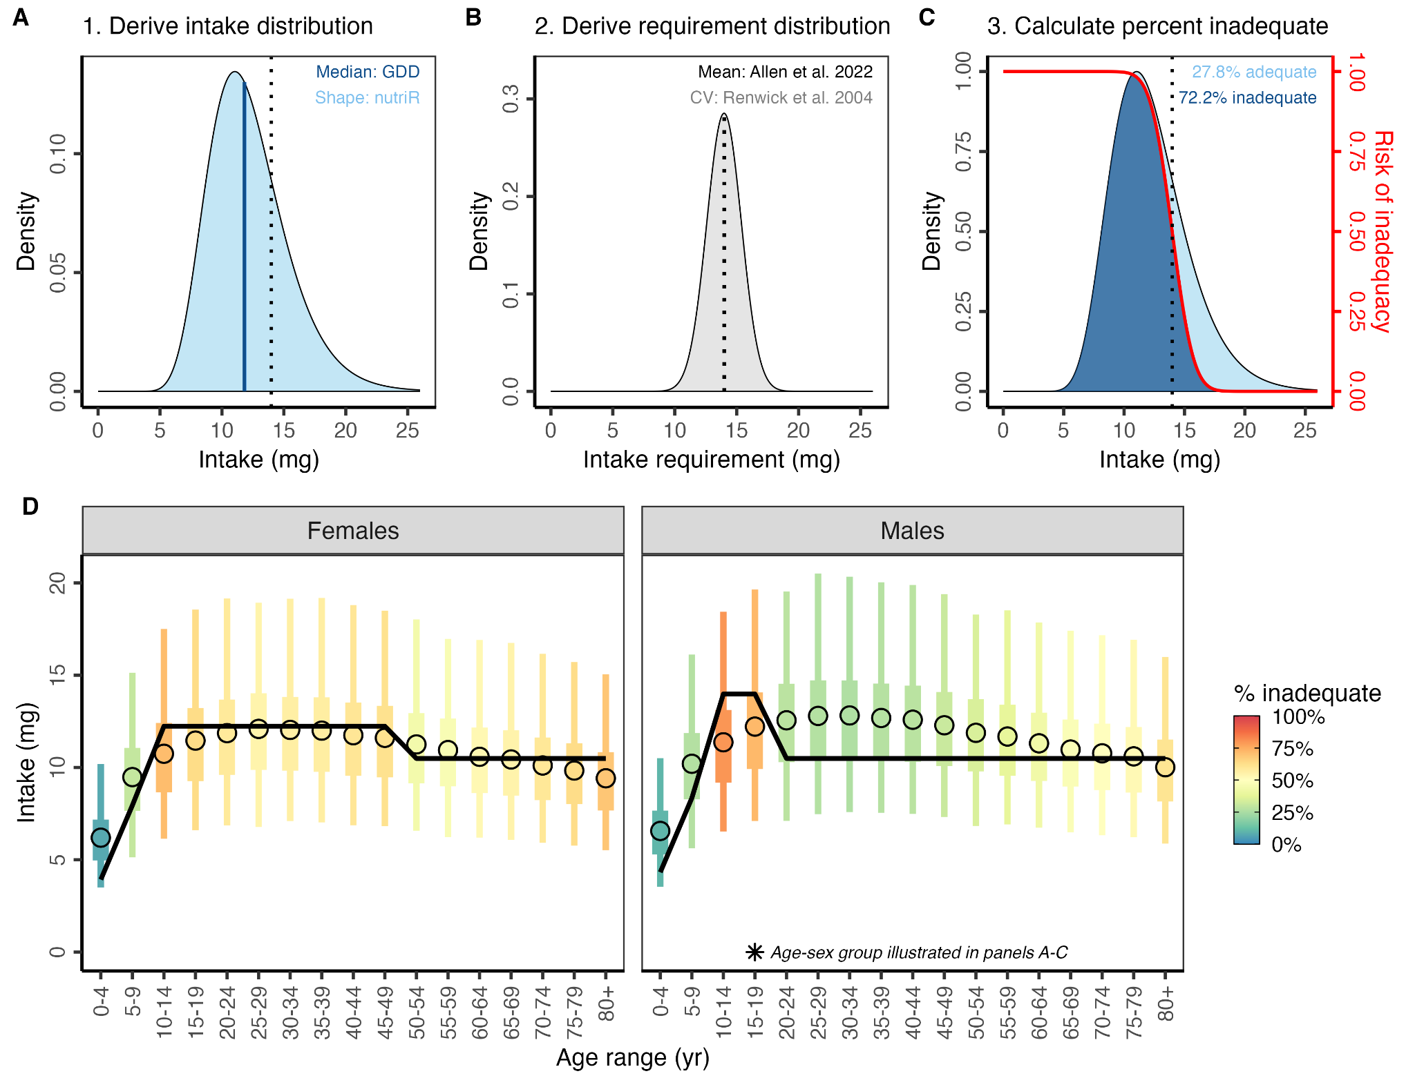

**Figure 1. A conceptual illustration of our methods for estimating the prevalence of inadequate micronutrient intakes using iron intakes in Kazakhstan as an example. The top row illustrates the procedure for males 15-19 years-old and the bottom row illustrates the results for all age-sex groups. First, we derive a skewed (gamma or log-normal) intake distribution, where the median (blue line) of distribution is drawn from the GDD and the shape of the distribution is drawn from the nutriR database (panel A). Second, we derive a normal requirement distribution, where the mean of the distribution is drawn from Allen et al.**[**24**](https://www.zotero.org/google-docs/?DuhXiM) **and the standard deviation of the distribution is derived assuming a coefficient of variation (CV) of 0.25 for vitamin B12 and 0.10 for all other nutrients based on Renwick et al.**[**32**](https://www.zotero.org/google-docs/?W3LNGj) **(panel B). Finally, we derive the percent inadequate intake by intersecting these two distributions using the probability approach (panel C). We calculate the number of people with inadequate intakes using population estimates from the World Bank.**[**26**](https://www.zotero.org/google-docs/?uWzmgV) **In panels A-C, the vertical dotted line indicates the average requirement. We repeat this process for every age-sex group as illustrated in panel D. In panel D, the color of the intake distribution lines indicates the prevalence of inadequate intakes. The point represents the median intake based on GDD. The thick line represents the inner 50% of the intake distribution and the thin line represents the inner 95% of the intake distribution. The black line shows the sex- and age-specific average requirements.**

6. I struggle with the figures. Figure 1 is too small for me to even evaluate, much less derive information from. Figure 2 is ok, but it's a lot at a regional level, so not sure how useful it is in policy. Same comment for Figure 3.

**We improved the legibility of Figure 1 (now Figure 2 due to the addition of the new figure described above) by: (1) making it 3 columns by 4 rows (rather than 4 columns by three rows) to better capitalize on page space; (2) eliminating as much white space between panels as possible.; (3) shortening the panel title to further aid in eliminating white space. We provide the figure below for reference.**

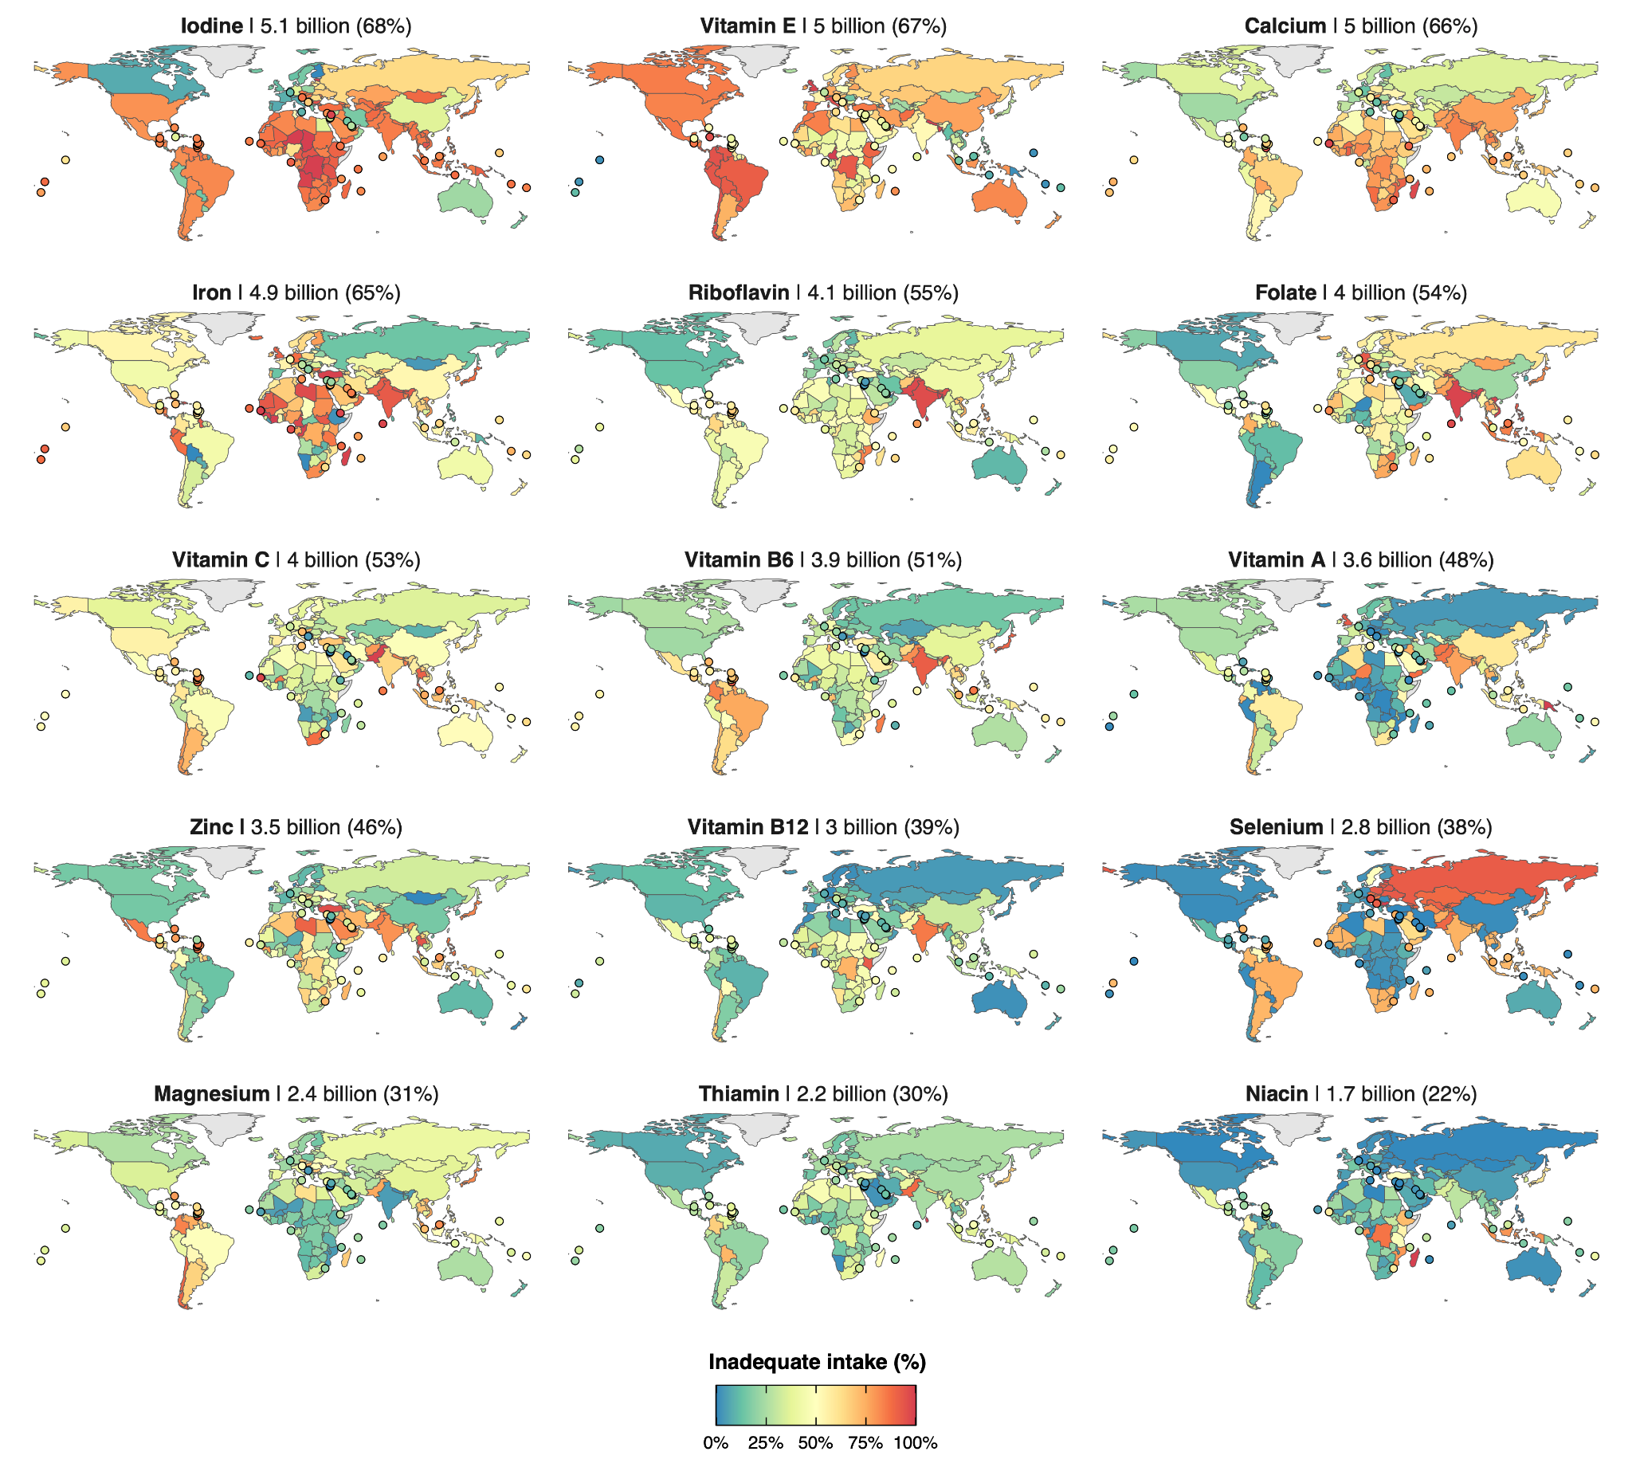

**We appreciate that the reviewer found former figures 2 and 3 (now figures 3 and 4) more clear. We agree that these figures provide valuable insights into patterns of inadequate nutrient intakes at the regional scale but that they are less suited for exploring country-scale results. This is exactly why we developed the interactive RShiny web application (**[**https://emlab-ucsb.shinyapps.io/global_intake_inadequacies/**](https://emlab-ucsb.shinyapps.io/global_intake_inadequacies/)**) published alongside our paper. This site allows the user to easily navigate detailed country-level plots, which could not possibly be published in a scientific paper. We highly encourage the reviewer to visit the website, which we include a snapshot of below.**

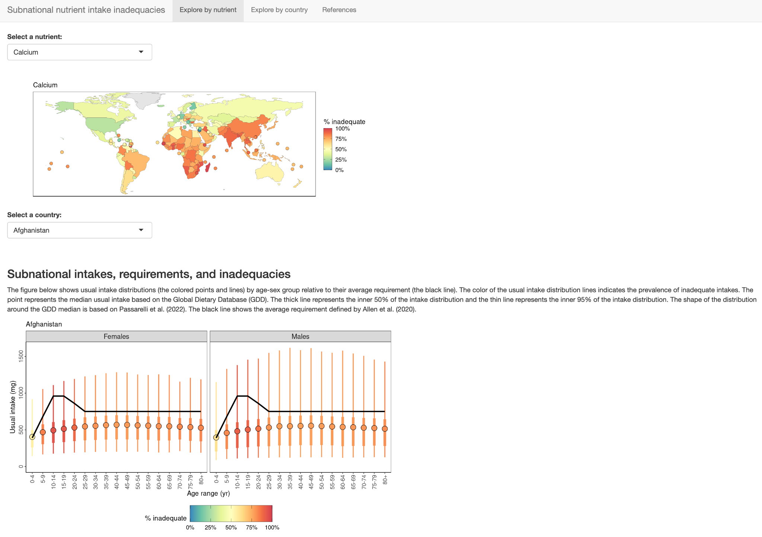  
7. Did the authors have to contend with missing data?

**In the original submission, we had to contend with missing data in setting (1) the mean of intake distribution for the 33 countries without GDD data and (2) the shape of the intake distribution for distributions without nutriR data. We now exclude the countries without GDD intake estimates so we no longer contend with the first category. The methods for borrowing shape parameters from countries with the most similar food intakes are well described in Section “2.4 Defining subnational intake shapes” and illustrated in Figure S2. We discuss this in the first paragraph of the “Limitations” section.**

## Reviewer #2:

**General comments**

The authors identified and attempted to address an important research gap using a novel approach. This is the main strength of this paper. I only have one major question on the study methods, and some minor suggestions and questions for the authors.

**Major comment**

1.Please explain how the 31 countries were selected, and discuss potential limitations in estimating the prevalence of global nutrient intake inadequacy across 218 countries based on dietary intake data from these 31 countries ( this was mentioned in the abstract and in section 2.4).

**We added the following underlined text to the methods (Section 2.4 Defining subnational intake shapes) to briefly describe how Passarelli et al. 2022 assembled dietary recall survey data for 31 countries to build the most comprehensive database of dietary recall survey currently available:**

**“Passarelli et al.**[**21**](https://www.zotero.org/google-docs/?vC7Iro) **assembled a database of dietary recall surveys from 31 countries and used this database to construct statistical distributions -- either log-normal or gamma distributions -- that describe usual intakes for 51 nutrients. The 31 countries were selected for inclusion based on whether there was an available dataset with 1) individual-level dietary data, 2) calculated nutrient-level data, 3) ≥2 d of dietary intake (for at least some participants), 4) data based on a 24-h recall or diet record/food diary, and 5) a sample size >200 people.”**

**We added the following text to the new “Limitations” section to discuss the limitations of this approach:**

**“By basing the global intake distribution shapes on datasets from only 31 countries, it is possible that some of the distribution shapes were incorrectly estimated, resulting in inaccurate estimates of inadequacy.”**

**Minor comments**

1.Please provide a reference for 'Deficiencies in these micronutrients and others collectively contribute to excess morbidity, mortality, and chronic undernutrition, but the scale of the problem is relatively unknown due to limited data'.

**We cited Stevens et al. (2022) as it collates all population-representative surveys of micronutrient deficiencies globally for its analysis, and the data are woefully sparse.**

* **Stevens, G. A., Beal, T., Mbuya, M. N., Luo, H., Neufeld, L. M., Addo, O. Y., ... & Young, M. F. (2022). Micronutrient deficiencies among preschool-aged children and women of reproductive age worldwide: a pooled analysis of individual-level data from population-representative surveys. The Lancet Global Health, 10(11), e1590-e1599.**

2.The first few paragraphs in the Introduction focused on micronutrient deficiency, suddenly the discussion moved to intake inadequacy in paragraph 5. I feel a transition between these two would help.

**We agree and we substantially revised paragraphs 4 and 5 to ease this transition and make it very clear what we are focusing on for this paper.**

3.These sentences should be removed from the Introduction as they described research methods: Using intake distribution shapes developed by Passarelli et al.21 in combination with dietary intake estimates from GDD19, we estimate the global prevalence of intake inadequacy for 15 micronutrients in 34 subnational age and sex groups across 218 countries. We evaluate inadequacy using a globally harmonized set of dietary intake requirements developed by Allen et al.24

**We agree and we moved this to the Methods.**

4.The discussion section would benefit from more discussion on the limitations of the novel method, how future work taking a similar/the same approach could be improved, the next step of the research team (if any) and recommendations for international stakeholders (users of the study findings, code and underlying data).

**We added a discussion section on the limitations of the study called “5. Limitations”. This section incorporated the existing paragraph on study limitations and new text resulting from the valuable reviewer feedback. We also added text about future research directions at the end of the Conclusion section.**

## Reviewer #4:

Article evaluates the inadequacy of 15 micronutrients sub-national age and sex groups in 218 countries, with a current methodology that is important for the different regions of the world in establishing nutritional strategies.  
  
These epidemiological data make it possible to establish the focus research on priority age and sex groups to assess biomarkers of intake.

**Thank you for this acknowledgement.**

## Reviewer #5:

I have read with interest this manuscript. It is a solid piece of work, which tries and overcome the limitations of the existing estimates of nutritional intake worldwide. The paper is well written and relatively easy to follow, the existing website is a great addition. I have quite a lot of concern regarding the reliability of the data, and suggest a number of edits, see below.

Abstract background "dietary data" is a bit vague individual dietary intake. Also replace in the introduction.

**Abstract Methods:**

- "average" nutrient requirements sound a bit strange: harmonized is enough, but should specify "age and sex specific", no?

**We deleted “average” and added “age- and sex-specific.”**

- remove "global" in "global nutrient intake inadequacy"

**We deleted “global” from this sentence.**

**Introduction**

First two sentences read a bit odd, also it is a bit too vague to talk about "improvement to our diets". They are not necessary and can be removed.

**We removed these two sentences.**

Reference 2 is not appropriate as only applied to preschool aged children and women of reproductive age. I would start the introduction by describing the nutrition / epidemiologic transition, the global deterioration of diet quality because of ultra-processed foods, and that micronutrient deficiency can be due both to undernutrition (not enough of EVERYTHING) and malnutrition (energy-dense nutrient-poor food)

**We thank the reviewer for this critique. We want to clarify that undernourishment is a type of malnutrition, and therefore we cannot express the distinctions as they have stated in the last sentence of their comment. To correct some of the other issues expressed in this comment, we have included the Afshin et al. 2019 reference in the current first sentence, along with the Stevens et al. 2022 reference, and jointly they support the first statement.**

* **Afshin A, Sur PJ, Fay KA, et al. Health effects of dietary risks in 195 countries, 1990–2017: a systematic analysis for the Global Burden of Disease Study 2017. The Lancet 2019; 393: 1958–72.**
* **Stevens, G. A., Beal, T., Mbuya, M. N., Luo, H., Neufeld, L. M., Addo, O. Y., ... & Young, M. F. (2022). Micronutrient deficiencies among preschool-aged children and women of reproductive age worldwide: a pooled analysis of individual-level data from population-representative surveys. The Lancet Global Health, 10(11), e1590-e1599.**

What do you mean "contribute to chronic undernutrition"? It is not a health outcome, is it? I would say it is the opposite, undernutrition leads to deficiency in micronutrients.

**We removed the term “chronic undernutrition”.**

There have been numerous efforts to estimate the burden of global micronutrient malnutrition, and significant methodological advances Change the order to: There have been numerous efforts and significant methodological advances to estimate the burden of global micronutrient malnutrition.

**This sentence no longer appears in the manuscript as a result of our massive overhaul of the introduction.**

What methodological advances are you talking about? In data collection? Data modelling? Then you mention the need of new methodological approaches, so it is a bit confusing.

**We removed this phrase from the sentence as you can see above. In terms of novel advances, there has been no attempt to estimate global inadequate micronutrient intakes to date. Our past AJCN paper (Passarelli et al. 2022) provided a novel methodology to do this. The current paper makes use of this approach and harnesses the GDD data to estimate it. Any other global efforts on adequacy are based on food supplies. We have tried to clarify this throughout the introduction.**

* **Passarelli, S., Free, C.M., Allen, L.H., Batis, C., Beal, T., Biltoft-Jensen, A.P., Bromage, S., Cao, L., Castellanos-Gutiérrez, A., Christensen, T. and Crispim, S.P., 2022. Estimating national and subnational nutrient intake distributions of global diets. *The American journal of clinical nutrition*, *116*(2), pp.551-560.**

"the role of nutrition as both a risk factor and outcome for four micronutrients": I don't understand this sentence.

**We clarified this sentence as follows:**

**“The Global Burden of Disease (GBD) study examines the burden of micronutrient malnutrition in 195 countries using a modeling approach combining clinical outcomes (e.g., goiter), biomarkers of micronutrient status (e.g., serum retinol) and anemia (e.g., hemoglobin concentration), and inadequacy in the food supply (e.g., zinc inadequacy).**[**12**](https://www.zotero.org/google-docs/?T68mp0)**”**

**Methods**

2.1 I really like the overview paragraph

**Thank you for this acknowledgment.**

2.3 Why is it called "intake means" if you only use medians?

**Thank you for catching this typo. We changed the section header to “2.3 Defining subnational intake medians”.**

What does "highly resolved subpopulations" mean?

**We deleted the words “highly resolved” because the next sentence defines these subpopulations. The sentences now read:**

**“The GDD uses datasets from household surveys and food balance sheets to estimate the median intake of 17 micronutrients from 19 food and beverage categories (Table S2) by subpopulation in 185 countries from 1990-2018 (5-yr intervals 1990-2015). Subpopulations are defined by 44 age-sex groups, three levels of education (i.e., low, medium, and high), and two areas of residence (i.e., rural and urban).”**

The GDD uses datasets from food balance sheets and household surveys: so it is exactly the limitation that you said you would overcome here? You said somewhere else that it is based on individual dietary intake surveys.

**The GDD also includes data on individual dietary intake surveys, not from food balance sheets or any food supply data. Their methodology can be found here:**

* **Karageorgou, D., Castor, L. L., de Quadros, V. P., de Sousa, R. F., Holmes, B. A., Ioannidou, S., ... & Micha, R. (2024). Harmonising dietary datasets for global surveillance: methods and findings from the Global Dietary Database. *Public Health Nutrition*, *27*(1), e47.**
* **Miller, V., Singh, G. M., Onopa, J., Reedy, J., Shi, P., Zhang, J., ... & Mozaffarian, D. (2021). Global Dietary Database 2017: data availability and gaps on 54 major foods, beverages and nutrients among 5.6 million children and adults from 1220 surveys worldwide. BMJ global health, 6(2), e003585.**

**We clarified this in our large revision to the introduction.**

I really don't understand why you would impute the data from neighbours to the 33 countries with missing data. This is basically making data up. How is it reasonable to think that North Korea diet resembles that of South Korea? Or Somalia is the same as Ethiopia?  
OK to have it as a sensitivity analysis, but need to present the results only for countries for which there is at least some data.

**We removed the 33 countries without GDD intake estimates from our analysis. Our analysis still covers 99.3% of the global population as these 33 countries only have a total population of 53 million people (0.7% of the global population).**

I am still unclear if the GDD has data for 185 countries or also imputed data from neighbours for some countries? From their website, I can see that a third of African countries do not have data. I believe the sentence in the discussion "Although GDD coverage has grown to include 98% of the global population and become more precise over time" is therefore plain wrong.

**Our description of the GDD is correct. The GDD provides intake estimates for 185 countries. The countries with data are illustrated in the figure below (previously Figure S2 in the paper). As shown below, the GDD provides intake estimates for most countries in Africa. Without a specific URL, we cannot explain this source of confusion.**

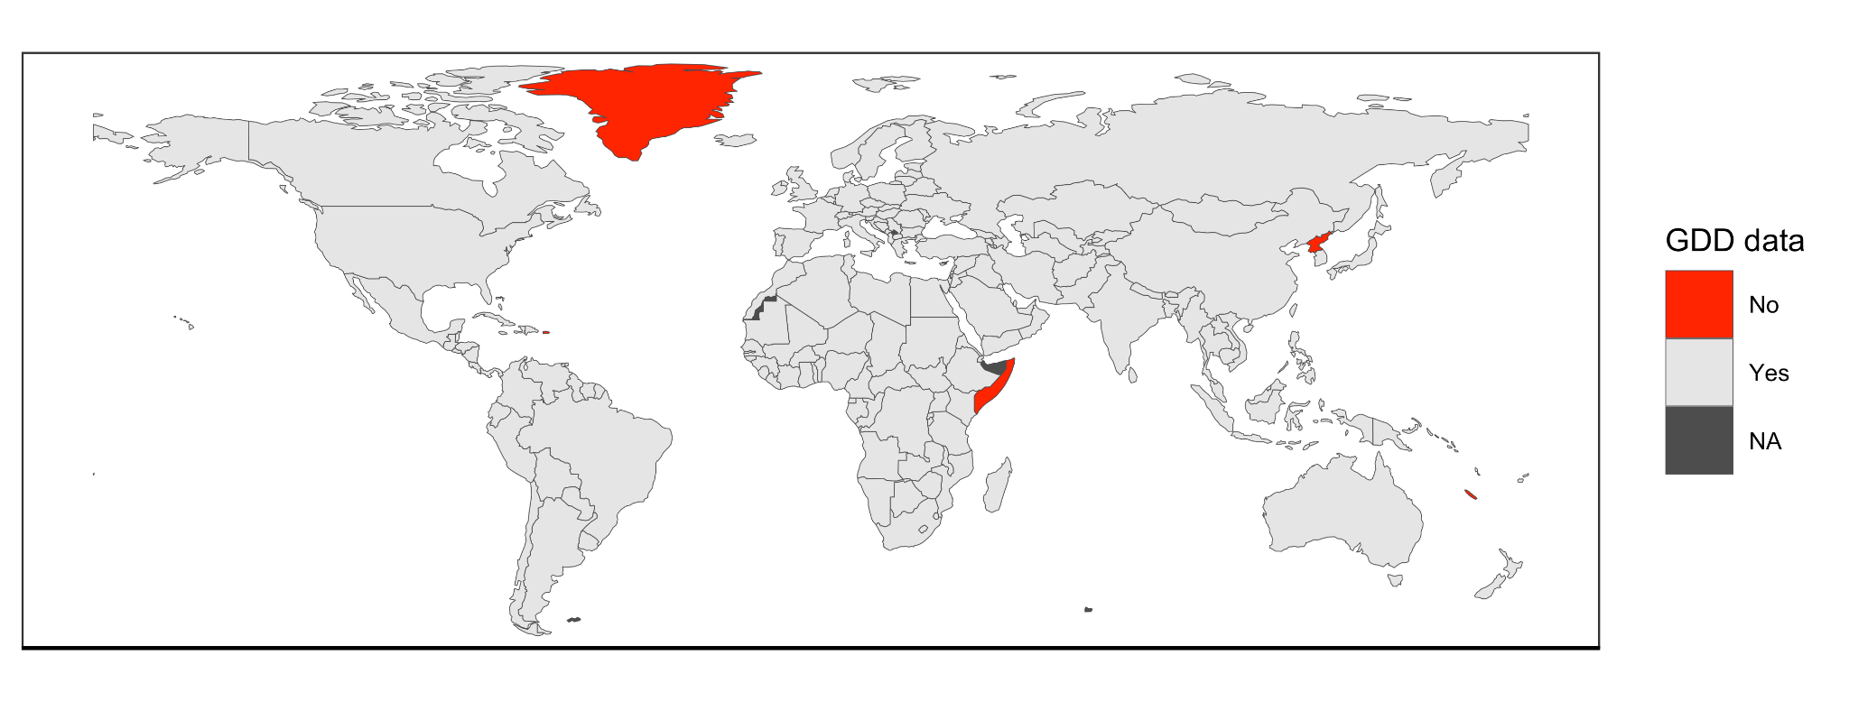

**The sentence that the reviewer flags is also correct. The 33 countries without GDD estimates have a total population of 53 million people (0.7% of the global population). The 185 countries with GDD estimates have a total population of 7.52 billion people (99.3% of the global population).**

The calcium estimation is clearly an oversimplified way of calculating it.

**We took two steps to improve these calculations.**

**First, we used age- and sex-specific estimates of daily water adequate intakes (AIs) from IOM (2004) to set age- and sex-specific estimates of water intakes. Previously, we assumed that all age-sex groups consumed 1.7 L of water per day.**

**Second, we updated our calcium concentration based on the average of the median sources of different types of drink water from around the world, as calcium concentration varies depending on the location and type of water source (WHO, 2009). This changed our estimate from 42 mg/L to 46 mg/L.**

**We used data from this same source to account for magnesium in water (16 mg/L) using the same approach.**

* **World Health Organization. (2009). Calcium and magnesium in drinking-water: public health significance. World Health Organization.**
* **IOM (2005) *Dietary reference intakes for water, potassium, sodium, chloride, and sulfate*. National Academies Press.**

**While dietary factors such as phytate, oxalate, and dairy intake affect calcium absorption, we know of no published algorithm for quantitatively calculating fractional absorption using dietary factors that are globally available at subnational resolution. For example, Weaver et al. (2024) provide an algorithm for estimating calcium absorption, but the algorithm critically depends on estimates of oxalate intake (algorithm with oxalate explained 45% of variation in calcium absorption while the model without oxalate explained only 1% of variation), which is not included in the GDD or any other global database that we know of.**

**We added the following sentence to the methods to acknowledge this limitation:**

**“While calcium absorption is also impacted by dietary factors such as phytate, oxalate, and dairy intake, we were unable to account for these impacts given a lack of data on global oxalate intakes, which are the dominant factors impacting calcium absorption.**[**35**](https://www.zotero.org/google-docs/?RGY5dH)**”**

**Weaver, C.M., Wastney, M., Fletcher, A. and Lividini, K., 2024. An Algorithm to Assess Calcium Bioavailability from Foods. *The Journal of Nutrition*, *154*(3), pp.921-927.**

2.6 I find the description of the prevalence estimation (first paragraph) a bit tricky to follow, especially I don't understand how does the coefficient of variation work here?

**We took several steps to address this comment.**

**First, we clarified that the coefficient of variation (CV) is used to derive the standard deviation of the requirement distribution by adding the following sentence:**

**“The CV is used to derive the standard deviation of the requirement distribution.”**

**We also added a new figure (Figure 1) to the manuscript to conceptually illustrate our work pipeline and to illustrate how the probability approach (IOM 2000) intersects the intake and requirement distributions to estimate the prevalence of inadequate intakes. We added a reference to panels B and C to this section to help the reader visualize the requirement distribution and its use in the probability approach. The figure is provided below for reference. The caption is in the paper and in the response to reviewer 1.**



Please specify that your ARs are age and sex specific, except for zinc and iron where they are also country-specific AR, due to the different phytate and ASF intakes across countries.

**We added the following underlined text to clarify that our average requirements (ARs) are age- and sex-specific and that the ARs for iron and zinc are also country-specific:**

**“We used the harmonized age- and sex-specific average requirements (ARs) provided by Allen et al.**[**24**](https://www.zotero.org/google-docs/?SYno6W) **as the average requirements for this analysis (Figure S5). We assumed a coefficient of variation of 0.25 for the requirement of vitamin B12 and 0.10 for the requirement of all other distributions based on the recommendation of Renwick et al.32. We further specified country-specific ARs for zinc and iron based on dietary factors that inhibit or enhance their absorption (Figure S6 & S7).”**

**3. Results**

I find it confusing to use the word "levels" in, e.g., "moderate levels of inadequate calcium intakes". Please stick to "prevalence" or "proportion of the population", but levels sound like circulating levels of calcium.

**We replaced “levels” with “prevalence” throughout places in the results, discussion, and figure captions where we refer to the “prevalence of inadequate intakes.”**

**4. Discussion**

The summary is a bit misleading, it sounds like five billion people do not consume enough of three nutrients in combination, that is, are deficient for the 3 nutrients together, whereas it might be different people.

**We clarified that >5 billion people do not consume each of three nutrients by adding the following underlined text:**

**“Globally, we found that more than five billion people do not consume enough of each of three nutrients– iodine, vitamin E, and calcium.”**

This sentence "GDD data are subject to similar limitations as methods that estimate food supply, including limited accuracy and complexity of underlying food composition data." is incomplete.

**This sentence no longer appears in the manuscript as a result of our massive overhaul of the introduction.**

The messages regarding the quality of the data in the GDD initiative are mixed: you mention that it is based on FAO balance sheets and household surveys, then you say "Notably, the GDD uses actual dietary intake data rather than food supply or household food purchase data.", please can you check throughout the manuscript and correct?

**We agree that this was confusing and we significantly rewrote the introduction to clarify the differences between the different studies and their different data inputs.**

**The GDD uses data on individual dietary intake surveys, not from food balance sheets or any food supply data. Their methodology can be found here:**

* **Karageorgou, D., Castor, L. L., de Quadros, V. P., de Sousa, R. F., Holmes, B. A., Ioannidou, S., ... & Micha, R. (2024). Harmonising dietary datasets for global surveillance: methods and findings from the Global Dietary Database. *Public Health Nutrition*, *27*(1), e47.**
* **Miller, V., Singh, G. M., Onopa, J., Reedy, J., Shi, P., Zhang, J., ... & Mozaffarian, D. (2021). Global Dietary Database 2017: data availability and gaps on 54 major foods, beverages and nutrients among 5.6 million children and adults from 1220 surveys worldwide. BMJ global health, 6(2), e003585.**

**We clarified this in our large revision to the introduction.**

Overall, I appreciate greatly the effort and the amount of work that have gone into this, but it is extrapolating the distribution from 31 countries to the rest of the world + using data from the GDD which has its limitations as explained. This should appear more clearly as a major limitation.

**We added a discussion section on the limitations of the study called “5. Limitations”. This section incorporated the existing paragraph on study limitations and new text resulting from the valuable reviewer feedback.**

Also, there is space to discuss more in detail the geographical differences, the major problem of lack of data in Africa for example. This could be a good paper to make a call for data collection and funding priorities in these regions of the world where it is lacking.

**The coverage for Africa is actually quite high (see comments above). However, we have taken the opportunity in the Conclusion to call out the need to fill dietary intake data gaps in other regions where there is a dearth of data.**

**“These data can provide insight into the critical micronutrient gaps that may afflict particular regions and sub-populations and can also act as a call-to-action for locations without necessary data to calculate these estimates, like in many small island developing states in the Pacific.”**

**Conclusions**

Agree that one of the easy measure to address nutrient deficiency is fortification and supplementation, but you are actually not taking supplementation into account in your estimations, so you don't know if the nutrient inadequate intake is actually a nutrient deficiency.

**We agree and added more discussion of fortification and supplementation to both the new “Limitations” section and the expanded “Conclusions” section:**

**Limitations: “The estimates presented in this paper are of inadequate nutrient intake and do not include information on fortification or supplementation. In essence, this means that our inadequate intake estimates likely overestimate risk for some key nutrients (e.g., iodine) in particular locations. Nonetheless, there is limited supplementation and fortification with many of these micronutrients globally.**[**39**](https://www.zotero.org/google-docs/?5YZvX6) **Among countries with available Demographic and Health Survey data, which operates in 90+ developing countries, supplementation for select demographic groups is somewhat common for iron, with 32% of pregnant women consuming iron for >90 days of their pregnancy, and 14% of children consuming a supplement in the previous week.**[**40**](https://www.zotero.org/google-docs/?ttMWCH) **Supplementation is the highest for vitamin A in children; an estimated 55% have had a high-dose vitamin A supplement in the previous six months.**[**40**](https://www.zotero.org/google-docs/?wROkYo) **There is inadequate data on fortification for most nutrients except iodine; UNICEF estimates that 89% of people worldwide consume iodized salt.**[**41**](https://www.zotero.org/google-docs/?X4UFjR) **Thus, iodine might be the only nutrient for which inadequate intake from food is largely overestimated.”**

**Conclusions: “ We envision this research providing invaluable information for researchers, policy makers, public health specialists, and other stakeholders involved in nutrition and food system interventions. These data can provide insight into the critical micronutrient gaps that may afflict particular regions and sub-populations and can also act as a call-to-action for locations without necessary data to calculate these estimates, like in many small island developing states in the Pacific. Future research on the role of fortification, supplementation, and other broad-scope nutrition and food system interventions can be used to calculate the public health gains associated with such actions.”**