## Supplemental Tables and Figures

**Table S1.** Nutrients included in analysis (AR=average requirement; IOM=U.S. Institute of Medicine; EFSA=European Food Safety Authority).

|  |  |  |  |  |  |
| --- | --- | --- | --- | --- | --- |
|  |  |  |  | **Prevalence of inadequacies** |  |
| **Type** | **Nutrient** | **Units** | **AR source** | **(billions of people)** | **% of people** |
| Vitamin | Vitamin E | mg | IOM | 5.0 | 66.9% |
| Vitamin | Riboflavin (vitamin B2) | mg | EFSA | 4.1 | 54.5% |
| Vitamin | Folate (vitamin B9) | µg DFE | EFSA | 4.1 | 53.8% |
| Vitamin | Vitamin C | mg | EFSA | 4.0 | 53.3% |
| Vitamin | Vitamin B6 (pyridoxine) | mg | EFSA | 3.9 | 51.5% |
| Vitamin | Vitamin A (RAE) | µg DFE | EFSA | 3.6 | 47.9% |
| Vitamin | Vitamin B12 (cobalamin) | ug | IOM | 3.0 | 39.4% |
| Vitamin | Thiamin (vitamin B1) | mg | IOM | 2.2 | 29.7% |
| Vitamin | Niacin (vitamin B3) | mg | IOM | 1.7 | 22.1% |
| Mineral | Iodine | ug | IOM | 5.1 | 67.5% |
| Mineral | Calcium | mg | EFSA | 5.0 | 66.3% |
| Mineral | Iron | mg | EFSA | 4.9 | 64.8% |
| Mineral | Zinc | mg | EFSA | 3.5 | 46.2% |
| Mineral | Selenium | ug | IOM | 2.8 | 37.6% |
| Mineral | Magnesium | mg | IOM | 2.4 | 31.4% |

**Table S2.** Dietary factors included in the Global Dietary Database (GDD). *** animal-source food used to derive average requirements for iron (see **Figures S7 and S9**).

|  |  |  |
| --- | --- | --- |
| **Type** | **Factor** | **Units** |
| Vitamins | Folate | µg DFE |
| Vitamins | Vitamin A (RAE) | µg RAE |
| Vitamins | Vitamin B1 | mg |
| Vitamins | Vitamin B12 | µg |
| Vitamins | Vitamin B2 | mg |
| Vitamins | Vitamin B3 | mg |
| Vitamins | Vitamin B6 | mg |
| Vitamins | Vitamin C | mg |
| Vitamins | Vitamin D | µg |
| Vitamins | Vitamin E | mg |
| Minerals | Calcium | mg |
| Minerals | Iodine | µg |
| Minerals | Iron | mg |
| Minerals | Magnesium | mg |
| Minerals | Potassium | mg |
| Minerals | Selenium | µg |
| Minerals | Zinc | mg |
| Fatty acids | Monounsaturated fatty acids | % of total kcal |
| Fatty acids | Plant omega-3 fatty acids | mg |
| Fatty acids | Saturated fat | % of total kcal |
| Fatty acids | Seafood omega-3 fatty acids | mg |
| Fatty acids | Total omega-6 fatty acids | % of total kcal |
| Macronutrients | Added sugars | % of total kcal |
| Macronutrients | Dietary cholesterol | mg |
| Macronutrients | Dietary fiber | g |
| Macronutrients | Dietary sodium | mg |
| Macronutrients | Total carbohydrates | % of total kcal |
| Macronutrients | Total protein | g |
| Beverages | Coffee | cups |
| Beverages | Fruit juices | g |
| Beverages | Sugar-sweetened beverages | g |
| Beverages | Tea | cups |
| Beverages | Total milk | g |
| Foods | Beans and legumes | g |
| Foods | Cheese | g |
| Foods | Eggs *** | g |
| Foods | Fruits | g |
| Foods | Non-starchy vegetables | g |
| Foods | Nuts and seeds | g |
| Foods | Other starchy vegetables | g |
| Foods | Potatoes | g |
| Foods | Refined grains | g |
| Foods | Total processed meats *** | g |
| Foods | Total seafoods *** | g |
| Foods | Unprocessed red meats *** | g |
| Foods | Whole grains | g |
| Foods | Yoghurt (including fermented milk) | g |

**Table S3.** Mapping Global Dietary Database (GDD) age groups to match the World Bank (WB)[26](https://www.zotero.org/google-docs/?mUQfjW) age groups.

|  |  |
| --- | --- |
| **GDD age group** | **WB age group** |
| 0-11 mo | 0-4 yr |
| 12-23 mo | 0-4 yr |
| 2-5 yr | 0-4 yr |
| 6-10 yr | 5-9 yr |
| 11-14 yr | 10-14 yr |
| 15-19 yr | 15-19 yr |
| 20-24 yr | 20-24 yr |
| 25-29 yr | 25-29 yr |
| 30-34 yr | 30-34 yr |
| 35-39 yr | 35-39 yr |
| 40-44 yr | 40-44 yr |
| 45-49 yr | 45-49 yr |
| 50-54 yr | 50-54 yr |
| 55-59 yr | 55-59 yr |
| 60-64 yr | 60-64 yr |
| 65-69 yr | 65-69 yr |
| 70-74 yr | 70-74 yr |
| 75-79 yr | 75-79 yr |
| 80-84 yr | 80+ yr |
| 85-89 yr | 80+ yr |
| 90-94 yr | 80+ yr |
| 95+ yr | 80+ yr |

**Table S4.** Key assumptions made throughout analysis.

|  |  |
| --- | --- |
| **#** | **Assumption** |
| 1 | Intake distribution shapes for subnational groups without nutriR data can be borrowed, in order of preference, from the nearest age-sex group, the opposite sex, or the country with the most similar diet. |
| 2 | When intake distributions shift higher or lower, the median changes but the shape remains the same. |
| 3 | The requirement distribution for Vitamin B12 has a coefficient of variation (CV) of 0.25 and the requirement distributions of all other nutrients have CVs of 0.10. |
| 4 | We do not quantitatively evaluate the impact of fortified foods. |

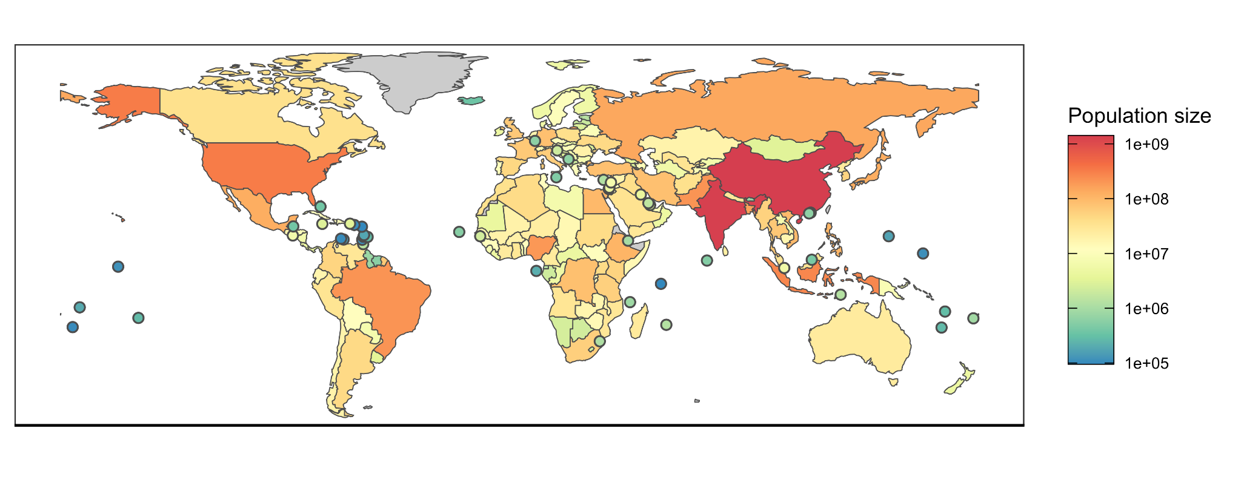**Figure S1.** Human population size in 2018 from the World Bank.[26](https://www.zotero.org/google-docs/?b9Sl9Z) Countries with land areas less than 25,000 km2 are shown as points to increase visibility.

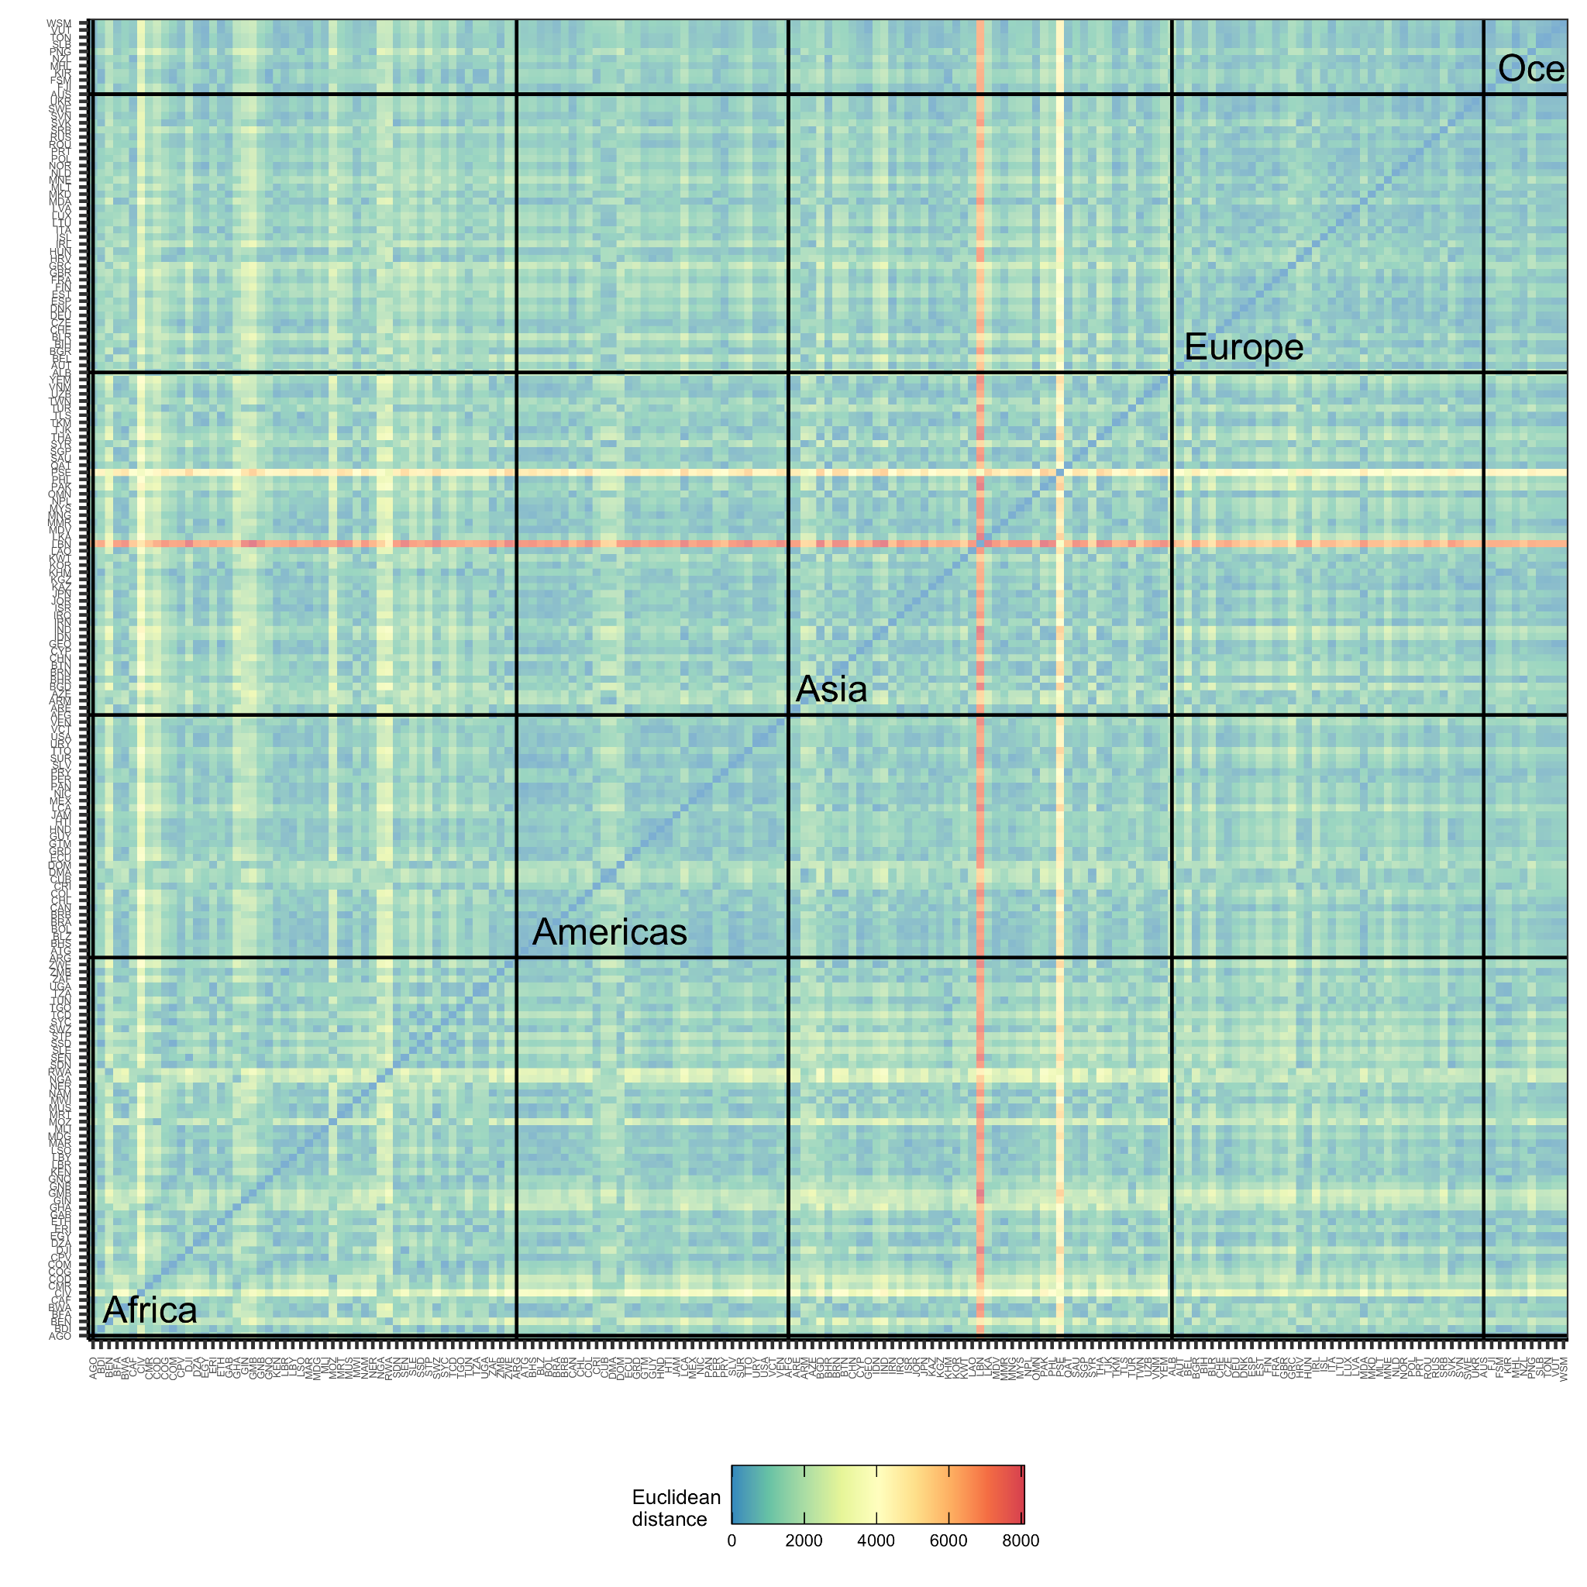**Figure S2.** The Euclidean distance between the nutrient intakes of the 185 countries with GDD intake estimates. Euclidean distances were calculated using national averages of vitamin and mineral intakes. Small Euclidean distances indicate countries with very similar national-scale nutrient intakes and large Euclidean distances indicate countries with very different national scale nutrient intakes. See **Table S2** for a list of the vitamins and minerals included in this calculation. Countries are grouped by continent. Palestinian territories (PSE) and Lebanon (LBN) have dramatically different nutrient intakes than every other country (the horizontal and vertical red bands represent extremely far Euclidean distance).

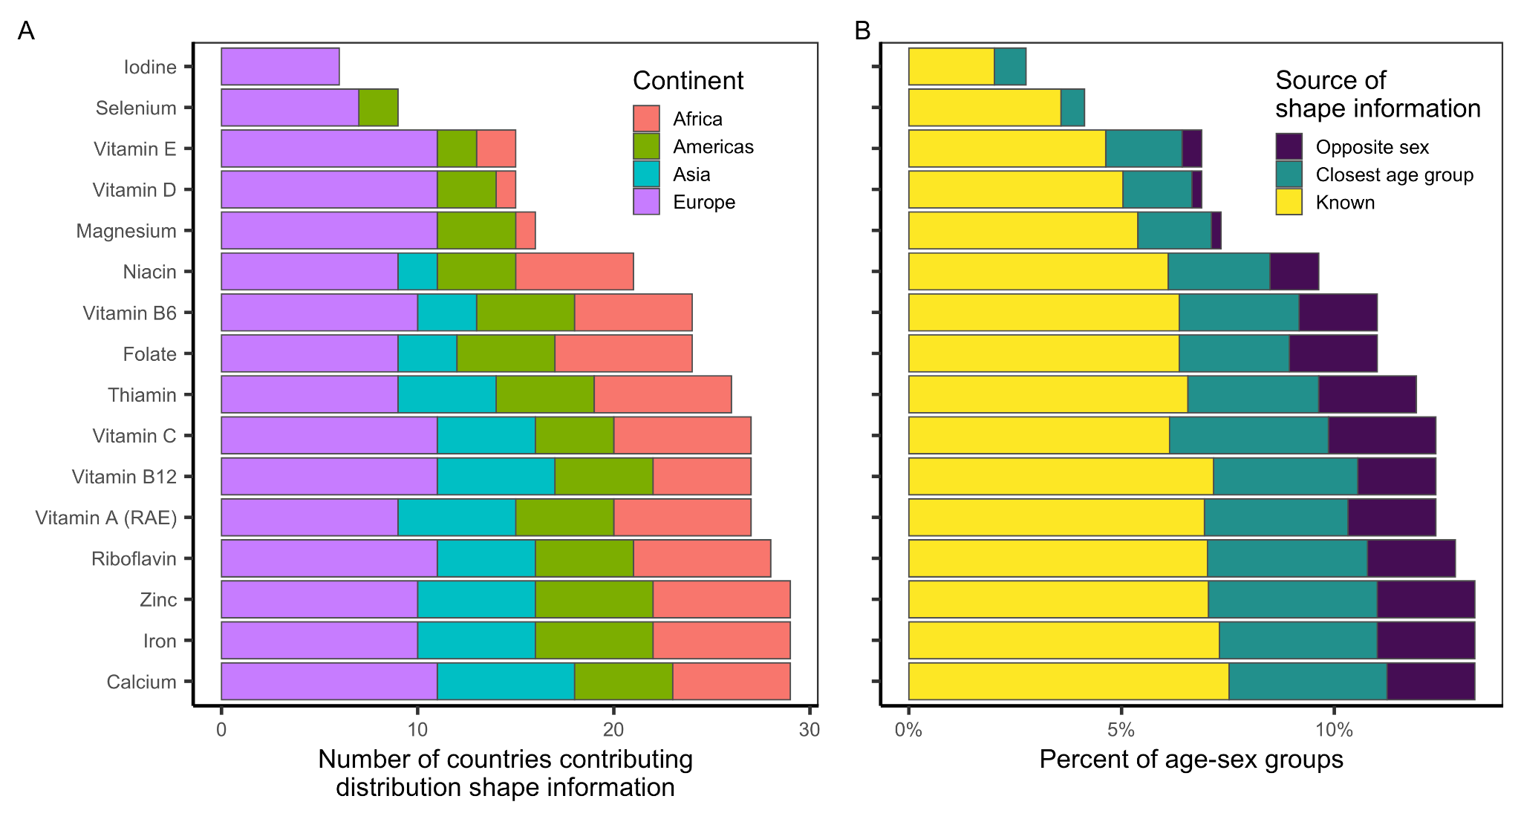**Figure S3.** The availability of distribution shape information for building usual intake distributions for all of the evaluated subnational age-sex groups. Panel A shows the number of countries contributing shape information and Panel B shows the percentage of age-sex groups with known shape information or with shape information borrowed from the closest age group or the opposite group. Shape information for the remaining percentage is borrowed from the corresponding age-sex group from the most similar country (see methods).

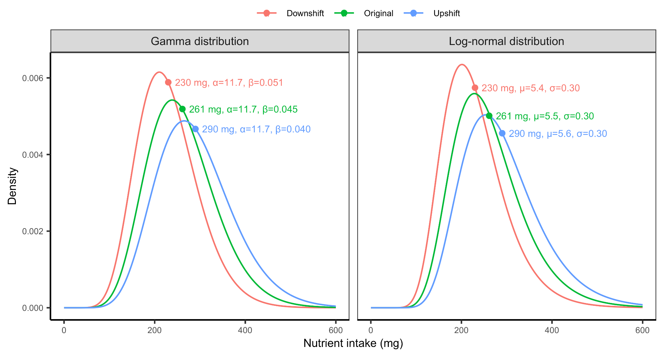**Figure S4.** Conceptual illustration of the methods used to shift the distributions defined by the matched shape parameters to match the Global Dietary Database median for each subnational group. Distributions were shifted by maintaining the variability parameter (*α* and *σ* for the gamma and log-normal distributions, respectively) and shifting the centrality parameter (*β* and *µ* for the gamma and log-normal distributions, respectively).

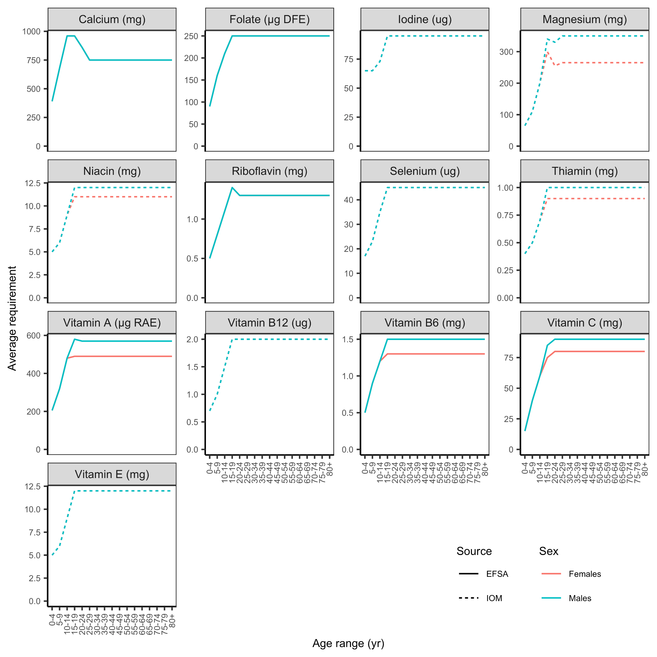**Figure S5.** Harmonized average requirements (H-ARs) from Allen et al.[24](https://www.zotero.org/google-docs/?Vqb6bE) for 13 of 15 nutrients evaluated in this paper. Males and females have identical average requirements for calcium, folate, iodine, riboflavin, selenium, vitamin B12, and vitamin E. Average requirements for iron and zinc are shown in **Figures S6 and S7**, respectively. Harmonized average requirements are drawn from the U.S. Institute of Medicine (IOM) and European Food Safety Authority (EFSA).

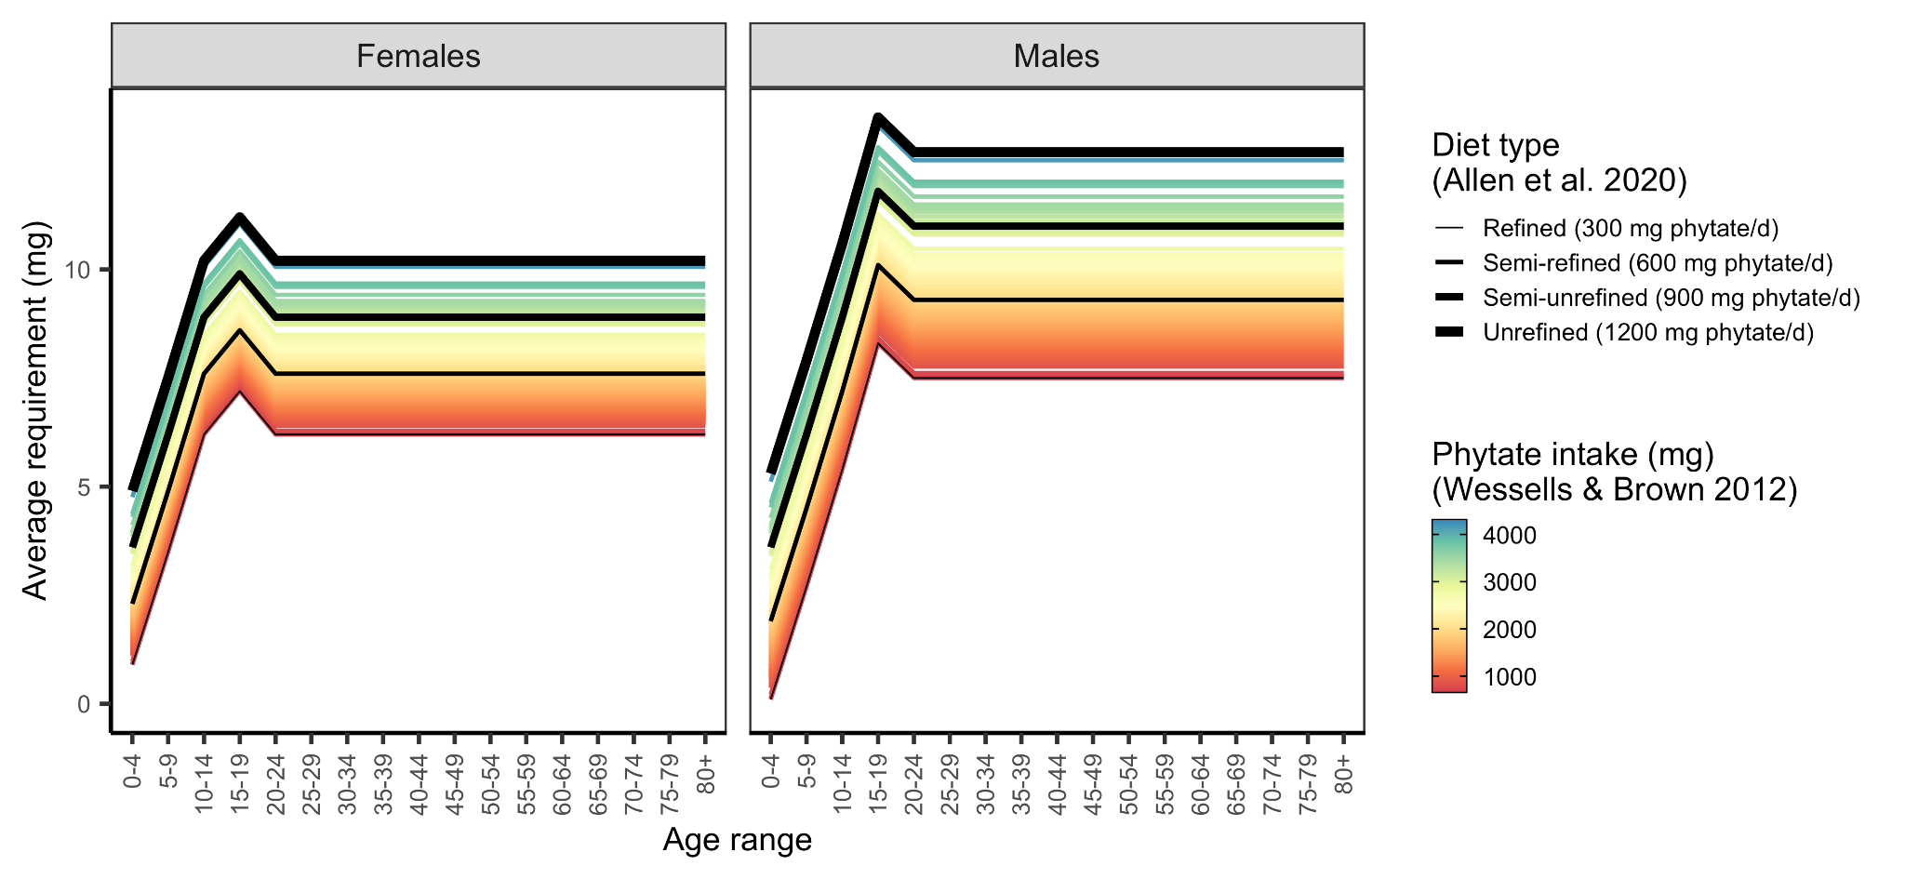**Figure S6.** Average requirements for zinc by age-sex group based on diet type, as specified by Allen et al.[24](https://www.zotero.org/google-docs/?t9v3wA), and 2005 phytate intake, as estimated by Wessells and Brown[36](https://www.zotero.org/google-docs/?TzuX3R). The colored lines represent the requirements estimated for each country.**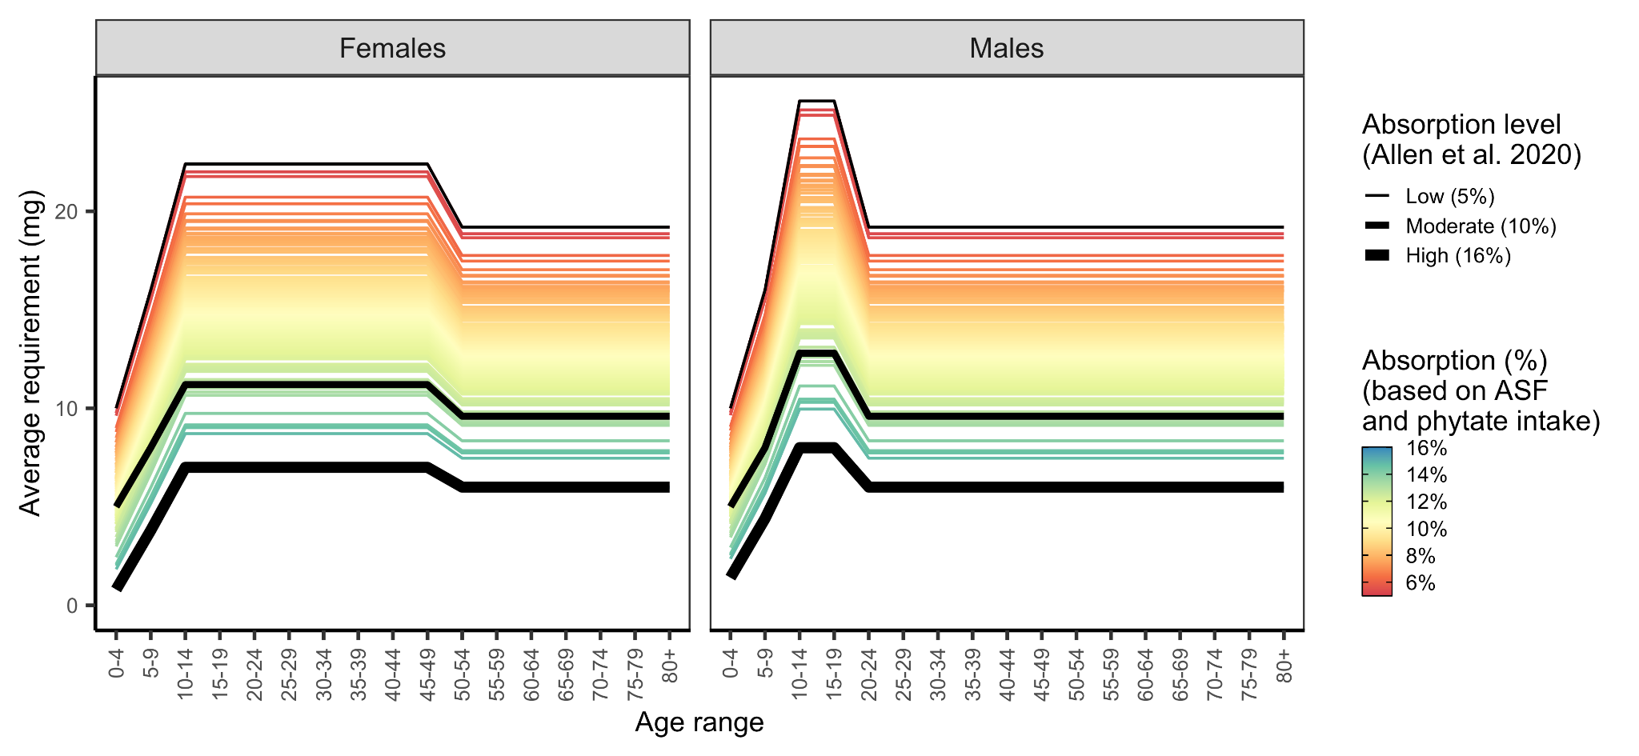Figure S7.** Average requirements for iron by age-sex group based on country-specific absorption levels. Countries were assigned an absorption level based on their phytate (**Figure S8**) and animal-source food (ASF) intakes (i.e., sum of unprocessed red meat, processed meat, seafood, and egg intakes) (**Figure S9**). See **Figure S10** for a map of absorption levels.

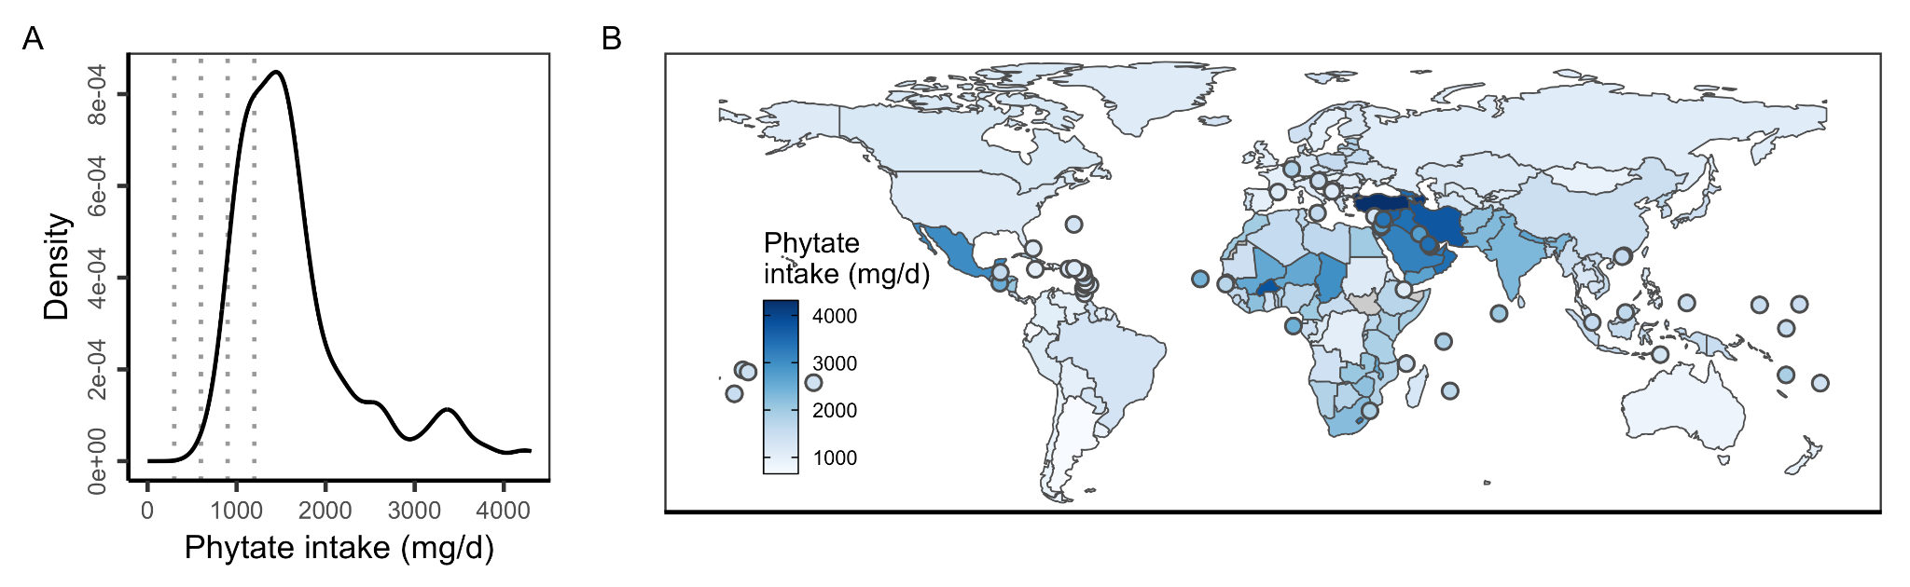**Figure S8.** Phytate intake in 2005 as estimated in Wessells and Brown[36](https://www.zotero.org/google-docs/?ghLy8L). In (A), vertical lines mark the phytate intake reference points used to specify average requirements in Allen et al.[24](https://www.zotero.org/google-docs/?HxTVxg). In **(B)**, countries with land areas less than 25,000 km2 are shown as points to increase visibility.

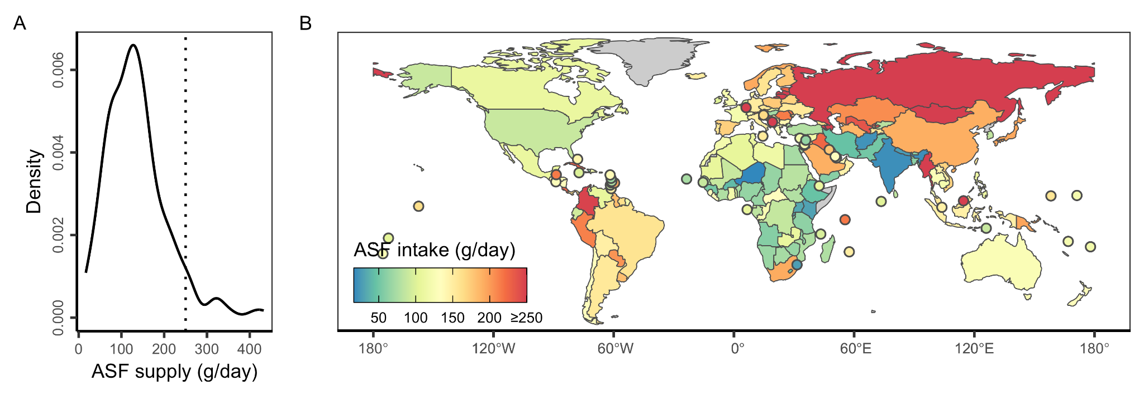**Figure S9.** Average country-level animal-source food (ASF) intake (i.e., sum of unprocessed red meat, processed meat, seafood, and egg intakes) in the Global Dietary Database.[20](https://www.zotero.org/google-docs/?JxevOm) In **(B)** ASF supply is capped at 250 g/day to ease visualization (vertical line in **A**).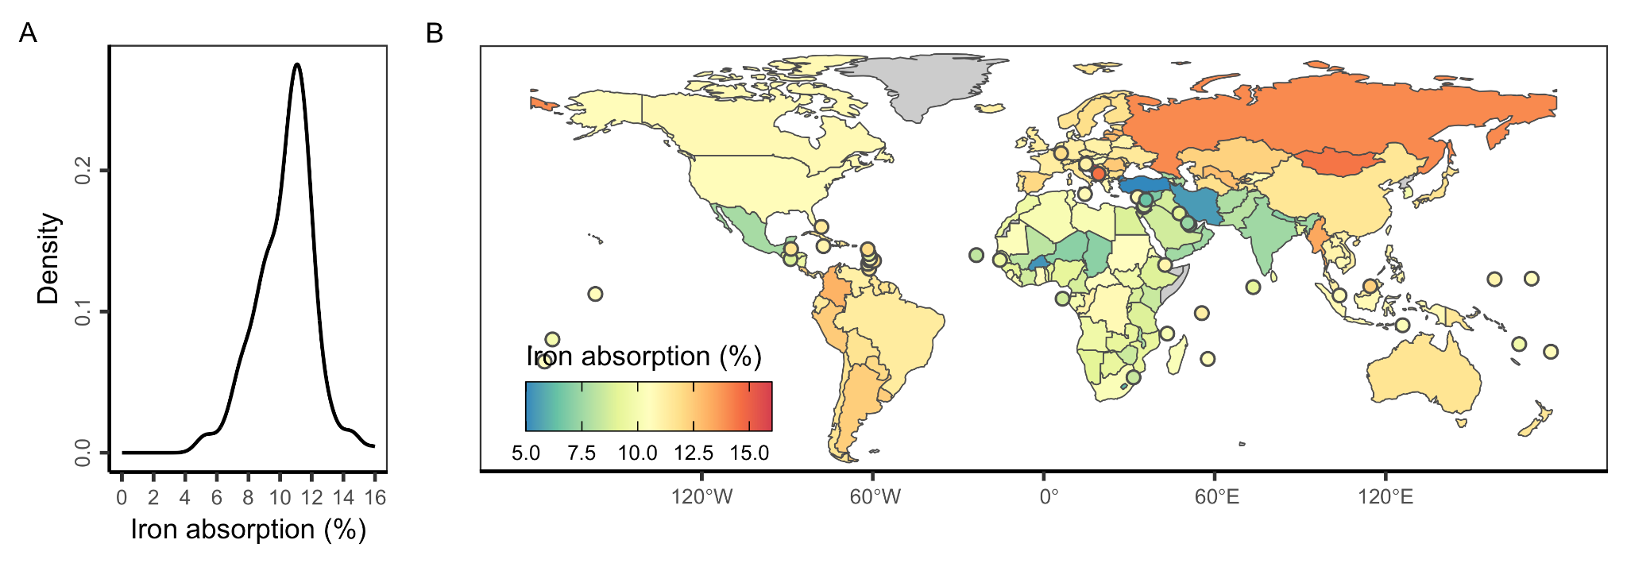

**Figure S10.** Estimated iron absorption levels for each country. Iron absorption levels were estimated based on country-specific phytate (**Figure S8**) and animal-source food (ASF) intakes (i.e., sum of unprocessed red meat, processed meat, seafood, and egg intakes) (**Figure S9**).

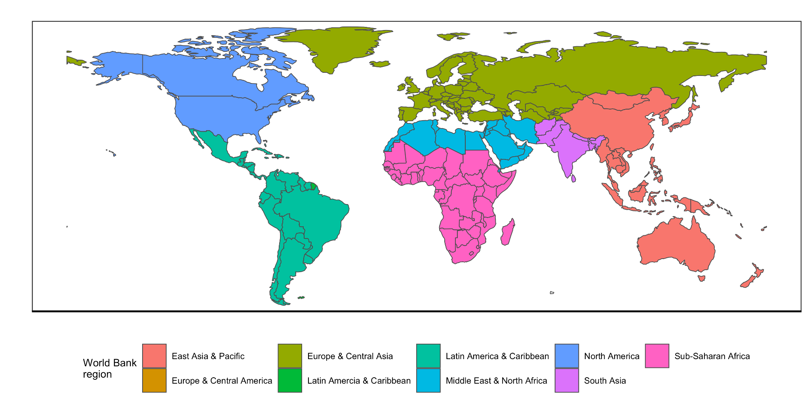

**Figure S11.** World Bank regions used to group results in the main text analysis.