**Disentangling the impacts of climate warming and fishing pressure on freshwater fish populations**

**Another suggestion:** The relative impacts of warming and fishing on freshwater fish populations

**Abstract:**

Both climate change and fishing pressure impact the abundance of freshwater fish populations. However, disentangling the relative contributions of these two stressors has been challenging. Here, we use a temperature-dependent population dynamics model to simultanesouly quantify the impact of lake warming and recreational and tribal fishing on the productivity of populations of eight species of freshwater fish in the American Midwest . Of the 720 populations analyzed, 83 populations have experienced a significant positive response to warming (11.5%) and 66 population have had a significant negative response to warming (9.1%). The direction and magnitudes of warming impacts were related to the thermal affinity of the species, the latitude of the population, and the level of exploitation experienced by the population. For the vast majority of the populations (93%), fishing had a greater impact on population size than warming. Accurate understanding of the primary causes of population fluctuations and the mechanisms by which fish populations respond to climate change can help managers choose appropriate fisheries management strategies.

**Keywords:** fish productivity; fishery population dynamics; surplus production model; climate change

**Introduction:**

Climate change, manifested primarily by the increase in global mean temperature, can significantly alter the freshwater habitats of inland lakes (citation). Such warming can then affect the abundance of the fish populations that inhabit these waters through a series of physiological, biochemical, and ecological processes (). For example, warming can directly affect the seasonal thermal structure of lakes (), exposing certain fish populations to temperatures outside their species-specific optimal ranges, while making thermal conditions more suitable for other populations. Warming can also affect the dynamics of freshwater fish populations include decreases in dissolved oxygen (), reduction and shortening of ice cover (), plankton bloom phenology (), and toxic algae blooms ().

The responses of fish populations to warming are likely to vary inter- and intraspecifically. Warm- and cold-water species may respond to warming in opposite directions based on their species-specific thermal requirements (). Populations of the same species may respond differently to warming, depending on their geographic position or local adaptations to thermal regimes (). Illustrating among- and within-species variation in responses to warming, a meta-analysis of global marine fish and invertebrates revealed that populations benefiting from historical ocean warming were roughly offset in number and magnitude by those that were negatively affected (). Although the general effects of warming on freshwater fish species from different thermal guilds have been documented (), the potentially heterogeneous effects of warming on the abundance of individual populations are less clear on regional or global scales.

One challenge in evaluating the effect of warming on freshwater fish abundance is that warming rarely occurs in isolation. Instead, it occurs in conjunction with other local stressors to create complex and entangled effects on fish population dynamics (). For the target species of commercial, recreational, or subsistence fisheries, fishing constitutes the most widespread stressor for freshwater fish populations. As a result, failure to accurately disentangle the joint effects of changes in fishing pressure and temperature on population abundance can lead to misattributions in the cause of population fluctuations (). Add something about how misunderstanding causes can lead to inappropriate and potentially detrimenetal management actions.

Separating the impact of fishing and warming on freshwater fish abundance is thus critical to fishery managers seeking to identify management strategies to grapple with the effects of both stressors (). Local and regional management agencies in the United States have developed adaptation strategies (e.g., regulating harvest or stocking) to keep the fisheries sustainable and to mitigate the effects of warming (). Although slowing the pace of climate warming through collective actions to reduce greenhouse gas emissions is the ultimate solution to conserve most fish and fisheries globally (), accurately quantifying the respective contributions of fishing and warming to changes in fish abundance can help managers prioritize practical measures that can be locally implemented.

Here, we collate data for 720 fish population from three Midwestern states in the United States to disentangle the relative impacts of fishing and warming at a large regional scale. The US Midwest provides a useful case study because it is home to diverse freshwater fish species that support prized recreational and subsistence species and that have endured rapid warming (Fig. 1). We developed a novel temperature-dependent population dynamic model that overcomes challenges presented by sparce and imprecise monitoring that is common in inland fisheries. We conduct rigorous simulation testing and sensitivity analysis to evaluate the robustness of the model to estimate the effect of temperature on fish abundance. Finally, we disentangled and compared the effects of warming and fishing on fish biomass by simulating two scenarios that assume the absence of fishing or warming, respectively. The application of this scalable approach in other regions would enhance the understanding of the relative importance of fishing and climate change on fluctuations of fish populations at a global scale.

**Materials and Methods:**

*1. Data sources and data characteristics*

Our temperature-dependent population dynamics model requires time series documenting three types of data for each population: (1) an index of relative abundance; (2) fishery removals and subsidies from stocking programs; and (3) environmental experience.

*1.1 Index of relative abundance*

Time series of relative abundance indices for each population were drawn from the fishery-independent biological surveys conducted by the Department of Natural Resources of each state (Minnesota, Wisconsin, Iowa; Fig. 1). Survey protocols differ between and within management agencies depending on the purpose of the survey. Therefore, we consulted experts from each state and obtained the relative abundance index that best reflected temporal changes in abundance for each population (Tab.S1 in the supplementary material).

*1.2 Fishery removals (harvest) and subsidies from stocking programs*

The evaluated populations are subject to mixture of recreational and tribal fishing pressure. Total recreational harvests were estimated based on the creel surveys conducted by Department of Natural Resources of each state. Data collated in the CreelCat database (<https://creelcat.shinyapps.io/CreelCat/>) were downloaded on 4 June 2022. Unlike large-scale commercial fisheries where accurate daily catch records are required, estimated recreational harvest data based on voluntary angler interviews are considered less precise (citation). Therefore, we treated recreational harvests as observations that are subject to observation error instead of known quantities in the model. The Great Lakes Indian Fish and Wildlife Commission (GLIFWC) collects tribal harvest data for all three states. Because all tribal fishing operations are under observation and all tribals fish harvest is recorded, we treated tribal harvests as known and accurate quantities in the model. Add something about the units of harvest, i.e., is it numbers or weight of individuals?

Many of the evaluated populations receive subsidies in the form of stocking from state-run hatcheries. Time series of the biomass of stocked fish added to each population were extracted from stocking report released by the Department of Natural Resources of each state. Stocking biomass was treated as known and accurate quantities in the model. Add something to confirm that stocking is in weight (kg) and not number of individuals. We want to show the reader that all the units are aligned here or what we did to align them.

*1.3 Environmental data*

The environmental data for each lake came from a process-based lake water temperature model (). The data were verified and released by the U.S. Geological Survey. Growing degree days (GDDs), the sum of the thermal energy above the base temperature (5℃ here) for the lake surface, was used as the climate warming index in this study. A 5°C base temperature was selected for this study as it reflected the cumulative thermal energy throughout the year and was commonly used for describing the thermal scope for fish growth (). To verify our selection of warming index, we also checked the correlations of the selected warming index with other warming indices including growing degree days with base temperature at 0℃ or 10℃, open water duration (i.e., number of days without ice cover), peak temperature of the year, and lake surface mean temperature of each month (SI.1 in the supplementary material).

*2. Model development*

*2.1 The Pella-Thomlinson surplus production model*

The biomass of a fish population after a certain time interval (e.g., a year) is equal to the biomass before that time interval, plus the recruitment and somatic growth of individual fish and biomass added through stocking (if present), and minus mortality due to natural processes and fishing (if present). Growth in biomass is commonly assumed to follow a density-dependent logistic pattern. The Pella-Tomlinson model commonly used to describe the fishery population dynamics can be written as follows ():

(1)

(2)

where *k* is the carrying capacity; *r* is the intrinsic growth rate of the population; is stock biomass at year *y*; *Cy* is the catch in year *y*; *Sy* is the stocked biomass in year *y*; *Iy* is the relative biomass index in year *y*; *q* is the catchability coefficient; and *ȵy* are observation errors, which are assumed to follow a normal distribution, i.e., , where is the variances of observation errors. The second quantity in equation (1) represents the surplus production in year *y* where *m* is a shape parameter that determines the *B/k* ratio where maximum surplus production would be attained. When the shape parameter *m* is two, the model is equivalent to the Schaefer surplus production model (citation), with the maximum surplus production attaining at half of the carrying capacity. The Pella-Tomlinson model is equivalent to the Fox model (citation) if shape parameter *m* approaches one, resulting in maximum surplus production attained when biomass equals 0.37*k*.

*2.2 The net effect of warming on stock biomass of fish populations*

Surplus production is a net gain in stock biomass in the absence of fishing, where the increase in biomass comes from recruitment and somatic growth of individual fish and the decrease in biomass is due to natural mortality. Warming may impact recruitment, individual fish growth and natural mortality of the same population in different directions and magnitudes. Here, rather than separately evaluating the effects of warming on the three dimensions mentioned, we attempted to quantify the net effect of warming on surplus production.

*2.3 A modified temperature-dependent surplus production model*

We modified the Pella-Thomlinson surplus production model to address the issue of nonconsecutive and imprecise recreational harvest data, a common challenge in inland fisheries with many dispersed lakes, rivers, and participants (citation). Annual recreational harvests were not treated as known and accurate quantities in the dynamic model, but as observations subjected to observation error. We then incorporated a multiplicative temperature effect term into the dynamic model to quantify the effect of warming on surplus production. The modified temperature-dependent surplus production model is written as follows:

(3)

(4)

(5)

where is the parameter of warming effect; represents the growing degree days in year *y*, is standardized and centered on the mean (so that positive suggests positive impact of warming on surplus production and vice versa); is the instantaneous recreational fishing mortality in year *y*; is the tribal harvest in year *y*; is the observation error associated with recreational harvest, is assumed to follow the normal distribution, i.e., , where is the variances of observation errors. The other parameters are the same as in the traditional Pella-Thomlinson model described in equation (1).

Finally, we reparametrized the population dynamics model by using the ratio of biomass over *k* (*P*) as the changing state instead of biomass (*B*) to improve the performance of model fitting (). The reparametrized model is written as follows:

(6)

(7)

(8)

*3. Model fitting*

*3.1 Prior distributions specification*

The model parameters were estimated using a Bayesian approach. We used non-informative or weak-informative prior distributions for all parameters. Prior ranges for intrinsic growth rate *r* were determined based on species-specific resilience estimates, which describe the capacity of a population to recover to its original state after disturbance. (Tab.S2 in supplementary materials). For the carrying capacity *k*, the lower bound of the range was set equal to the maximum harvest, and the upper bound was 10,000 times the maximum harvest (a wider range was tested in the sensitivity analysis). Since the log-normal prior was considered to have better convergence properties than the uniform prior, the ranges were converted into log-normal priors with the mean and standard deviation calculated by the following functions:

(9)

(10)

where and are the lower and upper bound of the range.

The catchability coefficient *q* was given an improper prior (i.e., p(q)∝1/q). *p_initial* (B/k for the initial year) followed a Beta distribution due to its desirable property of being bounded by [0,1] for ratios. Warming effect *θ* followed a normal distribution with mean equal to 0 and standard deviation equal to 1 (prior distribution for *θ* with a larger standard deviation was tested in the sensitivity analysis). The logarithm of the shape parameter *m* followed a skew normal distribution with the intention of penalizing small values of *m* that imply implausibly high population growth rates at very low population sizes. Instantaneous fishing mortality *F* was assigned an exponential distribution that corresponds to a uniform prior bounded by [0,1] on the proportion of biomass removed by fishing. The variances of observation errors associated with both the relative biomass index and recreational harvest followed an inverse gamma distribution that was conjugated to the normal distribution.

*3.2 Model execution and convergence*

We assumed there was no process error, hence we used the observation-error estimator instead of a state-space model (the consequence of violation of this assumption was checked in the simulation study). Model fitting was performed using Stan through the R package “rstan” (). Four chains of 20,000 iterations each were run, with the first 10,000 designated as warmup. This process produced a total of 40,000 posterior samples for each fitted model. The convergence of each model was checked by split- (<1.05) and by inspecting the trace plot for each parameter (). The number of effective samples (>0.01×iteration times), bulk effective sample size (>100/chain), and tail effective sample size (>100/chain) were also checked.

*4. Model validation*

We validated the ability of the model to accurately estimate the effect of warming using simulation and null model testing. We also explored the robustness of parameter estimates through a series of sensitivity analyses.

We conducted a simulation study to verify whether the temperature-dependent surplus production model was able to accurately estimate the effect of warming. We simulated scenarios consisting of six different fishing patterns (resulting in six different biomass trends). We also simulated a data collection process to generate nonconsecutive and imprecise CPUE and harvest observations representative of the analyzed data. We also incorporated process error in the simulated operating model for the fish population dynamics and used observation-error estimator to fit the simulated data (SI.2 in the supplementary material). And then how did we evaluate these results and performance?

To determine whether the model structure affected the estimation of the warming effect, we tested the sensitivity of our results to the use of different surplus production models (SI.3 in the supplementary material). We also conducted a sensitivity analysis to check whether the estimation of warming effect was affected by prior specification (SI.4 in the supplementary material). And then how did we evaluate these results and performance?

Finally, to test whether the estimates of warming effect came out by chance as an artefact, we compared the results from base models with those from null models in which the time series of GDDs were randomly re-ordered (SI.5 in the supplementary material).

*5. Disentangling the effect of warming and fishing in changing stock biomass*

We compared the effects of warming and fishing on abundance by simulating two scenarios that assumed the absence of fishing or warming, respectively. In the no-fishing simulation scenario, we set fishing mortality *F* to zero and other parameters to their estimates. In the no-warming simulation scenario, we set warming effect to zero (which is equivalent to setting GDDs of all years to the mean value) and other parameters to their estimates. We re-ran the population dynamic model and calculated the *B/k* ratio of the terminal year for both scenarios. I’d add a little text to set up the concept behind Figure 4 and how to interpret it.

**Results:**

Of the 720 populations analyzed, 83 populations (X%) had a significant positive response to historical warming and 66 populations (X%) had a significant negative response to historical warming (Fig. 2A). By comparing with a null model, the estimated temperature effects show stronger patterns than would be expected from random chance (Fig. Sx). The estimation of temperature effects was also robust to the model structure and parameter priors (Supplementary text).

The warming impacts were well explained by the characteristics of the species. The median of warming impacts were generally positive for warm-water species (i.e., largemouth bass, bluegill, and black crappie) and generally negative for cold-water species (i.e., cisco). For cool-water species, the average response of northern pike to warming was positive, while the average responses of the other three species (i.e., smallmouth bass, walleye, and yellow perch) was slightly negative (Fig. 2B). The warming impacts also depended, to some extent, on the latitude at which the population was located. The relationship between warming impact and latitude was relatively weak, but significantly positive (Fig. 2C), indicating that more southern populations tended to be slightly more vulnerable to the adverse effects of warming. A significant negative correlation was found between the absolute values of warming impacts and population depletion (the ratio of biomass to carrying capacity) of the initial year (Fig. 2D), indicating that the less-depleted populations were were more resistant to the impacts (positive or negative) of temperature change. Fig.2E shows the correlations between the warming impacts of different species in the same lakes. The warming impacts show universally positive correlations between different warm-water species that inhabit the same lakes. The correlations between most cool-water species were negative, with the exception of walleyes vs. northern pike and walleyes vs. smallmouth bass.

Population depletion in the terminal years for each population significantly varied both among- and within-species (Fig.3). For 47% of the populations, temperature variation more or less exacerbated biomass depletion in addition to fishing (Fig.3 and 4). By comparing the relative contributions to stock depletion, we found that in only 1% of the populations did warming deplete biomass more than fishing. 53% of the populations benefited from temperature change. For 6% of the populations, the benefits to productivity gained from warming fully compensated for the depletion caused by fishing. Overall, for the vast majority of populations (93%), fishing had a greater impact than warming in changing abundance (Fig.4).

**Discussion:**

Previous studies have noted the importance of fisheries management in maintaining the sustainability of marine fishery resources throughout the world that are impacted by climate change (). Our findings suggest a similarly important role that local fisheries management has for inland freshwater fish populations. Fishing had a greater impact than warming on historical biomass changes for the vast majority of the evaluated freshwater fish populations. Therefore, if the magnitudes of future warming impact on stock biomass do not differ significantly from empirical data, it is expected that the implementation of local fisheries management measures, such as regulating harvests, will continue to be the most important factor in maintaining the long-term sustainability of freshwater fish populations.

Relatedly, we found higher magnitudes of warming impact in more heavilily deplated populations. This phenomenon may be because recreational and tribal fishing not only decreases population size, but can also alter the age structure of fish populations by selectively targeting and removing fish with larger body sizes, leaving the population with a higher proportion of smaller and younger individuals that are less fecund (citation). This can disproportionately reduce the reproductive output of a population and reduce its reslience to environmental change (citation). As a result, overfishing may amplify fluctuations in population size caused by temperature variability. The phenomenon has been documented in marine species and commercial fisheries () but evidence for freshwater species has been limited. Therefore, preventing overfishing is critical to maintaining the ability of freshwater fish populations to adapt to climate warming.

In the ocean, fisheries productivity is predicted to generally decrease in tropical regions and increase at the poles under climate warming (). In the temperate region studied here, however, the responses of fish populations to warming diverge significantly between species. While the average impacts of historical warming on cold- and warm-water species are already profound, cool-water species in this area seem to be experiencing a turning point. Currently, populations of cool-water species benefiting from historical warming are roughly equal to those negatively affected. However, more populations of cool-water species are expected to endure adverse effects in the future, as continued warming may gradually drive habitats of these populations past their thermal optima.

In addition to experiencing reduced productivity, cool-water species may also be experiencing stronger interspecific competition as warming can reduce the spatial and temporal availability of cool-water refugia critical to food availability, individual growth, spawning, and recruitment survivals (citation). Increased interspecific competition due to dwindling suitable habitat is likely an explanation for the mostly negative correlations of responses to warming among different cool-water species in the same lakes. On the contrary, strong positive correlations between warming impacts on different warm-water species in the same lakes suggest a shared (non-competitive) response to warming for these species. Consequently, many lakes may be shifting from a more diversified community of fish assemblages toward warm-water species dominance. Worth adding something about the ”tropicalization” of marine fish communities here? Mitigation of global warming is essential to prevent the decline of cool-water species at a landscape scale and thus to keep the sustainability of fisheries that are valuable and culturally significant to tribal and recreational users, such as, among the most important, the Walleye fishery. In addition, given the wide variety of cool-water species in the temperate region, the conservation of these populations contributes significantly to the maintenance of ecosystem biodiversity.

These results suggest that fisheries management may need to be more population-specific, as populations of even the same species can have very different levels of depletion and vulnerability to climate change. In general, all three of states establish either region- or state-wide catch limits, rather than lake-specific catch limits (citation). There is also a tendency to further simplify regulations by implementing a more uniform and meanwhile generally more conservative statewide bag limit. For example, the latest Walleye Management Plan for Wisconsin is gauging public support for a statewide 3-daily bag limit for recreational walleye fishery (). While simpler regulations may improve understandability and increase compliance, these universal catch limits overlook the differences between populations. This may cause overfishing risks for some highly-depleted or climate-vulnerable populations while failing to maximize fishing opportunities for lightly-depleted populations or populations benefitting from warming.

The high prevalence of overfished population status estimated by our model contradicts the popular myth that recreational fishing is self-regulating (e.g., citations). It is unrealistic especially under the influence of climate change, which has been shown in a wealth of emerging evidence (). As self-regulating is at best a premature assumption, establishing top-down effective fishery management measures based on scientific assessment on populations is Important (Melnychuk and Hilborn papers). However, as a meta-analysis with the main purpose of disentangling impact of fishing and warming on biomass change, providing specific and solid lake-specific climate adaptive management advice is beyond the capacity of the data and modeling approach used in this study. Instead, research efforts could be put on understanding the underlying mechanism of the response of fish populations to climate change and then management advices can be provided accordingly. For example, stocking can be an effective approach for those populations that generate less recruitment in response to climate change.

Climate change is at the forefront of public perceptions of risks to ecosystem services thanks to the coverage of climate research in the media (). However, some studies, although significantly smaller in number, argue that climate change, while a challenge, is not the principal driver of declining ecosystem services, and may be a less imminent risk than stressors such as land-use change and overexploitation (). This study provides evidence that warming has been less important in changing the abundance of freshwater fish populations than fishing over the time scale of the last few decades. Using quantitative approaches to gain insight into the relative importance of different factors for ecosystem services is of considerable importance, as it allows the rational use of limited research funding and management resources to obtain maximum effectiveness in line with management objectives.

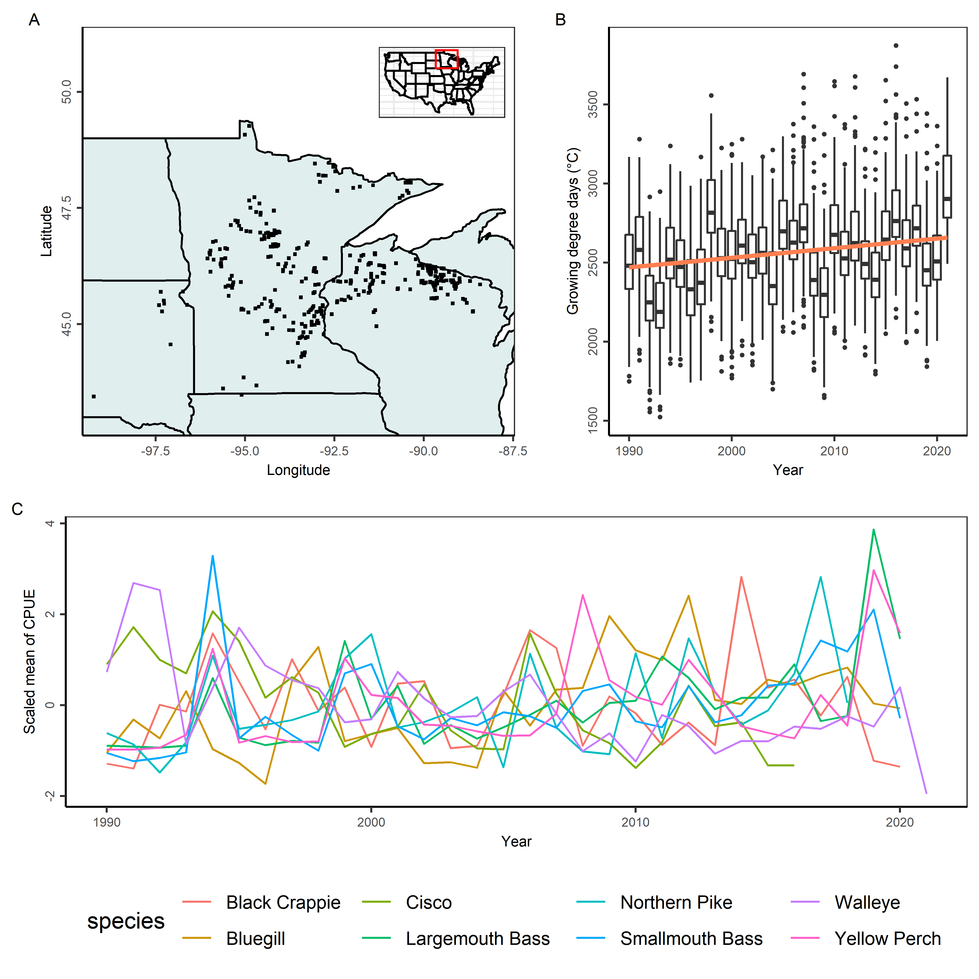

Fig.1. (A) The inset map with the red rectangle indicates the location of the study area in the United States, and the black dots on the map represent the lakes analysed. (B) The growing degree days from 1990 to 2021 for the lakes analysed. The orange line indicates a linear regression between growth degree days and year. In the boxplots, the solid line indicates the median, the box indicates the interquartile range (IQR; 25th to 75th percentiles), the whiskers indicate 1.5 times the IQR, and the points beyond the whiskers indicate outliers. (C) The fluctuations of the scaled mean of catch per unit effort (CPUE) of the eight species. The mean annual CPUE is calculated across all lakes where the abundance index is available.

Comments:

1. Panel A: Remove “Latitude” and “Longitude” axis titles; include “°N” and “°W” in axis labels; plot Canada; label states with abbreviations; make fill light grey (“grey90”) and make point color or size indicate the number of populations represented in that lake? Could make transparent or unfilled circles to show overlapping lakes
2. Panel A inset: Remove grid lines; make lines thinner
3. Panel B-C: Label years from 1990 to 2020 in intervals of 5
4. Panel C: Plot grey dotted line at zero to indicate the average for each species
5. Panel C: Remove “species” legend title or uppercase it; use “sentence case” for common names (e.g., “Black crappie”, “Northern pike”, etc.); would it be worth breaking into three panels for cold, cool, and warm water species?

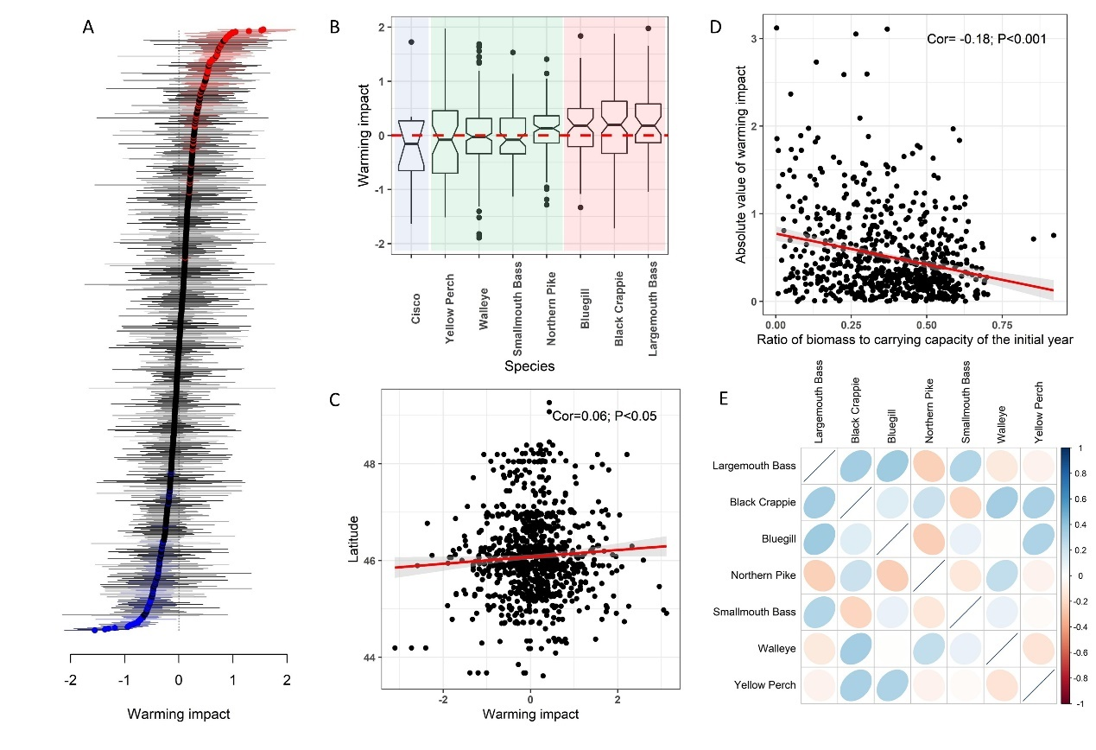

Fig.2. (A) Estimates of warming impact. Points show mean estimates and error bars show 95% confidence intervals. Significant positive and negative warming impacts are coloured red and blue, respectively. Describe vertical line at zero and describe what negative and positive values mean. (B) Estimates of warming impact grouped by eight species. Cold-water, cool-water, and warm-water species are delineated by the blue, green, and red shading, respectively. The thermal affinity classifications are based on either laboratory studies of thermal performance or suitable habitat index model for each species (citation). Optimal temperatures <18℃, 18℃<&< 25℃, and >25℃ are classified as cold-/cool- and warm-water species, respectively. In the boxplots, the solid line indicates the median, the box indicates the interquartile range (IQR; 25th to 75th percentiles), the whiskers indicate 1.5 times the IQR, and the points beyond the whiskers indicate outliers. (C) The relationship between latitude and warming impact. The correlation coefficient and the P value are printed on the figure. (D) The relationship between absolute value of warming impact and depletion rate (ratio of biomass over carrying capacity) of the initial year. The correlation coefficient and the P value are printed on the figure. (E) The correlations of estimates of warming impact for populations of cool-/warm-water species that coexist in the same lakes.

Comments

* Panel A – print number of sig. positive and number of sig. negative? What’s different between grey and black lines?
* Panel B – use same boxplot aesthetic as Figure 1B; remove grid-lines; align species names against axis (not centered); use “Sentence case” for species names
* Panel C – Use “Latitude (°N)” as y-axis title
* Panel D – remove grid lines; change x-axis to “Ratio of biomass to carrying capacity in the initial year”
* Panel E – give color bar legend a title

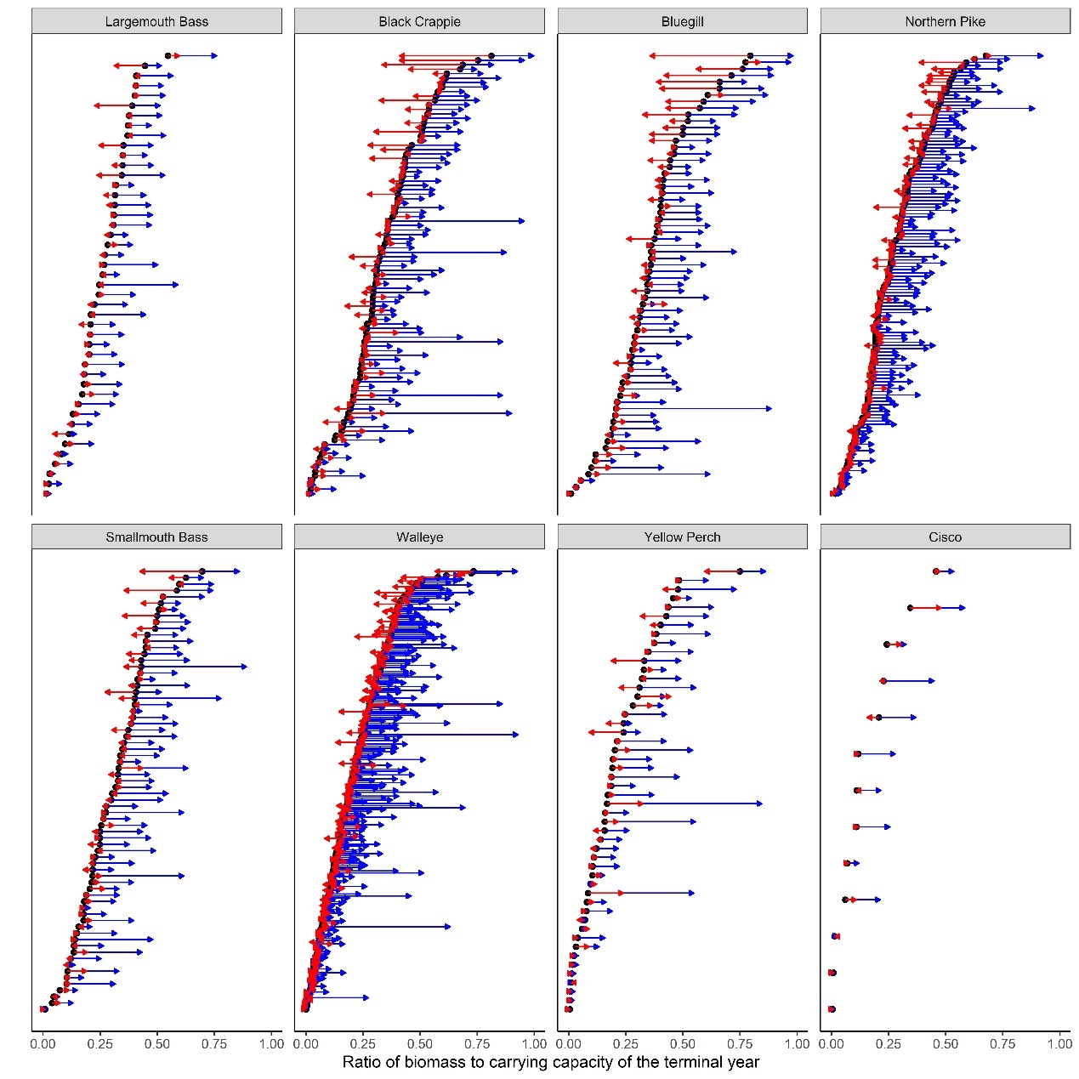

Fig.3. The depletion rates (ratio of biomass over carrying capacity) of the terminal years for each population grouped by species. The blue and red arrows point to the depletion rates in the absence of fishing and temperature variation, respectively.

Comments

* Use “Sentence case” for species name
* Add legend to explicity show what red / blue arrows mean so reader doesn’t have to look to the caption
* Is worth creating small sublots that show overlaid density distributions of the relative strength and direction of fishing and climate impacts?
* Change x-axis to “Ratio of biomass to carrying capacity in the terminal year” or consider the following “Depletion in terminal year \n (ratio of biomass to carrying capacity in the terminal year)”. What I like about this is that it gives us a simple pithy title with a title that explicitly defines it

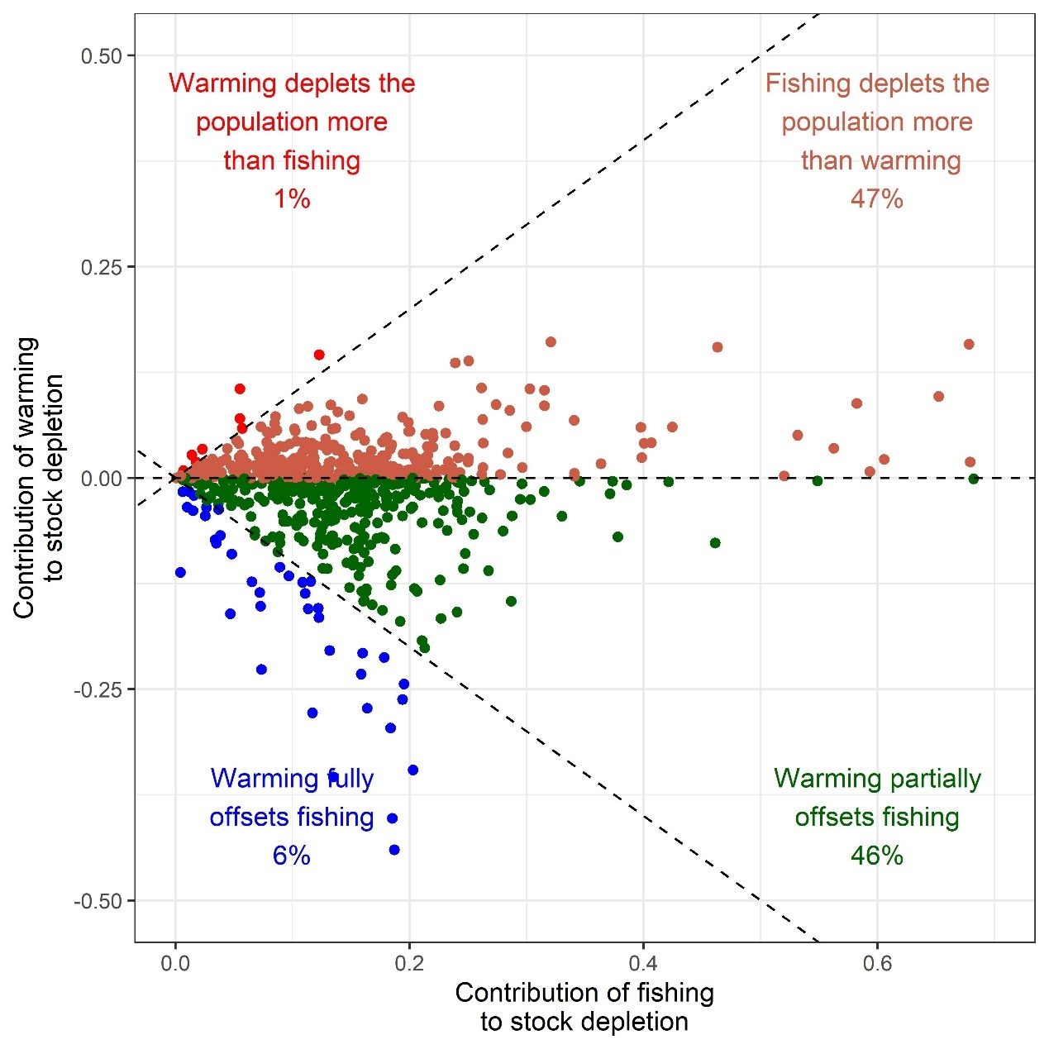

Fig.4. Comparison of relative contributions to stock depletion by temperature variation and fishing. The x-axis represents the difference of depletion rates in the terminal year with or without fishing. The y-axis represents the difference of depletion rates in the terminal year with or without temperature impacts. Describe the quadrants and what the percentages mean.

Comments:

* Remove gridlines
* Correct “deplets” to “depletes” in two places