**SI.1 Correlations of warming indices**

The correlations between GDDs_5 with other warming indices including growing degree days with base temperature at 0℃ or 10℃, open water duration, peak temperature of the year, and lake surface mean temperature of each month were calculated and the results were shown in Fig.S1. GDDs (base temperature at 5℃) was positively correlated with all other indices.

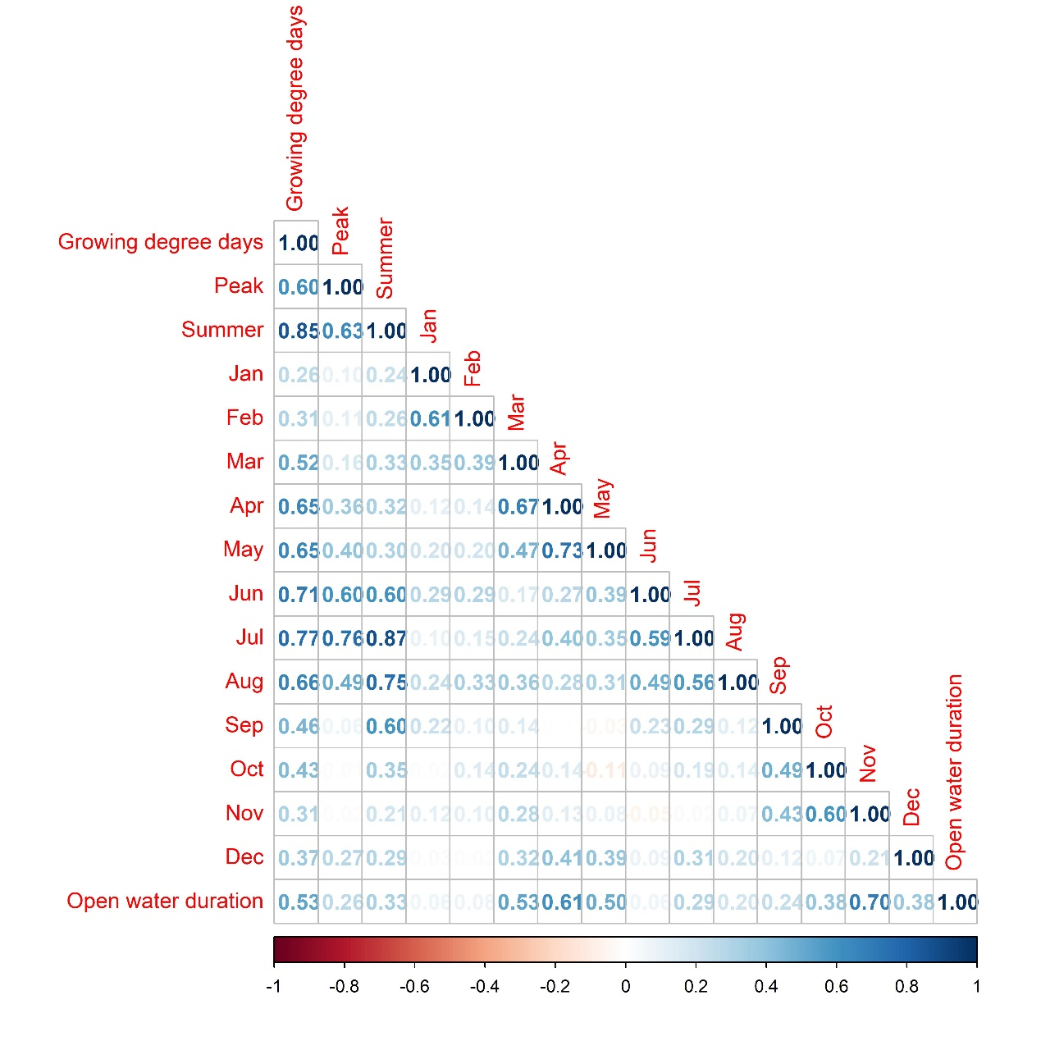

Fig. S1. The correlations between growing degree days (GDDs), open water duration, peak temperature of the year, lake surface mean temperature in summer, and lake surface mean temperature of each month

(the figure will be replaced)

**SI.2 Model validation simulation:**

Previous studies have shown that the parameter estimation of surplus production models can be influenced by how informative the input data are (). The lack of contrasts in historical fishing efforts and monotonically decreasing biomass trends (so-called “one way trip”) will result in the collected data being insufficiently informative about the dynamics of the populations concerned, hence is likely to produce biased parameter estimates. Here, we conducted a simulation study to verify whether the temperature-dependent surplus production model was able to estimate the parameter of warming effect with acceptable accuracy and precision by fitting the model to inconsecutive and imprecise harvest and CPUE data.

**SI.2.1 Simulation settings:**

We simulated six scenarios of different fishing patterns or biomass trends including (a) high fishing efforts and a low contrast in fishing efforts; (b) low fishing efforts and a low contrast in fishing efforts; (c) a high contrast in fishing effort; (d) a declining biomass trend with fluctuations; (e) an increasing biomass trend with fluctuations; and (f) a declining biomass trend followed by recovery. Fishing history was simulated for 40 years for all scenarios. (Fig.S2).

The standard deviations of observation errors for CPUE data from fishery-independent biological survey and recreational harvest data from creel survey were assumed to be 0.2. We assumed that the fishery-independent biological survey was conducted every 3 years and creel survey every 5 years. The frequencies were consistent with the average frequencies of the actual biological survey and creel survey. We assumed the standard deviation of process error in the population dynamic to be 0.1. The “true” warming effect was randomly sampled from a uniform distribution U(-1,1) for each simulation run. The time series of growing degree days (GDDs) for each simulation run were randomly extracted from the pool of real GDDs data set of the lakes studied. Stocking biomass and tribal harvest data were not included in the simulations as they were considered to be accurate without any observational error and therefore unlikely to cause estimation problems. The settings of the simulation are summarized in Tab.S5.

The generated data were used to fit the temperature-dependent surplus production model and to estimate the warming effect parameter. The estimates were then compared with the predetermined ‘true’ values. This procedure was repeated 50 times for each scenario. Note that the process error was assumed in the operating model of the simulation but not included in the estimating model.

**SI.2.2 Simulation results:**

For scenarios (a) and (c), the estimates of temperature effect are unbiased. Scenario (f) exhibits mild underestimation of the magnitude of temperature effect. For scenarios (b), the model systematically underestimates the magnitude of the temperature effect, with similar levels of underestimation regardless of whether the “true” warming effect is positive or negative. For scenario (d) and (e), model also tends to underestimate the magnitude of the temperature effect, however, with different levels of underestimation depending on whether the “true” warming effect is positive or negative (Fig. S3).

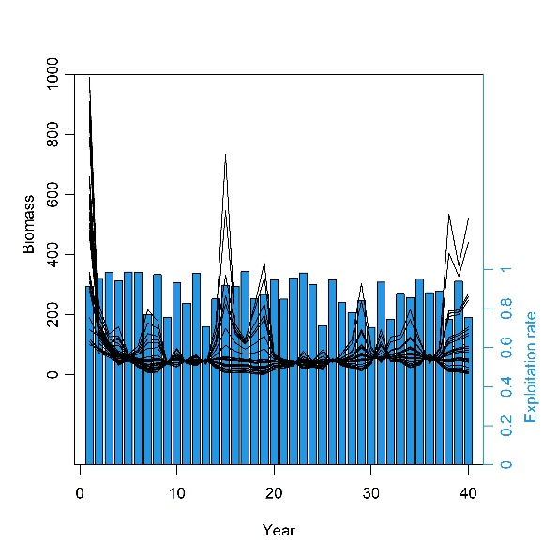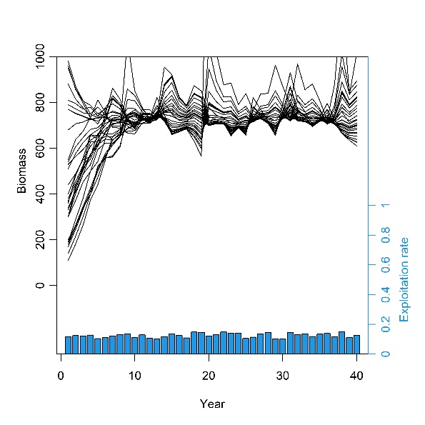

1. (b)

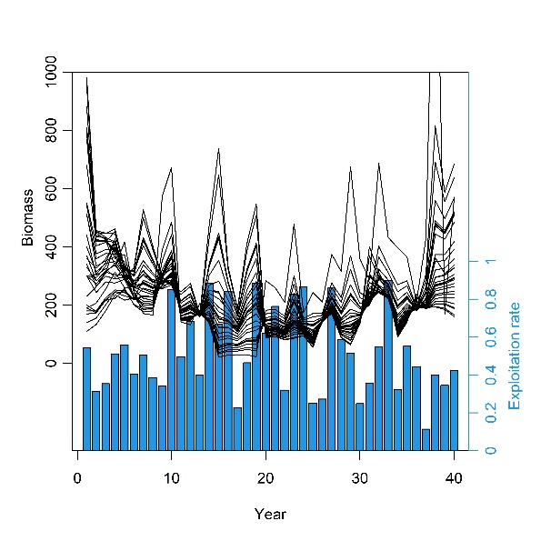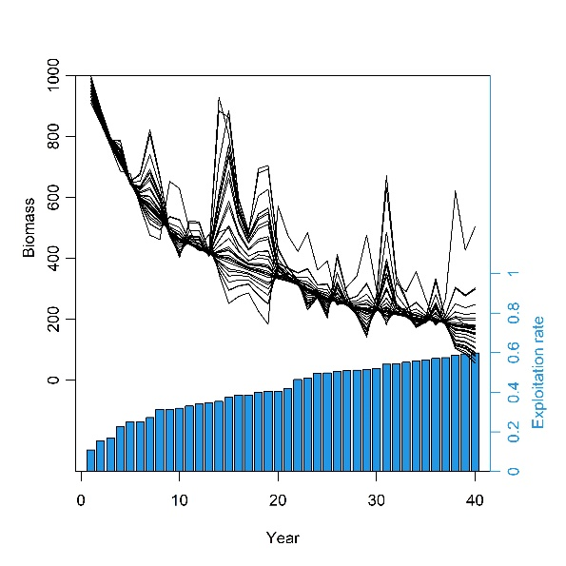

(c) (d)

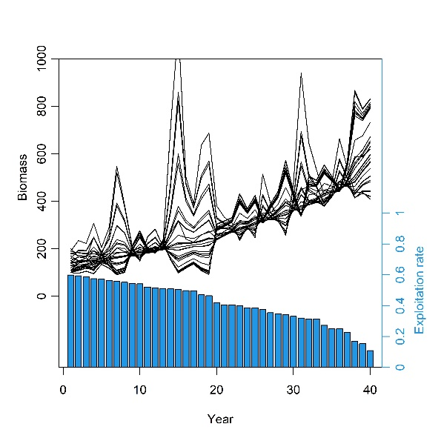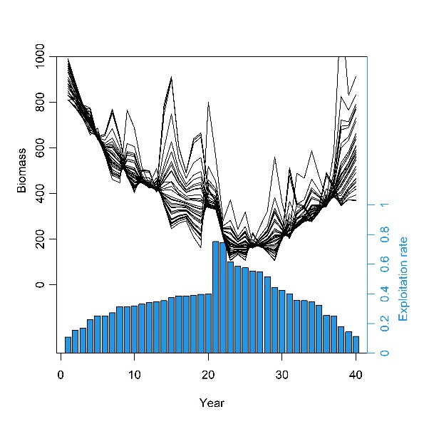

(e) (f)

Fig.S2 The biomass and exploitation rate of simulation scenarios characterized by (a) high fishing efforts and a low contrast in fishing efforts; (b) low fishing efforts and a low contrast in fishing efforts; (c) a high contrast in fishing effort; (d) a declining biomass trend with fluctuations; (e) an increasing biomass trend with fluctuations; and (f) a declining biomass trend followed by recovery.

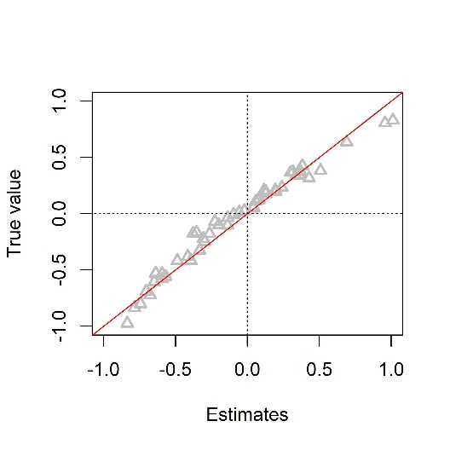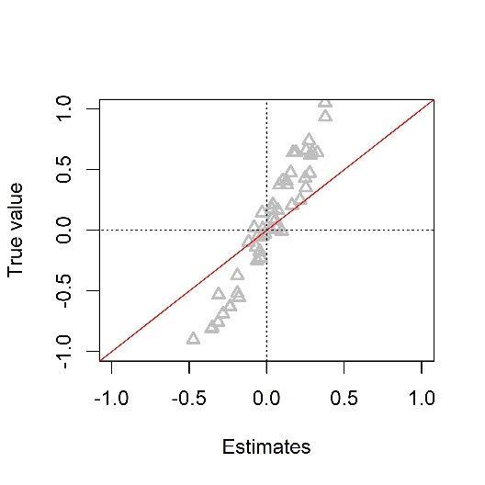

(a) (b)

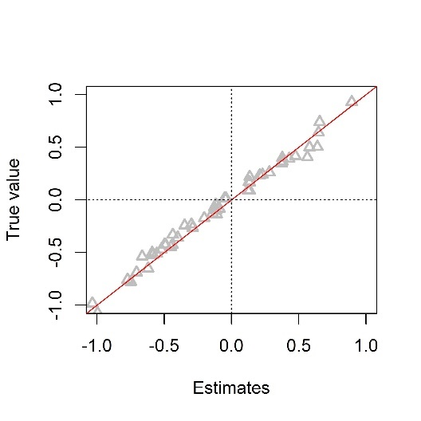 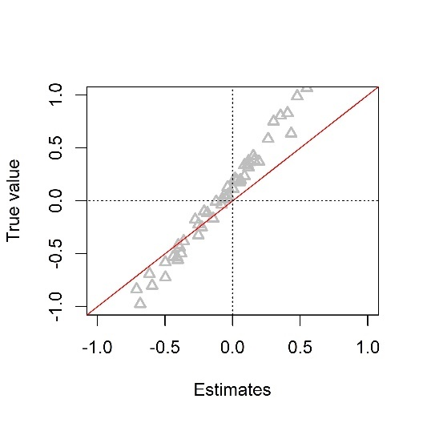

(c) (d)

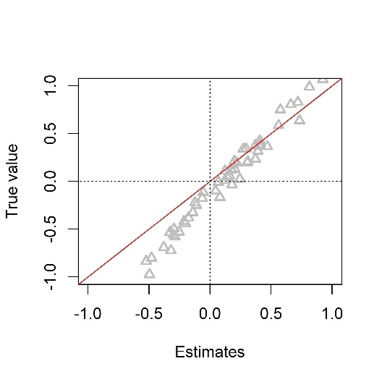 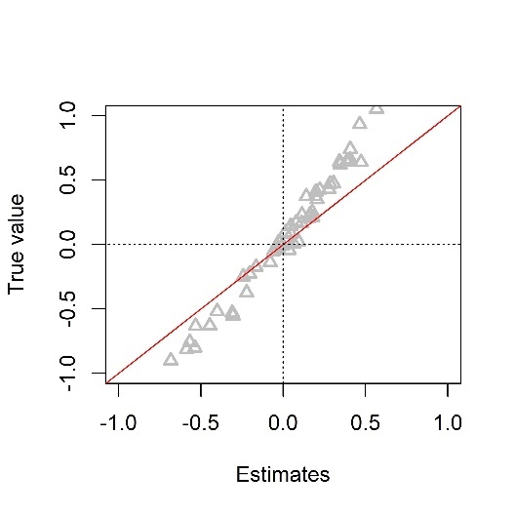

(e) (f)

Fig.S3. Comparison of true values and point estimates of temperature effect parameter in temperature-dependent surplus production model for simulation scenarios characterized by (a) high fishing efforts and a low contrast in fishing efforts; (b) low fishing efforts and a low contrast in fishing efforts; (c) a high contrast in fishing effort; (d) a declining biomass trend with fluctuations; (e) an increasing biomass trend with fluctuations; and (f) a declining biomass trend followed by recovery.

**SI.2.3 Point estimates adjustment:**

To correct the potential underestimation of the magnitude of warming effect in certain fishing pattern or biomass trajectory situations, we also provided the adjusted point estimates by multiplying estimates by average underestimation levels. The point estimates adjustment rules were as follows:

Rule one: If 90% of annual exploitation rates were under 0.2, the adjusted warming effect was 1.92 times original point estimate (corresponding to simulation scenario (b)).

Rule two: Calculated the difference in biomass between the two adjacent years (). If 80% of were negative, the adjusted warming effect was 1.73 times original point estimate when the estimate was positive and 1.25 times original point estimate when the estimate was negative (corresponding to simulation scenario (d)).

Rule three: Calculated the difference in biomass between the two adjacent years (). If 80% of were positive, the adjusted warming effect was 1.05 times original point estimate when the estimate was positive and 1.82 times original point estimate when the estimate was negative (corresponding to simulation scenario (e)).

Rule four: No adjustment for other situations.

**SI.3. Model structure sensitivity analysis:**

Previous simulation studies have suggested that the shape parameter in Pella-Thomlison model is difficult to estimate accurately (). Here, to test the sensitivity of temperature effect estimations to potential mismatch of shape parameters, we also fitted the data to two most commonly used surplus production models (i.e., Fox model and Schaefer model) that fixed shape parameters with different known values (Tab. S5). The results showed that the warming effect estimation was robust to the shape parameter value (Fig. S4)

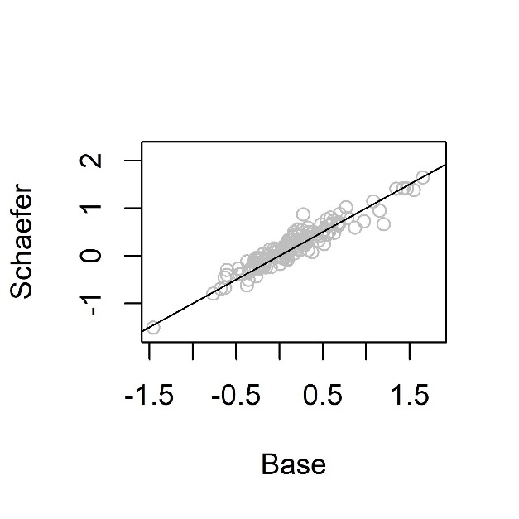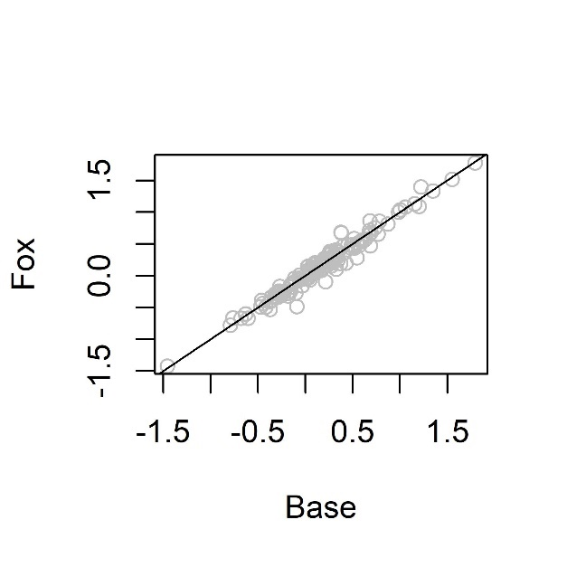

Fig.S4. Comparison of warming effect estimates from Pella-Thomlinson, Schaefer, and Fox surplus production model

**SI.4. Parameter prior sensitivity analysis:**

We tested whether the standard deviation of priors for carrying capacity *k* and warming effect *θ* limited estimating the magnitude of *θ*. We increased the standard deviation of the two prior distributions and fitted the model. Results showed robustness of estimation of *θ* to the priors (Fig. S5).

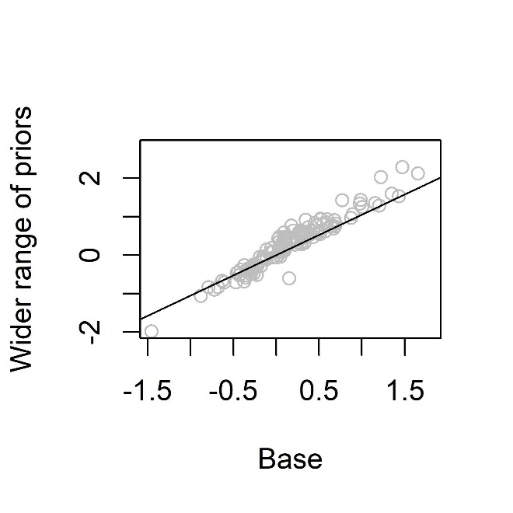

Fig.S5. Comparison of warming effect estimates from PT surplus production model with different priors

**SI.5. Null model:**

To test whether the estimates of warming effect came out by chance as an artefact of model structure, we compared the results from base models with those from null models in which the time series of growing degree days (GDDs) were randomly re-ordered. For each population, the corresponding time series of GDDs were randomly re-ordered for twenty times and each time series was used to fit the model and estimate the warming effect. We found significantly stronger pattern of warming effect from base models than that would be expected by chance from null models (Fig S6).

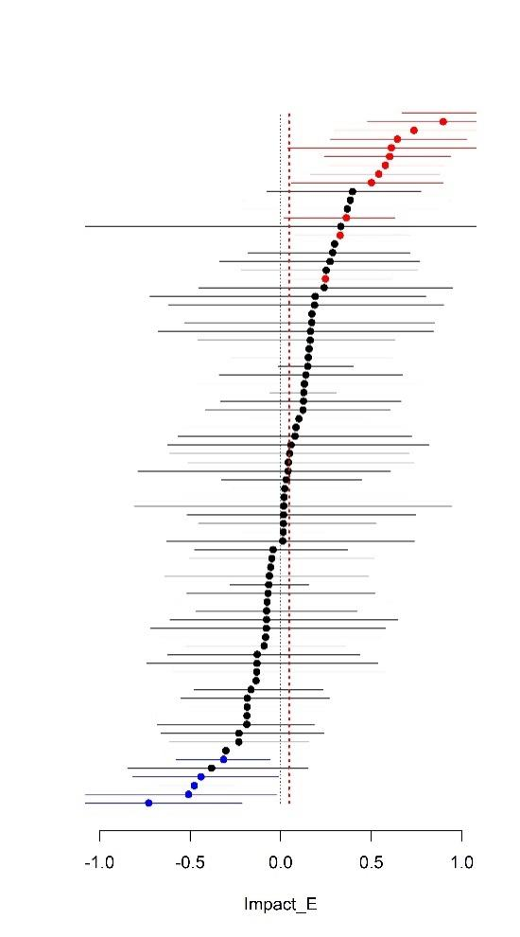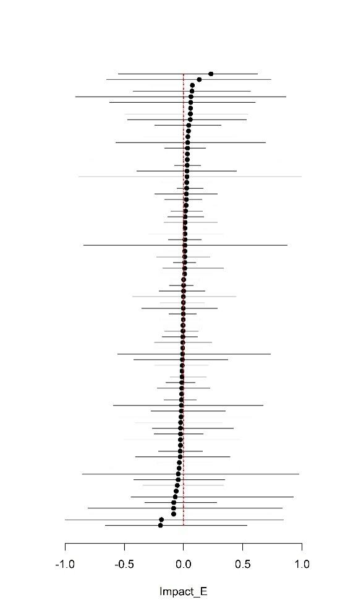

Fig.S6. Warming effect estimates from base model (left) and null model (right)

(The figure will be replaced)

Tab. S1. Details of fishery-independent biological surveys used to derive relative biomass indices

(The table will be updated including other states)

|  |  |  |  |  |  |
| --- | --- | --- | --- | --- | --- |
| State | Species | Survey gear | Effort units | Survey time | Sources |
| Wisconsin | Largemouth bass | Boom shocker | miles of fishing | Apr,May,June | WDNR FM Handbook |
| Wisconsin | Smallmouth bass | Boom shocker | miles of fishing | Apr,May,June | WDNR FM Handbook |
| Wisconsin | Cisco | Gill net | number of nets&nights | June,July,Aug | Feiner 2020 |
| Wisconsin | Bluegill | Boom shocker | miles of fishing | Apr,May,June | WDNR FM Handbook |
| Wisconsin | Walleye | Fyke net | number of nets&nights | Mar, Apr, May | Feiner 2020 |
| Wisconsin | Yellow perch | Fyke net | number of nets&nights | Mar, Apr, May | Feiner 2020 |
| Wisconsin | Northern pike | Fyke net | number of nets&nights | Mar, Apr, May | Feiner 2020 |
| Wisconsin | Black crappie | Fyke net | number of nets&nights | Mar, Apr, May | Feiner 2020 |
| Minnesota | Largemouth bass | Trap net | number of nets&nights | Mar~Nov | MDNR Survey Manual pg. 85-86 |
| Minnesota | Smallmouth bass | Gill net | number of nets&nights | Mar~Nov | MDNR Survey Manual pg. 79 |
| Minnesota | Cisco | Gill net | number of nets&nights | Mar~Nov | MDNR Survey Manual pg. 79 |
| Minnesota | Bluegill | Trap net | number of nets&nights | Mar~Nov | MDNR Survey Manual pg. 85-86 |
| Minnesota | Walleye | Gill net | number of nets&nights | Mar~Nov | MDNR Survey Manual pg. 79 |
| Minnesota | Yellow perch | Gill net | number of nets&nights | Mar~Nov | MDNR Survey Manual pg. 79 |
| Minnesota | Northern pike | Gill net | number of nets&nights | Mar~Nov | MDNR Survey Manual pg. 79 |
| Minnesota | Black crappie | Trap net | number of nets&nights | Mar~Nov | MDNR Survey Manual pg. 85-86 |

Table.S2 Prior ranges for intrinsic growth rate (*r*) based on species-specific resilience

|  |  |  |
| --- | --- | --- |
| Species | Resilience | Intrinsic growth rate (*r*) range |
| Largemouth bass | Low | 0.05~0.5 |
| Smallmouth bass | Medium | 0.2~0.8 |
| Cisco | Low | 0.05~0.5 |
| Bluegill | Medium | 0.2~0.8 |
| Walleye | Low | 0.05~0.5 |
| Yellow perch | Medium | 0.2~0.8 |
| Northern pike | Low | 0.05~0.5 |
| Black crappie | Medium | 0.2~0.8 |

Tab. S3. Parameter values in the simulated operating model

|  |  |
| --- | --- |
| Parameter | Value |
| Intrinsic growth rate (*r*) | 0.35 |
| Carrying capacity (*k*) | 1000 |
| Catchability coefficient (*q*) | 0.01 |
| Ratio of biomass over k of the initial year (*P_initial*) | Randomly sampled from U(0,1) |
| Warming effect (*θ*) | Randomly sampled from U(-1,1) |
| Shape parameter (*m*) | 2 |
| Fishing mortality (*F*) | Scenario-specific (see Fig. S1) |
| SD of observation error in recreational harvest (*σ_ȵ*) | 0.2 |
| SD of observation error in relative biomass index (*σ_ε*) | 0.1 |
| SD of process error (*σ_p*) | 0.1 |

Tab.S4 Prior distributions of parameters for the base case model

|  |  |  |
| --- | --- | --- |
| Parameters | Prior distribution | Distribution parameter values |
| Intrinsic growth rate (*r*) | Lognormal | Based on species-specific resilience |
| Carrying capacity (*k*) | Lognormal | mean = log ((max(harvest)+10000*max(harvest))/2); SD = (mean-log(max(harvest))) /2 |
| Catchability coefficient (*q*) | Improper | p(q)∝1/q |
| Ratio of biomass over k of the initial year (*P_initial*) | Beta | shape (α)=1; shape (β)=1 |
| Warming effect (*θ*) | Normal | mean=0; SD=2 |
| Shape parameter (*m*) | Skew normal | location=-0.5; scale=1; shape=10 |
| Instantaneous fishing mortality (*F*) | Exponential | rate (λ)=1 |
| Variance of observation error in recreational harvest (*σ_ȵ^2*) | Inverse gamma | shape (α)=4; scale (β)=0.01 |
| Variance of observation error in relative biomass index (*σ_ε^2*) | Inverse gamma | shape (α)=4; scale (β)=0.01 |

Tab. S5. Parameter settings for the sensitivity analysis

|  |  |  |  |  |
| --- | --- | --- | --- | --- |
| Parameters | Prior distribution | Prior sensitivity scenario | Model sensitivity scenario (Schaefer) | Model sensitivity scenario (Fox) |
| Intrinsic growth rate (*r*) | Lognormal | |  | | --- | | The same as base model | | |  | | --- | | The same as base model | | |  | | --- | | The same as base model | |
| Carrying capacity (*k*) | Lognormal | mean = log ((max(harvest)+100000*max(harvest))/2); SD = (mean-log(max(harvest)))^0.5/2 | The same as base model | The same as base model |
| Catchability coefficient (*q*) | Improper | The same as base model | The same as base model | The same as base model |
| Ratio of biomass over k of the initial year (*P_initial*) | Beta | |  | | --- | | The same as base model | | |  | | --- | | The same as base model | | |  | | --- | | The same as base model | |
| Warming effect (*θ*) | Normal | mean=0; SD=10 | The same as base model | The same as base model |
| Shape parameter (*m*) | Skew normal | |  | | --- | | The same as base model | | |  | | --- | | Fixed at 2 | | |  | | --- | | Fixed at 1.01 | |
| Instantaneous fishing mortality (*F*) | Exponential | The same as base model | The same as base model | The same as base model |
| Variance of observation error in recreational harvest (*σ_ȵ^2*) | Inverse gamma | The same as base model | The same as base model | The same as base model |
| Variance of observation error in relative biomass index (*σ_ε^2*) | Inverse gamma | The same as base model | The same as base model | The same as base model |