**Disentangling the impacts of climate warming and fishing pressure on freshwater fish populations**

Alternative title: **The relative impacts of warming and fishing on freshwater fish populations**

**Abstract:**

Climate change and fishing pressure are the two most widespread drivers of change in the abundance of freshwater fish populations. However, the relative importance of these two stressors has been widely debated given the challenge of disentangling their impacts on fish populations. Using a temperature-dependent population dynamics model, this study simultaneously quantifies the impact of lake warming and fishing on the abundance of freshwater fish populations in the American Midwest. Of the 520 evaluated populations, 77 populations (15%) had a significant positive response to warming and 67 populations (13%) had a significant negative response to warming. The directions and magnitudes of the warming impacts were related to the thermal affinity of the species and the level of exploitation experienced by the population. Only 1% of populations were depleted more by temperature variation than fishing. For 47% of populations, temperature exacerbated depletion, but to a lesser extent than fishing. Temperature variation fully or partially compensated for depletion caused by fishing for 6% and 46% of populations, respectively. An accurate understanding of the primary causes of population fluctuations and the mechanisms by which fish populations respond to climate change can aid in effective fisheries management.

**Keywords:** fish productivity; fishery population dynamics; surplus production model; climate change

**Significance:**

The impact of fishing and climate change on freshwater fish populations is widely debated given the difficulty in distinguishing their effects. Using a new temperature-dependent model for population dynamics that fits typical inland fishery data, we found that fishing has had a greater impact than warming on >500 fish populations in recent decades. Our results highlight the importance of both proper local fisheries management and global efforts to reduce warming to preserve the sustainability of these fish populations and their valuable fisheries. Effective fisheries management will improve population resilience to climate change, while limiting global warming will prevent limit the impact of future temperature increases on fish populations from surpassing its past level.

**Introduction:**

Climate change, manifested primarily by the increase in global atmospheric temperature, is significantly altering the freshwater habitats of inland lakes (citation). These changes affect the abundance of the fish populations that inhabit these waters through a series of physiological, biochemical, and ecological processes (). For example, warming can directly affect the seasonal thermal structure of lakes (), exposing certain fish populations to temperatures outside their optimal ranges, while making thermal conditions more suitable for other populations. Warming can also affect the dynamics of freshwater fish populations through decreases in dissolved oxygen (), reduction and shortening of ice cover (), changes in plankton bloom phenology (), and increases in toxic algae blooms ().

The responses of fish populations to warming are likely to vary inter- and intraspecifically. Warm- and cold-water species may respond to warming in opposite directions based on their species-specific thermal requirements (). Populations of the same species may respond differently to warming, depending on their geographic position or local adaptations to thermal regimes (). This variation in response to warming is demonstrated by a meta-analysis of global marine fish and invertebrates, which revealed that populations benefiting from historical ocean warming were roughly offset in number and magnitude by those negatively affected (). However, similar studies on freshwater fish populations are currently lacking. While the general effects of warming on freshwater fish species from different thermal guilds have been studied (citation), the potentially heterogeneous effects of warming on the abundance of individual populations at regional or global scales are not yet well understood.

One of the challenges in assessing the effects of warming on freshwater fish abundance is that warming rarely occurs in isolation from other stressors, creating complex and intertwined effects on fish population dynamics (citation). For populations of species targeted by recreational or subsistence fisheries, fishing is generally the most widespread and significant stressor. Therefore, an inability to accurately disentangle the joint effects of changes in fishing pressure and temperature on population abundance can lead to incorrect understanding of the cause of population fluctuations, which can result in ineffective or even detrimental management actions (citation).

Separating the impact of fishing and warming on freshwater fish abundance is thus critical to fishery managers seeking to identify management strategies that address the effects of both stressors (). Local and regional management agencies in the United States have developed adaptation strategies, such as regulating harvest and fish stocking (i.e., the practice of releasing fish cultivated from hatcheries into target lakes), to maintain sustainable fisheries and mitigate the effects of warming (citation). Although collective action to reduce greenhouse gas emissions and slow the pace of climate warming is the ultimate solution to conserving most fish and fisheries globally (), accurately quantifying the respective contributions of fishing and warming to changes in fish abundance can help managers prioritize practical measures that can be locally implemented.

In this study, we investigate the relative impacts of fishing and warming on 520 fish populations of eight species (walleye, northern pike, smallmouth bass, largemouth bass, cisco, yellow perch, black crappie, and bluegill) in the Midwestern United States over the past three decades (1990-2021). The US Midwest region presents an ideal case study due to the presence of diverse freshwater fish species that support prized recreational and subsistence fisheries and are experiencing rapid warming (Fig. 1). However, it also faces monitoring challenges that are common to many inland fisheries. The presence of a large number of geographically dispersed lakes means that monitoring surveys are sporadic and rarely occur in consecutive years. Furthermore, unlike in large-scale commercial fisheries where catch reporting is often required, recreational harvest data estimated from voluntary angler interviews (“creel” surveys) are considered less precise. Here, we developed a temperature-dependent population dynamics model to disentangle the impacts of fishing and lake warming on population dynamics while overcoming the common challenges posed by sparce and imprecise monitoring in inland fisheries. We conduct rigorous simulation testing and sensitivity analysis to confirm model skill despite limited data. Finally, we simulate two scenarios that assume the absence of fishing or temperature variation, respectively, to disentangle the impacts of the two factors on the abundance of freshwater fish populations. The application of this scalable approach in other regions would improve our understanding of the relative importance of fishing and climate change on the fluctuations of freshwater fish populations globally.

**Materials and Methods:**

*1. Data sources and data characteristics*

Our temperature-dependent population dynamics model requires time series documenting three types of data for each population: (1) an index of relative abundance; (2) fishery removals and subsidies from stocking programs; and (3) environmental experience.

*1.1 Index of relative abundance*

Relative abundance indices for each population were obtained from the fishery-independent biological surveys conducted by the Department of Natural Resources in Minnesota, Wisconsin, and South Dakota. The surveys employed a range of gears, including boom shocker, gill net, fyke net, trap net, and frame net, selected by respective state agencies to monitor different species. Experts were consulted to determine the index from the gear that most accurately reflects changes in abundance for each state and species (Table S5).

*1.2 Fishery removals (harvest) and subsidies from stocking programs*

All of the evaluated populations are subject to recreational fishing and a portion of them are subject to tribal spearing or netting pressure. Recreational harvests were estimated from creel surveys conducted by the Department of Natural Resources of each state and were obtained from the CreelCat database (downloaded on June 4, 2022). Since creel surveys are not a census, the estimated harvests are prone to sampling errors and were thus treated as observations (instead of known quantities) in the temperature-dependent population dynamics model. Tribal harvests were obtained from the Great Lakes Indian Fish and Wildlife Commission (GLIFWC), which collects tribal harvest data. Because all tribal fishing operations are monitored and all harvests are recorded, we treated tribal harvests as known quantities in the model. Finally, some populations receive subsidies in the form of stocking from state-run hatcheries. The biomass of fish added to each population was obtained from the stocking reports released by the Department of Natural Resources of each state. Stocking biomass was also treated as known quantities in the model. Both harvest and stocking data are inputted in the model as weight in kilograms.

*1.3 Environmental data*

Environmental data for each lake was obtained from a process-based water temperature model verified and released by the U.S. Geological Survey (citation). Growing degree days (GDDs), a measure of thermal energy above 5℃ at the lake surface, was used as the climate warming index as it describes cumulative thermal energy across the year. The selection of the GDD index was validated by comparing its correlation with other warming indices, including GDDs with base temperatures of 0℃ or 10℃, open water duration, peak temperature of the year, and monthly mean lake surface temperature. Positive correlations were found between GDDs and all other indices (Figure S1).

*2. Model development*

*2.1 Base surplus production model*

The biomass of a fish population after a certain time interval (e.g., a year) is equal to the biomass before that time interval, plus the recruitment, somatic growth of individual fish, and biomass added through stocking (if present), and minus mortality due to natural processes and fishing (if present). Growth in biomass is commonly assumed to follow a density-dependent logistic pattern. These dynamics are often described using the Pella-Tomlinson surplus production model: ():

(1)

where *k* is the carrying capacity; *r* is the intrinsic growth rate of the population; is stock biomass at year *y*; *Cy* is the catch in year *y*; and *Sy* is the stocked biomass in year *y*; The second quantity in equation (1) represents the surplus production in year *y* where *m* is a shape parameter that determines the *B/k* ratio where maximum surplus production would be attained. When the shape parameter *m* is two, the model is equivalent to the Schaefer surplus production model (citation), with the maximum surplus production attaining at half of the carrying capacity. The Pella-Tomlinson model is equivalent to the Fox model (citation) if shape parameter *m* approaches one, resulting in maximum surplus production attained when biomass equals 0.37*k*.

*2.2 Incorporation of observation errors*

We modified the Pella-Thomlinson surplus production model to address the issue of nonconsecutive and imprecise data for relative abundance index and recreational harvests commonly faced in inland fisheries. The main modification to the model was that annual recreational harvests were not treated as known and accurate quantities, as assumed in the base model, but rather as observations subject to observation error. The inclusion of observation errors in the relative abundance index is, nevertheless, a standard practice. The modified model is written as follows:

(2)

when is available (3)

when is available(4)

where is the instantaneous recreational fishing mortality in year *y*; is the tribal harvest in year *y*; *Iy* is the relative abundance index in year *y*; *q* is the catchability coefficient; *Cy* is the recreational harvest in year *y*; *ȵy* and are observation errors for relative abundance index and recreational harvests. The observation errors are assumed to follow normal distributions, i.e., , and where and are the variances of the respective observation errors. The other parameters are the same as in the base Pella-Thomlinson model described in equation (1).

*2.3 Temperature-dependent extension*

We then incorporated a multiplicative temperature effect term into the model to quantify the effect of warming on surplus production. The modified temperature-dependent surplus production model is written as follows:

(5)

where is the parameter of warming effect and represents the growing degree days in year *y*. is standardized and centered on the mean, so that a positive suggests positive impact of warming on surplus production and vice versa. The other parameters are the same as in equation (2).

*2.4 Reparameterization*

Finally, we reparametrized the model by replacing biomass (*B*) with the ratio of biomass over *k* (i.e., depletion) to improve the performance of model fitting (). The reparametrized model is written as follows:

(6)

where is the depletion in year *y*. The other parameters are the same as in equation (5).

*3. Model fitting*

*3.1 Prior distributions specification*

The model parameters were estimated using a Bayesian approach. We used non-informative or weak-informative prior distributions for all parameters. The prior ranges for the intrinsic growth rate *r* were determined based on species-specific estimates of resilience, which describe the capacity of a population to recover to its original state after disturbance (Table S2). For the carrying capacity *k*, the lower bound of the range was set equal to the maximum harvest, and the upper bound was 10,000 times the maximum harvest. Since the log-normal prior was considered to have better convergence properties than the uniform prior (), the ranges were converted into log-normal priors with the mean and standard deviation calculated by the following functions:

(7)

(8)

where and are the lower and upper bound of the range.

The catchability coefficient *q* was given an improper prior, specifically p(q)∝1/q. An improper prior is a function whose indefinite integral is infinite (contrary to probability density functions whose indefinite integral is a constant) and which provides no information for the posterior distributions. *p_initial* (depletion in the initial year), a ratio, followed a Beta distribution so it would be bounded by [0,1]. The logarithm of the shape parameter *m* followed a skew normal distribution to penalize small values of *m* that imply implausibly high population growth rates at very low population sizes. Instantaneous fishing mortality *F* was assigned an exponential distribution that corresponds to a uniform prior bounded by [0,1] on the proportion of biomass removed by fishing. The variances of observation errors associated with both the relative abundance index and recreational harvest followed an inverse gamma distribution that was conjugated to the normal distribution. The prior of warming effect *θ* followed a normal distribution with mean equal to 0 and standard deviation equal to 1. The distribution implies that the direction of warming effect (i.e., positive or negative) depends entirely on data. The standard deviation was set in reference to the study by Free *et al*’s about the impact of temperature on marine species productivity. The normal distributionwith a larger standard deviation was tested in a sensitivity analysis to ensure that the magnitude of the warming effect was not underestimated by the confinement of the prior distribution. See Table S3 for a summary of priors for all parameters.

*3.2 Model execution and convergence*

Model fitting was performed using Stan through the R package “rstan” (). Four chains of 20,000 iterations each were run, with the first 10,000 designated as warmup. This process produced a total of 40,000 posterior samples for each fitted model. The convergence of each model was verified by split- (<1.05) and by inspecting the trace plot for each parameter ().

*4. Model validation*

To validate the ability of the model to estimate the effect of warming, we performed (1) a simulation study; (2) a null model test; (3) and a sensitivity analysis.

*4.1 Simulation study*

Previous research has demonstrated that the performance of parameter estimation in surplus production models can be affected by the informativeness of input data (). In particular, a lack of contrast in historical fishing effort can lead to insufficiently informative data regarding population dynamics, potentially resulting in biased parameter estimates. In addition, the quantity of available data (i.e., relative abundance index and annual recreational harvest) varies significantly across fish populations. It is therefore important to determine a minimum required data quantity below which the model results may not be reliable. To address these concerns, we conducted a simulation study to investigate the model's ability to estimate the parameter of warming effect with acceptable accuracy and precision under different fishing pattern and data quantity scenarios. The simulation study revealed that the model exhibited satisfactory performance in general, however, it encountered difficulties when the quantity of data was inadequate or the population in question had been consistently exposed to low fishing pressure. Based on the results of the simulation, we determined that a minimum of four relative abundance index data points and two recreational harvests data points were required to produce reliable model results. Populations with less data than this were excluded from our model fitting. This resulted in a reduction in the number of eligible populations from XXX to 520 (XXX populations excluded). After fitting the model, we evaluated the estimated exploitation rate with the intent to exclude any results with a history of consistent low fishing pressure (highest exploitation rate less than 0.2). However, none of the populations met this criterion, which is not very surprising given that the analyzed populations were in lakes with high fishing activities and thus were prioritized and monitored by managers. See the Supplementary Material for details on the full simulation analysis.

*4.2 Null model testing*

To determine whether the estimates of warming effect were a artifact, we implemented a null model analysis. We compared the results from our model with those generated by null models in which the time series of GDDs were randomly re-ordered. For each population, we randomly re-ordered the corresponding time series of GDDs twenty times, and used each re-ordered time series to fit the model and estimate the warming effect. Essentially, this analysis evaluates whether the model would find similar rates of statistically significant temperature impacts when, in fact, no relationship between temperature and population dynamics was present. The results indicated a significantly stronger pattern of warming effect from our model than would be expected by chance from the null models (Figure S3).

*4.3 Sensitivity analysis*

Previous studies have shown that the shape parameter in the Pella-Thomlinson model can be difficult to estimate accurately (). To address this challenge and investigate the robustness of estimates of warming impact to different specifications of the shape parameter, we conducted a sensitivity analysis. In this analysis, the shape parameter was fixed at two distinct values (2 and 1.001) as specified in the widely used Schaefer and Fox surplus production models. The results of this analysis indicate that the estimate of warming impact was not sensitive to the specification of shape parameter (see Supplementary Material for full details). Additionally, to ensure that the magnitude of the warming effects were not underestimated due to confinement by the normally distributed prior, we conducted a second sensitivity analysis in which the standard deviation of the normal distribution was increased from two (the benchmark model specification) to five. The results showed that the magnitudes of warming impact estimates did not increase significantly with the increase in the standard deviation of the normal prior distribution. This suggests that the specification of the shape parameter and prior distribution for warming impact did not significantly affect the overall conclusion of the study. See the Supplementary Materials for details on both sensitivity analyses.

*5. Disentangling the effect of temperature variation and fishing*

We quantitatively evaluated the relative impacts of warming and fishing on population abundance by conducting simulations under two hypothetical scenarios - one in which fishing was absent (which reveals the contribution of fishing to population abundance) and another in which warming was absent (which reveals the contribution of temperature variation to population abundance). In the scenario where fishing was absent, we set fishing mortality (*F*) and subsistence harvest to zero while maintaining all other parameters at their estimated values. In the scenario where warming was absent, we set the warming effect (*θ*) to zero, effectively eliminating temperature variation, while keeping all other parameters at their estimated values. The population dynamics model was then re-run and depletion (*B/k*) in the terminal year was calculated for both scenarios. Comparing the terminal year's depletion from the benchmark model with those from the two hypothetical simulations, we were able to gain an quantitative understanding of the relative impact of fishing and temperature variation on population abundance. Specifically, the difference in terminal year depletion between the benchmark model and the no-fishing scenario represents the exclusive contribution of fishing on population depletion. Similarly, the difference in terminal year depletion rates between the benchmark model and the no-temperature-variation scenario represents the exclusive contribution of temperature variation on population depletion. Note that, unlike fishing which can only reduce abundance and thus only result in a positive difference, this difference could be negative, indicating an increase in abundance due to temperature change.

**Results:**

Of the 520 populations analyzed, 77 populations (15%) had a significant positive response to warming and 67 populations (13%) had a significant negative response to warming (Fig. 2A). By comparing with a null model, the estimated temperature effects show stronger patterns than would be expected from random chance (Figure SX). The estimation of temperature effects was also robust to model specification and parameter priors (Figure SX and SX). (13%)

The warming impacts were strongly determined by the thermal affinity of the species. The median of warming impacts was positive for warm-water species (i.e., largemouth bass, bluegill, and black crappie) and negative for cold-water species (i.e., cisco). For cool-water species, the average response of northern pike to warming was positive, while the average responses of the other three species (i.e., smallmouth bass, walleye, and yellow perch) were negative (Fig. 2B). A significant negative correlation was found between the absolute values of warming impacts and population depletion (ratio of biomass to carrying capacity) in the initial year (Fig. 2C). This suggests that the less-depleted populations were more resistant to the impacts (whether positive or negative) of temperature change.

Fig.3 showed the correlations between the warming impacts of different species in the same lakes. The warming impacts exhibited universally positive correlations between different warm-water species that inhabited the same lakes. Some strong negative correlations were observed among cool-water species and between cool-water species and warm-water species (e.g., smallmouth bass vs. black crappie, smallmouth bass vs. yellow perch, and northern pike vs. bluegill).

The population depletion in the terminal years varied significantly both among and within species (Fig.4). Fig.4 also displayed the depletion rate under two hypothetical scenarios: no fishing (represented by blue arrows) and no temperature variation (represented by red arrows). It was visually apparent that in the majority of populations, fishing had a greater impact on the depletion rate compared to temperature variation. Further analysis revealed that only 1% of populations were depleted more by temperature variation than fishing. For 47% of populations, temperature exacerbated depletion, but its impact was smaller than fishing. For 6% and 46% of populations, temperature variation fully or partially compensated for depletion caused by fishing (Fig. 5). Overall, fishing had a greater impact on changing abundance in the vast majority of populations (93%), compared to temperature variation.

**Discussion:**

Our findings show that fishing is the major contributor to abundance declines for most of the evaluated freshwater fish populations, outpacing the negative impacts of temperature variation. This highlights the vital importance of local fisheries management in safeguarding the sustainability of freshwater fish populations and the prosperity of inland fishery industry valued at $190 billion globally (citation). Even for the cold-water species experiencing the most harm from historical warming, our results show that fishing still led to a greater decline than temperature change in the majority of populations (4 of 5 cisco populations). Hence, appropriate local fisheries management can effectively mitigate the negative effects of climate change and has the potential to revive highly-depleted populations, provided that future warming is kept to a level where its magnitude of impact on freshwater populations does not differ significantly from past observations. Furthermore, the high prevalence of highly-depleted population status estimated by our model contradicts the popular myth that recreational fishing, which makes up most of the total harvest, is self-regulating (citations), further emphasizing the need for top-down fishery management to achieve sustainability objectives ().

Our findings also suggest that the magnitude of the warming impact is greater in populations that have suffered more severe depletion. This correlation may be attributed to the fact that recreational and tribal fishing not only reduce population size, but can also alter the age structure of fish populations. This is achieved through the selective removal of fish with larger body sizes, leaving the population with a higher proportion of younger, smaller, and less fecund individuals that are less able to adapt to environmental change (citation). As a result, overfishing may amplify fluctuations in population size caused by temperature variability. It is therefore imperative to prevent overfishing to preserve the adaptability of freshwater fish populations to future warming from climate change.

Our results also indicate the need for population-specific fisheries management, as even within the same species, depletion levels and vulnerability to climate change can vary greatly. With the exception of a few prioritized lakes with unique regulations, states currently enforce either regional or near-statewide catch limits for populations of the same species. There are proposals to further simplify regulations by implementing a uniform, and often more conservative, statewide bag limit. For example, the latest Walleye Management Plan in Wisconsin (citation) is seeking public opinions for a uniform 3-fish daily bag limit for recreational walleye fishing. While such uniform regulations may improve clarity and compliance, they disregard the differences between populations, potentially leading to overfishing in highly-depleted or climate-vulnerable populations or to failure to capitalize on fishing opportunities in lightly-depleted or warming-benefitted populations.

The response of populations to warming is strongly determined by the thermal affinity of the species. While the average impacts of historical warming on cold- and warm-water species have been significant and consistent with predictions based on theory (i.e., cold-water species negatively impacted by warming while warm-water species benefit), cool-water species in this region appear to be at a critical turning point. Currently, there are slightly more populations of cool-water species that have been negatively affected by historical warming than those that have been positively affected. As warming continues, it is expected that an increasing number of cool-water species populations will experience adverse effects as their habitats move beyond their thermal optima. I think we should add a sentence here about how the benefits to warm-water species can only last so long as some point they will be pushed past their optima on a dome-shaped thermal performance curve.

The continuous increase in temperature can harm reduce productivity through direct physiological stress, as well as through heightened interspecific competition. Warming can limit the spatial and temporal accessibility of vital cool water habitats, which are crucial to food availability and reproductive success for all species. This is supported by a recent study that highlights the critical importance of cool water habitat, even for warm-water species (). This decrease in cool water habitat may be the reason for some strong negative correlations observed among different cool-water species and between cool- and warm-water species in response to warming in the same lakes. Conversely, consistently positive correlations between warming impacts on different warm-water species in the same lakes suggest a shared, non-competitive response to warming for these species. As a result, many lakes may experience a shift from a more diverse community of fish assemblages to one dominated by warm-water species, akin to the so-called “tropicalization” patterns that have occurred in many temperate marine ecosystems (). Mitigating global warming is crucial to prevent the decline of cool-water species at a landscape scale, and thus preserve valuable and culturally significant fisheries, such as the walleye fishery, for tribal and recreational users. Moreover, conserving cool-water species populations, given their wide diversity in temperate regions, is important for maintaining ecosystem biodiversity.

Climate change is widely viewed as a significant threat to ecosystem services,. The importance of climate change cannot be underestimated, due to the scale , complexity, and unpredictability of its impacts, which frequently have no historical analogs (). Nevertheless, in certain situations, other factors may have a more significant impact on ecosystem services. For example, some studies argue that climate change, while a challenge, is not the principal driver of biodiversity loss, and may be a less imminent risk than stressors such as land-use change and overexploitation (). Our study provides evidence that fishing has had a more pronounced impact on the abundance of the evaluated freshwater fish populations than warming in recent decades. Quantitative analysis of the relative importance of factors in shaping ecosystem services has considerable values, as these insights help direct our focus on primary threats and prioritize management efforts to achieve optimal results.

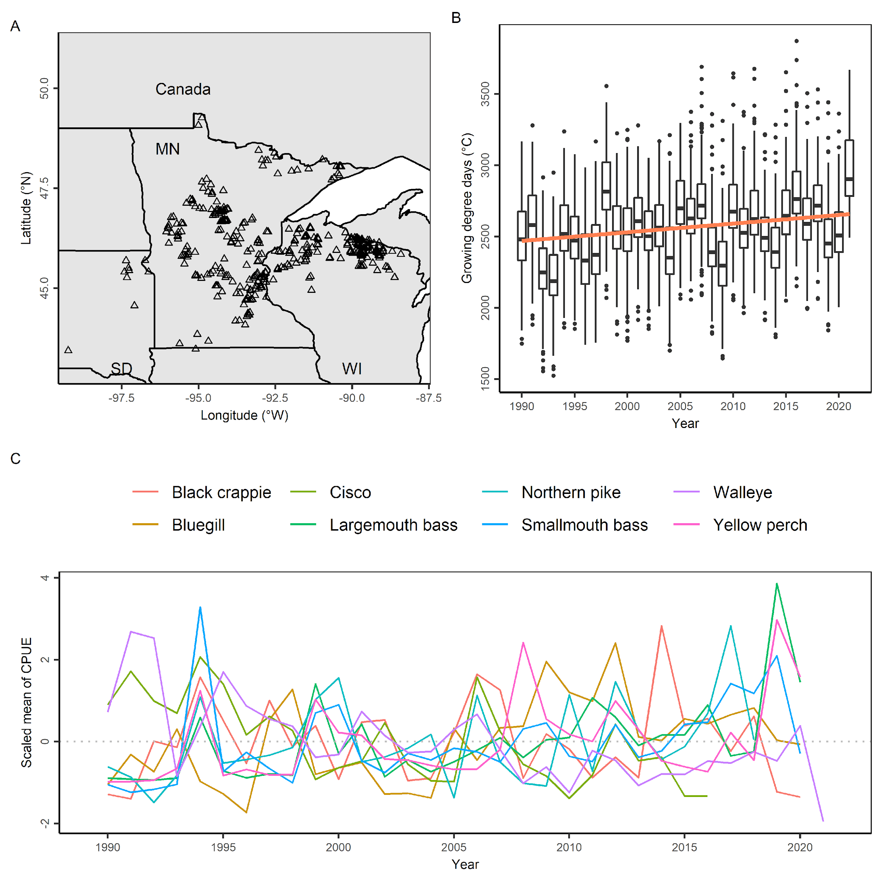

Fig. 1. (A) Map of the study area. The black triangles on the map represent the lakes analyzed. (B) The growing degree days from 1990 to 2021 for the XXX lakes analyzed. The orange line indicates a linear regression between growing degree days and year. In the boxplots, the solid line indicates the median, the box indicates the interquartile range (IQR; 25th to 75th percentiles), the whiskers indicate 1.5 times the IQR, and the points beyond the whiskers indicate outliers. (C) The fluctuations of the scaled mean of catch per unit effort (CPUE) of the eight species. The mean annual CPUE is calculated across all lakes where the abundance index is available.

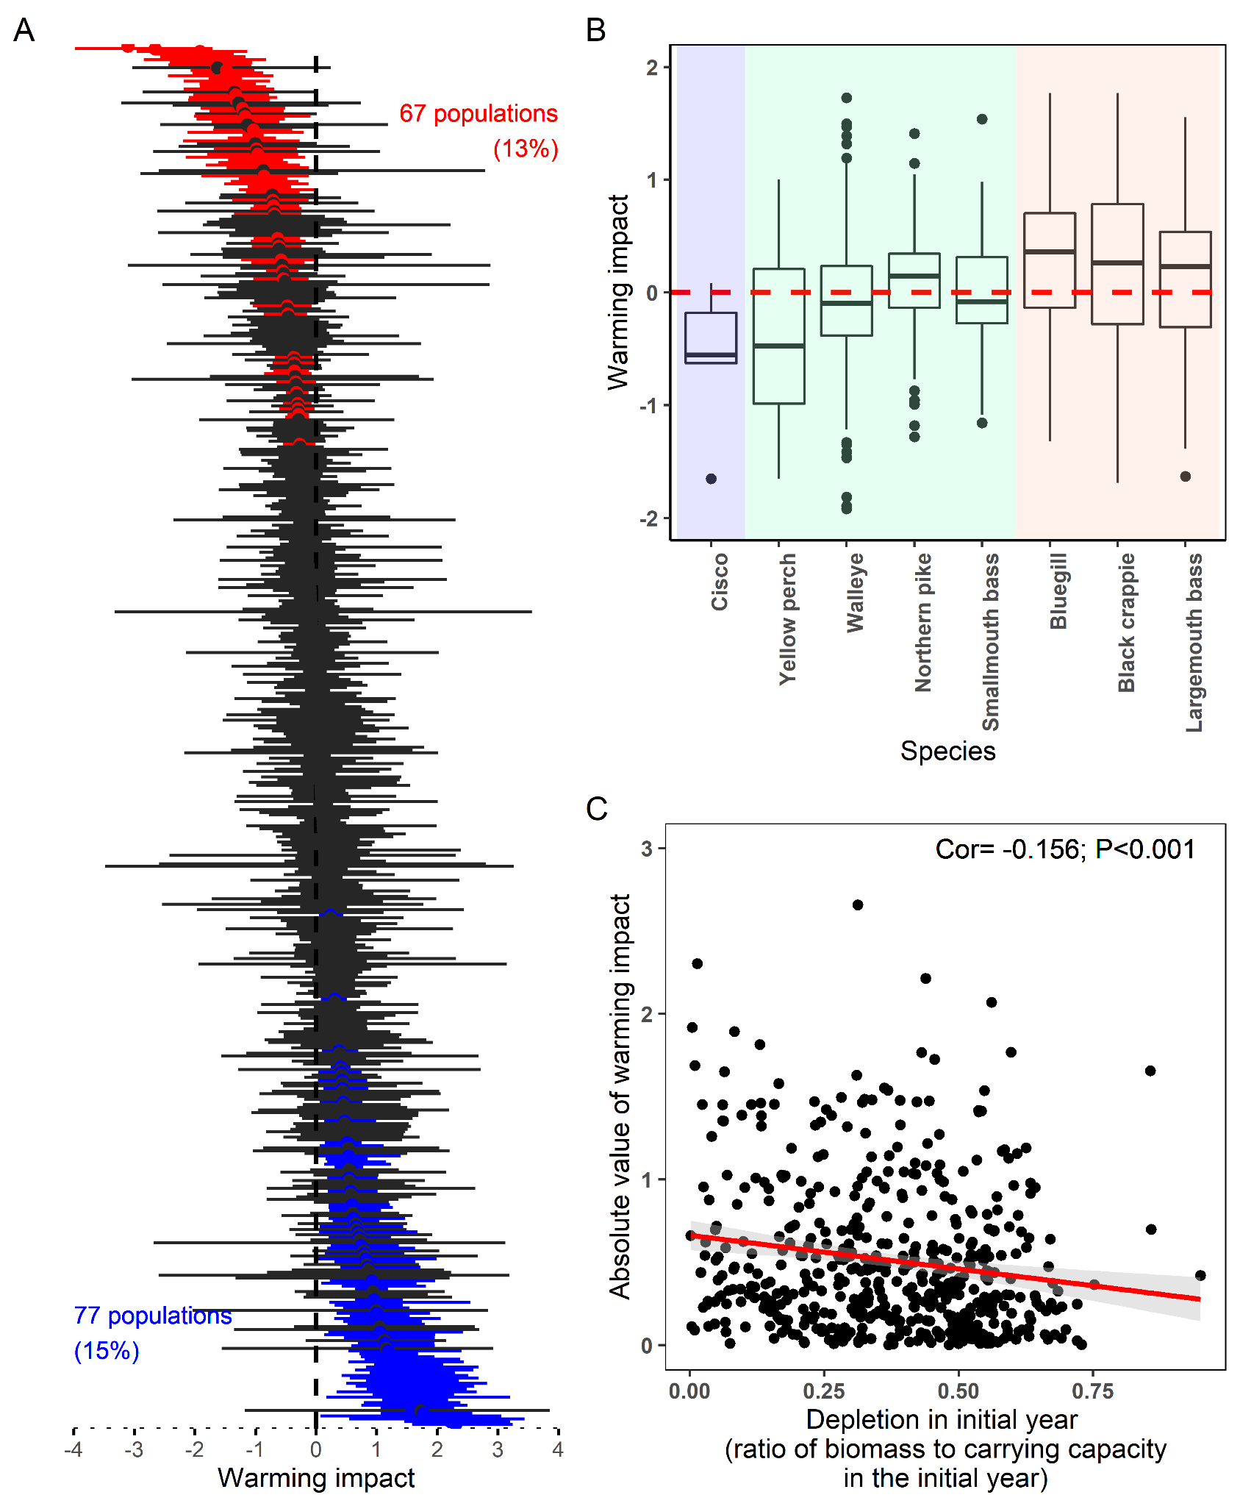

Fig. 2. (A) Estimates of warming impact. Points show mean estimates and error bars show 95% confidence intervals. Significant positive and negative warming impacts are colored blue and red, respectively. The amount of populations with significant positive and negative impacts of warming are indicated by the number and percentage shown in blue and red, respectively. (B) Estimates of warming impact grouped by eight species. Cold-water, cool-water, and warm-water species are delineated by the blue, green, and red shading, respectively. The thermal affinity classifications are based on field studies of distribution and abundance in relation to water temperature (citation). In the boxplots, the solid line indicates the median, the box indicates the interquartile range (IQR; 25th to 75th percentiles), the whiskers indicate 1.5 times the IQR, and the points beyond the whiskers indicate outliers. (C) The relationship between absolute value of the warming impact and depletion (ratio of biomass over carrying capacity) in the initial year. The correlation coefficient and the P value are printed in the top-right corner.

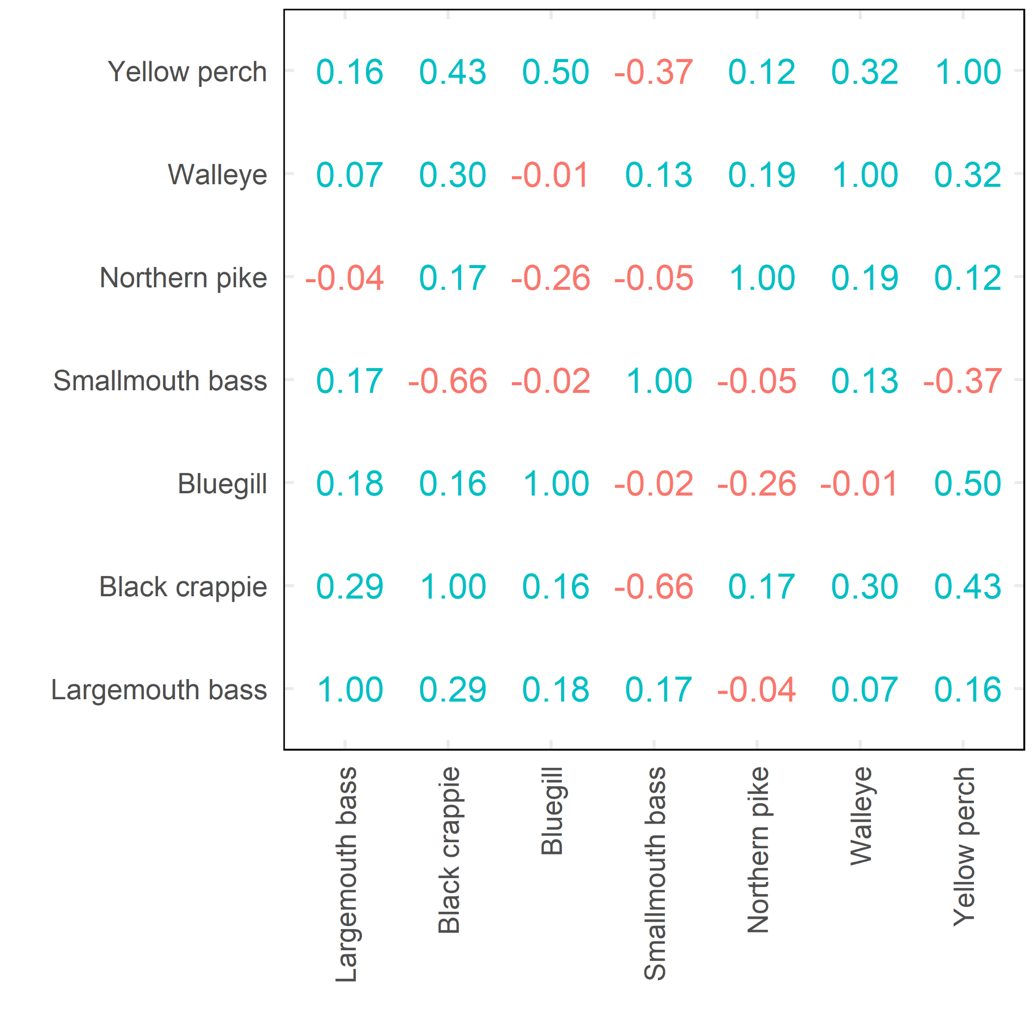

Fig. 3. Correlations of warming impacts on populations of cool-/warm-water species that coexist in the same lakes. Species are ordered based on increasing affinity to warm warter. Note that cold-water species cisco is not included due to the limited number of its populations and non-coexistence with most of the other species.

How about something like this (order by thermal affinity as in Fig. 2B):

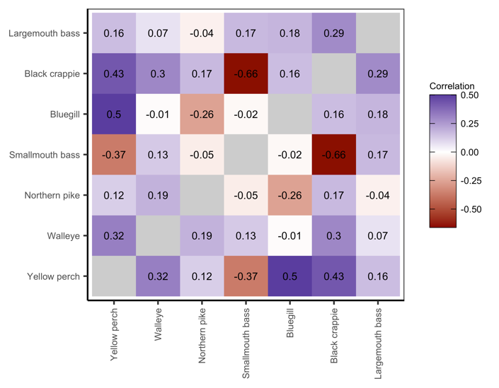

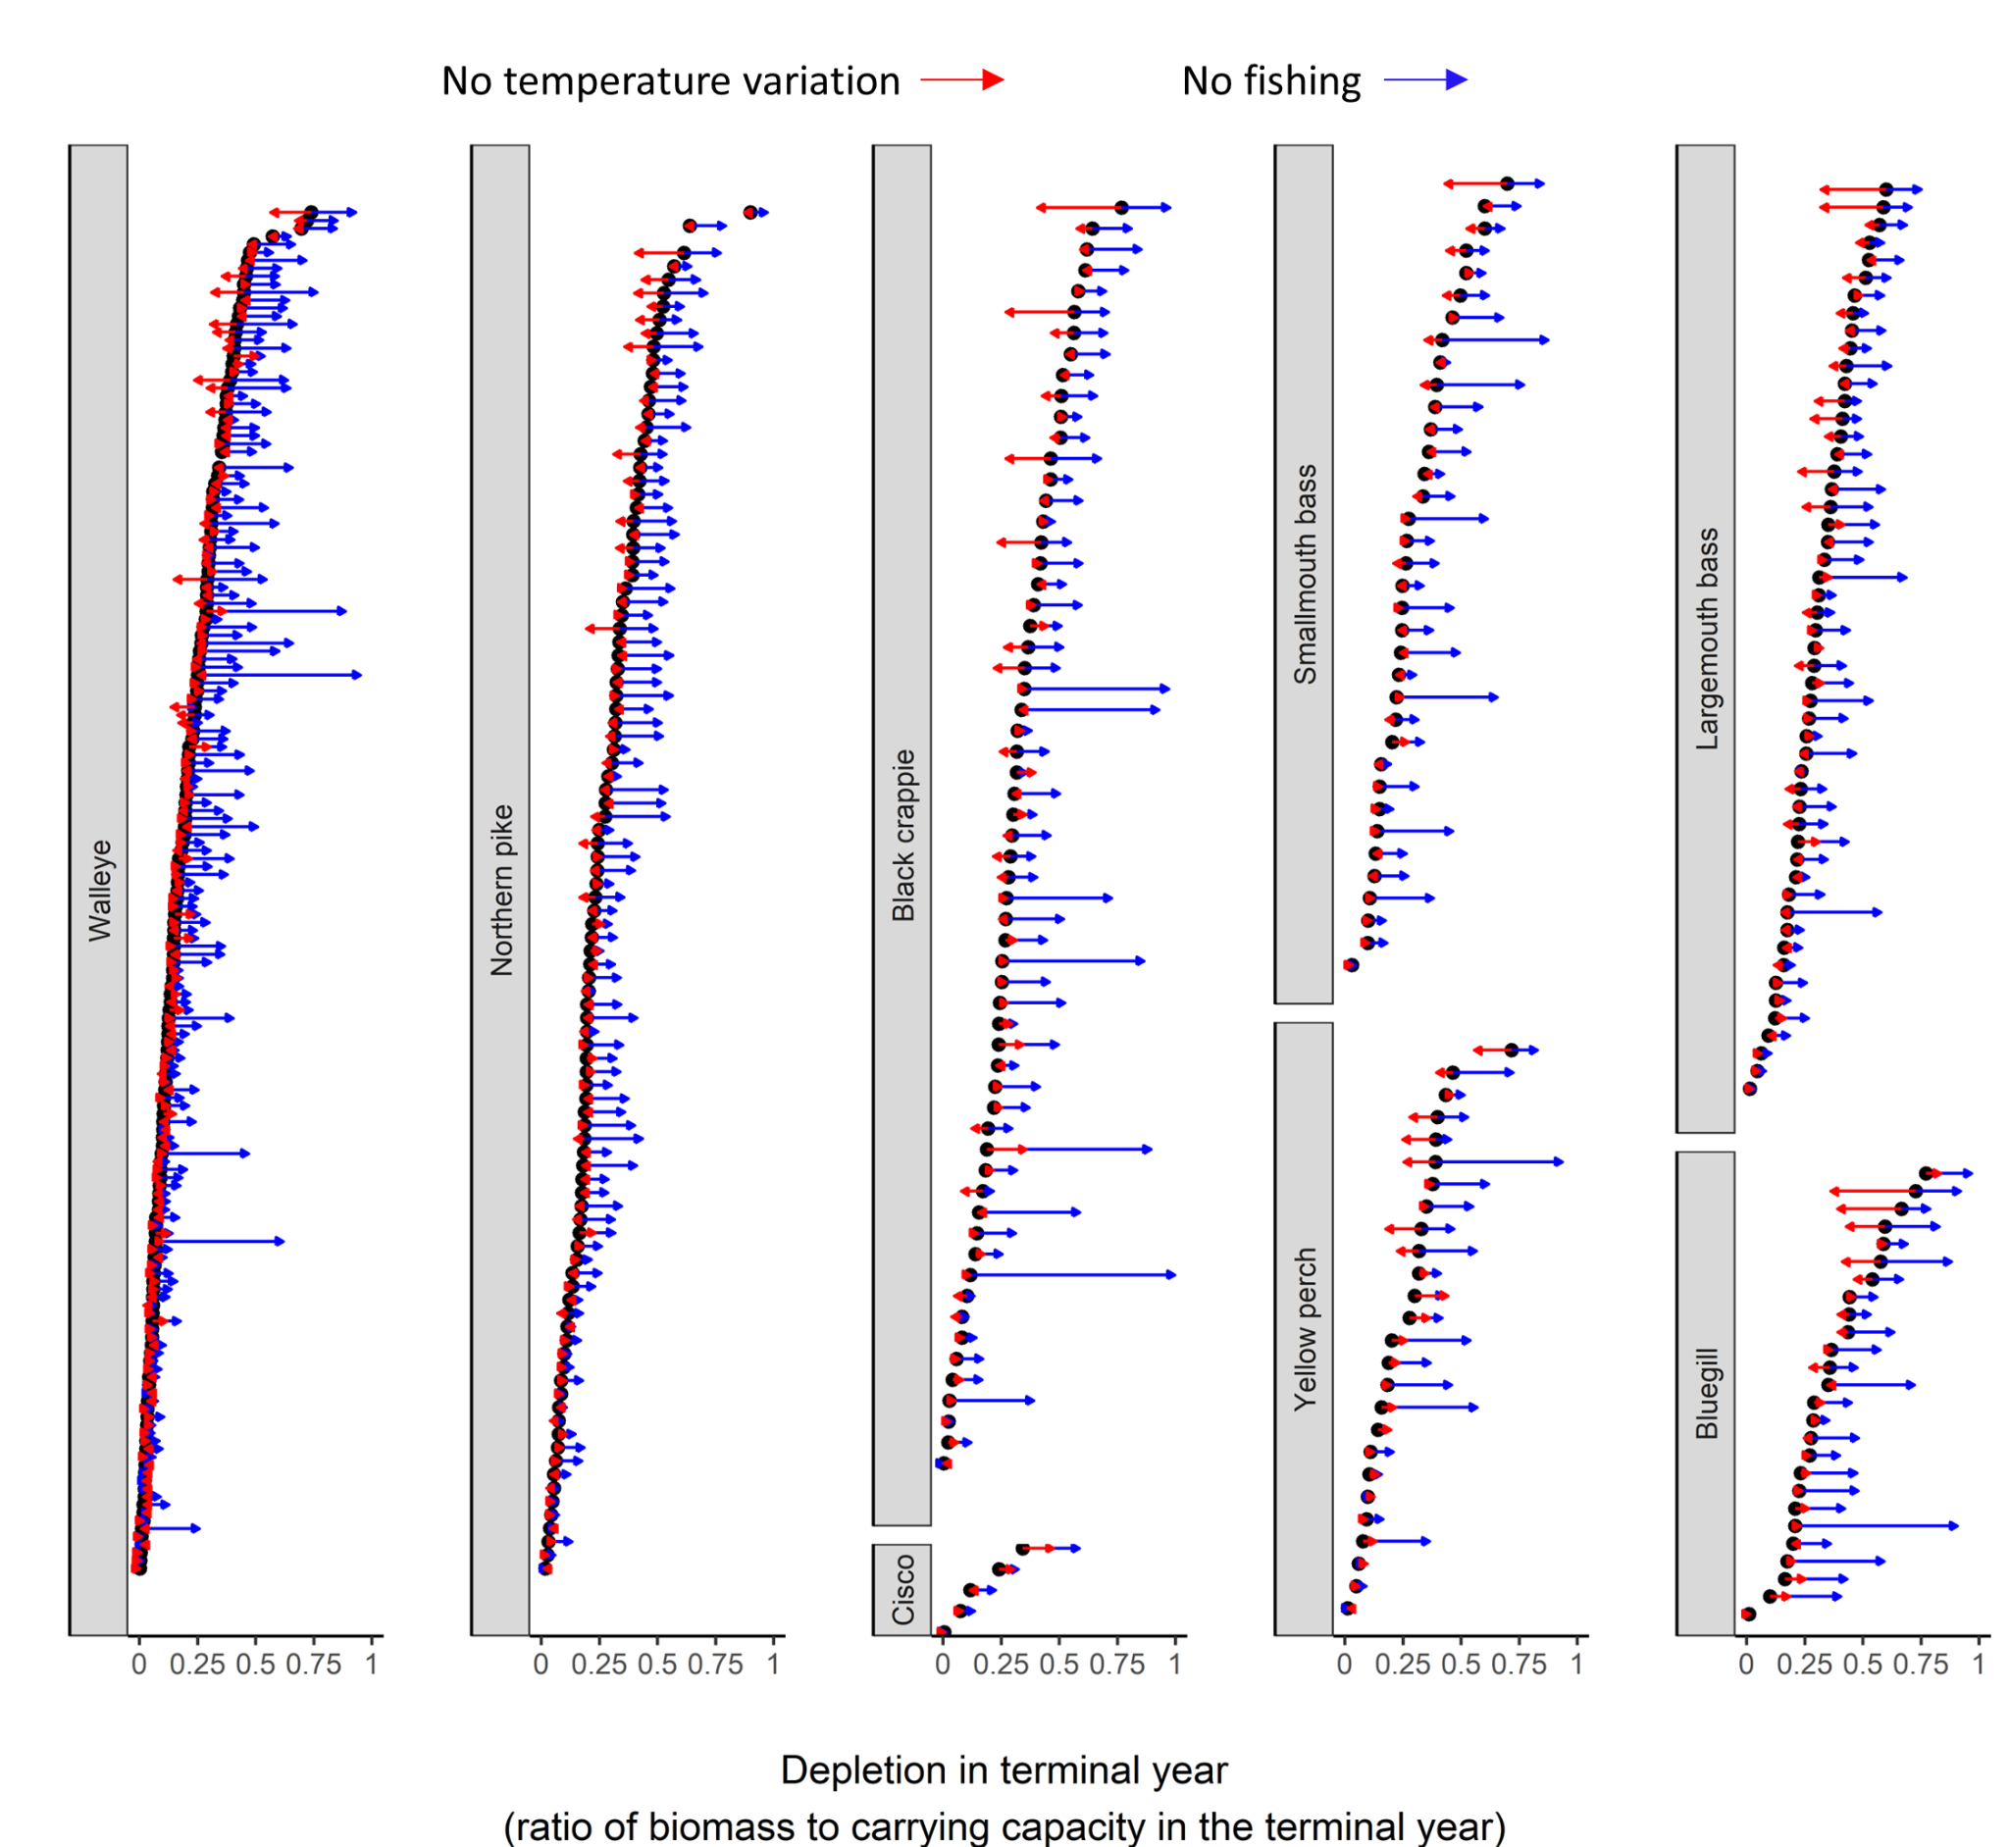

Fig. 4. The depletion (ratio of biomass to carrying capacity) in the terminal years for each population grouped by species and the expected change in depletion in the absence of fishing (blue arrows) and temperature variation (red arrows). As a general rule of thumb, populations with a depletion of 0.5 are considered maximally sustainably fished and populations with depletion less than 0.25 are considered overfished.

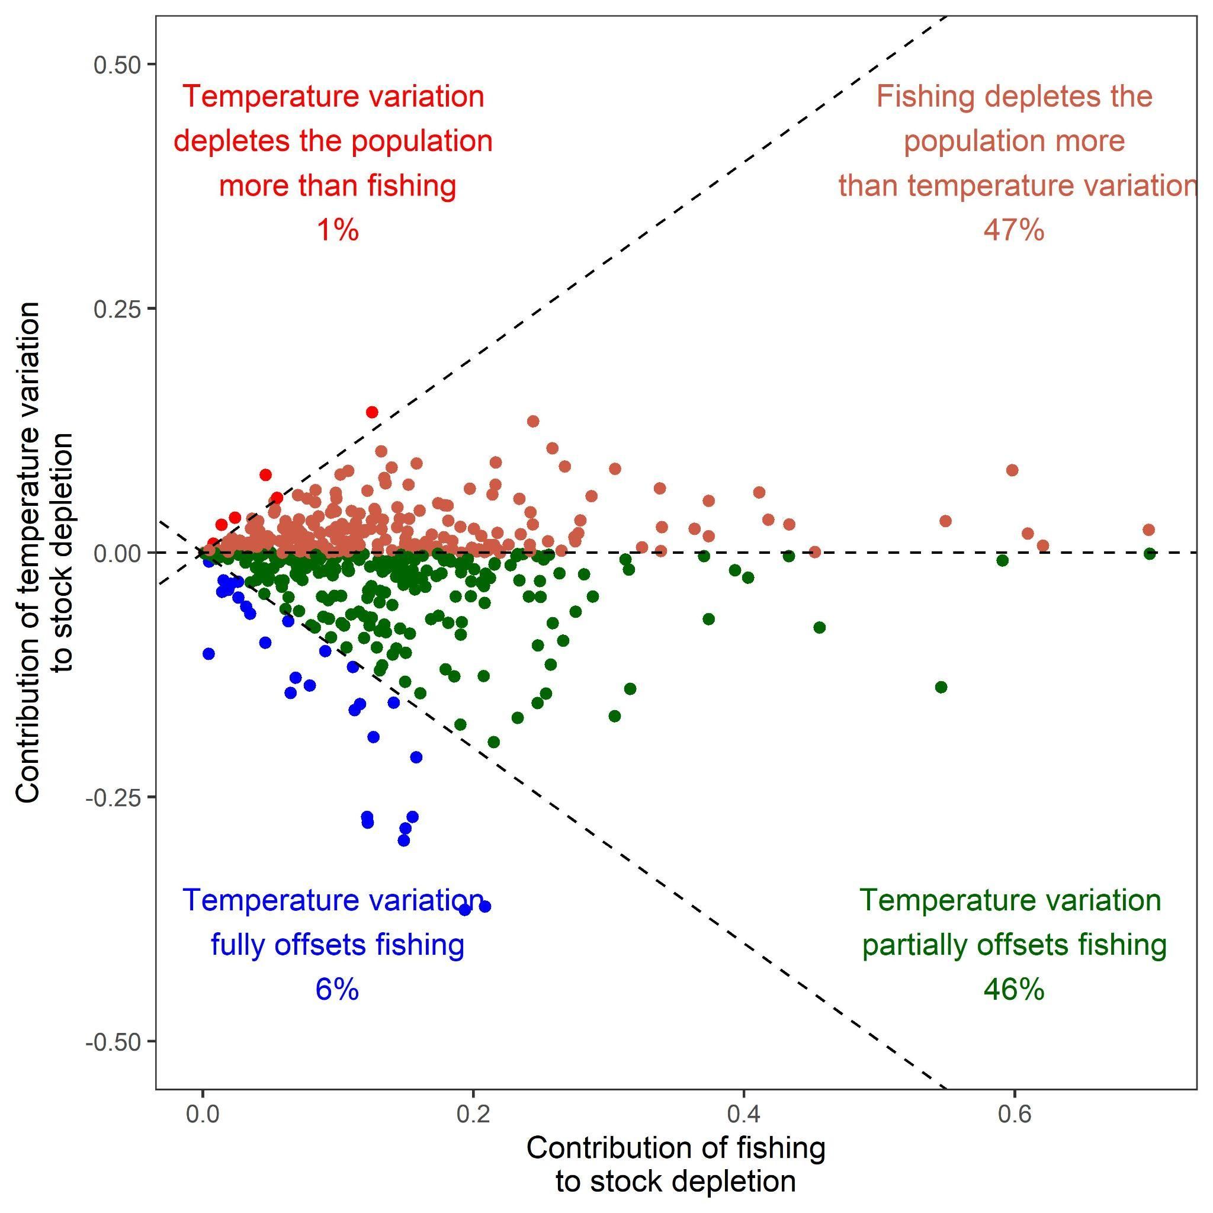

Fig. 5. Comparison of the relative impact of temperature variation and fishing on stock depletion. Each point represents a population where populations may be depleted by temperature variation more than fishing (red points), may be depleted more by fishing than temperature variation (orange points), may have fishing impacts partially offset by temperature variation (green points), or may have fishing impacts fully offset by temperature variation (blue points). The numbers in each color represent the percentage of populations that fall into each category.