**Supplemental Methods**

**1. Correlations of warming indices**

The correlations between growing degree days (GDDs) with a base temperature of 5°C and other warming indices, including growing degree days with base temperatures of 0°C or 10°C, open water duration, peak temperature of the year, and monthly mean lake surface temperature, were calculated and are displayed in Figure S1. A positive correlation was observed between GDDs and all other indices.

**2. Model validation simulation**

Previous research has demonstrated that the performance of parameter estimation in surplus production models can be affected by the informativeness of input data. In particular, a lack of contrast in historical fishing efforts can lead to insufficiently informative data regarding population dynamics, potentially resulting in biased parameter estimates. In addition, the quantity of available data (i.e., relative abundance index and annual recreational harvest) varies significantly across fish populations. It is important to determine a minimum required data quantity below which the model results may not be reliable. To address these concerns, we conducted a simulation study to investigate the model's ability to estimate the parameter of warming effect with acceptable accuracy and precision under different fishing pattern and data quantity scenarios.

**2.1. Simulation settings**

The full simulation analysis has three parts including (1) Operating model; (2) Parameter estimation using simulated data; and (3) Model performance evaluation by comparing estimates with pre-set “true” values.

*2.1.1. Operating model*

The operating model uses the temperature-dependent surplus production model with pre-determined parameters to simulate the population dynamics of the fishery and employs a data collection process similar to biological and creel surveys with simulated survey frequencies.

To examine the effect of different fishing histories on parameter estimates, three scenarios were simulated for the fishery population dynamics: (F1) high fishing effort with low contrast, (F2) low fishing effort with low contrast, and (F3) high contrast in fishing effort. F1 had an exploitation rate ranging from 0.6 to 0.7 for all years. In F2, the exploitation rate was between 0.1 and 0.2 for all years. And in F3, the exploitation rate varied from 0.1 to 0.7 for all years (as depicted in Figure S2). A fishing history was simulated over 30 years, matching the time frame analyzed in the actual data. The operating model took into account process error in the fishery population dynamics, simulating factors that can affect biomass but are not accounted for in the model. Process error was assumed to follow a normal distribution with mean 0 and standard deviation of 0.1. The warming impact was randomly chosen from a uniform distribution (-1,1) for each simulation. The time series of growing degree days (GDDs) was randomly selected from the pool of GDD data for the lakes studied. Stocking biomass and tribal harvest were not included in the operating model as they were accurately measured without observational errors and are thus unlikely to cause estimation issues.

To assess the impact of data quantity on parameter estimates, five scenarios with varying data quantities were simulated: (D1) one annual recreational harvest data point and two CPUE data points; (D2) two annual recreational harvest data points and four CPUE data points; (D3) three annual recreational harvest data points and six CPUE data points; (D4) four annual recreational harvest data points and eight CPUE data points; (D5) five annual recreational harvest data points and ten CPUE data points. The CPUE data quantity was set to twice that of the annual recreational harvest data in each scenario, reflecting the higher availability of CPUE data compared to annual recreational harvest data in our compiled dataset. The years when CPUE or harvest data were available during the 30-year fishing history were randomly selected for each scenario. Observation error was incorporated into the simulated data collection process and was assumed to follow a normal distribution with mean 0. The standard deviations of observation errors for CPUE data from the fishery-independent biological survey and recreational harvest data from the creel survey were set at 0.2.

The combination of three fishing scenarios and five data quantity scenarios results in a total of 15 scenarios. The operating model settings are summarized in Table SX.

*2.1.2. Estimating warming impact*

The generated data from the operating model were used to fit the temperature-dependent surplus production model and estimate the warming effect parameter. The model settings, execution, and convergence check were consistent with those used to fit real data, as described in the methods section of the main paper text. This process was repeated 50 times for each scenario.

*2.1.3. Comparing estimates of warming impact with pre-set “true” values*

The accuracy and precision of the estimates of warming impact can be measured by absolute relative error (ARE). Larger ARE indicates greater bias in the corresponding estimate. ARE was calculated as follows:

(1)

where *θest* and *θtrue* denote the parameter estimates and true values of warming impact.

To determine the effect of fishing histories and data quantities on the warming impact parameter estimate, a General Linear Model (GLM) was employed. The GLM quantified the relative contributions of the different scenarios to the ARE of the estimates, with ARE serving as the dependent variable. The five data quantity scenarios and three fishing pattern scenarios were treated as independent categorical variables. The coefficients assigned to these scenarios indicate the level of bias in the estimate caused by each scenario. The scenarios resulting in the least biased parameter estimates (F3 and D5) were used as the reference factors for the categorical variables.

**2.2. Simulation results**

The comparison of the parameter estimates and the actual values of the warming impact can be seen in Figure S2. As expected, increased accuracy was observed as more data was used to fit the model. In terms of the impact of fishing history, the most accurate estimates were observed in scenario F3 (high contract in fishing effort), which provides the most informative fishing pattern. The model systematically underestimated the magnitude of warming impact in scenario F2 (low effort, low contrast), regardless of whether the actual impact was positive or negative.

According to the results from GLM analysis, D1 (1 harvest, 2 CPUE) and F2 (low effort, low contrast) scenario caused significantly biased estimates compared with other scenarios (Table S1).

**2.3. Conclusions**

We found that having at least 4 CPUE and 2 harvests data points (D2) provided acceptable accuracy in estimates. Data quantity more than that did not cause significantly more biased estimates compared to the ideal scenario with the highest data quantity and most informative fishing history (D5-F3). Hence, we set 4 CPUE and 2 harvests as the minimum requirement for data. Populations with less data than this were excluded from the analysis. After fitting the model, we evaluated the estimated exploitation rate with the intent to exclude any results with a history of consistent low fishing pressure (highest exploitation rate less than 0.2). However, none of the populations met this criterion, which is unsurprising given that the analyzed populations were in lakes with high fishing activities and thus were prioritized and monitored by managers.

**3. Null model**

To test whether the estimates of warming effect came out by chance as an artefact of model structure, we compared the results from benchmark models with those from null models in which the time series of growing degree days (GDDs) were randomly re-ordered. For each population, the corresponding time series of GDDs were randomly re-ordered for twenty times and each time series was used to fit the model and estimate the warming effect. We found significantly stronger pattern of warming effect from benchmark models than that would be expected by chance from null models (Figure S3).

**4. Sensitivity analysis**

Previous simulation studies have suggested that the shape parameter in Pella-Thomlison model is difficult to estimate accurately (). Here, to test the sensitivity of warming impact estimations to potential mismatch of shape parameters, we also fitted the data to two of the most commonly used surplus production models (i.e., Fox model and Schaefer model) that fixed shape parameters with different known values (Table SX). Additionally, to ensure that the magnitude of warming effect was not underestimated due to the confinement of the prior normal distribution, we conducted another sensitivity analysis in which the standard deviation of the normal distribution was increased from two (the benchmark model specification) to five.

The results indicated that the estimation of the warming effect was robust to different shape parameter specification (Figure S4). The robustness of the estimation of the warming impact was also evident across different settings of prior ranges for the parameter. (Figure S4).

**Supplemental Figures**

**(The figure is subject to change by adding GDD0 and GDD10 and removing summer mean temperature)**

Fig. S1. Correlations between growing degree days at different base temperature, open water duration, peak temperature, and monthly mean lake surface temperatures. Numbers and colors indicate the strength and direction of the correlation coefficient.

Figure S2. Exploitation rate and 50 simulated biomass trajectories for scenarios F1, F2, and F3. Scenario F1 (high fishing effort and low contrast) is shown in the left panel, scenario F2 (low fishing effort and low contrast) in the middle panel, and scenario F3 (high contrast in fishing effort) in the right panel.

I suggest replacing this figure with something like the following (i.e., separating exploitation rate from biomass, making exploitation rate a line). 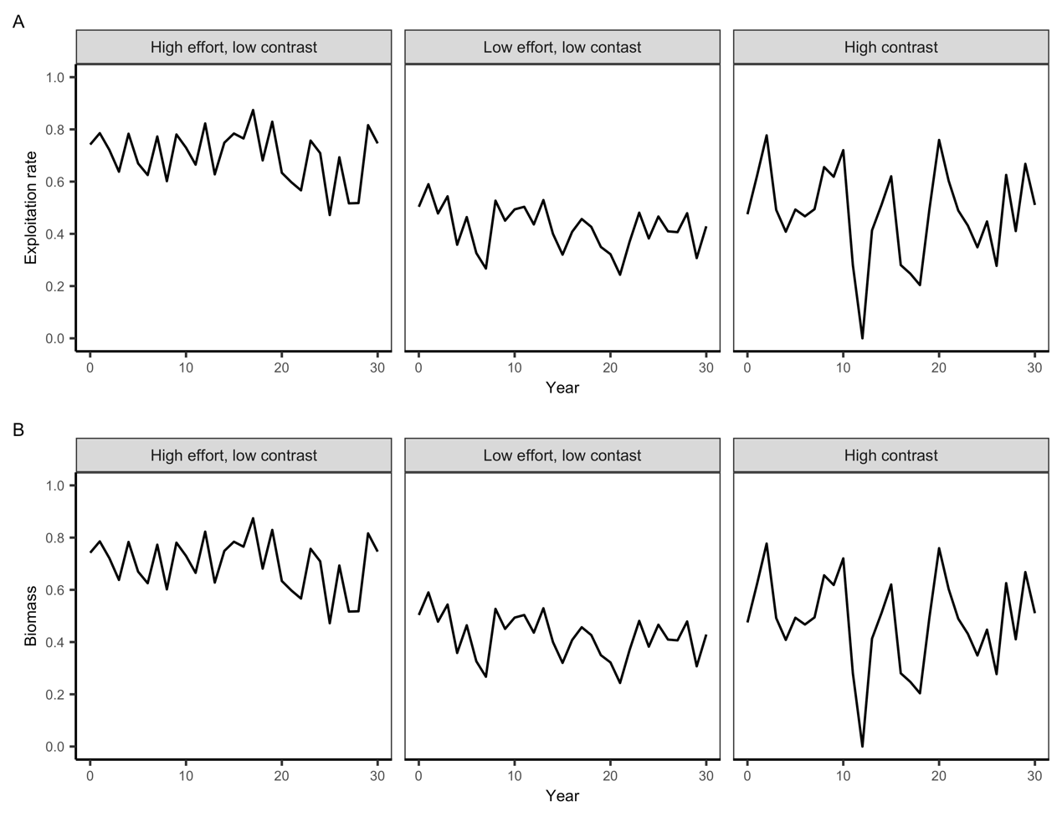

Fig. S2. Exploitation rate and 50 simulated biomass trajectories for three fishing effort scenarios.

Fig. S3. Comparison of true values and estimates of the warming impact in scenario F1 (high fishing efforts and low contrast in fishing efforts; **top** panel); scenario F2 (low fishing efforts and low contrast in fishing efforts; **middle** panel); and scenario F3 (high contrast in fishing efforts; **bottom** panel). The panels illustrate the data scenarios D1 to D5 in increasing order of data quantity, from left to right.

I would suggest replacing Figure S3 above with something like the following (scenario names spelled out, true values on x-axis, aspect ratio that produces square plots):

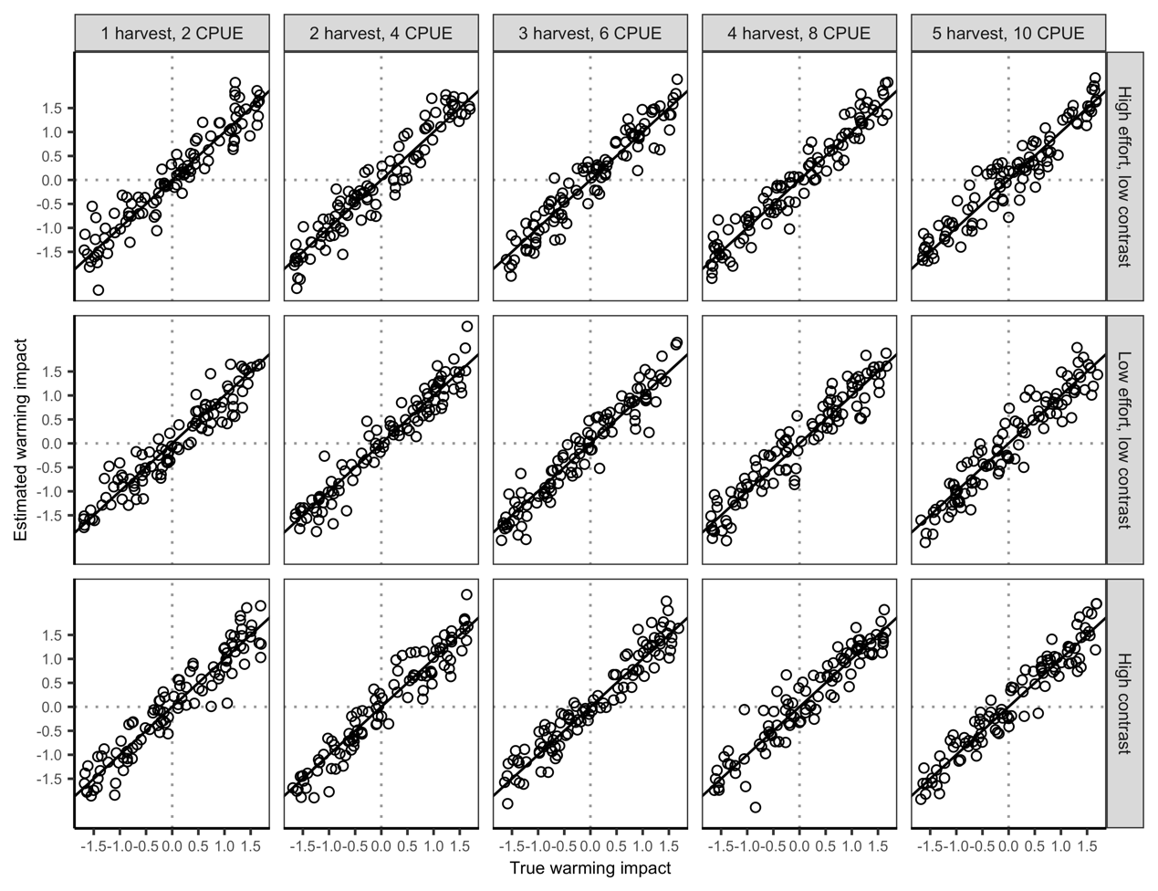

Fig. S3. Comparison of true values and estimates of the warming impact in the fifteen fishing effort (rows) and data quantity (columns) scenarios. The solid diagonal line indicates the 1:1 line and the dotted lines indicate a warming impact of zero.

Fig. S4. Warming impact estimates from the (A) benchmark and (B) null models. Points show mean estimates and error bars show 95% confidence intervals. Significant positive and negative warming impacts are colored blue and red, respectively. The number and proportion of populations with significant positive and negative impacts of warming are indicated by the blue and red text, respectively.

I suggest merging Figures S5 and S6 (the two below here) into something like the following:

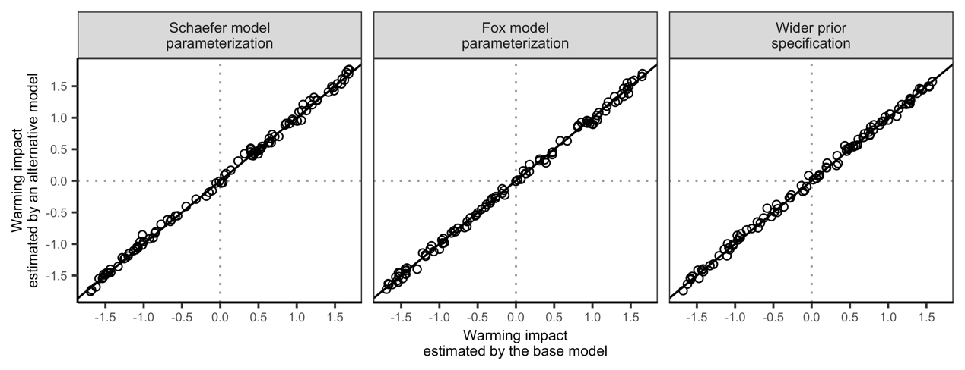

Fig. S5. Comparison of the warming impacts estimated by the base model and alternative models employing (A) the Schaefer surplus production model parameterization; (B) the Fox surplus production model parameterization; and (C) a wider prior specification. The solid diagonal line indicates the 1:1 line and the dotted lines indicate a warming impact of zero.

Fig. S5. Comparison of warming effect estimates from Pella-Thomlinson, Schaefer, and Fox surplus production models.

Fig. S6. Comparison of warming impact estimates with different range of priors.

**Supplemental Tables**

**Table S1**. Parameter values in the simulation operating model.

|  |  |
| --- | --- |
| **Parameter** | **Value** |
| Intrinsic growth rate (*r*) | 0.35 |
| Carrying capacity (*k*) | 1000 |
| Catchability coefficient (*q*) | 0.01 |
| Ratio of biomass over k of the initial year (*P_initial*) | Randomly sampled from U(0,1) |
| Warming effect (*θ*) | Randomly sampled from U(-1,1) |
| Shape parameter (*m*) | 2 |
| Fishing mortality (*F*) | Scenario-specific (see Figure S2) |
| SD of observation error in recreational harvest () | 0.2 |
| SD of observation error in relative biomass index () | 0.1 |
| SD of process error () | 0.1 |

**Table S2.** Summary statistics for the GLM analysis.

|  |  |  |
| --- | --- | --- |
| **Coefficient** | **Value** | **P value** |
| Intercept | -0.054 | 0.154 |
| D1 | 0.173 | <0.001 |
| D2 | 0.094 | 0.040 |
| D3 | 0.035 | 0.444 |
| D4 | 0.010 | 0.823 |
| F1 | 0.041 | 0.230 |
| F2 | 0.134 | <0.001 |

**Table S3.** Parameter settings for the sensitivity analysis. Parameters are set equal to the value in the benchmark model unless otherwise specified.

|  |  |  |  |  |  |  |
| --- | --- | --- | --- | --- | --- | --- |
| **Parameters** | **Prior distribution** | **Prior sensitivity scenario** | |  | | --- | | **Schaefer**  **model** | | |  | | --- | | **Fox**  **model** | |
| Intrinsic growth rate (*r*) | Lognormal |  |  |  |
| Carrying capacity (*k*) | Lognormal | Mean = log((max(harvest)+100000*max(harvest))/2)  SD = (mean-log(max(harvest)))^0.5/2 |  |  |
| Catchability coefficient (*q*) | Improper |  |  |  |
| Ratio of biomass over k of the initial year (*P_initial*) | Beta |  |  |  |
| Warming effect (*θ*) | Normal | Mean = 0; SD = 10 |
| Shape parameter (*m*) | Skew normal |  | Fixed at 2 | Fixed at 0.001 |
| Instantaneous fishing mortality (*F*) | Exponential |  |  |
| Variance of observation error in recreational harvest () | Inverse gamma |  |  |
| Variance of observation error in relative biomass index () | Inverse gamma |  |  |

**Table S4.** Summary of fishery-independent surveys for relative abundance indices.

|  |  |  |  |  |  |
| --- | --- | --- | --- | --- | --- |
| **State** | **Species** | **Survey gear** | **Effort unit** | **Survey month** | **Source** |
| Wisconsin | Largemouth bass | Boom shocker | Miles of fishing | Apr, May, Jun | WDNR FM Handbook |
| Wisconsin | Smallmouth bass | Boom shocker | Miles of fishing | Apr, May, Jun | WDNR FM Handbook |
| Wisconsin | Cisco | Gill net | Number of nets and nights | Jun, July, Aug | Feiner 2020 |
| Wisconsin | Bluegill | Boom shocker | Miles of fishing | Apr, May, Jun | WDNR FM Handbook |
| Wisconsin | Walleye | Fyke net | Number of nets and nights | Mar, Apr, May | Feiner 2020 |
| Wisconsin | Yellow perch | Fyke net | Number of nets and nights | Mar, Apr, May | Feiner 2020 |
| Wisconsin | Northern pike | Fyke net | Number of nets and nights | Mar, Apr, May | Feiner 2020 |
| Wisconsin | Black crappie | Fyke net | Number of nets and nights | Mar, Apr, May | Feiner 2020 |
| Minnesota | Largemouth bass | Trap net | Number of nets and nights | Mar~Nov | MDNR Survey Manual pg. 85-86 |
| Minnesota | Smallmouth bass | Gill net | Number of nets and nights | Mar~Nov | MDNR Survey Manual pg. 79 |
| Minnesota | Cisco | Gill net | Number of nets and nights | Mar~Nov | MDNR Survey Manual pg. 79 |
| Minnesota | Bluegill | Trap net | Number of nets and nights | Mar~Nov | MDNR Survey Manual pg. 85-86 |
| Minnesota | Walleye | Gill net | Number of nets and nights | Mar~Nov | MDNR Survey Manual pg. 79 |
| Minnesota | Yellow perch | Gill net | Number of nets and nights | Mar~Nov | MDNR Survey Manual pg. 79 |
| Minnesota | Northern pike | Gill net | Number of nets and nights | Mar~Nov | MDNR Survey Manual pg. 79 |
| Minnesota | Black crappie | Trap net | Number of nets and nights | Mar~Nov | MDNR Survey Manual pg. 85-86 |
| South Dakota | Largemouth bass | Boom shocker | Miles of fishing | Mar~Nov | https://apps.sd.gov/GF56FisheriesReports/ |
| South Dakota | Smallmouth bass | Frame net | Number of nets and nights | Mar~Nov | https://apps.sd.gov/GF57FisheriesReports/ |
| South Dakota | Bluegill | Frame net | Number of nets and nights | Mar~Nov | https://apps.sd.gov/GF59FisheriesReports/ |
| South Dakota | Walleye | Frame net | Number of nets and nights | Mar~Nov | https://apps.sd.gov/GF60FisheriesReports/ |
| South Dakota | Yellow perch | Gill net | Number of nets and nights | Mar~Nov | https://apps.sd.gov/GF61FisheriesReports/ |
| South Dakota | Black crappie | Frame net | Number of nets and nights | Mar~Nov | https://apps.sd.gov/GF63FisheriesReports/ |

**Table S5.** Prior ranges for intrinsic growth rate (*r*) based on species-specific resilience (fish base website and Froese et al.).

|  |  |  |
| --- | --- | --- |
| **Species** | **Resilience** | **Intrinsic growth rate (*r*) range** |
| Largemouth bass | Low | 0.05~0.5 |
| Smallmouth bass | Medium | 0.2~0.8 |
| Cisco | Low | 0.05~0.5 |
| Bluegill | Medium | 0.2~0.8 |
| Walleye | Low | 0.05~0.5 |
| Yellow perch | Medium | 0.2~0.8 |
| Northern pike | Low | 0.05~0.5 |
| Black crappie | Medium | 0.2~0.8 |

**Table S6.** Prior distributions of parameters for the benchmark case model.

|  |  |  |
| --- | --- | --- |
| **Parameters** | **Prior distribution** | **Distribution parameter values** |
| Intrinsic growth rate, *r* | Lognormal | Based on species-specific resilience |
| Carrying capacity, *k* | Lognormal | mean=log ((max(harvest)+10000*max(harvest))/2); SD=(mean-log(max(harvest)))/2 |
| Catchability coefficient, *q* | Improper | p(q)∝1/q |
| Ratio of biomass over k of the initial year, *P_initial* | Beta | shape (α) = 1; shape (β) = 1 |
| Warming effect, *θ* | Normal | mean = 0; SD = 2 |
| Shape parameter, *m* | Skew normal | location = -0.5; scale = 1; shape = 10 |
| Instantaneous fishing mortality, *F* | Exponential | rate (λ) = 1 |
| Variance of observation error in recreational harvest, | Inverse gamma | shape (α) = 4; scale (β) = 0.01 |
| Variance of observation error in relative biomass index, | Inverse gamma | shape (α) = 4; scale (β) = 0.01 |