**Impacts of historical warming on marine fisheries recruitment**

**Introduction**

Major papers for us to distinguish this paper from…

1. **Free et al. (in press) Impacts of historical warming on marine fisheries production. *Science.***
   1. Methods
      1. Very similar to approach applied here
      2. Fit SST-linked surplus production models to 235 stocks in the RAM Legacy Database to measure influence of warming on productivity
      3. Added hierarchy by taxonomy and geography to evaluate whether influences are structured by these groups
      4. Conducted post-hoc analyses to see if SST influence is driven by life history traits or characteristics of the population (thermal position, exploitation history, etc)
      5. Hindcast changes in MSY overall and by ecoregion
   2. Results
      1. SST influences fisheries production
      2. Influence of SST is structured by ecoregion and taxonomy
      3. Fast-lived species are more sensitive (both neg/pos) to warming
      4. Stocks experiencing overfishing are more neg. impacted by warming
      5. Stocks at the warm end of thermal niche are more vulnerable to warming
      6. MSY has declined on average with huge regional discrepancies
   3. Differences between present work
      1. Recruitment is a component of production
      2. We can see if impacts on recruitment align with impacts on production
2. **Britten et al. (2016) Changing recruitment capacity in global fish stocks. *PNAS.***
   1. Methods
      1. Estimated time-varying maximum recruitment capacity (RMAX) for 262 stocks in the RAM Legacy Database
      2. Calculate changes in *RMAX* over time (linear slope) for each stock (ΔRMAX)
      3. Calculate ΔRMAX meta-analytic averages by taxonomy and ecoregion
      4. Relate meta-analytic averages to change in environment and stock status
         1. ΔRMAX ~ ΔChl + ΔSST + ΔB/BMSY
   2. Results
      1. 128 stocks show declining RMAX
      2. Global average suggests 3% decline in RMAX (unweighted)
      3. N. Atlantic shows steep decline while N. Pacific shows neutral trend
      4. Groundfish show steep decline in RMAX
      5. ΔRMAX is significantly related to ΔChl (positive, generally most important) and ΔB/BMSY (negative, most important for groundfish)
         1. Not related to ΔSST!!!
   3. Differences between present work
      1. SST not directly incorporated into model
      2. SST not found to be important driver of changing recruitment
3. **Szuwalski et al. (2016) Changing fisheries productivity and food security. *PNAS.***
   1. Rebuttal to Britten et al. (2016)
   2. Argues that the 3% decline in recruitment capacity reported by Britten et al. is difficult to interpret because it is not weighted by stock size (i.e., catch or biomass); weighting by stock importance is necessary for thi
   3. Weighting by biomass removes negative trend (recruitment capacity same)
   4. Weighting by catch reverses trend (recruitment capacity increasing)
   5. Also argues that fitting linear slope to the 60% of stocks with regimes is problematic given the sensitivity to which regime you’re in at start/end of time series
4. **Szuwalski et al. (2015) Examining common assumptions about recruitment: a meta-analysis of recruitment dynamics for worldwide marine fisheries. *Fish and Fisheries.***
   1. Methods
      1. Use cross-correlation to investigate whether biomass and recruitment are positively related and whether biomass leads recruitment in 224 RAM Legacy Database stocks
      2. Cross-correlation examines at different lags so that you can see whether biomass drives recruitment or recruitment drives biomass
      3. Delineate two types of patterns:
         1. Biomass drives recruitment
         2. Environmentally driven=recruit drives biomass OR no relationship
      4. Stocks with dome-shaped recruitment (Ricker) have data truncated for testing
      5. Uses Rodionov’s sequential t-test algortith for regime shifts (STARS) to identify regime shifts
      6. Evaluated significance of synchronous changes in recruitment within an LME
   2. Results
      1. Ricker recruitment in 17% of stocks (n=38)
         1. 18% (7/38) of these showed pos relationship between SSB and R
      2. BH recruitment in remaining 83% of stocks (n=186)
         1. Spawning biomass had no affect on 47% of these stocks
      3. In 64% (52/81) of stocks (81/224=36%) showing positive relationship between SSB and R, R influenced SSB more strongly than SSB influenced R
      4. Regime shifts were present in 160 of 188 stocks
      5. SSB-driven dynamics were most common in Gadiformes
      6. R-driven SSB for Scorpaeniformes
      7. Cyclical influences for Clupeiformes
      8. Shows synchrony among LME and that there is a common driver
   3. Conclusions
      1. Recruitment driven by environment (but what in environment not shown)
   4. Differences between present work
      1. They ask whether environment or biomass drives recruitment and we show that environment AND biomass drive recruitment
      2. Identifies that environment matters but doesn’t say what about environment (not mechanistic)
      3. Speculates about common driver in LMEs but doesn’t say what it could be

**Methods**

Overview

We used a Ricker (1954) stock-recruit model with a multiplicative temperature influence term to measure the influence of ocean warming on the recruitment of 239 marine fish and invertebrate stocks in the RAM Legacy Stock Assessment Database (Ricard et al. 2012). We estimated the sea surface temperatures (SST) experienced by each stock by mapping the boundary of the stock (i.e., the spatial domain of the stock assessment) and calculating the mean annual SST within this boundary using the COBE SST dataset (Ishii et al. 2005). We evaluated whether SST influences were determined by: (1) life history traits such as growth rate, maximum age, or depth preference; (2) behavioral traits such as reproductive guild, migratory habits, or spawning behavior; (3) stock characteristics such as trend in biomass or fishing pressure; and (4) thermal experience such as mean SST, SST trend, or latitude. Lastly, we used the final model to hindcast SST-dependent maximum recruitment capacity from 1930-2010 over all stocks and among ecoregions. To ensure that the estimated distribution of SST influences was not due to chance alone, we compared the model results to results from a null model using simulated SST time series designed to decouple the observed SST and recruitment time series.

Data collection

*Stock selection*

We analyzed stocks in the RAM Legacy Stock Assessment Database (RAMLDB v4.4; Ricard et al. 2012) with time series of spawning stock biomass (metric tons) and recruitment (number of recruits) longer than 20 years after trimming years poorly informed by catch and survey data. We identified stocks and years to trim by visually inspecting the (1) stock-recruit and surplus production relationships and (2) biomass, recruitment, and catch time series for all candidate RAMLDB stocks (Appendix A). Stocks exhibiting smooth stock-recruit or surplus production relationships over the entire time series were excluded from the analysis. Years, largely at the beginning of the time series, exhibiting flat or smooth biomass or recruitment or perfectly linear catch were excluded from the analysis. Finally, we excluded 15 stocks that prevented model convergence because they exhibit no density-dependence at high biomass (Appendix). The resulting 239 stocks represent a variety of taxa (221 bony fish, 12 crabs/shrimps/lobsters, 5 bivalves, 1 shark), life histories, and locations and approximately XX% of reported global catch (XX of 86 million metric tons in 2000; FAO 2016).

*Temperature time series*

We estimated the sea surface temperatures (SST) experienced by each stock by calculating the mean annual SST within the stock boundary (Free et al. 2019) using the COBE SST dataset (COBE v2; Ishii et al. 2005). The COBE dataset provides monthly SST on a globally complete 1°x1° grid from 1850-present based on an interpolation of in-situ and satellite-derived SST observations.

* Currently, I’m using SST average across the boundary but might switch you using SST at the centroid to increase SST contrast
* Also, I’m not currently lagging the SST by the age at recruitment, which we should do ultimately. I have to fill in lots of missing ages at recruitments. Any ideas on doing this easily?

2. Modeling

*2.1 Standard stock-recruit model*

We modeled recruitment using a Ricker stock-recruit model with first-order autocorrelation in the residuals. The Ricker (1954) model describes a stock-recruit relationship where the number of recruits peaks at an intermediate spawner density after which recruitment falls as spawner abundance increases. The model is written as:

$R_{i,t}=α_{i}B_{i,t-τ}e^{-β_{i}B_{i,t-τ}}+ε_{i,t}$ Eq. 1

where recruitment *R* in year *t* is produced by spawning stock biomass *B* in the year *t-τ* where *τ* is the age of recruitment. The parameters *α* and *β*, constrained to be non-negative, govern the shape of the stock-recruit relationship. The parameter *α* represents the maximum reproductive output of an individual in the absence of density-dependent effects. Thus, the slope of the stock-recruit curve is a at the origin. The parameter *β* determines the rate at which recruitment is reduced by density-dependent feedbacks.

Residuals are assumed to follow a first-order autocorrelated (AR1) process:

$ε_{i,t}=ρ_{i}ε_{i,t-1}+\sqrt{1-ρ_{i}^{2}}δ_{i,t}$ Eq. 2

where $ρ_{i}$ is the first-order autocorrelation coefficient for stock *i*, $ε_{i,t}$ and $ε_{i,t-1}$ are the observed residuals around the production function for stock *i* in years *t* and *t-1*, respectively, and $δ_{i,t}$ is a normally distributed random variable representing uncorrelated errors for stock *i* in year *t*. Insert text/equations about variance in the first year.

In this model and in all the models described below, we scaled biomass and recruitment to unit variance (i.e., standard deviation equal to one) to ease model fitting. We fit all models using maximum likelihood estimation in the *TMB* package (Template Model Builder; Kristensen et al 2016) in R (R Core Team 2019). See Table for a key to all model symbols.

*2.2 SST-linked stock-recruit model*

To evaluate the influence of temperature on recruitment, we extended the standard recruitment model to include a multiplicative temperature influence term:

$R_{i,t}=α_{i}B_{i,t-τ}e^{-β_{i}B_{i,t-τ}}*\exp\left({SST}_{i,t}*θ_{i}\right)+ ε_{i}$ Eq. 3

where *SSTi,t* is the sea surface temperature for stock *i* in year *t* (centered on the mean SST for stock *i* to ease both model fitting and interpretation of the $θ_{i}$ parameter) and $θ_{i}$ is the influence of SST on the recruitment of stock *i*. We estimated SST influences, $θ_{i}$, as random effects:

$θ_{i} \sim N\left(μ_{SST},σ_{SST}^{2}\right)$ Eq. 4

where μSST and σSST are the mean and standard deviation of the global distribution of SST influences ($θ_{i}$), respectively. $θ_{i}$ < 0 means increasing SST reduces recruitment at a given biomass and $θ_{i}$ > 0 means increasing SST magnifies recruitment at a given biomass.

*2.3 Model validation*

We confirmed that the SST-linked stock recruitment model described population dynamics better than the standard stock recruitment model by competing the models using Akaike Information Criterion (AIC; Akaike 1974). We tested whether the results of the SST-linked model were an artifact of model structure by decoupling the SST and productivity time series using a null model with simulated SST time series exhibiting the same mean, variance, autoregressive properties, and trend as the original time series (Figure; Appendix). The SST simulations were performed using the R package *forecast* (Hyndman 2018). Insert text about using binomial exact test to compare null and final influence significances.

3. Data analysis

*3.1 Drivers of temperature influence*

Because the influence of SST on productivity was estimated as a random effect, our estimates of SST influence cannot be considered independent and cannot undergo post-hoc analyses using formal statistical methods (i.e., formal hypothesis testing requires including explanatory variables inside the model, as we did with taxonomy and geography). Therefore, we graphically evaluated whether SST influence is determined by: (1) life history traits such as growth rate, maximum age, or depth preference; (2) behavioral traits such as reproductive guild, migratory habits, or spawning behavior; (3) stock characteristics such as trend in biomass or fishing pressure; and (4) thermal experience such as mean SST, SST trend, or latitude. A list of evaluated explanatory variables and their sources is provided in Table S3. We could not include these drivers inside the model, as we did with taxonomy and geography, due to missing data for many of the evaluated explanatory variables (Table S3).

*3.2 Hindcasting maximum recruitment capacity*

We used the model’s estimates of *αi, βi*, and $θ_{i}$ to hindcast SST-dependent maximum recruitment capacity from 1930-2010 (Appendices E-G). We expanded the equation for maximum recruitment capacity:

$R_{MAX}=\frac{α}{β}e^{-1}$ Eq. 5

to include the SST influence term and calculated *RMAX* for stock *i* in year *t* as:

$R_{MAX}=\frac{α*exp\left({\hat{θ}}_{i}*{\overline{SST}}_{i,t}\right)}{β}e^{-1}$ Eq. 6

where ${\overline{SST}}_{i,t}$ is SST*i,t* centered on the mean of the SST data used in model fitting and ${\hat{θ}}_{i}$ is randomly drawn from a multivariate normal distribution described by the mean $θ_{i}$ estimate and the $θ_{i}$ covariance matrix. We bootstrapped 10,000 *RMAX* hindcasts for each stock to generate *RMAX* trends and confidence intervals.

I’d like to look at trends in mean RMAX, mean RMAX weighted by stock catch, mean RMAX weighted by stock biomass, and ideally, mean RMAX weighted by stock MSY (but this won’t be universally available).

We limited the hindcast from 1930-2010 to minimize the extrapolation of *RMAX* predictions to temperatures cooler or warmer than those used in model fitting (Figure) and explored the sensitivity of measures of *RMAX* change to the selection of hindcast window (Figure).

**Tables and Figures**

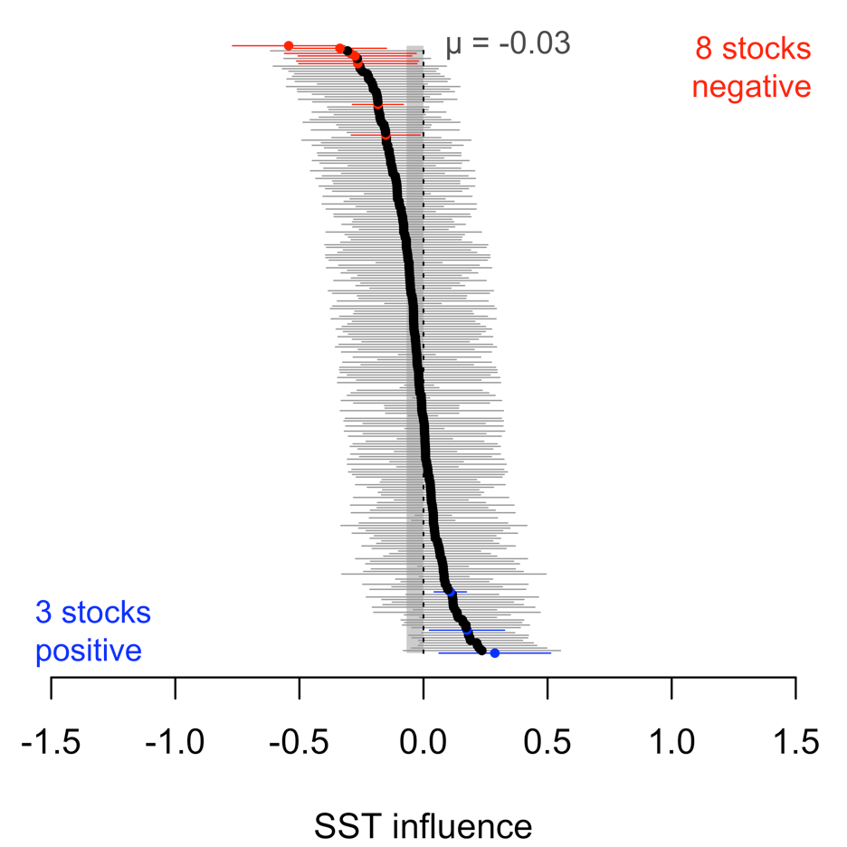

**Figure 1.** Distribution of temperature influences on recruitment. Points show mean estimates and error bars show 95% confidence intervals. Significant positive and negative temperature influences are shown in blue and red, respectively. The shaded grey column indicates the 95% confidence interval for the global mean of the temperature influences.

**Supplemental Tables and Figures**

**Table S1.** RAM Legacy Database stocks used in analysis (SSB=spawning stock biomass).

|  |  |
| --- | --- |
| **Condition** | **# of stocks** |
| All RAM Legacy Database stocks | 1291 |
| Only stocks with SSB/recruitment time series ≥ 20 years | 498 |
| Only stocks with SSB in metric tons and recruitment in number of recruits | 328 |
| Removed 19 stocks without 20 years of data after trimming | 309 |
| Removed 55 stocks without SST data (WILL FIX THIS PROBLEM) | 254 |
| Removed 7 stocks without density-dependence at high biomass | 247 |
| Removed 12 stocks preventing model convergence | 235 |

Will ultimately retain more stocks once I’ve fixed the SST problem.

**Table S2.** Model symbols and their definitions.

|  |  |  |
| --- | --- | --- |
| **Type** | **Symbol** | **Definition** |
| Data | Ri,t | Recruitment for stock *i* in year *t* |
| Data | SSBi,t | Spawning stock biomass for stock *i* in year *t* |
| Data | SSTi,t | Sea surface temperature (SST) experienced by stock *i* in year *t* |
| Data | Gi | Group (taxonomic, geographic, or stock assessment model) for stock *i* |
| Derived | εi,t | Residual process variability for stock *i* in year *t* |
| Parameter | αi | Maximum annual recruits per spawning stock biomass for stock *i* |
| Parameter | βi | Strength of density-dependence per spawning stock biomass for stock *i* |
| Parameter | θi | Influence of SST on productivity for stock *i* |
| Parameter | μSST | Mean of the distribution of SST influences (θi) |
| Parameter | σSST | Standard deviation of the distribution of SST influences (θi) |
| Parameter | μG,j | Mean of the distribution of SST influences (θi) for group *j* |
| Parameter | σG | Standard deviation of the group-specific distributions of SST influences (θi) |
| Parameter | σP,i | Standard deviation of the residual process variability for stock *i* |
| Parameter | ρi | First-order (AR1) autocorrelation coefficient for stock *i* |
| Index | t | Year |
| Index | i | Stock |
| Index | j | Group (taxonomic or geographic) |

**Appendix captions**

**Appendix A.** Biomass, recruitment, and catch time series and associated stock-recruit and surplus production relationships for 328 candidate RAM Legacy Database stocks. In the time series plots, vertical dashed lines indicate where time series were trimmed to remove strong model assumptions. In the stock-recruit and surplus production plots, red points indicate years trimmed from the time series. Stocks labeled in red and with a red asterisk in their stock-recruit plots were removed from the analysis due to an assumed stock-recruit relationship.

**Appendix B.** SST-linked stock-recruit relationships for the 239 stocks used in the analysis. Blue points represent cooler than average years and red points represent warmer than average years. Black lines show stock-recruit relationships at each stock’s average temperature. Blue and red lines show stock-recruit relationships at temperatures progressively cooler and warmer from the average, respectively. Stocks with positive SST influences are more productive at warmer temperatures (red curves on top) and stocks with negative SST influences are more productive at cooler temperatures (blue curves on top). SST influences (θi) are shown in the top-left corner of each plot and are colored to indicate the direction and significance of the SST influence (blue=positive, red=negative, bold=significant).