**Performance of catch-only stock assessment models at estimating time series of stock status**

Christopher M. Free, Olaf P. Jensen

*Rutgers University, Department of Marine & Coastal Sciences*

**Methods**

We extended the analysis of Free et al. (in review) to evaluate the ability of six catch-only stock assessment models (**Table 1**) to estimate time series of stock status (i.e., B/BMSY). We evaluated their performance by applying them to simulated fish stocks from Rosenberg et al. (2014). The simulated stocks represent a fully factorial dataset of simulated fisheries including three fish life histories, three levels of initial biomass depletion, four exploitation scenarios, two levels of recruitment variability, two levels of recruitment autocorrelation, two levels of measurement error, and two time series lengths (20 and 60 years), with each combination of parameters run through ten stochastic iterations (**Table S1**). Although we used both the 20- and 60-year simulations when evaluating the performance of terminal year status predictions (Free et al. in review), we only used the 60-year simulations in evaluating the performance of full time series status predictions (n=2880 stocks). We evaluated the ability of each model to estimate status by measuring each model’s bias, accuracy, and ability to correctly rank or correlate across populations in the last 40 years of the 60-year time series. We measured bias as the median proportional error (MPE) and measured accuracy as the median absolute proportional error (MAPE). Proportional error is calculated as $\left(\hat{θ}-θ\right) / \left|θ\right|$, where $\hat{θ}$ and $θ$ represent predicted and true B/BMSY values, respectively. We measured the ability to correctly rank populations as Spearman’s rank-order correlation between predicted and true values.

**Results & Discussion**

All of the evaluated catch-only models exhibit trends in performance over time. The performance of the superensemble model improves over time while the performance of the other models degrades over time (**Figure 1**). The superensemble model predictions increase in both accuracy (i.e., decrease in inaccuracy) and correlation over time. It exhibits the narrowest range in bias over time though it transitions from being negatively to positively biased (**Figure 1**). The other models show decreasing accuracy (i.e., increasing inaccuracy) and correlation over time; trends in bias vary among models (**Figure 1**). The degrading performance of the other catch-only models likely occurs because (1) these models assume low levels of depletion at the beginning of the catch time series and this assumption proves to be generally correct and (2) information in the catch time series degrades when management reduces fishing effort in response to population depletion (e.g., in the two-way trip scenario). As a result, we recommend that the superensemble model be favored over other catch-only models in making both terminal year (Free et al. in review) and full time series predictions of stocks status.

**References**

Anderson, S.C, A.B. Cooper, O.P. Jensen, C. Minto, J.T. Thorson, J.C. Walsh, J. Afflerbach, M. Dickey-Collas, K.M. Kleisner, C. Longo, G.C. Osio, D. Ovando, I. Mosqueira, A.A. Rosenberg, and E.R. Selig. 2017. Improving estimates of population status and trend with superensemble models. Fish and Fisheries 18(4):732–741.

Costello, C., D. Ovando, R. Hilborn, S.D. Gaines, O. Deschenes, and S.E. Lester. 2012. Status and solutions for the world’s unassessed fisheries. Science338:517–520.

Froese, R., N. Demirel, G. Coro, K.M. Kleisner, and H. Winker. 2017*.* Estimating fisheries reference points from catch and resilience. Fish and Fisheries 18(3):506–526.

Martell, S., and R. Froese. 2013. A simple method for estimating MSY from catch and resilience. Fish and Fisheries 14:504–514.

Rosenberg, A.A., M.J. Fogarty, A.B. Cooper, M. Dickey-Collas, E.A. Fulton, N.L. Gutiérrez, K.J.W. Hyde, K.M. Kleisner, C. Longo, C.V. Minte-Vera, C. Minto, I. Mosqueira, G.C. Osio, D. Ovando, E.R. Selig, J.T. Thorson, and Y. Ye. 2014. Developing new approaches to global stock status assessment and fishery production potential of the seas. FAO Fisheries and Aquaculture Circular, Rome, Italy.

Thorson, J.T., C. Minto, C.V. Minte-Vera, K.M. Kleisner, and C. Longo. 2013. A new role for effort dynamics in the theory of harvested populations and data-poor stock assessment. Canadian Journal of Fisheries and Aquatic Sciences 70(12):1829–1844.

Vasconcellos, M., and K. Cochrane. 2005. Overview of world status of data-limited fisheries: inferences from landings statistics. In: Kruse, G.H., V.F. Gallucci, D.E. Hay, R.I. Perry, R.M. Peterman, T.C. Shirley, P.D. Spencer, B. Wilson, and R. Woodby (eds.), Fisheries Assessment and Management in Data-Limited Situations. Alaska Sea Grant College Program, University of Alaska Fairbanks, Fairbanks, AK.

Zhou, S., A.E. Punt, Y. Ye, N. Ellis, C.M. Dichmont, M. Haddon, D.C. Smith, and A.D.M. Smith. 2017a. Estimating stock depletion level from patterns of catch history. Fish and Fisheries 18(4):742–751.

Zhou, S., A.E. Punt, A.D.M. Smith, Y. Ye, M. Haddon, C.M. Dichmont, and D.C. Smith. 2017b. An optimized catch-only assessment method for data poor fisheries. ICES Journal of Marine Science 75(3):964-976.

**Tables & Figures**

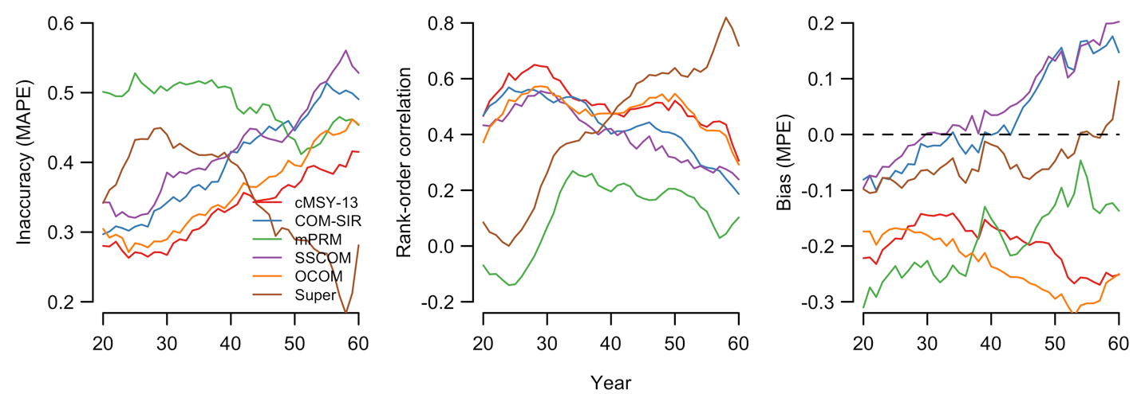

**Figure 1.** Status estimation performance of six catch-only stock status models.The performance of the superensemble model improves over time while the performance of the other catch-only models degrades over time.

**Table 1.** Catch-only stock assessment methods†.

|  |  |  |  |  |
| --- | --- | --- | --- | --- |
|  | **Method** | **References** | **Data input/output** | **Brief description** |
| 1 | **mPRM\*** Modified panel regression model | Costello et al. 2012 Anderson et al. 2017 | In: Catch, taxonomic group Out: B/BMSY | Uses a panel regression model trained on the RAMLDB to predict status from characteristics of the catch time series and taxonomic group |
| 2 | **cMSY-2013\*** Catch-MSY | Martell & Froese 2013 Rosenberg et al. 2014 | In: Catch, resilience Out: B/BMSY, MSY, B, BMSY | Uses a stock reduction analysis with priors for *r*, *K*, and initial/final year depletion derived from resilience and maximum catch to estimate status |
| 3 | **OCOM** Optimized catch-only model | Zhou et al. 2017b | In: Catch, natural mortality (M) Out: Saturation, MSY | Uses a stock reduction analysis with priors for *r* and final year depletion derived from *M* and saturation from zBRT to estimate status |
| 4 | **COM-SIR\*** Catch-only-model with sampling-importance-resampling | Vasconcellos & Cochrane 2005 Rosenberg et al. 2014 | In: Catch, resilience Out: B/BMSY | Uses a coupled harvest-dynamics model fit using a sampling-importance-resampling algorithm to estimate status |
| 5 | **SSCOM\*** State-space catch-only model | Thorson et al. 2013 | In: Catch, resilience Out: B/BMSY | Uses a coupled harvest-dynamics model fit using a Bayesian hierarchical state-space framework to estimate status |
| 6 | **Superensemble** Random forest superensemble model | Anderson et al. 2017 | In: Catch, B/BMSY from 4 COMs Out: B/BMSY | Uses a random forest model trained on simulated stocks to predict status from the B/BMSY predictions of 4 COMs and two spectral properties of the catch time series |

* Used as a predictor in the Anderson et al. (2017) superensemble model

† We excluded two catch-only models evaluated by Free et al. (in review) in this analysis: (1) zBRT (Zhou et al. 2017a) because it is an input into OCOM and (2) cMSY-2017 (Froese et al. 2017) because the authors’ published code does not output B/BMSY time series.

**Table S1.** Factorial design of the Rosenberg et al. (2014) simulated stocks.

|  |  |  |
| --- | --- | --- |
| **Factor** | **# of levels** | **Levels** |
| Life history | 3 | Demersal, small pelagic, or large pelagic |
| Initial biomass depletion | 3 | 100%, 70%, or 40% of carrying capacity |
| Exploitation dynamics | 4 | Constant, biomass-coupled, increasing, or roller coaster rates |
| Recruitment variability | 2 | Low or high variability |
| Recruitment autocorrelation | 2 | With or without autocorrelation |
| Catch measurement error | 2 | With or without catch measurement error |
| Time series length | 2 | 20 or 60 years |
| Iterations | 10 | Iterations for each combination of the above parameters |
| **Total number of stocks:** | 5760 |  |