# **Global trade network patterns coupled to marine fisheries sustainability**

**Abstract**

Increases in the speed and scale of seafood trade in the global trade network along with the simultaneous decline of many marine fisheries globally raises serious concerns about the sustainability of such trade development. The continuity, number and grouping of trade connections has changed: seafood trade in the Anthropocene is short-lived and globally connected. In this new reality, (i) the formation of new trade connections can outpace that of regulatory action in fisheries and (ii) the state of a fishery can depend on its trade-related connectivity to other fisheries. Despite mounting empirical and theoretical evidence of the importance of trade networks in natural resource management, indicators of network speed and scale are rarely used to understand fisheries sustainability. Here, we assess whether the speed and scale of the seafood trade network is indicative of fishery status. Our data consolidates post-1995 global, bilateral trade data including >400,000 bilateral trade flows and stock status estimates for 746 stocks from 222 countries and is analyzed with both static and dynamic panel analysis methods. We find that low levels of grouping in the network correlates with low fishery status and despite increasing numbers of trade connections grouping has declined. Contrary to earlier findings, we demonstrate that long-term trade connections correlate with low fishery status. These results highlight the importance of the way trade develops i.e. in the continuity and grouping of trade connections as key indicators of fisheries sustainability. Thus, policies aimed at improving fisheries sustainability cannot focus on regulating local fisheries alone. For one, trade agreements could target the formation of new multilateral trade alliances. Parallel efforts of international trade organizations, national trade and fisheries ministries need to create incentives that long-term trade connections enable sustainable fisheries use.

**Keywords:** sustainable fisheries; trade network patterns; speed and scale; Anthropocene ocean; stock status; seafood trade

## 

## **1. Introduction**

Oceans in the Anthropocene are characterized by dynamic changes in the speed and scale of human activities surrounding their resources [(Jouffray et al., 2020; Steffen et al., 2015)](https://www.zotero.org/google-docs/?X1GLRA). In marine fisheries, there has been an unprecedented increase in seafood trade and its importance as a source of income, food, and nutrition is only expected to grow [(FAO, 2018; Gephart and Pace, 2015)](https://www.zotero.org/google-docs/?CzaKRt). The 60 million metric tons of seafood products exported in 2016 represented a 245% increase since 1976 ([FAO, 2018](https://www.zotero.org/google-docs/?i8aoe7)), a growth largely driven by increased per capita demand, which reached 20kg in 2019, 11kg more than in the early 1960s. However, the marine resource base needed to support this rising demand is dwindling, with many marine fisheries becoming increasingly overfished [([FAO, 2018](https://www.zotero.org/google-docs/?i8aoe7); Rosenberg et al., 2018)](https://www.zotero.org/google-docs/?fw0hG2). This development threatens fishery livelihoods and global food security [(United Nations, 2018)](https://www.zotero.org/google-docs/?zlFwaW) and creates the urgent need to understand trade impacts on fisheries.

From a theoretical perspective, the export of seafood can lead to overfishing in unregulated, open access fisheries [(Brander and Scott Taylor, 1997; Brander and Taylor, 1998; Chichilnisky, 1994)](https://www.zotero.org/google-docs/?QcND1P). High export prices may also lead to collapse in fisheries, if costs of exploitation continue to be lower than prices or if there is high fishing effort [(Burgess et al., 2017; Eisenbarth, 2017; Fryxell et al., 2017)](https://www.zotero.org/google-docs/?ulIjep). However, present-time marine resource use patterns are more complex. For example, new patterns of marine resource use have emerged in recent years such as that of sequential exploitation in which one fish stock is substituted for another, facilitated by a trade network in which the number and speed of new trade connections forming is increasing [(Anderson et al., 2011a; Berkes et al., 2006; Eriksson et al., 2015)](https://www.zotero.org/google-docs/?iOsBXf). This phenomenon is mirrored globally by the rapid increase in speed and scale of the global trade network [(Bellmann et al., 2016; Gephart and Pace, 2015)](https://www.zotero.org/google-docs/?5HaFIc). This increase is illustrated by changes in the continuity, number and grouping of connections in the global trade network. It is now more interconnected than ever before, with a 65% increase in trade connections between 1994 and 2012 [(Gephart and Pace, 2015)](https://www.zotero.org/google-docs/?mkb6je) and seafood trade connections worldwide are generally short-lived, often lasting only a single year [(Asche et al., 2018; Gephart and Pace, 2015; Wang et al., 2018)](https://www.zotero.org/google-docs/?dofshP). In this new reality, (i) the formation of new trade connections may outpace that of regulatory action in fisheries [(Berkes et al., 2006; Eriksson et al., 2015)](https://www.zotero.org/google-docs/?5sjFCm) and (ii) the state of one fishery stock may depend on its trade-related connectivity to other stocks [(Eisenbarth, 2017; Gephart et al., 2016)](https://www.zotero.org/google-docs/?6RVnMf). An understanding of how the highly-connected, short-lived world of seafood trade impacts the sustainability of fisheries worldwide therefore requires discerning the relationship between speed and scale of the seafood trade network and the sustainability of the fisheries that it relies on.

The scale of trade networks has been associated with unsustainable resource use in a number of environments including fisheries (Anderson et al., 2011; Berkes et al., 2006; Eriksson et al., 2015), water use, [(Dalin et al., 2012)](https://www.zotero.org/google-docs/?m4wqqL) and land use [(Ahrends et al., 2010; Ercsey-Ravasz et al., 2012)](https://www.zotero.org/google-docs/?0oGv5o). For example, national seafood supplies of exporters with many import connections may be particularly vulnerable to external shocks due to trade exposure from a higher number of partners (Gephart et al. 2016). Also, the position of a country in the trade network is a good predictor of environmental pollution [(Burns et al., 2015; Prell, 2016; Prell et al., 2015)](https://www.zotero.org/google-docs/?gtYUL0) and environmental conditions have been found to affect the development of trade networks and their characteristics [(Prell et al., 2017; Prell and Feng, 2016)](https://www.zotero.org/google-docs/?KQsfpY). Collectively, this research suggests that changes in the speed and scale of trade networks impacts the sustainable use of natural environments.

The speed of international trade in marine resources has been linked with a number of ecosystem-level impacts [(Anderson et al., 2011a, 2011b; Eriksson et al., 2015)](https://www.zotero.org/google-docs/?tFQnVJ). For example, the global sea cucumber fishery developed ‘five to six times faster in 1990 compared to 1960’ and drove the sequential overexploitation of sea cucumber populations globally [(Anderson et al., 2011a)](https://www.zotero.org/google-docs/?vHf3iE). High-speed trade networks that exhibit high turnover with many, short-lived trade partnerships could be incongruous with the pace and time frames over which fisheries assessments and management occur. For example, in the United States, stock assessments are only conducted every two to five years [(Neubauer et al., 2018)](https://www.zotero.org/google-docs/?vaGRcr), and less frequently, or not at all, in countries with lower scientific and management capacities (Bundy et al., 2017; Hilborn et al., 2020). Internationally, bans or controls in trade for endangered species are only updated every two years through the U.N. Convention on International Trade in Endangered Species. Annual turnovers in trade connections may therefore drive unsustainable fishing practices as markets mediate demand and the subsequent exploitation of stocks at rates quicker than fisheries regulation can scrutinize and act [(Berkes et al., 2006)](https://www.zotero.org/google-docs/?E7jFZQ).

Collectively, the literature suggests that the speed and scale of trade can affect mechanisms and incentives for sustainable use of fisheries. Here, we tested the link between network characteristics of speed and scale and fisheries status. Specifically, we seek to identify whether the continuity, number and grouping of connections in trade networks is associated with low or high stock status. To this end, we assembled an extensive global dataset of stock status estimates of 1,740 fisheries, linked it to the status to 401,027 bilateral trade flows over a period of 20 years and analyzed it using both static and dynamic panel analysis methods. Our analysis allows us to highlight the importance of the way seafood trade networks develop for fisheries sustainability.

## **2. Methods**

Using the UN’s Comtrade International Trade Statistics Database [(United Nations, 2019)](https://www.zotero.org/google-docs/?6RWNVH) and fisheries landings data from the FAO global landings database [(FAO, 2018)](https://www.zotero.org/google-docs/?eFBvBG), we constructed a database of 401,027 bilateral trade transactions of 746 fished stocks classified into 24 distinct fisheries commodity groups between 222 countries from 1990 to 2015. Our final dataset contained time series from 1995 to 2015 of (i) bilateral trade flows between import and export countries; (ii) the mean status of individual stocks contributing to each commodity group; and (iii) characteristics of the speed and scale of the trade network for each commodity group.

### **2.1. Estimating FAO stock status**

We constructed time series of stock status (B/BMSY, i.e., biomass relative to the biomass that produces maximum sustainable yield or MSY) for 1,740 FAO fish stocks using an ensemble model that estimates B/BMSY from the B/BMSY predictions of four individual catch-only stock assessment models (**Table S1**) and two spectral properties of the catch time series. Stock status and fishery status are henceforth used interchangeably. The ensemble model was adapted from the Anderson et al. (2017) ensemble model, which produces better estimates of stock status than all other catch-only models [(Anderson et al., 2017; Free et al., 2020)](https://www.zotero.org/google-docs/?ihJ5jZ). Although individual catch-only models are poor predictors of stock status, the ensemble model performs similarly to statistical catch-at-age models provided low quality data [(Free et al., 2020)](https://www.zotero.org/google-docs/?kk6Mxu). Rosenberg et al. (2018) used the Anderson et al. (2017) ensemble model to estimate the terminal year status of 785 FAO fish stocks. We extended this analysis to estimate status from 1950-2015 for the FAO fish stocks (FAO area-country-species triples) meeting the following criteria: marine wild capture fisheries for finfish and invertebrates with taxonomic identification resolved to the species-level and with catch time series ≥20 yrs and ≥250 mt of median annual catch. We also excluded highly migratory species (i.e., tunas, marlins, and billfish) whose population dynamics cannot be described by catch within a single country’s exclusive economic zone [(Lascelles et al., 2014)](https://www.zotero.org/google-docs/?5juZLm).

The ensemble model developed here uses boosted regression trees (**Figure S1**) to estimate B/BMSY in year *t* using: (i) B/BMSY predictions for year *t* from four individual catch-only models (**Table S1**) applied to the full catch time series and (ii) the 0.20 and 0.05 spectral densities of the scaled catch time series (catch divided by maximum catch) from year *0* to year *t*. These spectral densities correspond to 5- and 20-year cycles and were shown by Anderson et al. (2016) to improve predictive performance. The model was trained on 90% of the simulated fish stocks from Rosenberg et al. (2014) and tested on the remaining 10% of simulated stocks.The model exhibits substantially higher accuracy and lower bias than other catch-only models both in the terminal year (**Figure S2**) and through time (**Figure S3**). The performance of the ensemble model increases through time and is especially good during the final 20 years of the 60 year time series (**Figure S3**). This is promising given that we evaluate the relationship between seafood trade and stock status from 1995 to 2015. See the supplementary information for more details on model fitting and validation.

### **2.2. Trade data**

We constructed global seafood trade networks for specific species groups (**Table S5**) using the United Nations’ Comtrade database [(United Nations, 2019)](https://www.zotero.org/google-docs/?peylAT) following best practices identified by Gephart and Pace (2015). Species groups were specified by commodity groups and contained class, family, genus and species classifications. The Comtrade database contains self-reported, national annual import and export bilateral trade flows. We included only seafood products destined for human consumption (selected from Harmonized System (HS) codes 03 and 16) during the years 1995-2015. Although the Comtrade data provides information on the amount and value of seafood product trades between nations, it does not necessarily represent the geographical origin of the fish products being traded. For example, seafood products caught in one country could be processed in another country and then exported again (Gephart et al., 2019; Stoll et al., 2018). For this reason, we excluded all exports explicitly labelled as re-exports and all exports of species groups exported by a country that did not land the same species group in capture fisheries (**section 2.3.**). Finally, HS commodity groups do not differentiate between wild capture and aquaculture landings. Therefore we excluded all species groups that accounted for more than 5% of global aquaculture production [(FAO, 2019)](https://www.zotero.org/google-docs/?NMk8cD).

### **2.3. Data matching**

We used a three step matching process to connect the UN Comtrade data with the stock status estimates. First, we used FishStat to generate a combined dataset of FAO trade data and the UN Comtrade data (FAO, 2020). This matching was based on FAO trade commodity groups and HS codes 2012 groups (World Customs Organisation, 2019).

Second, we matched FAO trade data to the stock status estimates. In particular, we used FAO trade commodity group descriptions with common and scientific name specifications used to describe species in the stock status estimates. Matchings between commodity groups and scientific names were first done at the species-level. For example, stock status estimates for European plaice (*Pleuronectes platessa*) were matched to the commodity group category ‘European plaice (*Pleuronectes platessa*), fresh or chilled’. When the commodity group category was not specified at the species-level, the next level of taxonomic resolution would be matched to the stock status estimates, which are always at the species-level. For example, stock status estimates for American lobster (*Homarus americanus*) were matched to the commodity group category ‘American/European lobsters (*Homarus* spp.), meat or tails, fresh or chilled’. When stock status estimates could only be matched to commodity groups of higher taxonomic resolution than class, we excluded the stock from the dataset. There was no suitable commodity group for 337 species with stock status estimates including roach (*Rutilus rutilus*), garfish (*Belone belone*), and surmullet (*Mullus surmulettus*).

Finally, we used the HS 2012 to HS 1992 correspondence table for matching the UN Comtrade time series starting in 1995. We associated HS 1992 commodity groups with 24 species groups (i.e. HS 1992 ‘Plaice (*Pleuronectes platessa*), frozen’ with species group ‘plaice’), being an aggregate of market substitutable species. This last step leads to a loss in taxonomic resolution of the stock status estimates. Therefore, in our final dataset, species groups contain an average of 1.5 stocks per exporter from the stock status estimates and a total of 746 stocks.

### **2.4. Network characteristics**

We characterized network scale as the clustering coefficient and degree of the network and network speed as the average duration and turnover rate of trade connections in the network. Clustering coefficient, average degree, average duration and turnover rate were specified on the species group network level. This means that there is one value for each of these network characteristics per year and per species group. This is different for trade duration, which is specified for each year, each species group there and exporter in the network.

#### **2.4.1. Network scale: clustering and degree**

The clustering coefficient, hereafter called clustering, is an indicator of network scale indicating the level of grouping in the network. It is a measure of the ratio of adjacent triangular relationships in a network i.e., the degree to which nodes in a network tend to cluster together (**Table S6**). Adjacent triangular relationships form, for example, if country X has seafood trade connections with country Y and country Z while country Y also trades with country Z. In a network with many adjacent triangular relationships, the clustering coefficient is high. Adjacent triangular relationships are accounted for independent of the directionality of a link, i.e., whether the link is an export or import link. We calculated the clustering coefficient at network level using the *igraph* R package [(Csárdi and Tamás, 2020)](https://www.zotero.org/google-docs/?DejEDp).

As a second indicator of the scale of the network, we calculated the average node degree, hereafter called degree. It is a measure of the total number of trade connections of a country i.e. the edges connected to a node. In the case of our trade networks, it measures the number of trade partners each country has (**Table S6**). In a dense network with many connections the average degree will be high. The number of trade partners is accounted for independently of the directionality of a link. For example, if country X exports to two countries and imports a species commodity group from three countries, its node degree is five. We calculated the average node degree of each network by aggregating per species group and year.

#### **2.4.2 Network speed: trade duration and turnover**

The first indicator of the speed of trade is trade duration. Trade duration measures the continuity of trade connections through the number of consecutive years of trade connections between two countries (**Table S6**). We created a dummy variable indicating whether a trade relation has existed for at least four years, which corresponds to the median duration of all of the trade connections in our data set. Four years also coincides with the time scale of a number of stock assessments [(Neubauer et al., 2018)](https://www.zotero.org/google-docs/?pD1EL0), which may allow fisheries authorities to take regulatory action in the case of changes in stock status due to novel trade connections. If the trade relation has existed for four years or more, the dummy is 1, if less than four years, the dummy is 0. For example, for a trade relation existing from 1995-1999, only the year 1998 and 1999 would be indicated with 1 and the years 1995-1997 indicated with 0. We averaged this dummy variable per exporter and species group so that it represented the percentage of all current trade relations that have lasted for at least 4 years. Thus, trade duration of fishery stocks with a value closer to 1 can be interpreted as long-term and those closer to 0 as short-lived.

As a second indicator of the speed of trade, we calculated the turnover of trade connections. Turnover measures the continuity of trade connections through the sum of unique trade connections subtracting overlapping unique trade connections in a network between two years (**Table S6**). Low values of turnover correspond to low numbers of common trade connections between the years. In a network with many short-lived and frequently substituted trade connections, this measure is expected to be high.

### **2.5. GMM estimations**

We used a generalized method of moments (GMM) estimator to assess contemporaneous correlation between network characteristics and stock status i.e., current networks predict current stock status. We use 2-5 year lags of the covariates as GMM-type instruments. GMM-type instruments are the lags of endogenous variables. These are different from standard instruments used in regression analysis, which are always strictly exogenous. The number of GMM instruments is less than the number of country and species groups (Roodman, 2009). Year dummies are used to remove time trends in dependent and independent variables. They are used as strictly exogenous instruments. They can be negligible if there are no common trends for each species group or each exporters’ stock or affect the analysis if there is insufficient variation in either stock status or network characteristics across species groups. We evaluate the robustness of the GMM estimator results by providing additional estimations using a fixed effects estimator (**Table S7**). The calculations of all network characteristics are based on the year 1995, for the GMM estimations we include observations from 1998 and after which constitutes the first year of calculated values for trade duration.

There are several potential sources of endogeneity. One source is the correlation between network characteristics and time-invariant fixed effects such as unchanged institutional and geographic characteristics. First differencing in the GMM estimator was used to eliminate country and species group time-invariant fixed effects and thus lessen the endogeneity problem. Another source of endogeneity is if there are time-variant factors in the error term that correlate with network characteristics and if there is dynamic endogeneity between network characteristics and stock status. We expect dynamic endogeneity if network characteristics affect stock status and vice versa. For example, short-lived trade connections impact stock status, while declines in stock status affect the continuity of the trade connection. In this situation, including lags of the dependent variable in the GMM estimator may provide better estimations (Blundell and Bond, 1998). For the GMM estimator, we tested autocorrelation of the error terms using the Arellano-Bond test for AR(2) and overidentification of instruments using the Hansen test [(Roodman, 2009a, 2009b)](https://www.zotero.org/google-docs/?toSwA5). P-values for the AR(2) test and the Hansen test are larger than 0.10, indicating that the first-differenced error term is not autocorrelated of order 2 and that the assumption of instrument exogeneity is not violated. We evaluated model significance using the p-value with a ≤ 0.05 alpha value.

#### **2.5.1 Model specification**

We employ three model settings of the GMM estimator. The first is the static GMM estimator and the network effects on fishery stocks are assumed to be contemporaneous, referred to as baseline model. It assumes the functional form described in equation 1 (**Model 1, Table 1**):

(1)

Where stock status (B/BMSY) of species group *g* exported by exporter *i*  in year *t* is predicted by the network scale metrics (clustering and degree) and network speed metrics (trade duration and turnover) of species group *g* in year *t*. The error term is composed of two terms: first, represents unobserved exporter-species time-invariant fixed effects, and, second, represents a stochastic error term to introduce variation in other variables that could potentially affect stock status but are not included in our model.

The second is the GMM estimator with time dummies. It is static and assumes the functional form described in equation 2 (**Model 2, Table 1**):

(2)

where (γt) are (t – 1) year dummies that capture the year-specific factors common to all exporter-species pairs.

The final specification is the dynamic GMM estimator and assumes the functional form described in equation 3 (**Model 3, Table 1**):

(3)

Where 1- and 2-year lags of stock status are used to lessen dynamic endogeneity.

## **3. Results**

### 3.1. Stock status and network characteristics

Between 1995 and 2015, stock status across all species groups and exporters decreased almost linearly (r2= 0.99) from 0.922 B/BMSY to 0.776 B/BMSY (**Figure 1**) with < 0.8 B/BMSY signifiying an overfished fishery [(FAO, 2018)](https://www.zotero.org/google-docs/?goTVbg). This observation confirms the declining trends reported in fisheries sustainability worldwide [(FAO, 2018)](https://www.zotero.org/google-docs/?eqKPmE). Network characteristics for scale of the trade network developed in opposite directions (**Figure 1**). We observed an increase in average degree, but a decrease in clustering. Degree peaked at 42.6 in 2014, after a total increase of 34.5%. Clustering, in contrast, was at the lowest level in 2008 and decreased on average by 16.0%. This observation reflects the fact that the international seafood trade network has increased in connectivity [(Gephart and Pace, 2015)](https://www.zotero.org/google-docs/?7MsF99), but is less clustered since 1995.

Trade duration and turnover increased from 1995-2015 by 10.6% and 9.1%, respectively (**Figure 1**). Interestingly, despite the high number of single year trade connections reported in Gephart et al. (2016) our data shows that the average trade duration across all species groups and exporters increased. At the same time, link turnover also increased, with average trade duration peaking in 2015. This implies that trade connections are added rather than replaced which coincides with the observation that degree is increasing.

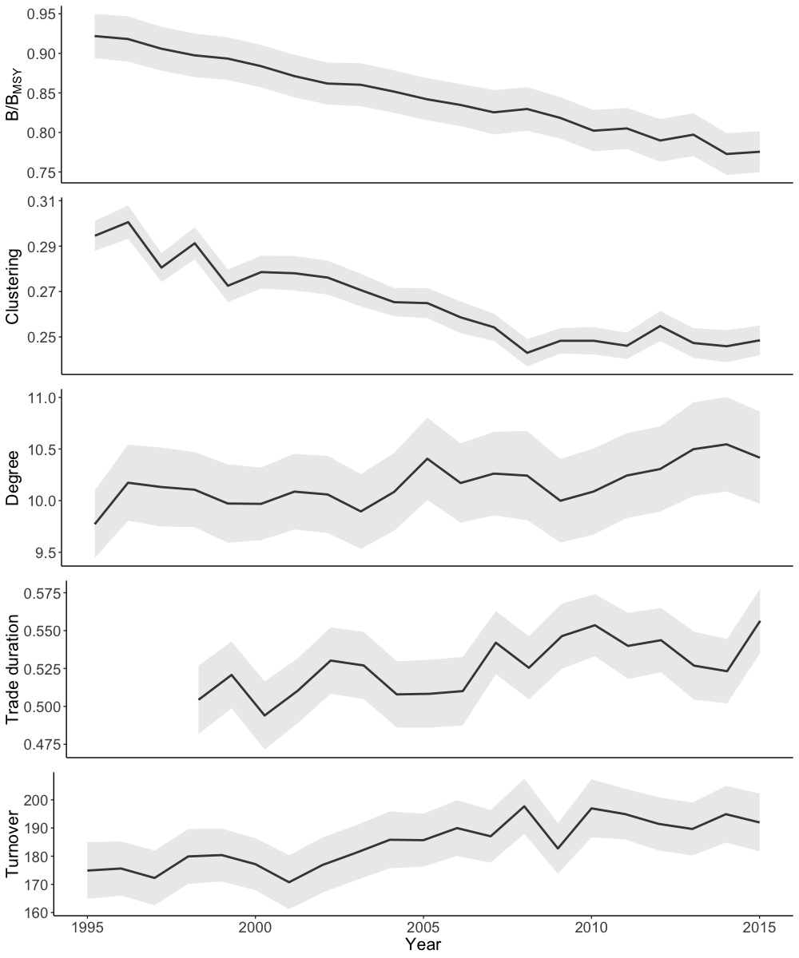

Fig. 1: B/BMSY and characteristics of trade network scale (clustering and degree) and speed (trade duration and turnover) from 1995 to 2015. Mean and confidence intervals for all exporters and species groups. The trade duration time series begins in 1998 because its calculation depends on the availability of data four years previous.

### 3.2. GMM estimator results

We found correlations between stock status and two network characteristics. In the baseline model specification of the GMM estimator, clustering and degree were statistically significant but only clustering and trade duration remained statistically significant throughout a number of specifications. Clustering was statistically significant and positively correlated with fishery stock status using dynamic and static specifications without year dummies (**Model 1 & 3, Table 1; SI Model 4, Table S7**). It was the only network characteristic that was significant in the dynamic GMM model specification (**Model 3, Table 1**). The effect of clustering across several models on stock status was consistently stronger than that of trade duration. Across all species groups clustering decreased over the observed time period (**Figure 1**), in contrast, degree increased. This means that percentage-wise fewer triangles exist in the entire trade network. That the coefficient of clustering was no longer significant, using time dummies, could point to spurious correlation caused by common time trends or to little variation in stock status and clustering across species groups.

Using the static GMM estimator with year dummies (**Model 2, Table 1**) and the same model specifications using the fixed effects estimator (**Table S7**) shows that trade duration is statistically significant and negatively correlated to stock status. Our data also show that countries with very low average duration of trades overall export less fish (**Figure S4**). The dynamic specification of the GMM estimator (**Model 3, Table 1**) indicates that the negative, significant correlation for trade duration is dynamically coupled implying that stock status is affected by trade duration and vice versa. Trade duration is therefore no driver of stock status rather it can be viewed as indicative of stocks status.

The similarity between the results of the GMM estimator and fixed effects estimator (**Table S7**) suggest that time-variant factors in the error term that correlate with network characteristics do not bias our estimations strongly. However, changes in significance between static and dynamic model specifications point to the importance of dynamic endogeneity. This suggests that network characteristics affect stock status but can be affected vice versa.

**Table 1.** GMM estimation for the contemporaneous model. Windmeijer’s finite-sample corrected standard errors in parentheses. Significance levels reported as * *p* < 0.05, ** *p* < 0.01, *** *p* < 0.001.

|  |  |  |  |
| --- | --- | --- | --- |
| Network Characteristics | Model 1 | Model 2 | Model 3 |
|  | B/BMSY | B/BMSY | B/BMSY |
| clustering | 0.795*** | -0.179 | 0.212* |
|  | (0.174) | (0.155) | (0.100) |
| degree | -0.0199*** | 0.00158 | -0.00193 |
|  | (0.00348) | (0.00384) | (0.00225) |
| turnover | 0.0000221 | 0.0000531 | -0.0000502 |
|  | (0.0000849) | (0.0000981) | (0.0000667) |
| trade duration | -0.0520 | -0.0718* | -0.00293 |
|  | (0.0335) | (0.0303) | (0.0306) |
| (B/BMSY) t-1 |  |  | 0.566*** |
|  |  |  | (0.0324) |
| (B/BMSY) t-2 |  |  | 0.148*** |
|  |  |  | (0.0221) |
| Year dummies | No | Yes | No |
| *N* | 5423 | 5423 | 4669 |
| *p-value AB test for AR(2)* | 0.256 | 0.590 | 0.860 |
| *p-value Hansen test* | 0.183 | 0.566 | 0.507 |

### 3.3. Trade network evolution and stock status

We illustrate the ways in which trade duration, clustering, and stock status relate to each other using the four species group networks with the highest and lowest values of clustering and trade duration from 1995 to 2015. Clustering across all species groups and exporters decreased (**Figure 1**). The haddock (*Melanogrammus aeglefinus*) network had the highest clustering values and rock lobster had the lowest clustering values. The clustering values of these two species group networks developed in opposite directions during the observed time period, with a decrease in clustering of haddock from an initial value of 0.45 in 1995 to 0.37 in 2015. The average status of the haddock export stocks increased by 9.7%, peaked in 2009 at a value of 0.73 B/BMSY, then declined to levels below 1995 levels. In contrast, clustering of the rock lobster network increased from 0.16 in 1998 to 0.22 in 2015. Stock status was always >0.8 B/BMSY, but average stock status declined by 13.3% between 1995 and 2015.

The highest value of trade duration among the species groups was in the plaice network and the lowest in the lobster network. Trade duration in the plaice network increased by 34% from 1998, peaking in 2002. At the same time, the average status (B/BMSY) of export stocks in the plaice network decreased and at times fell below >0.8 B/BMSY. Stock status across exporters of lobster (*Nephropidae*, excluding *Homarus spp.*) also decreased. This decrease is particularly visible in the network by a drastic increase in the number of red colored trade connections between 2005 and 2015 (**Figure 2**).

The geographic range of trade differed between the four species groups (**Figure 2**). The highest volumes of plaice (*Pleuronectes platessa*) were traded primarily across North-East Asia and Europe, whereas much of the largest volume trades in rock lobster (Palinuridae spp.) were centered around the American continent. A higher geographic range does not, however, directly translate into more trade connections. For example, there were much fewer importer-exporter pairs involved in the highest volume trades of the lobster (Nephropidae spp., excluding *Homarus* spp.*)* network compared to the plaice network.

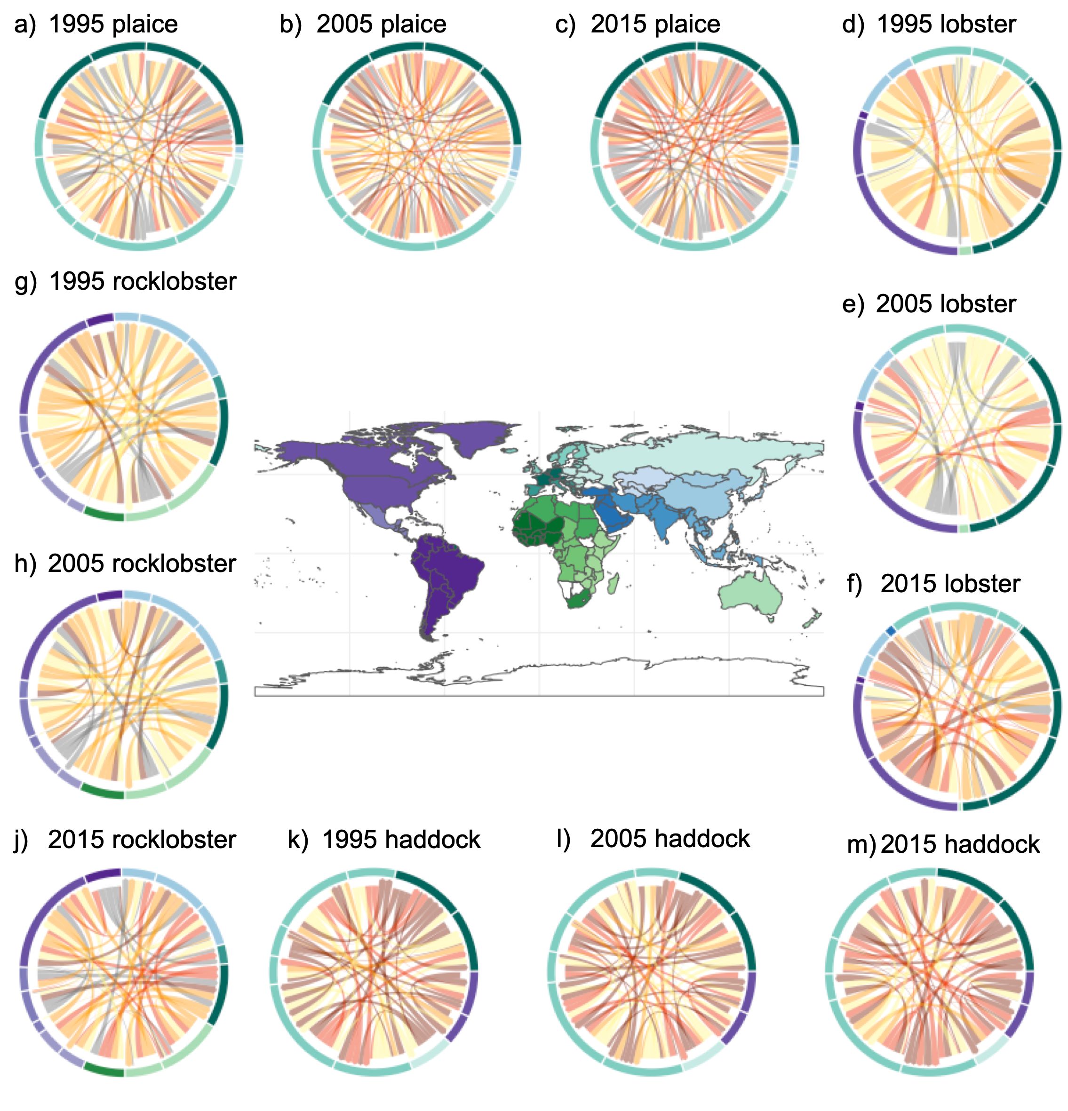

Fig. 2: The trade network figures illustrate the plaice (*Pleuronectes platessa*), lobster (Nephropidae spp., excluding Homarus spp.), haddock (*Melanogrammus aeglefinus*) and rock lobster (Palinuridae spp.) networks in the year 1995 (a,d,g,k), 2005 (b,e,h,l) and 2015 (c,f,j,m). Color of arrows indicates stock status here yellow is associated with high stock status (B/BMSY > 1) and dark red is associated with low stock status (B/BMSY ≤ 0.5). Arrows indicate the direction of trade and their weight shows maximum trade duration for a given importer exporter pair. The coloring of the outer ring of the networks represents geographical regions, as defined in the World Bank Development Indicators (see center map). Only countries which participate in the 25 largest trades by volume of any year in the time series are included in the figure.

## **4. Discussion**

Our findings highlight the importance of speed and scale of seafood trade networks on the status of fisheries traded internationally. Here, we explored the relationship between continuity, number and grouping of connections in trade networks and low or high stock status. We demonstrate, first, that high levels of grouping in the network correlate with high fisheries status. Groups that are more connected through trade with one another than with the remaining countries may have been reduced due to the addition of new trade connections, leading to a more globally connected trade network. Second, we show that long-term trade connections correlate with low fisheries status and that these connections are typically associated with high trade volumes. These results suggest that the way seafood trade networks develop is relevant to the sustainable use of fisheries globally.

The positive correlation we find between grouping in the network and fisheries status empirically advances recent theoretical findings that associate network structure and renewable resource sustainability. In fact, an increase in the number of importing countries per exporter alone could decrease the grouping of the network as percentage-wise fewer groups would exist. Increasing the number of trade connections has been shown to reduce the sustainability of renewable resources if there is little grouping (modularity) in the trade network (Tu et al., 2019). One suggested reason for this phenomenon is that high numbers of trade connections enable the propagation of supply shocks through the trade network [(Fair et al., 2017; Gephart et al., 2016; Tu et al., 2019)](https://www.zotero.org/google-docs/?d1RDFd). For this reason, the decrease in grouping and increase in connectivity we observe in the global seafood trade networks over the past two decades is worrying and may compromise the sustainability of many fisheries worldwide.

Surprisingly, our models consistenly showed that long-term trade connections are correlated with lower fisheries status and that this relationship is dynamically coupled in that fisheries status also relates to the continuity of trade connections. This finding stands in contrast to earlier global studies which associate short-term trade connections with low fisheries status [(Anderson et al., 2011; Berkes et al., 2006;](https://www.zotero.org/google-docs/?2qqXUU) [Eriksson et al., 2015](https://www.zotero.org/google-docs/?6AtXmb)[)](https://www.zotero.org/google-docs/?jcaFru). These previous studies argue that trade may drive the depletion of sea urchins and sea cucumber stocks before regulation can take action [(Berkes et al., 2006; Eriksson et al., 2015)](https://www.zotero.org/google-docs/?mKchuC). For other species that are more resilient to fishing pressure [(Neubauer et al., 2013)](https://www.zotero.org/google-docs/?ItkywV), the speed of regulatory action may not be as related to fisheries status and as such other mechanisms may be more relevant for different species groups.

The relationship between long-term trade connections and low fisheries status may in part be explained by the fact that countries with short-term trade connections overall exported less fish. However, the increase in continuity of trade connections contrasts with earlier studies which show that many trade connections globally last only one year [(Gephart and Pace, 2015)](https://www.zotero.org/google-docs/?25rkEj). We also find that there is not only a replacement of trade connections but also an addition of new ones, which would explain the co-existence of many short-term and few long-term trade connections. Recent work illuminates the consolidation of seafood trade to a handful of companies [(Österblom et al., 2015)](https://www.zotero.org/google-docs/?lcd8Vr). Long-term trade connections, which can be achieved through consolidation, are a necessary requirement for export growth [(Besedeš and Prusa, 2011)](https://www.zotero.org/google-docs/?6LOaoh). One hypothesis, that warrants further examination, is that long-term trade connections drive the continued exploitation of remaining stocks. This is particularly so if there is increasing competition for fewer fisheries stocks [(Anticamara et al., 2011; Bell et al., 2017; Watson et al., 2013)](https://www.zotero.org/google-docs/?dtCr1q).

Seafood trade to feed an increasing human population exerts huge pressure on fisheries worldwide [(FAO, 2018)](https://www.zotero.org/google-docs/?pe8WCK) and much of this demand has been supported by the development of the global trade network [(Gephart and Pace, 2015)](https://www.zotero.org/google-docs/?EvVTco). Changes in the speed and scale of the trade network may affect incentives and mechanisms relevant to the sustainable or unsustainable use of fisheries. Our results provide global empirical evidence for the relationship between trade network characteristics and marine fisheries status and opens avenues for further examination of this relationship. Our insights indicate that effective global management cannot focus on regulating local fisheries alone. In fact, international trade organizations such as the World Trade Organization, national trade bodies and fisheries ministries that aim to maintain fisheries sustainability and food security need to begin creating incentives for long-term trade connections that can support sustainable exploitation. Efforts of trade agreements should therefore target the formation of new multilateral trade alliances to support the future of sustainable fisheries.

## 

## **References**

[Ahrends, A., Burgess, N.D., Milledge, S.A.H., Bulling, M.T., Fisher, B., Smart, J.C.R., Clarke, G.P., Mhoro, B.E., Lewis, S.L., 2010. Predictable waves of sequential forest degradation and biodiversity loss spreading from an African city. Proc. Natl. Acad. Sci. 107, 14556–14561. https://doi.org/10.1073/pnas.0914471107](https://www.zotero.org/google-docs/?nWiliT)

[Anderson, S.C., Cooper, A.B., Jensen, O.P., Minto, C., Thorson, J.T., Walsh, J.C., Afflerbach, J., Dickey‐Collas, M., Kleisner, K.M., Longo, C., Osio, G.C., Ovando, D., Mosqueira, I., Rosenberg, A.A., Selig, E.R., 2017. Improving estimates of population status and trend with superensemble models. Fish Fish. 18, 732–741. https://doi.org/10.1111/faf.12200](https://www.zotero.org/google-docs/?nWiliT)

[Anderson, S.C., Flemming, J.M., Watson, R., Lotze, H.K., 2011a. Serial exploitation of global sea cucumber fisheries. Fish Fish. 12, 317–339. https://doi.org/10.1111/j.1467-2979.2010.00397.x](https://www.zotero.org/google-docs/?nWiliT)

[Anderson, S.C., Flemming, J.M., Watson, R., Lotze, H.K., 2011b. Rapid Global Expansion of Invertebrate Fisheries: Trends, Drivers, and Ecosystem Effects. PLOS ONE 6, e14735. https://doi.org/10.1371/journal.pone.0014735](https://www.zotero.org/google-docs/?nWiliT)

[Anticamara, J.A., Watson, R., Gelchu, A., Pauly, D., 2011. Global fishing effort (1950–2010): Trends, gaps, and implications. Fish. Res. 107, 131–136. https://doi.org/10.1016/j.fishres.2010.10.016](https://www.zotero.org/google-docs/?nWiliT)

[Asche, F., Cojocaru, A.L., Gaasland, I., Straume, H.-M., 2018. Cod stories: Trade dynamics and duration for Norwegian cod exports. J. Commod. Mark. 12, 71–79. https://doi.org/10.1016/j.jcomm.2017.12.002](https://www.zotero.org/google-docs/?nWiliT)

[Bell, J.D., Watson, R.A., Ye, Y., 2017. Global fishing capacity and fishing effort from 1950 to 2012. Fish Fish. 18, 489–505. https://doi.org/10.1111/faf.12187](https://www.zotero.org/google-docs/?nWiliT)

[Bellmann, C., Tipping, A., Sumaila, U.R., 2016. Global trade in fish and fishery products: An overview. Mar. Policy 69, 181–188. https://doi.org/10.1016/j.marpol.2015.12.019](https://www.zotero.org/google-docs/?nWiliT)

[Berkes, F., Hughes, T.P., Steneck, R.S., Wilson, J.A., Bellwood, D.R., Crona, B., Folke, C., Gunderson, L.H., Leslie, H.M., Norberg, J., Nyström, M., Olsson, P., Österblom, H., Scheffer, M., Worm, B., 2006. Globalization, Roving Bandits, and Marine Resources. Science 311, 1557–1558. https://doi.org/10.1126/science.1122804](https://www.zotero.org/google-docs/?nWiliT)

[Besedeš, T., Prusa, T.J., 2011. The role of extensive and intensive margins and export growth. J. Dev. Econ. 96, 371–379. https://doi.org/10.1016/j.jdeveco.2010.08.013](https://www.zotero.org/google-docs/?nWiliT)

[Brander, J.A., Scott Taylor, M., 1997. International trade between consumer and conservationist countries. Resour. Energy Econ. 19, 267–297. https://doi.org/10.1016/S0928-7655(97)00013-4](https://www.zotero.org/google-docs/?nWiliT)

[Brander, J.A., Taylor, M.S., 1998. The Simple Economics of Easter Island: A Ricardo-Malthus Model of Renewable Resource Use. Am. Econ. Rev. 88, 119–138.](https://www.zotero.org/google-docs/?nWiliT)

[Burgess, M.G., Costello, C., Fredston-Hermann, A., Pinsky, M., Gaines, S.D., Tilman, D., Polasky, S., 2017. Range contraction enables harvesting to extinction. Proc. Natl. Acad. Sci. U. S. A. 114, 3945–3950. https://doi.org/10.1073/pnas.1607551114](https://www.zotero.org/google-docs/?nWiliT)

[Burns, T., Davis, B., Kick, E., 2015. Position in the World-System and National Emissions of Greenhouse Gases. J. World-Syst. Res. 3, 432. https://doi.org/10.5195/jwsr.1997.98](https://www.zotero.org/google-docs/?nWiliT)

[Cherniwchan, J., Copeland, B.R., Taylor, M.S., 2017. Trade and the Environment: New Methods, Measurements, and Results. Annu. Rev. Econ. 9, 59–85. https://doi.org/10.1146/annurev-economics-063016-103756](https://www.zotero.org/google-docs/?nWiliT)

[Chichilnisky, G., 1994. North–South Trade and the Global Environment. Am. Econ. Rev. 851–874. https://doi.org/10.1201/9781420032628](https://www.zotero.org/google-docs/?nWiliT)

[Csárdi, G., Tamás, N., 2020. igraph Reference Manual. URL http://igraph. sourceforge. net/documentation](https://www.zotero.org/google-docs/?nWiliT)

[Dalin, C., Konar, M., Hanasaki, N., Rinaldo, A., Rodriguez-Iturbe, I., 2012. Evolution of the global virtual water trade network. Proc. Natl. Acad. Sci. 109, 5989–5994. https://doi.org/10.1073/pnas.1203176109](https://www.zotero.org/google-docs/?nWiliT)

[Diestel, R., 2017. Graph Theory, 5th ed, Graduate Texts in Mathematics. Springer-Verlag, Berlin Heidelberg. https://doi.org/10.1007/978-3-662-53622-3](https://www.zotero.org/google-docs/?nWiliT)

[Eisenbarth, S., 2017. Do exports of renewable resources lead to resource depletion ? Evidence on fisheries.](https://www.zotero.org/google-docs/?nWiliT)

[Ercsey-Ravasz, M., Toroczkai, Z., Lakner, Z., Baranyi, J., 2012. Complexity of the International Agro-Food Trade Network and Its Impact on Food Safety. PLOS ONE 7, e37810. https://doi.org/10.1371/journal.pone.0037810](https://www.zotero.org/google-docs/?nWiliT)

[Eriksson, H., Österblom, H., Crona, B., Troell, M., Andrew, N., Wilen, J., Folke, C., 2015. Contagious exploitation of marine resources. Front. Ecol. Environ. 13, 435–440. https://doi.org/10.1890/140312](https://www.zotero.org/google-docs/?nWiliT)

[Fair, K.R., Bauch, C.T., Anand, M., 2017. Dynamics of the Global Wheat Trade Network and Resilience to Shocks. Sci. Rep. 7, 7177. https://doi.org/10.1038/s41598-017-07202-y](https://www.zotero.org/google-docs/?nWiliT)

[dataset] [FAO, 2019. FAO Global Fishery and Aquaculture Production Statistics 1950–2017 (v2019.1.0), published through FishStatJ (March 2019). Rome, Italy.](https://www.zotero.org/google-docs/?nWiliT)

[FAO, 2018. The State of World Fisheries and Aquaculture - 2018 (SOFIA). Food and Agriculture Organization of the United Nations, Rome.](https://www.zotero.org/google-docs/?nWiliT)

[Free, C.M., Jensen, O.P., Anderson, S.C., Gutierrez, N.L., Kleisner, K.M., Longo, C., Minto, C., Osio, G.C., Walsh, J.C., 2020. Blood from a stone: Performance of catch-only methods in estimating stock biomass status. Fish. Res. 223, 105452. https://doi.org/10.1016/j.fishres.2019.105452](https://www.zotero.org/google-docs/?nWiliT)

[Fryxell, J.M., Hilborn, R., Bieg, C., Turgeon, K., Caskenette, A., McCann, K.S., 2017. Supply and demand drive a critical transition to dysfunctional fisheries. Proc. Natl. Acad. Sci. 114, 12333–12337. https://doi.org/10.1073/pnas.1705525114](https://www.zotero.org/google-docs/?nWiliT)

[Gephart, J.A., Pace, M.L., 2015. Structure and evolution of the global seafood trade network. Environ. Res. Lett. 10, 125014. https://doi.org/10.1088/1748-9326/10/12/125014](https://www.zotero.org/google-docs/?nWiliT)

[Gephart, J.A., Rovenskaya, E., Dieckmann, U., Pace, M.L., Brännström, Å., 2016. Vulnerability to shocks in the global seafood trade network. Environ. Res. Lett. 11, 035008. https://doi.org/10.1088/1748-9326/11/3/035008](https://www.zotero.org/google-docs/?nWiliT)

[Hilborn, R., Amoroso, R.O., Anderson, C.M., Baum, J.K., Branch, T.A., Costello, C., Moor, C.L. de, Faraj, A., Hively, D., Jensen, O.P., Kurota, H., Little, L.R., Mace, P., McClanahan, T., Melnychuk, M.C., Minto, C., Osio, G.C., Parma, A.M., Pons, M., Segurado, S., Szuwalski, C.S., Wilson, J.R., Ye, Y., 2020. Effective fisheries management instrumental in improving fish stock status. Proc. Natl. Acad. Sci. 117, 2218–2224. https://doi.org/10.1073/pnas.1909726116](https://www.zotero.org/google-docs/?nWiliT)

[Jouffray, J.-B., Blasiak, R., Norström, A.V., Österblom, H., Nyström, M., 2020. The Blue Acceleration: The Trajectory of Human Expansion into the Ocean. One Earth 2, 43–54. https://doi.org/10.1016/j.oneear.2019.12.016](https://www.zotero.org/google-docs/?nWiliT)

[Lascelles, B., Sciara, G.N.D., Agardy, T., Cuttelod, A., Eckert, S., Glowka, L., Hoyt, E., Llewellyn, F., Louzao, M., Ridoux, V., Tetley, M.J., 2014. Migratory marine species: their status, threats and conservation management needs. Aquat. Conserv. Mar. Freshw. Ecosyst. 24, 111–127. https://doi.org/10.1002/aqc.2512](https://www.zotero.org/google-docs/?nWiliT)

[Magurran, A.E., 1988. Ecological Diversity and Its Measurement. Springer Netherlands. https://doi.org/10.1007/978-94-015-7358-0](https://www.zotero.org/google-docs/?nWiliT)

[Neubauer, P., Jensen, O.P., Hutchings, J.A., Baum, J.K., 2013. Resilience and Recovery of Overexploited Marine Populations. Science 340, 347–349. https://doi.org/10.1126/science.1230441](https://www.zotero.org/google-docs/?nWiliT)

[Neubauer, P., Thorson, J.T., Melnychuk, M.C., Methot, R., Blackhart, K., 2018. Drivers and rates of stock assessments in the United States. PLOS ONE 13, e0196483. https://doi.org/10.1371/journal.pone.0196483](https://www.zotero.org/google-docs/?nWiliT)

[Österblom, H., Jouffray, J.-B., Folke, C., Crona, B., Troell, M., Merrie, A., Rockström, J., 2015. Transnational Corporations as ‘Keystone Actors’ in Marine Ecosystems. PLOS ONE 10, e0127533. https://doi.org/10.1371/journal.pone.0127533](https://www.zotero.org/google-docs/?nWiliT)

[Prell, C., 2016. Wealth and pollution inequalities of global trade: A network and input-output approach. Soc. Sci. J. 53, 111–121. https://doi.org/10.1016/j.soscij.2015.08.003](https://www.zotero.org/google-docs/?nWiliT)

[Prell, C., Feng, K., 2016. The evolution of global trade and impacts on countries’ carbon trade imbalances. Soc. Netw. 46, 87–100. https://doi.org/10.1016/j.socnet.2016.03.001](https://www.zotero.org/google-docs/?nWiliT)

[Prell, C., Sun, L., Feng, K., He, J., Hubacek, K., 2017. Uncovering the spatially distant feedback loops of global trade: A network and input-output approach. Sci. Total Environ. 586, 401–408. http://dx.doi.org/10.1016/j.scitotenv.2016.11.202](https://www.zotero.org/google-docs/?nWiliT)

[Prell, C., Sun, L., Feng, K., Myroniuk, T.W., 2015. Inequalities in Global Trade: A Cross-Country Comparison of Trade Network Position, Economic Wealth, Pollution and Mortality. PLOS ONE 10, e0144453. https://doi.org/10.1371/journal.pone.0144453](https://www.zotero.org/google-docs/?nWiliT)

[Roodman, D., 2009a. A Note on the Theme of Too Many Instruments*. Oxf. Bull. Econ. Stat. 71, 135–158. https://doi.org/10.1111/j.1468-0084.2008.00542.x](https://www.zotero.org/google-docs/?nWiliT)

[Roodman, D., 2009b. How to do Xtabond2: An Introduction to Difference and System GMM in Stata. Stata J. 9, 86–136. https://doi.org/10.1177/1536867X0900900106](https://www.zotero.org/google-docs/?nWiliT)

[Rosenberg, A.A., Kleisner, K.M., Afflerbach, J., Anderson, S.C., Dickey‐Collas, M., Cooper, A.B., Fogarty, M.J., Fulton, E.A., Gutiérrez, N.L., Hyde, K.J.W., Jardim, E., Jensen, O.P., Kristiansen, T., Longo, C., Minte‐Vera, C.V., Minto, C., Mosqueira, I., Osio, G.C., Ovando, D., Selig, E.R., Thorson, J.T., Walsh, J.C., Ye, Y., 2018. Applying a New Ensemble Approach to Estimating Stock Status of Marine Fisheries around the World. Conserv. Lett. 11, e12363. https://doi.org/10.1111/conl.12363](https://www.zotero.org/google-docs/?nWiliT)

[Steffen, W., Broadgate, W., Deutsch, L., Gaffney, O., Ludwig, C., 2015. The trajectory of the Anthropocene: The Great Acceleration. Anthr. Rev. 2, 81–98. https://doi.org/10.1177/2053019614564785](https://www.zotero.org/google-docs/?nWiliT)

[Tu, C., Suweis, S., D’Odorico, P., 2019. Impact of globalization on the resilience and sustainability of natural resources. Nat. Sustain. 2, 283–289. https://doi.org/10.1038/s41893-019-0260-z](https://www.zotero.org/google-docs/?nWiliT)

[dataset] [United Nations, 2019. Comtrade 2019. UN Commodities Trade Statistical Database.](https://www.zotero.org/google-docs/?nWiliT)

[United Nations (UN), 2018. Sustainable Development Goals Report 2018. United Nations, Rome, Italy.](https://www.zotero.org/google-docs/?nWiliT)

[Wang, P., Tran, N., Wilson, N.L.W., Chan, C.Y., Dao, D., 2018. An Analysis of Seafood Trade Duration: The Case of ASEAN. Mar. Resour. Econ. 34, 59–76. https://doi.org/10.1086/700599](https://www.zotero.org/google-docs/?nWiliT)

[Watson, R.A., Cheung, W.W.L., Anticamara, J.A., Sumaila, R.U., Zeller, D., Pauly, D., 2013. Global marine yield halved as fishing intensity redoubles. Fish Fish. 14, 493–503. https://doi.org/10.1111/j.1467-2979.2012.00483.x](https://www.zotero.org/google-docs/?nWiliT)

## 