**Work in Progress description**

**Title: Sequential exploitation, macro and micro-drivers of global fisheries expansion**

Authors: Maartje Oostdijk & Laura Elsler, Junfu Zhao, Elaine Bochniewicz, Stephanie Stefanski, Sanmitra Gokhale, Edward Tekwa, Andrew Frederick Johnson, Jessica Gephart

**Short abstract (100 words)**

International trade of seafood has doubled in the past four decades and the majority of global fish stocks are either fully- (58.1%) or over-exploited. Mechanisms of seafood trade expansion and their relation to stock status are not well understood. Patterns of fishery expansion have in the past been associated with profit and trophic level. Several signature patterns of expansion have been associated with fishery collapse and decline. Therefore, knowledge on the patterns of trade expansion is useful to understand the use of marine species. Spatial spread of fisheries effort is a characteristic of fisheries that are still developing, where increasing demand can still be met by increasing effort. We find that the rapid expansion in fisheries trade since the 1990’s was also accompanied by an increase in the connectivity between trade-partners. Although the amount of trade partners has grown, the traded volume has remained relatively stable. Stock biomass is a predictor of the choice of new trade partners.

**Long abstract (max 1000 words)**

1. **Introduction**

Seafood is a globally integrated food commodity traded at 40 percent internationally and the majority of global fish stocks are either fully- (58.1%) or over-exploited. Trade has a direct influence on the use of marine species. Expansion of the use of marine species due to international trade appears to take on several signature exploitation patterns. Therefore, knowledge on the patterns of trade expansion is useful to anticipate future use of marine species. Here, we connect spread of fisheries exploitation to global exports. We assess micro-drivers of trade expansion in fisheries. First, we assess the spatial spread of both global import and export networks on the per-country scale and relate them to fisheries exploitation. Second, we use regressions on global trade networks to assess how national characteristics including XX, XX, and XX affect the formation of new trade connections. We find that the rapid expansion in fisheries trade since the 1990’s was also accompanied by an increase in the connectivity between trade-partners. Although the number of trade partners has grown, traded volume has remained relatively stable. Stock biomass is a predictor of the choice of new trade partners.

**Extended abstract (750-1000 words)**

1. **Introduction**

Global trade has been implicated as a major driver of local ecosystem changes (Pace and Gephart, 2017), an example being the elimination of predators and filter feeders in aquatic ecosystems. Several lines of evidence suggest that this might also be the case for seafood and large marine ecosystems. Seafood is a globally integrated food commodity traded at 40 per cent internationally (Crona et al., 2015) and the majority of global fish stocks are either fully- (58.1%) or over-exploited (31.4%; FAO 2016). Over the past century, an increasing number of trade connections (Cash et al., 2006; Peters et al., 2008) has been accompanied by sequential exploitation to deeper waters (Pauly et al., 2005) and new areas. This has mainly been driven by northern industrialized countries moving into the waters of southern developing countries (Berkes et al. 2006; Anderson et al. 2011). The globalization of fisheries through demand from international markets has been proposed to help explain both gradual declines in fish stocks and stock collapses of many marine species (Lenzen et al., 2012).

Fisheries expansion due to international trade appear to take on several signature exploitation patterns. The most well-known cases are the “roving bandits”, in which distant fleets and mobile traders, driven by international markets, deplete valuable fisheries and move onward to new areas in search of better fishing (Berkes et al., 2006, Ostrom, 2007). Other types include “sequential exploitation,” in which fishing fleets sequentially move from coastal waters to deeper waters offshore or from higher to lower trophic levels (Pauly et al., 2002), and “contagious exploitation,” in which patterns of fish stock depletion mimic globalized epidemics which move through established market structures to deplete local populations. All of these patterns involve interactions between local and global stakeholders to produce fisheries outcomes, which we refer to collectively as cross-scale exploitation patterns.

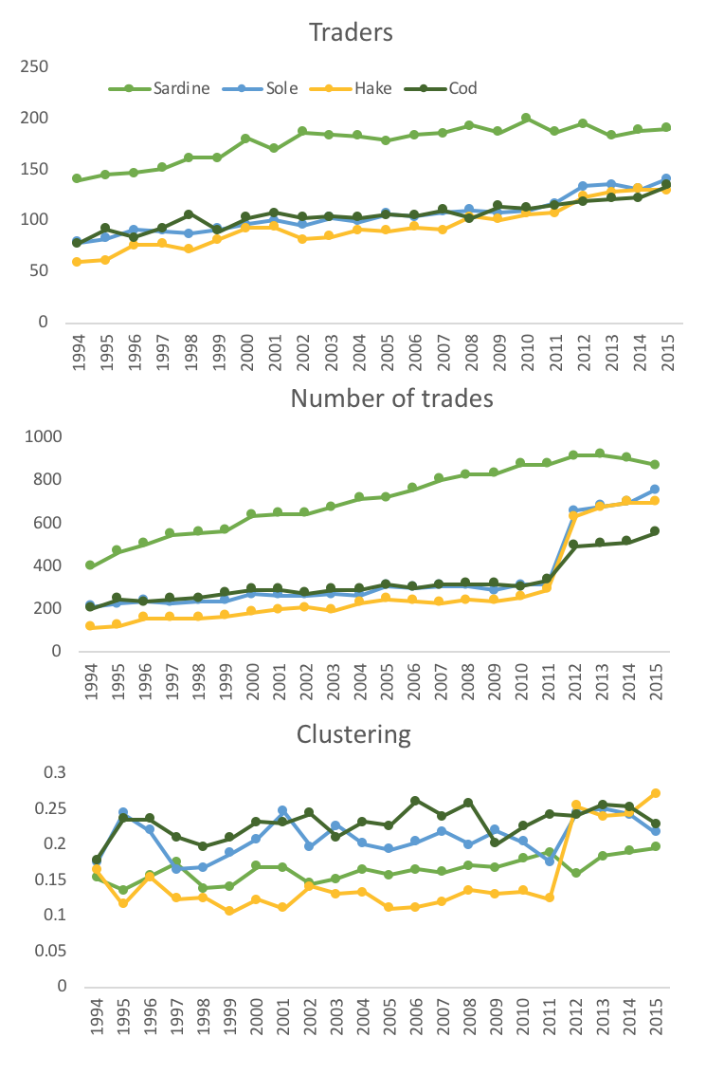

**Figure 1.** Traders, number of trades and global clustering of the trade networks of sardine, sole, hake and cod.

1. **Preliminary results**

The trade network for four of these commodities (cod, sole, hake and sardine) expanded between 1994 and 2015. For cod there was a small (n= 20 ± 4) set of countries that actively traded throughout the study period. During this period there was an increase in the number of countries that began trading in cod, but at much lower volumes than the “top-20” nations by traded volume. This highlights that there was an increasing number of low trade volumes (weaker connections) over time in the network. Global clustering (the amount of triangles in the networks, which occur when countries that trade with the same country also trade with each other) also increased within the four species studied which reiterates the idea of an expansion in these trade networks. Networks in later years of our trading data showed more, but weaker connected nodes. The trend of increased frequency of trades shows the increased connectedness of the network. For global trade in hake this is especially true in the most recent years of our dataset. The next step in this work will be to regress these changes in the network to countries characteristics (governance indicators such as rule of law and economic indicators such as GDP).

Next, we calculated a measure called “preferential attachment” following the methodology of Newman (2001) across all of the trade-data between 1995-1998. Preferential attachment is the relative probability of a node forming a new connection based on certain node attributes (in this case a node is a country). We hypothesized that countries with higher stock status would have a higher probability of forming new export connections and the reverse for import connection (i.e. in the case of local depletion of stocks there would be an increase in imports).

We can see in Figure 2 and 3 that the link between stock status and new exports or imports is non-linear with slightly higher probabilities for lower and higher stock-status. This is likely caused by some reverse causality between exports and stock-status, which a next step of analysis will address. It is likely that under certain conditions (for example low governance levels) stock status decreases due to high export levels. Implementing a time-lag in the data has so far not been enough to address this concern. The link between governance and the probability of forming new export or import is less clear but coefficient estimates for linear regressions are small and negative (-0.03, -0.05). Which may mean that countries with higher governance have more of the appropriate infrastructure in place necessary for accessing the global trade market for fish.

Should there be a concluding paragraph where we interpret implications of the results and clearly define next steps in expanding the analysis?

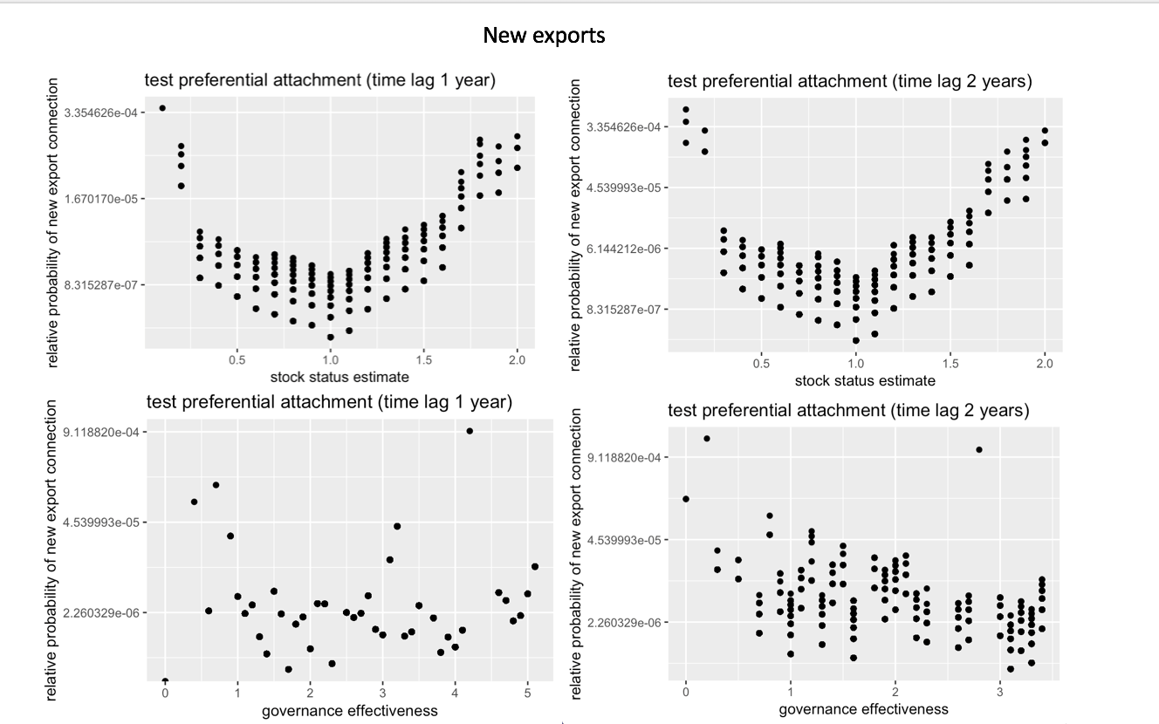

**Figure 2.** Relative probability for forming new export connections for different values of stock status estimate and governance effectiveness. Plots are with a time-lag of one year and two years between stock status and the number of new exports.

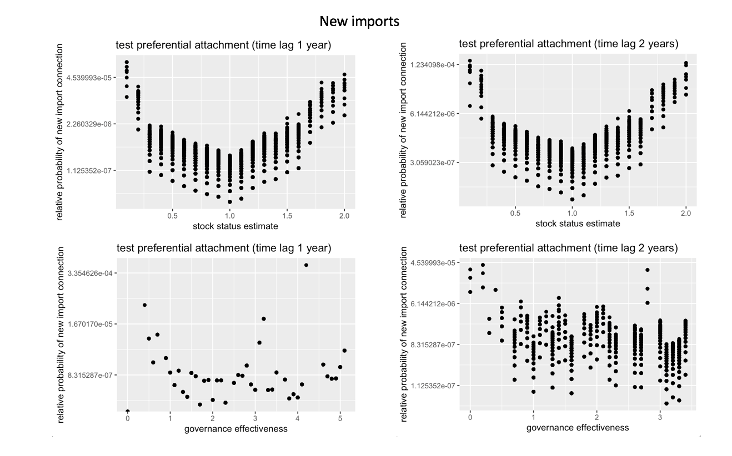

**Figure 3.** Relative probability for forming new import connections for different values of stock status estimate and governance effectiveness. Plots are with a time-lag of one year and two years between stock status and the number of new imports.

1. **References.**

Anderson, S.C., Flemming, J.M., Watson, R., Lotze, H.K., 2011. Serial exploitation of global sea cucumber fisheries. Fish and Fisheries 12, 317–339.

Berkes, F., Hughes, T.P., Steneck, R.S., Wilson, J.A., Bellwood, D.R., Crona, B., Folke, C., Gunderson, L.H., Leslie, H.M., Norberg, J., Nyström, M., Olsson, P., Österblom, H., Scheffer, M., Worm, B., 2006. Globalization, Roving Bandits, and Marine Resources. Science 311, 1557–1558. doi:10.1126/science.1122804

Cash, D.W., Adger, W.N., Berkes, F., Garden, P., Lebel, L., Olsson, P., Pritchard, L., Young, O., 2006. Scale and cross-scale dynamics: governance and information in a multilevel world. Ecology and society 11, 8.

Crona, B.I., Van Holt, T., Petersson, M., Daw, T.M., Buchary, E., 2015. Using social-ecological syndromes to understand impacts of international seafood trade on small-scale fisheries. Glob. Environ. Chang. 35, 162–175. doi:10.1016/j.gloenvcha.2015.07.00

Moran, D., Kanemoto, K., 2017. Identifying species threat hotspots from global supply chains. Nature Ecology & Evolution 1, 0023

Newman,  M. E. J.,  2001., Clustering and preferential attachment in growing networks, *Phys.* Rev. E 64, 025102

Osterblom, H., Jouffray, J.B., Folke, C., Crona, B., Troell, M., Merrie, A., Rockström, J., 2015.

Transnational corporations as “keystone actors” in marine ecosystems. PLoS One 10, 1–15.

doi:10.1371/journal.pone.0127533

Pace, M.L., Gephart, J.A., 2017. Trade: A Driver of Present and Future Ecosystems. Ecosystems 20,

44–53. doi:10.1007/s10021-016-0021-z

Pauly, D., Watson, R., Alder, J., 2005. Global trends in world fisheries: impacts on marine

ecosystems and food security. Philos. Trans. R. Soc. Lond. B Biol. Sci. 360, 5–12.

doi:10.1098/rstb.2004.1574

Peters, D.P., Bestelmeyer, B.T., Turner, M.G., 2007. Cross–scale interactions and changing pattern–process relationships: consequences for system dynamics



