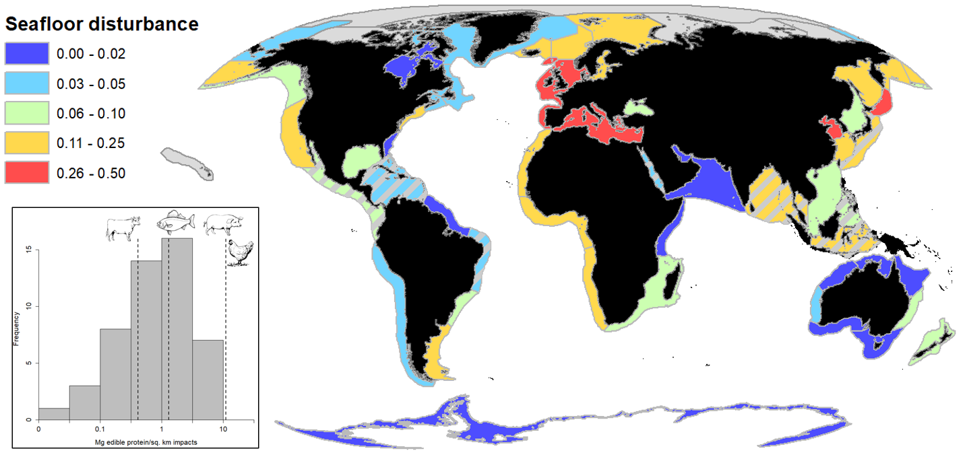

Figure 1. Main panel shows seafloor disturbance (% of continental shelf area) throughout the world’s Large Marine Ecosystems (LMEs). Cooler colors show less disturbed LMEs, warmer colors are more disturbed. Hashed lines show LMEs with estimated fishing effort due to low AIS coverage. Inset figure shows histogram of habitat efficiency (Mg edible protein/sq. km of disturbance) on log10 scale of world’s LMEs. The dashed lines show global mean for trawl fishing, as well as beef production (generally less efficient) and pork and poultry production (more efficient), as indicated by corresponding icons.

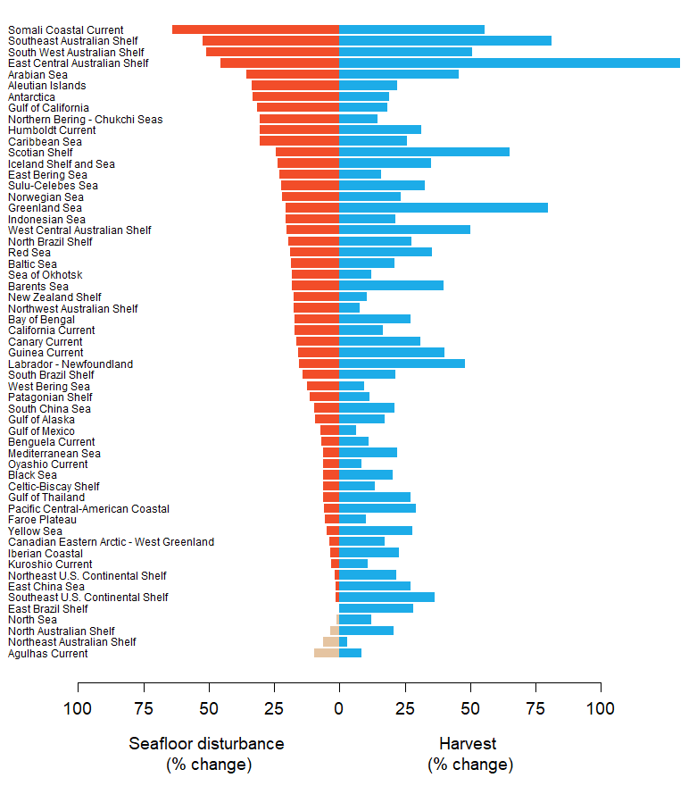

Figure 2. Tradeoffs between increased trawl harvest and seafloor disturbance among the world’s Large Marine Ecosystems (LMEs). Blue bars show percent increase in yearly trawl harvest at maximum sustainable yield over current harvest level. Red bars show estimated percent increase in seafloor disturbance over current levels. Grey bars show percent reduction in seafloor disturbance for those LMEs currently fishing above MSY in which case reducing fishing effort would lead to increased harvest.

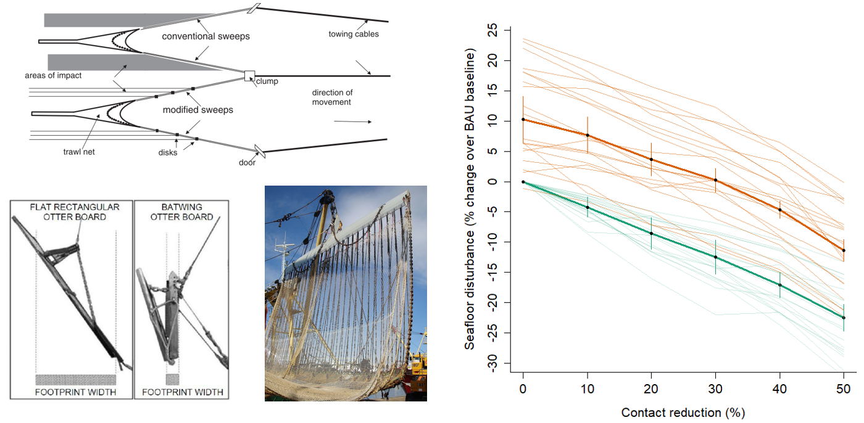

Figure 3. The left panel shows examples of gear modification. Clockwise from top of left panel is a drawing of a modified groundfish trawl with bobbins compared to a conventional groundfish trawl; a photo of a pulse trawl ; and a modified (“batwing”) trawl door compared to a conventional trawl door. The right panel shows global change in seafloor disturbance (% change over baseline) under a range of contact reduction scenarios. The solid green? line shows the business-as-usual scenario in which global trawl harvest remains constant stable relative to 2013-2018 harvest rates. The solid orange? line shows the relationship if global trawl harvest were increased to maximum sustainable yield. Vertical bars give two standard errors reflecting year-to-year variability in fishing effort. The thin lighter lines show the relationship for the 20 LMEs with seafloor disturbance >10%. The non-monotonic relationship of some LMEs reflects variability in year-to-year fishing effort that may counteract the effect of increasing contact reduction.