For reference:

Harvest control rule (HCR) options and descriptions for the “hcr_type” column below

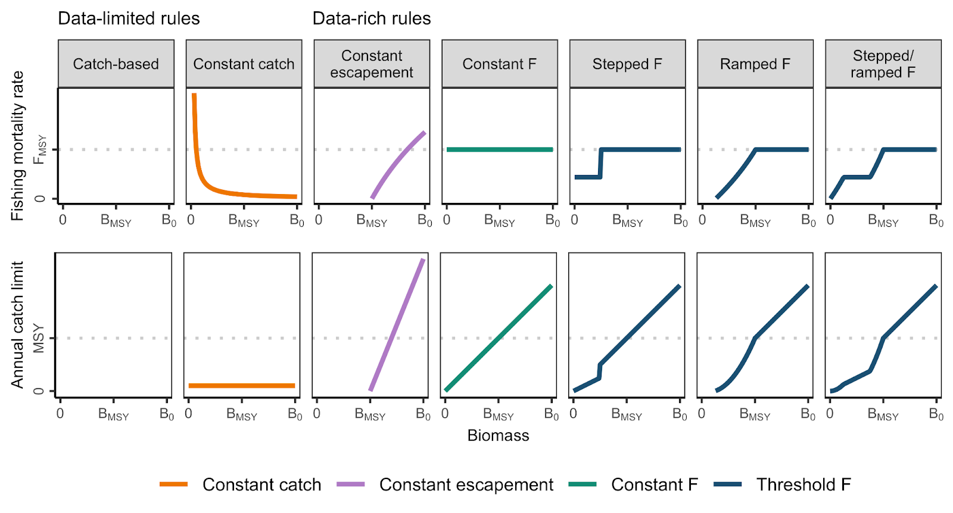

Illustrations of the seven harvest control rule (HCR) typologies used in U.S. federal fisheries management. Data-limited control rules are used in the absence of a reliable stock assessment and generally use catch histories to inform catch limits. The shape of catch-based control rules is unknown given the lack of available biomass estimates for stocks managed using these rules. Although the data-rich control rules are generally model-based (i.e., use stock assessment output to define the x-axis of the rule), they could theoretically be based on an index of abundance from a scientific survey (i.e., an empirical control rule).

**Guiding questions**

* Did we identify all of stocks managed in the FMP correctly?
* Did we correctly identify the type of HCR used to manage the stock (e.g. constant, threshold, catch-based, etc)?
* Did we correctly identify the magnitude of the P* (if used) and various uncertainty buffers (if used?)? Does the council maintain an authoritative table of these values that could be shared with us?

**Mid-Atlantic (MAFMC) Harvest Control Rule (HCR) info**

* biomass_limit = Does HCR have a biomass limit, where harvest drops to zero at a defined biomass level? 1 = yes, 0 = no
* p_star = p*
* abc_buffer = ABC buffer (e.g., if abc_buffer = 0.9, then ABC = 10% of OFL)
* acl_buffer = ACL buffer
* act_buffer = ACT buffer

|  |  |  |  |  |  |  |  |
| --- | --- | --- | --- | --- | --- | --- | --- |
| **FMP_FEP** | **stock** | **hcr_type** | **biomass_limit** | **p_star** | **abc_buffer** | **acl_buffer** | **act_buffer** |
| Bluefish FMP | Bluefish | Threshold F | 1 | NA | 0.3772189 | 0 | 0 |
| Golden and Blueline Tilefish FMP | Golden tilefish | Threshold F | 1 | NA | 0.2859014 | 0 | 0 |
| Golden and Blueline Tilefish FMP | Blueline tilefish | Catch-based | 0 | NA | NA | 0 | 0 |
| Mackerel, Squid, Butterfish FMP | Atlantic mackerel | Threshold F | 1 | NA | NA | 0 | NA |
| Mackerel, Squid, Butterfish FMP | Chub mackerel | Catch-based | 0 | NA | 0.2399207 | 0 | 0.04 |
| Mackerel, Squid, Butterfish FMP | Illex squid | Catch-based | 0 | NA | NA | 0.0461 | 0 |
| Mackerel, Squid, Butterfish FMP | Longfin squid | Catch-based | 0 | NA | NA | 0.02 | 0 |
| Mackerel, Squid, Butterfish FMP | Butterfish | Threshold F | 1 | NA | NA | 0 | 0.0500168 |
| Mid-Atlantic summer flounder, scup, black sea bass FMP | Summer flounder | Threshold F | 1 | NA | 0.1910149 | 0.4594487 | 0 |
| Mid-Atlantic summer flounder, scup, black sea bass FMP | Scup | Threshold F | 1 | NA | 0.01382064 | 0.2198692 | 0 |
| Mid-Atlantic summer flounder, scup, black sea bass FMP | Sea bass | Threshold F | 1 | NA | 0.2227953 | 0.536828 | 0 |
| Monkfish FMP | Gulf of Maine/Northern Georges Bank-Monkfish | Constant F | 0 | NA | NA | NA | NA |
| Monkfish FMP | Southern Georges Bank/Mid-Atlantic-Monkfish | Constant F | 0 | NA | NA | NA | NA |
| Spiny Dogfish FMP | Spiny dogfish | Threshold F | 1 | 0.4 | 0.19 | NA | NA |
| Surfclams and Ocean Quahogs FMP | Surfclam | Threshold F | 1 | NA | NA | NA | NA |
| Surfclams and Ocean Quahogs FMP | Ocean quahog | Threshold F | 1 | NA | NA | NA | NA |