# Harvest control rules used in U.S. federal fisheries and implications for climate resilience

Christopher M. Free1,2, Tracey Mangin1, Halley McVeigh1, Conner Smith1, Steven D. Gaines1,2

1 Bren School of Environmental Science and Management, University of California, Santa Barbara, Santa Barbara, CA, 93106, USA

2 Marine Science Institute, University of California, Santa Barbara, Santa Barbara, CA, 93106, USA

**\* Corresponding author:** Bren School of Environmental Science and Management, University of California, Santa Barbara, 2400 Bren Hall, Santa Barbara, CA 93106-5131; 610-999-4732; cfree14@gmail.com

## Abstract

Climate change is altering the productivity of marine fisheries and challenging the effectiveness of historical fisheries management. Harvest control rules, which describe the process for determining catch limits in fisheries, represent one pathway for promoting climate resilience. In the United States, federal law dictates that catch limits cannot be set above a stock’s overfishing limit, but otherwise gives U.S. Regional Fisheries Management Councils considerable flexibility in how they can further reduce catch limits to buffer for scientific and management uncertainty or to meet other socioeconomic or ecological goals. This flexibility has spawned diverse approaches for specifying harvest control rules for federally-managed fisheries, some of which may be more or less resilient to climate change. Here, we synthesize the control rules used to manage all 498 U.S. federally-managed fish stocks and stock complexes. We classified these rules as being (1) catch-based; (2) constant catch; (3) constant escapement; (4) constant F; or (5) threshold F (ramped, stepped, or a combination), and as having or not having a biomass limit (“cutoff”) value. When possible, we also recorded the type and size of the buffers used to protect against scientific and/or management uncertainty. Finally, we review the advantages and disadvantages of each typology for managing fisheries under climate change and provide six recommendations for updating harvest control rules to improve the resilience of U.S. federally-managed fisheries to climate change.

**Keywords:** climate change, fisheries management, fishery management councils, Magnuson-Stevens Fishery Conservation and Management Act, MSA, harvest control rules

## Acronyms

* FMC = Fishery Management Council
* FMP = Fishery Management Plan
* HCR = Harvest Control Rule
* MSY = Maximum Sustainable Yield
* OFL = Overfishing Limit
* ABC = Acceptable Biological Catch
* ACL = Annual Catch Limit
* ACT = Annual Catch Target
* F = Fishing Mortality Rate
* BMSY = Biomass that produces MSY when fished at FMSY
* P* = Probability of Overfishing
* CV = Coefficient of Variation
* MSE = Management Strategy Evaluation
* MSA = Magnuson-Stevens Act
* NEFMC = New England Fishery Management Council
* MAFMC = Mid-Atlantic Fishery Management Council
* SAFMC = South Atlantic Fishery Management Council
* GFMC = Gulf of Mexico Fishery Management Council
* CFMC = Caribbean Fishery Management Council
* PFMC = Pacific Fishery Management Council
* NPFMC = North Pacific Fishery Management Council
* WPFMC = West Pacific Fishery Management Council
* NOAA = National Oceanic and Atmospheric Administration
* HMS = Highly Migratory Species
* CPS = Coastal Pelagic Species
* GOA = Gulf of Alaska
* BSAI = Bering Sea & Aleutian Islands

## 1. Introduction

The general goal of fisheries management is to find and implement a socially, economically, and politically acceptable trade-off among competing fisheries objectives. These objectives often involve maintaining large and stable yields while also conserving fished resources and the ecosystems on which they depend for future generations [(Walters & Martell, 2005)](https://www.zotero.org/google-docs/?ulMe6l). Climate change is complicating the ability for traditional fisheries management to achieve these objectives for society [(Szuwalski & Hollowed, 2016)](https://www.zotero.org/google-docs/?v73A9f). Climate change has already resulted in significant shifts in fisheries productivity [(Free et al., 2019)](https://www.zotero.org/google-docs/?oE8Ajn), distributions [(Pinsky et al., 2013)](https://www.zotero.org/google-docs/?QCnm1F), and phenology [(Poloczanska et al., 2016)](https://www.zotero.org/google-docs/?REbhqd), and continued climate change is expected to exacerbate the magnitude of these shifts [(Bryndum-Buchholz et al., 2019; IPCC, 2019)](https://www.zotero.org/google-docs/?Za6uKC). Enhancing the resilience of fisheries to climate change will require adjustments throughout the entire fisheries management system [(Bryndum-Buchholz et al., 2021; Karp et al., 2019)](https://www.zotero.org/google-docs/?RxA0Qd).

Harvest control rules (HCRs), which constitute pre-defined procedures for setting catch limits based on the current state of a fishery [(Punt, 2010)](https://www.zotero.org/google-docs/?Hg6Y9K), represent one tool in the fisheries management toolbox that could be tuned to enhance climate resilience. There are three classes of control rules. Model-based control rules set catch limits based on estimates of stock size from stock assessments [(Kvamsdal et al., 2016)](https://www.zotero.org/google-docs/?6nakpM). Empirical control rules are specified using indices of stock size derived from scientific surveys (e.g., [(de Oliveira et al., 1998)](https://www.zotero.org/google-docs/?HWTgS3)). Finally, data-poor control rules derive catch limits using historical catch and expert knowledge (e.g., [(Newman et al., 2015)](https://www.zotero.org/google-docs/?phQvvH)). Model-based rules are generally preferred because they utilize best-available estimates of absolute stock size to derive catch limits and can use model-based estimates of confidence to buffer against scientific uncertainty. Empirical rules are convenient because they do not require stock assessments, which makes them less expensive, more transparent, and more reactive [(Punt, 2010)](https://www.zotero.org/google-docs/?IULLw6); however, they can be challenging to parameterize given the lack of information on absolute stock size. Data-poor rules are required for stocks without reliable indices of abundance, which are numerous even in the U.S. [(Berkson & Thorson, 2015)](https://www.zotero.org/google-docs/?0wuUub), and generally have to be highly precautionary to avoid overfishing, which often results in considerable foregone yield [(Wiedenmann et al., 2013)](https://www.zotero.org/google-docs/?Mz4j8M).

Traditionally, harvest control rules have adopted one of three “shapes” (**Figure 1**) with respect to stock size – constant catch, constant escapement, or constant fishing mortality (F) – each with its own advantages and disadvantages [(Deroba & Bence, 2008; Restrepo & Powers, 1999)](https://www.zotero.org/google-docs/?aValK2). Constant catch rules avoid the need for stock assessments and theoretically facilitate stable catches; however, establishing an appropriate level of constant catch is challenging and likely to lead to extinction in a stochastic environment. Constant escapement rules hold stock size as close to the target size as possible by setting catches equal to the difference between the current and target sizes. They are generally thought to maximize long-term yields, but result in highly variable catch limits, including years with zero harvests. As a result, these rules are generally only viable for fisheries that exploit a large number of independent stocks and are therefore buffered against the economic impacts of catch variability (e.g., salmon fisheries on the west coasts of the U.S. and Canada). Constant F rules set the catch equal to a fixed proportion of the current stock size; thus, they limit catch variability while also being responsive to fluctuations in stocks size (i.e., lower catch limits at lower stocks sizes).

Threshold F rules, a fourth approach to setting harvest control rules that reduces fishing mortality rates when stock sizes fall below a specified size threshold, are becoming increasingly used to account for scientific uncertainty, prevent overfishing, and expedite rebuilding [(NPFMC, 2020b; PFMC, 2020b)](https://www.zotero.org/google-docs/?cdTdM4), and may provide inherent resilience to uncertainty and variability resulting from climate change [(Kritzer et al., 2019)](https://www.zotero.org/google-docs/?biKr2Y). In their simplest forms, these rules are specified using two biomass (or abundance) reference points: (1) a *threshold value* below which fishing mortality is reduced (often, but not necessarily, equal to the target value); and (2) a *limit value* below which fishing mortality is prohibited (if equal to zero, then fishing is permitted across all stocks sizes but is reduced as stock size declines) (**Figure 2**). A number of modeling studies suggest that threshold F rules may be more effective than constant F rules at maintaining high catches while preventing overfishing under both increasing climate variability and directional climate change [(Kritzer et al., 2019; Mildenberger et al., 2022; Wiedenmann et al., 2017)](https://www.zotero.org/google-docs/?ZARKSf). For example, Wiedenmann et al. (2017) evaluated the performance of various harvest control rules in a management strategy evaluation model and found that threshold F rules reduced rebuilding times and generated larger long-term yields than constant F rules. Furthermore, whereas the ability for constant F rules to prevent overfishing deteriorated with increasing variability, threshold F rules were equally effective at preventing overfishing under both low and high variability scenarios [(Wiedenmann et al., 2017)](https://www.zotero.org/google-docs/?rvHSqt).

There are a number of opportunities to tune harvest control rules to better achieve fisheries objectives under climate change. On the more sophisticated but arguably more controversial end of the spectrum, control rules could be directly parameterized to consider the impacts of the environment on productivity [(Hofmann & Powell, 1998)](https://www.zotero.org/google-docs/?Edfb9s). However, there are two divergent perspectives on how to approach this [(Kaplan et al., 2020)](https://www.zotero.org/google-docs/?R18LfY). The “investment” perspective views unharvested fish as an investment in future yields and recommends increasing harvest intensity as productivity declines [(Costello et al., 2001)](https://www.zotero.org/google-docs/?tRIjwH). The “stabilization” perspective recommends decreasing harvest intensity as productivity declines to reduce variability in yields by preventing the boom-and-bust dynamics that get reinforced by the “investment” approach [(Parma, 1990)](https://www.zotero.org/google-docs/?UTUsoA). In practice, environmentally-linked control rules have been rare due to their large data requirements, reliance on stable and predictable environmental relationships, and marginal ability to improve objectives over simpler rules [(Punt et al., 2014)](https://www.zotero.org/google-docs/?R17yTK). On the less sophisticated but arguably more reliable end of the spectrum, control rules can be modified to buffer against the additional scientific uncertainty introduced by climate variability. This could be achieved by optimizing (1) the fishing mortality rate buffers used to protect against uncertainty across all stock sizes [(Da-Rocha et al., 2016)](https://www.zotero.org/google-docs/?MvYofF) and/or (2) the biomass threshold and limit values used to safeguard against low biomass under high uncertainty (**Figure 2**). In general, the tuned combination of these approaches are best [(Mildenberger et al., 2022)](https://www.zotero.org/google-docs/?4wpR7a).

In this study, we seek to synthesize the use of harvest control rules in U.S. federal fisheries management and evaluate the resilience of these rules to climate change. In the United States, federally-managed fisheries are managed using the precautionary principle, which accounts for scientific uncertainty in setting catch limits that prevent overfishing [(Restrepo et al., 1998)](https://www.zotero.org/google-docs/?S1kNhP). The 2006 reauthorization of the Magnuson-Stevens Act (MSA) established the framework for implementing the precautionary principle by requiring: (1) that annual catch limits be set for the majority of federally-managed stocks (exemptions for stocks managed with international agreements or with life cycles <1 year); (2) that these catch limits restrict the probability of overfishing to less than or equal to 50%; and (3) that the probability of overfishing be reduced with increasing scientific uncertainty (Federal Register, 2009) **(Figure 3**). The general procedures for setting catch limits differ based on data quality and the availability of a reliable stock assessment. For data-rich stocks, an *Overfishing Limit (OFL)*, the maximum catch that does not result in overfishing, is derived from a stock assessment. Next, an *Acceptable Biological Catch (ABC)*, which is less than or equal to the OFL in consideration of scientific uncertainty, is derived based on the magnitude of uncertainty in the OFL and the management organization’s risk tolerance policy. Finally, an *Annual Catch Limit (ACL)*, which is less than or equal to the ABC, is derived based on other socioeconomic or ecological considerations. For data-poor stocks, these management values are derived through catch-based procedures and expert-based judgment of scientific uncertainty.

The Magnuson-Stevens Act awards the eight U.S. Regional Fishery Management Councils (FMCs) charged with managing fisheries in federal waters considerable flexibility in developing harvest control rules that meet these requirements. This flexibility has resulted in significant regional heterogeneity in harvest control rule specifications, which could lead to regional differences in the resilience or vulnerability of fisheries to climate change. First, there is considerable variability in the type, quality, and frequency of stock assessment methods used to estimate overfishing limits [(Berkson & Thorson, 2015; Marshall et al., 2019; Neubauer et al., 2018)](https://www.zotero.org/google-docs/?n8x6Yo). Second, the councils employ different risk tolerance policies for reducing OFLs to ABCs in consideration of scientific uncertainty [(FLSM, 2012)](https://www.zotero.org/google-docs/?0ZWsji). Finally, the councils employ different procedures for reducing ABCs and ACLs in consideration of socioeconomic or ecological objectives besides maximizing yields. In many cases, these procedures even vary among the many Fishery Management Plans (FMPs) implemented by a council. A synthetic understanding of the heterogeneous landscape of harvest control rules used in U.S. federally-managed fisheries is needed to facilitate cross-council learning and to identify opportunities for modifying these rules to promote climate resilience.

Here, we synthesize the harvest control rules used to manage all U.S. federally-managed fish stocks and discuss the opportunities to improve the resilience of these rules to climate change. We extracted the control rules specified in all 45 U.S. Fishery Management Plans and visualized them using a standardized plotting framework and vocabulary. We then categorized them into one of the seven following control rule typologies: (1) catch-based; (2) constant catch; (3) constant escapement; (4) constant F; (5) stepped F; (6) ramped F, and (7) stepped/ramped F and recorded whether they included a biomass limit value or were environmentally-linked. When possible, we also recorded the type and size of the buffers used to protect against scientific and/or management uncertainty. Finally, we reviewed the advantages and disadvantages of each typology for managing fisheries under climate change and provide recommendations for updating harvest control rules to improve the resilience of U.S. federally-managed fisheries to climate change.

## 2. Methods

We reviewed the 45 Fisheries Management Plans (FMPs) and Fishery Ecosystem Plans (FEPs), hereafter referred to as management plans, used by the eight U.S. Regional Fishery Management Councils and extracted the harvest control rules specified in each plan (**Table S1**). The approaches for specifying harvest control rules varied across and within management plans. In some cases, the same control rule was used for all stocks listed in a management plan, while in other cases, different control rules were used for stocks of different species or data-quality tiers. The harvest control rules were also specified using variable biomass and harvest metrics, the x- and y-axes of control rules, respectively. For example, most management plans specified the harvest axis in terms of fishing mortality rates, though some used catch (e.g., Pacific Groundfish FMP) or the probability of overfishing (e.g., Mid-Atlantic FMPs). Similarly, some management plans specified the x-axes of their control rules in terms of biomass while others used biomass relative to the target biomass (e.g., B/BMSY). Furthermore, harvest control rules were specified using variable reference point proxies (e.g., BMSY, B40%, B20%) and variable nomenclature for limit and threshold values. For example, the Pacific Coast Groundfish FMP refers to the biomass limit as a “minimum abundance threshold”, while the Coastal Pelagic Species FMP refers to the value as a “cutoff”.

To ease the comparison of harvest control rules across management plans, we plotted the control rules using harmonized axes and reference point nomenclatures whenever possible. The harmonized plots illustrate the control rules expressed in terms of both fishing mortality rate and catch. The x-axes of each plot reflects the x-axis used to specify the control rule in the management plan (i.e., B/BMSY or biomass). When possible, we labeled the reference point values shown in **Table 1** on each plot. When additional values were required to specify the control rule, those values were also plotted. In general, we created these plots using Schaefer population dynamics for a theoretical population with a carrying capacity (*k*) of 1.0 and an intrinsic growth rate (*r*) of 0.2. For salmon, we used a higher intrinsic growth rate (*r*=0.8) to allow our plots to better match the scale of the plots in the original management plans. For stocks in which the magnitude of the ABC buffer is selected based on a target probability of overfishing (P*), we derived the target ABC assuming that the OFL estimate is log-normally distributed with a coefficient of variation (CV) of 0.5 (σ=log(CV2+1)).

After plotting the harvest control rules on harmonized axes, we categorized them into the seven typologies illustrated in **Figure 1**. For data-limited stocks without stock assessments, stock size is unknown. Thus, these stocks are managed using harvest control rules that employ either: (1) *catch-based* procedures that update catch recommendations based on catch time series and, sometimes, expert knowledge; or (2) simpler *constant catch* rules that use the same catch limit every year. For data-rich stocks with stock assessments, harvest control rules can consider estimates of stock size. These stocks are managed using control rules that fall into three categories: (3) *constant escapement* rules, which maintain the same level of escapement across stock sizes; (4) *constant F* rules, which apply the same fishing mortality rate (F) across stock sizes; and *threshold F* rules, which reduce fishing mortality rates below a threshold stock size using (5) *stepped*; (6) *ramped*; or (7) *stepped/ramped* rules. *Ramped* reductions in F may be either linear or curved. In some cases, the data-rich control rules employ *biomass limits* that prevent harvest below a limit stock size, and in rare cases, data-rich control rules may vary harvest rates based on environmental conditions (i.e., they are *environmentally-linked*). Thus, we also recorded whether ramped control rules were linear or curved and whether data-rich control rules included biomass limits or were environmentally-linked.

## 3. Results

Federally-managed fish stocks are managed using a diverse array of harvest control rules whose composition varies by regional management council (**Figure 4**). Approximately two thirds of all stocks are managed using data-rich control rules. Of these, only a few salmon stocks are managed using constant escapement rules, and the remainder are split between constant F and threshold F rules (**Figure 4**). Threshold F rules are used for all stocks in the Mid-Atlantic with reliable stock assessments. Threshold F rules are used for about half of the stocks in the Pacific and North Pacific with reliable stocks assessments (**Figure 4**). The remaining half of stocks with reliable stock assessments are managed using constant F rules with the exception of some North Pacific salmon stocks, which are managed using constant escapement rules (**Figure 4**). Only a small percentage of stocks in New England with reliable assessments are managed using threshold F rules. Threshold F rules are not used by the South Atlantic, Gulf of Mexico, Caribbean, Western Pacific Fishery Management Councils or by NOAA in its management of Highly Migratory Species (**Figure 4**). In the Caribbean, the use of threshold F rules is precluded by the absence of stock assessments. However, in the other councils, the availability of operational stock assessments and use of constant F rules implies that threshold F rules could be considered as an alternative to constant F rules.

The magnitude of the uncertainty buffers used in the harvest control rules varies widely by council, management plan, species, and stock (**Figure 5**). Among the stocks whose ABC buffers are set using a specified probability of overfishing, NEFMC-managed stocks (P* median=25%) are generally more precautionary than PFMC-managed stocks (P* median=45%) (**Figure 5A**). The Mid-Atlantic council manages its stocks using a P* of 49% above a biomass threshold but this P* ramps to zero as biomass declines. Among the stocks whose ABC buffers are set using a simple percent reduction, the magnitude of these reductions are similar and generally occur in the 75% to 80% range (i.e., ABC = 75-80% of the OFL) (**Figure 5B**). Exceptionally large reductions are used by the Pacific council for: Northern anchovy, Pacific mackerel, and market squid (ABC = 25% of OFL). Across councils, ACLs are generally equivalent or close to (>98% of) the ABC (**Figure 5C**). Exceptionally large reductions are used by the Pacific council for Southern Copper rockfish (ACL = 49% of ABC), Yelloweye rockfish (64%), Pacific cod (83%), and Dover sole (84%). ACTs are rarely specified across stocks and are generally large (>75%) proportions of the ACL (**Figure 5D**).

## 4. Discussion

The harvest control rules used in U.S. federal fisheries management are highly diverse and vary widely both across and within management councils and management plans. They differ in their general shape (e.g., threshold F, constant F, constant catch, etc.), specification (e.g., y-axis specified in terms of catch, fishing mortality, or probability of overfishing), choice of buffers used to account for scientific and/or management uncertainty, and consideration of other ecological and/or socioeconomic objectives. For example, the ramped/stepped F control rule used to manage Klamath River and Sacramento River Fall Chinook salmon [(PFMC, 2021b)](https://www.zotero.org/google-docs/?wT7Lys) is unique among data-rich stocks more commonly managed using constant, ramped, or stepped F rules. Furthermore, the Mid-Atlantic council is the only council to specify its control rules in terms of the probability of overfishing (P*) [(MAFMC, 2020)](https://www.zotero.org/google-docs/?1witAA). The New England skate stocks are the only stocks managed using an empirical control rule that varies fishing mortality based on a survey-based index of abundance [(NEFMC, 2018)](https://www.zotero.org/google-docs/?KwlKqx). Similarly, the Pacific sardine stock is the only stock managed using an environmentally-linked control rule that varies fishing effort based on sea surface temperature [(PFMC, 2021a)](https://www.zotero.org/google-docs/?SQ7txX). Finally, the Bering Sea and Aleutian Island groundfish management plan is the only plan to place an ecosystem-wide catch limit (2 million mt) on its actively managed stocks [(NPFMC, 2020a)](https://www.zotero.org/google-docs/?d2r7ba).

This diversity reflects the ability for councils to tailor fisheries management based on regional fisheries contexts and objectives but may also contribute to regional differences in their vulnerability to climate change. There is widespread recognition of the importance of fisheries management that is robust and responsive to climate impacts within the councils (e.g., [(MAFMC, 2022; PFMC, 2020a)](https://www.zotero.org/google-docs/?GDXlGw)) and optimizing harvest control rules for climate change is one pathway for increasing climate resilience. In the remainder of the paper, we detail six recommendations for councils to consider as they plan for the impacts of climate change on their fisheries. We encourage councils to consider: (1) replacing constant F rules with threshold F rules, which are often more resilient to climate change, for data-rich stocks with stock assessments; (2) fine tuning the parameters that define control rules, whether they are constant or threshold-based, in consideration of climate change impacts; (3) developing data-moderate empirical control rules for stocks currently managed using data-poor catch-based rules; (4) optimizing choice of catch-based method and precautionary measures for the data-poor fisheries for which only catch-based rules are possible; (5) prioritizing the previous four points over the development of environmentally-linked control rules; and (6) using management strategy evaluations that consider climate change impacts to guide these determinations.

### 4.1 Replace constant F rules with threshold F rules

The wider adoption of threshold F harvest control rules has potential to improve the resilience of federally-managed fisheries to climate change. Although inherent tradeoffs among harvest control rules means that no rule is a panacea [(Deroba & Bence, 2008)](https://www.zotero.org/google-docs/?GR8P8c), threshold F rules exhibit consistent advantages that have led to their selection over constant F rules in many regions in the U.S. and abroad [(Kvamsdal et al., 2016)](https://www.zotero.org/google-docs/?P8EcKq). While constant F rules commonly offer lower catch variability, higher short-term catch, and sometimes higher long-term catch than threshold F rules, threshold F rules commonly reduce the risk of overfishing, avoid overfished declarations that trigger austere rebuilding plans, and hasten rebuilding timelines, which can lead to higher long-term catches than constant F rules [(Mildenberger et al., 2022; Wiedenmann et al., 2017)](https://www.zotero.org/google-docs/?YiZfXC). Climate change may make these advantages even more attractive to managers and stakeholders weighing tradeoffs among alternative rules. First, the performance of threshold F rules is often more robust to uncertainty and variability than constant F rules [(Wiedenmann et al., 2017)](https://www.zotero.org/google-docs/?BLbUE8) and climate change is a common and growing contributor to this uncertainty [(Wiedenmann & Legault, 2022)](https://www.zotero.org/google-docs/?HMlbNX). This robustness stems from the precautionary nature of threshold F rules at low biomasses, which allows these rules to rebuild stocks quickly regardless of the reason for biomass decline, i.e., whether due to overfishing, uncertain stock assessments, or environmental shocks. Second, threshold F rules commonly perform better than constant F rules under directional climate change that lowers future productivity [(Kritzer et al., 2019; Wiedenmann, 2019)](https://www.zotero.org/google-docs/?P9SlPv).

There are two pathways for increasing the adoption of threshold F harvest control rules within the U.S. federal fisheries management system. The first pathway is to replace constant F rules with threshold F rules in the management plans of data-rich regions where the availability of stock assessments makes both rules possible. This is relevant in the New England, South Atlantic, Gulf of Mexico, Pacific, and North Pacific regions where there are already data-rich stock assessments to support constant F rules (**Figure 4**). In these regions, the availability of reliable stock assessments allows for the immediate adoption of model-based threshold F control rules. The second pathway is to amend management plans in data-poor regions to prepare for the implementation of threshold rules should stock assessments become available. This is relevant in the Caribbean and Western Pacific regions where the lack of historical assessments has necessitated the use of catch-based control rules and deprioritized considerations of more data-rich control rules (**Figure 4**). In recognition of this, the Caribbean council is currently considering revising its management plan to supplement catch-based rules with constant F rules should stock assessments become available (e.g., [(CFMC, 2019)](https://www.zotero.org/google-docs/?wLbcRO)). In collaboration with stakeholders, the council could expand these discussions to consider threshold F rules.

### 4.2 Fine tune precautionary buffers and threshold and limit values

There are also opportunities to improve the performance of data-rich harvest control rules, whether constant or threshold-based, and their resilience to climate change by fine tuning their parameterization. For constant rules, adjustments can be made to the precautionary buffers used to protect against scientific and/or management uncertainty. For threshold-based rules, adjustments can be made to these buffers and to the threshold and limit values that define additional precaution at low stock sizes. Although management strategy evaluations tailored to specific fisheries systems are necessary to guide tactical decisions over control rule specifications, the generalized management strategy evaluation conducted by Mildenberger et al. (2022) provides useful insights into the tradeoffs involved in tuning control rule parameters:

* **Constant rules with uncertainty buffers:** Intuitively, increasing uncertainty buffers (i.e., by decreasing P*) reduces overfishing risk and catch variability but at the cost of foregone yield [(Mildenberger et al., 2022)](https://www.zotero.org/google-docs/?fOwee8). These tradeoffs are more pronounced for long-lived species (e.g., halibut) than for fast-lived species (e.g., anchovy). Higher process uncertainty (e.g., as a result of climate change) results in greatly elevated overfishing risk and slightly reduced long-term yields; thus, decisions regarding preferred buffer sizes are likely to vary based on current or future process variability.
* **Threshold rules without uncertainty buffers or biomass limits:** Threshold rules without uncertainty buffers or biomass limits produce larger but more variable long-term catches than constant rules with uncertainty buffers at a given level of overfishing risk. These rules outperform every other threshold-based rule across all performance metrics for fast-lived species (e.g., both higher yields and lower variability at a given level of overfishing risk). Intuitively, more precautionary rules (i.e., larger threshold values) reduce risk of overfishing and catch variability but at the cost of reduced yields.
* **Threshold rules without uncertainty buffers but with biomass limits:** Without also using a precautionary buffer, introducing a limit value to threshold rules (i.e., prohibiting fishing below some cutoff) results in worse performance than a threshold rule without a biomass limit. At a given level of overfishing risk, these rules result in both lower and more variable yields, especially for fast-lived species. However, their performance is more robust to increasing uncertainty than constant F rules or the simpler threshold F rules, which highlights the value of biomass limits in fostering climate resilience.
* **Threshold rules with both uncertainty buffers and biomass limits:** Threshold rules that combined both uncertainty buffers and biomass limits led to more favorable risk-yield trade-offs than constant rules or threshold rules with only one of the precautionary features. Importantly, they were the least sensitive to the uncertainty in B/BMSY estimates and showed consistent trade-offs across life history types.

While recognizing the importance of stock-specific management strategy evaluations in setting harvest control rules, Mildenberger et al. (2022) use these results to conclude that harvest control rules should include both uncertainty buffers and threshold and limit values. They provide the following rules of thumb in setting these values:

* Threshold values should be between B/BMSY values of 0.5 and 2.0 for medium-lived to long-lived species and even higher (>1.0 B/BMSY) for fast-lived species.
* The uncertainty buffer should be based on a percentile of the OFL distribution and should be between 0.15 and 0.45 (and should certainly never exceed 0.5).

### 4.3 Empirical rules can replace catch-based rules or backup data-rich rules

In some cases, the development of empirical harvest control rules that adjust catch limits based on indices of abundance could be used to either replace catch-based rules or backup model-based rules. Catch-based harvest control rules are generally a last resort in fisheries management as they must be highly precautionary to avoid overfishing and therefore result in considerable foregone catches and profits [(Wiedenmann et al., 2013)](https://www.zotero.org/google-docs/?e2ANYi). Thus, replacing these rules with empirical harvest control rules presents an opportunity to increase catches and profits while avoiding overfishing, with or without climate change. However, the number of stocks for which this is relevant may be limited. Oftentimes, the availability of a reliable index of abundance, which is required for an empirical-based harvest control rules, implies an ability to conduct a stock assessment, which would enable the use of a more sophisticated model-based harvest control rule. However, in cases where funding or staff capacity limit the ability to conduct stock assessments, empirical harvest control rules may be worth pursuing. Furthermore, developing empirical harvest control rules as a backup for model-based control rules could provide a critical fail-safe in the event that a stock assessment model fails to pass peer review [(Rademeyer et al., 2007)](https://www.zotero.org/google-docs/?ASaoa1), which is common in the U.S. and abroad [(Punt et al., 2020)](https://www.zotero.org/google-docs/?YdujeO).

### 4.4 Consider climate change and additional precaution in catch-based rules

A large number of federally-managed fisheries in the U.S. are managed using data-poor catch-based rules (**Figure 4**) [(Berkson & Thorson, 2015; Newman et al., 2015)](https://www.zotero.org/google-docs/?ecodpK). Although these rules generally perform poorly [(Carruthers et al., 2014; Wiedenmann et al., 2013)](https://www.zotero.org/google-docs/?BR7sx6), they are required under the Magnuson-Stevens Act, which requires that all stocks, regardless of data availability, must be managed using annual catch limits [(Magnuson-Stevens Act Provisions; Annual Catch Limits; National Standard Guidelines, 2009)](https://www.zotero.org/google-docs/?3H6rK4). In general, these rules must be precautionary to avoid overfishing and uncertain impacts of climate change may necessitate the consideration of additional precaution. There are several pathways for incorporating potential climate change impacts into the uncertainty buffers used in the rules. In the South Atlantic, Gulf of Mexico, and Caribbean, where the “Only Reliable Catch Stocks” working group approach [(Berkson et al., 2011; Free et al., 2017)](https://www.zotero.org/google-docs/?29iCq4) for setting catch limits is used, a question on likely climate change impacts may be added to the questionnaire used to solicit expert opinion on likely stock status and the need for precaution in setting catch limits. In other councils, where the magnitude of the precautionary approach used to data-poor stocks is negotiated via less-formalized approaches, guidance on how to incorporate likely climate change impacts into the decision-making process may be necessary. However, it is important to remember the tradeoffs inherent to additional precaution. Catch-based rules are already prone to foregoing catches and profits and additional precaution could exacerbate this performance. Thus, the establishment of reliable indices of abundance for these stocks or the application of length-based stock assessment approaches [(Chong et al., 2019)](https://www.zotero.org/google-docs/?ZAYQP7) could be important next steps in improving the management of these stocks, with or without climate change.

### 4.5 Deprioritize environmentally-linked control rules

The direct incorporation of an environmental driver into harvest control rules is an alluring approach to adapting control rules to climate change but attempts at doing so have been rare due to large data requirements, reliance on stable and predictable environmental relationships, and marginal ability to improve objectives over simpler control rules [(Punt et al., 2014)](https://www.zotero.org/google-docs/?lKLBQG). Indeed, most studies find that parameterizing control rules to include environmental covariates fails to meet management objectives under short to medium-term time scales (see [(Punt et al., 2014)](https://www.zotero.org/google-docs/?jBoD0w) for a review). In fact, attempting to account for changes in productivity when none exist can lead to greater overfishing risk than stationary management approaches [(Szuwalski & Punt, 2013)](https://www.zotero.org/google-docs/?4WnNwt). Pacific sardine, the only U.S. fish stock managed using an environmentally-linked harvest control rule, may be subject to this challenge. Its harvest control rule adjusts fishing effort based on environmental conditions using a relationship derived from historical recruitment data and sea surface temperature [(PFMC, 1998, p. 8)](https://www.zotero.org/google-docs/?JRXcmg). In general, the rule prescribes higher fishing effort in warmer years with higher recruitment and lower fishing effort in cooler years with lower recruitment. However, this sophisticated rule has been met with limited success. The rule had to be rederived in 2014 [(PFMC, 2014)](https://www.zotero.org/google-docs/?vYiOns) when it was shown that the relationship between recruitment and temperature was no longer significant when reevaluated with new data [(McClatchie et al., 2010)](https://www.zotero.org/google-docs/?L0HbQ8). Then, the stock collapsed during a marine heatwave in 2015, a surprise given the longstanding belief that sardine recruitment is elevated during warm years [(Thompson et al., 2022)](https://www.zotero.org/google-docs/?KwZ8k6), leading to the closure of the fishery. The fishery has yet to re-open and was declared a federal fisheries disaster in 2018 [(Bellquist et al., 2021)](https://www.zotero.org/google-docs/?SBdOoJ). Although promising applications of environmentally-linked control rules could exist, they should be deprioritized relative to the recommendations discussed above.

### 4.6 Use management strategy evaluation to compare rules

The “best” harvest control rule is context dependent and will vary based on management objectives, life history, scientific uncertainty, and environmental conditions [(Deroba & Bence, 2008; Punt, 2010)](https://www.zotero.org/google-docs/?XDa4wu). The most robust method selecting harvest control rules among alternative options is through management strategy evaluation (MSE). Management strategy evaluation models use a simulation of the entire fisheries management system to measure and compare tradeoffs among alternative management strategies using pre-defined performance metrics under variable conditions and types of uncertainty [(Punt, Butterworth, et al., 2016)](https://www.zotero.org/google-docs/?LozpTy). The first step to conducting an MSE is to work with stakeholders (e.g., managers and fishers) to identify tractable harvest control rules and to define performance metrics for evaluating these rules [(Feeney et al., 2019)](https://www.zotero.org/google-docs/?grqyHT). This paper presents a useful inventory of the types of rules (**Figure 1**) and the range of their parameter values (**Figure 5**) that stakeholders can consider when designing strategies to compare. Performance metrics commonly consider the magnitude of catch or profits, variability of catch or profits, number of years spent overfished, number of years spent rebuilding, probability of overfishing, and magnitude of overfishing, among others (see [(Wiedenmann et al., 2017)](https://www.zotero.org/google-docs/?uORkiu) for a useful example). The next step is to develop operating models tailored to the life history of the species and data quality, assessment model skill, and anticipating impacts of climate change in the region [(Deroba et al., 2019)](https://www.zotero.org/google-docs/?H6k0kX). Critically, management strategy evaluations should consider multiple operating models with multiple assumptions about impacts of climate change on the fishery to identify strategies that are robust to the large uncertainties associated with future climate impacts [(Punt, MacCall, et al., 2016)](https://www.zotero.org/google-docs/?7NODqO).

Many U.S. fishery management councils have already commissioned management strategy evaluations to guide their selection of preferred harvest control rules. In 2011, the Mid-Atlantic council funded an MSE [(Wiedenmann et al., 2017; Wilberg et al., 2011)](https://www.zotero.org/google-docs/?RAwAa9) to evaluate the performance of eight different control rules: (a) a constant F of FMSY, (b) a constant F of 75% of FMSY, (c) three constant F rules based on different P* values, and (d) three threshold F rules specified as a ramped P* rules. They found that threshold F rules reduced rebuilding time, generated higher long-term catches, and were more robust to variability in productivity and one of these rules was ultimately selected for inclusion in the Mid-Atlantic fishery management plans [(MAFMC, 2011)](https://www.zotero.org/google-docs/?p0zAFs). In 2019, the Mid-Atlantic council commissioned an expansion of the MSE [(Wiedenmann, 2019)](https://www.zotero.org/google-docs/?YZXx18) to further fine tune the performance of this rule under multiple potential climate futures (i.e., average, good, and poor future productivity). Although the threshold F rules produced lower and less stable catch than the constant F rules, they reduced the risk of overfishing and the risk of becoming overfished (especially under average or poor future productivity) and the council again selected one of the threshold F rules for implementation in its fishery management plans [(MAFMC, 2020)](https://www.zotero.org/google-docs/?NvZhJm). The New England council recently revised the Atlantic herring management plan guided by a MSE of harvest control rules including constant catch, conditional constant catch, and threshold F rules [(Deroba et al., 2019; Feeney et al., 2019)](https://www.zotero.org/google-docs/?FlcaOL). They found that threshold F rules produced more variable catch than the constant rules but that they were better at avoiding low levels of herring biomass and detrimental impacts on predators such as dogfish, bluefin tuna, and terns [(Deroba et al., 2019)](https://www.zotero.org/google-docs/?Bz7Li2), and the council ultimately selected the threshold F rule for implementation in the management plan [(NEFMC, 2021)](https://www.zotero.org/google-docs/?48AZZp). The New England council recently commissioned an MSE of harvest control rules for its groundfish management plans [(Mazur et al., 2021)](https://www.zotero.org/google-docs/?cIglYa) and is considering revisions to these plans based on the results of this ongoing work (J. Plante, pers. comm.). Continued investments in management strategy evaluations, especially those that consider climate impacts, are critical to selecting control rules that are likely to achieve management objectives in a changing ocean.

These examples serve as useful templates for other U.S. fishery management councils as they consider revisions to their management plans and harvest control rules. For example, the Caribbean council currently employs catch-based control rules throughout its management plans but is considering amending these plans to employ a tier-based framework that would allow for the use of data-rich rules should stock assessments become available (e.g., [(CFMC, 2019)](https://www.zotero.org/google-docs/?65mKt3)). The current proposal recommends constant F control rules but conducting an MSE with stakeholder engagement could empower consideration of alternative rules, including threshold F rules. Similarly, NOAA Fisheries is currently considering amendments to the Atlantic Highly Migratory Species management plan that would add a tier system that increases the size of precautionary buffers for stocks with increasing scientific uncertainty [(NOAA, 2020)](https://www.zotero.org/google-docs/?WgR2l3). A management strategy evaluation model could be used to evaluate alternative buffer sizes or to consider threshold F rules. Finally, in the Gulf of Mexico council, there are less formal discussions about revising their harvest control rules, which employ constant F rules for data-rich stocks, to use threshold F rules [(Cass-Calay & Porch, 2019)](https://www.zotero.org/google-docs/?3LJtfZ). This decision could also be guided through management strategy evaluation.

## 5. Conclusions

Enhancing the resilience of U.S. fisheries to climate change will require adjustments throughout the management system [(Karp et al., 2019)](https://www.zotero.org/google-docs/?4kwPri), not just to harvest control rules. For example, after deriving a stock-wide catch limit via harvest control rules, managers often have to allocate this catch among different geographies (e.g., states or other pertinent management areas). As stocks shift distributions in response to climate change [(Morley et al., 2018; Pinsky et al., 2013)](https://www.zotero.org/google-docs/?UHHSqK), managers will need allocation strategies that are responsive to these shifts. Furthermore, increased international cooperation will be necessary to optimally manage straddling stocks (e.g., Pacific sardine and other PFMC coastal pelagics), whose availability in U.S. waters may shift under climate change [(Gaines et al., 2018; Pinsky et al., 2018)](https://www.zotero.org/google-docs/?oh5iZT). For example, the PFMC currently sets catch limits for Pacific sardine and other coastal pelagics assuming that a fixed proportion of stocks occur in the U.S. and Mexico [(PFMC, 2021a)](https://www.zotero.org/google-docs/?6HNAPB), yet this proportion is likely to change both directionally and interannually under climate change. Resilience to climate change can also be enhanced through adjustment occurring before setting catch limits. For example, stock assessments can incorporate environmental covariates in recruitment or natural mortality or allow for time-varying natural mortality to generate reference points that are more responsive to environmental conditions [(Marshall et al., 2019)](https://www.zotero.org/google-docs/?gjlmNj). Finally, efforts to enhance the socioeconomic resilience of fisher livelihoods to climate change are critical to buffering against negative climate impacts [(Mason et al., 2022)](https://www.zotero.org/google-docs/?H8ELIn). Overall, the impacts of climate change on fisheries will be complex and diverse and will need to be met with equally nuanced and diverse management actions.

## Acknowledgements

This research was funded by the Environmental Defense Fund (EDF). We are grateful to:

* Jeffrey Vieser (NOAA) for providing the StockSMART dat
* Chip Collier (SAFMC) for providing the SAFMC management tiers
* Julia Beaty (MAFMC) for providing the MAFMC management tiers
* Emily Muehlstein (GFMC) for providing the GFMC management tiers
* John DeVore (PFMC) for providing the PFMC management tiers
* David Witherell (NPFMC) for providing the NPFMC management tiers
* Joshua DeMello, Mark Fitchett (WPFMC) for providing the WPFMC management tiers
* Janice Plante (NEFMC) for guidance on NEFMC management
* Patrick Lynch (NOAA) for feedback on the report

## References

[Bellquist, L., Saccomanno, V., Semmens, B. X., Gleason, M., & Wilson, J. (2021). The rise in climate change-induced federal fishery disasters in the United States. *PeerJ*, *9*, e11186. https://doi.org/10.7717/peerj.11186](https://www.zotero.org/google-docs/?2rVWb1)

[Berkson, J., Barbieri, L., Cadrin, S., Cass-Calay, S. L., Crone, P., Dorn, M., Friess, C., Kobayashi, D., Miller, T. J., Patrick, W. S., Pautzke, S., Ralston, S., & Trianni, M. (2011). Calculating Acceptable Biological Catch for Stocks That Have Reliable Catch Data Only (Only Reliable Catch Stocks – ORCS). *NOAA Technical Memorandum NMFS-SEFSC-616*, 1–56.](https://www.zotero.org/google-docs/?2rVWb1)

[Berkson, J., & Thorson, J. T. (2015). The determination of data-poor catch limits in the United States: Is there a better way? *ICES Journal of Marine Science*, *72*(1), 237–242. https://doi.org/10.1093/icesjms/fsu085](https://www.zotero.org/google-docs/?2rVWb1)

[Bryndum-Buchholz, A., Tittensor, D. P., Blanchard, J. L., Cheung, W. W. L., Coll, M., Galbraith, E. D., Jennings, S., Maury, O., & Lotze, H. K. (2019). Twenty-first-century climate change impacts on marine animal biomass and ecosystem structure across ocean basins. *Global Change Biology*, *25*(2), 459–472. https://doi.org/10.1111/gcb.14512](https://www.zotero.org/google-docs/?2rVWb1)

[Bryndum-Buchholz, A., Tittensor, D. P., & Lotze, H. K. (2021). The status of climate change adaptation in fisheries management: Policy, legislation and implementation. *Fish and Fisheries*, *22*(6), 1248–1273. https://doi.org/10.1111/faf.12586](https://www.zotero.org/google-docs/?2rVWb1)

[Carruthers, T. R., Punt, A. E., Walters, C. J., Maccall, A., McAllister, M. K., Dick, E. J., & Cope, J. (2014). Evaluating methods for setting catch limits in data-limited fisheries. *Fisheries Research*, *153*, 48–68. https://doi.org/10.1016/j.fishres.2013.12.014](https://www.zotero.org/google-docs/?2rVWb1)

[Cass-Calay, S., & Porch, C. E. (2019, July 30). *Towards Revitalizing the ABC Control rule for the Gulf of Mexico Fishery Management Council*. GMFC SSC Meeting, Tampa, FL.](https://www.zotero.org/google-docs/?2rVWb1)

[CFMC. (2019). *Comprehensive Fishery Management Plan for the Puerto Rico Exclusive Economic Zone*. Caribbean Fishery Management Council. https://caribbeanfmc.com/FMP_Island_Based_2019/EA_FMP_Puerto_Rico_Final.pdf](https://www.zotero.org/google-docs/?2rVWb1)

[Chong, L., Mildenberger, T. K., Rudd, M. B., Taylor, M. H., Cope, J. M., Branch, T. A., Wolff, M., & Stäbler, M. (2019). Performance evaluation of data-limited, length-based stock assessment methods. *ICES Journal of Marine Science*. https://doi.org/10.1093/icesjms/fsz212](https://www.zotero.org/google-docs/?2rVWb1)

[Costello, C., Polasky, S., & Solow, A. (2001). Renewable Resource Management with Environmental Prediction. *The Canadian Journal of Economics / Revue Canadienne d’Economique*, *34*(1), 196–211.](https://www.zotero.org/google-docs/?2rVWb1)

[Da-Rocha, J.-M., de Vigo, U., & Gutierrez, M. J. (2016). *Harvesting Control Rules that deal with Scientiﬁc Uncertainty* (MPRA Paper No. 72059; Munich Personal RePEc Archive, p. 23). University Library of Munich, Germany.](https://www.zotero.org/google-docs/?2rVWb1)

[de Oliveira, J. A. A., Butterworth, D. S., Roel, B. A., Cochrane, K. L., & Brown, J. P. (1998). The application of a management procedure to regulate the directed and bycatch fishery of South African sardine *Sardinops sagax*. *South African Journal of Marine Science*, *19*(1), 449–469. https://doi.org/10.2989/025776198784126700](https://www.zotero.org/google-docs/?2rVWb1)

[Deroba, J. J., & Bence, J. R. (2008). A review of harvest policies: Understanding relative performance of control rules. *Fisheries Research*, *94*(3), 210–223. https://doi.org/10.1016/j.fishres.2008.01.003](https://www.zotero.org/google-docs/?2rVWb1)

[Deroba, J. J., Gaichas, S. K., Lee, M.-Y., Feeney, R. G., Boelke, D., & Irwin, B. J. (2019). The dream and the reality: Meeting decision-making time frames while incorporating ecosystem and economic models into management strategy evaluation. *Canadian Journal of Fisheries and Aquatic Sciences*, *76*(7), 1112–1133. https://doi.org/10.1139/cjfas-2018-0128](https://www.zotero.org/google-docs/?2rVWb1)

[Magnuson-Stevens Act Provisions; Annual Catch Limits; National Standard Guidelines, Pub. L. No. 74 FR 3177, 50 CFR 600 Magnuson-Stevens Act Provisions 3177 (2009). https://www.federalregister.gov/documents/2009/01/16/E9-636/magnuson-stevens-act-provisions-annual-catch-limits-national-standard-guidelines](https://www.zotero.org/google-docs/?2rVWb1)

[Feeney, R. G., Boelke, D. V., Deroba, J. J., Gaichas, S., Irwin, B. J., & Lee, M. (2019). Integrating management strategy evaluation into fisheries management: Advancing best practices for stakeholder inclusion based on an MSE for Northeast US Atlantic herring,. *Canadian Journal of Fisheries and Aquatic Sciences*, *76*, 1103–1111.](https://www.zotero.org/google-docs/?2rVWb1)

[FLSM. (2012). *Risk policy and managing for uncertainty across the regional fishery management councils*. Fisheries Leadership & Sustainability Forum. https://sites.nicholasinstitute.duke.edu/fisheries-forum/wp-content/uploads/sites/5/2019/02/2013-Risk-Policy-Report.pdf](https://www.zotero.org/google-docs/?2rVWb1)

[Free, C. M., Jensen, O. P., Wiedenmann, J., & Deroba, J. J. (2017). The refined ORCS approach: A catch-based method for estimating stock status and catch limits for data-poor fish stocks. *Fisheries Research*, *193*, 60–70. https://doi.org/10.1016/j.fishres.2017.03.017](https://www.zotero.org/google-docs/?2rVWb1)

[Free, C. M., Thorson, J. T., Pinsky, M. L., Oken, K. L., Wiedenmann, J., & Jensen, O. P. (2019). Impacts of historical warming on marine fisheries production. *Science*, *363*(6430), 979–983. https://doi.org/10.1126/science.aau1758](https://www.zotero.org/google-docs/?2rVWb1)

[Gaines, S. D., Costello, C., Owashi, B., Mangin, T., Bone, J., Molinos, J. G., Burden, M., Dennis, H., Halpern, B. S., Kappel, C. V., Kleisner, K. M., & Ovando, D. (2018). Improved fisheries management could offset many negative effects of climate change. *Science Advances*, *4*(8), eaao1378. https://doi.org/10.1126/sciadv.aao1378](https://www.zotero.org/google-docs/?2rVWb1)

[Hofmann, E. E., & Powell, T. M. (1998). Environmental Variability Effects on Marine Fisheries: Four Case Histories. *Ecological Applications*, *8*(sp1), S23–S32. https://doi.org/10.1890/1051-0761(1998)8[S23:EVEOMF]2.0.CO;2](https://www.zotero.org/google-docs/?2rVWb1)

[IPCC. (2019). *IPCC Special Report on the Ocean and Cryosphere in a Changing Climate*. https://report.ipcc.ch/srocc/pdf/SROCC_FinalDraft_FullReport.pdf](https://www.zotero.org/google-docs/?2rVWb1)

[Kaplan, I. C., Hansen, C., Morzaria-Luna, H. N., Girardin, R., & Marshall, K. N. (2020). Ecosystem-Based Harvest Control Rules for Norwegian and US Ecosystems. *Frontiers in Marine Science*, *7*, 652. https://doi.org/10.3389/fmars.2020.00652](https://www.zotero.org/google-docs/?2rVWb1)

[Karp, M. A., Peterson, J. O., Lynch, P. D., Griffis, R. B., Adams, C. F., Arnold, W. S., Barnett, L. A. K., deReynier, Y., DiCosimo, J., Fenske, K. H., Gaichas, S. K., Hollowed, A., Holsman, K., Karnauskas, M., Kobayashi, D., Leising, A., Manderson, J. P., McClure, M., Morrison, W. E., … Link, J. S. (2019). Accounting for shifting distributions and changing productivity in the development of scientific advice for fishery management. *ICES Journal of Marine Science*, fsz048. https://doi.org/10.1093/icesjms/fsz048](https://www.zotero.org/google-docs/?2rVWb1)

[Kritzer, J. P., Costello, C., Mangin, T., & Smith, S. L. (2019). Responsive harvest control rules provide inherent resilience to adverse effects of climate change and scientific uncertainty. *ICES Journal of Marine Science: Journal Du Conseil*, *71*, 298–12. https://doi.org/10.1093/icesjms/fsz038](https://www.zotero.org/google-docs/?2rVWb1)

[Kvamsdal, S. F., Eide, A., Ekerhovd, N.-A., Enberg, K., Gudmundsdottir, A., Hoel, A. H., Mills, K. E., Mueter, F. J., Ravn-Jonsen, L., Sandal, L. K., Stiansen, J. E., & Vestergaard, N. (2016). Harvest control rules in modern fisheries management. *Elementa: Science of the Anthropocene*, *4*(000114). https://doi.org/10.12952/journal.elementa.000114](https://www.zotero.org/google-docs/?2rVWb1)

[MAFMC. (2011). *2011 Omnibus ABC/ACL/AM Amendment*. Mid-Atlantic Fishery Management Council. https://static1.squarespace.com/static/511cdc7fe4b00307a2628ac6/t/5d8ce0004c04a40714d9fc7c/1569513491275/2011-Omnibus-ABC-AM-Amendment.pdf](https://www.zotero.org/google-docs/?2rVWb1)

[MAFMC. (2020). *Omnibus Acceptable Biological Catch and Risk Policy Framework Adjustment*. Mid-Atlantic Fishery Management Council.](https://www.zotero.org/google-docs/?2rVWb1)

[MAFMC. (2022). *East Coast Climate Change Scenario Planning*. Mid-Atlantic Fishery Management Council. https://www.mafmc.org/climate-change-scenario-planning](https://www.zotero.org/google-docs/?2rVWb1)

[Marshall, K. N., Koehn, L. E., Levin, P. S., Essington, T. E., & Jensen, O. P. (2019). Inclusion of ecosystem information in US fish stock assessments suggests progress toward ecosystem-based fisheries management. *ICES Journal of Marine Science*, *76*(1), 1–9. https://doi.org/10.1093/icesjms/fsy152](https://www.zotero.org/google-docs/?2rVWb1)

[Mason, J. G., Eurich, J. G., Lau, J. D., Battista, W., Free, C. M., Mills, K. E., Tokunaga, K., Zhao, L. Z., Dickey-Collas, M., Valle, M., Pecl, G. T., Cinner, J. E., McClanahan, T. R., Allison, E. H., Friedman, W. R., Silva, C., Yáñez, E., Barbieri, M. Á., & Kleisner, K. M. (2022). Attributes of climate resilience in fisheries: From theory to practice. *Fish and Fisheries*, *n/a*(n/a). https://doi.org/10.1111/faf.12630](https://www.zotero.org/google-docs/?2rVWb1)

[Mazur, M., Cadrin, S., Jesse, J., & Kerr, L. (2021). *Evaluation of Alternative Harvest Control Rules for New England Groundfish*. Gulf of Maine Research Institute. https://gmri-org-production.s3.amazonaws.com/documents/HCR_report_9_2_21.pdf](https://www.zotero.org/google-docs/?2rVWb1)

[McClatchie, S., Goericke, R., Auad, G., & Hill, K. (2010). Re-assessment of the stock–recruit and temperature–recruit relationships for Pacific sardine (Sardinops sagax). *Canadian Journal of Fisheries and Aquatic Sciences*, *67*(11), 1782–1790. https://doi.org/10.1139/F10-101](https://www.zotero.org/google-docs/?2rVWb1)

[Mildenberger, T. K., Berg, C. W., Kokkalis, A., Hordyk, A. R., Wetzel, C., Jacobsen, N. S., Punt, A. E., & Nielsen, J. R. (2022). Implementing the precautionary approach into fisheries management: Biomass reference points and uncertainty buffers. *Fish and Fisheries*, *23*(1), 73–92. https://doi.org/10.1111/faf.12599](https://www.zotero.org/google-docs/?2rVWb1)

[Morley, J. W., Selden, R. L., Latour, R. J., Frölicher, T. L., Seagraves, R. J., & Pinsky, M. L. (2018). Projecting shifts in thermal habitat for 686 species on the North American continental shelf. *PLoS ONE*, *13*(5), e0196127. https://doi.org/10.1371/journal.pone.0196127](https://www.zotero.org/google-docs/?2rVWb1)

[NEFMC. (2018). *Northeast Skate Complex FMP Frameowrk Adjustment 6*. New England Fishery Management Council.](https://www.zotero.org/google-docs/?2rVWb1)

[NEFMC. (2021). *Amendment 8 to the Atlantic Herring Fishery Management Plan*. New England Fishery Management Council. https://s3.amazonaws.com/nefmc.org/2020-29127.pdf](https://www.zotero.org/google-docs/?2rVWb1)

[Neubauer, P., Thorson, J. T., Melnychuk, M. C., Methot, R., & Blackhart, K. (2018). Drivers and rates of stock assessments in the United States. *PLOS ONE*, *13*(5), e0196483-19. https://doi.org/10.1371/journal.pone.0196483](https://www.zotero.org/google-docs/?2rVWb1)

[Newman, D., Berkson, J., & Suatoni, L. (2015). Current methods for setting catch limits for data-limited fish stocks in the United States. *Fisheries Research*, *164*, 86–93. https://doi.org/10.1016/j.fishres.2014.10.018](https://www.zotero.org/google-docs/?2rVWb1)

[NOAA. (2020). *Draft Amendment 14 to the 2006 Consolidated Atlantic Highly Migratory Species Fishery Management Plan*. NOAA Highly Migratory Species Management Division. https://s3.amazonaws.com/media.fisheries.noaa.gov/2020-09/Draft%20Amendment%2014_FINAL.pdf?9GS1bbZ5hJ5SCX1MX2SNNsP.aFBOjstl](https://www.zotero.org/google-docs/?2rVWb1)

[NPFMC. (2020a). *FMP for Groundfish of the BSAI Management Area*. North Pacific Fishery Management Council. https://www.npfmc.org/wp-content/PDFdocuments/fmp/BSAI/BSAIfmp.pdf](https://www.zotero.org/google-docs/?2rVWb1)

[NPFMC. (2020b). *FMP for Groundfish of the GOA*. North Pacific Fishery Management Council. https://www.npfmc.org/wp-content/PDFdocuments/fmp/GOA/GOAfmp.pdf](https://www.zotero.org/google-docs/?2rVWb1)

[Parma, A. M. (1990). Optimal Harvesting of Fish Populations with Non-Stationary Stock-Recruitment Relationships. *Natural Resource Modeling*, *4*(1), 39–76. https://doi.org/10.1111/j.1939-7445.1990.tb00131.x](https://www.zotero.org/google-docs/?2rVWb1)

[PFMC. (1998). *Amendment 8 to the Northern Anchovy Fishery Management Plan*. Pacific Fishery Management Council. https://www.pcouncil.org/documents/1998/12/cps-fmp-amendment-8-feis.pdf/](https://www.zotero.org/google-docs/?2rVWb1)

[PFMC. (2014). *Pacific sardine temperature parameter review*. Pacific Fishery Management Council. https://www.pcouncil.org/documents/2014/03/i-coastal-pelagic-species-management-march-2014.pdf/](https://www.zotero.org/google-docs/?2rVWb1)

[PFMC. (2020a). *2040 Scenarios for West Coast Fisheries* [Climate and Communities Initiative]. Pacific Fishery Management Council’s Climate and Communities Core Team. https://www.pcouncil.org/documents/2020/11/scenarios-for-west-coast-fisheries-climate-and-communities-initiative.pdf/](https://www.zotero.org/google-docs/?2rVWb1)

[PFMC. (2020b). *Pacific Coast Groundfish FMP*. https://www.pcouncil.org/documents/2016/08/pacific-coast-groundfish-fishery-management-plan.pdf/](https://www.zotero.org/google-docs/?2rVWb1)

[PFMC. (2021a). *Coastal Pelagic Species Fishery Management Plan*. https://www.pcouncil.org/documents/2021/10/coastal-pelagic-species-fishery-management-plan-as-amended-through-amendment-18-january-2021.pdf/](https://www.zotero.org/google-docs/?2rVWb1)

[PFMC. (2021b). *Pacific Coast Salmon Fishery Management Plan*. Pacific Fishery Management Council. https://www.pcouncil.org/documents/2016/03/salmon-fmp-through-amendment-20.pdf/](https://www.zotero.org/google-docs/?2rVWb1)

[Pinsky, M. L., Reygondeau, G., Caddell, R., Palacios-Abrantes, J., Spijkers, J., & Cheung, W. W. L. (2018). Preparing ocean governance for species on the move. *Science*, *360*(6394), 1189–1191. https://doi.org/10.1126/science.aat2360](https://www.zotero.org/google-docs/?2rVWb1)

[Pinsky, M. L., Worm, B., Fogarty, M. J., Sarmiento, J. L., & Levin, S. A. (2013). Marine taxa track local climate velocities. *Science*, *341*(6151), 1239–1242. https://doi.org/10.1126/science.1239352](https://www.zotero.org/google-docs/?2rVWb1)

[Poloczanska, E. S., Burrows, M. T., Brown, C. J., García Molinos, J., Halpern, B. S., Hoegh-Guldberg, O., Kappel, C. V., Moore, P. J., Richardson, A. J., Schoeman, D. S., & Sydeman, W. J. (2016). Responses of Marine Organisms to Climate Change across Oceans. *Frontiers in Marine Science*, *3*. https://doi.org/10.3389/fmars.2016.00062](https://www.zotero.org/google-docs/?2rVWb1)

[Punt, A. E. (2010). Harvest Control Rules and Fisheries Management. In R. Q. Grafton, R. Hilborn, D. Squires, M. Tait, & M. J. Williams (Eds.), *Handbook of Marine Fisheries Conservation and Management* (p. 13). Oxford University Pres.](https://www.zotero.org/google-docs/?2rVWb1)

[Punt, A. E., A’mar, T., Bond, N. A., Butterworth, D. S., de Moor, C. L., De Oliveira, J. A. A., Haltuch, M. A., Hollowed, A. B., & Szuwalski, C. (2014). Fisheries management under climate and environmental uncertainty: Control rules and performance simulation. *ICES Journal of Marine Science: Journal Du Conseil*, *71*(8), 2208–2220. https://doi.org/10.1093/icesjms/fst057](https://www.zotero.org/google-docs/?2rVWb1)

[Punt, A. E., Butterworth, D. S., Oliveira, J. A. A. D., & Haddon, M. (2016). Management strategy evaluation: Best practices. *Fish and Fisheries*, *17*(2), 303–334. https://doi.org/10.1111/faf.12104](https://www.zotero.org/google-docs/?2rVWb1)

[Punt, A. E., MacCall, A. D., Essington, T. E., Francis, T. B., Hurtado-Ferro, F., Johnson, K. F., Kaplan, I. C., Koehn, L. E., Levin, P. S., & Sydeman, W. J. (2016). Exploring the implications of the harvest control rule for Pacific sardine, accounting for predator dynamics: A MICE model. *Ecological Modelling*, *337*, 79–95. https://doi.org/10.1016/j.ecolmodel.2016.06.004](https://www.zotero.org/google-docs/?2rVWb1)

[Punt, A. E., Tuck, G. N., Day, J., Canales, C. M., Cope, J. M., de Moor, C. L., De Oliveira, J. A. A., Dickey-Collas, M., Elvarsson, B. Þ., Haltuch, M. A., Hamel, O. S., Hicks, A. C., Legault, C. M., Lynch, P. D., & Wilberg, M. J. (2020). When are model-based stock assessments rejected for use in management and what happens then? *Fisheries Research*, *224*, 105465. https://doi.org/10.1016/j.fishres.2019.105465](https://www.zotero.org/google-docs/?2rVWb1)

[Rademeyer, R. A., Plagányi, É. E., & Butterworth, D. S. (2007). Tips and tricks in designing management procedures. *ICES Journal of Marine Science*, *64*(4), 618–625. https://doi.org/10.1093/icesjms/fsm050](https://www.zotero.org/google-docs/?2rVWb1)

[Restrepo, V. R., & Powers, J. E. (1999). Precautionary control rules in US fisheries management: Specification and performance. *ICES Journal of Marine Science*, *56*(6), 846–852. https://doi.org/10.1006/jmsc.1999.0546](https://www.zotero.org/google-docs/?2rVWb1)

[Restrepo, V. R., Thompson, G. G., Mace, P. M., & Gabriel, W. L. (1998). *Technical guidance on the use of precautionary approaches to implementing National Standard 1 of the Magnuson-Stevens Fishery Conservation and …*. … Memorandum NMFS-F/SPO …. http://scholar.google.com/scholar?q=related:zVbXJsIrQbcJ:scholar.google.com/&hl=en&num=20&as_sdt=0,5](https://www.zotero.org/google-docs/?2rVWb1)

[Szuwalski, C. S., & Hollowed, A. B. (2016). Climate change and non-stationary population processes in fisheries management. *ICES Journal of Marine Science*, *73*(5), 1297–1305. https://doi.org/10.1093/icesjms/fsv229](https://www.zotero.org/google-docs/?2rVWb1)

[Szuwalski, C. S., & Punt, A. E. (2013). Fisheries management for regime-based ecosystems: A management strategy evaluation for the snow crab fishery in the eastern Bering Sea. *ICES Journal of Marine Science*, *70*(5), 955–967. https://doi.org/10.1093/icesjms/fss182](https://www.zotero.org/google-docs/?2rVWb1)

[Thompson, A. R., Ben-Aderet, N. J., Bowlin, N. M., Kacev, D., Swalethorp, R., & Watson, W. (2022). Putting the Pacific marine heatwave into perspective: The response of larval fish off southern California to unprecedented warming in 2014–2016 relative to the previous 65 years. *Global Change Biology*, *n/a*(n/a). https://doi.org/10.1111/gcb.16010](https://www.zotero.org/google-docs/?2rVWb1)

[Walters, C. J., & Martell, S. J. D. (2005). Fisheries Ecology and Management. In *Fisheries Ecology and Management*. Princeton University Press. https://doi.org/10.1515/9780691214634](https://www.zotero.org/google-docs/?2rVWb1)

[Wiedenmann, J. (2019). *Fine-tuning the ABC control rule for Mid-Atlantic fisheries*. Mid-Atlantic Fishery Management Council.](https://www.zotero.org/google-docs/?2rVWb1)

[Wiedenmann, J., & Legault, C. M. (2022). Something strange in the neighborhood: Diverging signals in stock assessment data for Northeast U.S. fish stocks. *Fisheries Management and Ecology*, *n/a*(n/a). https://doi.org/10.1111/fme.12532](https://www.zotero.org/google-docs/?2rVWb1)

[Wiedenmann, J., Wilberg, M. J., & Miller, T. J. (2013). An Evaluation of Harvest Control Rules for Data-Poor Fisheries. *North American Journal of Fisheries Management*, *33*(4), 845–860. https://doi.org/10.1080/02755947.2013.811128](https://www.zotero.org/google-docs/?2rVWb1)

[Wiedenmann, J., Wilberg, M., Sylvia, A., & Miller, T. (2017). An evaluation of acceptable biological catch (ABC) harvest control rules designed to limit overfishing. *Canadian Journal of Fisheries and Aquatic Sciences*, *74*(7), 1028–1040. https://doi.org/10.1139/cjfas-2016-0381](https://www.zotero.org/google-docs/?2rVWb1)

[Wilberg, M. J., Miller, T. J., & Wiedenmann, J. (2011). *Evaluation of Acceptable Biological Catch (ABC) control rules for Mid-Atlantic stocks. Report to the Mid-Atlantic Fishery Management Council. UMCES*. http://scholar.google.com/scholar?q=related:p4X6lIu8oMoJ:scholar.google.com/&hl=en&num=20&as_sdt=0,5](https://www.zotero.org/google-docs/?2rVWb1)

## Tables & Figures

**Table 1.** Common reference points in the harmonized harvest control rule plots.

|  |  |
| --- | --- |
| **Reference point** | **Definition** |
| *Biomass (mt)* |  |
| B0 | Unexploited biomass |
| Btarget | Biomass target (e.g., BMSY or its proxy) |
| Brebuild | Biomass below which a stock is declared to be overfished and is thus required to enter a rebuilding program. In the U.S., overfishing is declared at half the target (e.g., B/BMSY=0.5) |
| Bthresh | Biomass below which F declines |
| Blimit | Biomass below which fishing is prohibited (F=0) |
| *Catch (mt)* |  |
| MSY | Maximum sustainable yield |
| *Fishing mortality rate (1/yr)* |  |
| FOFL | Fishing mortality rate resulting from a catch equal to the overfishing limit (OFL); often equivalent to FMSY |
| FABC | Fishing mortality rate resulting from a catch equal to the acceptable biological catch (ABC); must be less than or equal to the FOFL |
| FACL | Fishing mortality rate resulting from a catch equal to the annual catch limit (ACL); must be less than or equal to the FABC |
| FACT | Fishing mortality rate resulting from a catch equal to the annual catch target (ACT); must be less than or equal to the FACL |

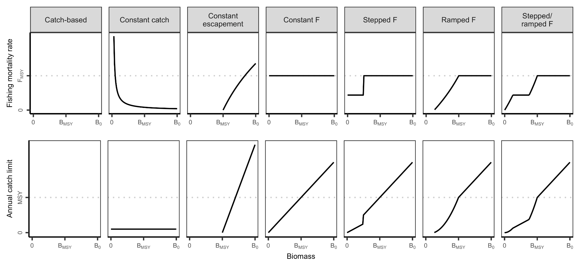**Figure 1.** Illustrations of the seven harvest control rule (HCR) typologies used in U.S. federal fisheries management. The shape of catch-based control rules is unknown given the lack of available biomass estimates for stocks managed using these rules. See **Table 1** for definitions of the biomass and fishing mortality reference points.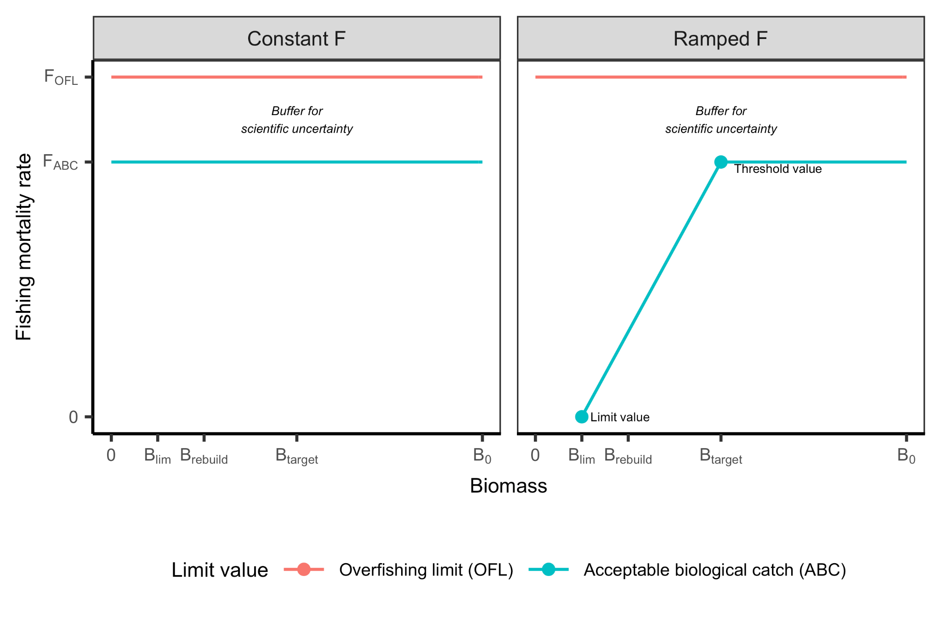

**Figure 2.** Illustration of the reference points and parameters commonly used to define harvest control rules and buffer them against scientific uncertainty. In both constant F and ramped F control rules, precautionary buffers are used to reduce the OFL to the ABC to protect against scientific uncertainty .In their simplest forms, ramped F rules are specified using two biomass (or abundance) reference points: (1) a *threshold value* below which fishing mortality is reduced (often, but not necessarily, equal to the target value); and (2) a *limit value* below which fishing mortality is prohibited (if equal to zero, then fishing is permitted across all stocks sizes but is reduced as stock size declines). See **Table 1** for definitions of all other biomass and fishing mortality reference points.

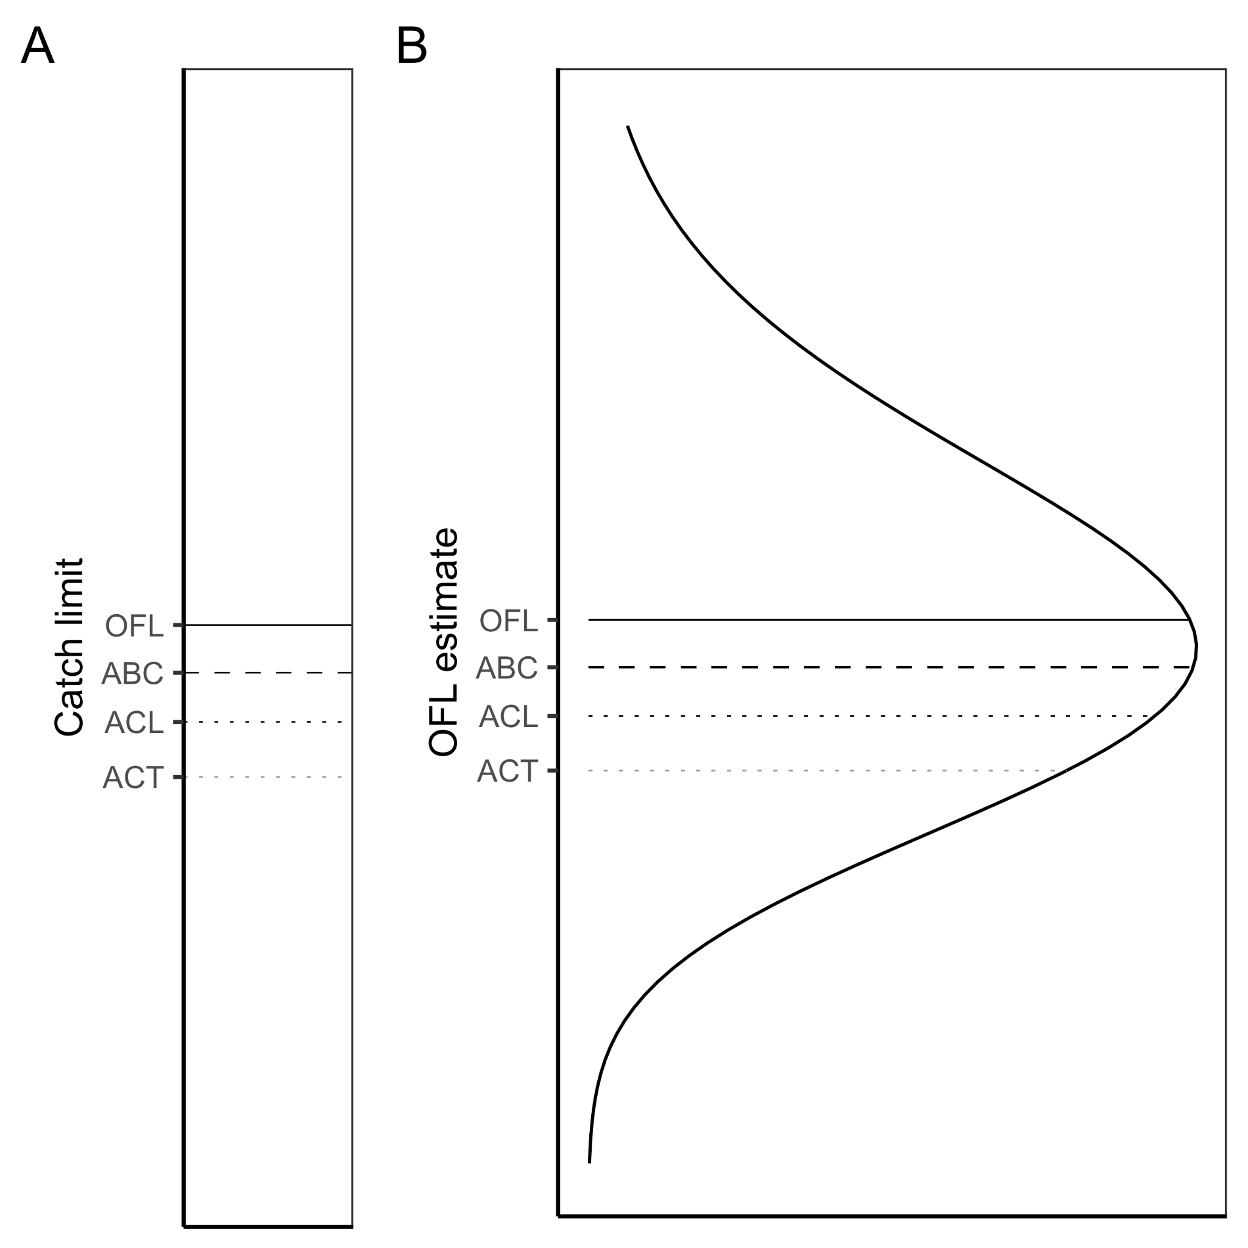

**Figure 3.** The relationship between catch limit reference points under U.S. federal law. In general, the following equation must be followed: ACT ≤ ACL ≤ ABC ≤ OFL. There are two approaches for reducing the OFL to the ABC in consideration of scientific uncertainty: **(A)** the reduction is performed using a simple percentage buffer, e.g., the ABC is 75% of the OFL; or **(B)** the ABC is calculated as a percentile of the OFL posterior distribution, e.g., the ABC is the 40th percentile of the OFL distribution, reflecting a probability of overfishing (P*) of 40%.

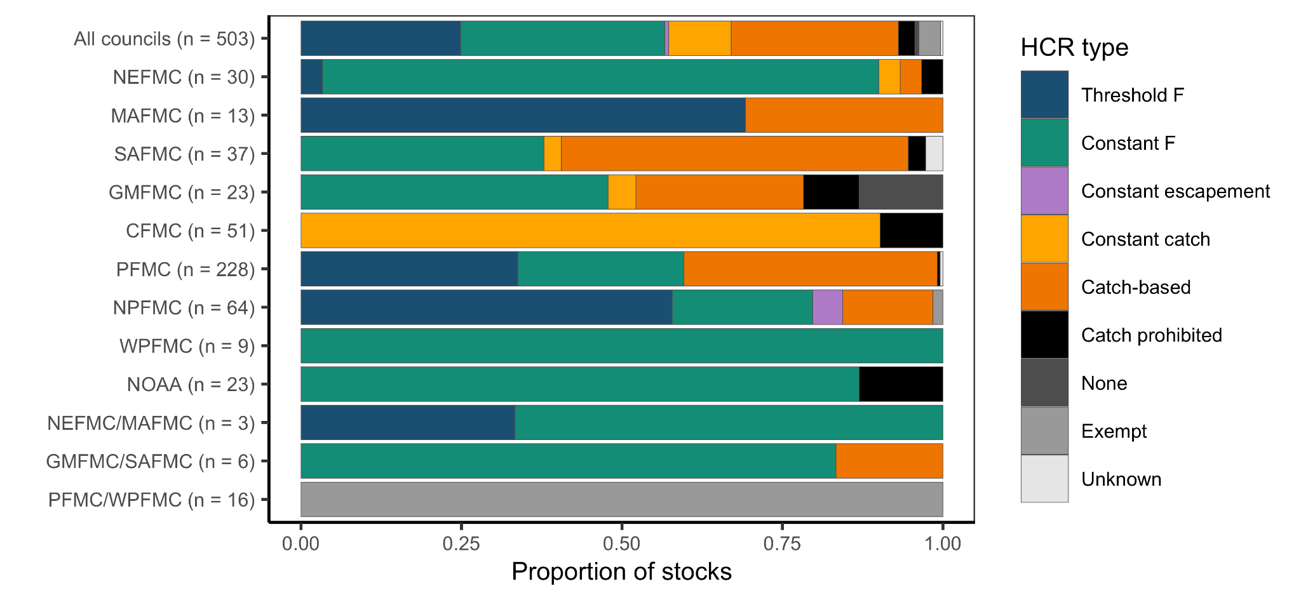

**Figure 4.** Proportion of U.S. federally-managed fish stocks and stock complexes managed using each harvest control rule (HCR) type by fishery management council. The top bar represents all stocks/stock complexes. Some stocks are jointly managed by two fishery management councils (see the bottom three rows in Fig. 4). NOAA represents the Consolidated Atlantic Highly Migratory Species Management plan.

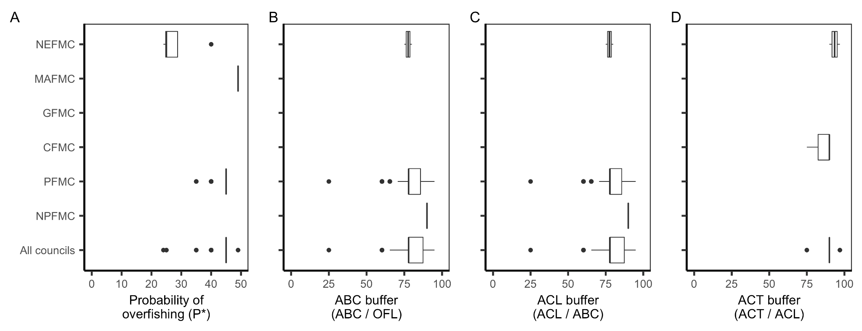**Figure 5.** Distribution of ABC buffers derived using either (A) a probability of overfishing (P*) or (B) a simple percent reduction. In the boxplots, the solid line indicates the median, the box indicates the interquartile range (IQR; 25th and 75th percentiles), the whiskers indicate 1.5 times the IQR, and the points beyond the whiskers indicate outliers.

## Supplemental Tables

**Table S1.** U.S. Fishery Management Plans (FMPs) and Fishery Ecosystem Plans (FEPs)1.

​​

|  |  |  |  |
| --- | --- | --- | --- |
| **#** | **Abbreviated FMP/FEP name** | **Year** | **Notes** |
| *New England (NEFMC)* | |  |  |
| 1 | Atlantic Sea Scallop | 1982 |  |
| 2 | Deep-Sea Red Crab | 2002 |  |
| 3 | Northeast Multispecies | 1985 |  |
| 4 | Northeast Skate Complex | 2003 |  |
| 5 | Atlantic Herring | 1999 |  |
| 6 | Atlantic Salmon | 1988 |  |
| 8 | Monkfish (with MAFMC) | 1998 |  |
| 9 | Spiny Dogfish (with MAFMC) | 1999 |  |
| *Mid-Atlantic (MAFMC)* | |  |  |
| 9 | Atlantic Surfclam & Ocean Quahog | 1977 |  |
| 10 | Bluefish | 1990 |  |
| 11 | Mackerel, Squid, Butterfish | 1978 |  |
| 12 | Summer Flounder, Scup, Black Sea Bass | 1988 |  |
| 13 | Tilefish | 2001 |  |
| *South Atlantic (SAFMC)* | |  |  |
| 14 | Dolphin & Wahoo | 2004 |  |
| 15 | Golden Crab | 1996 |  |
| 16 | Shrimp | 1993 |  |
| 17 | Snapper-Grouper | 1983 |  |
| 18 | Coastal Migratory Pelagics (with GFMC) | 1983 |  |
| 19 | GOM & SA Spiny Lobster (with GFMC) | 1982 |  |
| 20 | SA Corals | 1984 | Habitat, no fisheries |
| 21 | Sargassum | 2002 | Habitat, no fisheries |
| *Gulf of Mexico (GFMC)2* | |  |  |
| 22 | Red Drum | 1986 |  |
| 23 | GOM Reef Fish | 1984 |  |
| 24 | GOM Shrimp | 1981 |  |
| 25 | GOM Corals | 1984 | Habitat, no fisheries |
| *Caribbean (CFMC)3* | |  |  |
| 26 | Reef Fish | 1985 |  |
| 27 | Spiny Lobster | 1984 |  |
| 28 | Queen Conch | 1996 |  |
| 29 | Corals | 1995 | Habitat, no fisheries |
| *Pacific (PFMC)* | |  |  |
| 30 | Coastal Pelagic Species | 2000 |  |
| 31 | Pacific Groundfish | 1982 |  |
| 32 | Pacific Salmon | 2016 |  |
| *North Pacific (NPFMC)* | |  |  |
| 33 | BSAI King & Tanner Crabs | 1989 |  |
| 34 | BSAI Groundfish | 1982 |  |
| 35 | GOA Groundfish | 1978 |  |
| 36 | AK Salmon | 1979 |  |
| 37 | AK Scallop | 1995 |  |
| 38 | Arctic Fish | 2009 | HCRs but no fisheries |
| *Western Pacific (WPFMC)* | |  |  |
| 39 | American Samoa Archipelago Ecosystem | 2009 |  |
| 40 | Hawaii Archipelago Ecosystem | 2009 |  |
| 41 | Mariana Archipelago Ecosystem | 2009 |  |
| 42 | Pelagic Fisheries | 2009 |  |
| 43 | Remote Island Areas Ecosystem | 2009 |  |
| *Highly Migratory Species (NOAA)* | |  |  |
| 44 | Atlantic HMS | 2006 |  |
| 45 | Pacific HMS | 2003 |  |

1 FMC=fishery management council; HCR=harvest control rule; GOM=Gulf of Mexico; SA=South Atlantic; BSAI=Bering Sea & Aleutian Islands; GOA=Gulf of Alaska

2 The GOM Stone Crab FMP was implemented in 1979 but repealed in 2011. The WPFMC replaced its five FMPs (Bottomfish, Crustaceans, Coral Reef Ecosystem, Precious Corals, Pelagic FMPs) with five FEPs in 2009.

3 The following three FMPs are currently under development: (1) Puerto Rico FMP, (2) St. Croix FMP, and (3) St. Thomas and St. John FMP.