## Appendix A: Harvest control rules by FMP

### 1. New England (NEFMC)

#### 1.1 Groundfish (Northeast multispecies)

The Northeast Multispecies FMP, often referred to as the Groundfish FMP, was implemented in 1985 and governs the management of 13 species and 20 stocks of groundfish. All stocks are managed using the same **constant F harvest control rule** in which the ABC is determined as the catch at 75% of FMSY. However, if a stock is determined to be overfished and catch at 75% of FMSY would not achieve the mandated rebuilding timeline, then the ABC would be set to a fishing mortality rate that would rebuild the stock within the mandated rebuilding period (Frebuild).

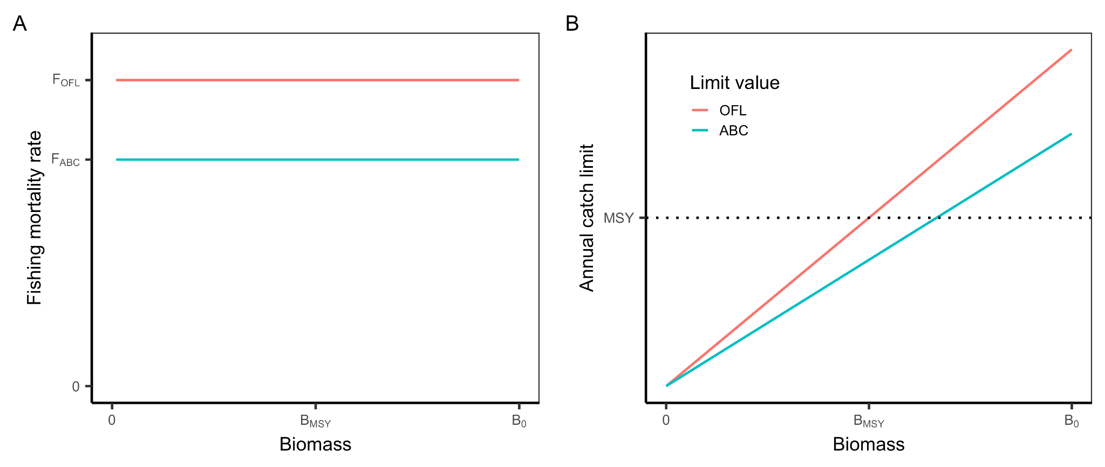

**Figure A1.** The harvest control rule for the NEFMC Northeast Multispecies FMP in terms of **(A)** fishing mortality rate (F) and **(B)** catch. FABC is 75% of FOFL. FOFL = FMSY and FABC = FACL.

#### 

#### 1.2 Small-mesh multispecies

The Northeast Small-mesh Multispecies FMP, often known as the Whiting FMP, was implemented in 2000 and governs the management of 3 species and 5 stocks of hake: two stocks of silver hake (*Merluccius bilinearis*), two stocks of red hake (*Urophycis chuss*), and one stock of offshore hake (*Merluccius albidus*). All stocks are managed using the same **constant F harvest control rule** in which the ABC is defined as a species-specific percentile of the OFL posterior and the ACL is defined as 95% of the ABC. The species-specific OFL posterior percentiles are as follows: red hake (40th percentile), silver hake (25th percentile), offshore hake (25th percentile with 4% increase).

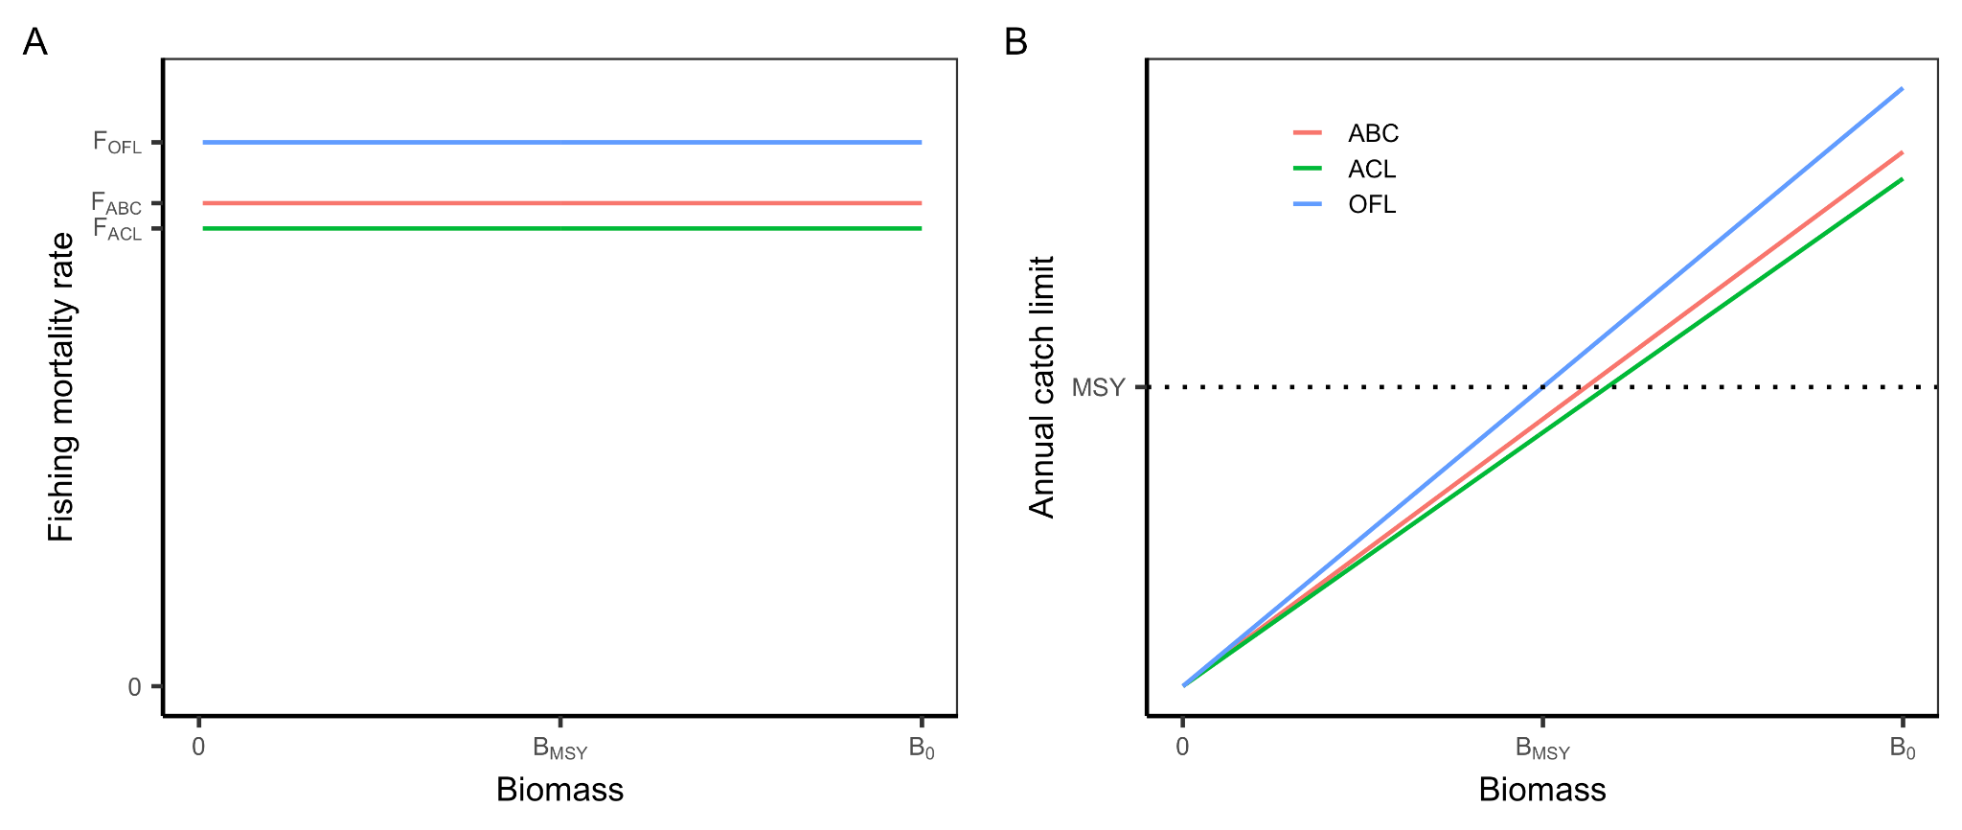

**Figure A2.** The harvest control rule for the NEFMC Small-mesh Multispecies FMP in terms of **(A)** fishing mortality rate (F) and **(B)** catch. The ABC is a species-specific percentile of the OFL posterior. The ACL is 95% of the ABC.

#### 

#### 1.3 Herring

The NEFMC Herring FMP was implemented in 1999 and governs the management of the U.S. Atlantic herring (*Clupea harengus*) stock. The NEFMC updated the harvest control rule in 2021 to a **ramped F harvest control with a biomass cutoff**. This rule is used to calculate a stock-wide ACL that is then allocated to each of four management areas. When the stock is at or above 50% of BMSY (or its proxy), the ABC is set at the catch associated with an F of 80% of FMSY (or its proxy), When the stock is below this *threshold* value, F declines linearly to zero at a *limit* value of 10% of BMSY (or its proxy). The ACL is defined as 95% of the ABC.

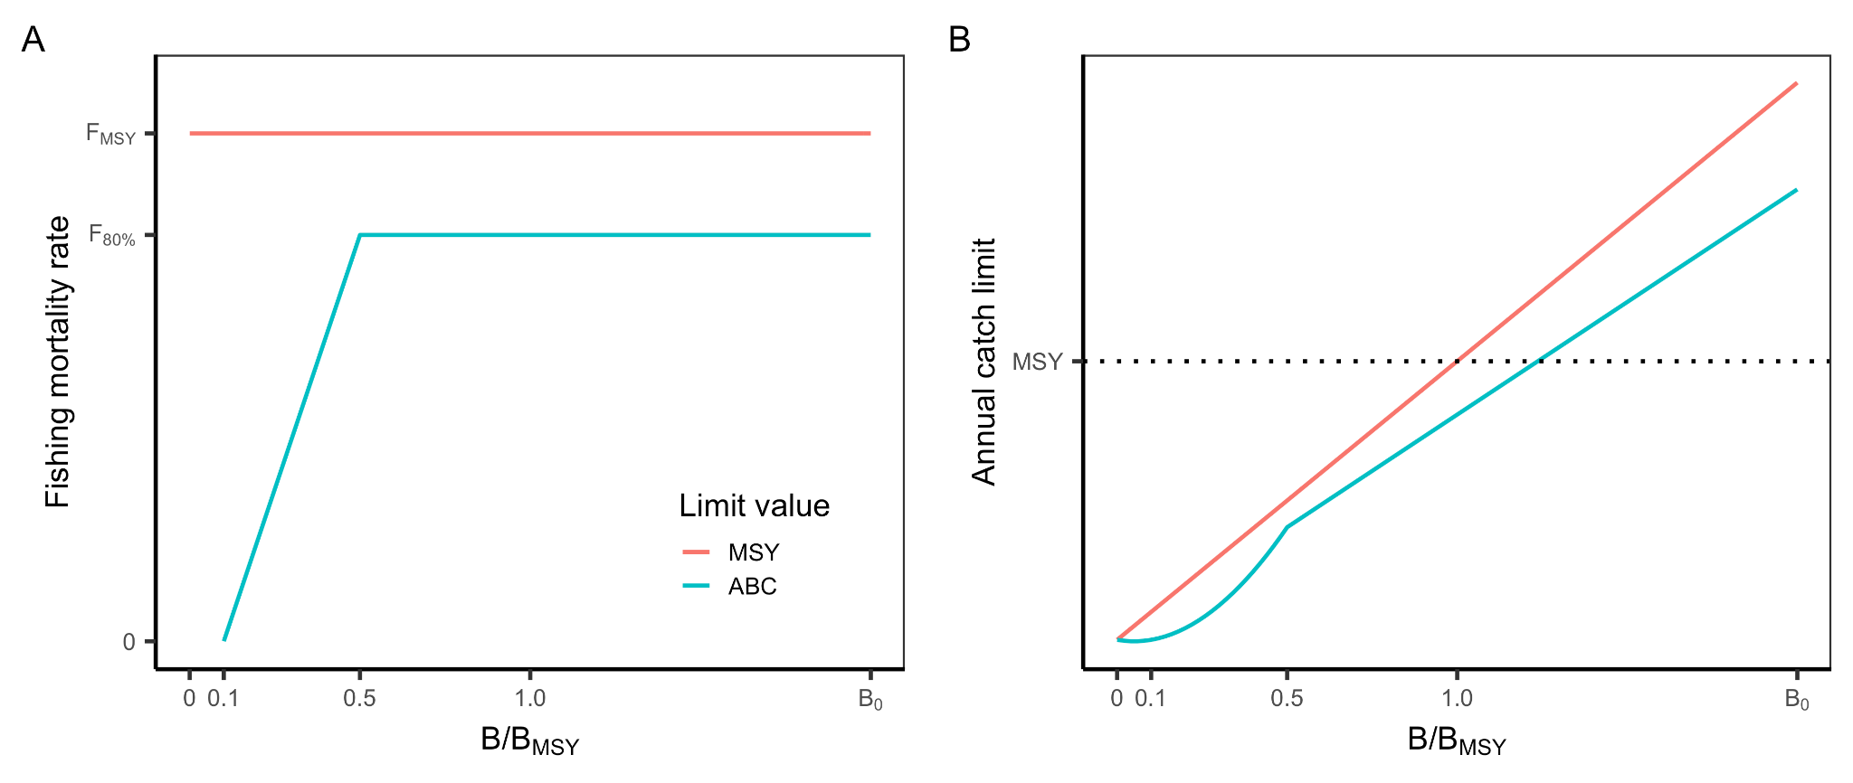

**Figure A3.** The harvest control rule for the NEFMC Atlantic Herring FMP in terms of **(A)** fishing mortality rate (F) and **(B)** catch.

#### 1.4 Monkfish

The Monkfish FMP was implemented in 1998, is led by the NEFMC but is jointly governed with the MAFMC, and governs the management of monkfish (*Lophius americanus*) stocks located in a northern (NFMA) and southern (SFMA) management zone. Both stocks are managed using a **constant F harvest control rule.** When a stock assessment is conducted for one or both of the monkfish stocks, the OFL is derived by multiplying the Fthreshold (a proxy for FMSY) and current biomass. The Fthreshold is 0.31 for the northern stock and 0.40 for the southern stock. The ABC, however, is set through a less typical procedure. It is calculated by multiplying current biomass by the average exploitation rate (U) during periods of stable or increasing trends in biomass. For the northern zone, the average exploitation rate is 0.18 (F=0.23) based on 1999-2006. For the southern management zone, the average exploitation rate is 0.14 (F=017) based on 2000-2006. The ACL is equal to the ABC. To account for management uncertainty, the ACT is 97% of the ACL in both management zones.

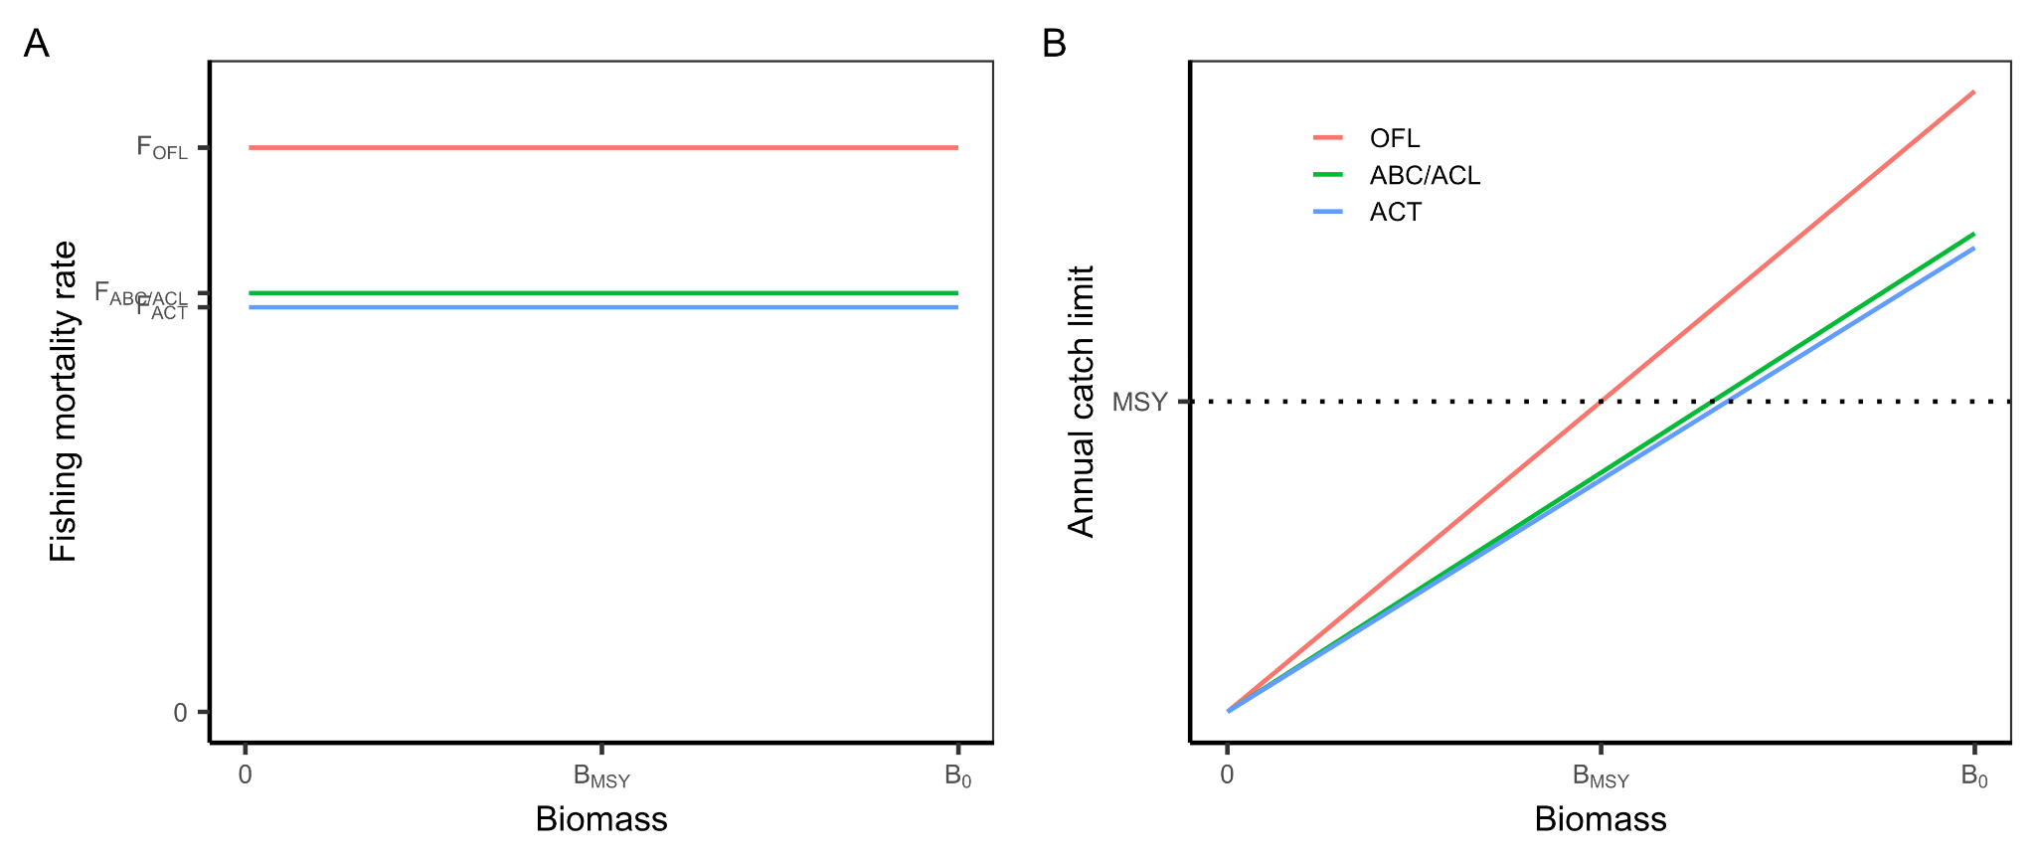**Figure A4.** The harvest control rule for the NEFMC Monkfish FMP in terms of **(A)** fishing mortality rate (F) and **(B)** catch.

#### 

#### 1.5 Skates

The NEFMC Skate FMP was implemented in 2003 and governs the management of seven skate species (**Table A1**). The skate stocks are data-poor and lack traditional quantitative stock assessments. As a result, quantitative estimates of MSY, OFL, and OY are not determined. Instead, an overfishing determination is made using an abundance index from the NMFS trawl survey (little skate based on spring survey; all others based on fall survey). If the three-year moving average of the abundance index declines by more than the average coefficient of variation, then overfishing is declared to be occurring (**Table A1**). If the abundance index falls below half of the BMSY proxy (i.e., the biomass threshold), the stock is declared to be overfished. The BMSY proxy is the 75th percentile of the survey years shown in Table A1 for all but barndoor skate; for barndoor skate, the BMSY proxy is the average of those years. The ABC is calculated using an **empirical catch-based harvest control rule** as the median ratio of catch to the biomass index multiplied by its three-year moving average stratified mean biomass index (kg/tow). This is considered an interim procedure until an OFL can be estimated via a stock assessment. The ACL is equal to the ABC. The ACT is 90% of the ACL to account for management uncertainty, projected dead discards, and projected state landings. However, if the ABC/ACL is exceeded in a given year, the percent buffer between the ACL and ACT is increased by 1% for each 1% of ACL overage in the following year.

**Table A1.** Skate species managed under the NEFMC Skate FMP and the reference points used to determine their status and derive their ABCs.

|  |  |  |  |
| --- | --- | --- | --- |
| **Species** | **Survey** | **BMSY proxy (kg/tow)** | **Biomass threshold (kg/tow)** |
| Barndoor skate (*Dipturis laevis*) | Fall  1963-1966 | 1.57 | 0.78 |
| Clearnose skate (*Raja eglanteria*) | Fall  1975-2007 | 0.66 | 0.33 |
| Little skate (*Leucoraja erinacea*) | Spring  1982-2008 | 6.15 | 3.07 |
| Rosette skate (*Leucoraja garmani*) | Fall  1967-2007 | 0.048 | 0.024 |
| Smooth skate (*Malacoraja senta*) | Fall  1963-2007 | 0.27 | 0.134 |
| Thorny skate (*Amblyraja radiata*) | Fall  1963-2007 | 4.13 | 2.06 |
| Winter skate (*Leucoraja ocellata*) | Fall  1967-2007 | 5.66 | 2.83 |

#### 1.6 Red crab

The NEFMC Red Crab FMP was implemented in 2002 and governs the management of Atlantic deep-sea red crab (*Chaceon quinquedens*). It employs a **constant catch harvest control rule** that calculates the ABC as the average landings from 1974-2008 (3.91 million lb of crabs). The ACL and TAL are equal to the ABC. The OFL and OY are not calculated for this data-poor fishery.

#### 1.7 Sea scallop

The NEFMC Atlantic Sea Scallop FMP was implemented in 1982 and governs the management of Atlantic sea scallop (*Placopecten magellanicus*). It employs a **constant F harvest control rule** that sets the ABC to the catch resulting from a fishing mortality that has a 25% probability of exceeding the fishing mortality associated with OFL. The ACL is equal to the ABC. The ACK is subdivided between the two fisheries for Atlantic scallop – the limited access (LA) fishery and the limited access general category (LAGC) fishery – and an ACT is specified for each fishery. The ACT for the LAGC fishery is equal to sub-ACL for this fishery. The ACT for the LA fishery is the fishing mortality rate associated with a 25% probability of exceeding the sub-ACL.

#### 1.8 Atlantic salmon

The NEFMC Atlantic Salmon FMP was implemented in 1988 and governs the management of Atlantic salmon (*Salmo salar*). The FMP **prohibits the commercial and recreational catch of Atlantic salmon**. All Atlantic salmon caught incidentally in other fisheries must be released in a manner that ensures maximum probability of survival.

### 

### 2. Mid-Atlantic (MAFMC)

The MAFMC implements seven fishery management plans including two plans jointly managed with the NEFMC (**Table A2**). The MAFMC leads the jointly managed Spiny Dogfish FMP.

**Table A2.** FMPs implemented by the MAFMC.

|  |  |
| --- | --- |
| **FMP** | **Year** |
| Summer Flounder, Scup, Black Sea Bass | 1988 |
| Mackerel, Squid, Butterfish | 1978 |
| Surfclams, Ocean Quahogs | 1977 |
| Bluefish | 1990 |
| Golden and Blueline Tilefish | 2001 |
| Spiny Dogfish *(led by MAFMC with NEFMC)* | 1999 |
| Monkfish *(led by the NEFMC with MAFMC)* | 1998 |

The MAFMC employs the same multi-level approach for specifying ABC control rules for all stocks managed under the six FMPs that it leads (**Table A3**). The four levels, referred to as types, vary based on the magnitude of stock assessment uncertainty. The SSC determines which type is appropriate for each stock. Stocks in Types 1-3 have stock assessments that estimate biomass, fishing mortality, and associated reference points and can therefore be managed using the **ramped F harvest control with a biomass cutoff** outlined by the MAFMC’s risk policy (**Figure A5**). This harvest control rule is unique in U.S. federal fisheries management in that the ramping is performed directly on the probability of overfishing (P*) rather than on fishing mortality (F) or catch. Stocks in Type 4 are managed using a catch-based control rule.

**Table A3.** ABC control rules based on the level of scientific uncertainty.

|  |  |  |  |
| --- | --- | --- | --- |
| **Type - ABC basis** | **Data availability** | **ABC control rule** | **Stocks** |
| 1 - Analytically-based | Stock assessment fully estimates OFL uncertainty; OFL posterior comes from assessment | Ramped F w/ cutoff | None |
| 2 - Expert-based | Stock assessment partially estimates OFL uncertainty; OFL posterior modified by experts (SSC) | Ramped F w/ cutoff | None |
| 3 - Empirically-based | Stock assessment does not estimate OFL uncertainty; OFL posterior entirely dictated by experts (SSC) | Ramped F w/ cutoff | All other stocks |
| 4 - Catch-based | No stock assessment or unreliable/incomplete stock assessment; | Catch-based | Longfin squid, *Illex* squid, blueline tilefish, chub mackerel |

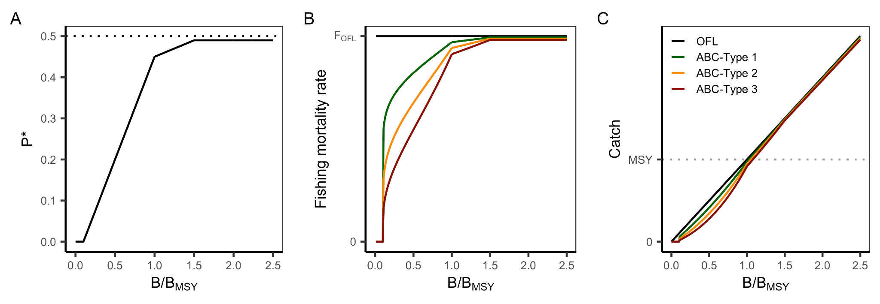

**Figure A5.** The **(A)** MAFMC risk tolerance policy and harvest control rules by level in terms of **(B)** fishing mortality rate (F) and **(C)** catch. P* = probability of overfishing.

### 

### 3. South Atlantic (SAFMC)

The SAFMC implements eight fishery management plans including two plans jointly managed with the GFMC (**Table A4**). The SAFMC leads the jointly managed Coastal Migratory Species (CMS) FMP.

**Table A4.** FMPs implemented by the MAFMC (CMS=coastal migratory species).

|  |  |  |  |
| --- | --- | --- | --- |
| **FMP** | **Year** | **Level** | **HCR category** |
| Dolphin/wahoo | 2004 | Level 5 | Catch-based |
| Golden crab | 1996 | Level 5 | Constant catch (2 million lbs) |
| Shrimp | 1993 | Not in tier-system (exempt) | *White shrimp, rock shrimp, pink shrimp:* catch-based *Brown shrimp:* unknown |
| Snapper-grouper | 1983 | Levels 1, 4, and 5 | Constant F or Catch-based |
| CMS *(led by SAFMC with GFMC)* | 1983 | Not in tier-system (exempt) | Constant F |
| Spiny lobster *(led by GFMC with SAFMC)* | 1982 | Tier 3a (GFMC rule) | Catch-based |
| Coral | 1984 | Not in tier-system (habitat) | N/A |
| Sargassum | 2002 | Not in tier-system (habitat) | N/A |

The SAFMC employs the same multi-level approach for specifying ABC control rules for all stocks managed under the five FMPs for fished resources that it leads (**Table A5**). The five levels vary based on the level of data availability and corresponding magnitude of stock assessment uncertainty. The SSC determines which type is appropriate for each stock. Only stocks in Level 1 have stock assessments that estimate biomass, fishing mortality, and associated reference points. Stocks in Levels 2-5 have decreasing data availability and increasing stock assessment uncertainty. Level 1 stocks are managed using a **constant F harvest control** in which the magnitude of the P*buffer is set based on expert scoring of four assessment dimensions. Stocks in Levels 2-5 are managed using various catch-based control rules.

**Table A5.** ABC control rules based on the level of scientific uncertainty.

|  |  |  |  |
| --- | --- | --- | --- |
| **Level** | **Data availability** | **ABC control rule** | **Stocks** |
| Level 1 | **Stock assessment:** adequate data to support quantitative assessment | **Constant F:** Stock assessment or other quantitative assessment used to derive OFL with estimates of uncertainty; P* used to derive ABC; the value of P* is set based on expert scoring of four assessment dimensions | Black Sea Bass, Blueline Tilefish, Gag, Golden Tilefish, Greater Amberjack, FLK/EFL Hogfish, Mutton Snapper, Red Grouper, Red Porgy, Red Snapper, Snowy Grouper, Vermillion Snapper, Wreckfish, Yellowtail Snapper |
| Level 2 | **No stock assessment;** but reliable catch time series and life history data support DB-SRA | **Catch-based:** DB-SRA used to derive OFL with estimates of uncertainty; P* used to derive ABC; the value of P* is set based on expert scoring of four assessment dimensions | None |
| Level 3 | **No stock assessment** and inadequate data to support DB-SRA; requires a higher degree of “informed expert judgment” than Level 2 | **Catch-based:** DCAC used to derive ABC (OFL not provided) without estimates of uncertainty; within this approach, there are four-tiers based on data availability | None |
| Level 4 | **No stock assessment;** “only reliable catch stocks” (ORCS) | **Catch-based:** OFL and ABC derived on case-by-case basis; guided by ORCS approach to determine catch statistic and scalar | Atlantic Spadefish, Bar Jack, Black Grouper, Cubera Snapper, GA-NC Hogfish, Gray Snapper, Gray Triggerfish, Lane Snapper, Margate, Red Hind, Rock Hind, Scamp, Silk Snapper, Tomtate, White Grunt, Yellowedge Grouper |
| Level 5 | **No stock assessment** and no reliable catch time series | **Catch-based:** OFL and ABC derived on case-by-case basis; guided by decision tree; options include: 3rd highest catch from 1999-2008; median catch from 1999-2008 | Almaco Jack, Banded Rudderfish, Blackfin Snapper, Coney, Dolphin, Golden Crab, Graysby, Jolthead Porgy, Knobbed Porgy, Lesser Amberjack, Misty Grouper,  Queen Snapper, Sailor’s Choice, Sand Tilefish, Saucereye Porgy, Scup,  Speckled Hind, Wahoo, Whitebone Porgy, Warsaw Grouper, Yellowfin Grouper, Yellowmouth Grouper |
| N/A | N/A | **Catch prohibited** | Goliath Grouper, Nassau Grouper |

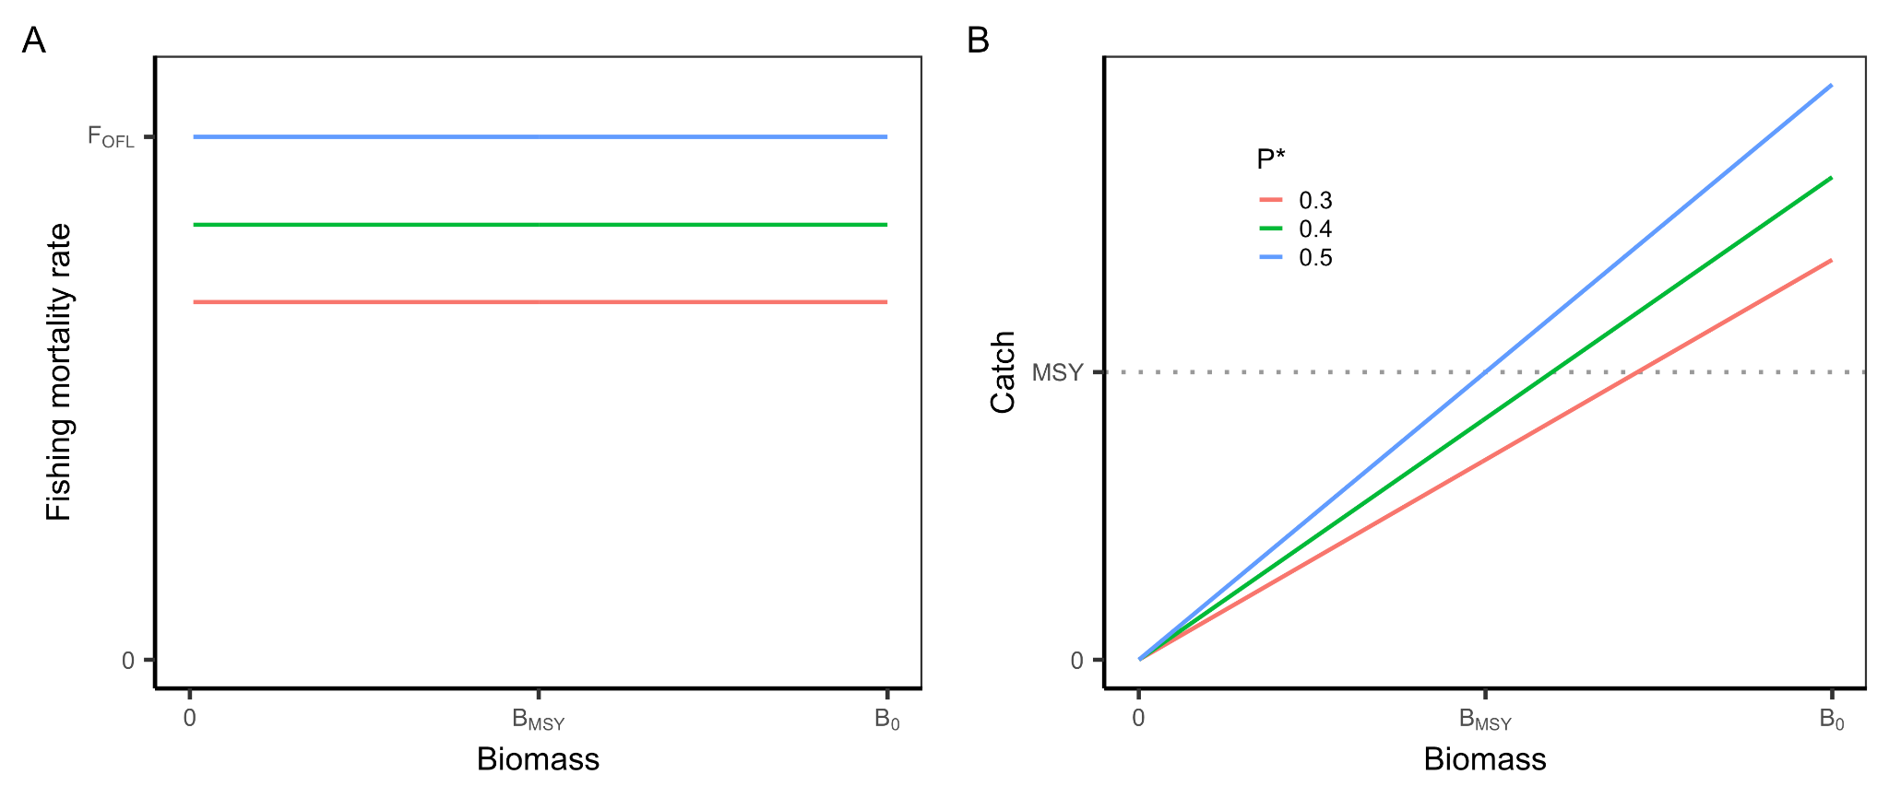**Figure A6.** The harvest control rule for Level 1 stocks in SAFMC FMPs for fished resources in terms of **(A)** fishing mortality rate (F) and **(B)** catch.

### 4 Gulf of Mexico (GFMC)

The GFMC implements six fishery management plans including two plans jointly managed with the GFMC (**Table A6**). The GFMC leads the jointly managed Spiny Lobster FMP.

**Table A6.** FMPs implemented by the GFMC.

|  |  |  |  |
| --- | --- | --- | --- |
| **FMP** | **Year** | **Tier** | **HCR category** |
| Reef fish | 1984 | Many | Constant/catch-based |
| Shrimp | 1981 | NA | catch-based/none |
| Red drum | 1986 | No harvest | N/A |
| Spiny lobster *(led by GFMC with SAFMC)* | 1982 | 3a | Catch-based |
| Coastal Migratory Pelagic *(led by SAFMC with GFMC)* | 1983 | 1 | Constant |
| Coral | 1984 | Habitat | N/A |

The GFMC employs the same multi-level approach for specifying ABC control rules for all stocks managed under the four FMPs for fished resources that it leads (**Table A7**). The four levels vary based on the level of data availability and corresponding magnitude of stock assessment uncertainty. The SSC determines which type is appropriate for each stock. Stocks in Tier 1-2 have stock assessments that estimate biomass; Tier 1 stocks directly estimate the OFL and its uncertainty while Tier 2 stocks do so indirectly. Stocks in Tier 3 do not have stock assessments but do have a time series of landings; Tier 3a is for stocks not judged to be experiencing overfishing while Tier 3b is for stock judged to be experiencing overfishing . Tier 1 and 2 stocks are managed using a **constant F harvest control** in which the magnitude of the P*buffer is determined based on expert review. Stocks in Levels 2-3b are managed using various catch-based control rules.

The GFMC may also incorporate management uncertainty into its control rules by specifying an ACL or ACT. When an ACT is used, the ACL is usually set to the ABC. When an ACT is not used, the control rules can also guide the council in determining appropriate reductions in ABCs to yield ACLs. The ACL/ACT control rule relies on indicators of management success, including the history of exceeded catch limits, the precision of landings data, whether the ACL applies to a single stock or a complex, and the status of the stock. Buffers resulting from the application of the control rule are typically between 15 and 20% for non-ITQ managed fisheries. ITQ fisheries have stricter monitoring and reporting requirements, resulting in less management uncertainty, and thus are usually assigned buffers between 0% and 5%.

**Table A7.** ABC control rules based on the level of scientific uncertainty.

|  |  |  |  |
| --- | --- | --- | --- |
| **Level** | **Data availability** | **Control rules** | **Stocks** |
| Tier 1 | - Assessment  - MSY/proxy estimate  - Uncertainty quantified | **Constant F:**  - OFL directly from assessment  - ABC = yield at P*, where P* is between 0.3 and 0.5 | Cobia, Gag, Gray Snapper, Gray Triggerfish, Greater amberjack, Hogfish, King Mackerel, Mutton Snapper, Red grouper, Red Snapper, Spanish Mackerel, Vermilion Snapper, Yellowtail Snapper |
| Tier 2 | - Assessment  - No MSY/proxy estimate  - But alternative OFL estimate  - Uncertainty quantified | **Constant F:**  - OFL indirectly from assessment  - ABC = yield at P*, where P* is 0.3 as a default, but can be 0.4 or 0.5 | Lane Snapper |
| Tier 3a | - No assessment  - Landings data available  - Expert opinion suggest recent landings sustainable | **Catch-based:**  - OFL = mean recent landings plus two standard deviations - ABC = mean of landings plus a determined number of SDs (0, 0.5, 1, or 1.5) | Almaco jack, Banded rudderfish, Black grouper, Blackfin Snapper, Blueline tilefish, Cubera Snapper, Golden Tilefish, Goldface tilefish, Lesser amberjack, Queen Snapper, Silk Snapper, Snowy grouper, Speckled hind, Spiny Lobster, Warsaw grouper, Wenchman, Yellowedge grouper, Yellowfin grouper, Yellowmouth grouper, **Scamp (moving to Tier 1 soon)** |
| Tier 3b | - No assessment  - Landings data available  - Expert opinion suggest recent landings unsustainable | **Catch-based:**  - OFL = mean landings  - ABC = 75% of OFL as default | (none in this tier) |
| No harvest |  |  | Goliath grouper, red drum |

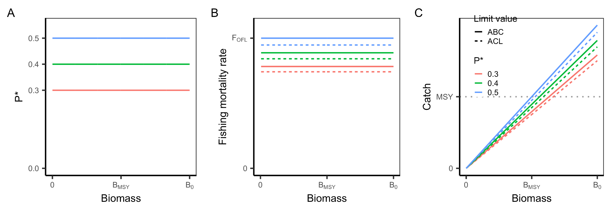

**Figure A7.** The harvest control rule for Tier 1 and 2 stocks in GFMC FMPs for fished resources in terms of **(A)** fishing mortality rate (F) and **(B)** catch.

### 

### 5. Caribbean (CFMC)

#### 5.1 Existing rules

##### 5.1.1 Reef fish

The CFMC Reef Fish FMP was implemented in 1985 and governs the management of 11 fisheries management units (FMUs). The FMP manages all stocks using **catch-based harvest control rules** that vary by island and fisheries management unit (**Table A8**).

**Table A8.** Catch-based harvest rules used in the Reef Fish FMP.

|  |  |  |  |
| --- | --- | --- | --- |
| **Limit** | **Island1** | **FMU2** | **Rule** |
| MSY | PR | Grunts, goatfishes, squirrelfish, scups/porgies, jacks, triggerfish/filefish, boxfish, wrasses | MSY proxy = median annual landings during reference period |
| MSY | STT/STJ/STX | All | MSY proxy = mean annual landings during reference period |
| MSY | PR | Surgeonfish, angelfish, tilefish | MSY proxy = 3 x maximum recreational landings |
| OFL | PR | All | OFL = MSY proxy adjusted based on expert opinion |
| OFL | STT/STJ/STX | All | OFL = MSY proxy |
| ABC | All | All | ABC = OFL |
| ACL/OY | All | Surgeonfish, angelfish | OY = ACL = ABC * 0.75 |
| ACL/OY | All | Grunts, goatfishes, squirrelfish, scups/porgies, jacks, triggerfish, filefish, boxfish, tilefish | OY = ACL = ABC * 0.90 |

1 All islands = Puerto Rico (PR), St. John (STJ), St. Thomas (STT), St. Croix (STX)

2 All FMUs = grunts, goatfishes, squirrelfish, scups/porgies, jacks, triggerfish/filefish, boxfish, wrasses, angelfish, surgeonfish, tilefish

##### 5.1.2 Queen conch

The CFMC Queen Conch FMP was implemented in 1997 and governs the management of queen conch (*Strombus gigas*). The FMP manages all stocks using **catch-based harvest control rules** that vary by island.

**Table A9.** Catch-based harvest rules used in the Queen Conch FMP.

|  |  |  |
| --- | --- | --- |
| **Limit** | **Island1** | **Rule** |
| MSY | PR/STX | MSY proxy = mean annual landings from 1999-2005 |
| MSY | STT/STJ | MSY proxy = mean annual landings from 2000-2005 |
| OFL | All | OFL = MSY proxy |
| ABC/ACL/OY | All | OY = ACL = ABC = specified by SSC |

1 All islands = Puerto Rico (PR), St. John (STJ), St. Thomas (STT), St. Croix (STX)

##### 5.1.3 Spiny Lobster

The CFMC Spiny Lobster FMP was implemented in 1981 and governs the management of spiny lobster (*Panulirus argus*). The FMP manages all stocks using **catch-based harvest control rules** that vary by island.

**Table A10.** Catch-based harvest rules used in the Spiny Lobster FMP.

|  |  |  |
| --- | --- | --- |
| **Limit** | **Island1** | **Rule** |
| MSY | PR | MSY proxy = median annual landings during reference period |
| MSY | STT/STJ/STX | MSY proxy = mean annual landings during reference period |
| OFL | PR | OFL = MSY proxy adjusted using expert opinion |
| OFL | STT/STJ/STX | OFL = MSY proxy |
| ABC | All | ABC = OFL |
| ACL/OY | All | ACL = OY = ABC * 0.90 |

1 All islands = Puerto Rico (PR), St. John (STJ), St. Thomas (STT), St. Croix (STX)

#### 

#### 5.2 Proposed rules

The proposed island-based FMPs would use the same multi-level approach for specifying ABC control rules for all of its stocks.

**Table A11**. ABC control rules based on the level of scientific uncertainty.

|  |  |  |  |
| --- | --- | --- | --- |
| **Tier** | **Data availability** | **Control rules** | **Notes** |
| 1 | **Data-rich:** stage-structured stock assessment using time series of catch, abundance index, and stage composition | **Constant F:**  OFL = FMSY * B  ABC = OFL * buffer |  |
| 2 | **Data-moderate:** stock assessment using time series of catch and an abundance index (no stage structure) | **Constant F:**  OFL = FOFL * B  ABC = OFL * buffer |  |
| 3 | **Data-limited:** data-limited or out-of-date assessment available | **Constant F:**  OFL = FMSY * B  ABC = OFL * buffer |  |
| 4a | **Data-limited:** no assessment available and the stock has relatively low vulnerability to fishing pressure | **Catch-based:**  OFL = scalar * 75th percentile of reference period landings  ABC = OFL * buffer | Reference period, scalar (≤3), and buffer (≤0.9) set by SSC |
| 4b | **Data-limited:** no accepted assessment available and the stock has relatively *high* vulnerability to fishing pressure | **Catch-based:**  OFL = scalar * mean of reference period landings  ABC = OFL * buffer | Reference period, scalar (<2), and buffer (≤0.9) set by SSC |

##### 

### 

### 6. Pacific (PFMC)

#### 6.1 Groundfish

The PFMC Groundfish FMP was implemented in 1982 and governs the management of 87 groundfish species. The FMP employs a multi-level approach for specifying ABC control rules based on the level of data availability and the corresponding magnitude of stock assessment uncertainty (**Table A12**). Stocks in Categories 1 and 2 have stock assessments and are managed using a **ramped F harvest control rule with a biomass cutoff**. The size of the ABC buffer is generally larger for data-moderate Category 2 stocks than for data-rich Category 1 stocks. When a Category 1 or 2 stock is at or above its BMSY proxy, the ABC is set at the catch associated with its FMSY proxy multiplied by the ABC buffer. However, when the stock is below this *threshold* value (Bthresh), the ABC declines linearly to zero at a *limit* value (Blim) that varies based on species. The default Bthresh is B25% for flatfish and B40% for all other species. The default Blim is B5% for flatfish and B10% for all other species. Stocks in Category 3 are managed using a **catch-based harvest control rule**.

**Table A12.** ABC control rules based on the level of scientific uncertainty.

|  |  |  |  |
| --- | --- | --- | --- |
| **Category** | **Data availability** | **Control rule** | **Stocks** |
| 1 | **Data-rich:** a reliable quantitative stock assessment (e.g., age/length composition data included) is available | **Ramped w/ cutoff:** the selection of P* is based on level of variability in the biomass estimates (σ) |  |
| 2 | **Data-moderate:** a less reliable quantitative stock assessment (e.g., age/length composition data not included) is available | **Ramped w/ cutoff:** the choice of P* is more precautionary than for Category 1 stocks by either (1) using a buffer of 0.25 or (2) doubling the CV of Category 1 stocks |  |
| 3 | **Data-poor:** no reliable abundance index is available so catch-based methods are used | **Catch-based:** OFL based on DB-SRA, DCAC, or a historical catch statistic and the P* buffer is more precautionary than for Category 1 or 2 stocks by either (1) using a buffer of 0.50 or (2) quadrupling the CV of Category 1 stocks | All other species |

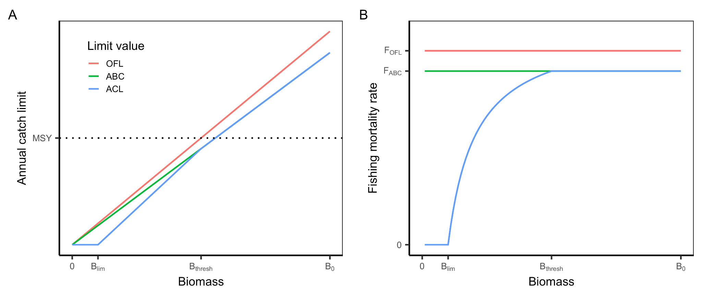

**Figure A8**. A conceptual illustration of the harvest control rule used to establish catch limits for Category 1 and 2 groundfish stocks. The OFL is derived from FMSY or its proxy values. The default FMSY proxy values are as follows: F50% for rockfish and elasmobranchs, F45% for roundfish, F40% for whiting, and F30% for flatfish. The default Bthresh is B25% for flatfish and B40% for all other species. The default Blim is B5% for flatfish and B10% for all other species.

#### 

#### 6.2 Coastal Pelagics

The PFMC Coastal Pelagic FMP was implemented in 2000 and governs the management of 3 actively managed species, 3 monitored species, and krill species whose harvest is prohibited (**Table A13**). Actively managed species are managed using a **ramped harvest control rule with a biomass cutoff** using the system of equations shown in **Table A13** and parameters in **Table A14**. The HCR for Pacific sardine rule includes an exploitation rate that is **environmentally-linked** to sea surface temperature in the CalCOFI survey. Monitored species are managed using catch-based harvest control rules using the system of equations shown in **Table A13**. Harvest is not allowed for prohibited species (all krill species).

**Table A13.** Harvest control rules used in the PFMC Coastal Pelagic Species FMP.

|  |  |
| --- | --- |
| **Tier** | **Control rules** |
| **Active**  Pacific chub mackerel | **Ramped with biomass cutoff:**  OFL = B * FMSY * distribution  ABC = B * FMSY * distribution * buffer  HG = (biomass - cutoff) * fraction * distribution |
| **Active**  Pacific sardine | **Ramped with biomass cutoff and environmental-link:**  EMSY = -18.46452 + 3.25209\**T* - 0.19723\**T*2 + 0.0041863\**T*3; where *T* = 3-yr running average of CalCOFI SST  OFL = B * EMSY * distribution, EMSY = [0-0.25]  ABC = B * EMSY * distribution * buffer; EMSY = [0-0.25]  HG = pmin(maxcat, (biomass - cutoff) * EMSY * distribution); EMSY = [0.05-0.20] |
| **Monitored** Northern anchovy, jack mackerel, market squid | **Catch-based:**  OFL = MSY proxy  ABC = OFL * 0.25  ACL ≤ ABC, based on OY considerations |
| **Prohibited** All krill species | No harvest |

**Table A14.** Parameters for the HCRs of the actively managed species.

|  |  |  |  |
| --- | --- | --- | --- |
| **Parameter** | **Definition** | **Pacific sardine** | **Pacific chub mackerel** |
| cutoff (mt) | Lowest biomass at which directed harvest is allowed | 150,000 mt | 18,200 mt |
| fraction (%) | Percent of the biomass above the cutoff that can be taken by the fishery | 5-20% depending on SST (higher in warm years, lower in cool years) | 30% |
| distribution (%) | Average percent of biomass assumed to be in US waters | 87% | 70% |
| maxcat (mt) | Maximum allowable catch | 200,000 mt | None (appears limited to 40,000 mt by markets) |
| buffer | ABC buffer | ~90% | ~90% |

**Table A15.** Assumed distribution of actively managed and monitored species in the U.S. Exclusive Economic Zone (EEZ).

|  |  |
| --- | --- |
| **Species** | **% of distribution on US EEZ** |
| Pacific sardine | 87 |
| Pacific chub mackerel | 70 |
| Northern anchovy - central stock | 82 |
| Northern anchovy - northern stock | Unknown (some in Canada) |
| Jack mackerel | 65 |
| Market squid | N/A |

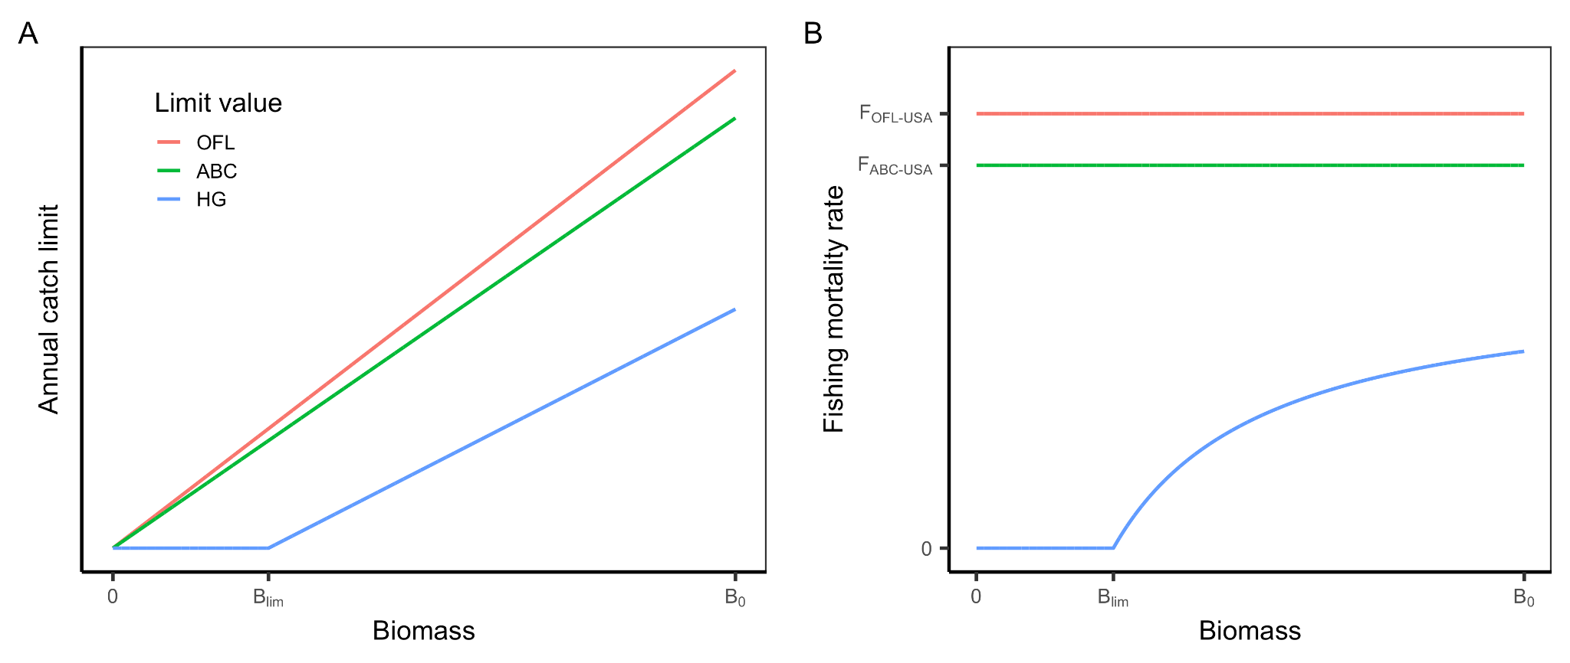

**Figure A9.** The harvest control rule for Pacific chub mackerel.

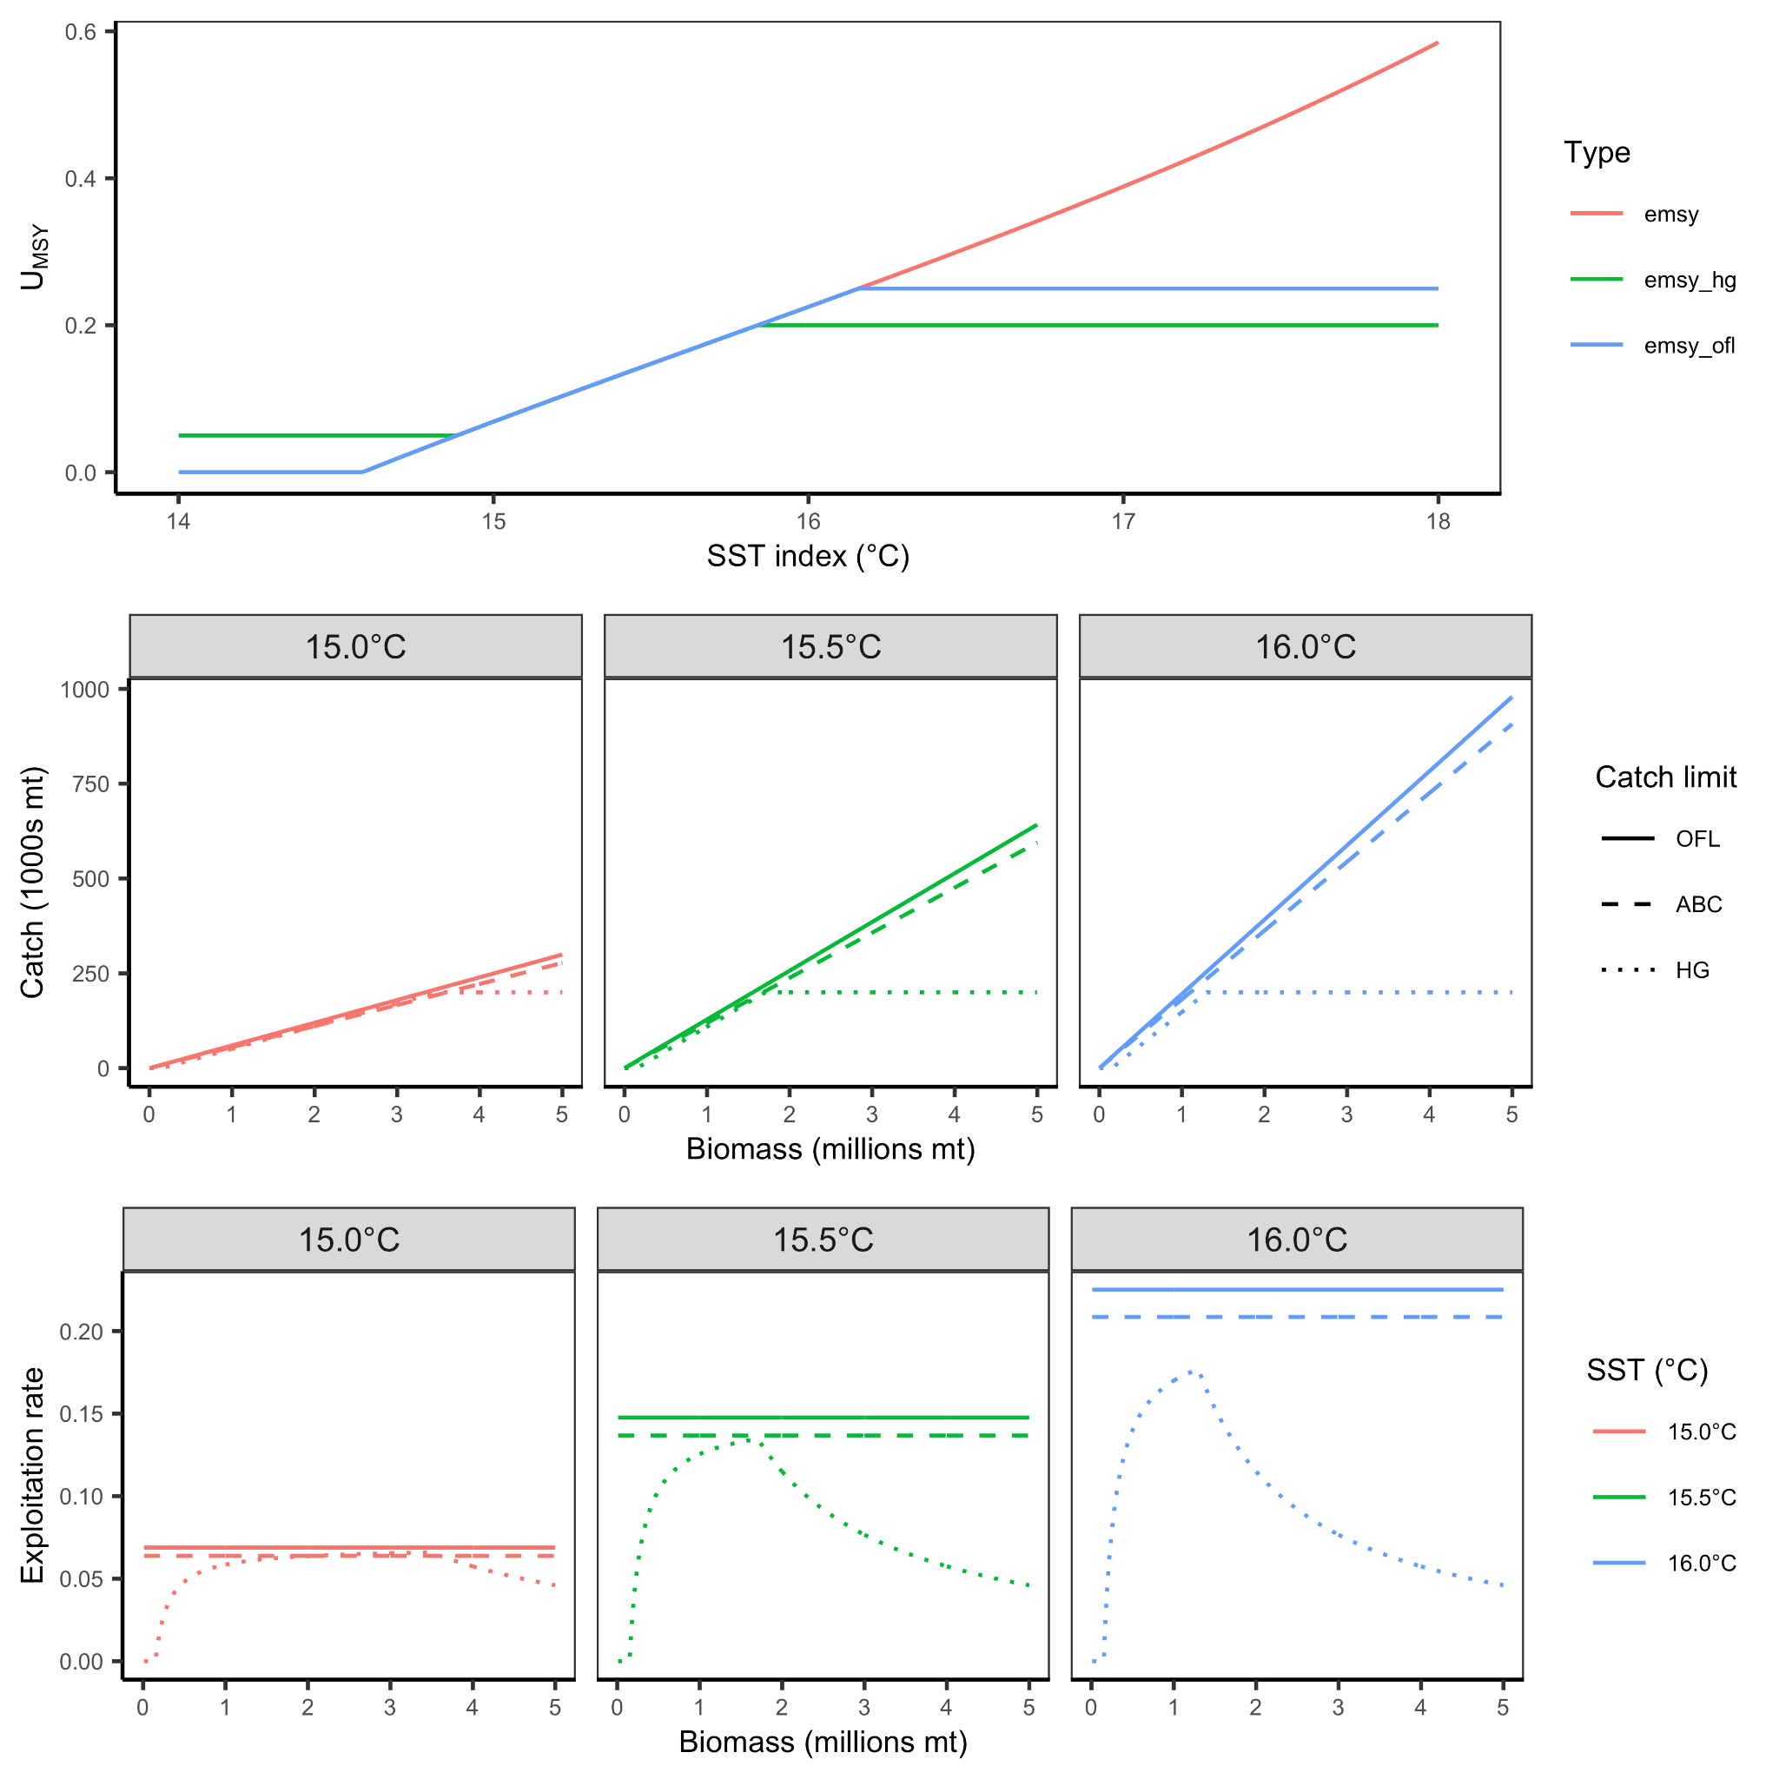

**Figure A10.** The environmentally-linked harvest control rule for Pacific sardine.

#### 

#### 6.3 Salmon

The PFMC Salmon FMP was implemented in 2016 and governs the management for Chinook salmon (*Oncorhynchus tshawytscha*), coho salmon (*Oncorhynchus kisutch*), and pink salmon (*Oncorhynchus gorbuscha*) (odd numbered years only). The majority of salmon stocks are managed using the default **constant F harvest control rule**. However, the Puget Sound Coho salmon stock is managed using a stepped harvest control rule and the Klamath River and Sacramento River Fall Chinook salmon stocks are managed using a **ramped/stepped F harvest control rule**. Under the default rule, the magnitude of the ABC buffer varies by tier. For Tier 1 stocks, in which FMSY is estimated directly, FABC = FMSY x 0.95 whereas FABC = FMSY x 0.90 for Tier 2 stocks, in which a proxy value is used Under the default rule, the ACL is equal to the ABC.

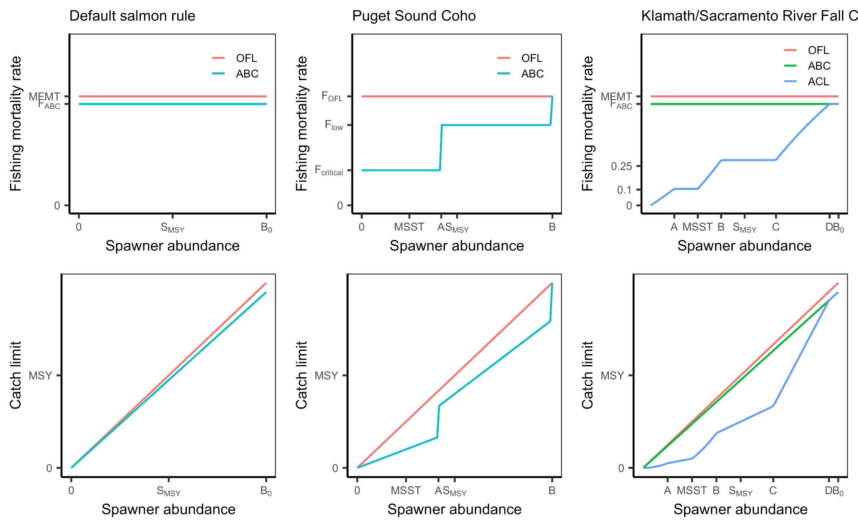

**Figure A11.** Harvest control rules for Pacific salmon.

### 

### 7. North Pacific (PFMC)

#### 7.1 GOA & BSAI Groundfish

Groundfish in the North Pacific are managed under FMPs for the Gulf of Alaska (GOA), implemented in 1978, and for the Bering Sea and Aleutian Islands (BSAI), implemented in 1982. Both FMPs manage groundfish stocks using the same multi-level approach for specifying ABC control rules (**Table A16**). The five levels, referred to as tiers, vary based on the level of data availability and corresponding magnitude of stock assessment uncertainty. The SSC determines which tier is appropriate for each stock. Stocks in Tiers 1-3 are managed using **ramped F harvest control rules with biomass cutoffs** with increasing precaution to buffer against scientific uncertainty. Stocks in Tiers 4-5 are managed using **constant F harvest control rules** with increasing precaution to buffer against scientific uncertainty. Stocks in Tier 6 lack estimates of biomass and are managed using a **catch-based harvest control rule**.

**Table A16.** Six-tier system for setting OFLs and ABCs in the GOA & BSAI Groundfish FMP.

|  |  |  |  |
| --- | --- | --- | --- |
| **Tier** | **Data availability** | **Control rules** | **Stocks** |
| 1 | B, BMSY, FMSY w/ uncertainty | **Ramped w/ cutoff:**  FOFL ~ arithmetic mean of FMSY posterior  FABC ~ harmonic mean of FMSY posterior | **GOA:** None  **BSAI:** Eastern Bering Sea pollock Yellowfin sole Northern Rock sole |
| 2 | B, BMSY, FMSY, F35%, F40% | **Ramped w/ cutoff:**  FOFL ~ BMSY, FMSY  FABC ~ BMSY, FMSY, F35%, F40% | **GOA:** None  **BSAI:** None |
| 3 | B, B40%, F35%, F40% | **Ramped w/ cutoff:**  FOFL ~ B40%, F35%  FABC ~ B40%, F40% | **GOA:** Pollock, Pacific cod, Sablefish, Northern and southern rock sole, Rex sole, Arrowtooth flounder, Flathead sole, Pacific ocean perch, Northern rockfish, Rougheye & blackspotted rockfish, Dusky rockfish, Deepwater flatfish (Dover) (also in 6)  **BSAI:** Aleutian Islands pollock, Eastern Bering Sea Pacific Cod, Sablefish, Greenland Turbot, Arrowtooth flounder, Kamchatka flounder, Flathead sole, Alaska plaice, Pacific ocean perch, Northern rockfish, Rougheye & blackspotted rockfish, Atka mackerel |
| 4 | B, F35%, F40% | **Constant:**  FOFL = F35%  FABC = F40% | **GOA:** Other rockfish (also in 5 and 6)  BSAI:  Sharpchin rockfish |
| 5 | B, natural mortality (M) | **Constant:**  FOFL = M  FABC = M * 0.75 | **GOA:** Shallow water flatfish (excluding northern and southern rock sole), Shortraker rockfish, Thornyhead rockfish, Skates, Sharks (also in 6)  **BSAI:** Shortspine thornyhead, Shortraker rockfish, Longnose skate, Sculpin complex, Yellowfin sole, Butter sole, Starry flounder, English sole, Sand sole, Alaska plaice,  Silvergray rockfish, Splitnose rockfish, Stripetail rockfish, Bocaccio, Chilipepper, Darkblotched rockfish, Greenstriped rockfish , Harlequin rockfish, Northern rockfish, Pygmy rockfish, Redbanded rockfish, Redstripe rockfish, Vermilion rockfish  Widow rockfish, Yellowmouth rockfish, Yellowtail rockfish, Big skate |
| 6 | Reliable catch from 1978-1995 | **Catch-based:**  OFL = average catch from 1978-1995  ABC = OFL * 0.75 | **GOA:** Atka mackerel, Octopus, Squid complex  **BSAI:** Aurora rockfish, Shortbelly rockfish, Canary rockfish,  China rockfish, Copper rockfish, Quillback rockfish, Rosethorn rockfish, Tiger rockfish, Yelloweye rockfish, Giant octopus, Atka mackerel |

#### 

**Figure A12.** Harvest control rules for GOA and BSAI groundfish stocks in Tiers 1-3.

#### 

#### 7.2 BSAI King and Tanner Crabs

The BSAI King an Tanner Crab FMP was implemented in 1989 and governs the management of four red king crab (*Paralithodes camtschaticus*), two blue king crab (*Paralithodes platypus*), two golden (brown) king crab (*Lithodes aequispinus*), one tanner crab (*Chionoecetes bairdi*), and one snow crab (*Chionoecetes opilio*) stocks in the Bering Sea and Aleutian Islands management area. It excludes the following stocks managed by the State of Alaska: Aleutian Islands tanner crab, Dutch Harbor red king crab, St. Matthew golden king crab, and St. Lawrence blue king crab. It implements a **ramped F harvest control rule with a biomass cutoff** for stocks with data availability (Tiers 1-4) and a **catch-based control rule** for stocks without data availability (Tier 5). For stocks in Tiers 1-4, the equations for describing the ramped rule with the biomass cutoff are the same; they differ only in the availability of BMSY, FMSY, or their proxy values. For stocks in Tier 5, the OFL is set equal to the average catch from a time period deemed by experts to represent the production potential of the stock. The ABC is set as less than or equal to the 90% of the OFL (the size of the buffer varies based on scientific uncertainty and is set by the SSC). The ACL is equal to the ABC.

**Table A17.** Five-tier system for setting OFLs and ABCs in the BSAI King and Tanner Crab FMP.

|  |  |  |  |
| --- | --- | --- | --- |
| **Tier** | **Data availability** | **ABC control rule** | **Stocks** |
| 1 | B, BMSY, FMSY w/ uncertainty | Ramped w/ cutoff |  |
| 2 | B, BMSY, FMSY w/out uncertainty | Ramped w/ cutoff |  |
| 3 | B, B35%, F35% | Ramped w/ cutoff | EBS snow crab, Bristol Bay red king crab, EBS Tanner crab and Aleutian Island golden king crab |
| 4 | B, B35%, M | Ramped w/ cutoff | St. Matthew blue king crab, Pribilof Islands blue king crab, Pribilof Islands red king crab, and Norton Sound red king crab) |
| 5 | No reliable estimates of B or M | Catch-based | Pribilof Islands golden king crab, and Western Aleutian Islands red king crab |

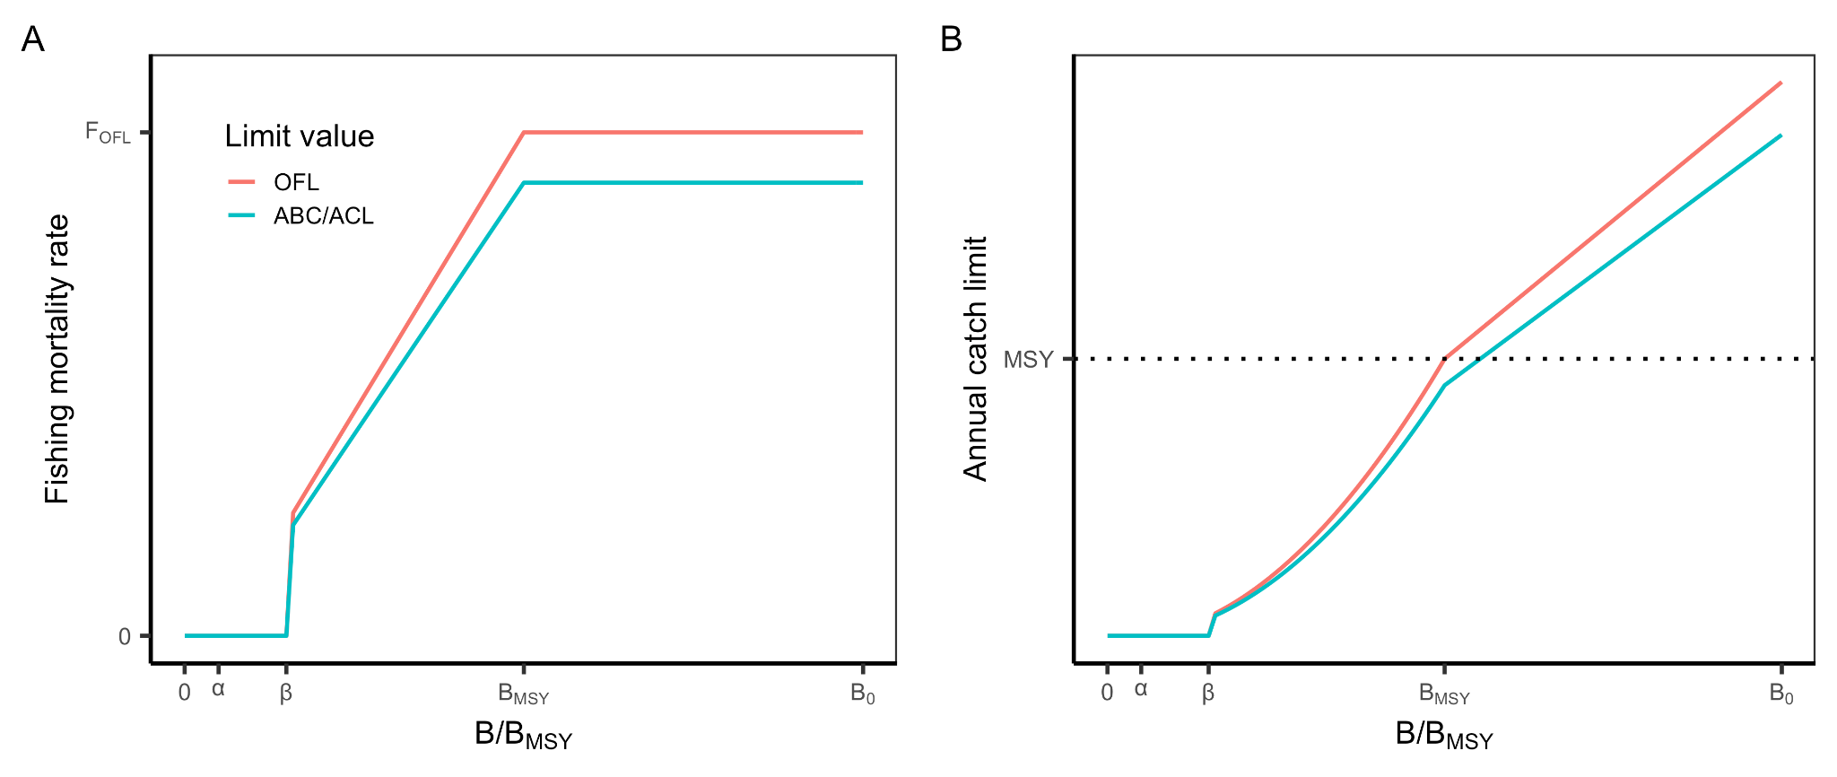

**Figure A13.** The harvest control rule for the NPFMC BSAI King and Tanner Crab FMP in terms of **(A)** fishing mortality rate (F) and **(B)** catch. FABC <= 90% of FOFL. FOFL = FMSY and FABC = FACL.

#### 7.3 Salmon

The NPFMC Salmon FMP was implemented in 1979 and was comprehensively revised in 1990 and again in 2011. The NPFMC delegates the regulatory authority for implementing the FMP to the Alaska Department of Fish and Game. The FMP manages North Pacific salmon stocks falling into three tiers (**Table A18**). Chinook salmon managed under the Pacific Salmon Treaty represent Tier 1. Although they are exempt from the MSA ACL requirement since they are managed under an international agreement, they set ACLs based on a monitored abundance index that results in an **empirical downward sloping harvest control rule.** Tier 2 and 3 stocks are managed using a **constant escapement harvest control rule**.

**Table A18.** Harvest control rules for NPFMC salmon stocks.

|  |  |  |
| --- | --- | --- |
| Tier | Stocks | Harvest control rule |
| Tier 1 | Chinook salmon managed under Pacific Salmon Treaty | Exempt from ACL requirement because managed under international agreement; however, a segmented linear relationship is used |
| Tier 2 | Coho salmon managed by the ADFG | Constant escapement |
| Tier 3 | Coho, pink, chum, and sockeye salmon managed as mixed-species complexes by the ADFG | Constant escapement |

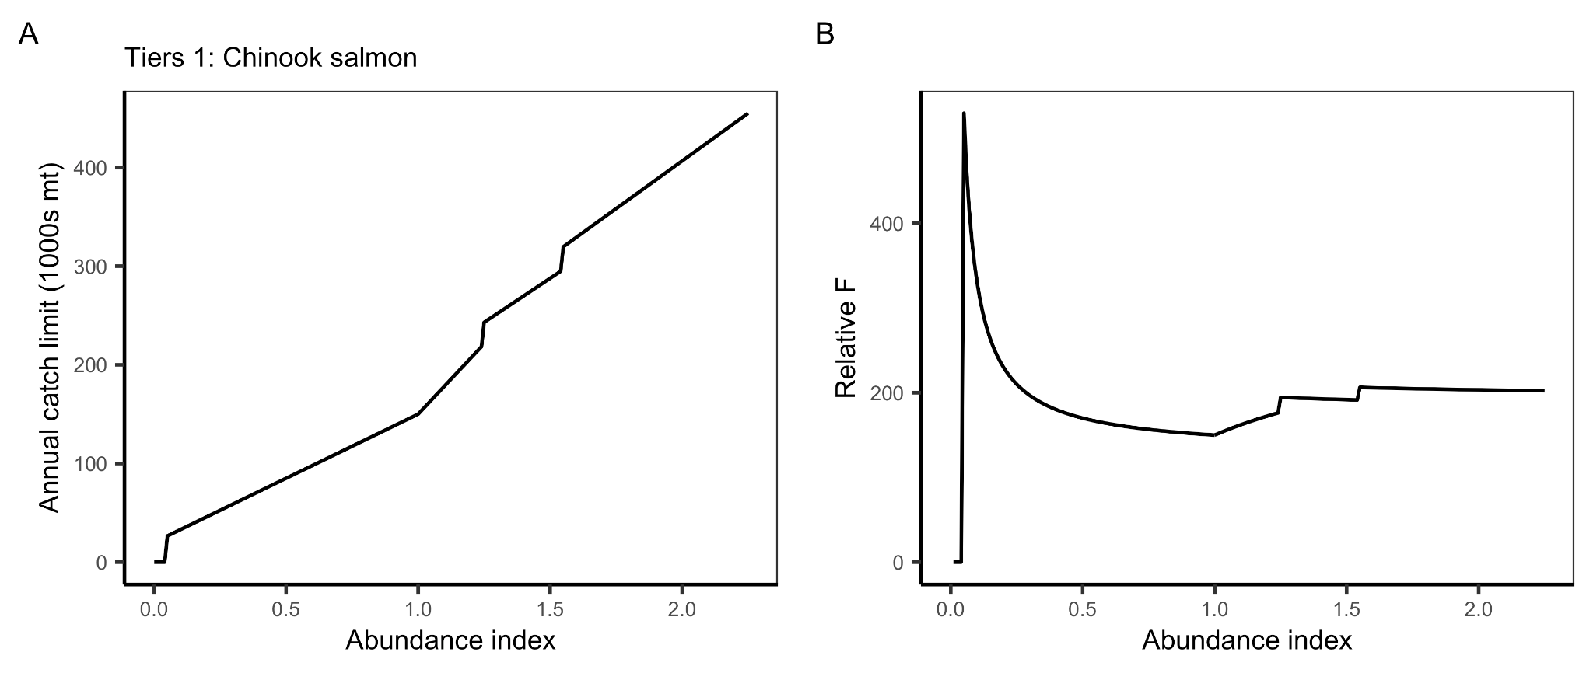**Figure A14.** The harvest control rule for Tier 1 salmon stocks in terms of **(A)** catch and (B) relative fishing mortality rate (catch / abundance index).

#### **Figure A15.** The harvest control rule for Tier 2 and 3 salmon stocks in terms of **(A)** fishing mortality rate (F) and **(B)** catch. In this example, escapement is set equal to BMSY.

#### 7.4 Scallop

The NPFMC Scallop FMP was implemented in 1995 and governs the management of scallop fisheries in nine management zones (scallop registration areas) off the coast of Alaska. The FMP covers weathervane scallops (*Patinopecten caurinus*), which are targeted in the fishery, and other scallop species that are not targeted. The FMP employs a **constant F harvest control rule** when an estimate of biomass is available. If no biomass estimate is available, then it is managed using a **constant catch rule** (OFL = 1.284 million lbs; ABC = 90% of the OFL). The FOFL is calculated using a natural mortality (M) estimate of 0.13/yr as an FOFL proxy. FABC is 90% of the FOFL.

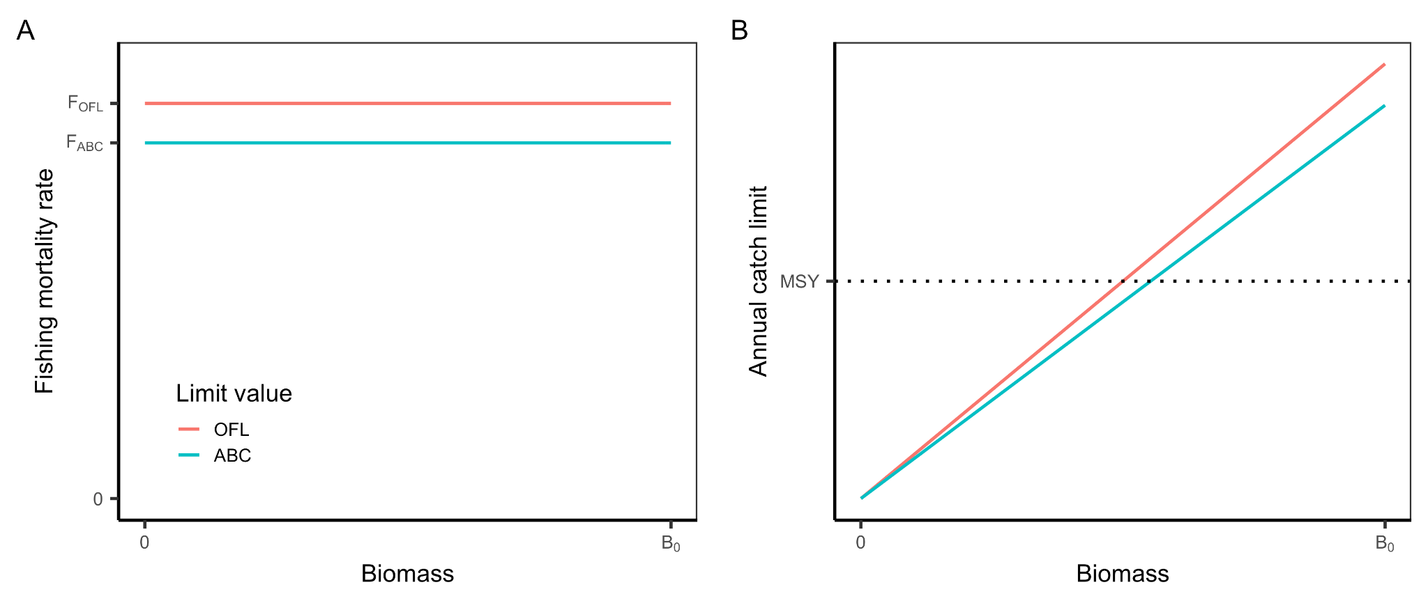

#### **Figure A16.** The harvest control rule for NPFMC scallops.

#### 

#### 7.5 Arctic Fish Resources

There are no fisheries currently authorized to operate in the Arctic; however, the FMP specifies rules for if and when commercial fisheries are authorized. The FMP species OFL and ABC values for finfish using a five-tier system and for crabs using a four-tier system.

**Table A18.** Finfish tiers.

|  |  |  |
| --- | --- | --- |
| **Tier** | **Data availability** | **Category** |
| 1 | B, BMSY, FMSY | Ramped w/ biomass cutoff |
| 2 | B, BMSY, FMSY, F35%, F45% | Ramped w/ biomass cutoff |
| 3 | B, B40%, F35%, F40% | Ramped w/ biomass cutoff |
| 4 | B, F35%, F40% | Constant |
| 5 | B, M | Constant |



**Figure A17.** Harvest control rule for Tier 1, 2, and 3 finfish stocks in the Arctic Fish Resources FMP. For Tier 4 stocks, FOFL = F35% and FABC ≤ F40%. For Tier 5 stocks, FOFL = M (natural mortality) and FABC ≤ 0.74*M.



**Figure A18.** Harvest control rule for Tier 4 and 5 finfish stocks in the Arctic Fish Resources FMP. For Tier 4 stocks, FOFL = F35% and FABC ≤ F40%. For Tier 5 stocks, FOFL = M (natural mortality) and FABC ≤ 0.74*M.

**Table A19.** Crab tiers.

|  |  |  |
| --- | --- | --- |
| **Tier** | **Data availability** | **Category** |
| 1 | B, BMSY, FMSY w/ uncertainty | Ramped w/ biomass cutoff |
| 2 | B, BMSY, FMSY | Ramped w/ biomass cutoff |
| 3 | B, B35%, F35% | Ramped w/ biomass cutoff |
| 4 | B, BMSY, M | Ramped w/ biomass cutoff |



**Figure A19.** Harvest control rule for crab stocks in the Arctic Fish Resources FMP.

### 8. Western Pacific (WPFMC)

The WPFMC replaced its five species-based Fishery Management Plans (FMPs) with five place-based Fishery Ecosystem Plans (FEPs) in 2009. These FEPs comprise plans for the following ecosystems: American Samoa Archipelago, Hawaii Archipelago, Mariana Archipelago, Pacific Pelagic Fisheries of the Western Pacific Region, Pacific Remote Island Areas.

The WPFMC employs the same multi-level approach for specifying ABC control rules for all of the stocks that it manages (**Table A20**). The five levels, referred to as tiers, vary based on the magnitude of stock assessment uncertainty. The SSC determines which type is appropriate for each stock. Stocks in Tiers 1-4 are managed using a **constant F harvest control rule** with increasing precautionary buffers between the OFL and ABC. Stocks in Tier 5 lack estimates of biomass and are managed using a catch-based harvest control rule.

The WPFMC has designed two procedures for reducing the ABC to an ACL based on management uncertainty. In order of decreasing data requirements, the methods for calculating the magnitude of the buffer are: (1) a comprehensive Social, Economic, Ecological, and Management (SEEM) analysis that accounts for objectives beyond accounting for management uncertainty; and (2) an expert-based analysis that considers only management uncertainty. The ACL may additionally be reduced to an ACT.

**Table A20.** ABC control rule categories and specifications by tier of data availability.

|  |  |  |  |
| --- | --- | --- | --- |
| **Tier** | **Data availability** | **ABC control rule** | **Stocks** |
| 1 | OFL and uncertainty from traditional assessment model and are reliable | **Constant F:** ABC = percentile of OFL posterior (P*) | MHI Deep 7 BF, Uku |
| 2 | OFL and uncertainty from traditional assessment model but are unreliable | **Constant F:** ABC = percentile of OFL posterior (P*) | Kona Crab, Territorial BF |
| 3 | OFL and uncertainty from DCAC and are not reliable | **Constant F:** ABC = percentile of OFL posterior (P*) |  |
| 4 | OFL and uncertainty are unknown; MSY is known but there is no fishery | **Constant F:** FABC = 0.70 * FMSY (91% of MSY) | Precious Corals, Deepwater Shrimp |
| 5 | OFL and uncertainty and MSY are unknown; but catch data are available | **Catch-based:** ABC = scalar * median catch  (scalar = 1.00, 0.67, 0.33 for under, fully, overexploited stocks, respectively) |  |

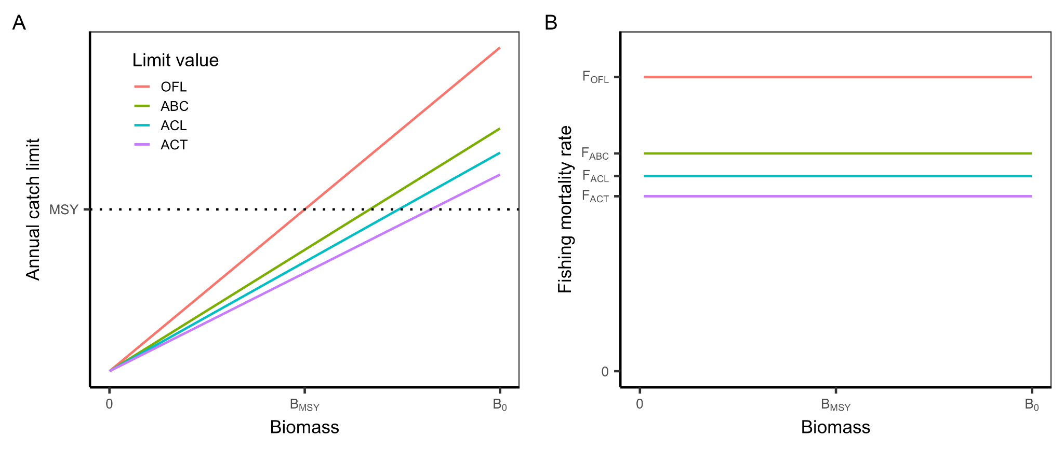

**Figure A20.** The harvest control rule used in all of the WPFMC FEPs in terms of **(A)** fishing mortality rate (F) and **(B)** catch.

### 

### 9. Highly Migratory Species

#### 9.1 Atlantic

The Atlantic Highly Migratory Species (HMS) FMP was implemented in 2006 and governs the management of highly migratory species. Many of the stocks and stock complexes are governed under additional international agreements and are therefore **exempt from the annual catch requirement**. Annual catch limits, if they are used, are set through a process that we do not document here. Others are managed using a **constant F harvest control rule** with precautionary buffers of various sizes.

#### 9.2 Pacific

The Pacific Highly Migratory Species (HMS) FMP was implemented in 2003 and governs the management of highly migratory species. These species are governed under additional international agreements and are therefore **exempt from the annual catch requirement**. Annual catch limits, if they are used, are set through a process that we do not document here.