Introduction
We review all of the stock assessments conducted for U.S. marine mammals from 1994 to 2024 and evaluate trends in the number of stocks, their population size, interactions with fisheries, and status. We also characterize the type and quality of the most recent (2024) assessments and their alignment with the MMPA and official NOAA guidance.
- What is the current status of marine mammal populations and how has status changed over the past 30 years (MMPA status, Strategic status, number of whales over time, number of S/MI over time)?
- What is the current status of marine mammal stock assessments?
  - What type of methods are used? How many assessment models?
  - How regularly are they updated?
  - How frequently do they use default R_{MAX} methods?
  - How much abundance data is there?
- What are the biases of the assessments in terms of precaution?
  - Does PBR rise as fast as N_{EST}/N_{MIN}?
  - Is F_{R} selected reasonably?
  - Is the default less than or more than other info available?
- To what extent are they aligned with the MMPA and GAMMS?

Methods
This allowed us to assess the status of U.S. marine mammal stock assessment methods against the best practices identified by Hammond et al. (2021).
For the R_{MAX} sensitivity analysis, we only evaluated the XX stocks assessed using their default R_{MAX} value (Fig. X) as we assume that the non-default R_{MAX} values for the remaining stocks are unbiased and based on the best information available.
Model-bases assessment discussion
Before the adoption of the 1994 Amendments, 12 of 153 stocks (8%) were assessed against an MPNL (Taylor et al., 2000).

Results
The R_{MAX} is central to setting the PBR, which is the mortality reference point used to determine whether a stock is strategic or non-strategic. However, we found that the 2024 status determinations are minimally sensitive to the choice of R_{MAX}. The perceptions of risk of fisheries to dolphin and porpoises stocks was reduced when RMAX was increased to XX. The perceptions of risk to large whales increased when RMAX was reduced to XXX. The perceptions of risk to the remaining groups were insensitive to the choice of RMAX.

Values of non-ESA-listed species
Hooded seal value of 0.75 from 208 forward is incorrect and should be changed to 1.0 – I might have done this??? Check, I don’t remember.
0.7 and 0.3 values: Harbor seals in Alaska
Marine mammal stocks such as the harbor seal stocks in Alaska that are taken by subsistence hunting may be given FR values up to 1.0, provided they are “known to be increasing” or “not known to be decreasing” and “there have not been recent increases in the levels of takes” (NMFS 2016). For harbor seals in Alaska, these guidelines were followed by assigning all harbor seal stocks an initial, default recovery factor of 0.5. The default value was adjusted up to 0.7 if the estimated probability of decrease was less than 0.3. The value was adjusted down to 0.3 if the estimated probability of decrease was greater than 0.7.
0.44 value: Hawaii Pelagic false killer whale
An intermediate value of the recovery factor was chosen to reflect different levels of uncertainty around mortality and serious injury estimates across the assessment area. Outside of the EEZ, there is significant uncertainty in the magnitude of mortality and serious injury in foreign longline fleets operating within the assessment area, as there are presently no mortality and serious injury estimates for any foreign fleet. Therefore, a recovery factor of 0.4 is appropriate in this portion of the assessment area given the unknown status of the stock and the unknown total mortality and serious injury rate (NMFS 2023a). However, within the EEZ portion of the assessment area, the mortality and serious injury CV is less than 0.3 so a recovery factor of 0.5 is appropriate (NMFS 2023a). Taken together, a final prorated recovery factor was calculated based on the proportion of total stock abundance inside and outside the EEZ, resulting in a final recovery factor of 0.44 for the stock.

The rarity of model-based assessment and MNPL estimation
Adopting more model-based stock assessments would be very useful in U.S. marine mammal stock assessment. Currently, a model-based assessment is used for only a single stock (California sea lion) and thus this is the only stock with a abundance status determination based on MNPL. This is actually a reduction in use as Taylor et al. 2000 report that 12 (8%) of stocks had an MNP after the first 22 years of the MMPA. A lot of studies say that MNPL isn’t that useful of a reference point because its reactive and not proactive and that the establishment of the PBR as a mortality reference point in 1994 and its widespread use has been sufficient. Although the PBR has certainly been a great thing, abundance based reference points are still valuable because they robustly demonstrate the need for greater or less precaution. The use of model-based assessments could more definitely define population status, which ensures that TRTs are only triggered when necessary. Importantly, it would allow for the establishment of more accurate Recovery Factors, where lightly depleted stocks get the high R_{F} values they deserve and highly depleted get the low R_{F} values they deserve.

The benefits of model-based assessment beyond MNPL estimation
There are many other benefits to model-based assessment beyond MNPL estimation and empirical/robust status determinations. Model-based assessments can avoid ecologically unrealistic jumps in design-based abundance estimates because it is governed by underlying growth mechanisms (however, conversely, it might not be large declines in abundance that can’t be explained by existing human-caused mortality information). Model-based assessments empirically estimate R_{MAX}, which allows this parameter to be stock-specific rather than relying on default priors. This can lead to more accurate and unbiased PBR estimates. Furthermore, the empirically estimates of these values can be used to support other data-poor, taxonomically related stocks. Finally, use of a population dynamics model estimates abundance in between years with surveys and design-based estimates, which can support more robust assessments of population trend. Trend information is missing for many stocks (X% in 2024; high rates in many other years) but is actually used in several places in the management process: X-Y-Z.

The benefits of model-based assessment to fishermen
Ultimately, the nt effect of adopting more model-based assessments would benefit fishermen by resulting in higher recovery factors. Currently, the adoption of 1.0 recovery factors is very rare, because the status of stocks is unknown. The use of model-based assessments to determine status would thus flip many stocks from unknown to good status, since stocks are generally believed to have recovered. This switch is highly impactful on the PBR: a switch from 0.5 to 1.0 would double the PBR. The impact of model-based assessments on the other components of the PBR equation, R_{MAX} and N_{MIN}, is unlikely change by as much. N_{MIN} is highly informed by the design-based estimate and R_{MAX} is constrained by the ecology of the species and by priors on the value. Our thought experiment shows that changing the R_{F} from 0.5 to 1.0 would reduce the number of strategic stocks from XX to XX, dramatically changing the perception of the impact of fisheries on marine mammals and the constraints on fisheries as a result of this perception.

The data and methods exist for model-based assessment
The data and methods exist for model-based stock assessment to be more widely used. First, we found that many species have time series of estimated abundance longer than X years, which could be sufficient to support good model-based assessments. Second, there are many examples of model-based assessments in the academic literature that could be readily transferred into operational assessments. A common argument against the practicality of model-based assessments is that it is very difficult to estimate the shape parameter (z) that determines the percentage of the carrying capacity at which productivity is maximized. This is correct but is not overcomeable. The IWC, for example, fixes the shape parameter at 60% for all of it stock assessments. The U.S. could adopt a single fixed value or could pioneer the use of taxa-specific fixed values based on reliable estimates of z (Kanaji). As time series grow and depleted stocks recover past their MNPL, these fixed values may be able to be replaced with informed priors and z can actually be estimated (longer time series won’t benefit already recovered stocks, as the estimation of z really depends on data when depleted).

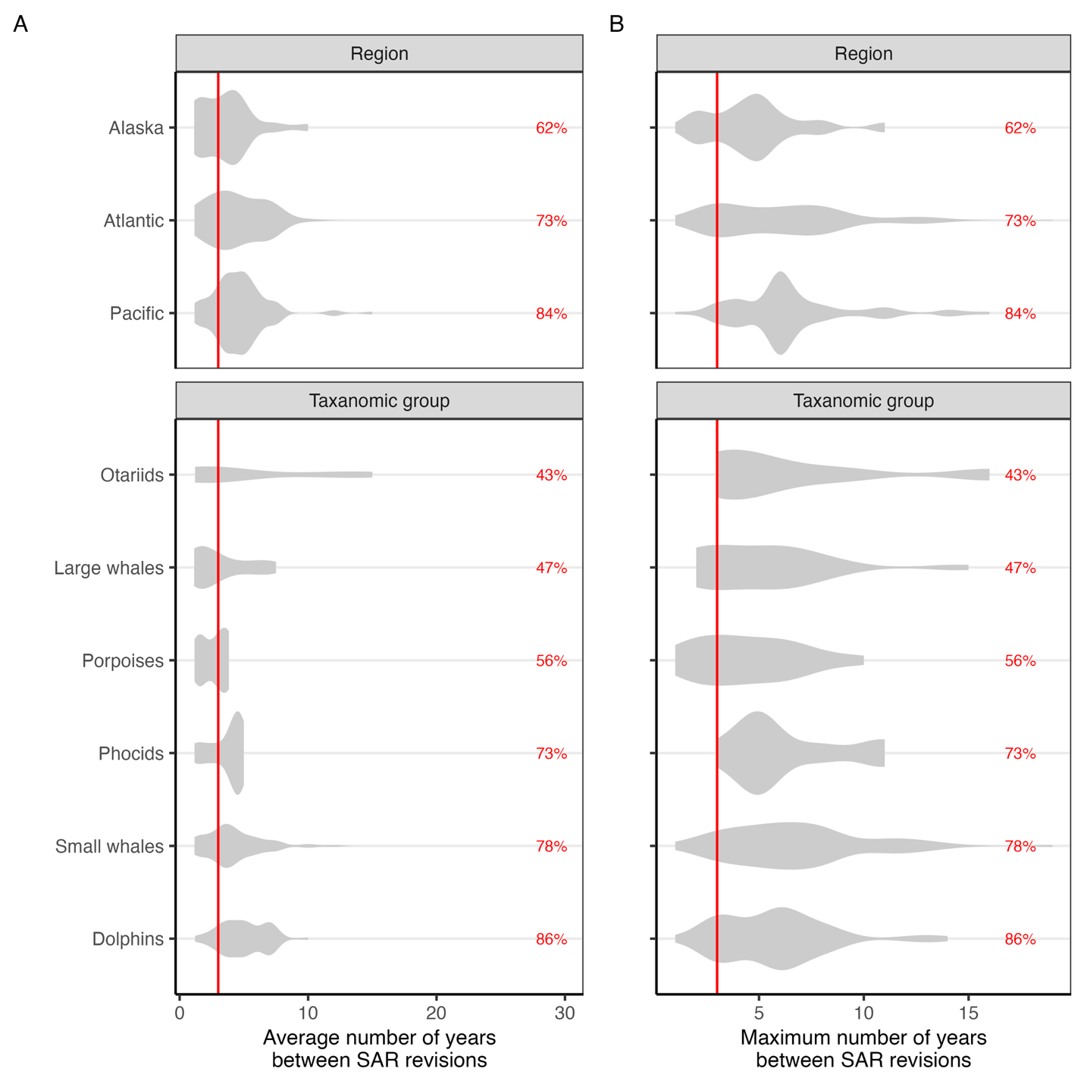Figure 3. The (A) average and (B) maximum number of years between Stock Assessment Report revisions by region (top) and taxonomic group (bottom). The Marine Mammal Protection Act requires that stocks are reviewed every 3 years (red vertical line); however, they only need to be revised if new information is available. The percent of stocks with revision periods exceeding the 3-year target is provided for each category.

