Our new multi-agency, open-access @FishandFisheries paper synthesizes impacts of the 2014-2016 NE Pacific heatwave on US and Canada West Coast fisheries and extracts lessons for building climate-resilient fisheries: <https://onlinelibrary.wiley.com/doi/10.1111/faf.12753>

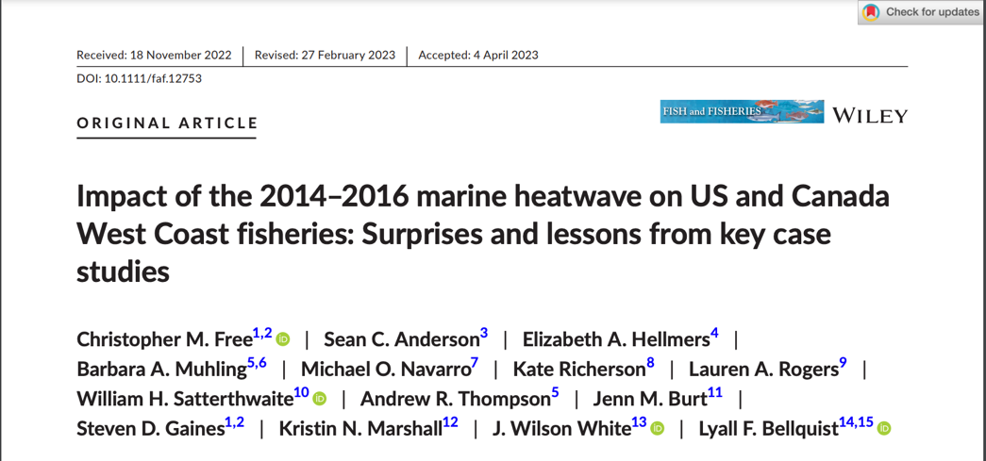

The 2014-16 NE Pacific heatwave was the largest on record: it lasted >700 days, spanned >2.5 million sqkm, and temperatures were, on average, >2.0°C above the long-term mean. It put fisheries management through a "stress test” that exposed both vulnerabilities & resilience (2/9).

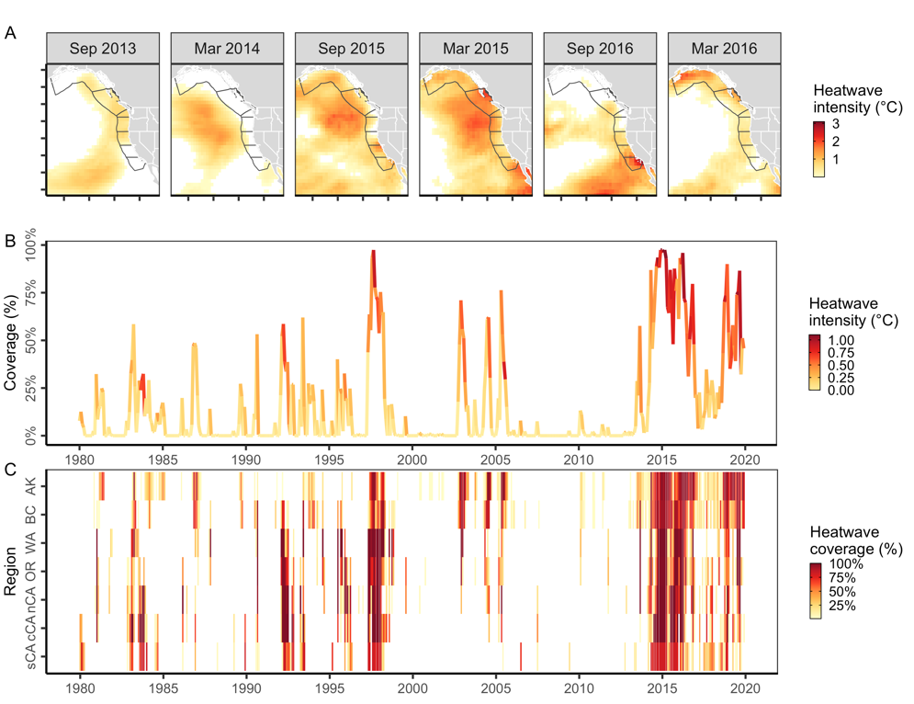

The heatwave led to large revenue losses and federal fisheries disaster declarations, especially in Washington salmon fisheries and the California Dungeness crab fishery (3/9).

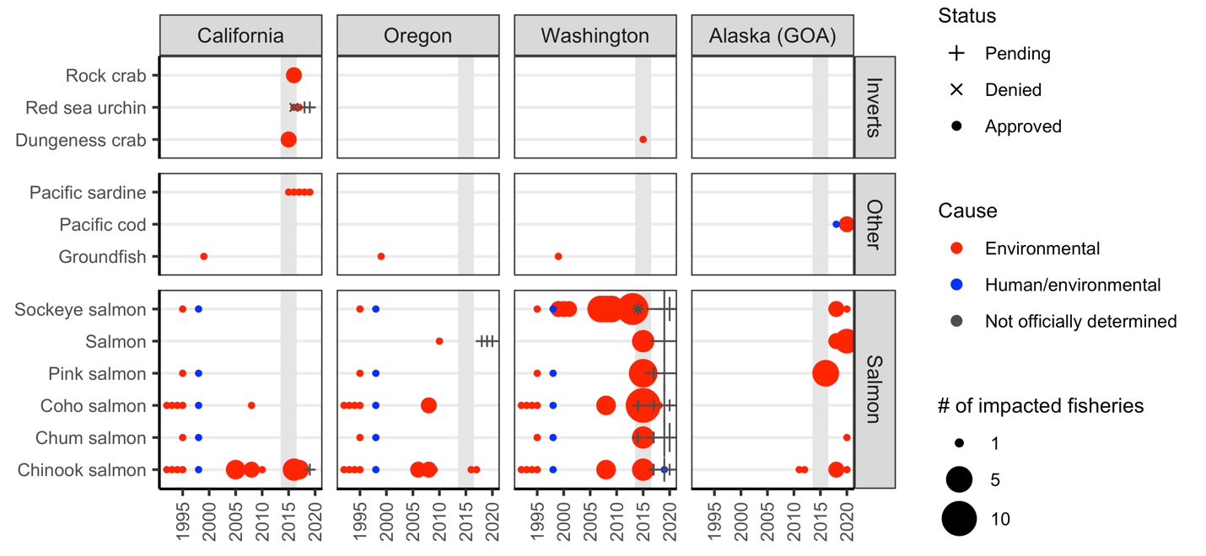

However, it also coincided with large increases in shrimp, bivalves, and flatfish revenues along much of the US and Canada west coast (4/9).

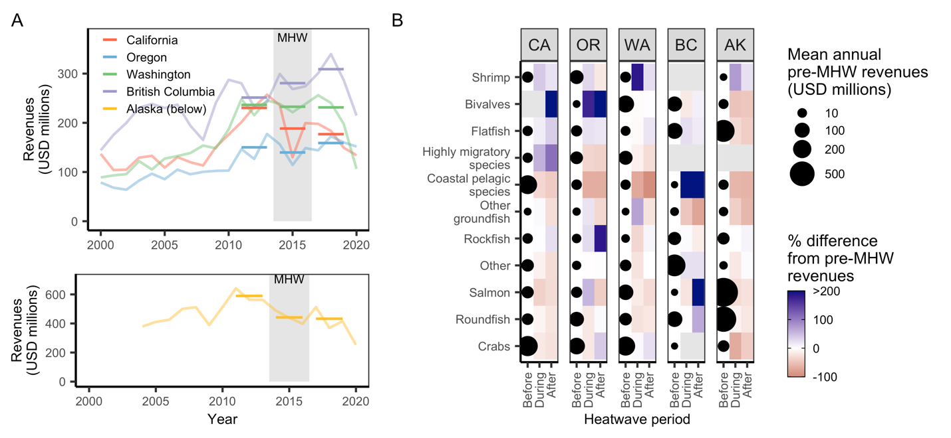

In our paper, we examine 10 case studies that provide instructive examples of the complex and surprising challenges that heatwaves pose to fisheries social-ecological systems. These challenges arise from both negative and positive ecological impacts (5/9).

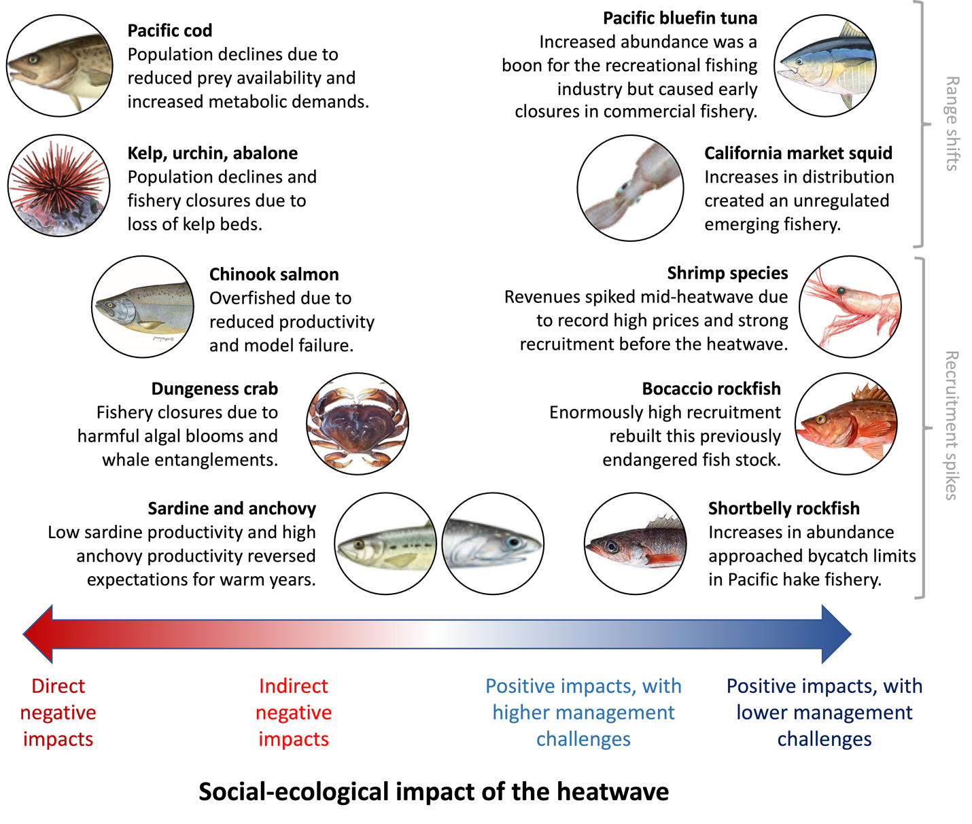

Dive in to learn more about how an explosion of shortbelly rockfish nearly closed the Pacific hake fishery, how a large harmful algal bloom and spike in whale entanglements has challenged the Dungeness crab fishery, how an explosion of bluefin tuna ignited the recreational fishing industry and more (6/9)!

Improved resilience to heatwaves & climate change will require: (1) expanding monitoring to enhance mechanistic understanding, provide early warning signals, and improve predictions of impacts; (2) increasing the flexibility, adaptiveness, and inclusiveness of management; (7/9)

… (3) using simulation testing to help guide management decisions; and (4) enhancing the adaptive capacity of fishing communities by promoting engagement, flexibility, experimentation, and failsafes (8/9).

This multi-agency collaboration (@BrenUCSB, @NOAAFisheries, @CaliforniaDFW, @Conserve_CA) was possible b/c of incredible co-authors: @j_wilson_white, @satterwil, @knmarshall, @kate_richerson, @sean_anderson, @burt_jenn, @lauren_a_rogers, @NoaaAndrew, and many not on here (9/9)!