**Title: Methods for assessing and responding to bias and uncertainty in U.S. West Coast salmon abundance forecasts**

Authors: William. H. Satterthwaitea,*, Andrew Olaf Sheltonb

a Fisheries Ecology Division, Southwest Fisheries Science Center, National Marine Fisheries Service, National Oceanic and Atmospheric Administration, Santa Cruz, CA, USA

b Conservation Biology Division, Northwest Fisheries Science Center, National Marine Fisheries Service, National Oceanic and Atmospheric Administration, Seattle, WA, USA

*Corresponding author. 110 McAllister Way, Santa Cruz, California, USA, 95060. will.satterthwaite@noaa.gov

**Highlights**:

• Uncertainty in salmon abundance forecasts can be modeled based on past performance

• Bias corrections and/or buffers often bring forecasts closer to postseason estimates

• Buffers were predicted to reduce risks of under-escapement and overfished status

• Harvest reductions from buffers often smaller than recent management error overages

**Abstract:** We quantified the bias and accuracy of U.S. West Coast salmon abundance forecasts using lognormal distributions fitted to annual ratios between postseason abundance estimates and preseason forecasts, or constrained to assume unbiased forecasts. Accuracy was modest to low, with CVs exceeding 50% for 8/19 Chinook and 17/17 coho stocks. We evaluated the fitted median as a bias correction, and uncertainty buffers based on quantiles below the median. We tested whether retrospective application of bias corrections and/or buffers brought forecasts closer on average to postseason estimates; and performed retrospective and prospective analyses of consequences for stock status, harvest, and escapement for Sacramento River Fall Chinook (SRFC), a key fishery stock. Bias corrections and/or buffers improved most forecasts, with buffers providing improvement more often. For SRFC, bias correction alone could have led to one less year of overfished status, while buffers could have further shortened or avoided overfished status and reduced the frequency of under-escapement. Reductions in mean annual harvest resulting from applying bias corrections and/or moderate buffers were predicted to be smaller than the increases in harvest resulting from forecast and implementation error. Prospective simulations showed buffers could reduce risks of overfished status and under-escapement, at small costs to long-term mean harvests. However, this metric misses substantial harvest reductions in some years, since mean harvest is most sensitive to harvest at high abundance; though our analyses also neglected benefits of increased escapement for future production. Future work should incorporate observation error and nonstationarity, and the combined effects of forecast and implementation error on the probability of missing escapement goals.

**Keywords**: Forecasting; bias; uncertainty; buffer; salmon

**1. Introduction**

Fisheries management for salmon in both the Atlantic (*Salmo salar*, ICES 2021) and Pacific (*Oncorhynchus* spp., Peterman et al. 2016, PFMC 2021a) relies on preseason abundance forecasts. Forecasting is known to be a challenging task (Mertz and Myers 1995, Glaser et al. 2014, Haltuch et al. 2019), especially for short-lived species like salmon (Ward et al. 2014, Peterman et al. 2016). The performance of particular forecast methodologies often worsens over time (Winship et al. 2015), leading to calls for the development of salmon management frameworks that are robust to forecasting uncertainty (ICES 2021, Wainwright 2021).

Different salmon species and populations vary substantially in how thoroughly, if at all, uncertainty is accounted for in the management of fisheries impacts. Well-developed examples include European Atlantic salmon (*Salmo salar*, ICES 2021), Fraser River sockeye salmon (*O. nerka*, Michielsen and Cave 2019, Hawkshaw et al. 2020), and Yukon River Chinook salmon (*O. tshawytscha*, Staton and Catalano 2019, Brenner et al. 2022). Approaches incorporating uncertainty have also been proposed for specific populations of other species including pink salmon (*O. gorbuscha*, Adkison 2002) and coho salmon (*O. kisutch*, DeFilippo et al. 2021). Often, this is done using a Bayesian approach producing explicit probability distributions for expected run sizes. In most cases, these approaches have leveraged the ability to perform in-season updating based on information gained over the course of a run in terminal area fisheries (i.e. in-river, or in the ocean area immediately outside a river at the expected time of spawner return). Such in-season information gathering and responses are more difficult in mixed-stock ocean fisheries that are substantially spread out in time and space. Partially as a result of such difficulties, management of ocean fisheries on Chinook and coho salmon along the west coasts of Canada and the United States uses deterministic forecasts that do not account for uncertainty (Peterman et al. 2016, PFMC 2021a), and this is often true of terminal fisheries management as well.

Ocean fisheries for Chinook and coho salmon along the west coast of the United States are managed under the purview of the Pacific Fishery Management Council (PFMC 2021a). Each year, maximum allowable exploitation rates for targeted stocks are determined by applying control rules to preseason forecasts of abundance (generally expressed as expected spawning escapement in the absence of fishing), using deterministic point estimates. Forecasts that are too high may result in inappropriately high exploitation rates, jeopardizing future productivity and fishing opportunities and creating conservation concerns. Conversely, forecasts that are too low may reduce harvest opportunities and thereby impose unnecessary costs on fishing communities. Forecast errors in either direction may cause especially complex problems in mixed-stock fisheries, where a missed-forecast for a single stock may lead to mis-specifying target harvest rates for a suite of co-occurring stocks (e.g., SMAW 2022).

The PFMC tracks forecast performance for key Chinook and coho salmon stocks by reporting preseason forecasts and postseason abundance estimates over time (PFMC 2022a), but does not quantify forecast performance with formal metrics, nor does it define acceptable forecast performance. As a pre-cursor to developing detailed new forecast methodologies for particular stocks, and to help prioritize such efforts, it is useful to provide an overview of forecast performance to date and to develop bias corrections and/or uncertainty buffers that could be applied to existing forecasts based on their past performance. Quantifying the amount of uncertainty, and potentially bias, associated with forecasts for particular stocks could also aid in prioritizing forecasts for in-depth review and revision.

Scientific advisors have long called for the PFMC to formally report and incorporate uncertainty in the use of preseason forecasts for salmon management (SSC 2002, Bradford 2006, Pawson 2006, SSC 2021a). However, the only incorporation of uncertainty or buffers into current PFMC salmon management is multiplying the reference point for the fishing mortality rate producing MSY, FMSY, by 0.95 (for stocks with data used to estimate stock-specific FMSY values) or 0.90 (for data-poor stocks using a proxy value) when determining the maximum allowable harvest rate at high abundance, FABC (PFMC 2021a). Because exploitation rates below FABC are required at low abundance in order to meet escapement goals even in the absence of forecast error, such buffers provide no protection against overharvest at low abundance, when the consequences of overharvest are likely most severe. While some methods adopted by the PFMC are capable of producing distributions for forecasts rather than point estimates (O’Farrell et al. 2016, DeFilippo et al. 2021), and a 95% prediction interval for SRFC was reported (but not used) in two years (PFMC 2010, 2011), to date only the medians or means of these distributions have been used.

The use of deterministic, point estimate forecasts to determine allowable harvest rates for salmon contrasts to the formal incorporation of uncertainty buffers into the use of assessment outputs in PFMC management of both groundfish (PFMC 2020) and coastal pelagic species (PFMC 2021b). Briefly, the ratio between the true and estimated overfishing limit (OFL) or maximum catch compatible with MSY is assumed to follow a lognormal distribution with median 1.0 and a log-scale standard deviation specified based on the form of the assessment model. The acceptable biological catch (ABC) is reduced from the OFL based on a buffer chosen as the P* quantile of the distribution of the modeled ratio between true and assessed OFLs (Ralston et al. 2011). If all model assumptions are met, P* indicates the probability that fishing at the ABC would result in catch higher than the OFL corresponding to perfect knowledge of the population. If salmon forecasts were viewed as distributions rather than point estimates, P* buffers (or similar approaches) could be derived before applying control rules to determine allowable exploitation rates (PFMC 2021a).

To demonstrate an approach that would allow fuller and more objective consideration of uncertainty in salmon management, this paper pursues four goals. First, to document the extent of uncertainty and bias, we quantified forecast performance for all available Chinook and coho salmon forecasts tracked in PFMC records (PFMC 2022a). Second, for all of these stocks, we assessed the biases and trends in forecast performance over time. Third, we quantified the extent to which bias corrections and/or uncertainty buffers could bring preseason forecasts closer to postseason abundance estimates. Fourth, the management consequences of a forecast can depend on more than accuracy alone (Rupp et al. 2012) due to factors including mixed-stock effects, implementation error (i.e., realized exploitation rates different from those projected by preseason planning models), and supplemental management guidance. Therefore, we performed detailed retrospective and prospective analyses of likely management consequences of bias corrections and/or buffers applied to a single stock of high conservation and fishery importance, Sacramento River Fall Chinook (SRFC).

**2. Methods**

*2.1 Data sources*

We obtained records of preseason forecasts and postseason abundance estimates for most PFMC-managed Chinook and coho salmon stocks from Tables II-4 (total adults), II-8 (April STT Modeled Forecast), II-9, III-1, III-3, and III-4 in Preseason Report 1 (PFMC 2022a), obtaining non-rounded values and year-specific values for early years from a spreadsheet version of the tables provided by Robin Ehlke, the PFMC salmon staff officer. We provide a full list of stocks analyzed, and the years covered, in Table 1. Data limitations or other issues led to the exclusion of a few stocks or years as described in the Supplementary Material.

The PFMC report tables do not include information for SRFC, for which a new forecast methodology was adopted in 2014 (PFMC 2022a). For SRFC, we obtained records of what the current forecast approach would have yielded based on data at the time if applied as far back as 1995 from validation exercises performed when the forecast method was developed (Winship et al. 2015, Model 8) along with recent records maintained by the PFMC but not presented in tabular form (PFMC 2022a Figure II-4).

Our analysis neglects the potential effects of past forecast methodology changes for stocks other than SRFC due to limited documentation of such changes (SSC 2021a), simply using the records of forecast performance as reported, and thus may not always reflect performance of the current forecast methods. Following precedent set by almost every salmon model used to inform PFMC management (but see Allen et al. 2017 and Auerbach et al. 2021 for partial exceptions), we did not attempt to address the effects of observation error on the postseason abundance estimate, nor on escapements, catches, or exploitation rates used in the SRFC case study described in more detail below.

*2.2 Quantification of forecast uncertainty and bias*

For each stock each year, we calculated the ratio *R* between the postseason abundance *Npost* and preseason forecasts *Npre*:

Equation 1

and assumed:

$loglog \left(R\right) \sim Normal\left(μ,σ\right)$ Equation 2

where $μ$ is the mean of log(*R*) (throughout this paper, “mean” denotes arithmetic mean unless specified otherwise, and logarithms are natural [base *e*]) and $σ$ is the log-scale standard deviation. In other words, we assumed that the ratio of postseason abundance estimates (which we assumed equaled true abundances) to preseason forecasts followed a lognormal distribution with arithmetic-scale median *C* where:

$C=e^{μ}$ Equation 3

with arithmetic-scale CV:

$CV=\sqrt{e^{σ^{2}}-1}$ Equation 4

We calculated 80% and 95% confidence intervals on *C*, the median postseason:preseason ratio, using the normal approximation:

${CI}_{80}=\left(e^{μ-1.28SE},e^{μ+1.28SE}\right);{CI}_{95}=\left(e^{μ-1.96SE},e^{μ+1.96SE}\right)$ Equation 5

where SE is the standard error ($\frac{σ}{\sqrt{Y}}$, with *Y* the number of years with observations). To identify scenarios in which bias could be confidently identified when present, we performed a power analysis by solving for the largest value of *C* at each sample size (number of years) where the upper bound of these confidence intervals first excluded 1.0 based on different values of $σ$.

For each stock, we performed these calculations for all available data (results denoted with the subscript “all”) and, when available, for the period 2001-2020 to provide for a common period of reference across stocks with different temporal coverage (denoted with subscript “20”). Although postseason estimates were available for 2021 for some stocks, 2020 was the most recent postseason abundance estimate available for others.

*2.3 Alternative quantification of uncertainty, assuming unbiased forecasts*

Because of the inherent challenges in accurately quantifying bias for noisy forecasts with modest sample sizes, we considered a method similar to the approach that the PFMC employs for groundfish and coastal pelagic species to quantify uncertainty in overfishing limits, which assumes that stock assessments are uncertain but unbiased. In this approach we assume that forecasts are unbiased and derive an alternative estimator $σ_{0}$ for the uncertainty based on log-scale standard deviations around E[log(*R*)]=0 rather than around $μ$,

$σ_{0}=\sqrt{\frac{\sum{}{loglog \left(R_{y}\right) }^{2}}{Y-1}}$ Equation 6

reflecting the alternative assumption:

$loglog \left(R\right) \sim Normal\left(0,σ_{0}\right)$ Equation 7

*2.4 Potential drivers of forecast performance*

To explore variation in forecast performance over time, we fit linear models of log(*R*) as a function of time, using all available years for each stock:

$loglog \left(R\right) =a+bY+ϵ$ Equation 8

where *Y* is year and $ϵ$ is a normally distributed error term. A similar model using the postseason abundance estimate as the predictor would not be appropriate for statistical inference, since postseason abundance also appears in log(*R*) and so would appear on both sides of the equation. However, to visualize relationships between forecast performance and abundance, we generated plots of percent error ([*N*pre-*N*post]/*N*post) as a function of the postseason abundance estimate and added loess smoothed fits with width of 1.5 fitted using the stat_smooth function in the ggplot2 R package (Wickham 2016).

*2.5 Derivation and evaluation of potential bias corrections and uncertainty buffers*

For all stocks with at least 18 years of reported forecast ratios, we simulated applying a bias correction factor by multiplying each years’ preseason forecast *Npre* by an estimate of *C* estimated from preceding forecast ratios, starting in year 11. Thus, we used a bias correction factor estimated from the first 10 years’ data to adjust the forecast in year 11, used the first 11 years’ data to adjust the forecast in year 12, and so on.   
 In addition to a bias correction based only on *C*, we explored the application of a buffer based on the P* quantile of the forecast ratio distribution estimated from preceding years. If all model assumptions (notably stationarity and the distributional form of annual forecast ratios) are met, P* represents the probability that the adjusted forecast in a given year will be an over-forecast. We explored P* values of 0.50 (i.e., a risk neutral approach), 0.45 and 0.40 (based on PFMC precedent for groundfish and coastal pelagic species), and 0.33 (the highest value that the Intergovernmental Panel on Climate Change [IPCC] characterizes as “unlikely” [Table 3 of Mastrandrea et al. 2010], and close to the 0.35 value that the PFMC has considered in some risk-averse options but not used to date [John Devore, PFMC, pers. comm.]). We also investigated the performance of a buffer that assumed unbiased forecasts, using the P* quantile of a lognormal distribution with median=1.0 and estimated stock-specific $σ_{0}$.

For each year, we then calculated the percent error (PE) between the raw forecast *Npre,raw*and the postseason abundance estimate *Npost*, as well as between the bias-adjusted forecast *Npre,adj* and *Npost*:

Equation 9

Under this definition, positive PE represents over-forecasting and negative PE represents under-forecasting. We then summarized performance across adjusted years using mean percent error (MPE) by taking a mean across adjusted years and mean absolute percent error (MAPE) by taking a mean across adjusted years of the absolute value of the annual PE. These are familiar metrics often used to evaluate bias (MPE) and accuracy (MAPE) of forecasts, but are more sensitive to over-forecasting than under-forecasting because forecast ratios tend to follow lognormal or at least asymmetric distributions and (assuming forecasts cannot be negative) PE can never be less than -100% but can be greater than 100%. Therefore, we also calculated the median log accuracy ratio (MLAR, Morley et al. 2018) which is equally sensitive to proportional over- versus under-forecasts (with positive MLAR indicating over-forecasting). Note that the sign conventions for assessing forecast error (values greater than zero indicate over-forecasting) differs from the interpretation of *C* (values less than zero indicate over-forecasting).

$MLAR=Median\left(loglog \left(\frac{N_{pre}}{N_{post}}\right) \right)$ Equation 10

We calculated these performance statistics for a one-year ahead validation exercise applied to each stock with at least 18 years of observations (to allow for at least 10 years of training data when the bias correction or buffer was first applied, and at least eight years of testing data). We also summarized the median forecast ratio and its 80% confidence interval calculated from the first 10 years of data to explore how well an initial assessment of forecast performance predicted the degree to which a bias correction and/or buffer increased or decreased forecast performance. The analysis of bias corrections and buffers excluded Skagit Hatchery Chinook, Columbia River Summer Chinook, Lower Columbia Natural coho, and Willapa Bay natural coho due to insufficient temporal coverage.

*2.6 Retrospective application of bias correction and/or buffers to SRFC*

To explore the potential management consequences of applying a bias correction and/or buffer, we performed a retrospective analysis of SRFC management performance. Because of its southerly distribution (Satterthwaite et al. 2013, Shelton et al. 2019), this stock is relatively unaffected by Pacific Salmon Treaty management, such that only PFMC management actions need to be carefully considered. SRFC makes up the majority of ocean harvest off of California (Satterthwaite et al. 2015) and often much of Oregon (Bellinger et al. 2015), and frequently experiences the highest ocean exploitation rate of any salmon stock managed by the PFMC (PFMC 2022a). SRFC was determined to be overfished based on the three-year geometric mean escapement from 2015-2017 being below the Minimum Stock Size Threshold (MSST) of 91,500 (O’Farrell and Satterthwaite 2021), then subsequently declared rebuilt based on the geometric men of escapements from 2018-2020 being above the reference point for spawning escapement producing maximum sustainable yield (SMSY) of 122,000 (PFMC 2022b). Additionally, SRFC serves as an indicator for the Central Valley Fall (and late-fall) Chinook salmon stock complex (PFMC 2021a) which is recognized by the National Marine Fisheries Service as a “species of concern” (https://www.st.nmfs.noaa.gov/data-and-tools/Salmon_CVA/pdf/Salmon_CVA_Name_Central_Valley_fall-late_fall-run_Chinook.pdf). Crucially, we know the history of the forecasts used in SRFC management and can generate retrospective estimates of what the current method (Winship et al. 2015, Model 8) would have forecasted in previous years based on data available at the time.

The retrospective analysis began with 2014, the first year that the current forecasting model was used by managers, and the third year (the window used for calculating status relative to the overfished criterion) since the first application of the current control rule. Each year, we determined the value of the SRFC forecast actually used, *Npre,rec* and the value the forecast would have taken if adjusted using one of the methods described earlier, with multipliers calculated using all years available at the time of the forecast in question. For these analyses, in addition to the P* values of 0.50, 0.45, 0.40, and 0.33 considered previously, we also tested P* values of 0.25 based on ICES (2021) guidelines calling for a 75% probability of meeting all conservation criteria and 0.10 based on the highest value that IPCC characterizes as “highly unlikely” (Mastrandrea et al. 2010).

The consequences for management depend on multiple steps after the forecast, and simply comparing control rule outputs for the raw and adjusted forecast would not capture this. We were interested in comparing the exploitation rates derived from the forecasts of record (*Frec*) with exploitation rates expected to have occurred based on adjusted forecasts (*Fadj*). When simulating adjusted forecasts, we needed to account for the effects of the control rule (*control*), supplemental guidance from the PFMC (*guidance*), mixed stock constraints on the exploitation rate planned for at the start of the fishing season (*plan*), and implementation error that leads to a realized exploitation rate different from the planned rate.

To generate an appropriate *Fadj*, we first applied the SRFC control rule (Figure 1, PFMC 2021a) to determine the allowable exploitation rate, *Fcontrol.* We then searched PFMC preseason planning records for additional SRFC-specific guidance (generally expressed as crafting fisheries to target an escapement goal above SMSY, see Supplementary Material) and determined the allowable exploitation rate *Fguidance* needed to accommodate the additional guidance (in the absence of additional guidance, *Fguidance*=*Fcontrol*). For example, for a target escapement *Eguidance*,

Equation 11

Note that Equation 11 neglects the effects of natural mortality or maturation rates, but this follows the convention in SRFC management models (O’Farrell et al. 2013). Note that blind application of Equation 11 regardless of how much a bias correction and/or buffer reduced a forecast could theoretically lead to *Fguidance*<0, so we constrained *Fguidance*≥0.

**Figure 1**. Control rule for SRFC. Hash marks denote forecasts of record during 2014-2021 (note two forecasts were very close together near 641 thousand). The shaded region indicates uncharted territory of the control rule, which has the steepest sections and allowable exploitation rates that have not been generated in practice as of 2021.

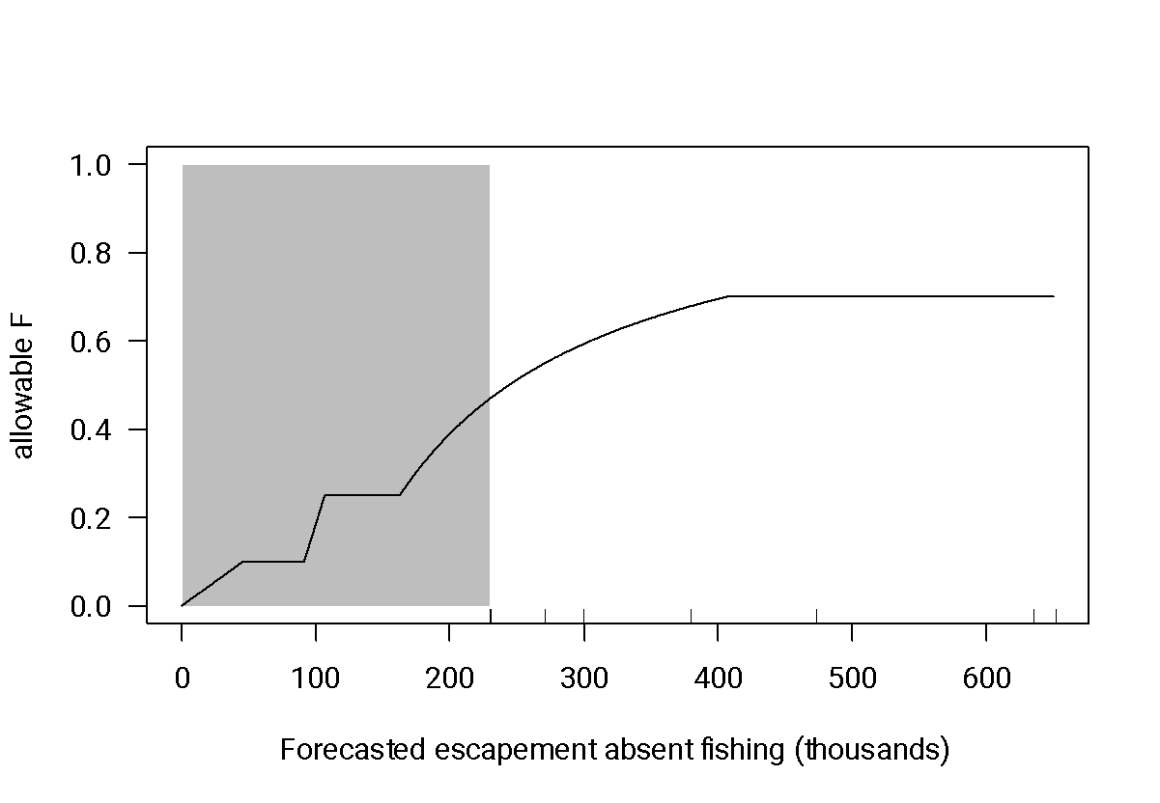

To account for mixed stock constraints (e.g., it may be impossible to plan a fishing season expected to achieve the full exploitation rate *Fguidance* on SRFC without being expected to exceed the allowable impacts on endangered Sacramento River Winter Chinook [O’Farrell and Satterthwaite 2015]), we then determined the exploitation rate that managers expected to achieve based on the regulations ultimately adopted, $F_{plan}^{*}$ from Table 5 of each year’s Preseason Report III. If $F_{plan}^{*}$ was less than *Fguidance* we set *Fplan*=; otherwise *Fplan*=*Fguidance*

Finally, we determined the historical exploitation rate *Frec* as the postseason estimate of the SRFC exploitation rate reported by the PFMC (2022a). We assumed that if the adjusted forecast would have led to a different planned exploitation rate, the same proportional implementation error would have occurred. Thus, we set the hypothetical alternative exploitation rate as:

$F_{adj}=F_{plan}\frac{F_{rec}}{F_{plan}^{*}}$ Equation 12

We then used *Npost* and *Fadj* to determine the harvest *H* and escapement *E* expected upon implementation of management based on the adjusted forecast,

$H_{adj}=F_{adj}N_{post}$ Equation 13

$E_{adj}=N_{post}-H_{adj}$ Equation 14

and compared these to the harvest and escapement estimates of record *Hrec* and *Erec* (Table II-1 of PFMC 2022a)

Finally, we calculated mean harvest across all years for the baseline and adjusted scenarios, tracked the frequency of escapements less than the SMSY (122,000) and MSST (91,500) reference points, and calculated status each year based on the geometric mean of escapements over the last three years. Following PFMC nomenclature, stock status was “OK” if it never became “overfished” and was classified as “overfished” if the three-year geometric mean escapement fell below the MSST. The stock remained overfished if the three-year geometric mean *E* was less than MSST, was “rebuilding” if the three-year geometric mean *E* was at or above MSST but below SMSY, and “rebuilt” if the three-year geometric mean *E* was at or above SMSY (PFMC 2021a).

To put differences in annual mean harvest among the different scenarios in context, we also calculated the mean annual harvest expected if the exploitation rates planned at the end of the preseason planning process ($F_{plan}^{*}$) had been implemented without error (so removing the effects of implementation error, but leaving effects of forecast error and mixed stock constraints on allowable harvest rates) or if exploitation rates corresponding to application of the control rule to the postseason abundance estimate had been applied without error in place of the forecast (so removing the effects of forecast error, implementation error, and mixed stock constraints).

*2.7 Simulated prospective application of bias correction and/or buffers to SRFC*

The retrospective exercise had the advantage of incorporating *ad hoc* PFMC guidance and mixed-stock constraints, but only explored a limited range of abundance forecasts – in particular, the 2014-2022 period did not include any instances where the unadjusted forecast was less than 229,432 or the allowable exploitation was less than 46% and therefore did not involve the complicated control rules that govern fishing at lower abundances (see shaded region in Figure 1) where the consequences of adjusting forecasts may be more pronounced.

To simulate application of bias corrections and buffers to management, we modified the closed loop simulation of SRFC developed for the SRFC Rebuilding Analysis (O’Farrell and Satterthwaite 2021). Under this approach, we simulated the pre-fishing abundance *Nsim* into the future based on autocorrelated draws from a lognormal distribution parameterized based on the postseason abundance estimates for SRFC from 1995-2022 (yielding arithmetic-scale mean 461 thousand fish, log-scale standard deviation 0.957, and log-scale autocorrelation 0.784). We simulated a biased, noisy forecast as

$N_{pre,sim}=N_{sim}e^{0.473-{5.49×{10}^{-7}N}_{sim}+ε}$ Equation 15

where

$ϵ\sim Normal\left(mean=0,SD=0.419\right)$ Equation 16

and *Npre,sim* is the simulated preseason forecast. Equations 15 and 16 were parameterized based on fitting a linear model of the log (preseason:postseason) forecast ratio as a function of the logged postseason abundance estimate to SRFC observations from 1995-2021 (Figure S.1 in the Supplementary Material). We included abundance as a predictor of forecast error because in 11 years with a postseason SRFC abundance estimate less than 500,000, there were nine cases of over-forecasting, some of which were substantial, compared to relatively small proportional under-forecasts in the remaining two years. To avoid extrapolating this relationship beyond the range of the input data, when *Nsim* was greater than the highest postseason estimate on record, we applied the multiplier corresponding to the maximum observed postseason abundance.

We then performed 2,000 replicate simulations of 25 years each, starting from conditions in 2021. For each simulated year, we determined a target exploitation rate based on applying the SRFC control rule to *Npre,sim* or *Npre,sim* after adjustment using each of the bias correction and/or buffers described previously (we did not simulate updating these values based on simulated data). To approximate mixed-stock constraints, we limited the target exploitation rate to be no higher than 0.60, based on a maximum preseason expected exploitation rate of 0.58 for 2014-2021. Following O’Farrell and Satterthwaite (2021), we modeled the achieved exploitation rate using a random draw from a beta distribution with mean equal to the target exploitation rate and a CV of 0.10. We then tracked the simulated harvest and escapement each year, and determined the mean annual probability of being in overfished status, frequency of allowable exploitation rates <0.25 or <0.10, mean and median annual SRFC harvest, frequency of escapement less than SMSY, and frequency of escapement less than MSST.

Although O’Farrell and Satterthwaite (2021) simulated observation error in escapements (but not harvests), they had no empirical basis for the value used. Since we were more interested in true stock status than estimated status, we ignored observation error. Note also that although the autocorrelated abundance was meant to capture some degree of biological realism relative to independent random draws, this analysis neglects the effects of escapement on future production (i.e., lacks a stock-recruit relationship) due to both natural production and the ability of hatcheries to meet their production goals.

*2.8 Data availability*

Compiled data, along with the code required to reproduce all results presented here, are available from Mendeley Data at <https://dx.doi.org/10.17632/pym9v82t7b.2>.

**3. Results**

Forecast performance was highly variable across years (Figure 2), and over-forecasting (i.e., postseason abundance estimate less than the preseason forecast) was more common than under-forecasting for 11 out of 19 Chinook stocks and 14 out of 17 coho stocks. Over-forecasting occurred more often, and to a greater proportional extent, at low abundance (Figure 3).

**Figure 2**. Box plots displaying the annual distribution of ratios between postseason abundance and preseason forecast. Values less than one (to the left of the dotted line) indicate over-forecasting. In box plots, the vertical lines are the medians (derived as the midpoint of an ordered list, and thus possibly divergent from *C* calculated assuming a lognormal distribution), boxes are the central quartiles (25%-75%), whiskers are ±1.5 interquartile range, and dots are individual observations more than 1.5 times the interquartile arrange beyond the median.

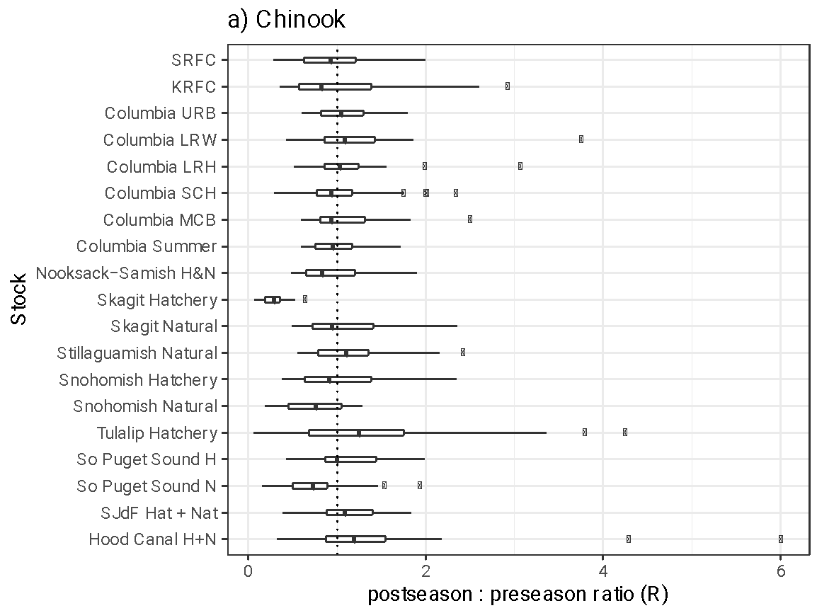

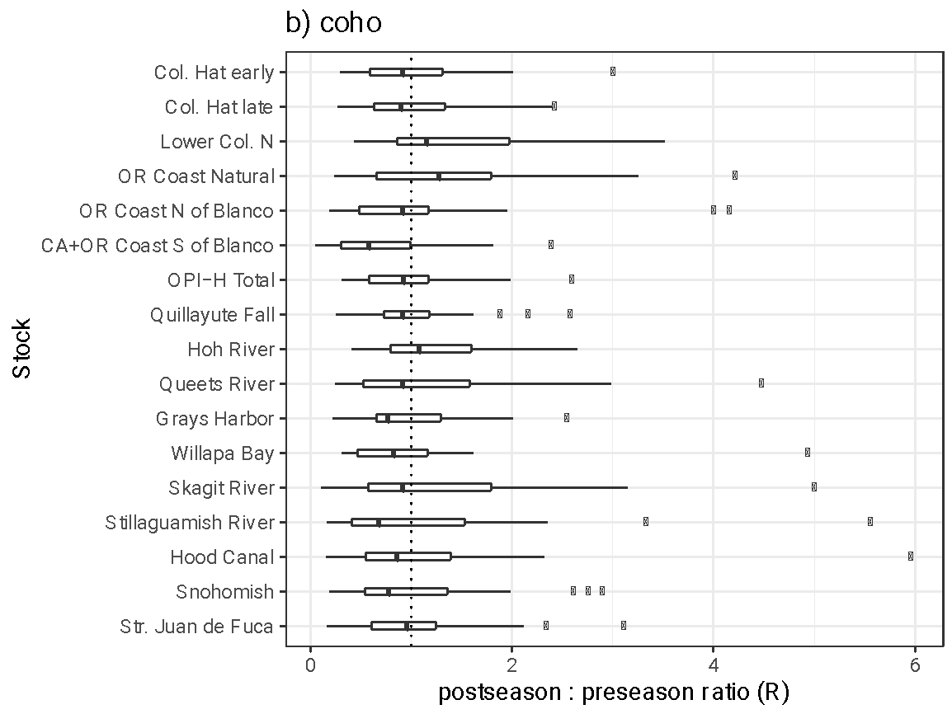

**Figure 3.** Relationship between postseason abundance and forecast error for each stock. The fitted curves are loess smoothed fits. Stocks are grouped by species and region, and distinguished by darkness (print version) or color (online) within each grouping. A small number of very large positive percent errors are outside of the plotted range, but included in calculation of the smoothed fits.

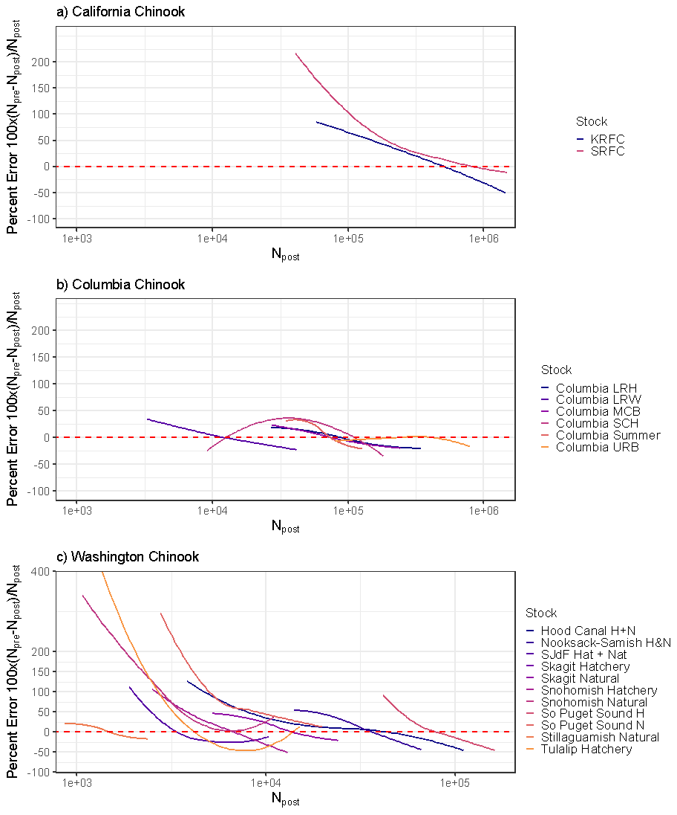

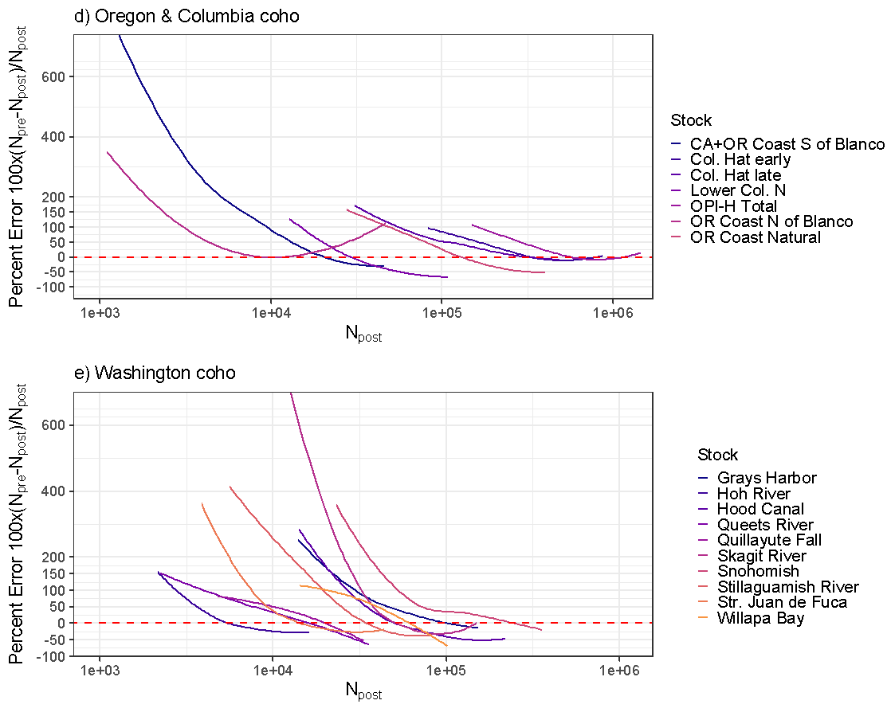

*3.1 Quantification of forecast uncertainty and bias*

When analyzing the full time period available for each stock, out of 19 Chinook stocks with adequate data, the point estimate of *C* indicated over-forecasting in nine cases, with the 80% confidence interval excluding a median ratio of 1.0 in five cases and the 95% confidence interval excluding it in three cases (Table 1). The point estimate of *C* indicated under-forecasting in ten cases, although the 80% confidence interval only excluded 1.0 in one of these cases, and the 95% confidence interval never excluded 1.0. For coho stocks, the point estimate of *C* indicated over-forecasting in 14 out of 17 stocks, with 80% confidence intervals excluding 1.0 in six cases and 95% confidence intervals excluding it in one case. For the three coho stocks where the point estimate indicated under-forecasting, 80% confidence intervals included 1.0 in two cases. The log-scale standard deviation ($σ$) ranged from 0.29 to 0.94 for Chinook salmon and 0.50 to 0.94 for coho. The quality of fit of the assumed lognormal distribution to yearly values varied substantially across stocks (Supplementary Figure S.2).

For just the common period 2001-2020 (Table S.1 in Supplementary Material), patterns were broadly similar, although some stocks had to be dropped from the analysis due to inadequate temporal coverage and confidence intervals generally widened due to the smaller sample sizes. The 80% confidence intervals on *C* for Snohomish Hatchery Chinook and Strait of Juan de Fuca coho in the recent dataset indicated over-forecasting despite including 1.0 for the longer dataset, while the 80% confidence intervals on *C* were entirely above 1.0 (but only by 0.0006 or 0.00005, respectively) indicating under-forecasting for Hood Canal Chinook and Strait of Juan de Fuca Chinook despite including 1.0 in the longer dataset. Otherwise results were broadly similar between the full dataset and recent period except that confidence intervals on *C* grew to include 1.0 for several stocks (Columbia Lower River Wild Chinook, Oregon Coast North of Cape Blanco coho, Oregon Production Index-Hatchery Total coho, Grays Harbor coho, Stillaguamish River coho, and Snohomish coho) where it was excluded in the full dataset.

**Table 1**. Summary of forecast performance (postseason abundance : preseason forecast ratio *C*) for all available years. Bold text denotes stocks where the 95% confidence interval on *C* excluded 1.0. Values of 1.00 are greater than 1.00 at full precision, values between 0.99 and 1.00 are repeated to a higher precision.

|  |  |  |  |  | post:pre ratio | |  |  |  |  |  |  |  |  |
| --- | --- | --- | --- | --- | --- | --- | --- | --- | --- | --- | --- | --- | --- | --- |
| Species | Stock | Year Range | | | *Call* | CVall | 80% CIall | | | 95% CIall | | |  |  |
| Chinook | SRFC | 1995 | - | 2021 | 0.89 | 51% | 0.79 | - | 0.998 | 0.74 | - | 1.06 | 0.49 | 0.50 |
| KRFC | 1985 | - | 2021 | 0.93 | 59% | 0.83 | - | 1.05 | 0.78 | - | 1.11 | 0.54 | 0.55 |
| Columbia URB | 1984 | - | 2021 | 1.06 | 29% | 0.997 | - | 1.12 | 0.97 | - | 1.16 | 0.29 | 0.29 |
| Columbia LRW | 1988 | - | 2021 | 1.11 | 44% | 1.01 | - | 1.22 | 0.97 | - | 1.28 | 0.42 | 0.43 |
| Columbia LRH | 1984 | - | 2021 | 1.04 | 36% | 0.97 | - | 1.12 | 0.93 | - | 1.16 | 0.35 | 0.35 |
| Columbia SCH | 1984 |  | 2021 | 0.96 | 47% | 0.88 |  | 1.05 | 0.83 |  | 1.10 | 0.44 | 0.44 |
| Columbia MCB | 1990 |  | 2021 | 1.02 | 35% | 0.94 |  | 1.10 | 0.90 |  | 1.15 | 0.34 | 0.34 |
| Columbia Summer | 2012 | - | 2021 | 0.95 | 34% | 0.83 | - | 1.08 | 0.77 | - | 1.16 | 0.33 | 0.33 |
| Nook.-Samish H&N | 1993 | - | 2020 | 0.89 | 42% | 0.81 | - | 0.98 | 0.77 | - | 1.03 | 0.40 | 0.42 |
| **Skagit Hatchery** | **2004** | **-** | **2020** | **0.25** | **72%** | **0.20** | **-** | **0.30** | **0.18** | **-** | **0.33** | **0.64** | **1.59** |
| Skagit Natural | 1993 | - | 2020 | 1.01 | 45% | 0.91 | - | 1.12 | 0.87 | - | 1.19 | 0.43 | 0.43 |
| Stillaguamish Natural | 1995 | - | 2020 | 1.09 | 41% | 0.99 | - | 1.20 | 0.94 | - | 1.27 | 0.40 | 0.41 |
| Snohomish Hatchery | 1994 | - | 2020 | 0.96 | 55% | 0.84 | - | 1.09 | 0.79 | - | 1.16 | 0.52 | 0.52 |
| **Snohomish Natural** | **1993** | **-** | **2020** | **0.65** | **61%** | **0.57** | **-** | **0.74** | **0.53** | **-** | **0.80** | **0.56** | **0.71** |
| Tulalip Hatchery | 1993 | - | 2020 | 1.06 | 119% | 0.84 | - | 1.33 | 0.75 | - | 1.50 | 0.94 | 0.94 |
| So Puget Sound H | 1993 | - | 2020 | 1.07 | 38% | 0.98 | - | 1.16 | 0.93 | - | 1.22 | 0.37 | 0.37 |
| **So Puget Sound N** | **1993** | **-** | **2020** | **0.68** | **63%** | **0.59** | **-** | **0.78** | **0.55** | **-** | **0.84** | **0.58** | **0.70** |
| Coho | SJdF Hat + Nat | 1993 | - | 2020 | 1.04 | 40% | 0.95 | - | 1.14 | 0.90 | - | 1.20 | 0.39 | 0.39 |
| Hood Canal H+N | 1994 | - | 2020 | 1.17 | 72% | 0.999 | - | 1.37 | 0.92 | - | 1.49 | 0.64 | 0.66 |
| Col. Hat early | 1996 | - | 2021 | 0.90 | 61% | 0.78 | - | 1.04 | 0.73 | - | 1.12 | 0.56 | 0.57 |
| Col. Hat late | 1996 | - | 2021 | 0.86 | 68% | 0.73 | - | 1.00 | 0.68 | - | 1.09 | 0.62 | 0.64 |
| Lower Col. N | 2007 | - | 2021 | 1.23 | 68% | 1.00 | - | 1.51 | 0.90 | - | 1.68 | 0.62 | 0.66 |
| OR Coast Natural | 1996 | - | 2021 | 1.11 | 85% | 0.92 | - | 1.34 | 0.84 | - | 1.48 | 0.74 | 0.75 |
| OR Coast N of Blanco | 1996 | - | 2021 | 0.80 | 98% | 0.65 | - | 0.99 | 0.59 | - | 1.10 | 0.82 | 0.85 |
| **CA+OR Co S of Blanco** | **1996** | **-** | **2021** | **0.54** | **118%** | **0.42** | **-** | **0.68** | **0.37** | **-** | **0.77** | **0.93** | **1.13** |
| OPI-H Total | 1996 | - | 2021 | 0.86 | 58% | 0.76 | - | 0.99 | 0.70 | - | 1.06 | 0.54 | 0.56 |
| Quillayute Fall | 1990 | - | 2020 | 0.92 | 53% | 0.82 | - | 1.04 | 0.78 | - | 1.10 | 0.50 | 0.50 |
| Hoh River | 1990 | - | 2020 | 1.10 | 55% | 0.97 | - | 1.23 | 0.91 | - | 1.31 | 0.51 | 0.52 |
| Queets River | 1990 | - | 2020 | 0.94 | 82% | 0.80 | - | 1.11 | 0.73 | - | 1.21 | 0.72 | 0.72 |
| Grays Harbor | 1990 | - | 2020 | 0.85 | 64% | 0.74 | - | 0.97 | 0.69 | - | 1.04 | 0.59 | 0.61 |
| Willapa Bay | 2010 | - | 2020 | 0.84 | 93% | 0.62 | - | 1.14 | 0.53 | - | 1.34 | 0.79 | 0.81 |
| Skagit River | 1997 | - | 2020 | 0.95 | 118% | 0.75 | - | 1.22 | 0.66 | - | 1.39 | 0.94 | 0.94 |
| Stillaguamish River | 1990 | - | 2020 | 0.76 | 118% | 0.61 | - | 0.94 | 0.55 | - | 1.05 | 0.93 | 0.97 |
| Hood Canal | 1990 | - | 2020 | 0.84 | 96% | 0.70 | - | 1.01 | 0.63 | - | 1.12 | 0.81 | 0.83 |

Power to confidently detect bias was limited (Figure 4) due to a combination of high inter-annual variability and modest sample sizes. With a typical $σ$ = 0.5, over-forecasting with *C* of 0.80 would require at least nine years of data for the 80% confidence interval to support this bias and at least 19 years for the 95% confidence interval to support it. For the typical 30-year dataset with $σ$ = 0.5, *C* would need to be less than 0.89 for support via the 80% confidence interval or less than 0.84 for the 95% confidence interval. For $σ$ = 1.0, even 50 years of data would not suffice for the 80% confidence interval to exclude 1.0 if *C* was greater than 0.83.

**Figure 4**. The maximum of the median ratio of postseason abundance : preseason forecast for which the 80% (solid lines) or 95% (dashed lines) confidence interval would exclude 1.0 given $σ$ = 0.3 (thick black lines), 0.5 (thin black lines) or 1.0 (thin grey lines) increases with increasing years of observations.

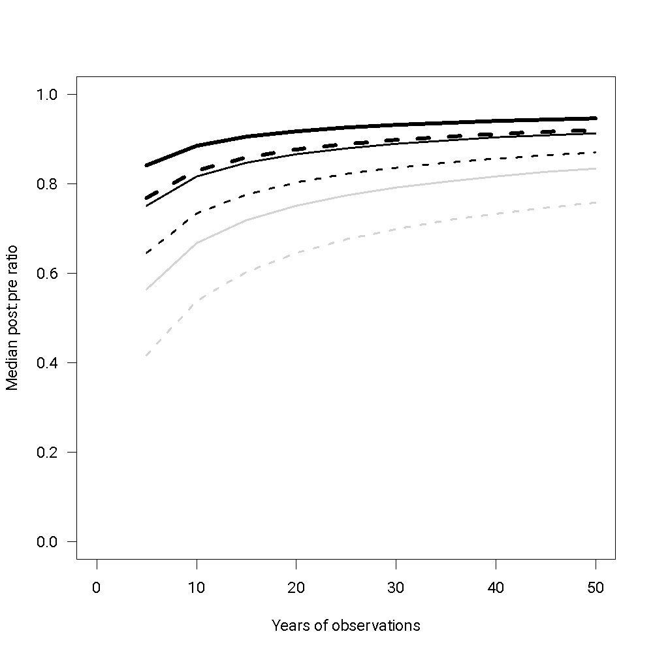

*3.2 Potential drivers of forecast performance*

Relationships between time and forecast performance (i.e., linear models of log(*R*) as a function of year) rarely met the p<0.05 criterion for statistical significance, but KRFC, Tulalip Hatchery Chinook, California/Oregon coho South of Cape Blanco, and Queets River coho showed a significant tendency toward increased incidence under-forecasting over time while Stillaguamish River coho showed a significant tendency toward increased incidence of over-forecasting (Figure S.3 , Table S.2 in Supplementary Material). Statistical considerations precluded simple regressions of forecast performance against postseason abundance estimates (because postseason abundance would occur on both sides of the regression equation), but Figure 3 strongly suggests a tendency to over-forecast at low abundance for most stocks.

*3.3 Alternative quantification of uncertainty, assuming unbiased forecasts*

Estimates of the log-scale standard deviation assuming unbiased forecasts ($σ_{0}$) were always larger than the corresponding $σ$ for each stock, with small differences for stocks with small estimated biases in their forecasts and larger differences when estimated biases were more substantial (Table 1 and Supplementary Table S.1).

*3.4 Evaluation of potential bias corrections and uncertainty buffers*

To give an indication of how well an initial estimate of *C* would predict the utility of bias corrections or buffers going forward, Table 2 reports the estimate of *C* and its 80% confidence interval based on the first decade available for each stock for which one-year-ahead application of potential bias corrections and/or buffers was performed, along with MPE in the raw forecasts or adjusted forecasts for each year in the testing dataset. Note that out of the nine stocks included in this table for which the 80% confidence interval on *C* for the full dataset indicated over-forecasting, three had estimates of *C* for the first ten years >1.0 (i.e., suggesting under-forecasting), and in a fourth case the 80% confidence interval included unbiased forecasts. Conversely, for both stocks where the 80% confidence intervals from the full dataset indicated under-forecasting, this was also the case for the point estimate from the first decade. Supplementary Table S.3.a reports performance of raw versus adjusted forecasts using MAPE, and Supplementary Table S.3.b reports performance measured via MLAR.

For all but three out of 32 cases, a buffer improved performance according to MPE, and more conservative buffers often performed better. For MPE raw forecasts performed best (had MPE closest to zero) in only two cases, both Chinook; and a bias correction without buffer (P*=0.50) performed best for one Chinook stock (Table 2). A bias correction plus P*=0.33 buffer performed best in 13 cases, P*=0.33 with no bias correction performed best in six cases, bias correction plus P*=0.40 performed best in five cases, P*=0.40 with no bias correction performed best in three cases, and P*=0.45 with no bias correction performed best in two cases (bias correction plus P*=0.45 never performed best by MPE). Note that within each selection regarding use of bias correction, P*=0.33 was the optimal buffer according to MPE most often and P*=0.45 was optimal least often.

Results for MAPE were broadly similar to results for MPE (Supplementary Table S.3.a), although application of a bias correction was favored less often (perhaps reflecting MPE’s greater sensitivity to bias). In some but not all cases where MAPE favored dropping the bias correction it also favored a more conservative (lower P*) buffer. Overall, MAPE favored P*=0.33 with no bias correction 13 times, P*=0.33 with a bias correction 11 times, P*=0.40 with no bias correction three times, P*=0.40 with a bias correction once, P*=0.45 with no bias correction twice, and raw forecasts twice. Results for MLAR diverged more substantially from the MPE and MAPE results and generally favored less precautionary approaches, which likely reflects the different sensitivities of mean versus median error (Supplementary Table S.3.b). Overall, MLAR favored raw forecasts in six cases, a bias correction with no buffer in four cases, P*=0.45 with no bias correction in six cases, P*=0.45 with a bias correction in four cases, P*=0.40 with no bias correction in one case, P*=0.40 with a bias correction in six cases, P*=0.33 with no bias correction in two cases, and P*=0.33 with a bias correction in three cases. There was no stock for which the raw forecast was identified as the best approach according to all three scoring metrics.

**Table 2**. Performance of raw or adjusted forecasts for the period after the first ten years as measured via Mean Percent Error (MPE. *C* is the median postseason:preseason ratio estimated for the first ten years of data. Start year indicates the beginning of the period over which performance was tested. Note that *C* estimates for the first decade were not always concurrent with the longer-term conclusions regarding bias. Bold text indicates the adjustment (or lack thereof) performing best (closest to zero error, regardless of sign) for each stock-performance metric combination. Italics in the bias corrected, no buffer (i.e., P*=0.50) column indicate cases where the bias-adjusted forecast outperformed the “raw” forecast receiving neither a bias correction nor a buffer. (Some cases appear to be ties at the precision reported in the table, but optimal choices were identified at full precision.)

| MPE |  | First Decade | | | |  |  | Apply bias correction | | | | Assume unbiased | | |
| --- | --- | --- | --- | --- | --- | --- | --- | --- | --- | --- | --- | --- | --- | --- |
| Sp. | Stock | *C* | 80% CI | | | Start | raw | no buffer | P=0.45 | P=0.40 | P=0.33 | P=0.45 | P=0.40 | P=0.33 |
| Chnk | SRFC | 1.08 | 0.97 | - | 1.22 | 2005 | 45% | *35%* | 28% | 21% | **12%** | 37% | 29% | 19% |
|  | KRFC | 1.03 | 0.78 | - | 1.35 | 1995 | 25% | 29% | 20% | 12% | **1%** | 16% | 8% | -3% |
|  | Columbia URB | 1.12 | 1.04 | - | 1.20 | 1994 | 1% | 12% | 9% | 5% | **0%** | -2% | -6% | -10% |
|  | Columbia LRW | 1.20 | 1.06 | - | 1.36 | 1998 | 2% | 20% | 15% | 9% | **1%** | -3% | -9% | -16% |
|  | Columbia LRH | 0.96 | 0.85 | - | 1.09 | 1994 | **-1%** | 6% | 2% | -3% | -9% | -5% | -9% | -15% |
|  | Columbia SCH | 1.05 | 0.92 | - | 1.21 | 1994 | 21% | 24% | 18% | 13% | 5% | 15% | 10% | **2%** |
|  | Columbia MCB | 1.01 | 0.90 | - | 1.14 | 2000 | 4% | 8% | 3% | -1% | -7% | **0%** | -4% | -10% |
|  | Nook.-Samish H&N | 1.08 | 0.90 | - | 1.29 | 2003 | 32% | *29%* | 22% | 16% | **7%** | 25% | 18% | 9% |
|  | Skagit Natural | 1.22 | 0.98 | - | 1.52 | 2003 | 14% | 23% | 15% | 9% | **-1%** | 8% | 1% | -8% |
|  | Stillaguamish Natural | 1.03 | 0.93 | - | 1.15 | 2005 | -2% | **2%** | -3% | -7% | -12% | -6% | -10% | -16% |
|  | Snohomish Hatchery | 1.04 | 0.83 | - | 1.32 | 2004 | 22% | *13%* | 5% | **-2%** | -11% | 14% | 6% | -5% |
|  | Snohomish Natural | 0.79 | 0.68 | - | 0.91 | 2003 | 109% | *45%* | 36% | 28% | **17%** | 93% | 78% | 59% |
|  | Tulalip Hatchery | 1.86 | 1.49 | - | 2.33 | 2003 | 131% | 200% | 175% | 152% | 121% | 109% | 89% | **63%** |
|  | So Puget Sound H | 1.19 | 1.06 | - | 1.34 | 2003 | 7% | 23% | 18% | 14% | 7% | 3% | **-1%** | -7% |
|  | So Puget Sound N | 0.78 | 0.68 | - | 0.89 | 2003 | 96% | *26%* | 19% | 12% | **3%** | 81% | 66% | 47% |
|  | SJdF Hat + Nat | 0.90 | 0.77 | - | 1.06 | 2003 | **-4%** | -6% | -11% | -15% | -22% | -9% | -14% | -20% |
|  | Hood Canal H+N | 1.46 | 1.05 | - | 2.04 | 2004 | 10% | 43% | 31% | 21% | 6% | **0%** | -9% | -20% |
| coho | Col. Hat early | 1.05 | 0.87 | - | 1.27 | 2006 | 43% | 45% | 36% | 28% | 16% | 35% | 26% | **15%** |
|  | Col. Hat late | 0.90 | 0.71 | - | 1.13 | 2006 | 45% | *38%* | 29% | 20% | **8%** | 35% | 26% | 13% |
|  | OR Coast Natural | 1.28 | 0.94 | - | 1.75 | 2006 | 29% | 55% | 40% | 27% | 10% | 17% | **5%** | -10% |
|  | OR Coast N of Blanco | 0.66 | 0.51 | - | 0.84 | 2006 | 64% | *27%* | 16% | **5%** | -9% | 48% | 34% | 15% |
|  | CA+OR Co S Blanco | 1.06 | 0.82 | - | 1.36 | 2006 | 319% | *202%* | 175% | 150% | **117%** | 276% | 237% | 187% |
|  | OPI-H Total | 0.96 | 0.81 | - | 1.14 | 2006 | 45% | *40%* | 32% | 24% | **14%** | 37% | 29% | 18% |
|  | Quillayute Fall | 0.95 | 0.74 | - | 1.23 | 2000 | 20% | *18%* | 11% | **3%** | -6% | 13% | 5% | -4% |
|  | Hoh River | 1.23 | 0.97 | - | 1.57 | 2000 | 7% | 28% | 19% | 11% | **0%** | -1% | -8% | -17% |
|  | Queets River | 1.21 | 0.93 | - | 1.57 | 2000 | 50% | 72% | 57% | 44% | 26% | 37% | 25% | **9%** |
|  | Grays Harbor | 0.70 | 0.56 | - | 0.86 | 2000 | 29% | *13%* | 5% | -3% | -13% | 20% | 11% | **-1%** |
|  | Skagit River | 0.87 | 0.61 | - | 1.24 | 2007 | 58% | *55%* | 38% | 24% | **5%** | 41% | 26% | 7% |
|  | Stillaguamish River | 0.35 | 0.27 | - | 0.46 | 2000 | 28% | *-19%* | -28% | -36% | -46% | 12% | **-2%** | -20% |
|  | Hood Canal | 0.65 | 0.44 | - | 0.96 | 2000 | 32% | *19%* | 6% | **-5%** | -19% | 18% | 5% | -11% |
|  | Snohomish | 0.62 | 0.53 | - | 0.73 | 2000 | 41% | *21%* | 12% | **3%** | -9% | 30% | 19% | 5% |
|  | Str. Juan de Fuca | 1.13 | 0.90 | - | 1.43 | 2000 | 67% | 70% | 56% | 44% | 27% | 54% | 41% | **24%** |
|  |  |  |  |  |  |  |  |  |  |  |  |  |  |  |
|  |  |  |  |  |  |  |  |  |  |  |  |  |  |  |

*3.5 Retrospective application of bias correction and/or buffers to SRFC*

Expected management consequences varied depending on the application of a bias correction and the level of buffering applied, compared to the outcomes observed under 2014-2021 status quo management (Table 3). Of the scenarios explored, only a bias correction along with P*≤0.33 or a buffer with P*≤0.25 (if assuming unbiased forecasts) were predicted to prevent overfished status, at a cost of approximately 40,000 fewer SRFC harvested annually (or larger costs for even more conservative buffers). However, numerous options could have reduced the duration of the overfished state and/or reduced the number of low escapement years at lower cost to harvest (Table 3). If the exploitation rate expected at the end of the preseason planning process had been implemented without error each year (i.e. if there was no implementation error, but the observed levels of forecast error and mixed-stock constraints), annual harvest would have been 158,638 fish; within 1,000 fish of a scenario that could have prevented overfished status (note however that removing implementation error alone would not be predicted to have avoided overfished status, due to the over-forecast of the critically low 2017 abundance and allowing a high harvest rate on it). Thus, overfished status could have been prevented at a cost comparable to the overages resulting from implementation error alone (or shortened at even lower cost), and less than the overages resulting from over-forecasting and implementation error combined. Conversely, if the full exploitation rate allowed by the control rule applied to true abundance could be achieved each year (i.e., in the absence of forecast and implementation error and mixed stock constraints), annual harvest would have been 189,998 (versus an estimated actual harvest of 197,313). Note also that these scenarios do not account for the potential benefits of increased natural production due to higher spawning escapement for future harvest and escapement.

**Table 3**. Management outcomes for 2014-2020 based on management actually implemented, as well as modified outcomes expected based on alternative scenarios for applying a bias correction and/or uncertainty buffer.

| Scenario | Mean ann. SRFC harvest | Years overfished | Years rebuilding | Years Esc<SMSY | Years Esc<MSST |
| --- | --- | --- | --- | --- | --- |
| Status quo | 197,313 | 3 | 0 | 5 | 2 |
| Bias adjustment, no buffer (P*=0.5) | 186,469 | 2 | 1 | 4 | 2 |
| Bias adjustment, P*=0.45 buffer | 179,193 | 1 | 1 | 3 | 2 |
| Bias adjustment, P*=0.40 buffer | 170,790 | 1 | 1 | 3 | 1 |
| Bias adjustment, P*=0.33 buffer | 156,871 | 0 | 0 | 3 | 1 |
| Bias adjustment, P*=0.25 buffer | 143,060 | 0 | 0 | 2 | 1 |
| Bias adjustment, P*=0.10 buffer | 116,909 | 0 | 0 | 2 | 1 |
| Assume unbiased, P*=0.45 buffer | 193,336 | 2 | 1 | 5 | 2 |
| Assume unbiased, P*=0.40 buffer | 187,306 | 2 | 1 | 4 | 2 |
| Assume unbiased, P*=0.33 buffer | 175,637 | 1 | 1 | 3 | 1 |
| Assume unbiased, P*=0.25 buffer | 157,860 | 0 | 0 | 3 | 1 |
| Assume unbiased, P*=0.10 buffer | 127,638 | 0 | 0 | 2 | 1 |

*3.6 Simulated prospective application of bias correction and/or buffers to SRFC*

Simulated intermediate-term (next 25 years) performance (Table 4) of the various forecast treatments showed similar patterns to the retrospective analysis. The probability of overfished status was highest if forecasts were used without adjustment, declining if a bias correction was applied and declining with the amount of buffering applied. Similarly, increasingly precautionary approaches decreased the frequency of years with low escapement but increased the frequency of years with low allowable exploitation rates (although allowable F<0.10 was rare across all scenarios, and occurred less than 5% of the time with P*≥0.25). Although mean harvest generally declined slightly with increasing precaution, differences were generally small (<10% for P*≥0.25) and sometimes swamped by stochasticity (even with 2,000 replicates) that caused departures from the expected monotonic decline with increased precaution. Median harvest showed a stronger decline with increasing precaution, but remained within 10% of baseline for P*≥0.33 without bias correction or P*≥0.40 if accompanied by a bias correction. The lack of strong contrast in harvest except for the most precautionary scenarios is because numbers of fish harvested were primarily driven by high abundance years, and mean harvest was sensitive to random variation across runs in how high the highest simulated abundances were.

**Table 4**. Simulated 25-year performance of SRFC management based on adjusted forecasts, or applying the control rule to forecasts adjusted to include a bias correction and/or uncertainty buffer.

| Scenario | Probability Overfished | Allowable F<0.25 | Allowable F<0.10 | Mean SRFC Harvest | Median SRFC Harvest | Escapement < SMSY | Escapement < MSST |
| --- | --- | --- | --- | --- | --- | --- | --- |
| Status quo | 0.27 | 8% | 1.0% | 262,544 | 169,687 | 47% | 31% |
| Bias adjustment, no buffer (P*=0.5) | 0.24 | 10% | 1.6% | 258,589 | 167,066 | 44% | 28% |
| Bias adjustment, P*=0.45 buffer | 0.22 | 11% | 1.9% | 251,865 | 161,478 | 43% | 26% |
| Bias adjustment, P*=0.40 buffer | 0.20 | 12% | 2.2% | 257,000 | 156,847 | 42% | 25% |
| Bias adjustment, P*=0.33 buffer | 0.19 | 14% | 2.7% | 251,383 | 150,369 | 40% | 23% |
| Bias adjustment, P*=0.25 buffer | 0.16 | 17% | 3.6% | 244,364 | 144,533 | 36% | 20% |
| Bias adjustment, P*=0.10 buffer | 0.13 | 27% | 6.8% | 221,479 | 102,482 | 29% | 16% |
| Assume unbiased, P*=0.45 buffer | 0.25 | 9% | 1.4% | 266,076 | 171,333 | 45% | 29% |
| Assume unbiased, P*=0.40 buffer | 0.24 | 10% | 1.6% | 252,895 | 162,101 | 45% | 28% |
| Assume unbiased, P*=0.33 buffer | 0.20 | 12% | 2.1% | 260,881 | 160,687 | 42% | 25% |
| Assume unbiased, P*=0.25 buffer | 0.19 | 15% | 2.9% | 248,802 | 152,169 | 39% | 23% |
| Assume unbiased, P*=0.10 buffer | 0.13 | 22% | 5.1% | 235,726 | 120,924 | 31% | 17% |

**4. Discussion**

*4.1 Prevalence of uncertainty*

We found evidence of substantial uncertainty in all salmon forecasts used by the PFMC. Using the full available timeseries for each forecast, Chinook stocks had a median CV of 45% (ranging as high as 119%) and coho stocks had a median CV of 80% (ranging as high as 118%). Lewis (1982, as cited in Vélez-Espino et al. 2019) suggests classifying MAPE<10% as highly accurate forecasting, 10-20% as good forecasting, 20-50% as reasonable forecasting, and MAPE>50% as inaccurate forecasting. Under these criteria, none of the salmon forecasts examined would qualify as either highly accurate or good, while four out of 17 Chinook forecasts, and 13 out of 15 coho forecasts, would qualify as inaccurate. On top of the substantial noise, we detected evidence for bias in multiple forecasts, despite limited statistical power. While performing multiple tests may increase the risk of detecting spurious patterns, failure to account for important covariates can also obscure real effects (Simpson 1951).

Forecasts varied in how well their annual performance was described by the assumed lognormal distribution of proportional forecast errors (Figure S.2 in Supplementary Material). This is not surprising given the presence of observation error in postseason abundance estimates that is not accounted for in PFMC salmon management, confounding factors such as abundance (as suggested here), time (Peterman et al. 2016) or environmental conditions (Satterthwaite et al. 2020) that may affect forecast performance, and the potential for the effects of confounding factors to vary over time (Litzow et al. 2019). In addition, forecast methods for some stocks may have changed over time in ways not captured by the PFMC reports we relied on for information (SSC 2021a), a common problem in evaluating the performance of forecasts used in management (Peterman et al. 2016).

*4.2 Suitability of bias corrections and buffers derived using this approach*

We identified statistical evidence of bias in several stocks. However, conclusions about the presence or even sign of bias were not always constant for the full timeseries versus shorter subsets, and precisely quantifying the amount of bias is difficult to impossible given typical inaccuracies and sample sizes. There was a tendency toward poorer forecast performance and over-forecasting at low abundance which we speculate may be statistically inevitable to some extent (i.e., only a limited amount of under-forecasting is possible at low abundance if forecasts are constrained to be positive), but still of concern in terms of its management implications. If a bias correction was deemed suitable for a particular case, we recommend applying the bias correction both when calculating allowable exploitation rates through the application of a control rule, and when inputting the forecast into a harvest model (e.g., SMAW 2022) that requires abundance forecasts for multiple stocks when setting quotas.

Application of uncertainty buffersimproved the forecast performance (as measured by MPE or MAPE) for most Chinook stocks and all coho stocks. This approach offers a quantitative, objective, and repeatable method to accommodating uncertainty and varying degrees of risk tolerance, similar to the P*/ $σ$ approach (Shertzer et al. 2008) used by the PFMC for groundfish and coastal pelagic species (PFMC 2020, 2021b), and by other fishery management entities. Although the annual forecast ratios were not always well described by the fitted lognormal distributions, the same could be said of many of the assessments used in the initial derivation of $σ$ values for use by the PFMC (Ralston et al. 2011, see their Figure 3). Nevertheless, the Ralston et al. (2011) values informed management for about a decade and provided a valuable starting point for later analyses that incorporated additional sources of uncertainty (Wetzel and Hamel 2019, Privitera-Johnson and Punt 2020). Similarly, we view our proposed method not as an endpoint, but a potential starting point for formally incorporating uncertainty and risk tolerance decisions into salmon fishery management. If uncertainty buffers intended to reflect risk aversion are employed, it may be appropriate to incorporate them when determining allowable exploitation rates, but not when providing forecasts for multiple stocks as inputs into mixed-stock harvest models (e.g., SMAW 2022) to avoid complications in setting total catch quotas.

For forecasting methods that are capable of outputting predictive distributions rather than simply point estimates (O’Farrell et al. 2016, Auerbach et al. 2021), the buffer approach might be better applied based on quantiles of the model-generated predictive distribution, perhaps ideally using a fully Bayesian approach. Additionally, $σ$ values to inform buffer calculations could come from meta-analyses of related forecasts rather than using stock-specific distributions; and the values could be updated only periodically rather than annually to provide for some predictability and stability in the annual management process.

*4.3 SRFC case study*

For the SRFC case study, applying a bias correction and uncertainty buffer yielded the highest forecast accuracy. Our retrospective evaluation showed that application of a bias correction alone was predicted to result in one less year in an “overfished” state and one less year of under-escapement (escapement below the SMSY reference point). The addition of an uncertainty buffer was predicted to reduce or eliminate time spent in an overfished state. More precautionary buffers are also predicted to further reduce the frequency of under-escapement, including avoiding some cases of escapement below MSST. While application of a bias correction or buffer would have reduced harvest, the reduction in harvest is similar to or less than the excess catch attributable to forecast and implementation error over the same years, except for the most precautionary buffers explored.

Our prospective evaluation for SRFC further documented the ability of a bias correction and/or uncertainty buffer to reduce the risk of an overfished state or under-escapement. This came at a relatively small expected cost to the mean long-term harvest, which is most sensitive to harvest during periods of high abundance. That said, there are social and economic consequences from short-term reductions in harvest opportunity (Richerson and Holland 2017, Richerson et al. 2018) even if mean harvest is minimally or modestly affected.

Note that the retrospective analysis reflected restrictions on harvest arising from supplemental guidance issued by PFMC to target higher escapement in two years while SRFC was classified as overfished, but in the most highly buffered scenario the overfished state could have been avoided and so presumably harvest could have been higher during those years. In addition, these analyses ignored the benefits to both the fishery and to conservation from increased escapement leading to increased future production (e.g., Munsch et al. 2020), and thus potentially overstate the fishery costs and understate the conservation benefits of bias corrections or buffers. This could be addressed through a fuller management strategy evaluation (Punt et al. 2016) incorporating a stock-recruit relationship. The closed loop simulation may further over-estimate costs to the fishery because it assumes implementation error is unbiased, whereas the postseason exploitation rate estimate exceeded the preseason estimate every year from 2014-2021.

*4.4 PFMC-specific management implications*

At minimum, the forecast performance statistics calculated here could be used to identify priority stocks/forecasts for methodology review*.* In addition, erring on the side of precaution (incorporating an uncertainty buffer based on a P*<0.50, and possibly a bias correction) might be warranted when applying the control rule for SRFC given its recently overfished state, frequency of under-escapement, and evidence for biased forecasts (especially at low abundance); along with concerns about outdated conservation objectives / reference points (Lindley et al. 2009, California HSRG 2012, PFMC 2019, STT 2020, SSC 2021b).

The most suitable approaches for other PFMC-managed stocks, particularly the choice of the degree of precaution incorporated into an uncertainty buffer, would require careful stock-specific considerations and coordination with co-managers. This should involve analyses of both forecast error and its management consequences, as presented here for SRFC. It is important to note that SRFC had forecast errors larger than most other Chinook stocks examined (e.g., MPE larger than all but three other Chinook stocks), though errors for most coho stocks were comparable or larger. Management performance for stocks with less error-prone forecasts might show smaller benefits from bias corrections or buffers. The apparent high frequency of over-forecasting in coho could be worrying, especially given its implications for fisheries impacting ESA-listed listed stocks. Thus, while the preferred long-term alternative would be development of unbiased forecasts that fully incorporate multiple sources of uncertainty, a bias correction may be a suitable near-term response for some stocks. Additional precaution might be warranted for stocks classified as overfished, rebuilding, or at risk of approaching an overfished condition (see PFMC 2021a for definitions of these terms), as well as for stocks listed under the Endangered Species Act. It could also be sensible to make the level of precaution a function of abundance or environmental state, with increased precaution at low abundance or when the environmental state is unfavorable (Harvey et al. 2022) or in a state associated with poor forecast performance in the past (Satterthwaite et al. 2020). To some extent, the control rules for SRFC and many other Council-managed stocks (PFMC 2021a) would inherently be more responsive to application of a buffer when forecasted abundance is low, because the allowable exploitation rate asymptotes at high abundance such that small adjustments to a large forecast have no effect, but small adjustments to a small forecast might substantially change the allowable exploitation rate.

Some forecasts (O’Farrell et al. 2016, Auerbach et al. 2021) have the capability to generate predictive distributions in addition to point estimates, in such cases the uncertainty buffer could be directly derived from the predictive distribution. Buffers could be applied to forecasts when determining allowable exploitation rates from control rules, but not as inputs to modeling quotas for mixed-stock fisheries, to avoid confounding of mixed-stock quotas. That is, when determining the allowable exploitation rate on a particular stock, it could be appropriate to apply precaution; but when predicting the composition of mixed-stock catch, the likely contribution of individual stocks toward the total should not be deliberately under-estimated.

*4.5 Alternative approaches*

We have offered a series of approaches for quantifying forecast performance and potential ways to correct for biases and/or apply uncertainty buffers when using forecasts to guide management. There are of course alternative methods for measuring forecast performance (e.g., Ward et al. 2014, DeFilippo et al. 2021, Kiaer et al. 2021) and alternative ways for accounting for uncertainty when making management decisions based on forecasts. Risk tables (Dorn and Zador 2020) might be used for guidance on when forecasts should be treated with more caution, and harvest control rules may be inherently more conservative when forecasted abundance is low (e.g., PFMC 2021a), although it may be important to account for the possibility that true abundance is in the precautionary zone even when a deterministic forecast is not. When in-season updating is possible, this may reduce the need for uncertainty buffers, or may allow for a more precautionary approach early in the course of a terminal run fishery along with more confident management as information accumulates. Improved forecast performance may also reduce the need for precaution, although there are likely limits to achievable forecast skill (Wainwright 2021). For stocks showing trends in forecast performance over time, non-stationarity in the drivers incorporated in forecasts may be an important issue (Litzow et al. 2019, Duplisea et al. 2019), and it is possible that a moving-window approach might improve performance in such cases. However, a moving-window approach was not well supported in an earlier comparison of forecast methods for our SRFC case study (Winship et al. 2015), although the model chosen for that stock does include an autocorrelated error term that might capture some degree of nonstationary effects. Rather than modifying forecasts, modification of reference points and targets might be an appropriate response to maintain a consistent level of risk tolerance (Roux et al. 2022). Management strategy evaluations (Punt et al., 2016) provide a valuable tool for considering the tradeoffs among management goals and risks.

*4.6 Broader considerations*

We encourage careful consideration of bias and uncertainty, and possible application of bias correction factors and/or uncertainty buffers, throughout the use of forecast models in fishery management. When determining the appropriate level of precaution, careful consideration of the tradeoffs among potentially conflicting goals is warranted (Mildenberger et al. 2022), as illustrated by our case study of SRFC. Different management systems have adopted differing degrees of precaution. For example, ICES (2021) describes an approach where adopted regulations for Atlantic Salmon are expected to achieve conservation criteria with at least 75% probability, loosely corresponding to P*=0.25. Conversely, using raw (or bias-corrected but non-buffered) forecasts most of the time but occasionally adopting a more precautionary approach is loosely equivalent to using P*=0.50 (and assuming no bias, if no bias correction is applied) in most years but lower P* in years with worrying conditions (and/or for stocks of particular conservation concern), but less reproducible .

Importantly, while discussing the ideas behind this paper with several colleagues involved in salmon fishery management, they indicated their belief that managers providing forecasts for some stocks are already applying informal buffers not reflected in easily-accessed reports. While this may explain some instances of under-forecasting, and could obviate the need for an additional uncertainty buffer, informal or undocumented buffers have the potential to confound harvest models that depend on unbiased forecast estimates for multiple stocks when establishing quotas. We suggest that a formal, documented, and repeatable approach to buffering would be preferable. Similarly, we encourage also keeping careful records of the unadjusted forecast for use in future performance evaluations.

While we hope that ongoing evaluation and revision of forecasting methods will make them more accurate and reduce the need for the sorts of adjustments described here, we echo Wainwright’s (2021) warning that “Improved models and improved indicators can only go so far in reducing prediction error, and are unlikely to completely prevent the sudden prediction failures that characterize salmon management. The best strategy would be to devise management systems that can deal with the uncertainties inherent in [forecasts].” An uncertainty buffer approach like the one we describe here could be a substantial first step in addressing this goal, that should ultimately be accompanied by consideration of uncertainty in escapement, harvest, and resultant total abundance estimates whenever possible. Ideally, estimates of uncertainty in preseason abundance forecasts would be combined with estimates of uncertainty in the achieved harvest rates expected based on the adopted season structure (e.g., SMAW 2022) so that fishery season structures could be evaluated and adopted based on their probabilities of achieving escapement goals (SSC 2002).

**Supplementary Material:** <https://docs.google.com/document/d/1TKgX5GwgA9iu1QvtE-xZG0-nYRU7YnEd/edit?usp=sharing&ouid=104827636620164352408&rtpof=true&sd=true>

**Acknowledgments**

We thank Robin Ehlke and all members past and present of the Pacific Fishery Management Council’s Salmon Technical Team for compiling, maintaining, and reporting information on forecast performance. Dan Auerbach, Thomas Buehrens, Galen Johnson, Peter McHugh, and Michael O’Farrell provided valuable discussions and feedback; and two anonymous reviewers provided numerous helpful suggestions. We have no competing interests to declare. This research did not receive any specific grant from funding agencies in the public, commercial, or not-for-profit sectors.

**References Cited**

Adkison, M., 2002. Preseason forecasts of pink salmon harvests in Southeast Alaska using Bayesian model averaging. Alaska Fish. Res. Bull. 9, 1-8. <http://www.adfg.alaska.gov/fedaidpdfs/AFRB.09.1.001-008.pdf>.

Allen, S.D., Satterthwaite, W.H., Hankin, D.G., Cole, D.J., Mohr, M.S., 2017. Temporally varying natural mortality: Sensitivity of a virtual population analysis and an exploration of alternatives. Fish. Res. 185, 185-197. <http://dx.doi.org/10.1016/j.fishres.2016.09.002>.

Auerbach, D., Buehrens, T., Kendall, N.W., 2021. A proposed forecast methodology for natural-origin Willapa Bay Coho (*O. kisutch*). Report to Pacific Fishery Management Council, Portland, OR. <https://www.pcouncil.org/documents/2021/10/f-1-attachment-3-a-proposed-forecast-methodology-for-natural-origin-willapa-bay-coho-o-kisutch-electronic-only.pdf/>.

Bellinger, M.R., Banks, M.A., Bates, S.J., Crandall, E.D., Garza, J.C., Sylvia, G., Lawson, P.W., 2015. Geo-referenced, abundance calibrated ocean distribution of Chinook salmon (*Oncorhynchus tshawytscha*) stocks across the west coast of North America. PLoS One 10, e0131276. <http://dx.doi.org/10.1371/journal.pone.0131276>.

Bradford, M., 2006. Klamath River Fall Chinook Salmon Assessment Approach and Methods Review. Center for Independent Experts. <https://www.st.nmfs.noaa.gov/Assets/Quality-Assurance/documents/peer-review-reports/2006/2006_12_07%20Bradford%20Klamath%20River%20salmon%20assessment%20report%20review%20report.pdf>.

Brenner, R.E., Donnellan, S.J., Munro, A.R., 2022. Run Forecasts and Harvest Projections for 2022 Alaska Salmon Fisheries and Review of the 2021 Season. Alaska Department of Fish and Game Special Publication 22-11. <https://www.adfg.alaska.gov/FedAidPDFs/SP22-11.pdf>

California HSRG (Hatchery Scientific Review Group), 2012. California Hatchery Review Report. Prepared for the US Fish and Wildlife Service and Pacific States Marine Fisheries Commission. <https://swfsc-publications.fisheries.noaa.gov/publications/CR/2012/2012California.pdf>.

DeFilippo, L.B., Buehrens, T.W., Scheuerell, M., Kendall, N.W., Schindler, D.E., 2021. Improving short-term recruitment forecasts for coho salmon using a spatiotemporal integrated population model. Fish. Res. 242, 106014. <https://doi.org/10.1016/j.fishres.2021.106014>.

Dorn, M.W., Zador, S.G., 2020. A risk table to address concerns external to stock assessments when developing fisheries harvest recommendations. Ecosystem Health and Sustainability 6, 1813634. <https://doi.org/10.1080/20964129.2020.1813634>

Duplisea, D.E, Roux, M.-J., Hunter, K.L., Rice, J., 2021. Fish harvesting advice under climate change: A risk-equivalent empirical approach. PLoS ONE 16, e0239503. https://doi.org/ 10.1371/journal.pone.0239503

Glaser, S.M., Fogarty, M.J., Liu, H., Altman, I., Hsieh, C.-H., Kaufman, L., MacCall, A.D., Rosenberg, A.A., Yea, H., Sugihara, G., 2014. Complex dynamics may limit prediction in marine fisheries. Fish. Fish. 15, 616-633. <https://dx.doi.org/10.1111/faf.12037>.

Haltuch, M.A., Brooks, E.N., Brodziak, J., Devine, J.A., Johnson, K.F., Klibansky, N., Nash, R.D.M., Payne, M.R., Shertzer, K.W., Subbey, S., Wells, B.K., 2019. Unraveling the recruitment problem: A review of environmentally-informed forecasting and management strategy evaluation. Fish. Res. 217, 198-216. <https://doi.org/10.1016/j.fishres.2018.12.016>.

Harvey, C.J., Garfield, T., Williams, G., Tolimieri, N., 2022. 2021-2022 California Current Ecosystem Status Report. Report of the NOAA California Current Integrated Ecosystem Assessment Team (CCIEA) to the Pacific Fishery Management Council. <https://www.pcouncil.org/documents/2022/02/h-2-a-cciea-team-report-1-2021-2022-california-current-ecosystem-status-report-and-appendices.pdf/>

Hawkshaw, M., Xu, Y., Davis, B., 2020. Pre-season Run Size Forecasts for Fraser River Sockeye (*Oncorhynchus nerka*) Salmon in 2020. Canadian Technical Report of Fisheries and Aquatic Sciences 3392. <https://publications.gc.ca/collections/collection_2020/mpo-dfo/Fs97-6-3392-eng.pdf>

ICES (International Council for the Exploration of the Sea), 2021. Working Group on North Atlantic Salmon (WGNAS). ICES Sci. Rep. 3, 29. <https://doi.org/10.17895/ices.pub.7923>.

Kiaer, C., Neuenfeldt, S., Payne, M. R., 2021. A framework for assessing the skill and value of operational recruitment forecasts. ICES J. Mar. Sci. 78, 3581-3591. <https://doi.org/10.1093/icesjms/fsab202>.

Lewis, C.D., 1982. Industrial and Business Forecasting Methods: A Practical Guide to Exponential Smoothing and Curve Fitting. Butterworth Scientific, London, UK.

Lindley, S.T., Grimes, C.B., Mohr, M.S., Peterson, W., Stein, J., Anderson, J.T., Bots- ford, L.W., Bottom, D.L., Busack, C.A., Collier, T.K., Ferguson, J., Garza, J.C., Grover, A.M., Hankin, D.G., Kope, R.G., Lawson, P.W., Low, A., MacFarlane, R.B., Moore, K., Palmer-Zwahlen, M., Schwing, F.B., Smith, J., Tracy, C., Webb, R., Wells, B.K., Williams, T.H., 2009. What Caused the Sacramento River fall Chinook Stock Collapse? US Department of Commerce, NOAA Tech. Memo., NOAA-TM-NMFS-SWFSC-447. <https://repository.library.noaa.gov/view/noaa/3664/noaa_3664_DS1.pdf>.

Litzow, M.A., Ciannelli, L., Puerta, P., Wettstein, J.J., Rykaczewski, R.R., Opiekun, M., 2019. Nonstationary environmental and community relationships in the North Pacific Ocean. Ecology 100, e02760. <https://dx.doi.org/10.1139/cjfas-2019-0120>.

Mastrandrea, M.D., Field, C.B., Stocker, T.F., Edenhofer, O., Ebi, K.L., Frame, D.J., Held, H., Kriegler, E., Mach, K.J., Matschoss, P.R., Plattner, G.-K., Yohe, G.W., Zwiers, F.W., 2010. Guidance Note for Lead Authors of the IPCC Fifth Assessment Report on Consistent Treatment of Uncertainties. Intergovernmental Panel on Climate Change (IPCC). <https://www.ipcc.ch/site/assets/uploads/2017/08/AR5_Uncertainty_Guidance_Note.pdf>.

Mertz, G., Myers, R.A., 1995. Estimating the predictability of recruitment. Fish. Bull. 93, 657-665. <https://spo.nmfs.noaa.gov/content/estimating-predictability-recruitment>.

Michielsen, C.G.J., Cave, J.D., 2019. In-season assessment and management of salmon stocks using a Bayesian time–density model. Can J. Fish. Aquat. Sci. 76, 1073-1085. <https://dx.doi.org/10.1139/cjfas-2018-0213>.

Mildenberger, T.K., Berg, C.W., Kokkalis, A., Hordyk, A.R., Wetzel, C., Jaconsen, N.S., Punt, A.E., Nielsen, J.R., 2022. Implementing the precautionary approach into fisheries management: Biomass reference points and uncertainty buffers. Fish. Fish. 23, 73–92. <https://dx.doi.org/10.1111/faf.12599>.

Morley, S.K., Brito, T.V., Welling, D.T., 2018. Measures of model performance based on the log accuracy ratio. Sp. Weather 16, 69–88. <https://doi.org/10.1002/2017SW001669>.

Munsch, S.H., Greene, C.M., Johnson, R.C., Satterthwaite, W.H., Imaki, H., Brandes, P.L., O'Farrell, M.R., 2020. Science for integrative management of a diadromous fish stock: interdependencies of fisheries, flow, and habitat restoration. Can J. Fish. Aquat. Sci. 77, 1487-1504. <https://dx.doi.org/10.1139/cjfas-2020-0075>.

O'Farrell, M.R., Hendrix, N., Mohr, M., 2016. An evaluation of preseason abundance forecasts for Sacramento River winter Chinook salmon. Report to Pacific Fishery Management Council. <https://www.pcouncil.org/documents/2016/11/agenda-item-d-2-attachment-1-an-evaluation-of-preseason-abundance-forecasts.pdf/>.

O’Farrell, M.R., Mohr, M.S., Palmer-Zwahlen, M.L., Grover, A.M., 2013. The Sacramento Index (SI). NOAA Tech. Memo NMFS-SWFSC-512. <https://repository.library.noaa.gov/view/noaa/4449>.

O'Farrell, M.R., Satterthwaite, W.H., 2015. Inferred historical fishing mortality rates for an endangered population of Chinook salmon (*Oncorhynchus tshawytscha*). Fish. Bull. 113, 341-35. <https://doi.org/10.7755/FB.113.3.9>

O'Farrell, M.R., Satterthwaite, W.H., 2021. A rebuilding time model for Pacific salmon. Fish. Res. 238, 105900. <https://doi.org/10.1016/j.fishres.2021.105900>.

Pawson, M., 2006. 2006. Klamath River Fall Chinook Salmon Assessment Approach and Methods. Center for Independent Experts. <https://www.st.nmfs.noaa.gov/Assets/Quality-Assurance/documents/peer-review-reports/2006/2006_12_07%20Pawson%20Klamath%20River%20salmon%20assessment%20report%20review%20summary%20report.pdf>.

Peterman, R.M., Beamesderfer, R., Bue, B. 2016. Review of Methods for Forecasting Chinook Salmon Abundance in the Pacific Salmon Treaty Areas. Pac. Salmon Comm. Tech. Rep. 35. <https://www.psc.org/download/333/special-reports/7687/6_panelreport-chinookforecasting-final-14nov2016.pdf>.

PFMC (Pacific Fishery Management Council), 2010. Preseason Report I: Stock Abundance Analysis and Environmental Assessment Part 1 for 2010 Ocean Salmon Fishery Regulations. (Document prepared for the Council and its advisory entities.) PFMC, Portland, OR. <https://www.pcouncil.org/documents/2010/09/c-salmon-management-september-2010.pdf/>.

PFMC (Pacific Fishery Management Council), 2011. Preseason Report I: Stock Abundance Analysis and Environmental Assessment Part 1 for 2011 Ocean Salmon Fishery Regulations. (Document prepared for the Council and its advisory entities.) PFMC, Portland, OR. <https://www.pcouncil.org/documents/2011/03/2011-preseason-report-i.pdf/>.

PFMC (Pacific Fishery Management Council), 2019. Salmon Rebuilding Plan for Sacramento River Fall Chinook. PFMC, Portland, OR. <https://www.pcouncil.org/documents/2019/07/sacramento-river-fall-chinook-salmon-rebuilding-plan-regulatory-identifier-number-0648-bi04-july-2019.pdf/>.

PFMC (Pacific Fishery Management Council), 2020. Pacific Coast Groundfish Fishery Management Plan for the California, Oregon, and Washington Groundfish Fishery. PFMC, Portland, OR. <https://www.pcouncil.org/documents/2016/08/pacific-coast-groundfish-fishery-management-plan.pdf/>.

PFMC (Pacific Fishery Management Council), 2021a. Pacific Coast Salmon Fishery Management Plan for Commercial and Recreational Salmon Fisheries Off the Coasts of Washington, Oregon, and California as Amended Through Amendment 21. PFMC, Portland, OR. <https://www.pcouncil.org/documents/2016/03/salmon-fmp-through-amendment-20.pdf/> [sic].

PFMC (Pacific Fishery Management Council), 2021b. Coastal Pelagic Species Fishery Management Plan as Amended through Amendment 18. PFMC, Portland, OR. <https://www.pcouncil.org/documents/2021/10/coastal-pelagic-species-fishery-management-plan-as-amended-through-amendment-18-january-2021.pdf/>.

PFMC (Pacific Fishery Management Council), 2021c. Preseason Report II: Proposed Alternatives and Environmental Assessment - Part 2 for 2021 Ocean Salmon Fishery Regulations. (Document prepared for the Council and its advisory entities.) PFMC, Portland, OR. <https://www.pcouncil.org/documents/2021/03/2021-preseason-report-ii.pdf/>

PFMC (Pacific Fishery Management Council), 2022a. Preseason Report I: Stock Abundance Analysis and Environmental Assessment Part 1 for 2022 Ocean Salmon Fishery Regulations. (Document prepared for the Council and its advisory entities.) PFMC, Portland, OR. <https://www.pcouncil.org/documents/2022/03/2022-preseason-report-i.pdf/>.

PFMC (Pacific Fishery Management Council), 2022b. Review of 2021 Ocean Salmon Fisheries: Stock Assessment and Fishery Evaluation Document for the Pacific Coast Salmon Fishery Management Plan. PFMC, Portland, OR. <https://www.pcouncil.org/documents/2022/02/review-of-2021-ocean-salmon-fisheries.pdf/>

Privitera-Johnson, K.M., Punt, A.E., 2020. Leveraging scientific uncertainty in fisheries management for estimating among-assessment variation in overfishing limits. ICES J. Mar. Sci. <https://doi.org/10.1093/icesjms/fsz237>.

Punt, A.E., Butterworth, D.S., de Moor, C.L., De Oliveira, J.A.A., Haddon, M., 2016. Management strategy evaluation: best practices. Fish Fish. 17, 303–334. <https://dx.doi.org/10.1111/faf.12104>.

Ralston, S., Punt, A.E., Hamel, O.S., Devore, J.D., Conser, R.J., 2011. A meta-analytic approach to quantifying scientific uncertainty in stock assessments. Fish. Bull. 109, 217–231. <https://spo.nmfs.noaa.gov/content/meta-analytic-approach-quantifying-scientific-uncertainty-stock-assessments>.

Richerson, K., Holland, D.S., 2017. Quantifying and predicting responses to a US West Coast salmon fishery closure. ICES J. Mar. Sci. 74, 2364–2378. <http://dx.doi.org/10.1093/icesjms/fsx093>.

Richerson, K., Leonard, J., Holland, D.S., 2018. Predicting the economic impacts of the 2017 West Coast salmon troll ocean T fishery closure. Mar. Pol. 95, 142-152. <https://doi.org/10.1016/j.marpol.2018.03.005>.

Roux, M.-J., Duplisea, D.E., Hunter, K.L., Rice, J., 2022. Consistent risk management in a changing world: Risk equivalence in fisheries and other human activities affecting marine resources and ecosystems. Front. Clim. 3, 781559. <https://doi.org/10.3389/fclim.2021.781559>

Rupp, D.E., Wainwright, T.C., Lawson, P.W., 2012. Effect of forecast skill on management of the Oregon coast coho salmon (*Oncorhynchus kisutch*) fishery. Can. J. Fish. Aquat. Sci. <https://doi.org/10.1139/F2012-040>.

Satterthwaite, W.H., Mohr, M.S., O’Farrell, M.R., Wells, B.K., 2013. A comparison of temporal patterns in the ocean spatial distribution of California’s Central Valley Chinook salmon runs. Can. J. Fish. Aquat. Sci. 70, 574–584. [http://dx.doi.org/10. 1139/cjfas-2012-0395](http://dx.doi.org/10.%201139/cjfas-2012-0395).

Satterthwaite, W.H., Ciancio, J., Crandall, E., Palmer-Zwahlen, M.L., Grover, A.M., O'Farrell, M.R., Anderson, E.C., Mohr, M.S., Garza, J.C., 2015. Stock composition and ocean spatial distribution inference from California recreational Chinook salmon fisheries using genetic stock identification. Fish. Res. 170, 166–178. <http://dx.doi.org/10.1016/j.fishres.2015.06.001>.

Satterthwaite, W.H., Andrews, K.S., Burke, B.J., Gosselin, J.L., Greene, C.M., Harvey, C.J., Munsch, S.H., O'Farrell, M.R., Samhouri, J.F., Sobocinski, K.L., 2020. Ecological thresholds in forecast performance for key United States West Coast Chinook salmon stocks. ICES J. Mar. Sci. 77, 1503-1515. <https://dx.doi.org/doi:10.1093/icesjms/fsz189>.

Shelton, A.O., Satterthwaite, W.H., Ward, E.J. Feist, B.E., Burke, B., 2019. Using hierarchical models to estimate stock-specific and seasonal variation in ocean distribution, survivorship, and aggregate abundance of fall run Chinook salmon. Can. J. Fish. Aquat. Sci. 76, 95-108. <https://dx.doi.org/10.1139/cjfas-2017-0204>.

Shertzer, K.W., Prager, M.H., Williams, E.H., 2008. A probability-based approach to setting annual catch levels. Fish. Bull. 106, 225–232. <https://media.fisheries.noaa.gov/dam-migration/ns1-shertzer-et-al-2008.pdf>.

Simpson, E.H., 1951. The Interpretation of interaction in contingency tables. J. Roy. Stat. Soc. Ser. B. 13, 238–241. <http://www.jstor.org/stable/2984065>.

SMAW (Salmon Modeling and Analysis Workgroup), 2022. FRAM Overview in FRAM Documentation. <https://framverse.github.io/fram_doc/>.

SSC (Scientific and Statistical Committee of the Pacific Fishery Management Council), 2002. Comments on final review of methodology changes to the Klamath Ocean Harvest Model (KOHM) and coho Fishery Regulation Assessment Model (FRAM). <https://www.pcouncil.org/documents/2002/03/b-salmon-management-march-2002.pdf>.

SSC (Scientific and Statistical Committee of the Pacific Fishery Management Council), 2021a. Report on future Council meeting agenda and workload planning. <https://www.pcouncil.org/documents/2021/06/c-10-a-supplemental-ssc-report-1.pdf/>.

SSC (Scientific and Statistical Committee of the Pacific Fishery Management Council), 2021b - 2021 topic selection <https://www.pcouncil.org/documents/2021/09/f-2-a-supplemental-ssc-report-1-3.pdf/>.

Staton, B.A., Catalano, M.J., 2019. Bayesian information updating procedures for Pacific salmon run size indicators: evaluation in the presence and absence of auxiliary migration timing information. Can. J. Fish. Aquat. Sci. 76, 1719-1727. <https://dx.doi.org/10.1139/cjfas-2018-0176>.

STT (Salmon Technical Team of the Pacific Fishery Management Council), 2020. Report on Executive Order 13921: Promoting American seafood competitiveness and economic growth – final recommendations. <https://www.pcouncil.org/documents/2020/09/c-2-a-supplemental-stt-report-1.pdf/>.

Vélez-Espino , L.A., Parken, C.K., Clemons, E.R., Peterson, R., Ryding, K., Folkes, M., Pestal, G., 2019. ForecastR: tools to automate forecasting procedures for salmonid terminal run and escapement. Report to Pacific Salmon Commission. <http://dx.doi.org/10.13140/RG.2.2.18579.73763>

Wainwright, T.C., 2021. Ephemeral relationships in salmon forecasting: a cautionary tale. Prog. Oceanogr. 193, 102522 <https://doi.org/10.1016/j.pocean.2021.102522>.

Ward, E.J., Holmes, E.E., Thorson, J.T., Collen, B., 2014. Complexity is costly: a meta- analysis of parametric and non-parametric methods for short-term population forecasting. Oikos 123, 652–661. <https://doi.org/10.1111/j.1600-0706.2014.00916.x>.

Wetzel, C.R., Hamel, O., 2019. Accounting for increased uncertainty in setting precautionary harvest limits from past assessments. Report to PFMC. <https://www.pcouncil.org/documents/2019/02/agenda-item-g-3-supplemental-revised-attachment-3-accounting-for-increased-uncertainty-in-setting-precautionary-harvest-limits-from-past-assessments.pdf/>.

Winship, A.J., O’Farrell, M.R., Satterthwaite, W.H., Wells, B.K., Mohr, M.S., 2015. Expected future performance of salmon abundance forecast models with varying complexity. Can. J. Fish. Aquat. Sci. 72, 557–569. <https://doi.org/10.1139/cjfas-2014-0247>.

Wickham, H., 2016. ggplot2: Elegant Graphics for Data Analysis. <https://ggplot2.tidyverse.org>.