Thanks for downloading and using our codes. You can do Datasheet Scrubbing by running Datasheet_Scrubbing.py, which you can input a datasheet (between one of ADC, CDC, DCDC, PLL, LDO, SRAM, Temperature Sensor categories) and observe the extracted specs and pins. Instruction steps of each of these would be as follows:

**Datasheet Scrubbing**

These are steps for compiling codes:

1. Make a work directory similar to Fig. 1, and write this directory at the first line of Address.txt file (replace the current line of Address.txt, which is “C:\Users\morte\Box Sync\Education_tools\project_python_document” with your directory.)

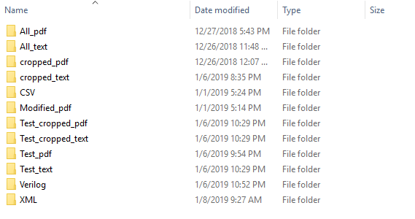

Figure 1. Work Directory

2. Inside All_pdf, create folders similar to Fig. 2.

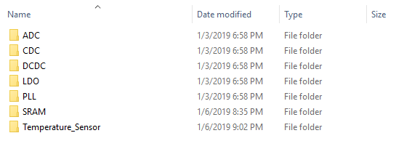

Figure 2. Inside All_pdf folder

3. All_pdf, All_text, cropped_pdf, and cropped_text are training directories. For making your training dataset, put your labeled pdf files in All_pdf directory (it means put ADC datasheets in ADC folder inside All_pdf, CDC datasheet in CDC folder inside All_pdf and so on).

4. Open and run make_training_set function to make appropriate files in All_text, cropped_pdf, and cropped_text.

5. Put pdf files of datasheets that you want to test in Test_pdf folder and **please email them to** [**fayazi@umich.edu**](mailto:fayazi@umich.edu) **in order to have a better repository.**

6. Open and run Datasheet_Scrubbing.py which you can input a datasheet (between one of ADC, CDC, DCDC, PLL, LDO, SRAM, Temperature Sensor categories) and observe the extracted specs and pins.

**Note:** **We appreciate if you email your labeled datasheets to** [**fayazi@umich.edu**](mailto:fayazi@umich.edu) **in order to have a better repository.**