**Neurophysiological responses to threatening and/or unexpected stimuli**

author: Don Lyons and Nicole Sullivan autosize: true

**Applied Question**

Why are some individuals resilient in the face of experienced aggression, while others develop high aggression?

**Research Question**

How do those who have high lifetime committed aggression differ neurophysiologically from those who have low committed aggression? How does lifetime experienced aggression impact this relationship?

**Background, Methods & Techniques**

Lower alpha-amplitude, recently, has been correlated with high aggression. This lower alpha-amplitude, generally, is correlated with recruitment of lesser cognitive resources in response to a stimulus. In athletes, this "alpha burst" has been found to be helpful in reducing cognitive activity and increasing motor activity just prior to execution of a well-rehearsed movement, with optimal performance occurring following lowest alpha amplitude. This study sought, first, to replicate findings that aggressive individuals exhibit lower alpha in response to angry stimuli, and second, sought explore differences between individuals who had low committed aggression, but high experienced aggression, and individuals who had both high committed and experienced aggression.

{r setup, include=FALSE}

knitr::opts_chunk$set(echo = FALSE, warning = FALSE, message = FALSE)

library(tidyverse)

erp_erd <- read_csv("ERP_ERD.csv")

**Stripchart of Expressions in the Angry Task**

[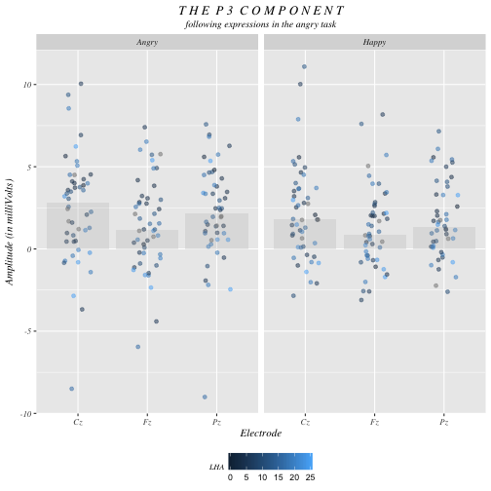](https://github.com/uc-cfss/viz-dalyons3/blob/master/unnamed-chunk-2-1.png)

Cz_Fz_Pz <- erp_erd %>%

filter(Electrode == "Cz" | Electrode == "Pz" | Electrode == "Fz")

Cz_Fz_Pz %>%

filter(Task == "A") %>%

mutate(Expression = ifelse(Expression == "A", "Angry", "Happy")) %>%

ggplot(aes(Electrode, Mean_Amplitude, color = LHA)) +

geom_jitter(position=position_jitter(0.2), alpha = 0.5) +

stat_summary(fun.y=median, geom="bar", fill ="darkgray", size = 1, alpha = 0.2) +

labs(title = "T H E P 3 C O M P O N E N T",

subtitle = "following expressions in the angry task",

y = "Amplitude (in milliVolts)") +

facet_wrap(~Expression) +

theme(plot.title = element_text(family = "Times", face = "italic", hjust = 0.5),

plot.subtitle = element_text(family = "Times", face = "italic", hjust = 0.5),

axis.title = element_text(family = "Times", face = "italic"),

axis.text = element_text(family = "Times", face = "italic"),

plot.caption = element_text(family = "Times", size = 8),

strip.text.x = element_text(family = "Times", face = "italic"),

legend.position = "bottom",

legend.title = element_text(family = "Times", face = "italic", size = 8))

**Stripchart of Expressions in the Neutral Task**

[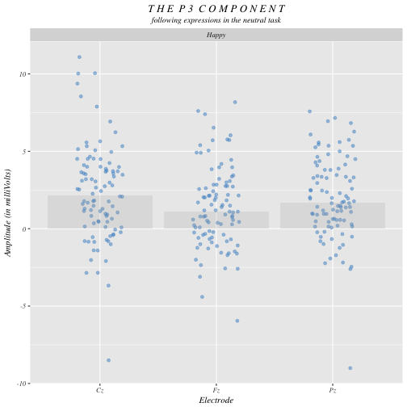](https://github.com/uc-cfss/viz-dalyons3/blob/master/unnamed-chunk-3-1.png)

Cz_Fz_Pz %>%

filter(Task == "A") %>%

mutate(Expression = ifelse(Expression == "N", "Neutral", "Happy")) %>%

ggplot(aes(Electrode, Mean_Amplitude, color = LHA)) +

geom_jitter(position=position_jitter(0.2), alpha = 0.5, color = "steelblue3") +

stat_summary(fun.y=median, geom="bar", fill ="darkgray", size = 1, alpha = 0.2) +

labs(title = "T H E P 3 C O M P O N E N T",

subtitle = "following expressions in the neutral task",

y = "Amplitude (in milliVolts)") +

facet_wrap(~Expression) +

theme(plot.title = element_text(family = "Times", face = "italic", hjust = 0.5),

plot.subtitle = element_text(family = "Times", face = "italic", hjust = 0.5),

axis.title = element_text(family = "Times", face = "italic"),

axis.text = element_text(family = "Times", face = "italic"),

strip.text.x = element_text(family = "Times", face = "italic"))

**Cairo's 5 Qualities of Great Visualizations**

*Truthful*   
We chose a stripchart because we wanted to preserve the amplitude for each individual and then map LHA score onto points using the color channel. Each electrode was given a separate column because this is generally the most truthful way of conveying EEG data (vs. a cortical average which could be seen as data manipulation).

*Functional*We used a stripchart to ensure that the key perceptual task was determining position along a common scales. Cleveland and McGill claim that this task is elementary to meaningful perception. Additionally, grouping in the plot as coded by color was utilized to allow for a third dimension of data that assists the reader in understanding the overall point of the visualization.

*Beautiful*  
We chose jittering and transparency as further aesthetics for the points because we felt it a beautiful way of conveying the data truthfully. Wide kettering was utilized in the title to draw attention to the simple overall theme of the graph and draw the eye to the top of the graph and consequently down.

*Insightful & Enlightening*  
Using color to encode LHA, it's possible to see that there is really no pattern with increasing aggression - those with both low and high LHA scores are scattered across all amplitudes. By using a spectrum of color in this way, we advance the intended conclusion that LHA score does not impact on increasing aggression.

**Race Boxplot for P3 in Angry Task**

[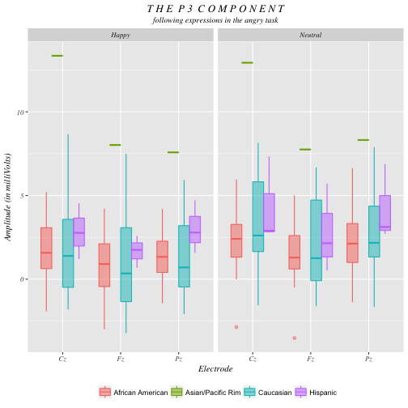](https://github.com/uc-cfss/viz-dalyons3/blob/master/unnamed-chunk-4-1.png)

Cz_Fz_Pz %>%

filter(Task == "N") %>%

mutate(Expression = ifelse(Expression == "N", "Neutral", "Happy")) %>%

mutate(Race = ifelse(Race == 1, "Caucasian",

ifelse(Race == 2, "African American",

ifelse(Race == 3, "Asian/Pacific Rim", "Hispanic")))) %>%

ggplot(aes(Electrode, Mean_Amplitude)) +

geom_boxplot(aes(color = Race, fill = Race), alpha = 0.5) +

labs(title = "T H E P 3 C O M P O N E N T",

subtitle = "following expressions in the angry task",

y = "Amplitude (in milliVolts)") +

facet_wrap(~Expression) +

theme(plot.title = element_text(family = "Times", face = "italic", hjust = 0.5),

plot.subtitle = element_text(family = "Times", face = "italic", hjust = 0.5),

axis.title = element_text(family = "Times", face = "italic"),

axis.text = element_text(family = "Times", face = "italic"),

strip.text.x = element_text(family = "Times", face = "italic"),

legend.position = "bottom",

legend.title = element_blank())

**Cairo's Qualities**

*Truthful*   
When analysis returned several significant interactions for race, we wondered if the P3 component also differed as a function of race. However, via visualization, we were able to determine that this result was due to the responses of the Asian/Pacific Rim group, which had only two subjects. Therefore, this visualization itself centered truth in quantitative analysis.

*Functional*While Cleveland and McGill generally don’t encourage the use of length as a channel for information due to the elementary effectiveness of position on a common scale, that lesser usefulness of length strengthens the contrast between races. The observer notes that it is the Asian/Pacific Rim group’s position that accounts for the significant difference, as opposed to the less compelling differences between box length across the other races.

*Beautiful*  
We chose color because we found it a highly attractive way to distinguish each race from another. We purposefully chose to encode the race channel by the three primary colors and purple, as the three primary colors of red, green, and blue allow for unambiguous contrast and group assignment. While purple is not a primary color, it allowed the use of a distinct color channel that remained both visible and beautiful. Again, kettering was utilized to present the title in a welcoming way that encourages one to read the caption below.

*Insightful & Enlightening*  
Again, the insights gleaned via this visualization were highly useful - not only did they deter us from drawing improper conclusions (that neurophysiological responses differ as a function of race), but they enlightened us: quite interestingly, it appears that all races have similar P3 amplitude in response to different facial stimuli.

**Comparing Responses as a Function of Aggression**

[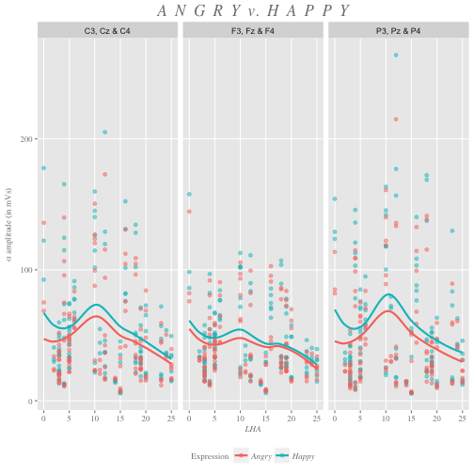](https://github.com/uc-cfss/viz-dalyons3/blob/master/unnamed-chunk-5-1.png)

erp_erd_data <- erp_erd %>%

mutate(Laterality = ifelse(Electrode == "C3" | Electrode == "P3" | Electrode == "F3", "L",

ifelse(Electrode == "Cz" | Electrode == "Pz" | Electrode == "Fz", "M",

ifelse(Electrode == "C4" | Electrode == "P4" | Electrode == "F4", "R", "NA")))) %>%

mutate(Anterior_Posterior = ifelse(Electrode == "F3" | Electrode == "Fz" | Electrode == "F4", "F",

ifelse(Electrode == "C3" | Electrode == "Cz" | Electrode == "C4", "C",

ifelse(Electrode == "P3" | Electrode == "Pz" | Electrode == "P4", "P", "NA")))) %>%

rename(Mean = Mean_Amplitude) %>%

gather(Mean, Delta, Theta, Alpha, Beta, Gamma, key = "Amplitude_Type", value = "Amplitude")

alpha_theta <- erp_erd_data %>%

filter(Electrode == "C3" | Electrode == "P3" | Electrode == "F3" | Electrode == "Cz" | Electrode == "Pz" | Electrode == "Fz" |

Electrode == "C4" | Electrode == "P4" | Electrode == "F4") %>%

filter(Amplitude_Type == "Alpha" | Amplitude_Type == "Theta")

alpha_theta %>%

filter(Task == "A") %>%

filter(Amplitude_Type == "Alpha") %>%

mutate(Expression = ifelse(Expression == "A", "Angry", "Happy")) %>%

mutate(Anterior_Posterior = ifelse(Anterior_Posterior == "C", "C3, Cz & C4",

ifelse(Anterior_Posterior == "F", "F3, Fz & F4", "P3, Pz & P4"))) %>%

na.omit %>%

ggplot(aes(LHA, Amplitude, color = Expression)) +

geom_point(alpha = 0.5) +

geom_smooth(se = FALSE) +

facet_wrap(~Anterior_Posterior) +

labs(title = "A N G R Y v. H A P P Y",

y = expression(paste(alpha, " amplitude (in mVs)"))) +

theme(plot.title = element_text(hjust = 0.5, size = 17, face = "italic",

family = "Times", color = "gray50"),

axis.title.x = element_text(hjust = 0.5, size = 9, face = "italic",

family = "Times", color = "gray50"),

axis.title.y = element_text(hjust = 0.5, size = 9, face = "italic",

family = "Times", color = "gray50"),

plot.caption = element_text(size = 8, color = "gray50", family = "Times"),

panel.grid.minor = element_blank(),

axis.text.x = element_text(family = "Times", color = "gray50"),

axis.text.y = element_text(family = "Times", color = "gray50"),

axis.ticks = element_line(color = "gray50"),

legend.position = "bottom",

legend.title = element_text(family = "Times", color = "gray50", size = 9),

legend.text = element_text(family = "Times", color = "gray50", size = 9, face = "italic"))

**Comparing Responses as a Function of Aggression**

[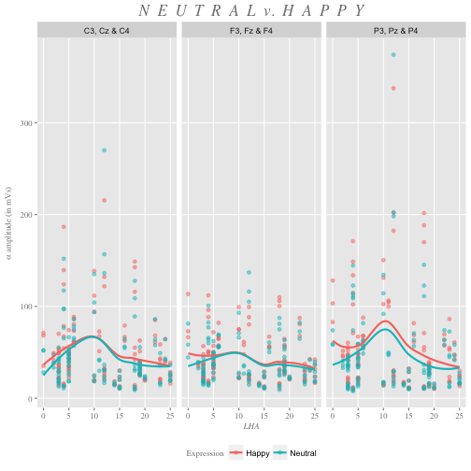](https://github.com/uc-cfss/viz-dalyons3/blob/master/unnamed-chunk-6-1.png)

alpha_theta %>%

filter(Task == "N" & Amplitude_Type == "Alpha") %>%

mutate(Expression = ifelse(Expression == "N", "Neutral", "Happy")) %>%

mutate(Anterior_Posterior = ifelse(Anterior_Posterior == "C", "C3, Cz & C4",

ifelse(Anterior_Posterior == "F", "F3, Fz & F4", "P3, Pz & P4"))) %>%

na.omit() %>%

ggplot(aes(LHA, Amplitude, color = Expression)) +

geom_point(alpha = 0.5) +

geom_smooth(se = FALSE) +

facet_wrap(~Anterior_Posterior) +

labs(title = "N E U T R A L v. H A P P Y",

y = expression(paste(alpha, " amplitude (in mVs)"))) +

theme(plot.title = element_text(hjust = 0.5, size = 17, face = "italic",

family = "Times", color = "gray50"),

axis.title.x = element_text(hjust = 0.5, size = 9, face = "italic",

family = "Times", color = "gray50"),

axis.title.y = element_text(hjust = 0.5, size = 9, face = "italic",

family = "Times", color = "gray50"),

plot.caption = element_text(size = 8, color = "gray50", family = "Times"),

panel.grid.minor = element_blank(),

axis.text.x = element_text(family = "Times", color = "gray50"),

axis.text.y = element_text(family = "Times", color = "gray50"),

axis.ticks = element_line(color = "gray50"),

legend.position = "bottom",

legend.title = element_text(family = "Times", color = "gray50", size = 9))

**Cairo's Qualities**

*Truthful & Functional*  
We chose to use the contrasting primary colors of red and blue to encode expression so that expressions would appear on the same graph and would be easier to compare to one another. In this case, infrequent neutral stimuli were jittered with frequent happy stimuli for the purposes of the P3 analysis; hence, we were interested if responses appeared to be significantly different in the frequency condition based on expression. Again, position on a common scale was used as it is the most elementary and direct perceptual channel.

*Beautiful*  
We used the built-in ggplot colors to distinguish between the two different expressions because we felt that, as primary colors, the red and blue contrast nicely. We greyed fonts to bring out the color of the points, and to complement the palette more closely. We also changed most of the fonts to serif as these are generally easier to read and used more often for scientific audiences.

*Insightful & Enlightening*  
We chose to include trend lines because their close proximity is enlightening - it shows that responses to the two different expressions don't differ significantly - furthermore, despite a spike in the middle (which is easier to see is caused by one or two individuals with especially high amplitude alpha), the line is mainly flat, indicating that low aggressives and high aggressives don't exhibit significant differences in alpha amplitude in response to either neutral or happy faces. The use of this functionality reflects the influence of Bateman’s work on visual embellishment, as we believe that meaningful embellishment will enhance a viewer’s longterm recall of the takeaways.

**Comparing Responses of Groups**

[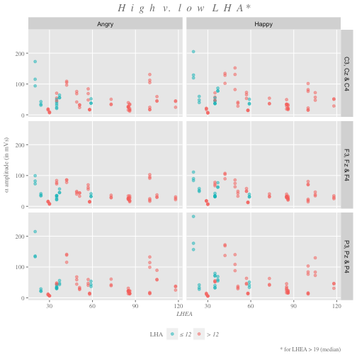](https://github.com/uc-cfss/viz-dalyons3/blob/master/unnamed-chunk-7-1.png)

alpha_theta %>%

filter(Task == "A") %>%

filter(Amplitude_Type == "Alpha") %>%

mutate(Expression = ifelse(Expression == "A", "Angry", "Happy")) %>%

mutate(Anterior_Posterior = ifelse(Anterior_Posterior == "C", "C3, Cz & C4",

ifelse(Anterior_Posterior == "F", "F3, Fz & F4", "P3, Pz & P4"))) %>%

mutate(high_low_LHA = ifelse(LHA <= 12, "\u2264 12", "> 12")) %>%

filter(LHEA > 19) %>%

na.omit %>%

ggplot(aes(LHEA, Amplitude, color = high_low_LHA)) +

geom_point(alpha = 0.5) +

facet_grid(Anterior_Posterior ~ Expression) +

scale_color_discrete(breaks = c("\u2264 12","> 12")) +

labs(title = "H i g h v. l o w L H A *",

caption = "* for LHEA > 19 (median)",

y = expression(paste(alpha, " amplitude (in mVs)")),

color = "LHA") +

theme(plot.title = element_text(hjust = 0.5, size = 15, face = "italic",

family = "Times", color = "gray50"),

plot.subtitle = element_text(hjust = 0.5, size = 12, face = "italic",

family = "Times", color = "gray50"),

axis.title.x = element_text(hjust = 0.5, size = 9, face = "italic",

family = "Times", color = "gray50"),

axis.title.y = element_text(hjust = 0.5, size = 9, face = "italic",

family = "Times", color = "gray50"),

plot.caption = element_text(size = 8, color = "gray50", family = "Times"),

panel.grid.minor = element_blank(),

axis.text.x = element_text(family = "Times", color = "gray50"),

axis.text.y = element_text(family = "Times", color = "gray50"),

axis.ticks = element_line(color = "gray50"),

legend.position = "bottom",

legend.title = element_text(family = "Times", color = "gray50", size = 9),

legend.text = element_text(family = "Times", color = "gray50", size = 9, face = "italic"))

**Comparing Responses of Groups**

[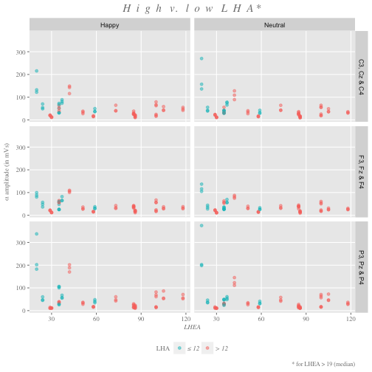](https://github.com/uc-cfss/viz-dalyons3/blob/master/unnamed-chunk-8-1.png)

alpha_theta %>%

filter(Task == "N") %>%

filter(Amplitude_Type == "Alpha") %>%

mutate(Expression = ifelse(Expression == "N", "Neutral", "Happy")) %>%

mutate(Anterior_Posterior = ifelse(Anterior_Posterior == "C", "C3, Cz & C4",

ifelse(Anterior_Posterior == "F", "F3, Fz & F4", "P3, Pz & P4"))) %>%

mutate(high_low_LHA = ifelse(LHA <= 12, "\u2264 12", "> 12")) %>%

filter(LHEA > 19) %>%

na.omit %>%

ggplot(aes(LHEA, Amplitude, color = high_low_LHA)) +

geom_point(alpha = 0.5) +

facet_grid(Anterior_Posterior ~ Expression) +

scale_color_discrete(breaks = c("\u2264 12","> 12")) +

labs(title = "H i g h v. l o w L H A *",

caption = "* for LHEA > 19 (median)",

y = expression(paste(alpha, " amplitude (in mVs)")),

color = "LHA") +

theme(plot.title = element_text(hjust = 0.5, size = 15, face = "italic",

family = "Times", color = "gray50"),

plot.subtitle = element_text(hjust = 0.5, size = 12, face = "italic",

family = "Times", color = "gray50"),

axis.title.x = element_text(hjust = 0.5, size = 9, face = "italic",

family = "Times", color = "gray50"),

axis.title.y = element_text(hjust = 0.5, size = 9, face = "italic",

family = "Times", color = "gray50"),

plot.caption = element_text(size = 8, color = "gray50", family = "Times"),

panel.grid.minor = element_blank(),

axis.text.x = element_text(family = "Times", color = "gray50"),

axis.text.y = element_text(family = "Times", color = "gray50"),

axis.ticks = element_line(color = "gray50"),

legend.position = "bottom",

legend.title = element_text(family = "Times", color = "gray50", size = 9),

legend.text = element_text(family = "Times", color = "gray50", size = 9, face = "italic"))

**Cairo's Qualities**

*Truthful & Functional*  
We chose to use contrasting primary colors to encode expression so that expressions would appear on the same graph and would be easier to compare to one another. In this case, infrequent neutral stimuli were jittered with frequent happy stimuli for the purposes of the P3 analysis; hence, we were interested if responses appeared to be significantly different in the frequency condition based on expression. With the dimension of LHA difference effectively coded on the color channel, we use distance on a common scale to encode amplitude as well as LHEA in a way that is consistent and elementary.

*Beautiful*  
We used primary colors to distinguish between the two different expressions because we felt that the red and blue contrast nicely. We greyed fonts to bring out the color of the points, and to complement the palette more closely. We also changed most of the fonts to serif as these are generally easier to read and used more often for scientific audiences. Again, kettering allows for an impactful title that does not distract from the below data.

*Insightful & Enlightening*  
[Need help with this one] The use of a faceted approach allows for easy 3 x 2 comparison of data that cannot necessarily be plotted on a shared axis due to the independence of the groups. Since the basic shapes of all six of the plots appear similar enough for an at-a-glance comparison to be made, we felt that this allowed an immediate understanding of the commonalities across condition while allowing one to gaze further and pick up differences.