2024
GROUNdWATER Springflow
AND
Pumping



2024 Groundwater SpringFlow and Pumping

Groundwater is lost from the Edwards Aquifer either as springflow or as water pumped from wells. Comal and San Marcos springs, the largest and second-largest springs in Texas, respectively, are fed by the Edwards Aquifer. This springflow greatly benefits the recreational economies in New Braunfels and San Marcos, and both springs provide habitat for threatened and endangered species. Figure 1 shows locations of the major springs in the Edwards Aquifer region. Wells drilled into the Edwards Aquifer throughout the region provide water for many uses, including irrigation, municipal water supplies, industrial applications, and domestic/livestock consumption.
Estimates of total annual groundwater loss from combined springflow and pumping for the Edwards Aquifer are provided in Table 1 for the period of record (1934–2024). Annual total groundwater discharge estimates range from a low of 388,800 acre-feet in 1955 to a high of 1,130,000 acre-feet in 1992. In 2024, the total groundwater discharged from the Edwards Aquifer from both wells and springs is estimated at 493,073 acre-feet: 172,200 acre-feet as springflow and 320,873 acre-feet as pumping from wells.
Springflow is estimated by measuring streamflow downstream of the springs and converting the streamflow measurements to spring discharge by subtracting any estimated contributions from upstream runoff. Total annual springflow has varied from a low of 69,800 acre-feet in 1956 to a high of 802,800 acre-feet in 1992. Monthly springflow estimates for 2024 at each of the six major Edwards Aquifer springs are provided in Table 2.
In Figures 2 and 3, flows at Comal and San Marcos springs are shown as mean annual flows compared with the long-term historical mean annual flow rate for the available period of record. The 2024 mean annual flow rate was less than the historical mean discharge at both Comal Springs and San Marcos Springs.
Well pumping is classified as either reported or unreported discharge. Reported discharge refers to water pumped from the aquifer by a person or entity holding a groundwater withdrawal permit. These users, who are typically large-quantity users, meter their withdrawals and report the totals to the EAA. Unreported discharge refers to pumped use that does not require a groundwater withdrawal permit from the EAA, such as domestic, livestock, or federal facility use. Unreported discharge is estimated based on numbers of wells and statistical estimates of per-well usage. In 2024, unreported discharge for domestic and livestock wells was estimated at 15,149 acre-feet, and non-reporting federal facility discharge was estimated at 5,414 acre-feet, for a total of 20,563 acre-feet of unreported discharge. Reported discharge totaled 300,309 acre-feet. The total of all reported and unreported pumping discharge is 320,873 acre-feet.
Table 3 provides a summary of well and spring discharge for 2024 based on type of use and county. The distribution of discharge from springflows and the different types of pumping for 2024 is shown graphically in Figure 4. Total annual discharge from pumping and springflow are compared in Figure 5 for the period of record from 1934–2024. The years when springflow exceeds pumping tend to be wet years when pumping demand is lowered by more frequent rainfall and higher aquifer levels produce increased springflows. Conversely, during dry years pumping tends to exceed springflow due to increased municipal and agricultural demand and lower aquifer levels. Since 1997, however, the increase in pumping demand during dry years has been limited by the withdrawal permit system and critical period pumping reductions implemented under the Edwards Aquifer Authority Act. Table 4 provides a historical list of total annual discharge by type of use for the period 1955–2024.

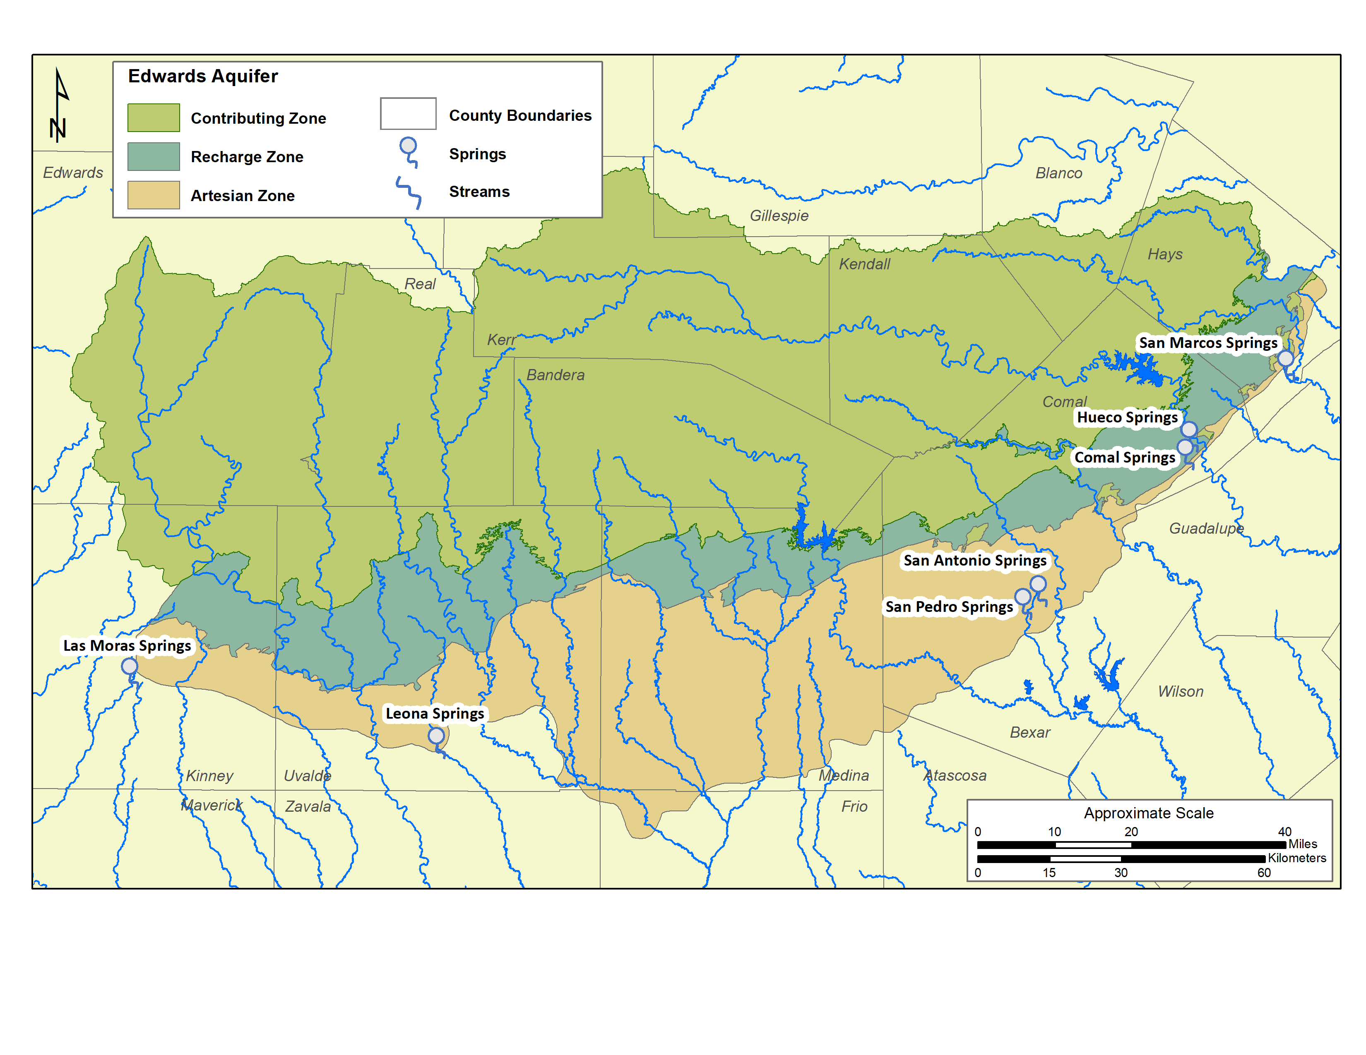
Figure 1. Locations of major Springs in the San Antonio segment of the Edwards (Balcones Fault Zone) Aquifer.

Table 1. Annual Estimated Groundwater Discharge Data by County for the Edwards Aquifer 1934–2024 (measured in thousands of acre-feet)
Year | Uvaldeª | Medina | Bexar^{b} | Comal^{c} | Hays | Total | Total Wells | Total Springs
1934 | 12.6 | 1.3 | 109.3 | 229.1 | 85.6 | 437.9 | 101.9 | 336.0
1935 | 12.2 | 1.5 | 171.8 | 237.2 | 96.9 | 519.6 | 103.7 | 415.9
1936 | 26.6 | 1.5 | 215.2 | 261.7 | 93.2 | 598.2 | 112.7 | 485.5
1937 | 28.3 | 1.5 | 201.8 | 252.5 | 87.1 | 571.2 | 120.2 | 451.0
1938 | 25.2 | 1.6 | 187.6 | 250.0 | 93.4 | 557.8 | 120.1 | 437.7
1939 | 18.2 | 1.6 | 122.5 | 219.4 | 71.1 | 432.8 | 118.9 | 313.9
1940 | 16.1 | 1.6 | 116.7 | 203.8 | 78.4 | 416.6 | 120.1 | 296.5
1941 | 17.9 | 1.6 | 197.4 | 250.0 | 134.3 | 601.2 | 136.8 | 464.4
1942 | 22.5 | 1.7 | 203.2 | 255.1 | 112.2 | 594.7 | 144.6 | 450.1
1943 | 19.2 | 1.7 | 172.0 | 249.2 | 97.2 | 539.3 | 149.1 | 390.2
1944 | 11.6 | 1.7 | 166.3 | 252.5 | 135.3 | 567.4 | 147.3 | 420.1
1945 | 12.4 | 1.7 | 199.8 | 263.1 | 137.8 | 614.8 | 153.3 | 461.5
1946 | 6.2 | 1.7 | 180.1 | 261.9 | 134.0 | 583.9 | 155.0 | 428.9
1947 | 13.8 | 2.0 | 193.3 | 256.8 | 127.6 | 593.5 | 167.0 | 426.5
1948 | 9.2 | 1.9 | 159.2 | 203.0 | 77.3 | 450.6 | 168.7 | 281.9
1949 | 13.2 | 2.0 | 165.3 | 209.5 | 89.8 | 479.8 | 179.4 | 300.4
1950 | 17.8 | 2.2 | 177.3 | 191.1 | 78.3 | 466.7 | 193.8 | 272.9
1951 | 16.9 | 2.2 | 186.9 | 150.5 | 69.1 | 425.6 | 209.7 | 215.9
1952 | 22.7 | 3.1 | 187.1 | 133.2 | 78.8 | 424.9 | 215.4 | 209.5
1953 | 27.5 | 4.0 | 193.7 | 141.7 | 101.4 | 468.3 | 229.8 | 238.5
1954 | 26.6 | 6.3 | 208.9 | 101.0 | 81.5 | 424.3 | 246.2 | 178.1
1955 | 28.3 | 11.1 | 215.2 | 70.1 | 64.1 | 388.8 | 261.0 | 127.8
1956 | 59.6 | 17.7 | 229.6 | 33.6 | 50.4 | 390.9 | 321.1 | 69.8
1957 | 29.0 | 11.9 | 189.4 | 113.2 | 113.0 | 456.5 | 237.3 | 219.2
1958 | 23.7 | 6.6 | 199.5 | 231.8 | 155.9 | 617.5 | 219.3 | 398.2
1959 | 43.0 | 8.3 | 217.5 | 231.7 | 118.5 | 619.0 | 234.5 | 384.5
1960 | 53.7 | 7.6 | 215.4 | 235.2 | 143.5 | 655.4 | 227.1 | 428.3
1961 | 56.5 | 6.4 | 230.3 | 249.5 | 140.8 | 683.5 | 228.2 | 455.3
1962 | 64.6 | 8.1 | 220.0 | 197.5 | 98.8 | 589.0 | 267.9 | 321.1
1963 | 51.4 | 9.7 | 217.3 | 155.7 | 81.9 | 516.0 | 276.4 | 239.6
1964 | 49.3 | 8.6 | 201.0 | 141.8 | 73.3 | 474.0 | 260.2 | 213.8
1965 | 46.8 | 10.0 | 201.1 | 194.7 | 126.3 | 578.9 | 256.1 | 322.8
1966 | 48.5 | 10.4 | 198.0 | 198.9 | 115.4 | 571.2 | 255.9 | 315.3
1967 | 81.1 | 15.2 | 239.7 | 139.1 | 82.3 | 557.4 | 341.3 | 216.1
1968 | 58.0 | 9.9 | 207.1 | 238.2 | 146.8 | 660.0 | 251.7 | 408.3
1969 | 88.5 | 13.6 | 216.3 | 218.2 | 122.1 | 658.7 | 307.5 | 351.2
1970 | 100.9 | 16.5 | 230.6 | 229.2 | 149.9 | 727.1 | 329.4 | 397.7
1971 | 117.0 | 32.4 | 262.8 | 168.2 | 99.1 | 679.5 | 406.8 | 272.7
1972 | 112.6 | 28.8 | 247.7 | 234.3 | 123.7 | 747.1 | 371.3 | 375.8
1973 | 96.5 | 14.9 | 273.0 | 289.3 | 164.3 | 838.0 | 310.4 | 527.6
1974 | 133.3 | 28.6 | 272.1 | 286.1 | 141.1 | 861.2 | 377.4 | 483.8
1975 | 112.0 | 22.6 | 259.0 | 296.0 | 178.6 | 868.2 | 327.8 | 540.4
1976 | 136.4 | 19.4 | 253.2 | 279.7 | 164.7 | 853.4 | 349.5 | 503.9
1977 | 156.5 | 19.9 | 317.5 | 295.0 | 172.0 | 960.9 | 380.6 | 580.3
1978 | 154.3 | 38.7 | 269.5 | 245.7 | 99.1 | 807.3 | 431.8 | 375.5
1979 | 130.1 | 32.9 | 294.5 | 300.0 | 157.0 | 914.5 | 391.5 | 523.0
1980 | 151.0 | 39.9 | 300.3 | 220.3 | 107.9 | 819.4 | 491.1 | 328.3

Table 1. (Continued)
Year | Uvaldeª | Medina | Bexar^{b} | Comal^{c} | Hays | Total | Total Wells | Total Springs
1981 | 104.2 | 26.1 | 280.7 | 241.8 | 141.6 | 794.4 | 387.1 | 407.3
1982 | 129.2 | 33.4 | 305.1 | 213.2 | 105.5 | 786.4 | 453.1 | 333.3
1983 | 107.7 | 29.7 | 277.6 | 186.6 | 118.5 | 720.1 | 418.5 | 301.6
1984 | 156.9 | 46.9 | 309.7 | 108.9 | 85.7 | 708.1 | 529.8 | 178.3
1985 | 156.9 | 59.2 | 295.5 | 200.0 | 144.9 | 856.5 | 522.5 | 334.0
1986 | 91.7 | 41.9 | 294.0 | 229.3 | 160.4 | 817.3 | 429.3 | 388.0
1987 | 94.9 | 15.9 | 326.6 | 286.2 | 198.4 | 922.0 | 364.1 | 557.9
1988 | 156.7 | 82.2 | 317.4 | 236.5 | 116.9 | 909.7 | 540.0 | 369.7
1989 | 156.9 | 70.5 | 305.6 | 147.9 | 85.6 | 766.5 | 542.4 | 224.1
1990 | 118.1 | 69.7 | 276.8 | 171.3 | 94.1 | 730.0 | 489.4 | 240.6
1991 | 76.6 | 25.6 | 315.5 | 221.9 | 151.0 | 790.6 | 436.0 | 354.6
1992 | 76.5 | 9.3 | 370.5 | 412.4 | 261.3 | 1,130.0 | 327.2 | 802.8
1993 | 107.5 | 17.8 | 371.0 | 349.5 | 151.0 | 996.7 | 407.3 | 589.4
1994 | 95.5 | 41.1 | 297.7 | 269.8 | 110.6 | 814.8 | 424.6 | 390.2
1995 | 90.8 | 35.2 | 272.1 | 235.0 | 127.8 | 761.0 | 399.6 | 361.3
1996 | 117.6 | 66.3 | 286.8 | 150.2 | 84.7 | 705.6 | 493.6 | 212.0
1997 | 77.0 | 31.4 | 260.2 | 243.3 | 149.2 | 761.1 | 377.1 | 383.9
1998 | 113.1 | 51.3 | 312.4 | 271.8 | 168.8 | 917.6 | 453.5 | 464.1
1999 | 104.0 | 49.2 | 307.1 | 295.5 | 143.0 | 898.8 | 442.7 | 456.1
2000 | 89.1 | 45.1 | 283.6 | 226.1 | 108.4 | 752.3 | 414.8 | 337.5
2001 | 68.6 | 33.9 | 291.6 | 327.7 | 175.4 | 890.0 | 367.7 | 529.6
2002 | 76.2 | 40.6 | 311.9 | 350.4 | 202.1 | 981.2 | 371.3 | 609.9
2003 | 89.4 | 34.8 | 331.7 | 344.7 | 176.3 | 976.9 | 362.1 | 621.5
2004 | 91.3 | 22.5 | 331.9 | 341.4 | 153.1 | 940.3 | 317.4 | 622.9
2005 | 107.4 | 37.3 | 366.1 | 349.3 | 175.6 | 1,035.7 | 388.5 | 647.1
2006 | 107.5 | 64.9 | 289.5 | 216.7 | 87.9 | 766.5 | 454.5 | 312.0
2007 | 64.6 | 18.4 | 330.2 | 331.7 | 196.0 | 940.9 | 319.9 | 621.0
2008 | 102.0 | 48.8 | 320.4 | 266.6 | 108.0 | 845.7 | 428.6 | 417.1
2009 | 76.9 | 47.3 | 265.2 | 206.6 | 87.8 | 683.7 | 395.7 | 287.9
2010 | 53.1 | 36.4 | 298.5 | 312.1 | 162.5 | 862.6 | 372.6 | 490.0
2011 | 79.6 | 57.4 | 277.2 | 187.7 | 91.0 | 692.9 | 427.7 | 265.2
2012 | 57.6 | 44.3 | 267.5 | 193.4 | 124.2 | 687.0 | 384.7 | 302.3
2013 | 43.6 | 42.8 | 251.0 | 154.9 | 96.0 | 588.6 | 355.8 | 232.8
2014 | 41.5 | 43.1 | 230.5 | 114.5 | 97.9 | 527.5 | 332.2 | 195.4
2015 | 27.1 | 27.6 | 256.3 | 239.8 | 178.8 | 729.7 | 325.2 | 404.5
2016 | 46.9 | 31.9 | 262.6 | 320.7 | 208.3 | 870.3 | 325.3 | 545.0
2017 | 63.0 | 43.6 | 305.3 | 294.0 | 166.8 | 872.2 | 379.2 | 493.0
2018 | 69.9 | 42.0 | 277.1 | 244.0 | 130.4 | 763.6 | 370.6 | 393.0
2019 | 76.8 | 40.9 | 290.7 | 306.1 | 225.0 | 884.6 | 358.6 | 526.0
2020 | 79.1 | 50.5 | 236.6 | 235.2 | 114.7 | 716.2 | 362.4 | 353.7
2021 | 56.1 | 39.8 | 222.3 | 235.2 | 113.7 | 667.1 | 326.6 | 340.5
2022 | 70.7 | 56.4 | 241.7 | 143.1 | 92.9 | 607.2 | 387.2 | 219.9
2023 | 45.4 | 39.9 | 216.5 | 99.1 | 68.5 | 471.7 | 320.5 | 151.1
2024 | 48.8 | 44.4 | 207.8 | 101.7 | 88.4 | 493.1 | 320.9 | 172.2

Table 1. (Continued)
For period of record (1955-2024):
Median | 68.6 | 22.6 | 253.2 | 235.0 | 116.9 | 692.9 | 329.4 | 375.8
Mean | 70.6 | 25.6 | 248.8 | 227.2 | 124.0 | 695.6 | 318.8 | 376.9
For last ten years (2014-2024):
Median | 56.1 | 42.0 | 241.7 | 235.2 | 114.7 | 716.2 | 332.2 | 353.7
Mean | 56.9 | 41.8 | 249.8 | 212.1 | 135.0 | 691.2 | 346.2 | 344.9
Data source: USGS Letter Report to Edwards Aquifer Authority files, dated April 3, 2025.
a = As of 2008, no longer includes Kinney County discharge; prior years include 1,900 acre-feet of discharge for Kinney County.
b = Includes reports of Edwards Aquifer irrigators in Atascosa County.
c = Includes reports of Edwards Aquifer industrial and municipal users in Guadalupe County.
Differences in totals may occur due to rounding.

Table 2. Estimated Spring Discharge from the Edwards Aquifer in 2024 (in acre-ft)
Month | Leona Springs and Leona River | San Pedro Springs | San Antonio Springs | Comal Springs | Hueco Springs | San Marcos Springs | Total
Jan | 0 | 0 | 0 | 9,430 | 2,080 | 6,460 | 17,970
Feb | 0 | 0 | 0 | 10,400 | 1,730 | 9,680 | 21,810
Mar | 0 | 0 | 0 | 9,810 | 1,030 | 9,260 | 20,100
Apr | 0 | 0 | 0 | 8,910 | 601 | 7,410 | 16,921
May | 0 | 0 | 0 | 7,870 | 503 | 7,910 | 16,283
Jun | 0 | 0 | 0 | 5,460 | 334 | 6,650 | 12,444
Jul | 0 | 0 | 0 | 6,160 | 1,200 | 6,630 | 13,990
Aug | 0 | 0 | 0 | 6,100 | 1,130 | 6,170 | 13,400
Sep | 0 | 0 | 0 | 5,230 | 601 | 5,470 | 11,301
Oct | 0 | 0 | 0 | 3,920 | 223 | 5,370 | 9,513
Nov | 0 | 0 | 0 | 4,050 | 421 | 4,870 | 9,341
Dec | 0 | 0 | 0 | 3,720 | 274 | 5,150 | 9,144
Total | 0 | 0 | 0 | 81,100 | 10,100 | 81,000 | 172,000
Data source: USGS letter report dated April 3, 2025
Totals may not equal sum of discharge values due to rounding

Table 3. Discharge Summary for Calendar Year 2024 (in acre-feet)
 | Wells – measured |  |  | Wells – estimated
County | Irrigation | Municipal | Industrial | Domestic, Livestock, Limited Pumping† | Federal Facilities† | Total Well Discharge | Total Spring Discharge | Total Well and Spring Discharge
Atascosa | 1,600 | 0 | 1 | 0 | 0 | 1,601 | 0 | 1,601
Bexar | 2,923 | 176,936 | 13,652 | 9,235 | 5,100 | 207,846 | 0 | 207,846
Comal | 61 | 6,996 | 2,668 | 794 | 0 | 10,519 | 91,200 | 101,719
Guadalupe | 0 | 72 | 198 | 13 | 0 | 282 | 0 | 282
Hays | 107 | 4,770 | 1,258 | 926 | 314 | 7,374 | 81,000 | 88,374
Medina | 28,836 | 9,299 | 4,876 | 1,398 | 0 | 44,409 | 0 | 44,409
Uvalde | 42,801 | 3,126 | 130 | 2,785 | 0 | 48,842 | 0 | 48,842
Total | 76,329 | 201,198 | 22,782 | 15,149 | 5,414 | 320,873 | 172,200 | 493,073
†Federal facilities, and domestic and livestock wells are not required to report annual use; these quantities are estimated.
Totals may not equal sum of discharge values due to rounding.

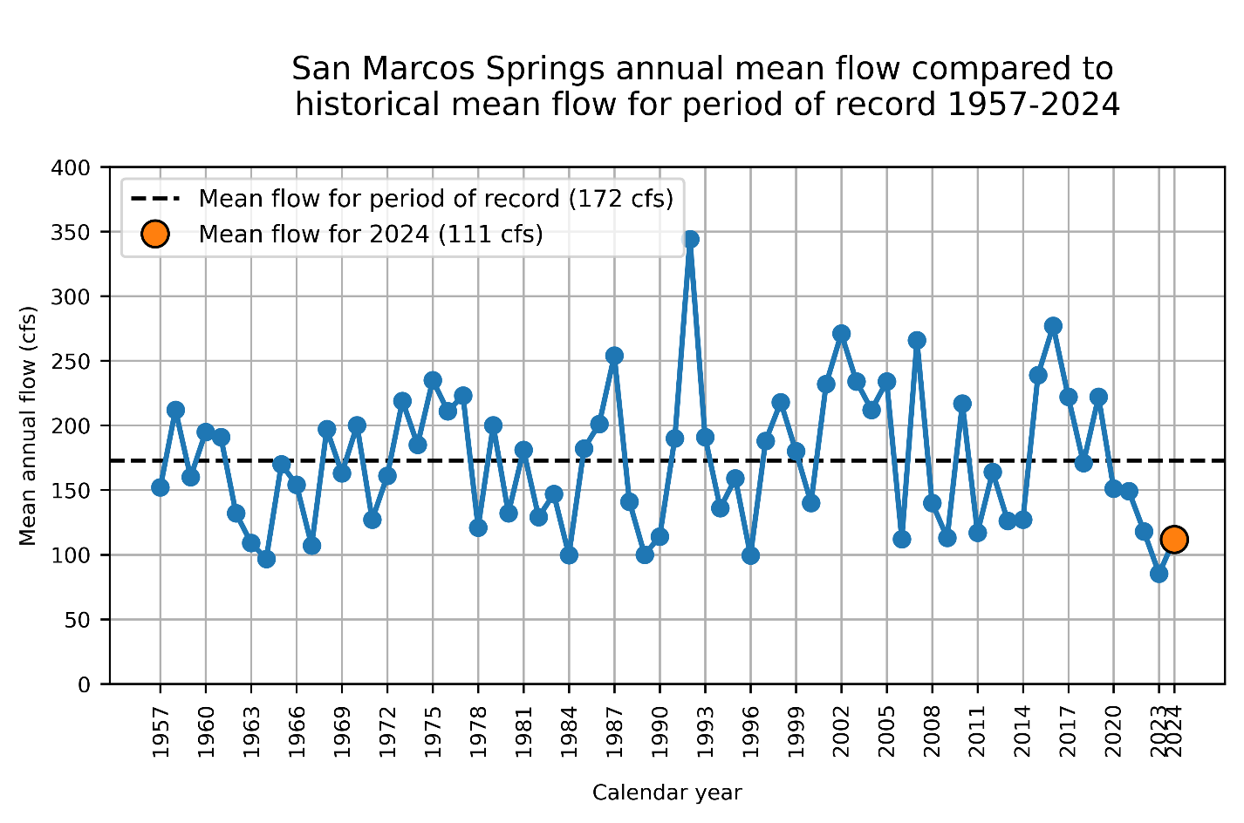
Figure 2. Historical time series of mean annual flow at San Marcos Springs.

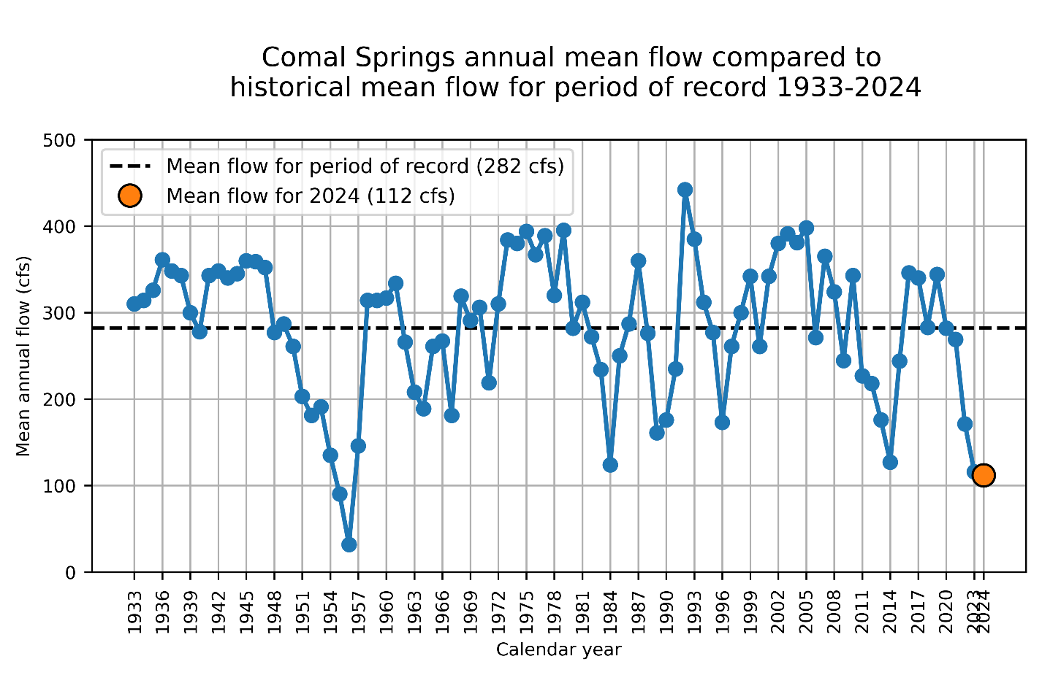
Figure 3. Historical time series of mean annual flow at Comal Springs.

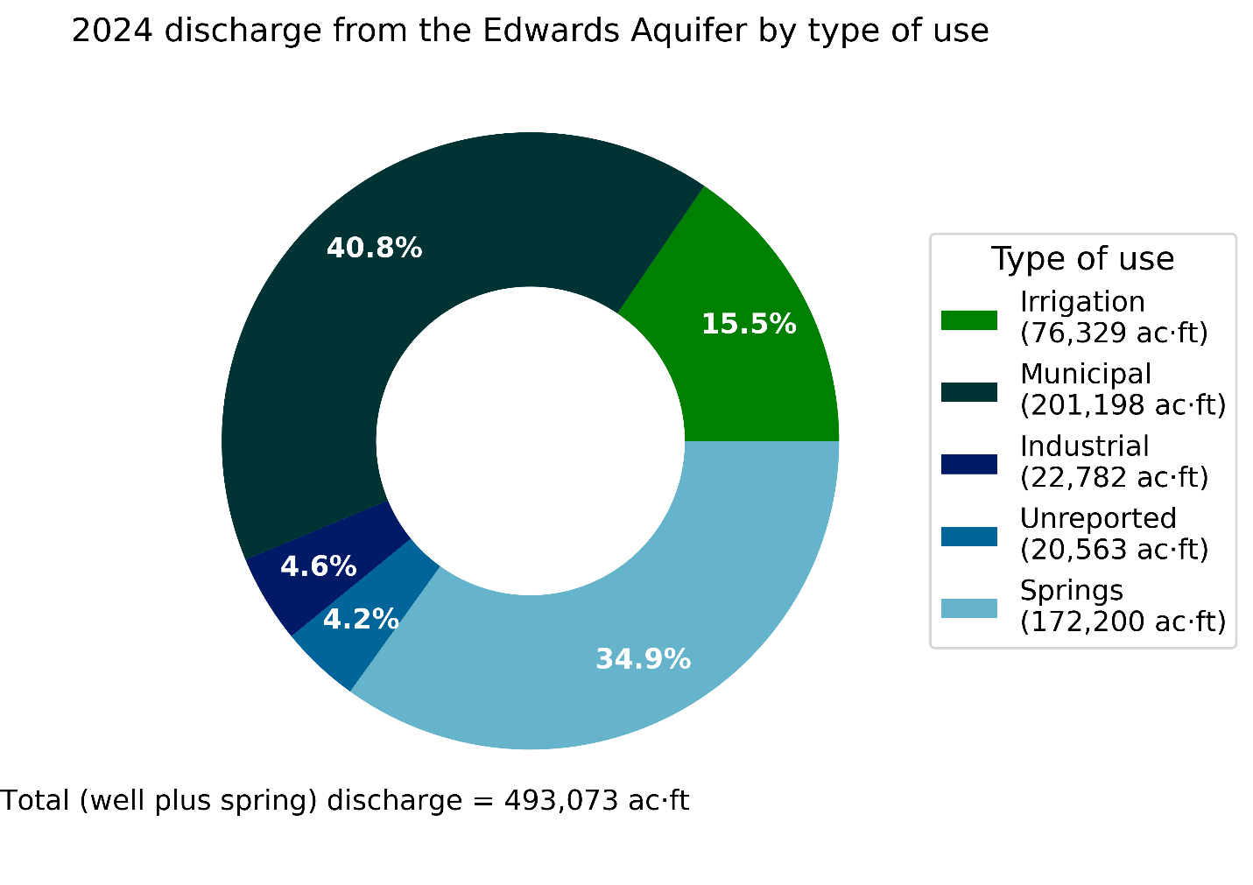
Figure 4. Discharge from the Edwards Aquifer by type of use.

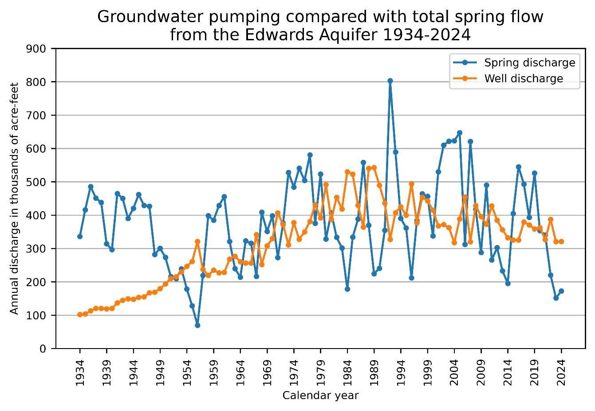
Figure 5. Historical time series of Edwards Aquifer spring discharge compared with groundwater pumping.

Table 4. Annual Estimated Edwards Aquifer Groundwater Discharge by Use, 1955–2024 (in thousands of acre-feet)
Year | Irrigation | Municipal | Domestic/ Stock | Industrial/ Commercial | Springs
1955 | 85.2 | 120.5 | 30.1 | 25.1 | 127.8
1956 | 127.2 | 138.3 | 28.9 | 22.4 | 69.8
1957 | 68.8 | 116.1 | 29.8 | 22.6 | 219.2
1958 | 47.2 | 113.7 | 33.4 | 25.1 | 398.2
1959 | 60.0 | 118.9 | 31.5 | 24.2 | 384.5
1960 | 54.9 | 121.1 | 31.5 | 23.3 | 428.3
1961 | 52.1 | 124.5 | 29.6 | 22.2 | 455.3
1962 | 72.7 | 143.7 | 28.8 | 22.8 | 321.1
1963 | 75.4 | 151.8 | 27.8 | 21.8 | 239.6
1964 | 72.6 | 140.2 | 26.3 | 21.7 | 213.8
1965 | 68.0 | 138.8 | 27.0 | 22.3 | 322.8
1966 | 68.2 | 141.8 | 23.3 | 22.6 | 315.3
1967 | 119.4 | 171.0 | 25.1 | 25.8 | 216.1
1968 | 59.3 | 146.9 | 25.5 | 20.0 | 408.3
1969 | 95.2 | 162.0 | 29.2 | 21.1 | 351.2
1970 | 110.1 | 167.5 | 29.3 | 22.5 | 397.7
1971 | 159.4 | 196.2 | 28.6 | 22.6 | 272.7
1972 | 128.8 | 190.5 | 30.8 | 21.1 | 375.8
1973 | 82.2 | 177.1 | 32.3 | 18.8 | 527.6
1974 | 140.4 | 174.6 | 33.5 | 15.1 | 483.3
1975 | 96.4 | 182.5 | 33.6 | 15.3 | 540.4
1976 | 118.2 | 182.1 | 34.6 | 14.7 | 503.9
1977 | 124.2 | 205.3 | 38.1 | 13.0 | 580.3
1978 | 165.8 | 214.2 | 40.3 | 11.5 | 375.5
1979 | 126.8 | 208.9 | 40.7 | 15.2 | 523.0
1980 | 177.9 | 256.2 | 43.3 | 13.7 | 328.3
1981 | 101.8 | 231.8 | 40.9 | 12.6 | 407.3
1982 | 130.0 | 268.6 | 39.5 | 15.0 | 333.3
1983 | 115.9 | 249.2 | 38.8 | 14.7 | 301.5
1984 | 191.2 | 287.2 | 36.2 | 15.2 | 178.3
1985 | 203.1 | 263.7 | 39.2 | 16.5 | 334.0
1986 | 104.2 | 266.3 | 42.0 | 16.8 | 388.0
1987 | 40.9 | 260.9 | 43.5 | 18.7 | 557.9
1988 | 193.1 | 286.2 | 41.9 | 18.8 | 369.7
1989 | 196.2 | 285.2 | 38.2 | 22.9 | 224.1
1990 | 172.9 | 254.9 | 37.9 | 23.7 | 240.6
1991 | 88.5 | 240.5 | 39.5 | 67.5 | 354.6
1992 | 27.1 | 236.5 | 34.8 | 29.0 | 802.8
1993 | 69.3 | 252.0 | 49.9 | 36.1 | 589.4
1994 | 104.5 | 247.0 | 33.9 | 39.3 | 390.2
1995 | 95.6 | 255.0 | 11.6 | 37.3 | 361.3
1996 | 181.3 | 261.3 | 12.3 | 38.8 | 212.0

Table 4. (Continued)
Year | Irrigation | Municipal | Domestic/ Stock | Industrial/ Commercial | Springs
1997 | 77.4 | 253 | 12.3 | 34.4 | 383.9
1998 | 131.9 | 266.5 | 13.4 | 41.7 | 464.1
1999 | 113.6 | 273.3 | 13.4 | 42.4 | 456.1
2000 | 106.3 | 261.3 | 13.4 | 33.8 | 337.5
2001 | 79 | 245.9 | 13.4 | 29.4 | 529.4
2002 | 97.1 | 228.4 | 13.6 | 32.3 | 609.9
2003 | 79.6 | 237.2 | 13.7 | 31.7 | 621.5
2004 | 55.4 | 220.3 | 13.8 | 28.1 | 622.9
2005 | 85.3 | 255.1 | 13.8 | 34.3 | 647.1
2006 | 149.1 | 259.1 | 13.8 | 34.5 | 312
2007 | 42.5 | 236 | 13.8 | 27.6 | 620.6
2008 | 112.7 | 273.6 | 13.5 | 28.8 | 417.1
2009 | 108.9 | 247.5 | 13.6 | 25.7 | 288
2010 | 72.7 | 259.9 | 13.6 | 26.4 | 490
2011 | 124.9 | 265.5 | 13.6 | 23.6 | 265.2
2012 | 90.6 | 257.9 | 13.7 | 22.6 | 302.3
2013 | 76.3 | 239.5 | 13.7 | 26.3 | 232.8
2014 | 75.3 | 220.1 | 13.9 | 22.8 | 195.4
2015 | 42.2 | 247.2 | 13.9 | 21.9 | 404.5
2016 | 54.7 | 232.6 | 14 | 24 | 545
2017 | 74.1 | 268.3 | 14 | 22.8 | 493
2018 | 84 | 250.5 | 14.1 | 22.1 | 393
2019 | 73.7 | 241.5 | 14.1 | 23.8 | 526
2020 | 97.7 | 223.4 | 14.6 | 26.8 | 353.7
2021 | 74.3 | 212 | 14.5 | 25.7 | 340.5
2022 | 111.0 | 228.1 | 14.9 | 27.7 | 220.0
2023 | 69.8 | 206.6 | 15.0 | 23.6 | 151.0
2024 | 76.3 | 201.2 | 15.1 | 22.8 | 172.2
For period of record (1955-2024):
Median | 92.9 | 234.3 | 27.4 | 22.9 | 375.7
Mean | 100.1 | 216.6 | 25.4 | 24.8 | 383.1
For last ten years (2014-2024:
Median | 74.3 | 228.1 | 14.1 | 23.6 | 353.7
Mean | 75.7 | 230.1 | 14.4 | 24.0 | 344.9

