-Cesar Vasquez

-Homework 1

-January 24, 2016

-Question 1:

The fork processes will create 8 processes including the parent. A picture of a diagram is provided below:

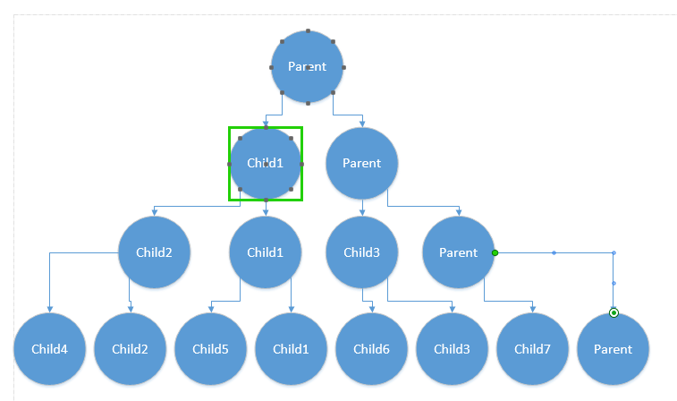

-Question 2:

-2a:

The picture of the code is below:

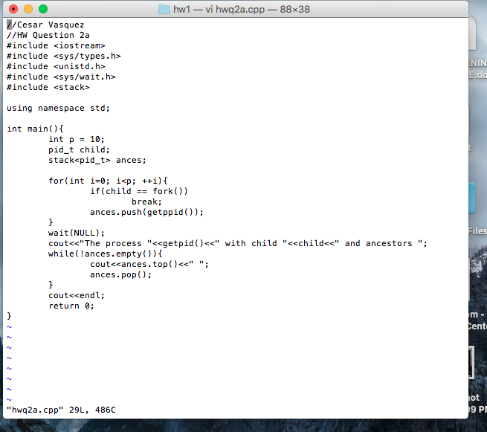

The code being executed is below:

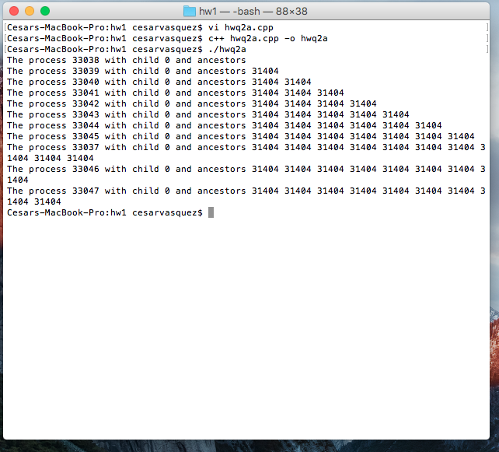

-2b:

The picture of the code is below:

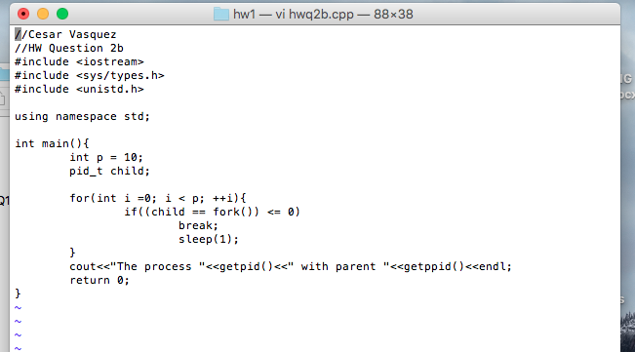

The code is being executed:

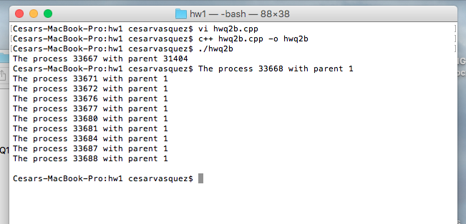

-Question 3:

-3a: Screen shot of the .cpp code:

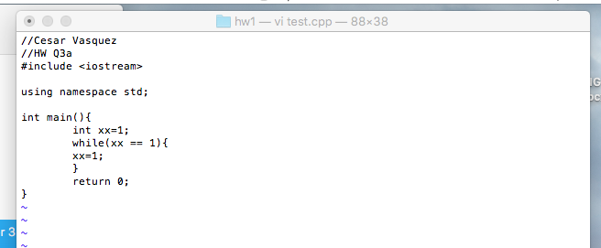

-3b: Screen shot of the shell script code:

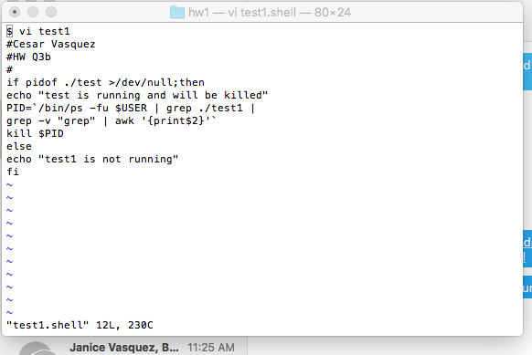

And below is the screen shot of the code running together:

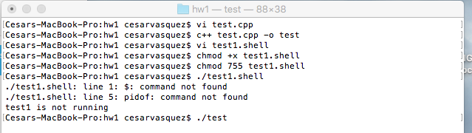

-Summary:

Even though this lab was very challenging and I had some help, I give my self 40/40.