-Cesar Vasquez

-Lab1 Report

-January 12, 2016

**Lab Objective**

-1. Review Basic Unix Commands (ls,cp,rm,mv,cp,mkdir,vi):

-2. Develop C++ program (two files) using Makefile:

**-1:** I used the (*ls, cd, mkdir, cd, vi, mkdir, cp, cd, ls, mv, ls, rm, and ls)* Unix commands in that order. The picture below shows that.

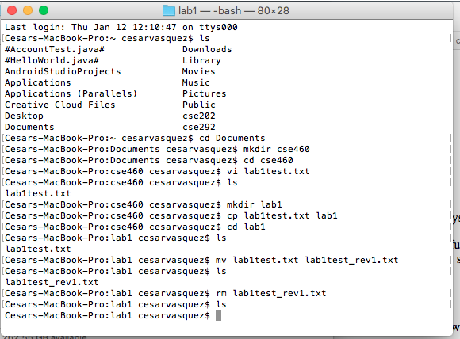

Also, the picture below shows the *vi* use.

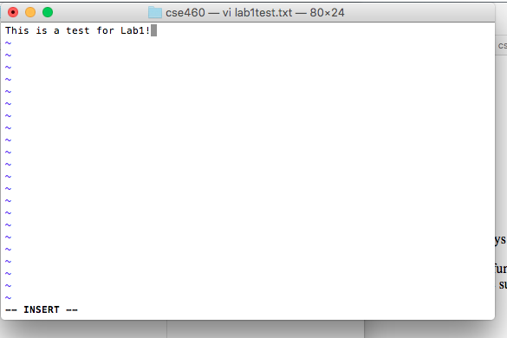

**-2:** Below are the screen shots of creating the main, the cpp, and the header files under *vi*. Also, the make file screen shot is included.

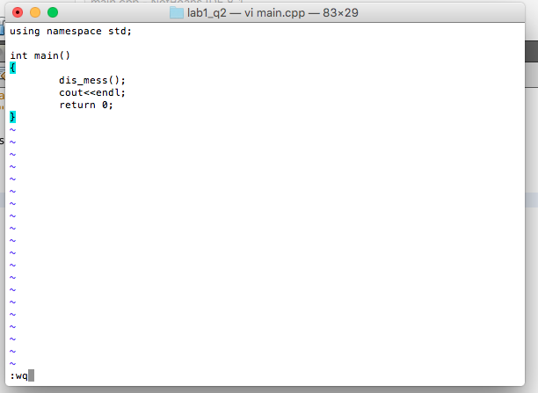

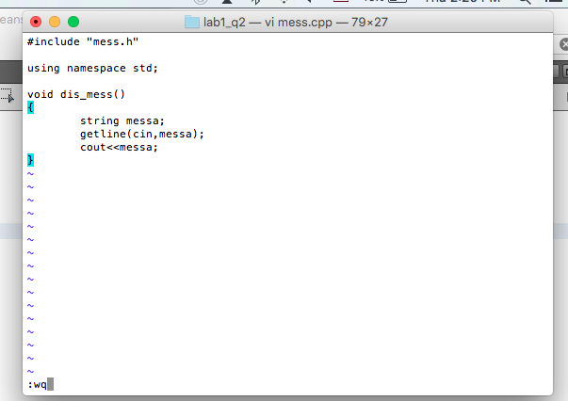

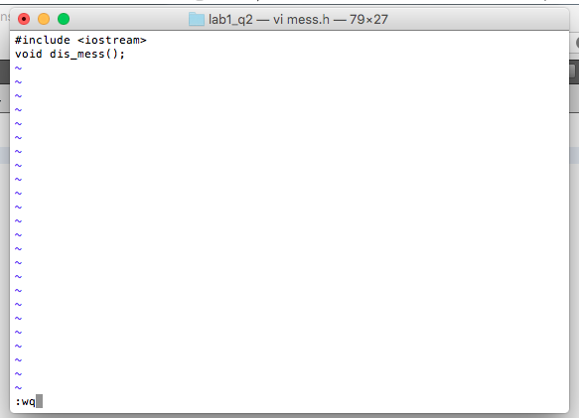

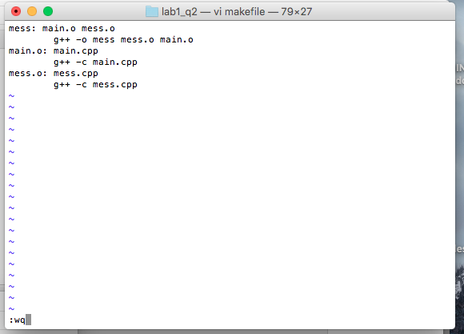

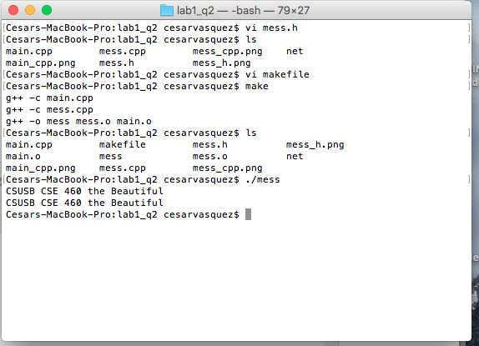

**Summer:** This lab was easy. Everything that was instructed to do has been done in other classes. This was just a review for me. I give my self 20/20.