-Cesar Vasquez

-Lab2 Report

-January 19, 2016

**Lab Objective**

-1. Basic Shell Programming:

-2. AWK scripting language:

-3. Viewing Processes:

-4. Starting New Processes:

-5. Shell Programming Practice:

**-1.** **Basic Shell Programming:**

-The difference between ‘./ginfo’ and ‘.ginfo’ after writing the script and setting permissions is that with ‘./ginfo’ is being executed from the current directory. And, with ‘.ginfo’ is being executed as a system command.

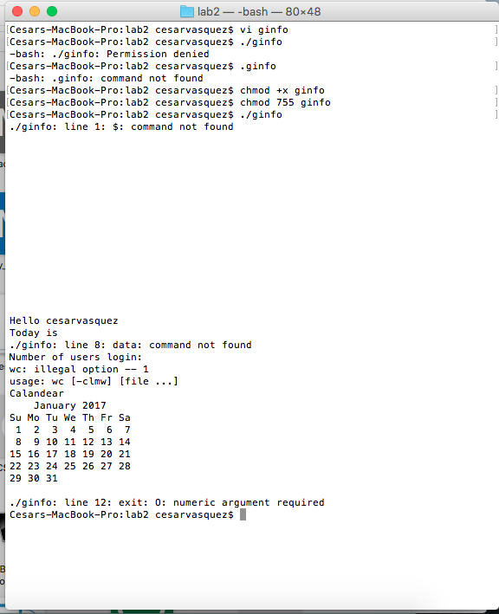

-All the question of the exercises of the UDV section was done. I just had an issue with question 5 because the syntax was incorrect.

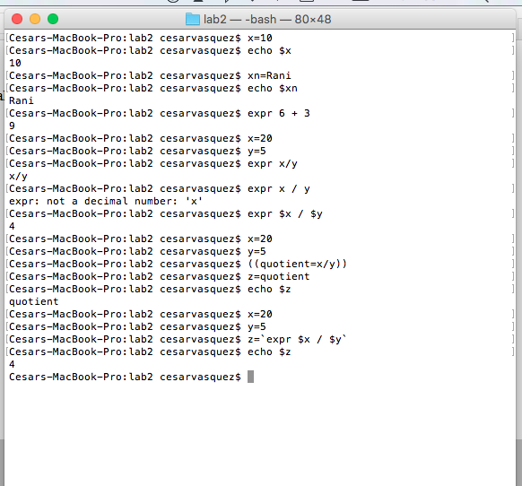

-The ‘testShell.sh’ script was difficult to execute. The script will run after the ‘. ./testShell.sh’ executes, and the other dose not.

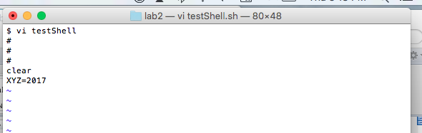

**-2. AWK:**

-PS reports a snap shot of the current processes.

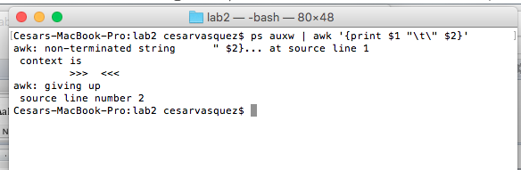

**-3. Viewing Processes:**

-I studied the ‘man ps’ and the ‘man kill’. I even went ahead and took screen shots from both guides.

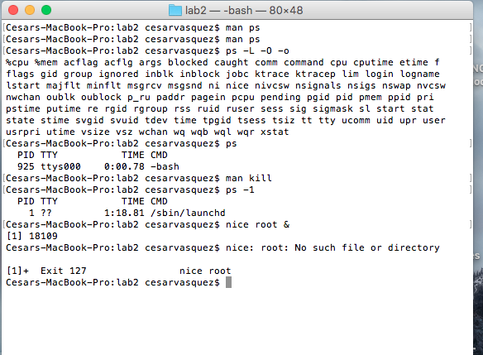

**-4. Starting New Processes**

-Well, when the file is executed first with the ‘ps –ax’ code, the code is executed and exit the program automatically. Now, when the ‘&’ is added, the code is executed and once is done, it pauses and the code is terminated once a key on the keyboard is press.

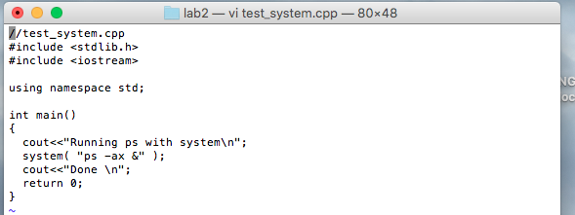

**-5. Shell Programming Practice:**

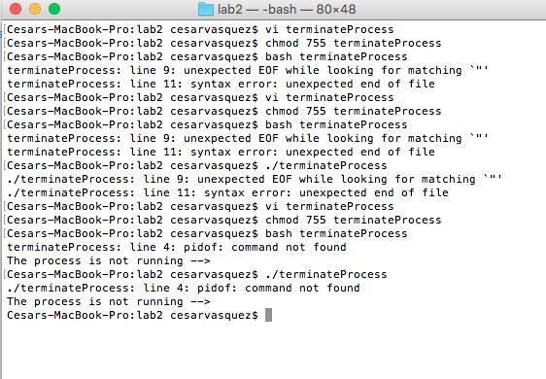

After running the code, I did not get any process running.

Below is a pic of the code it self.

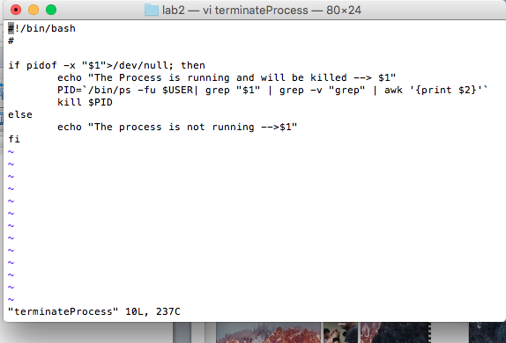

**Summery:**

This lab was challenging. I give my self a 20/20.