-Cesar Vasquez

-Lab3 Report

-January 26, 2016

**Lab Objective**

-1. Replacing a process image:

-2. Duplicating a process image:

-3. Waiting for a process:

-4. Signals

**-1. Replacing a process image:**

-Below it’s the code with ‘execlp’ code:

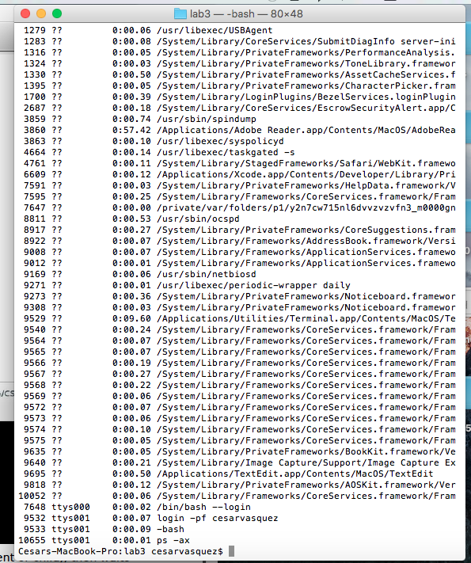

-Now, the code was replaced with ‘execl’:

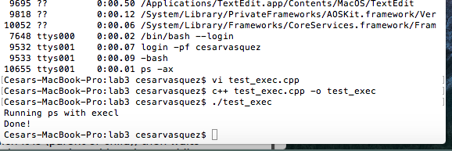

**-2. Duplicating a process image:**

-Below is a screen shot of the code executing. The console displays when the process is a parent or child process.

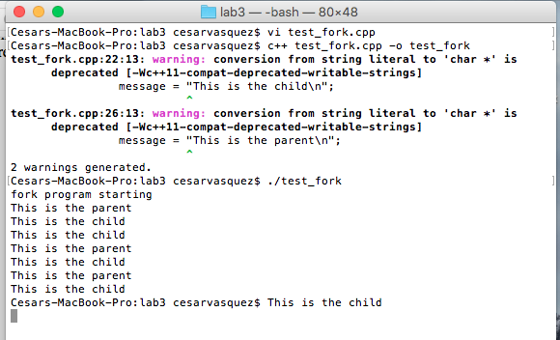

**-3. Waiting for a Process:**

The code of this section is almost the same from the previous section, but the difference is that the parent waits for the child to finish. Then, the parent prints its process ID, and the code terminates. A picture is provide below:

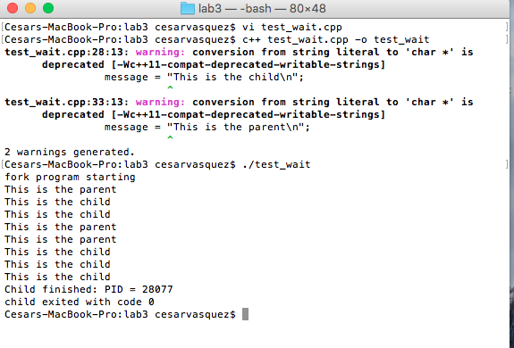

**-4. Signals:**

-The print screen of the code is below. When ‘^C’ was press noting was happening because the code had a for loop with a limit of 20 times.

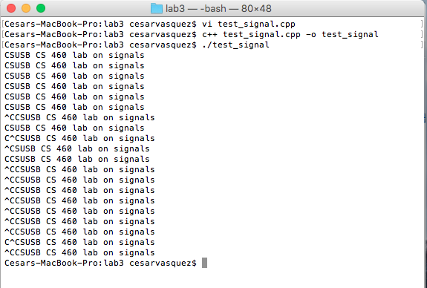

-Now, for ‘test_alarm’, the code being executed is below. This occurs because fork is executed then it is stopped with sleep then re-executed with return 1. Finally, the void signal is send and the alarms is executed.

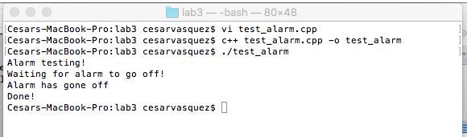

**-Summary:**

This lab was kind of difficult, but I will still give my self 20/20.