Cristian Ortiz

Math 32

11/6/19

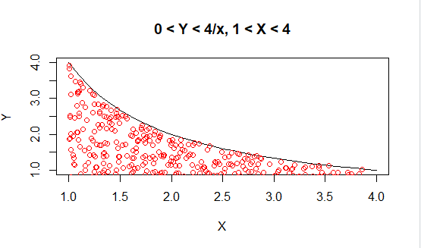1)

Observed covariance of X and Y in a simulation with 500 data points =

-0.3750256 and our hand calculated results were -.24.

However the monte carlo is more accurate

2)

Observed covariance of X and Y in a simulation with 1000 data points = 3.870382 which is very close to what I hand calculated which was 3.91.

Hand Calculation