Cristian Ortiz

Math32

Lab 12

1)

a. = 0.3308744 According to the central Limit Theorem not very likely with roughly 33% chance of finding someone below 98.25 degrees.

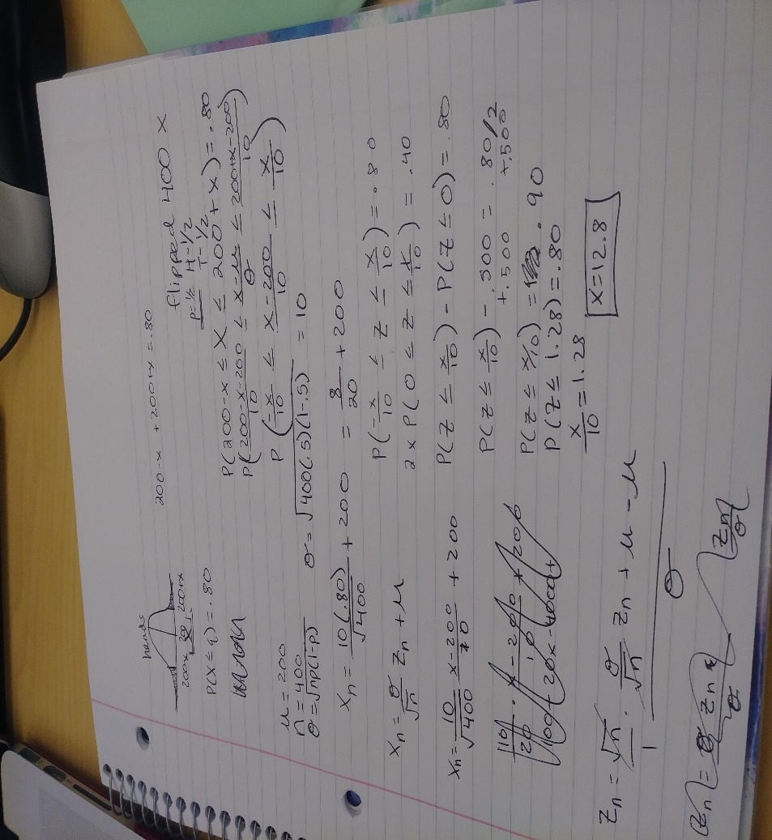

b)

c) 2,000,000, its large b/c to get a more accurate measurement value of the averages that are within 1 foot, as per the law of large

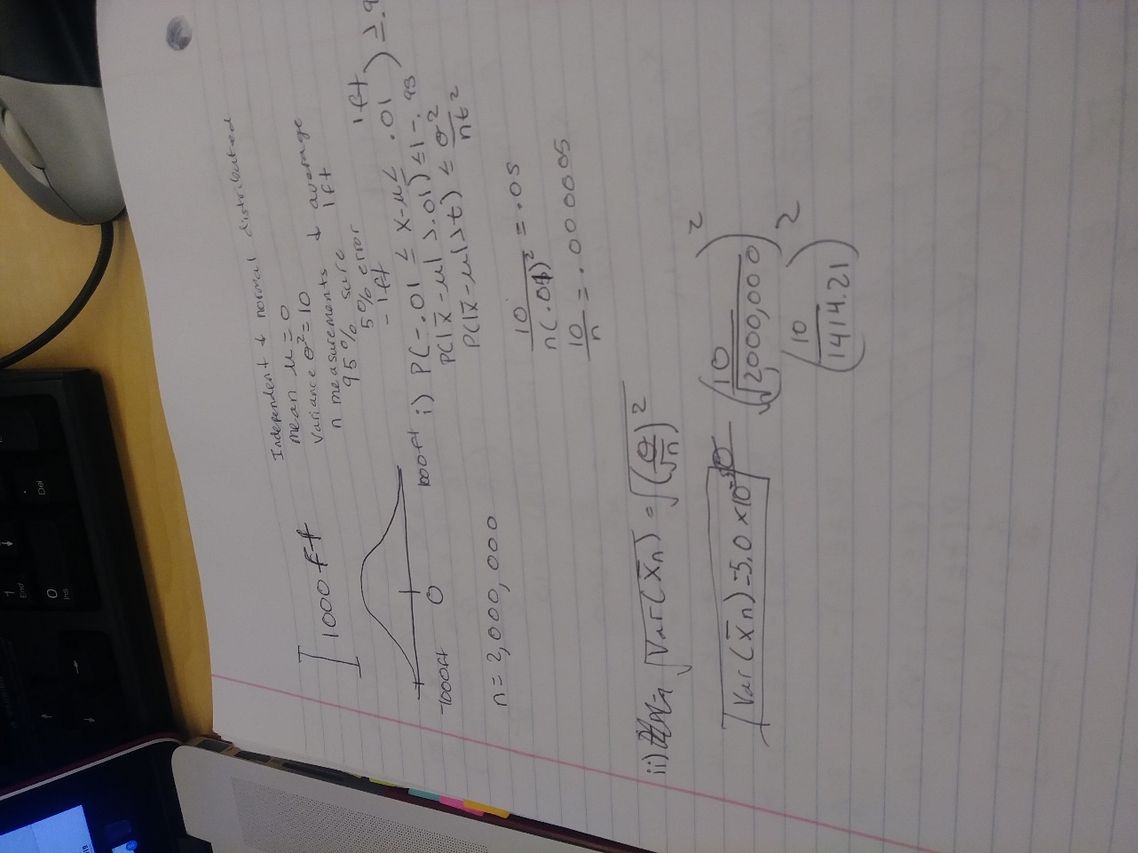

2) Lions.CSV is not meet the criteria to use the Central Limit Theorem B/c the sample size is way to small and not very close to normal.

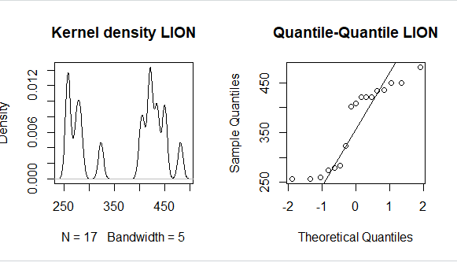However the Quiz.csv does meet the criteria because the sample size is large and close to normal

