Cristian Ortiz

Math 32 Lab

12/4/2019

1. To get the R^2 value as close to one as possible I used trial and error by using different models for P. I used log, and different exponentials before settling on P^10 as the it gave me the closest value to 10. This Is due to P having a higher quadratic which gave the closest approximation to 1.

Multiple R-squared: 0.9953, Adjusted R-squared: 0.9943

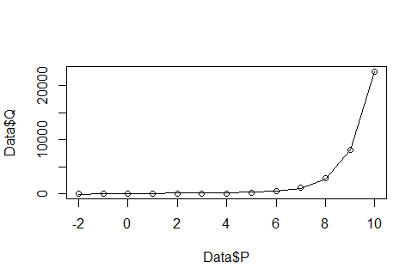

2)