Cristian Ortiz

Math 32-5D

Lab 2 Report

1. Calculate the true probabilities in this scenario. (This will be in your written report.)

The True Probability of 10^2



True Probability of 10^4

3) Provide output from your code (the figures comparing both probabilities) for at least these two different scenarios:

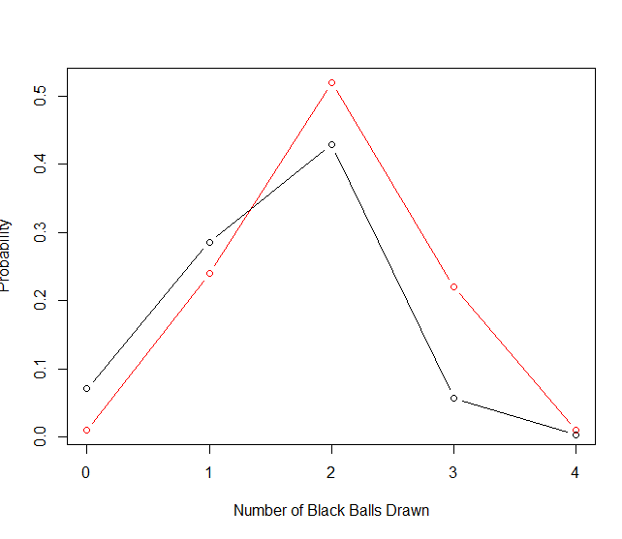 (a) numTrials = 102

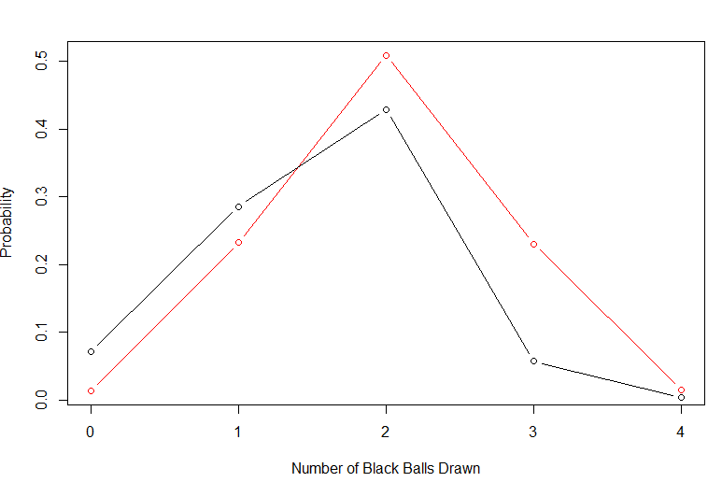(b) numTrials = 104

4) both of the graphs show an estimated probability and the true probability values. The Red lines is the true probability while the black is the estimated ideal line needed. Overall the larger the number of trials the more accurate the approximation becomes.

5) the True probability I got was not very accurate because it went slightly over 1. The graph did not change much after going over 10,000 test.