Cristian Ortiz

Math 32

Lab9

10/30/19

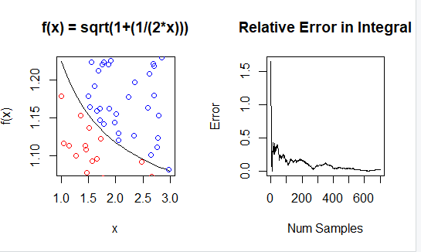

1)

For the function f(x) = sqrt(1+1/2x),I skipped the “By hand” integration as per lab instruction and found the Numerical and Monte Carlo. For the Numerical Integration I got 2.256671 and for the Monte Carlo I got 2.297143. The left graph shows how likely the value will be under the curve, red if under and blue if over. The right shows the relative error of the integration. As we can see with 700 samples we get a large error and the beginning, but the error gets smaller and smaller as we approach the 700th sample giving us the closest possible approximation.

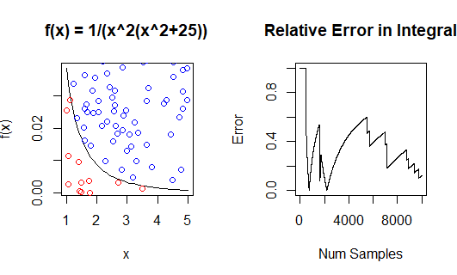

2)

For the function f(x) = 1/x^2(x^2+25), I ran it through the “By hand”, Numerical and Mont Carlo Integration. For the By Hand I got .02729598 for the Numerical Integration I got .02729598 and for Monte Carlo I got .024. For this function I also increased the sample size 10-fold to 10,000 as the previous sample size 700 was not large enough to get a proper approximation. The left shows the that large amount of numbers were over the curve rather than under the curve and the right graph shows that our error were at its lowest towards the 4000’s than spiked before dropping again.

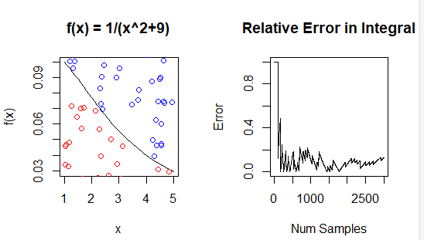3)

For the function f(x) = 1/(x^2+9) I used all 3 methods once again.

For each I got ,With sample 3000

|  |
| --- |
| Calculus (By Hand) Integral = 0.2362088  Numerical Integration = 0.2362088  Monte Carlo Integration = 0.2066667    The red and blue circles were more or less evenly matched through the x and y range. I also kept the sample size above 1000 but less than 10,000 because I noticed that to many samples doesn’t always improve the result approximation. I also kept my function to be 1D. My error was very low through the sample size which can amount to the 3 result being in close approximation of each other. |
|  |
| |  | | --- | |  | |