Cristian Ortiz

Math 32

Lab 4

1. 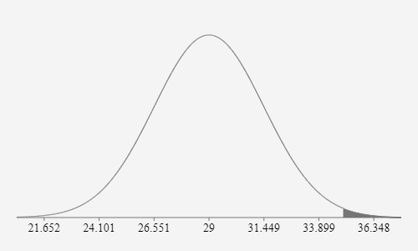P(X>35) = .0072

* Plugged in the mean as 29 and since variation is 6 then the SD is the sqrt of 6. Then given that we are find that probability that x > 35 we plug in 35 for the “above”.
* Verified with R code results match by modifying the pnorm function

upperTail = pnorm(35, mean=mu, sd=sigma, lower.tail=FALSE);

cat("P(X > 35) ", " = ",upperTail,"\n")

sigma = 2.45;

> #Integrate the PDF for x > (mu + tolerance) (Upper Tail)

> upperTail = pnorm(35, mean=mu, sd=sigma, lower.tail=FALSE);

> cat("P(X > 35) ", " = ",upperTail,"\n")

P(X > 35) = 0.007163078

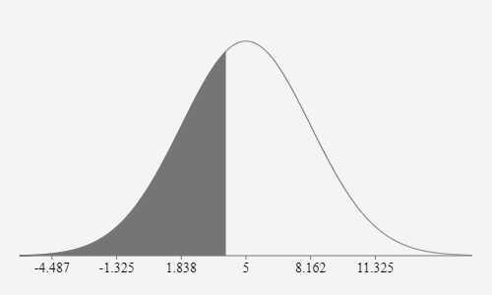

1. P(x < 4) = .3759

* Plugged in the mean as 6 and the sqrt of 10 as the SD with the given “below” of 4.
* Verified with R code by modifying the pnorm.

#Integrate the PDF for x < (mu - tolerance) (Lower Tail)

#lowerTail = pnorm(4, mean=mu, sd=sigma, lower.tail=FALSE);

#cat("P(X<4) ", " = ",lowerTail,"\n")

* > mu = 5;
* > sigma = 3.16;
* P(X<4) = 0.3758283

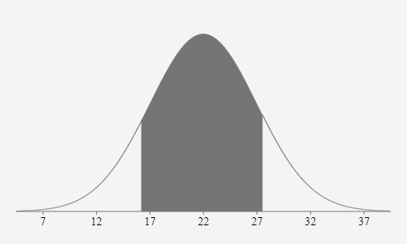

1. P(16.2 < X < 27.5) = .7413

* Plugged in 22 as mean, SD is 5 and given a range of 16.2 and 27.5 plugged into “Between “ Verified with R Code results match.

Integrate the PDF for x > (mu + tolerance) (Upper Tail)

upperTail = pnorm(16.2, mean=mu, sd=sigma, lower.tail=TRUE);

cat("P(X > 16.2) ", " = ",upperTail,"\n")

Integrate the PDF for x < (mu - tolerance) (Lower Tail)

lowerTail = pnorm(27.5, mean=mu, sd=sigma, lower.tail=TRUE);

cat("P(X<27.5) ", " = ",lowerTail,"\n")

> source('C:/Users/cortiz42/Downloads/normalDistributionExperiments.R')

P(X > 16.2) = 0.1230244

P(X<27.5) = 0.8643339

P(X>16.2) = .1230244

P(X<27.5) = .864339

TotalProb: .864339-.7413 = .7413 which matches our result.

1. 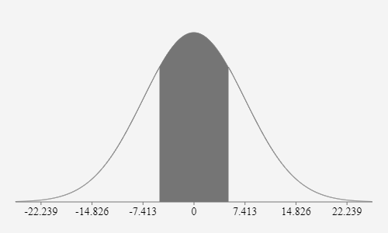Standard Deviation is σ=7.412 when P(−5 ≤ X ≤ 5) = 0.5 and the mean is 0.

* Through trial and error using the given online tool I was able to find the SD.

mu = 0;

sigma = 7.412;

#Integrate the PDF for x > (mu + tolerance) (Upper Tail)

upperTail = pnorm(-5, mean=mu, sd=sigma, lower.tail=TRUE);

cat("P(X > -5) ", " = ",upperTail,"\n")

#Integrate the PDF for x < (mu - tolerance) (Lower Tail)

lowerTail = pnorm(5, mean=mu, sd=sigma, lower.tail=TRUE);

cat("P(X<5) ", " = ",lowerTail,"\n")

> source('C:/Users/cortiz42/Downloads/normalDistributionExperiments.R')

>P(X > -5) = 0.2499708

>P(X<5) = 0.7500292

Total Prob = .7500292 - 0.2499708 = .5 ish

Meaning that the sigma I found with the math tool was correct.