Cristian Ortiz

Math 32

10/16/19

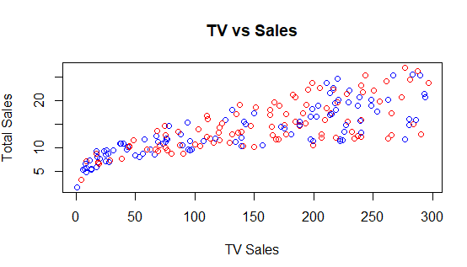LAB 7

1. A) TV vs Sales

* As the amount of TV sales increase so do the total amount of Sales. We can extrapolate that the Total Sales is dependent on the amount of TV sales.

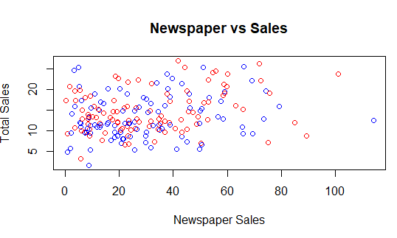

B) Newspaper vs Sales

* There is no form of Correlation between the total sales and the newspaper sales as they are independent of each other as shown in the scatter plot.

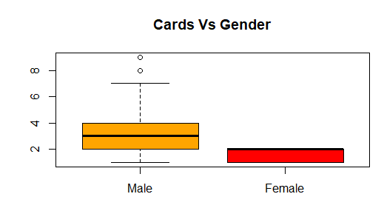

2) A)

* As we can see here for the graph of number of cards owned by males and females, that males have twice as many credit cards as females and for some outliers some have as many as 4 times more.

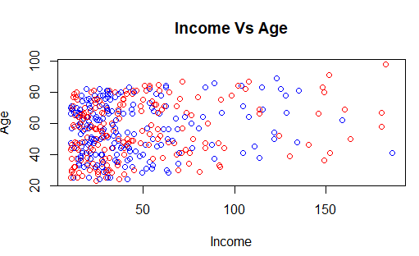

B)

* From the graph on it seems that there wasn’t that much of a correlation between age and income as the scatter plot is bunched up near the start, meaning that regardless of age many people are earning up to 50K a year. However for the outliers the older people seem to be making the big bucks with 100K plus a year.

plot(Credit$Income , Credit$Age, main = "Income Vs Age", xlab = "Income", ylab = "Age", col = c("Blue", "Red"))