Gauss Jordan Elimination

Chaithanya Gadiyam

Abstract
This lab exercise performs Gauss Jordan Elimination of a matrix on both CPU and GPU. CPU and GPU execution times, computation error and speedup against CPU are measured to analyze the performance of CPU and GPU. The program is run for several matrix sizes and graphs are plotted for speedups for different matrix sizes using the results.

Procedure
The source code is organized into four files. Main.cpp determines the sequential flow of the program and it also includes measurement of computation time, L2Norm. Common.h includes the declaration of Gauss Jordan elimination functions of CPU and GPU. GJEliminationCPU.cpp contains CPU implementation for Gauss Jordan elimination. GJEliminationGPU.cu contains GPU implementation of Gauss Jordan elimination which includes GPU kernel. Elements of the input matrix are generated using the random function rand() and RAND_MAX, which range from 0 to 1. CPU implementation is done by making the diagonal element of the operating column as 1 by scaling the entire row and the remaining elements in the column are made zero by doing row operations. This process is done as many times as number of rows by incrementing the operating row for each iteration. The resultant matrix is an identity matrix with solution on the extreme right column. For GPU implementation, two kernels are written, one for scaling the row which contains the diagonal element and one for performing row operations on rows which contain non diagonal elements. These two kernels are run as many times as number of rows. In each kernel, indexing through the matrix is done using x and y coordinates of the thread. Each block in the GPU is defined as two dimensional with 16 as tile width. Tile width is chosen as 16 for effective utilization of Stream multiprocessor threads (since the maximum number of threads per multiprocessor is 1536). Matrix dimensions define the dimensions of the grid, i.e. total number of blocks in the 2D grid. Execution times of the algorithm on both CPU and GPU are measured. Also computation error between CPU and GPU is also measured by calculating the L2Norm. The program is run for different matrix sizes ranging from 4 x 4 to 2048 x 2048 and the results are captured.

Results

CPU execution time, GPU execution time, speed up and L2Norm for Gauss Jordan elimination are measured for various matrix sizes and listed down in the table shown below. Also a graph is plotted between speedup and matrix size which is shown below.
From the results it can inferred that better speedups are achieved in GPU for larger matrices, i.e. speedup increases with increase in matrix size. Also the computation error is negligible even for larger matrices. But from the results it can be said that computation error is increases with increase in matrix size, because the number of passes increase with number of rows and with increase in number of operations, elements in resultant matrix gets rounded off more often.

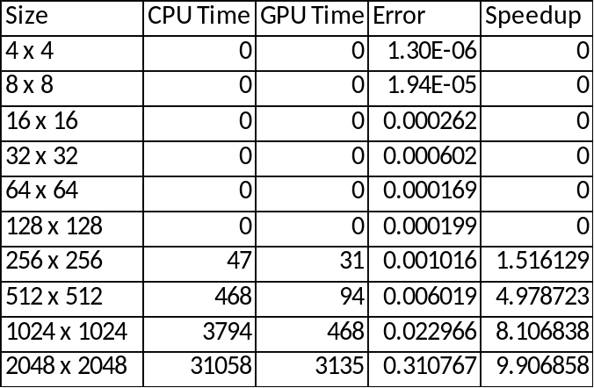
Table 1. Results Summary

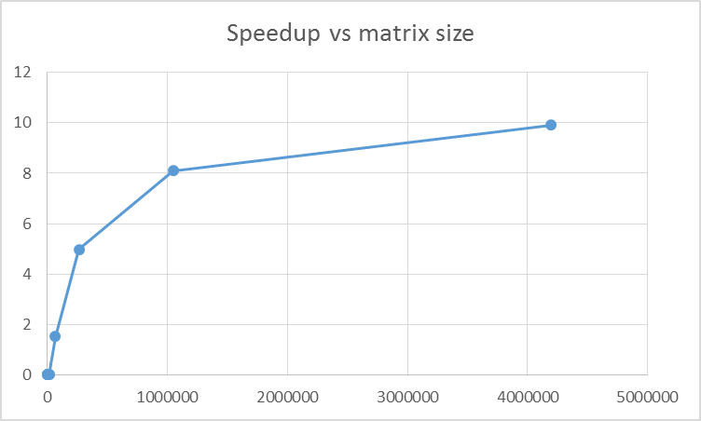
Figure 1. speedup as a function of number of elements
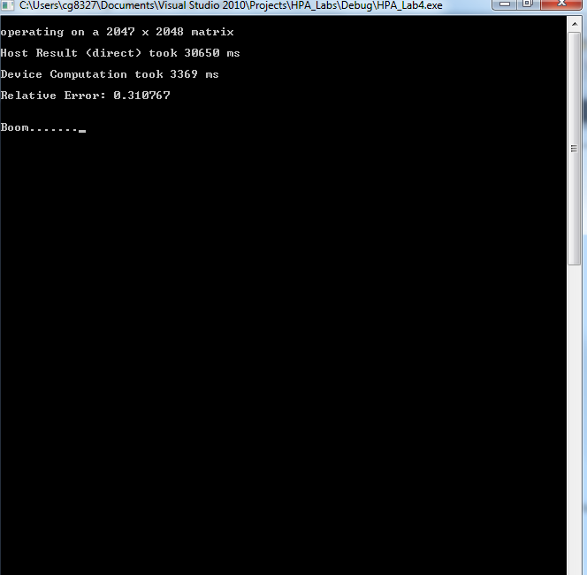
Figure 2. sample console ouput

Conclusion
This exercise helps in analyzing how to orchestrate a parallel computation by implementing a complex algorithm like gauss Jordan elimination on GPU. Also it is observed that by reducing the number of memory copies from host to device and device to host, better speedups can achieved in GPU. It can be inferred from the results that the speedup increases with increase in number of elements in the matrix and computation error increases with increase in number of elements.

Questions
- Gauss-Jordan Elimination (or similar algorithms such as Gaussian Elimination) are used to implement matrix inversion. Finding the inverse of a matrix is avoided in real-world algorithms, though, since it can be numerically unstable. The matrices generated in this lab are simple enough to not cause problems, but if the elements of the matrix were very large (or very small), how might that cause problems? (Partial Pivoting is designed to minimize this problem, but is does not eliminate it.)
- If the elements in the matrix are very large or very small, precise solution might not be achieved because while scaling, the row elements in the matrix would be divided by a smaller value and get rounded off. Since this process happens multiple times with multiple passes, exact solution might not be achieved. Partial pivoting swaps the active row with a row having greatest leading element. Partial pivoting does not eliminate this issue because if all the leading elements are larger, some precision is lost while making row operations.

- Using the GPU to perform calculations only makes sense when the computational performance outweighs the overhead. Approximately what size matrix is the “break-even” point, where the GPU begins to offer a performance advantage?
- .GPU begins to offer a performance advantage starting from matrix size 174 x 174

- For the provided CPU declaration, the matrix was stored as a float**. Based on the CPU and GPU implementations, how do the access patterns differ? Why might this make an impact on the overall execution time and resulting speedup?
- CPU implementation access the two dimensional array using double pointer, whereas GPU implementation converts the two dimensional array into one dimensional one and sends it to kernel. Accessing a two dimensional array takes less time than a one dimensional array. Hence it increases the overall execution time in GPU and affects the speedup to an extent.

