Heat Transfer Simulation

Chaithanya Gadiyam

Abstract
This lab exercise implements Heat Transfer algorithm to calculate temperature of each cell in the given heat map. It is implemented on GPU using texture memory, to store heat map for each step. The program was run on different input sizes ranging from 10x10 to 1000x1000 and the results are tabulated.

Design Methodology
A simple heat transfer algorithm has been implemented, which calculates temperature of each cell in the heat map for each step and the final temperature of each in the heat map after multiple steps. For GPU implementation, texture memory is used to hold the data of each cell in the heat map for every step. To calculate the temperature of each cell in the heat map, each thread in the grid access the 4 neighboring cells of the current cell. Since each cell in the heat map is accessed multiple times and all cells in the heat map are arranged in a two dimensional array, usage of texture memory to store the heat map is a viable option. Initially the one dimensional array of data is stored as a two dimensional data on GPU. Using texture reference object, the two dimensional array of data of heat map in global memory is mapped to texture memory. A two dimensional grid and two dimensional blocks of threads are used for kernel configuration. The kernel is called multiple times for multiple steps. For each step, the texture memory is unbinded, the resulting heat map is copied to the two dimensional array of data in global memory of GPU and then texture memory is mapped to the two dimensional array of data using texture reference. The kernel calculates the temperature of each cell in the heat map, by accessing its neighboring cells in texture memory and based on the given heat speed. The calculation is based on the equation provided in the handout. The kernel stores the resultant data for each cell in a one dimensional output array. As with the provided CPU implementation, temperature of bordering cells in the heat map is not updated in any of the iterations in the GPU implementation too. The compiled and built library file of CUDA implementation in visual studio is exported to MATLAB files folder to run the project on MATLAB for the specified data size and number of steps. The output console provides the average time taken per iteration and average time taken per step by both CPU and GPU implementations, along with the GPU vs CPU speedup. Also figures of initial heat map, CPU output heat map and GPU heat map are generated. A short animation of generated heat maps is created using the file ffmpeg.exe.

Results
This program is run on MATLAB for input sizes of heat map ranging from 10 x 10 to 1000 x 1000. For each of those input sizes, CPU execution time per iteration, GPU execution time per iteration, GPU vs CPU speedup, error between the implementations are noted and listed down in a table 1. The point at which the speedup is goes above 1, i.e. the break-even point of the implementation is 29 x29. Speedup values of 28 x 28, 30 x 30 input sizes are also used along with the values listed in table 1 to plot a graph between GPU vs CPU speedup and input data size, which is shown in figure 1. Initial heat map, CPU output heat map, GPU output heat map and sample console output of MATLAB for input size 1000 x 1000 are added. From the results we can observe that the speedup increases with the increase in input size and error between implementations is low for all input sizes. Also a short animation of generated heat maps is created for input size 1000 x 1000 and shown during demo.

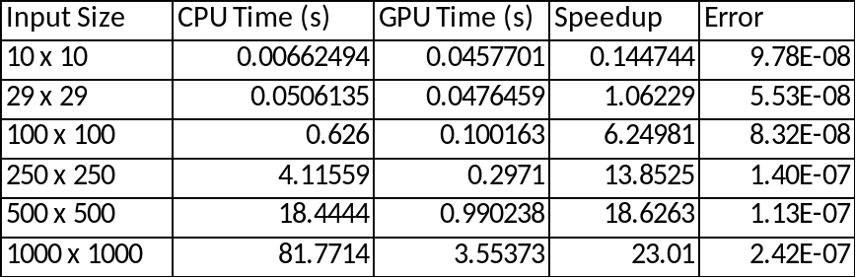

Table 1. Results Summary

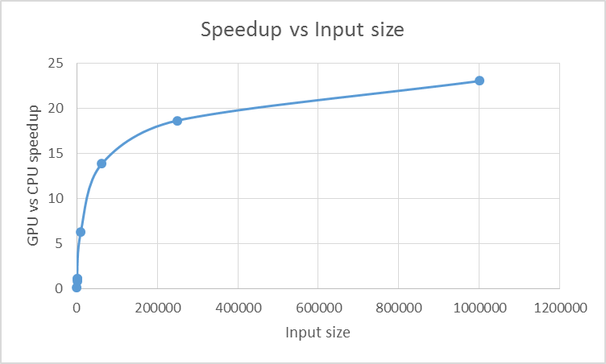

Figure 1. GPU speedup as a function of Input size

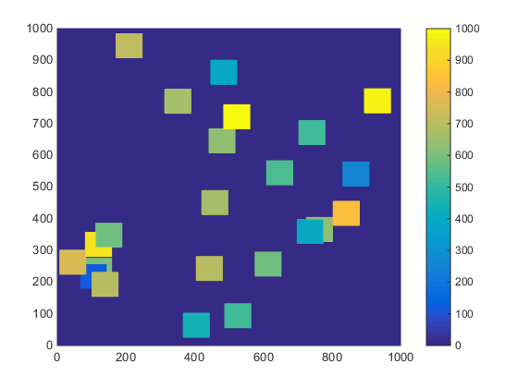
Figure 2. Initial Heat map for input size 1000 x 1000

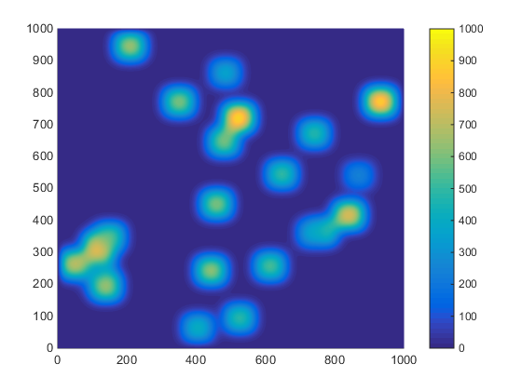
Figure 3. CPU Output Heat map for input size 1000 x 1000

Figure 4. GPU Output Heat map for input size 1000 x 1000

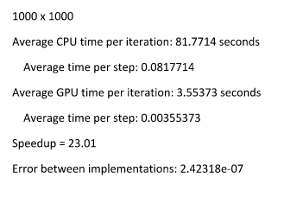
Figure 5. Sample console ouput

Conclusion
This lab exercise helps in getting familiar with usage of texture memory through the implementation of heat transfer algorithm on GPU. Texture memory is used to store the heat map data in every step, since all cells in the heat map are accessed multiple times and also due to the spatial locality of memory accesses in heat transfer algorithm. From the results, it can be inferred that better speedups can be achieved with larger input data sizes.

Questions
- When you used constant and shared memory, you had to explicitly copy data into those locations. However, texture memory needs to have the notion of binding a variable to it. Perform some research and describe the sequence of events that occurs when you bind a variable to texture memory and then later access that value in the kernel.
- When a variable in global memory is bound to a texture reference, the data present in the variable address in global memory is cached into texture memory. This cached data in texture memory can be accessed using the texture reference which is bound to the variable in global memory. Within a kernel call, the texture cache is not kept coherent with respect to global memory writes, so texture fetches from addresses that have been written via global stores in the same kernel call return undefined data.

