K - Means Clustering

Chaithanya Gadiyam

Abstract
This lab exercise implements K- means clustering algorithm for the classification of unknown data, both on CPU and GPU. The clustering algorithm implemented operates on two dimensional data, which is classified into 3 clusters. The program was run on data sets ranging up to 2^25 samples and the results are tabulated.

Design Methodology
K-means clustering algorithm is implemented on both CPU and GPU for classification of two dimensional data into 3 clusters. Cluster locations are assigned to initial values before executing the K-means algorithm. Basically this algorithm is implemented in two steps. The first one for the assignment of each data point to a cluster, which is done by calculating the distance of each data point from each cluster and assigning it to the nearest cluster. The second one is to update the cluster locations, which is implemented by calculating the mean of all points in cluster. This algorithm iterates until no data point change the cluster to which they belong. For GPU implementation, the first part is implemented in the kernel, i.e. assignment of each data point to a cluster by calculating the distance from each cluster and assigning to the nearest cluster. Since the cluster locations are accessed multiple times, all three cluster locations are stored in constant memory for faster memory access. These cluster locations are updated in constant memory for every iteration. A 1 dimensional grid with 1 dimensional block of threads is used as the configuration of kernel. Block size of 768 threads per block is chosen for optimal usage of threads per multiprocessor. Number of blocks is dependent on data size. Execution times for CPU computation and GPU computation are calculated and displayed on console. Also percentage of data points misclassified is calculated.

Results
This program is tested on data sizes ranging from 2^15 to 2^25 samples and execution times of CPU and GPU implementations, GPU speedup and percentage of data points that are misclassified are listed for each data size in the following table. From the results, it can inferred that the GPU speedup remains almost same for all data sizes. This is because that as the data size increases, the number of iterations of K-means algorithm increase and with that the number of memory copies from host to device and device to host increase. Hence the GPU speedup remains almost the same for all data sizes. Also for the data size 65536, a plot with the original data set colored with ground truth and a plot of the data points with the correct cluster assignment is shown.

Data Size | CPU Time (ms) | GPU Time (ms) | GPU Speedup | % Misclassified
32768 | 57.5862 | 14.5172 | 3.966756675 | 11.3617
65536 | 127.207 | 31.2414 | 4.071744544 | 11.5036
131072 | 234.172 | 53.8621 | 4.347621055 | 11.4357
262144 | 590.241 | 134.276 | 4.395729691 | 11.5189
524288 | 1158.48 | 270.897 | 4.276459318 | 11.5545
1048576 | 2627.34 | 606.793 | 4.329878558 | 11.5609
2097152 | 5855.62 | 1351.17 | 4.333740388 | 11.5922
4194304 | 12311.8 | 2860.2 | 4.304524159 | 11.5828
8388608 | 23408.6 | 5354.6 | 4.371680424 | 11.5779
16777216 | 62383 | 14144 | 4.410562783 | 11.5828
33554432 | 98771 | 22583 | 4.373688173 | 11.5679

Table 1. Results Summary

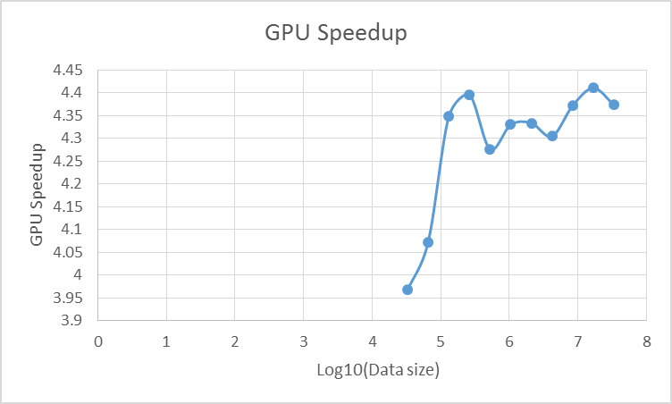
Figure 1. GPU speedup as a function of log10 of data size

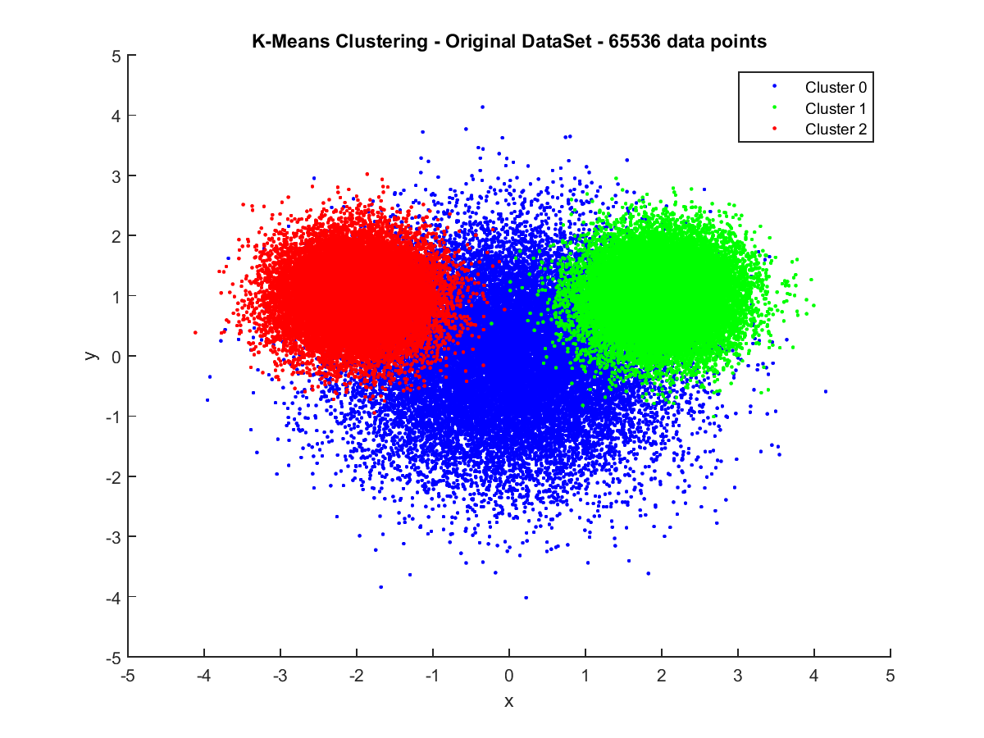
Figure 2. Colored with ground truth
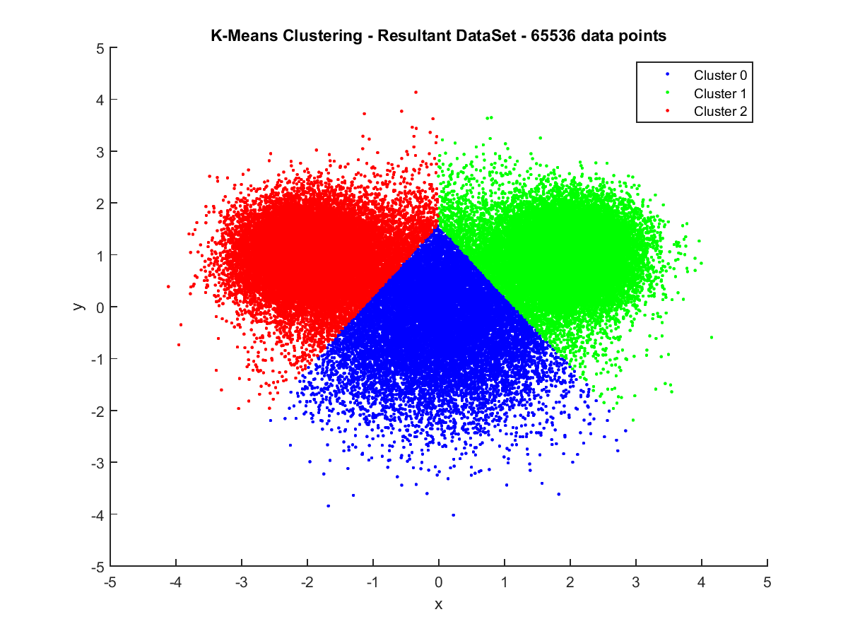

Figure 3. Clustering algorithm output
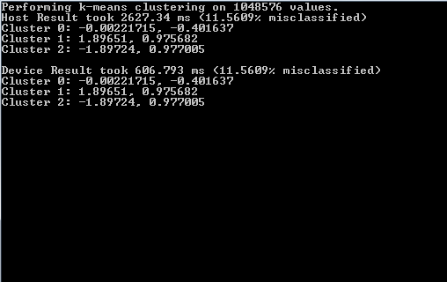
Figure 4. Sample console ouput

Conclusion
This lab exercise gives an opportunity to work with constant memory for the GPU implementation of K-means algorithm. Clusters are stored in constant memory, since each cluster is read multiple times to determine the nearest cluster for each data point. Also this exercise gives a simple approach for the classification of unknown data through K-means algorithm.

Questions
- You used constant memory as part of this implementation. Why does it make sense to use constant memory for the clusters? What is the maximum number of clusters that you could store in constant memory?
- Clusters are stored in constant memory, because to calculate the nearest cluster for each data point, all three clusters are accessed, i.e. clusters are accessed multiple times and not modified by the kernel. Since each cluster has two float values, it needs 8 bytes of memory for each cluster. Constant memory in GPU is of size 64 KB. Therefore the maximum number of clusters that can be stored in constant memory is 8000.

- Could you have used constant memory for the data points as well? Make sure that your answers are very specific and include concrete numbers to back up your claim.
- Since Constant memory size in GPU is 64 KB and each data point needs 11 bytes of memory, we can only store a maximum of 5818 data points. But the program is designed to work on much bigger data sizes. Hence it is not feasible to use constant memory for data points.

